Dashboard_Padaye
Feature Inventory & Microservices Architecture Plan
Spring Boot microservices • PostgreSQL • Free & open-source stack

1. Current Feature Inventory
The existing React (Create React App) dashboard already implements the following, across 8 user roles.

1.1 User Roles
• Principal — Full school head — school-wide oversight, staff & user management, finance, exams, reports.
• Headmaster — Academic administrator — timetables, exams, homework tracking, staff & student oversight.
• Teacher — Subject/class teacher — attendance, homework, notes, grading, messaging.
• Student — Views own timetable, homework, exams, results, attendance and notices.
• Parent / Guardian — Tracks a child's attendance, results, homework, fees; contacts teachers.
• Accountant — Finance staff — manages fee records and views notices (shared Staff Portal).
• Support Staff — Gate Keeper, Watchman, Cleaner, Maintainer, Security, Other — notices & calendar (shared Staff Portal).
• Guest — Unauthenticated visitor — public school info, notices, calendar, login prompt.

1.2 Master Feature List (deduplicated across all roles)
• Login / Authentication (with demo-account quick login)
• Registration / User Management (create accounts by role)
• Dashboard home (stats overview, cards, recent activity)
• Sidebar navigation + Navbar with page title header
• Notifications bell (recent announcements)
• Search bar
• User profile / avatar display
• Logout
• Class Management (create/edit classes)
• Staff Management / Staff Overview
• Student Directory (searchable, with attendance %)
• Timetable / Weekly Schedule
• Attendance Management (mark, view, school-wide/class/personal breakdown)
• Homework / Assignment Management (create, track, submit, status filter)
• Notes / Study Materials (upload, browse, download by subject)
• Exam Management (schedule, edit)
• Question Papers (create/manage, past papers download)
• Grade Book / Results (enter marks, view grades, percentages, averages)
• Fee & Finance Management (fee records, fee status, "Pay Now")
• Holiday Calendar / Academic Calendar (view/edit)
• Notices / Announcements (post, view)
• Messages / Contact (compose, inbox/sent, contact teacher)
• Analytics (pass rate, grade distribution, subject-wise performance)
• Reports (attendance, exam results, fee collection, staff performance, topper's report, report card generation)
• Public School Info page (for Guests — about, contact, portal access guide)

2. Target Microservices Architecture
Goal: split the monolithic frontend’s implicit backend needs into small, independently deployable Spring Boot services, each owning its own data, backed by a single free PostgreSQL instance.

2.1 Infrastructure Services
Service | Port | Role
eureka-server | 8761 | Service discovery/registry — every domain service registers here; api-gateway and peer services resolve locations dynamically instead of hard-coded URLs.
config-server | 8888 | Centralized configuration (Spring Cloud Config) — externalizes each service’s application.yml (DB URL, JWT secret, feature flags) from a shared Git-backed config repo.
api-gateway | 8080 | Single entry point (Spring Cloud Gateway) — routes /api/** to the right domain service, validates the JWT on every request, and is the only port exposed to the React client.

2.2 Domain Microservices
Service | Port | DB Schema | Responsibilities
auth-service | 8081 | auth_db | Handles login, registration / user management, role assignment, JWT issuance and basic profile data for all 8 user roles.
people-service | 8082 | people_db | Owns the student and staff directories and the parent ↔ student relationship.
class-timetable-service | 8083 | class_db | Manages class definitions and weekly timetables per class and per teacher.
attendance-service | 8084 | attendance_db | Records and reports attendance at school, class and individual student level.
academics-service | 8085 | academics_db | Covers homework, study materials/notes, exam management, question papers and the grade book/results.
fee-service | 8086 | fee_db | Tracks fee records, per-student fee status and payments.
communication-service | 8087 | communication_db | Handles school notices/announcements, internal messaging and the notification feed.
reporting-service | 8088 | reporting_db (aggregation cache only) | Aggregates data from the other services (via Eureka + Feign) to produce analytics and report documents; does not own primary data.

2.3 Technology Stack (all free / open-source)
• Spring Boot 3.2.x — each microservice is an independent, deployable application
• Spring Data JPA + Hibernate — persistence per service
• PostgreSQL — free, open-source relational database (single instance, schema-per-service)
• Spring Cloud Gateway — API Gateway / single entry point
• Netflix Eureka — service discovery/registry
• Spring Cloud Config — centralized, Git-backed configuration
• springdoc-openapi (Swagger UI) — auto-generated, annotation-driven API docs per service
• Spring Security + JWT — stateless authentication validated at the gateway
• OpenFeign / WebClient — typed service-to-service calls resolved via Eureka
• Maven — build tool per service
• Lombok — boilerplate reduction (getters/setters/builders)

2.4 Database Strategy
One PostgreSQL instance (local via Docker, or a free-tier host such as Neon / Supabase) hosting one schema per microservice. This keeps data ownership logically separated per bounded context while staying on a single free database instance. Splitting into one Postgres instance per service is listed in the Roadmap as the scale-out path.

2.5 Communication Pattern
Client → api-gateway over REST (the only exposed port). The gateway validates the JWT on every request and routes to the correct service. Service-to-service calls (e.g. reporting-service calling academics-service and attendance-service) use Eureka-resolved OpenFeign/WebClient clients rather than hard-coded URLs. Asynchronous/event-driven messaging (Kafka/RabbitMQ) is deferred — see Roadmap.

3. Architecture Diagram
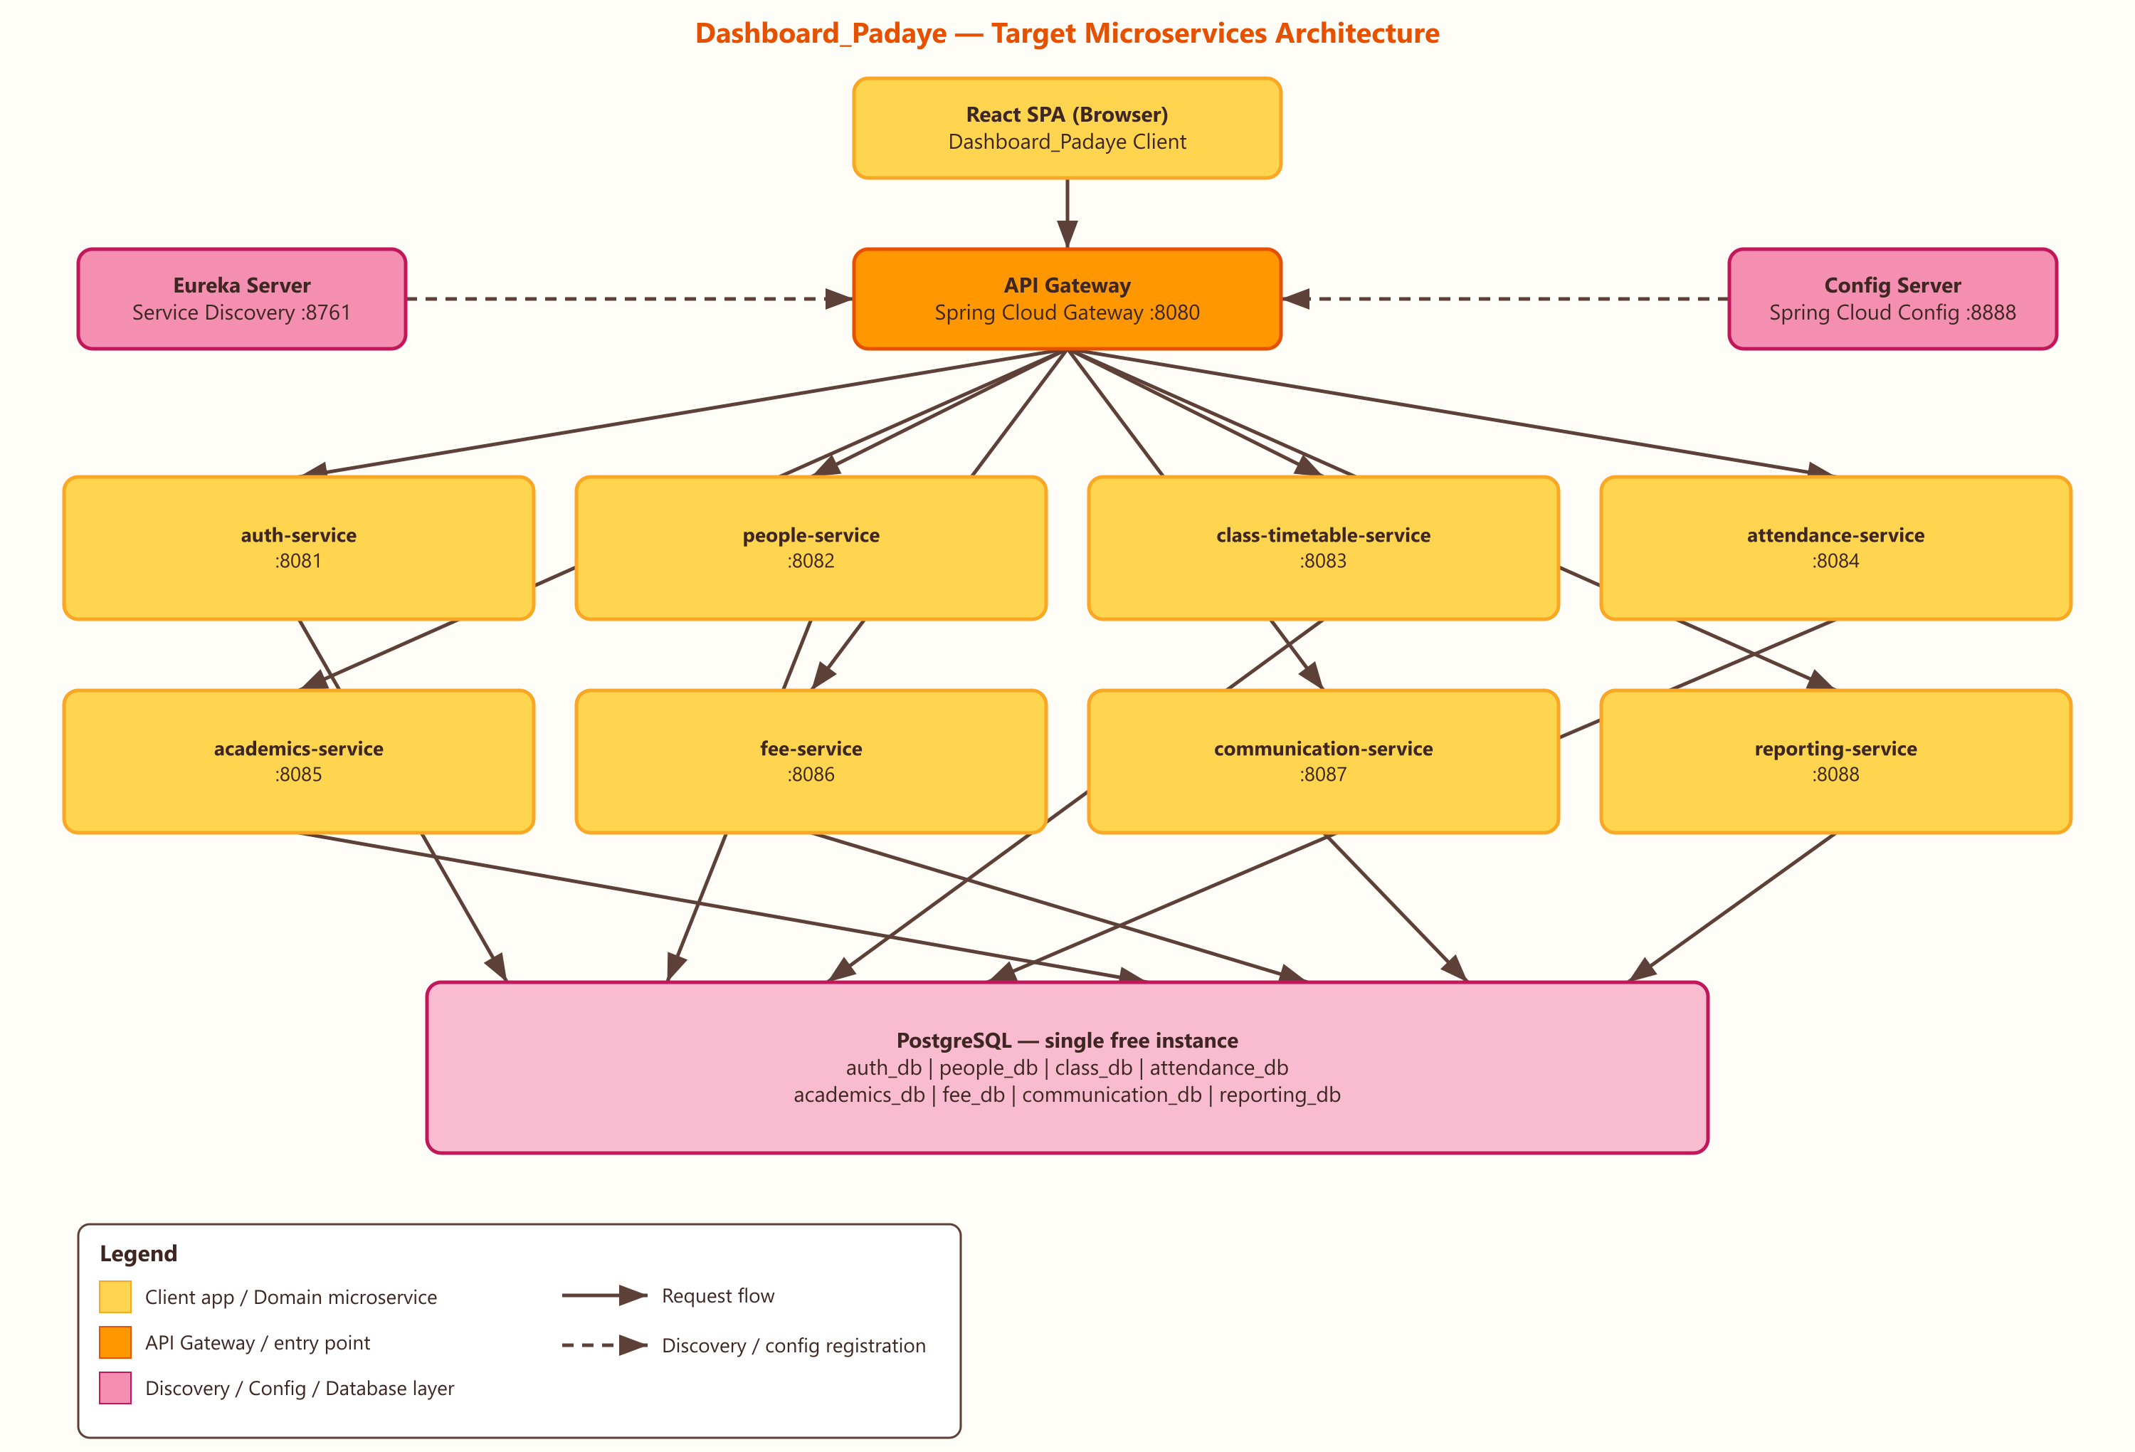
Yellow = client app / domain microservice. Orange = API Gateway (entry point). Pink = discovery, config & database layer. Solid arrows = request flow. Dashed arrows = discovery/config registration.

4. Per-Service API Documentation
Each service exposes its endpoints via springdoc-openapi (Swagger UI at /swagger-ui.html on its own port, and aggregated through the gateway). Below: an endpoint table plus one representative annotated controller per service.

4.1 auth-service (:8081)
Handles login, registration / user management, role assignment, JWT issuance and basic profile data for all 8 user roles.
Method | Path | Description | Allowed Roles
POST | /api/auth/register | Register a new user account | Principal, Headmaster
POST | /api/auth/login | Authenticate credentials and issue a JWT | All (public)
POST | /api/auth/refresh | Refresh an expired access token | Authenticated
GET | /api/users | List / search users, optional role filter | Principal, Headmaster
GET | /api/users/{id} | Get a single user's profile | Self, Principal, Headmaster
PUT | /api/users/{id} | Update a user's profile | Self, Principal, Headmaster
DELETE | /api/users/{id} | Deactivate a user account | Principal

Sample Annotated Controller — AuthController — POST /api/auth/login
@RestController
@RequestMapping("/api/auth")
@Tag(name = "Auth", description = "Login, registration and token operations")
public class AuthController {

private final AuthService authService;

public AuthController(AuthService authService) {
this.authService = authService;
}

@Operation(summary = "Authenticate a user and issue a JWT")
@ApiResponse(responseCode = "200", description = "Login successful, token returned")
@ApiResponse(responseCode = "401", description = "Invalid credentials")
@PostMapping("/login")
public ResponseEntity<AuthResponse> login(@Valid @RequestBody LoginRequest request) {
return ResponseEntity.ok(authService.login(request));
}
}

4.2 people-service (:8082)
Owns the student and staff directories and the parent ↔ student relationship.
Method | Path | Description | Allowed Roles
GET | /api/students | Search/list students (filter by class, attendance %) | Principal, Headmaster, Teacher
GET | /api/students/{id} | Get one student's profile | Self, Parent, Teacher, Principal
POST | /api/students | Create a student record | Principal, Headmaster
PUT | /api/students/{id} | Update a student record | Principal, Headmaster
GET | /api/staff | List/search staff (teachers, accountants, support) | Principal, Headmaster
GET | /api/staff/{id} | Get one staff profile | Principal, Headmaster, Self
GET | /api/parents/{id}/children | Get children linked to a parent account | Parent, Principal

Sample Annotated Controller — StudentController — GET /api/students/{id}
@RestController
@RequestMapping("/api/students")
@Tag(name = "Students", description = "Student directory operations")
public class StudentController {

private final StudentService studentService;

public StudentController(StudentService studentService) {
this.studentService = studentService;
}

@Operation(summary = "Get a single student's profile by id")
@ApiResponse(responseCode = "200", description = "Student found")
@ApiResponse(responseCode = "404", description = "Student not found")
@GetMapping("/{id}")
public ResponseEntity<StudentDto> getStudent(@PathVariable Long id) {
return ResponseEntity.ok(studentService.getById(id));
}
}

4.3 class-timetable-service (:8083)
Manages class definitions and weekly timetables per class and per teacher.
Method | Path | Description | Allowed Roles
GET | /api/classes | List all classes | All staff roles
POST | /api/classes | Create a class | Principal, Headmaster
PUT | /api/classes/{id} | Update a class | Principal, Headmaster
GET | /api/timetable/class/{classId} | Get weekly timetable for a class | Student, Parent, Teacher, Admin
GET | /api/timetable/teacher/{teacherId} | Get a teacher's personal weekly schedule | Teacher, Headmaster
POST | /api/timetable | Create/update a timetable entry | Principal, Headmaster

Sample Annotated Controller — TimetableController — GET /api/timetable/class/{classId}
@RestController
@RequestMapping("/api/timetable")
@Tag(name = "Timetable", description = "Class and teacher schedules")
public class TimetableController {

private final TimetableService timetableService;

public TimetableController(TimetableService timetableService) {
this.timetableService = timetableService;
}

@Operation(summary = "Get the weekly timetable for a class")
@ApiResponse(responseCode = "200", description = "Timetable returned")
@GetMapping("/class/{classId}")
public ResponseEntity<List<TimetableSlotDto>> getClassTimetable(@PathVariable Long classId) {
return ResponseEntity.ok(timetableService.getByClass(classId));
}
}

4.4 attendance-service (:8084)
Records and reports attendance at school, class and individual student level.
Method | Path | Description | Allowed Roles
POST | /api/attendance/mark | Mark attendance for a class/session | Teacher
GET | /api/attendance/student/{studentId} | Get one student's attendance history & % | Student, Parent, Teacher, Principal
GET | /api/attendance/class/{classId} | Get attendance for a class on a date | Teacher, Headmaster, Principal
GET | /api/attendance/summary | School-wide attendance overview | Principal, Headmaster
GET | /api/attendance/teacher/{teacherId}/today | Teacher's attendance for today | Headmaster

Sample Annotated Controller — AttendanceController — POST /api/attendance/mark
@RestController
@RequestMapping("/api/attendance")
@Tag(name = "Attendance", description = "Marking and querying attendance")
public class AttendanceController {

private final AttendanceService attendanceService;

public AttendanceController(AttendanceService attendanceService) {
this.attendanceService = attendanceService;
}

@Operation(summary = "Mark attendance for a class session")
@ApiResponse(responseCode = "201", description = "Attendance recorded")
@PreAuthorize("hasRole('TEACHER')")
@PostMapping("/mark")
public ResponseEntity<Void> markAttendance(@Valid @RequestBody MarkAttendanceRequest request) {
attendanceService.mark(request);
return ResponseEntity.status(HttpStatus.CREATED).build();
}
}

4.5 academics-service (:8085)
Covers homework, study materials/notes, exam management, question papers and the grade book/results.
Method | Path | Description | Allowed Roles
GET | /api/homework | List homework (filter by class/status) | Student, Parent, Teacher
POST | /api/homework | Create a homework assignment | Teacher
GET | /api/notes | Browse study materials by subject | Student, Teacher
POST | /api/notes | Upload a study material | Teacher
GET | /api/exams | List/schedule exams | Student, Teacher, Principal, Headmaster
POST | /api/exams | Create/edit an exam | Principal, Headmaster
GET | /api/question-papers | List/download question papers | Teacher, Principal, Student
POST | /api/question-papers | Create a question paper | Teacher, Principal
GET | /api/results/student/{studentId} | Get a student's results/grades | Student, Parent, Teacher
POST | /api/results | Enter marks/grades for a student | Teacher

Sample Annotated Controller — HomeworkController — POST /api/homework
@RestController
@RequestMapping("/api/homework")
@Tag(name = "Homework", description = "Homework and assignment operations")
public class HomeworkController {

private final HomeworkService homeworkService;

public HomeworkController(HomeworkService homeworkService) {
this.homeworkService = homeworkService;
}

@Operation(summary = "Create a new homework assignment")
@ApiResponse(responseCode = "201", description = "Homework created")
@PreAuthorize("hasRole('TEACHER')")
@PostMapping
public ResponseEntity<HomeworkDto> createHomework(@Valid @RequestBody CreateHomeworkRequest request) {
return ResponseEntity.status(HttpStatus.CREATED).body(homeworkService.create(request));
}
}

4.6 fee-service (:8086)
Tracks fee records, per-student fee status and payments.
Method | Path | Description | Allowed Roles
GET | /api/fees/student/{studentId} | Get fee status (total/paid/pending) for a student | Parent, Student, Accountant, Principal
GET | /api/fees/records | List/search all fee records | Accountant, Principal
POST | /api/fees/pay | Record/initiate a fee payment | Parent, Accountant
PUT | /api/fees/{id} | Update a fee record | Accountant, Principal

Sample Annotated Controller — FeeController — GET /api/fees/student/{studentId}
@RestController
@RequestMapping("/api/fees")
@Tag(name = "Fees", description = "Fee records and payments")
public class FeeController {

private final FeeService feeService;

public FeeController(FeeService feeService) {
this.feeService = feeService;
}

@Operation(summary = "Get fee status for a student")
@ApiResponse(responseCode = "200", description = "Fee status returned")
@GetMapping("/student/{studentId}")
public ResponseEntity<FeeStatusDto> getFeeStatus(@PathVariable Long studentId) {
return ResponseEntity.ok(feeService.getStatus(studentId));
}
}

4.7 communication-service (:8087)
Handles school notices/announcements, internal messaging and the notification feed.
Method | Path | Description | Allowed Roles
GET | /api/notices | List notices/announcements | All roles
POST | /api/notices | Post a new notice | Principal, Headmaster
GET | /api/messages | Get inbox/sent messages for the current user | Teacher, Parent, Principal
POST | /api/messages | Send a message (e.g. Contact Teacher) | Teacher, Parent, Principal
GET | /api/notifications/{userId} | Get recent notifications for a user (navbar bell) | All roles

Sample Annotated Controller — NoticeController — GET /api/notices
@RestController
@RequestMapping("/api/notices")
@Tag(name = "Notices", description = "School-wide announcements")
public class NoticeController {

private final NoticeService noticeService;

public NoticeController(NoticeService noticeService) {
this.noticeService = noticeService;
}

@Operation(summary = "List notices visible to the current user")
@ApiResponse(responseCode = "200", description = "Notices returned")
@GetMapping
public ResponseEntity<List<NoticeDto>> getNotices() {
return ResponseEntity.ok(noticeService.getVisibleNotices());
}
}

4.8 reporting-service (:8088)
Aggregates data from the other services (via Eureka + Feign) to produce analytics and report documents; does not own primary data.
Method | Path | Description | Allowed Roles
GET | /api/reports/attendance | Attendance summary report | Principal, Headmaster
GET | /api/reports/exam-results | Exam performance/analysis report | Principal, Headmaster
GET | /api/reports/fee-collection | Fee collection report | Principal, Accountant
GET | /api/reports/staff-performance | Staff/teacher performance report | Principal, Headmaster
GET | /api/reports/report-card/{studentId} | Generate a full report card | Principal, Headmaster, Parent
GET | /api/reports/analytics | Pass rate, grade distribution, subject-wise performance | Principal

Sample Annotated Controller — ReportController — GET /api/reports/report-card/{studentId}
@RestController
@RequestMapping("/api/reports")
@Tag(name = "Reports", description = "Cross-service analytics and report generation")
public class ReportController {

private final ReportCardService reportCardService;

public ReportController(ReportCardService reportCardService) {
this.reportCardService = reportCardService;
}

@Operation(summary = "Generate a full report card for a student")
@ApiResponse(responseCode = "200", description = "Report card generated")
@GetMapping("/report-card/{studentId}")
public ResponseEntity<ReportCardDto> getReportCard(@PathVariable Long studentId) {
// Calls academics-service (results) + attendance-service (attendance %)
// via Eureka-resolved Feign clients, then merges into one DTO.
return ResponseEntity.ok(reportCardService.generate(studentId));
}
}

5. Roadmap / Next Steps
Deliberately deferred from this first plan, to keep the initial cut simple and free-tier friendly:
• Containerize every service with Docker + a docker-compose.yml for local multi-service startup
• CI/CD pipeline (GitHub Actions) to build, test and deploy each service independently
• Event-driven messaging (Kafka or RabbitMQ) for notifications and cross-service updates instead of synchronous calls
• Move from schema-per-service to a dedicated PostgreSQL instance per service as usage scales
• Centralized logging & tracing (ELK stack / Zipkin or Spring Cloud Sleuth) across all services
• Resilience4j circuit breakers, retries and rate limiting at the gateway
• Wire the existing React app to call api-gateway instead of local/mock data
• Turn this document into the PowerPoint presentation (next requested deliverable)

