Aharvika Gangavarapu
Software Engineer
Ph.No: 7981327399

Education and certificates

Education :
B.Tech – Electrical and Electronics

Profile Summary
Email : gangavarapu.aharvika@ capgemini.com

Recent Assignments
City : Bangalore
Engineering
Sir C.R.Reddy college of Engineering ,
Eluru (2024)

Tools s Technologies :
SQL
Spark Pyspark


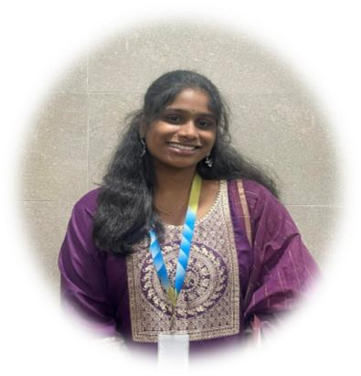
- Completed hands-on Big Data training at Capgemini with experience in distributed systems and large-scale data processing.
- · Worked on data migration projects involving ETL development and movement of large datasets across distributed environments.
- · Built ETL pipelines and automated data validation using Spark, PySpark , and SQL for schema checks, record reconciliation, and data quality verification.
- · Focused on creating reliable, scalable data migration frameworks and strengthening expertise in data engineering technologies.
Education Analytics ETL Pipeline
- Developed an ETL pipeline using Scala and Apache Spark to process student exam results, attendance records, and learning activity data.
- Extracted raw data from CSV files, performed data cleaning (handling missing
values, normalizing student IDs), and calculated average performance metrics.
- Implemented grade classification (A/B/C/D/F) and attendance-based metrics to support dropout risk analysis.
- Loaded the curated dataset into a PostgreSQL database for structured storage and advanced querying.
- Designed interactive Power BI dashboards to visualize performance trends and
provide actionable insights for stakeholders.

.
Power BI Java Postgresql

Certifications :
- Database SQL Foundation - OCEAN
- Scripting Python Foundation - OCEAN

