CAR PRICE PREDICTION USING MACHINE LEARNING
Prepared by: Chitturi Gowtham Surya Prakash

Certificate
This is to certify that the project titled 'Car Price Prediction Using Machine Learning' was completed successfully as part of internship/project work. This is to certify that the project titled 'Car Price Prediction Using Machine Learning' was completed successfully as part of internship/project work. This is to certify that the project titled 'Car Price Prediction Using Machine Learning' was completed successfully as part of internship/project work.
This is to certify that the project titled 'Car Price Prediction Using Machine Learning' was completed successfully as part of internship/project work. This is to certify that the project titled 'Car Price Prediction Using Machine Learning' was completed successfully as part of internship/project work. This is to certify that the project titled 'Car Price Prediction Using Machine Learning' was completed successfully as part of internship/project work.

Declaration
I hereby declare that this project is my original work. I hereby declare that this project is my original work. I hereby declare that this project is my original work.
I hereby declare that this project is my original work. I hereby declare that this project is my original work. I hereby declare that this project is my original work.

Acknowledgement
I express my gratitude to my mentors, faculty members, and all contributors. I express my gratitude to my mentors, faculty members, and all contributors. I express my gratitude to my mentors, faculty members, and all contributors.
I express my gratitude to my mentors, faculty members, and all contributors. I express my gratitude to my mentors, faculty members, and all contributors. I express my gratitude to my mentors, faculty members, and all contributors.

Abstract
This project predicts car prices using machine learning algorithms by analyzing vehicle features and historical data. This project predicts car prices using machine learning algorithms by analyzing vehicle features and historical data. This project predicts car prices using machine learning algorithms by analyzing vehicle features and historical data.
This project predicts car prices using machine learning algorithms by analyzing vehicle features and historical data. This project predicts car prices using machine learning algorithms by analyzing vehicle features and historical data. This project predicts car prices using machine learning algorithms by analyzing vehicle features and historical data.

Table of Contents
1. Introduction
2. Problem Statement
3. Objectives
4. Literature Survey
5. System Requirements
6. Dataset Description
7. Tools and Technologies
8. Methodology
9. Data Preprocessing
10. Feature Engineering
11. Model Building
12. Code Explanation
13. Results
14. Conclusion
15. References 1. Introduction
2. Problem Statement
3. Objectives
4. Literature Survey
5. System Requirements
6. Dataset Description
7. Tools and Technologies
8. Methodology
9. Data Preprocessing
10. Feature Engineering
11. Model Building
12. Code Explanation
13. Results
14. Conclusion
15. References 1. Introduction
2. Problem Statement
3. Objectives
4. Literature Survey
5. System Requirements
6. Dataset Description
7. Tools and Technologies
8. Methodology
9. Data Preprocessing
10. Feature Engineering
11. Model Building
12. Code Explanation
13. Results
14. Conclusion
15. References
1. Introduction
2. Problem Statement
3. Objectives
4. Literature Survey
5. System Requirements
6. Dataset Description
7. Tools and Technologies
8. Methodology
9. Data Preprocessing
10. Feature Engineering
11. Model Building
12. Code Explanation
13. Results
14. Conclusion
15. References 1. Introduction
2. Problem Statement
3. Objectives
4. Literature Survey
5. System Requirements
6. Dataset Description
7. Tools and Technologies
8. Methodology
9. Data Preprocessing
10. Feature Engineering
11. Model Building
12. Code Explanation
13. Results
14. Conclusion
15. References 1. Introduction
2. Problem Statement
3. Objectives
4. Literature Survey
5. System Requirements
6. Dataset Description
7. Tools and Technologies
8. Methodology
9. Data Preprocessing
10. Feature Engineering
11. Model Building
12. Code Explanation
13. Results
14. Conclusion
15. References

Introduction
Car price prediction helps buyers and sellers estimate vehicle values accurately. Machine learning can identify patterns from historical datasets. Car price prediction helps buyers and sellers estimate vehicle values accurately. Machine learning can identify patterns from historical datasets. Car price prediction helps buyers and sellers estimate vehicle values accurately. Machine learning can identify patterns from historical datasets.
Car price prediction helps buyers and sellers estimate vehicle values accurately. Machine learning can identify patterns from historical datasets. Car price prediction helps buyers and sellers estimate vehicle values accurately. Machine learning can identify patterns from historical datasets. Car price prediction helps buyers and sellers estimate vehicle values accurately. Machine learning can identify patterns from historical datasets.

Problem Statement
Manual car valuation is difficult and inconsistent. A machine learning model can automate and improve accuracy. Manual car valuation is difficult and inconsistent. A machine learning model can automate and improve accuracy. Manual car valuation is difficult and inconsistent. A machine learning model can automate and improve accuracy.
Manual car valuation is difficult and inconsistent. A machine learning model can automate and improve accuracy. Manual car valuation is difficult and inconsistent. A machine learning model can automate and improve accuracy. Manual car valuation is difficult and inconsistent. A machine learning model can automate and improve accuracy.

Objectives
Predict car prices accurately, analyze vehicle data, train machine learning models, and evaluate performance. Predict car prices accurately, analyze vehicle data, train machine learning models, and evaluate performance. Predict car prices accurately, analyze vehicle data, train machine learning models, and evaluate performance.
Predict car prices accurately, analyze vehicle data, train machine learning models, and evaluate performance. Predict car prices accurately, analyze vehicle data, train machine learning models, and evaluate performance. Predict car prices accurately, analyze vehicle data, train machine learning models, and evaluate performance.

Literature Survey
Various studies use Linear Regression, Random Forest, and Gradient Boosting models for car price prediction. Various studies use Linear Regression, Random Forest, and Gradient Boosting models for car price prediction. Various studies use Linear Regression, Random Forest, and Gradient Boosting models for car price prediction.
Various studies use Linear Regression, Random Forest, and Gradient Boosting models for car price prediction. Various studies use Linear Regression, Random Forest, and Gradient Boosting models for car price prediction. Various studies use Linear Regression, Random Forest, and Gradient Boosting models for car price prediction.

System Requirements
Python, Jupyter Notebook, Pandas, NumPy, Matplotlib, Scikit-learn, Windows/Linux. Python, Jupyter Notebook, Pandas, NumPy, Matplotlib, Scikit-learn, Windows/Linux. Python, Jupyter Notebook, Pandas, NumPy, Matplotlib, Scikit-learn, Windows/Linux.
Python, Jupyter Notebook, Pandas, NumPy, Matplotlib, Scikit-learn, Windows/Linux. Python, Jupyter Notebook, Pandas, NumPy, Matplotlib, Scikit-learn, Windows/Linux. Python, Jupyter Notebook, Pandas, NumPy, Matplotlib, Scikit-learn, Windows/Linux.

Dataset Description
Dataset includes car name, year, fuel type, transmission, seller type, owner details, and selling price. Dataset includes car name, year, fuel type, transmission, seller type, owner details, and selling price. Dataset includes car name, year, fuel type, transmission, seller type, owner details, and selling price.
Dataset includes car name, year, fuel type, transmission, seller type, owner details, and selling price. Dataset includes car name, year, fuel type, transmission, seller type, owner details, and selling price. Dataset includes car name, year, fuel type, transmission, seller type, owner details, and selling price.

Tools and Technologies Used
Python, Pandas, NumPy, Matplotlib, Seaborn, Scikit-learn, Jupyter Notebook. Python, Pandas, NumPy, Matplotlib, Seaborn, Scikit-learn, Jupyter Notebook. Python, Pandas, NumPy, Matplotlib, Seaborn, Scikit-learn, Jupyter Notebook.
Python, Pandas, NumPy, Matplotlib, Seaborn, Scikit-learn, Jupyter Notebook. Python, Pandas, NumPy, Matplotlib, Seaborn, Scikit-learn, Jupyter Notebook. Python, Pandas, NumPy, Matplotlib, Seaborn, Scikit-learn, Jupyter Notebook.

Methodology
Data Collection → Data Cleaning → Feature Engineering → Model Training → Evaluation → Prediction. Data Collection → Data Cleaning → Feature Engineering → Model Training → Evaluation → Prediction. Data Collection → Data Cleaning → Feature Engineering → Model Training → Evaluation → Prediction.
Data Collection → Data Cleaning → Feature Engineering → Model Training → Evaluation → Prediction. Data Collection → Data Cleaning → Feature Engineering → Model Training → Evaluation → Prediction. Data Collection → Data Cleaning → Feature Engineering → Model Training → Evaluation → Prediction.

Data Preprocessing
Handling missing values, encoding categorical data, and scaling features. Handling missing values, encoding categorical data, and scaling features. Handling missing values, encoding categorical data, and scaling features.
Handling missing values, encoding categorical data, and scaling features. Handling missing values, encoding categorical data, and scaling features. Handling missing values, encoding categorical data, and scaling features.

Feature Engineering
Creating useful features such as car age and transformed variables. Creating useful features such as car age and transformed variables. Creating useful features such as car age and transformed variables.
Creating useful features such as car age and transformed variables. Creating useful features such as car age and transformed variables. Creating useful features such as car age and transformed variables.

Model Building
Random Forest Regressor and Linear Regression are commonly used models. Random Forest Regressor and Linear Regression are commonly used models. Random Forest Regressor and Linear Regression are commonly used models.
Random Forest Regressor and Linear Regression are commonly used models. Random Forest Regressor and Linear Regression are commonly used models. Random Forest Regressor and Linear Regression are commonly used models.

Code Explanation
Example:
import pandas as pd
from sklearn.ensemble import RandomForestRegressor
Load dataset, preprocess data, train model, evaluate accuracy. Example:
import pandas as pd
from sklearn.ensemble import RandomForestRegressor
Load dataset, preprocess data, train model, evaluate accuracy. Example:
import pandas as pd
from sklearn.ensemble import RandomForestRegressor
Load dataset, preprocess data, train model, evaluate accuracy.
Example:
import pandas as pd
from sklearn.ensemble import RandomForestRegressor
Load dataset, preprocess data, train model, evaluate accuracy. Example:
import pandas as pd
from sklearn.ensemble import RandomForestRegressor
Load dataset, preprocess data, train model, evaluate accuracy. Example:
import pandas as pd
from sklearn.ensemble import RandomForestRegressor
Load dataset, preprocess data, train model, evaluate accuracy.

Results
Expected R² Score: 0.85 - 0.95 depending on dataset quality. Predictions closely match actual prices. Expected R² Score: 0.85 - 0.95 depending on dataset quality. Predictions closely match actual prices. Expected R² Score: 0.85 - 0.95 depending on dataset quality. Predictions closely match actual prices.
Expected R² Score: 0.85 - 0.95 depending on dataset quality. Predictions closely match actual prices. Expected R² Score: 0.85 - 0.95 depending on dataset quality. Predictions closely match actual prices. Expected R² Score: 0.85 - 0.95 depending on dataset quality. Predictions closely match actual prices.

Advantages
Fast prediction, improved accuracy, supports decision-making. Fast prediction, improved accuracy, supports decision-making. Fast prediction, improved accuracy, supports decision-making.
Fast prediction, improved accuracy, supports decision-making. Fast prediction, improved accuracy, supports decision-making. Fast prediction, improved accuracy, supports decision-making.

Limitations
Depends on data quality and market changes. Depends on data quality and market changes. Depends on data quality and market changes.
Depends on data quality and market changes. Depends on data quality and market changes. Depends on data quality and market changes.

Future Scope
Deep Learning, Web App Deployment, Real-Time Prediction Systems. Deep Learning, Web App Deployment, Real-Time Prediction Systems. Deep Learning, Web App Deployment, Real-Time Prediction Systems.
Deep Learning, Web App Deployment, Real-Time Prediction Systems. Deep Learning, Web App Deployment, Real-Time Prediction Systems. Deep Learning, Web App Deployment, Real-Time Prediction Systems.

Conclusion
Machine learning provides efficient and reliable car price estimation. Machine learning provides efficient and reliable car price estimation. Machine learning provides efficient and reliable car price estimation.
Machine learning provides efficient and reliable car price estimation. Machine learning provides efficient and reliable car price estimation. Machine learning provides efficient and reliable car price estimation.

References
Scikit-learn Documentation, Pandas Documentation, Research Papers. Scikit-learn Documentation, Pandas Documentation, Research Papers. Scikit-learn Documentation, Pandas Documentation, Research Papers.
Scikit-learn Documentation, Pandas Documentation, Research Papers. Scikit-learn Documentation, Pandas Documentation, Research Papers. Scikit-learn Documentation, Pandas Documentation, Research Papers.

Output Screenshot 1
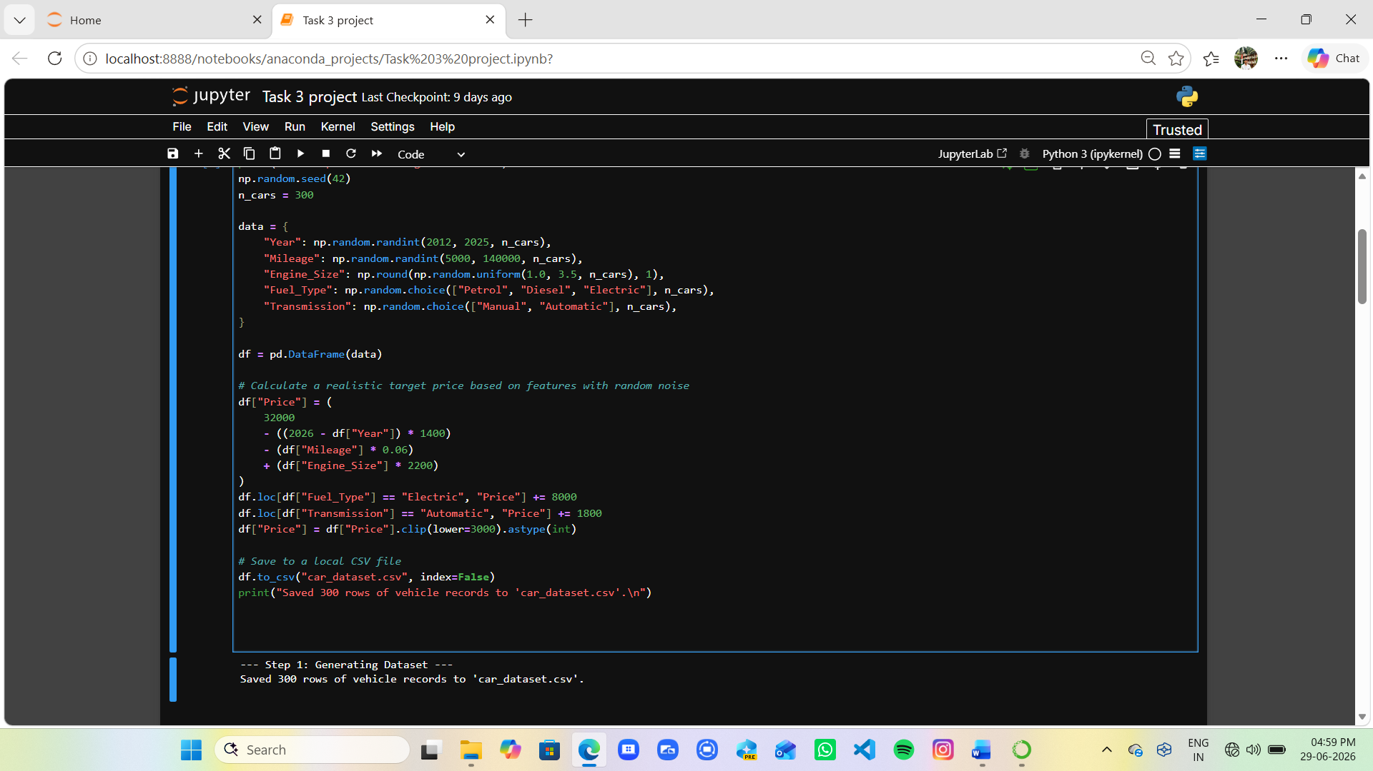

Output Screenshot 2
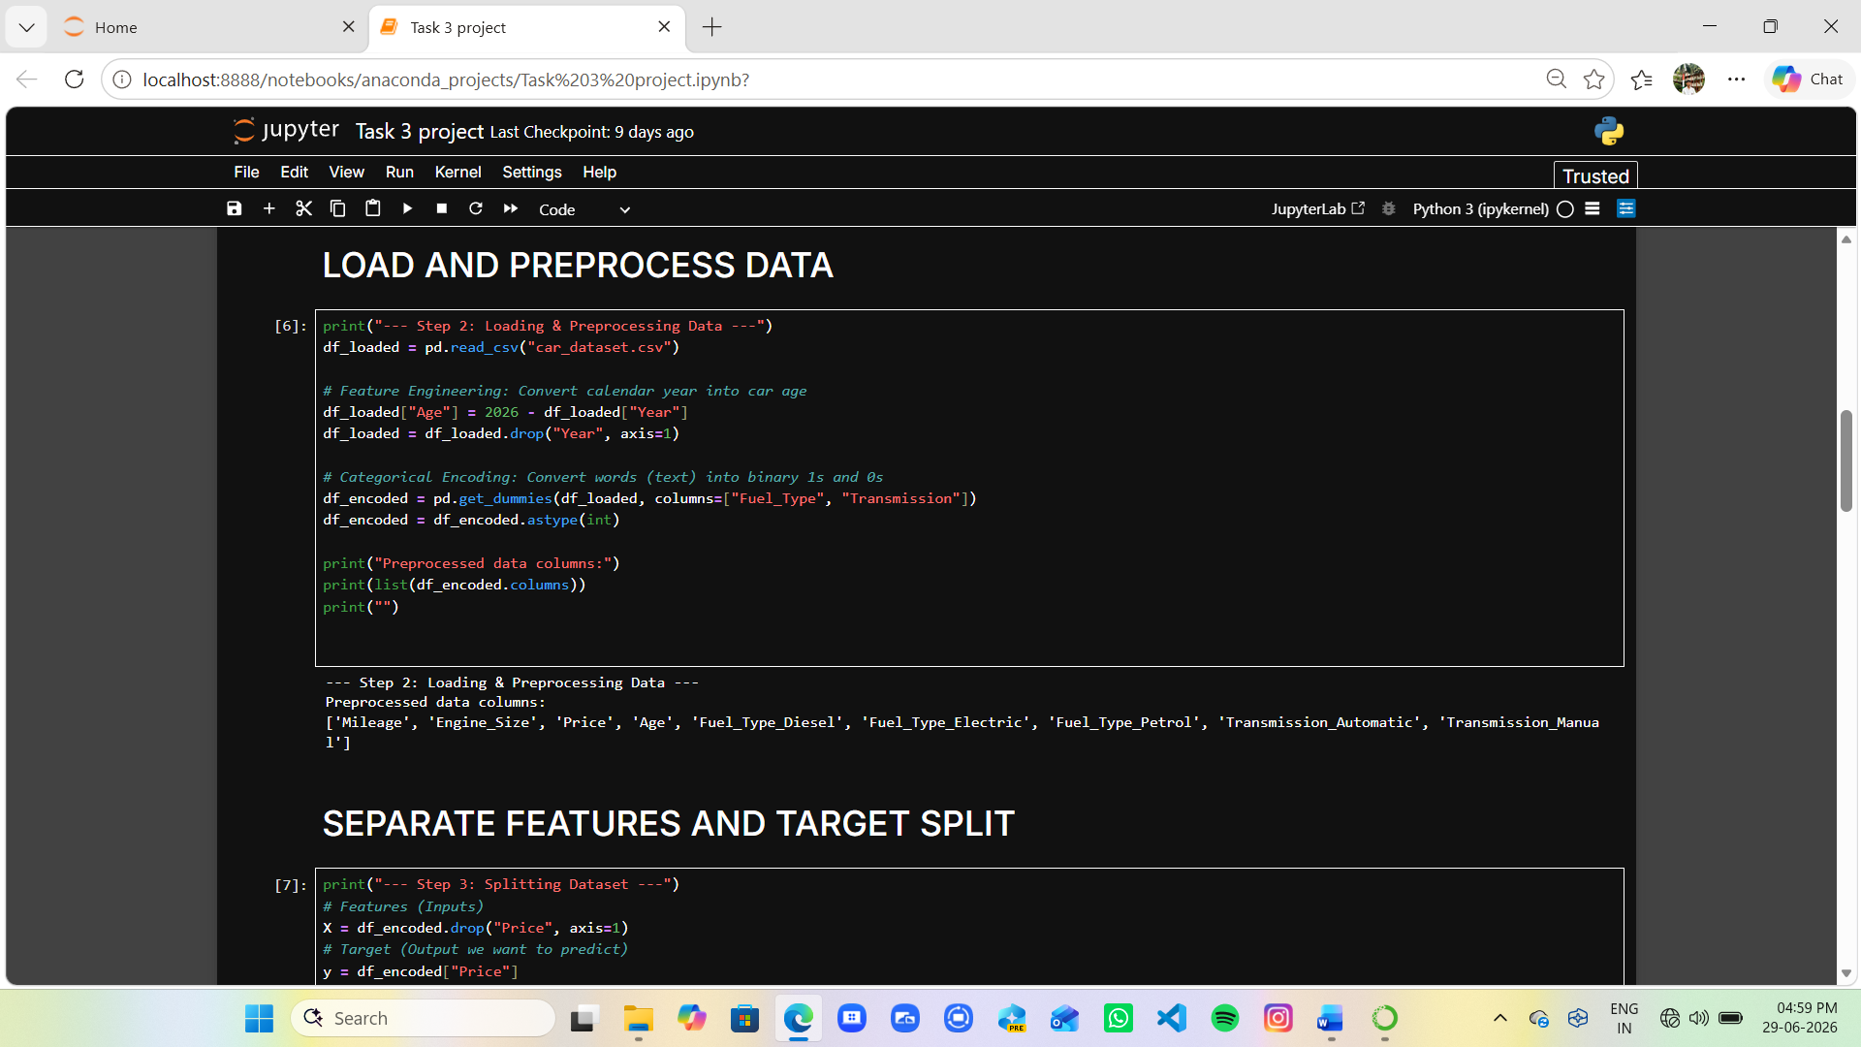

Output Screenshot 3
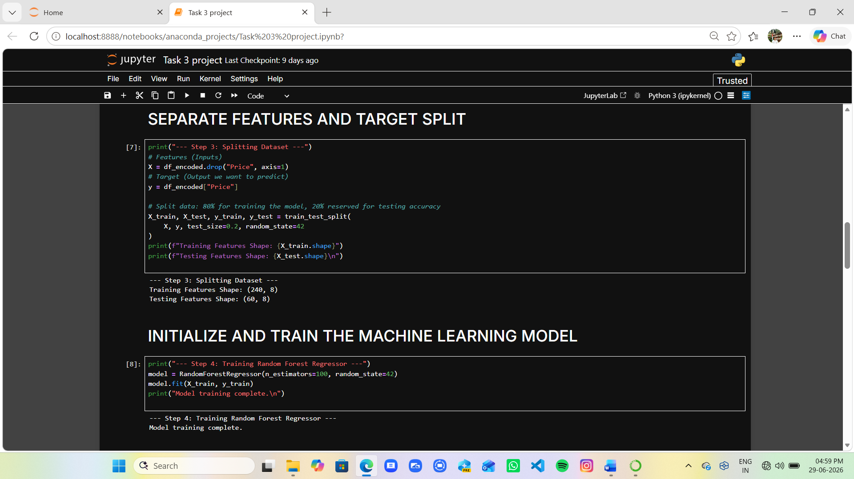

Output Screenshot 4
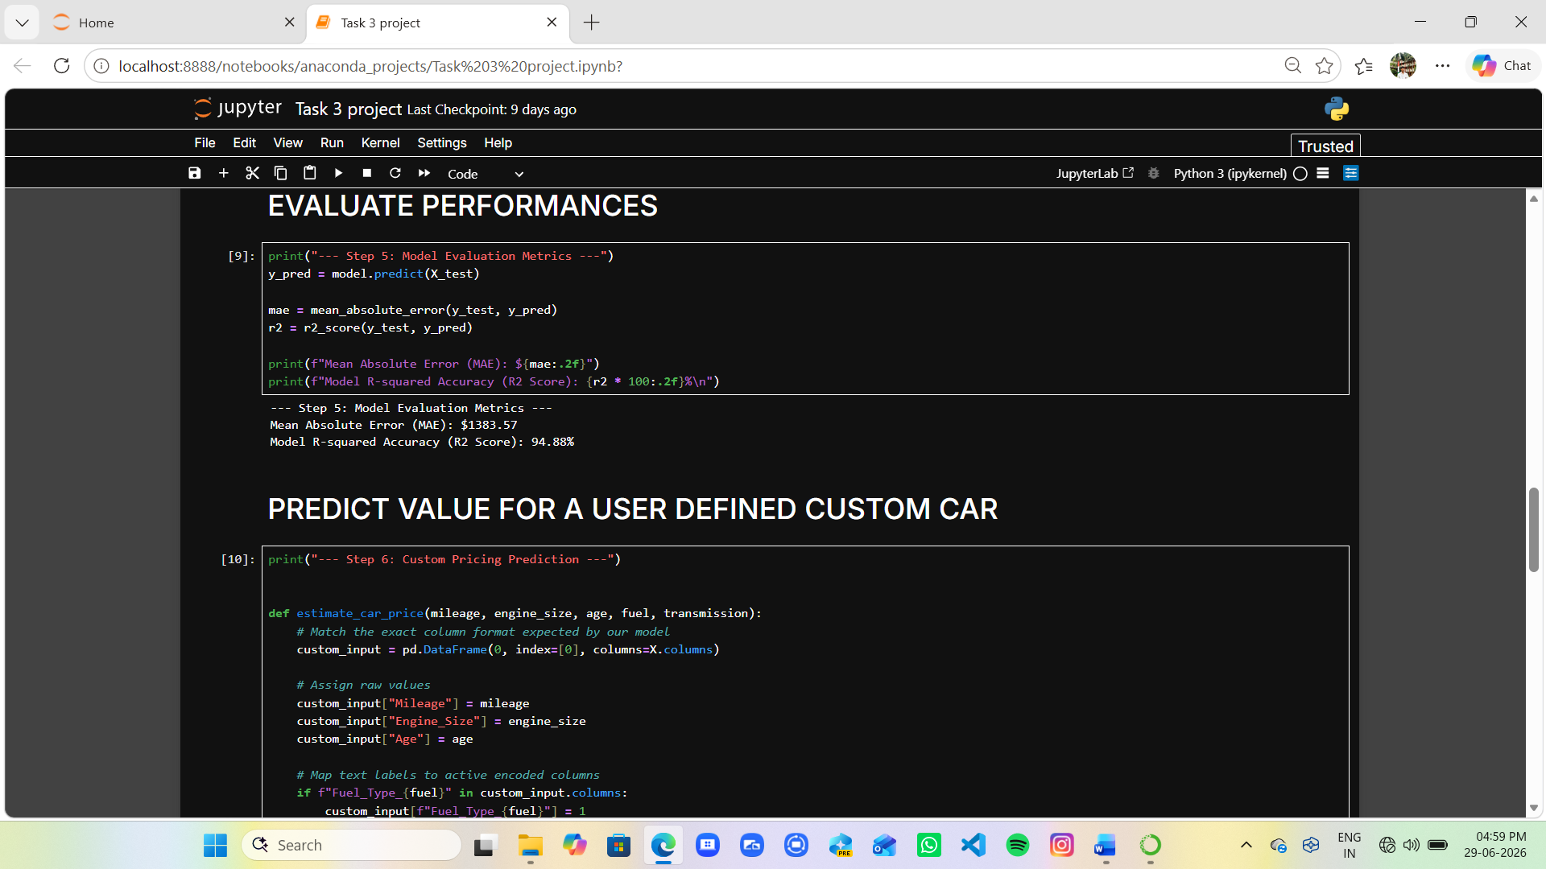

Output Screenshot 5
