Abstract
The NWA 13106 meteorite is a newly discovered basaltic shergottite with a gabbroic texture, dominated by pyroxene (57.0 area%) and plagioclase (34.18 area%), with accessory minerals including Fe-Ti oxides (2.0 area%), phosphates (1.8 area%), silica-rich phases (1.6 area%), fayalite (0.6 area%), Fe-sulfides (0.4 area%), and trace baddeleyite. Pyroxene exhibits distinct compositional zoning, characterized by Mg-rich cores and Fe-enriched rims. Plagioclase displays homogeneous compositions and smooth textures, with near-complete transformation to maskelynite. The Ti/Al ratios in pyroxene cores provide critical constraints on crystallization pressures and corresponding depths. Redox conditions during late-stage magmatic evolution are inferred using oxygen fugacity calculations based on Fe-Ti oxides equilibria. Major element compositions combined with MELTS thermodynamic modeling reveal the crystallization sequence and evolving P-T conditions of NWA 13106, thereby constraining the liquidus temperature range of its parental magma. Trace element signatures further characterize its mantle source. Baddeleyite U-Pb chronology clarifies the timescales of magmatic processes. Comparative studies between NWA 13106 and other shergottites advance our understanding of Martian mantle heterogeneity and evolution.
（Only the petrology-related content is included here; raw datasets are temporarily withheld for further verification.）
Petrographic texture
NWA 13016 is a medium to fine-grained basaltic shergottite with an intersertal texture, composed predominantly of pyroxene (57.03 area %) and lath-like maskelynite (34.18 area%) with minor Fe-Ti oxides (2.02 area%), Phosphate (1.82 area%), Silica (1.62 area%), fayalite (0.60 area%), pyrrhotite (0.42 area%)（Fig.1）.
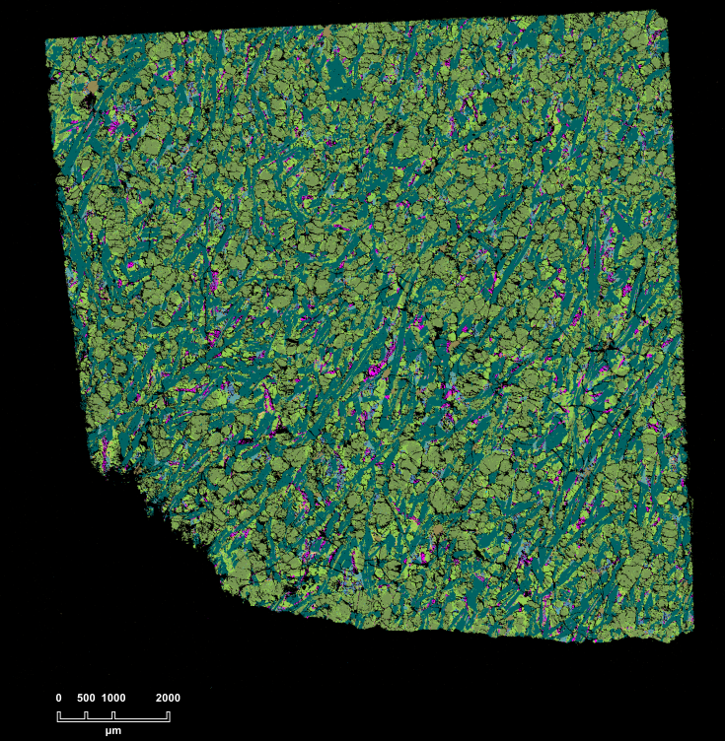
Fig.1 Back-scattered electron (BSE) images of NWA13106
Pyroxenes occur as subhedral to euhedral prismatic grains, measuring 0.2-1.5 mm in length, exhibiting distinct core-to-rim compositional zoning patterns. Two distinct zoning patterns are recognized: (1) gradual transitions, which are prevalent in shergottites, and (2) abrupt compositional shifts with highly irregular boundaries within pyroxene patchy zoning domains as documented in Guo et al., 2024. Notably, Well-developed exsolution lamellae are observed within some pyroxene grains. Maskelynites occurs as subhedral, lath-shaped grains with a prominent lattice preferred orientation, interstitial to pyroxenes, and measuring 0.8-3.4 mm in length.
The Fe-Ti oxides exhibit euhedral to subhedral morphologies and are distributed in four texturally distinct domains within titanomagnetite-ilmenite intergrowths: (1). Cloth-textured ilmenite lamellae: This texture consists of a network of micrometer-scale ilmenite lamellae, typically around 1 μm in length, oriented parallel to the (100) crystallographic plane of the titanomagnetite host(Buddington et al, 1964). These ilmenite lamellae intersect at right angles, dividing the titanomagnetite grains into micrometer-sized cubes and rectangles. (谭伟, 2016) also documented this texture and attributed its formation to Ti⁴⁺–Fe²⁺ exchange, which promotes ilmenite exsolution accompanied by magnetite oxidation. (2). Exsolution–oxidation grids: Titanomagnetite hosts contain grid-like exsolution textures characterized by thin ilmenite lamellae (typically <1 μm in width), forming square-patterned networks with maximum dimensions of approximately 1.5 × 2.5 μm. Similar mineral assemblage also can be observed in other basaltic shergottites, e.g. NWA 480 (Barrat et al, 2002). (3). Exsolution–oxidation triangular interlayer structures: Ilmenite lamellae (≤1 µm in width) are arranged in a triangular, intersecting pattern within the titanomagnetite. These lamellae are fully embedded within the titanomagnetite grain. This mineral paragenesis is ubiquitous in basaltic shergottites, with NWA 13763 serving as a representative example.(张晋瑜 et al, 2024) (4). Direct exsolution lamellae: Platy ilmenite exsolution structures developed within the interior and along the margins of titanomagnetite crystals, with individual lamellae reaching widths of up to approximately 3 μm. Noticeable cracks are observed in the ilmenite, but no such cracks are present in the titanomagnetite, also seen in basaltic shergottite NWA 8653(Wu et al, 2021).
Pyrrhotites occur in three distinct textural forms. (1). Primary anhedral sulfide melt droplets are distributed within the interstitial matrix, occurring at grain boundaries, within the glassy mesostasis, and inside melt pockets/veins. These droplets are randomly dispersed throughout the thin section, with maximum diameters reaching approximately 60 μm. Internally, the sulfide spheres commonly display shock-induced fractures but lack the vesicles reported in NWA 14672(Lorand et al, 2024). (2). Subhedral to anhedral grains are either enclosed within or in direct contact with Fe-oxides and Fe–Ti oxides. Based on EDS analyses, the Fe-oxides are more consistent with magnetite. (3). Veinlets composed of pyrrhotite and Fe–Ti oxides crosscut pyroxenes. Pyrrhotite-magnetite/Fe-Ti oxide associations is a common feature in both terrestrial and shergottites(Wei et al, 2020; LORAND et al, 2005).
Phosphates are merrillite and apatite. Merrillite (approximately 95 area%) occurs as euhedral grains adjacent to Fe-rich pyroxene rims and plagioclase. In contrast, apatite (approximately 5 area%) is typically anhedral and occurs in similar settings.
Baddeleyites occur as subhedral to anhedral grains within the interstitial medium, reaching up to approximately 15 × 2 μm in size. Most grains exhibit pronounced fractures and vesicles, which may reflect shock-related features or secondary degassing processes.
Other accessory minerals include silica, fayalite present as late-stage mineral assemblages, including: (1). Three-phase symplectites occur in two mineral assemblages: one composed of pyroxene, fayalite, and Si-rich glass, and the other composed of pyrrhotite, fayalite, and Si-rich glass and are characterized by a vermicular texture. (2). Two-phase symplectites consist of intergrowths of fayalite and Si-rich glass, exhibiting fine-grained (1–2 μm) vermicular to micrographic textures. Both types of symplectites are interpreted as breakdown products of rapidly cooled Fe-rich pyroxenes formed under low-pressure conditions. (3). Si-rich and Si-Al-K-rich mesostasis are present within the maskelynite, and the assemblages include very fine-grained Fe-Ti oxides, pyrrhotites, pyroxenes and Baddeleyites. Si-rich and Si-Al-K-rich mesostasis is common in enriched shergottites(Lindner et al, 2022).
The shock metamorphic features include fractured pyroxenes, plagioclase transforming into maskelynite, and abundant shock melt pockets and veins. The longest shock melt vein is 2.1 mm long and 30 μm wide. The shock melt pockets are mostly elliptical or irregular, with the largest being 0.8 mm across. These melt features are predominantly observed adjacent to pyroxenes and maskelynite.

谭伟 2016. 火成岩体中铁钛氧化物的显微出溶结构成因及其对岩浆氧逸度变化的指示.
张晋瑜, 陈宏毅, 谢兰芳, et al. 2024. 火星陨石 NWA 13763 矿物岩石学特征及其岩浆演化. Journal of Guilin University of Technology [J], 44.
BARRAT J A, GILLET P, SAUTTER V, et al. 2002. Petrology and chemistry of the basaltic shergottite North West Africa 480. Meteoritics & Planetary Science [J], 37: 487-499.
BUDDINGTON A F, LINDSLEY D 1964. Iron-titanium oxide minerals and synthetic equivalents. Journal of Petrology [J], 5: 310-357.
EGGLER D H, LORAND J 1993. Mantle sulfide geobarometry. Geochimica et Cosmochimica Acta [J], 57: 2213-2222.
FROST B, LINDSLEY D H. Occurrence of iron-titanium oxides in igneous rocks[C]//Oxide Minerals.De Gruyter,2018:433-468.
HEAMAN L M 2009. The application of U–Pb geochronology to mafic, ultramafic and alkaline rocks: an evaluation of three mineral standards. Chemical Geology [J], 261: 43-52.
LATTARD D 1995. Experimental evidence for the exsolution of ilmenite from titaniferous spinel. American Mineralogist [J], 80: 968-981.
LI J, ZONG K, HE Q, et al. 2021. Accurate determination of major and trace elements of lunar soil simulant by ICP⁃ MS. Journal of Nanjing University (Natural Sciences) [J], 57: 944-956.
LI Q-L, LI X-H, LIU Y, et al. 2010. Precise U–Pb and Pb–Pb dating of Phanerozoic baddeleyite by SIMS with oxygen flooding technique. Journal of Analytical Atomic Spectrometry [J], 25: 1107-1113.
LINDNER M, HEZEL D, GERDES A, et al. 2022. AGE OF ENRICHED GABBROIC SHERGOTTITE NORTHWEST AFRICA 6963 AND ITS SI-RICH MESOSTASIS. Meteoritics & Planetary Science [J], 57.
LIU Y, GAO S, HU Z, et al. 2010. Continental and oceanic crust recycling-induced melt–peridotite interactions in the Trans-North China Orogen: U–Pb dating, Hf isotopes and trace elements in zircons from mantle xenoliths. Journal of Petrology [J], 51: 537-571.
LIU Y, LI Q-L, TANG G-Q, et al. 2015. Towards higher precision SIMS U–Pb zircon geochronology via dynamic multi-collector analysis. Journal of Analytical Atomic Spectrometry [J], 30: 979-985.
LIU Y, LI X H, LI Q L, et al. 2020. Breakthrough of 2‐to 3‐μm scale U–Pb zircon dating using Cameca IMS‐1280HR SIMS. Surface and Interface Analysis [J], 52: 214-223.
LORAND J P, CHEVRIER V, SAUTTER V 2005. Sulfide mineralogy and redox conditions in some shergottites. Meteoritics & Planetary Science [J], 40: 1257-1272.
LORAND J P, PONT S, HEWINS R H, et al. 2024. Shock‐induced pervasive remelting of Fe sulfides in the basaltic shergottite Northwest Africa 14672: A benchmark for shock stages S6/S7 on Mars. Meteoritics & Planetary Science [J], 59: 2523-2544.
WEI Y, NIU Y, GONG H, et al. 2020. Geochemistry and iron isotope systematics of coexisting Fe-bearing minerals in magmatic FeTi deposits: a case study of the Damiao titanomagnetite ore deposit, North China Craton. Gondwana Research [J], 81: 240-251.
WU Y, 徐伟彪, LI Q-L, et al. 2021. Heterogeneous martian mantle: Evidence from petrology, mineral chemistry, and in situ U-Pb chronology of the basaltic shergottite Northwest Africa 8653. Geochimica et Cosmochimica Acta [J], 309: 352-365.
ZHAO W, ZONG K, LIU Y, et al. 2019. An effective oxide interference correction on Sc and REE for routine analyses of geological samples by inductively coupled plasma-mass spectrometry. Journal of Earth Science [J], 30: 1302-1310.
ZONG K, WANG Z, LI J, et al. 2022. Bulk compositions of the Chang’E-5 lunar soil: Insights into chemical homogeneity, exotic addition, and origin of landing site basalts. Geochimica et Cosmochimica Acta [J], 335: 284-296.

