Chapter 4 SPRING BOOT

Nguyễn Lâm Chí Tường

MSSV: 22714591

Link github:
Building a CRUD Web Application with MySQL
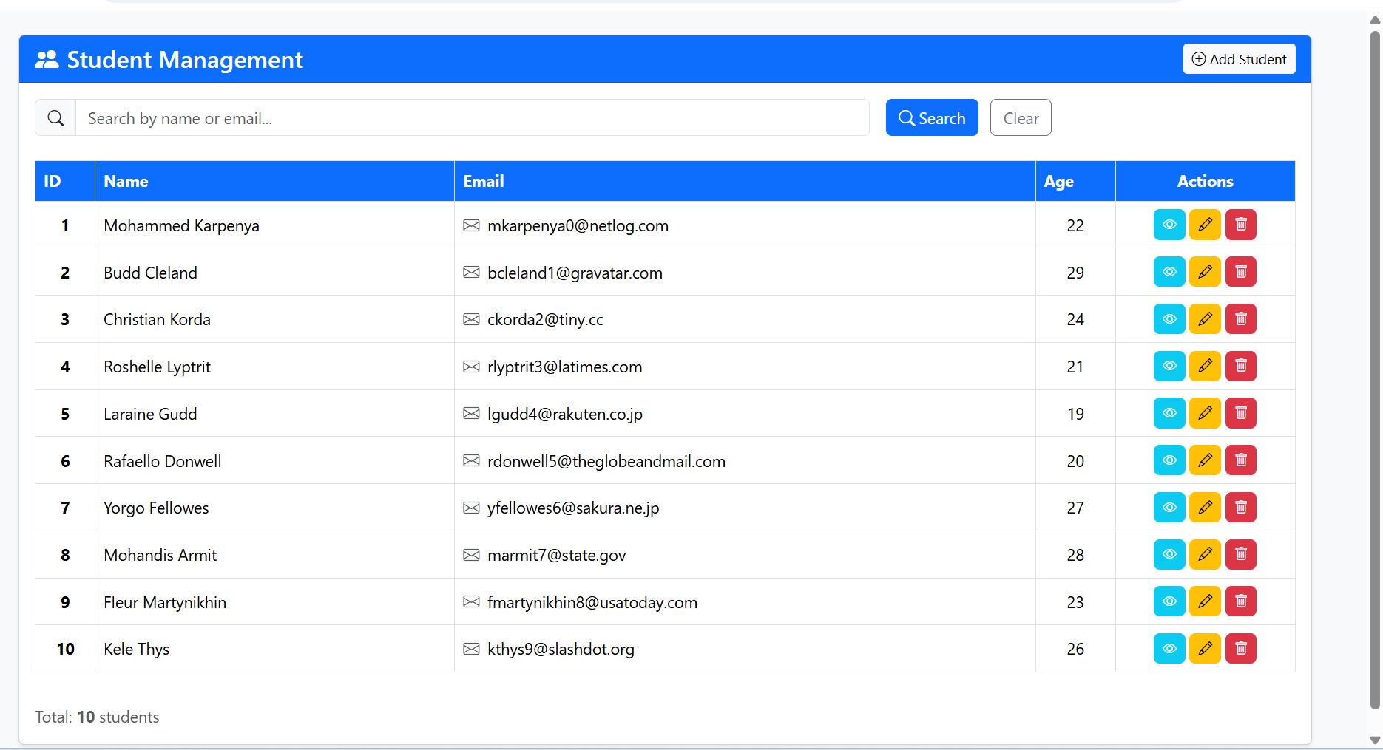
Student Details
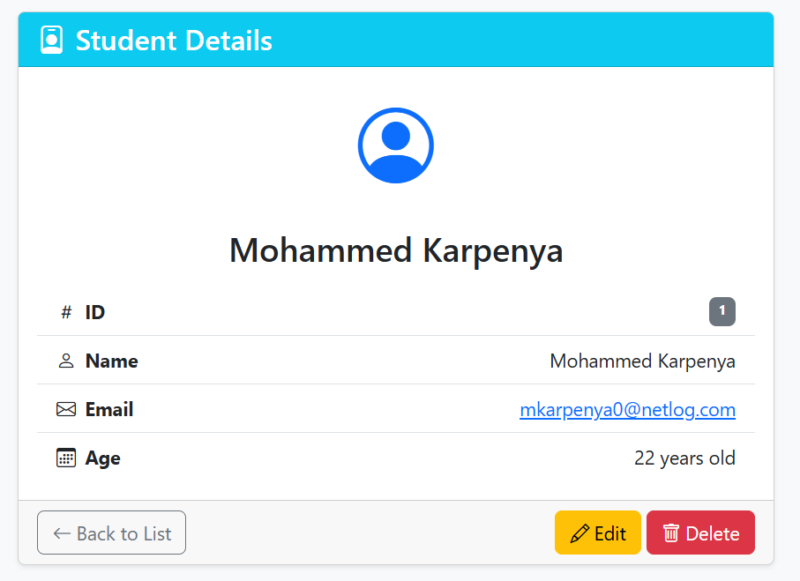
Edit 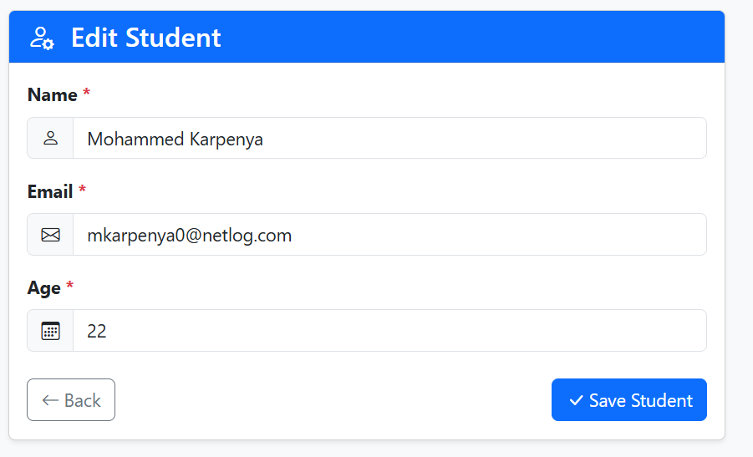
Add 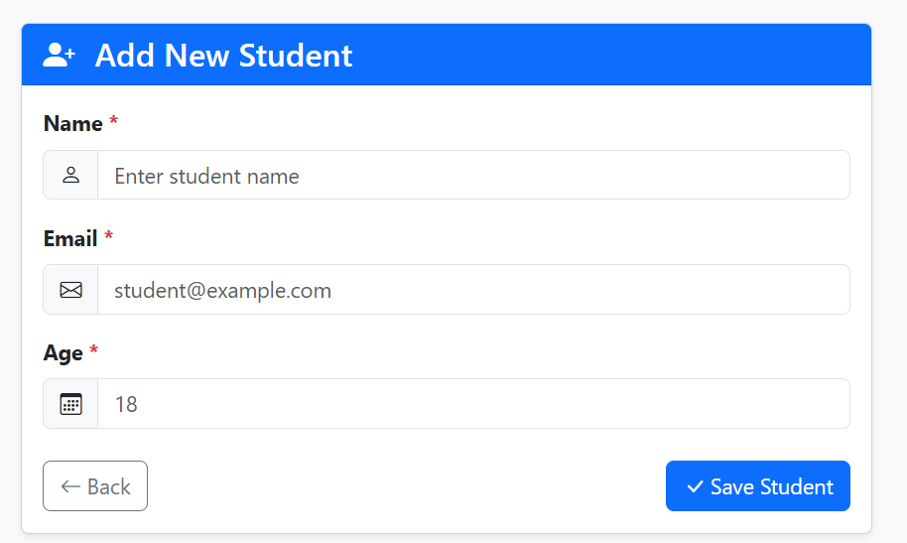
Search 