Project name: MYREPORT.COM

Class Design Specification

DOCUMENT VERSION HISTORY

Document Version | Date Issued | Comments
1.0 | 28-08-2019 | First version of the Web Portal

Table of Contents

Table of Contents 2
Class Design
1 Introduction 3
2 Conventions followed 3
3 Class Diagram 4

Introduction

The class diagram is the main building block of object oriented modelling. It is used both for general conceptual modelling of the systematics of the application, and for detailed modelling translating the models into programming code. Class diagrams can also be used for data modeling. The classes in a class diagram represent both the main objects and or interactions in the application and the objects to be programmed. In the class diagram these classes are represented with boxes which contain three parts:
A class with three sections:
- The upper part holds the name of the class
- The middle part contains the attributes of the class
- The bottom part gives the methods or operations the class can take or undertake

Conventions followed

Hungarian Convention

Class Diagram
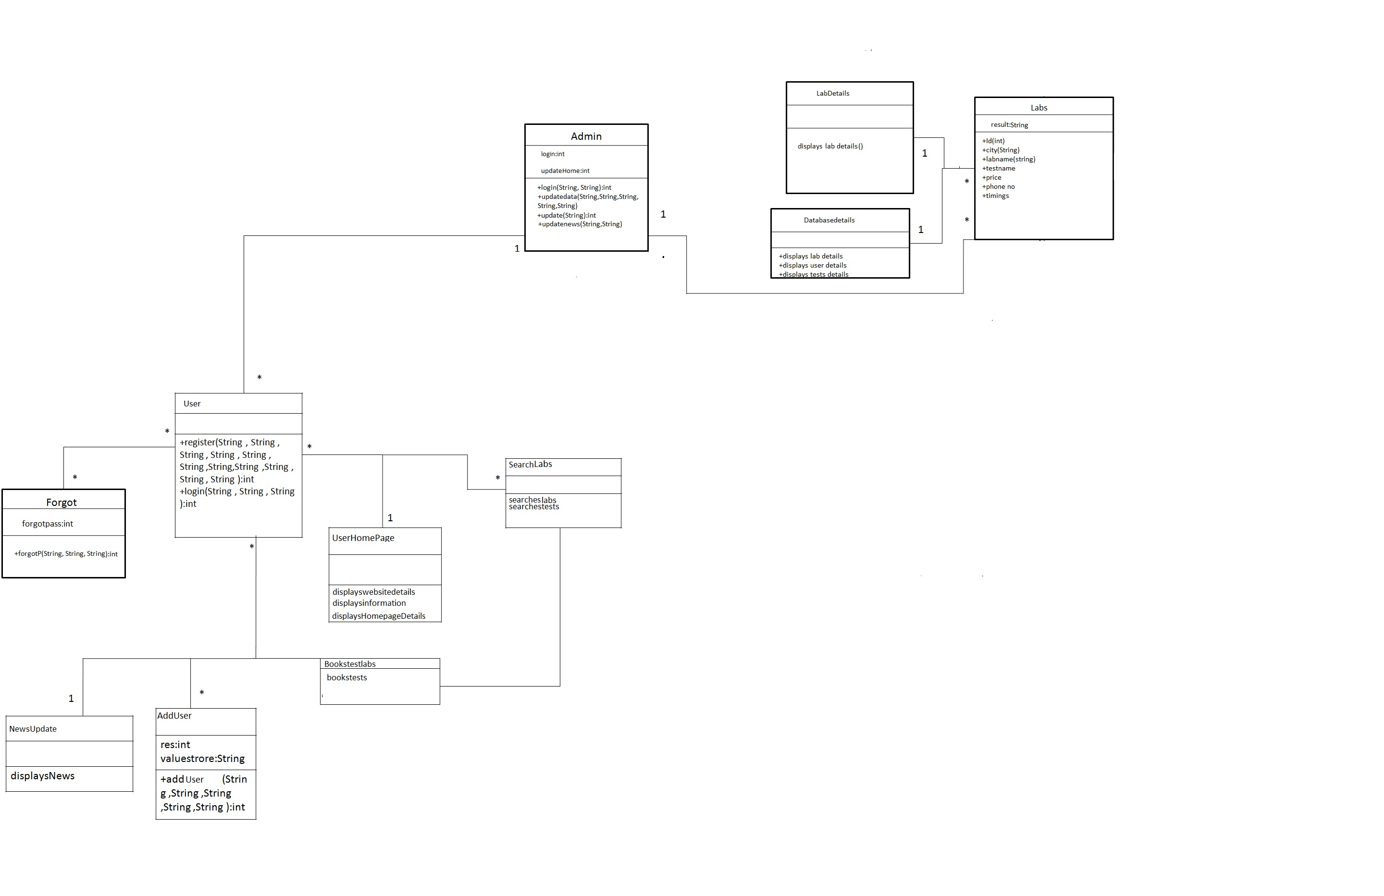

Classes

Admin

Class Description :
The Administrator class holds those attributes and functions which may be used for the functioning of the system. The administrator manages users and labs. The administrator updates new labs to the website.

Methods
 | Function | OutPut Parameters | Description
1 | login(String, String) | int | checks for the authentic username and password and provides the login
2 | updateData(String, String, String, String, String) | int | the administrator make changes in the user details etc.
3 | update(String) | int | the administrator keeps the website updated by updating the home page details
4 | updateNews(String, String) | int | the administrator keeps its user updated with the world by giving them regular updates about the new technologies and subjects

User
Class Description :
The Student class contains the attributes and related functionality for the students

Methods
 | Function | OutPut Parameters | Description
1 | register(String, String, String, String, String, String, String, String, String, String, String) | int | registers the new student in the portal
2 | login(String, String,String) | int | authenticates the student to login

SearchLabs
Class Description :
This class holds the business logic to display the values stored in the database.

Methods
 | Function | OutPut Parameters | Description
1  2 | searchesLabs  searchestests | displays the list of labs on the searched query  displays the list of the tests on the searched query

Forgot
Class Description:
The Forgot class enables the user to reset his password if he/she has forgot it.

Methods
 | Function | OutPut Parameters | Description
1 | forgot(String, String, String, String) | int | This function enables the tutor to reset his password.

5.3 Labs
Class Description:
The Labs class enables the user to see all the details related to his/her searched query.

 | Function | OutPut Parameters | Description
1 | Id(String) | Int | Displays Id of the lab.
2 | City(String) | String | Displays location of the lab.
3 | Labname(String) | String | Displays Name of the lab.
4 | Testname(String) | String | Displays test name of the lab.
5 | Price(String) | Int | Displays Price of the lab.
6 | Phone No(String) | Int | Displays phone no of the lab.
7 | Timings(String) | String | Displays timings of the lab.

