Name:M.Bharath
Roll no:2303A52060
Batch No:39

Task Description #1

(Password Strength Validator – Apply AI in
Security Context)
• Task: Apply AI to generate at least 3 assert test cases for
is_strong_password(password) and implement the validator
function.
• Requirements:
o Password must have at least 8 characters.
o Must include uppercase, lowercase, digit, and special
character.
o Must not contain spaces.
Example Assert Test Cases:
assert is_strong_password("Abcd@123") == True
assert is_strong_password("abcd123") == False
assert is_strong_password("ABCD@1234") == True

Prompt:

#test-driven Development with AI – Generating and Working with Test Cases
#Task 1-Password strength validator -Apply AI in security content
#Password must have at least 8 characters.
# Must include uppercase, lowercase, digit, and special
#character. Must not contain spaces.

#change the password string and integers also to test different cases
#use proper if statement if the input string is wrong or right and print the result accordingly

Code:
#test-driven Development with AI – Generating and Working with Test Cases
#Task 1-Password strength validator -Apply AI in security content
#Password must have at least 8 characters.
# Must include uppercase, lowercase, digit, and special
#character. Must not contain spaces.
def password(password_string):
if len(password_string) < 8:
return False
has_upper = False
has_lower = False
has_digit = False
has_special = False
special_characters = "!@#$%^&*()-+"
for char in password_string:
if char.isupper():
has_upper = True
elif char.islower():
has_lower = True
elif char.isdigit():
has_digit = True
elif char in special_characters:
has_special = True
elif char == " ":
return False # Contains space, invalid password

return has_upper and has_lower and has_digit and has_special
#Test cases give in userdefined input
password_string = input("Enter a password to validate: ")
#change the password string and integers also to test different cases
#use proper if statement if the input string is wrong or right and print the result accordingly
if password(password_string):
print("Password is strong.")
else:
print("Password is weak. It must at least 8 characters long, include uppercase, lowercase, digit, and special character, and must not contain spaces.")

Output:

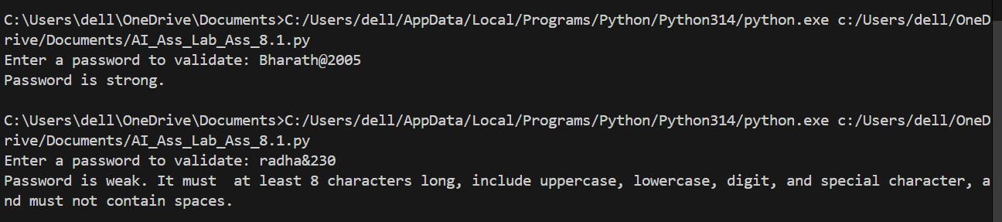

Task Description #2
(Number Classification with Loops – Apply
AI for Edge Case Handling)
• Task: Use AI to generate at least 3 assert test cases for a
classify_number(n) function. Implement using loops.
• Requirements:
o Classify numbers as Positive, Negative, or Zero.
o Handle invalid inputs like strings and None.
o Include boundary conditions (-1, 0, 1).
Example Assert Test Cases:
assert classify_number(10) == "Positive"
assert classify_number(-5) == "Negative"
assert classify_number(0) == "Zero"
Prompt:
#Number classification with loops Apply Ai for edge case Handling
#Classify numbers as Positive, Negative, or Zero.
#Handle invalid inputs like strings and None.
#Include boundary conditions (-1, 0, 1).
#give a primary code for number classification and then test it with different cases
give Test cases of user defined for number classification

Code:
def classify_number(num):
if num is None:
return "Invalid input: None is not a number."
if isinstance(num, str):
return "Invalid input: String is not a number."
if num > 0:
return "Positive"
elif num < 0:
return "Negative"
else:
return "Zero"
# give Test cases of user defined for number classification
test_cases = [1, -1, 0, None, "abc"]
for case in test_cases:
print(f"Input: {case}, Output: {classify_number(case)}")

Output:

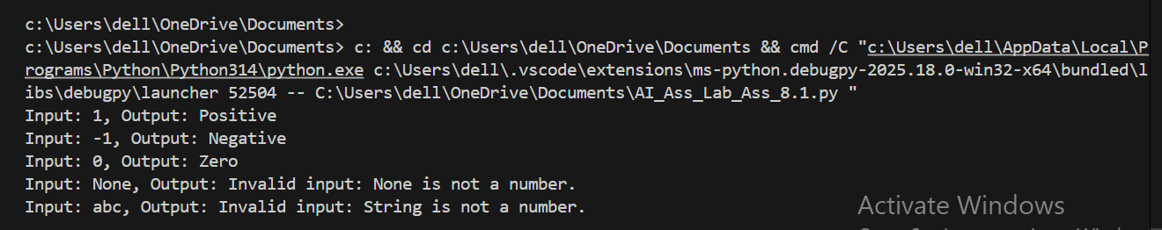

Task Description #3

(Anagram Checker – Apply AI for String
Analysis)
• Task: Use AI to generate at least 3 assert test cases for
is_anagram(str1, str2) and implement the function.
• Requirements:
o Ignore case, spaces, and punctuation.
o Handle edge cases (empty strings, identical words)

Prompt:
#anagram checker with AI for string analysis
#give code for but ignore case,spaces,and punctuation and handle edge cases like empty strings and non-string inputs
# user defined Test cases for anagram checker give some false statements also to check the validity of the code

Code:
import string
def clean_string(s):
return ''.join(char.lower() for char in s if char.isalnum())
def are_anagrams(str1, str2):
if not isinstance(str1, str) or not isinstance(str2, str):
return "Invalid input: Both inputs must be strings."
cleaned_str1 = clean_string(str1)
cleaned_str2 = clean_string(str2)
return sorted(cleaned_str1) == sorted(cleaned_str2)
# user defined Test cases for anagram checker give some false statements also to check the validity of the code
test_cases = [
("listen", "silent"), # True
("Triangle", "Integral"), # True
("Apple", "Pabble"), # False
("Dormitory", "Dirty Room"), # True
("Conversation", "Voices Rant On"), # True
("Astronomer", "Moon man"), # True
("The eyes", "They see"), # True
("A gentleman", "Elegant man"), # True
("Clint Eastwood", "Old West Action"), # True
("Software", "Swear oft"), # False
("", ""), # True (both are empty)
(None, "test"), # Invalid input
("test", None), # Invalid input
(123, "321"), # Invalid input
("123", 321), # Invalid input
]
for str1, str2 in test_cases:
result = are_anagrams(str1, str2)
print(f"Input: '{str1}' and '{str2}', Output: {result}")

Output:

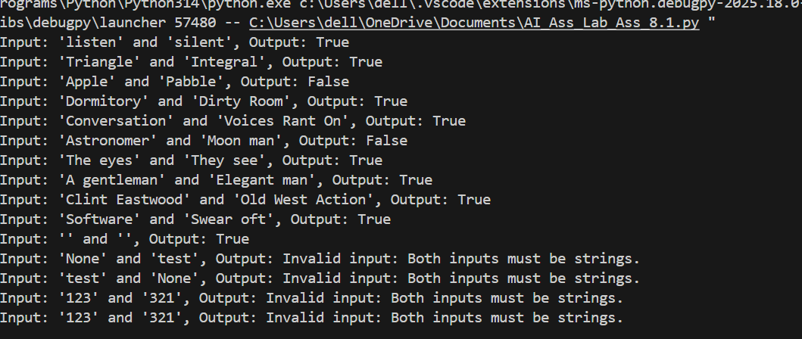

Task Description #4

(Inventory Class – Apply AI to Simulate Real-
World Inventory System)
• Task: Ask AI to generate at least 3 assert-based tests for an
Inventory class with stock management.
• Methods:
o add_item(name, quantity)
o remove_item(name, quantity)

Prompt:

#Inventory class- Apply Ai to simulate real-world Inventory System
#add_item(name, quantity),remove_item(name, quantity) get_stock(name)
# user defined test cases for inventory class

class Inventory:
def __init__(self):
self.stock = {}
def add_item(self, name, quantity):
if name in self.stock:
self.stock[name] += quantity
else:
self.stock[name] = quantity
def remove_item(self, name, quantity):
if name in self.stock and self.stock[name] >= quantity:
self.stock[name] -= quantity
return True
return False
def get_stock(self, name):
return self.stock.get(name, 0)
# user defined test cases for inventory class
inventory = Inventory()
inventory.add_item("apple", 10)
inventory.add_item("banana", 20)
print(inventory.get_stock("apple")) # Output: 10
print(inventory.get_stock("banana")) # Output: 20
print(inventory.get_stock("orange")) # Output: 0 (not in stock)
print(inventory.remove_item("apple", 5)) # Output: True
print(inventory.get_stock("apple")) # Output: 5
print(inventory.remove_item("banana", 25)) # Output: False (not enough stock)
print(inventory.get_stock("banana")) # Output: 20 (unchanged)
inventory.add_item("apple", 5)
print(inventory.get_stock("apple")) # Output: 10 (5 added to existing stock)

Output:

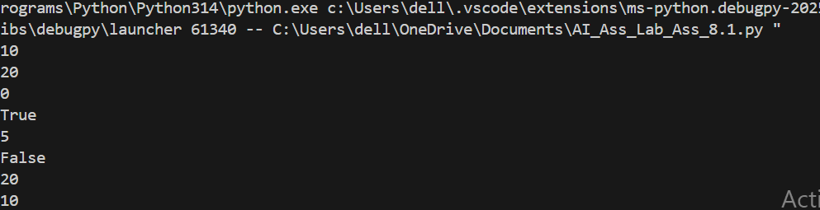

Task Description #5

(Date Validation & Formatting – Apply AI for
Data Validation)
• Task: Use AI to generate at least 3 assert test cases for
validate_and_format_date(date_str) to check and convert
dates.
• Requirements:
o Validate "MM/DD/YYYY" format.
o Handle invalid dates.
o Convert valid dates to "YYYY-MM-DD".

Prompt:

#Date validation formatting with AI for date Validation
#validate date format (DD/MM/YYYY) and handle edge cases like leap years and invalid dates
#dont use comments

Code:

import re
def is_leap_year(year):
return (year % 4 == 0 and year % 100 != 0) or (year % 400 == 0)
def validate_date(date_string):
pattern = r'^(0[1-9]|[12][0-9]|3[01])/(0[1-9]|1[0-2])/(19|20)\d{2}$'
if not re.match(pattern, date_string):
return "Invalid date format. Please use DD/MM/YYYY."
day, month, year = map(int, date_string.split('/'))
if month in [1, 3, 5, 7, 8, 10, 12]:
return "Valid date." if day <= 31 else "Invalid date."
elif month in [4, 6, 9, 11]:
return "Valid date." if day <= 30 else "Invalid date."
elif month == 2:
if is_leap_year(year):
return "Valid date." if day <= 29 else "Invalid date."
else:
return "Valid date." if day <= 28 else "Invalid date."
#give user defined test cases for date validation including valid and invalid dates, leap years, and edge cases
test_dates = [
"29/02/2020", # Valid leap year date
"29/02/2019", # Invalid non-leap year date
"31/04/2021", # Invalid date (April has 30 days)
"30/06/2021", # Valid date
"31/12/2021", # Valid date
"01/01/2021", # Valid date
"31/11/2021", # Invalid date (November has 30 days)
"15/08/1947", # Valid date
"31/09/2021", # Invalid date (September has 30 days)
"00/01/2021", # Invalid day
"01/00/2021", # Invalid month
"32/01/2021", # Invalid day
"01/13/2021", # Invalid month
"abc", # Invalid format
"12-12-2021" # Invalid format
]
for date in test_dates:
result = validate_date(date)
print(f"Input: '{date}', Output: {result}")

Output:

