2024亚马逊变体违规申诉 详细教程

最近亚马逊在打击变体违规，很多卖家都收到了变体违规的封店通知。

如果你也正在为变体违规发愁，可以看看这个变体违规申诉的详细教程。

首先，在变体违规申诉前，我们要知道下面这些事项。

第一 ，查看警告邮件，找到变体违规根本原因：

1 .确定哪些ASIN 存在违规， 一般邮件会说明哪些变体违规。 2 .如果不清楚哪些ASIN 违规，建议逐一排查所有ASIN。

第二，变体违规的具体解决措施及相关证据：

1.删除错误的变体关系，解散了违规的变体。 2 .列举具体调整的ASIN 和内容。
3 .将学习变体关系政策纳入POA 行动计划。

第三，预防未来问题而采取的措施：

1.制定员工每周培训任务，并进行考核。 2 .定期检查所有Listing,以防再次违规。 3.严格检查账户，确保合规运营和操作。

第四，申诉变体违规注意事项：

1.在明确原因之前，不要随意提交申诉，申诉次数有限，多次未成功可能导致亚 马逊团队不再回复，延长申诉周期。

2.正确理解违规原因是申诉的关键和难点，申诉之前，建议先搞懂亚马逊的ASIN 创建政策和变体关系政策。
3.避免重复使用相同的申诉信，如果第一次申诉不成功， 一定要再次排查违规原 因，重新撰写 POA。
4.不要依赖模板式申诉信，POA 一定要根据自己的情况对模板进行修改，POA 需 要准确理解违规原因，并提供充分的证据和解决方案，同时也需要预防未来问题 的措施。

接下来讲讲提交申诉的具体步骤：

1.进入【账户状况】,点击【违反政策警告】,然后点击【申诉】。

排序方式
口期：近-世学
原因 日 期 采取的操作 账户状况评级影响 后续步据
立年不正地 | 2094-0302 | 已x运e | 同-至深述 | 中再

2.打勾【我已查看原始通知】和【我确认...】,点击【我已经纠正.….】,方框内输入 对违规ASIN 纠正的具体措施，如：已经删除错误的变体关系，解散了违规的变 体。

解决您的违规问题
接下来我该怎么办?
·You can view your violations on“账户状况”页面

请确认您了解井同意以下声明：
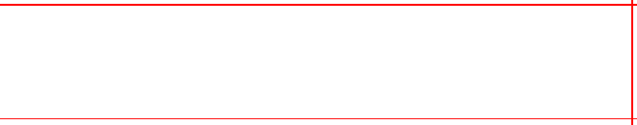
☑我已查看原始通知，并已知晓我的商品违反了亚马逊政策。
☑我确认，我已制定并完成了所有必要的纠正措施，用来防止今后出现任何
违反亚马逊政策的情况。
选择并确认您已完成的以下补救措施(选择其中 一 项)
O 我已经纠正了账户中违规的商品信息或内容。
O 我不会销售无法更正的商品。
提供您已更正的ASIN 的列表，并简要说明对每个ASIN 进行了哪些更正：
F协ASIM#173456780简更说B目十对AS IN进行了K比纠正操作

Atpresent,the variant relationship between the parent ASIN:
BC and the child ASIN:B has been actively
removed,and the saleofthe child ASIN:BO has been stopped.
We guarantee that BO will not be merged illegally in the
future.

3. (1)【问题的根本原因】全部打勾，【缺少对员工的培训】全部打勾，然后上传 一份【亚马逊员工培训表格】 (Amazon employee training form)。

(2)【质量或库存管理不完善】全部打勾，然后上传一份【亚马逊 Listing 定 期 检 查表格】 (Regularly check the lisitng form)。

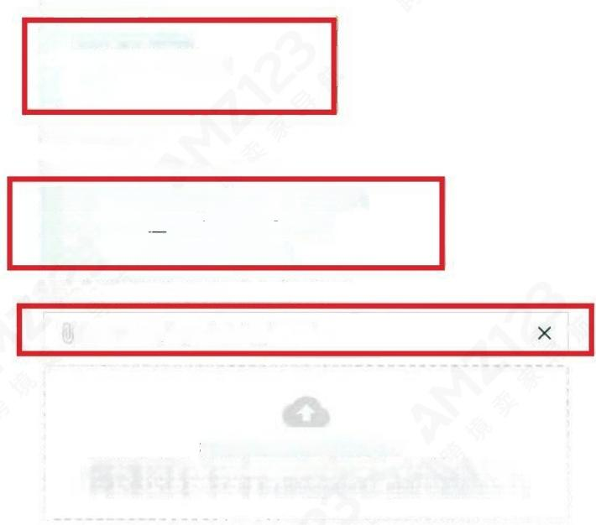
问题的根本原因
☑ 缺少对员工的培训
☑质量或库存管理不完善 ☑其 他
缺少对员工的培训
确认您为解决该问题所采取的措施：
☑定期为员工举办有关亚马逊政策的培训活动
☑定期评估员工对亚马逊政策的了解情况
☑已雇用的熟悉亚马逊政策的员工
为已采取的纠正措施提供证明文件(如培训表):
Amazon employee training form.xls

将文件拖动到此处或选择文件。
接受的文件类型：图片jpeg、gif、tiff、png)、文 档(pdf、docx、
txt)、 电子表格 (xlsx、csv)、电 子 邮 件(eml) 。总大小不能超过10MB。
质量或库存管理不完善
确认您为解决该问题所采取的措施：
√ 我已对库存中的所有商品实施了亚马逊政策合规性定期检查。
√ 我已经对我的商品详情页面实施了定期审核，以避免出现任何违反亚马逊 政策的情况
为已采取的纠正措施提供证明文件(如库存检查表):
Regularly check the lisitng form .xlsx X

4. 【其他】填写避免将来出现此问题而采取的步骤，字数有限，在这里可以将 POA 以附件形式上传，然后检查无误，确定【提交】。
其 他
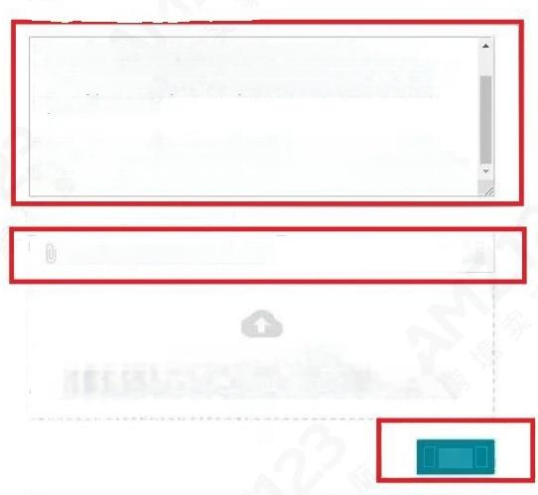
你为鱼烙来出现此问题而平取的步骤
Wereceived your notification about incorrectvariation,we are
currently doing our best to takeactionsto resolve the problemafter receiving your warning,and pledgenot to commit such violations
again in the future.
The following are the detail and POA that we made to resolve the
problem and prevent misuse of ASIN variations similar violation in the future,please kindly check the POA of Incorrect Variation(s)for details.
为已采取的纠正措施提供证明文件
POA of Incorrect Variation(s).docx ×

将文件拖动到此处或选择文件。
接受的文件类型：图片(jpeg、gif、tiff、png)、 文 档(pdf、doc
txt)、电 子 表 格(xlsx,csv)、 电 子 邮 件(eml)。 总大小不能超过10MB。

提 交

提交申诉之后，就耐心等待审核了，申诉成功的话，亚马逊会发来一份移除相关

政策警告通知。

您的亚马逊账户
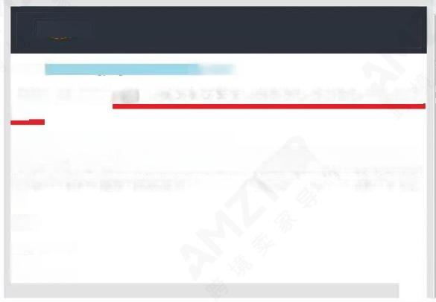
amazon

尊敬的 雪：您好!
感谢您提交相关信息 。 我们已审核您提供的信息 ， 并从您的账户中移除了相应政策警 告。
您 可 以 通 过 两 种 方 式 查 看 账 户 绩 效 ： 一 是 访 问
https.//sellercentral.amazon.com/performance/dashboard?ref=ah_em_ap;二 是 使 用 iOS 或安卓设备在亚马逊卖家应用主屏幕上选择”账户状况”。“账户状况”部分会根 据您在亚马逊商城销售商品所需达到的绩效指标和要遵守的政策显示您账户的表现情 况。
谢 谢 !
Amazon
谢 谢 !
Amazon
com
com

变体违规POA 回复模板

注意：大家一定要根据实际情况修改，切勿照抄!

Dear Amazon performance team,

We received your notification about incorrect variation(ASIN:BOXXXXXXXX),we are currently doing our best to take actions to resolve the problem after receiving your warning,and pledge not to commit such violations again in the future.

The following are the detail and POA that we made to resolve the problem and prevent misuse of ASIN variations similar violation in the future,please kindly check it,we promise that we did not let this issue happen again in the future.

--Adding children products that are not true variations of the parent product.

--Changing a product detail page sub-item,causing it to be significantly different from the originally published item.

The issue that caused the warning:

Our mistake is that we modified the product details of thechild ASIN:BOXXXXXXXX to be the same as another child BOXXXXXXXX,the parent ASIN is BOXXXXXXXX,the theme is XXXXXXXX and XXXXXXXX,and merged duplicate child variations,resulting in an incorrect variant violation was issued.( 此处写违规的具体原因)

Immediate actions we took:

1,our sales manager checked all our on-sale listings one by one,anyone which has been violated the rules ofAmazon has been removed,please kindly check some details as follows:

At present,the variant relationship between the parentASIN:BOXXXXXXXX and the child ASIN: BOXXXXXXXX has been actively removed,and the sale of the child ASIN:BOXXXXXXXX has been stopped.We guarantee that BOXXXXXXXX will not be merged illegally in the future.We are confident that ourvariant is now bug-free.( 此处写纠正错误的具体措施)

To prevent similar violation in the future,we will follow the ASIN creation Policy,we learn ASIN Creation Policy again:

Matching our products to existing products in the Amazon catalog helps drive high-quality customer experience.Matching to an existing product instead of creating a duplicate listing

allows us to more fully benefit from buyer interest and traffic for that product.

The following prohibited practices are a misuse of variations (also known as parent-child relationships).I create a negative customer experience and can result in our ASIN creation or selling privileges being temporarily or permanently removed.

Adding children that are not variations of the parent product;

Changing the parent product's detail page so it does not match the children;

Here are things to keep in mind to help ensure we create the relationship correctly: 1.Parent/Child Relationship
Every variation relationship includes a parent and a number of unique children.The parent can be thought of as an items that cannot be purchased which connects the different variation of children.When you create a variation relationship,you use a parent SKU as this umbrella for your products.The parent SKU should represent the core product.Do not include any child-level information (size,color,UPC)on the parent SKU.

2.Variation Themes

Variation themes are the way that Amazon systems determine how a set of products varies. The theme is set only on the parentand all children must have valid values for the attributes corresponding to the parent's theme.Examples of variation themes include Color/Name,Size /Count,Color,Style,etc.

The relationship we create is a relationship between your specific SKUS.When you submit your product information,Amazon will use the relationship information that you provide in connection with the information provided by other sellers of the same products to determine the specific relationship that is presented to customers.This means that the information displayed on the site may vary from your submitted relationship.The SKUS in your inventory however will reflect the most recent information you submitted,regardless of how the products are displayed on the site.

Our plans to prevent adding children products that are not true variations of the parent product,we make some plans as follows:

(此处写未来的防范措施)

1.Train our employees Amazon ASIN Creation policy,make sure they are familiar with Amazon policy,and before uploading a new listing on our stores,our sales manager will check all the contents especially the true variations of the parent products;

2.Before uploading a listing on Amazon,we will have to make sure the Parent/Child relationship,full check if this catalog support variation or not,if it doesn't support variation, we will upload these listings one by one instead of adding children products that are not true variations of the parent product;

3.We will only use the correct same variations when creating parent/child relationships.Our sales managerwill check this each week for all our online listings.Any listings will be removed once they were found in the invalid listings or variations to product detail page or violate other Amazon policies or rules;

4.We will follow the ASIN Creation Policy in the future,we will arrange employees to learn and have a test for this policy every week to make sure that this issue will not happen again.

5.Designed our new policy,our sales manager will supervise our future selling,the sales manager will check each new ASIN regularly for a double check to be sure no ASIN violates any rules of Amazon.

We promise that we will follow Amazon's policy in the future,meets Amazon's every metric and selling policy.Please kindly consider removing our account warnings.

Please check the attachment we uploaded for the Amazon employee training form,and check the listing form regularly.

Thank you for your time and look forward to considering this appeal.

If you have any other questions,please feel free to contact us,we are waiting for your reply.

