Dear Amazon,
We received your notification about that our selling privilege was
removed due to we misusing the ASIN variations and we have not sent
you an acceptable plans to address the problem with our account, but
actually, we did take actions to resolve the problem after received your
warning, and email you about that; on 2018/06/02, we received your
respond about that you appreciated our effort to comply with Amazon
selling policy.
The following are the detail and POA that we made to resolve the
problem and prevent misuse ASIN variations similar violation in the
future, please kindly check it, we promise that we did not let this issue
happen again in the future;
--Adding children products that are not true variations of the parent
product
-- Changing the patent product’s detail page so it does not match
the children.
The issue that caused the complaints:
Our mistake is that we used clothes category to upload our goods for
phone accessories , due to we cannot choose colors variations from the
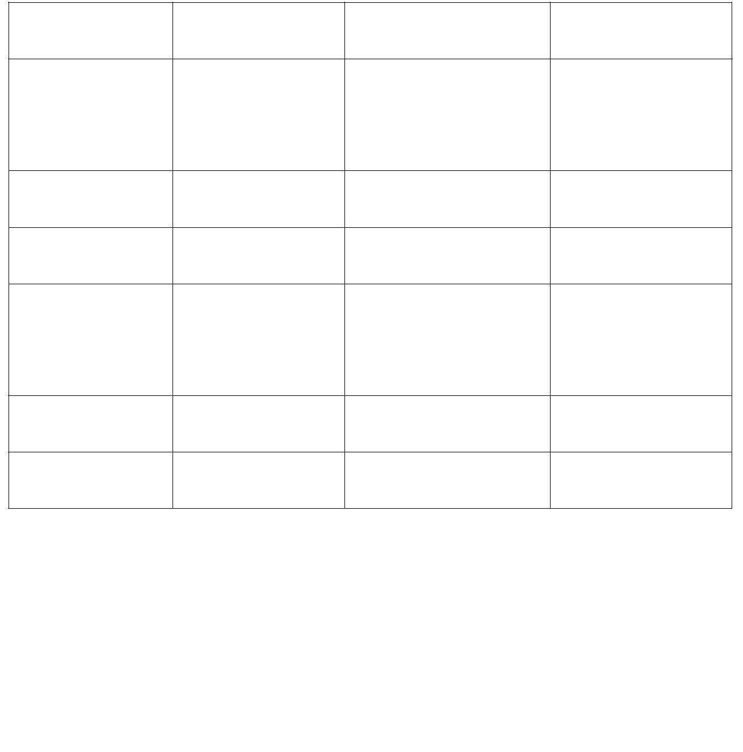phone accessories category. This mistake was made by our new staff
who just worked at our company for a week.
Immediate Actions we taken
1, our sales manager checked all our on-line listings one by one , any one
which has been violated the rules of Amazon has been removed, please
kindly check the some details as follows :
ASIN Item Problem measure
 | B07CYMXW7  C |  | Phone case Incorrect variation Removed it
B07CYYX76B Phone case Incorrect variation Removed it
B076ZKBF24 Phone case Incorrect variation Removed it
 | B076ZDVQM  S |  | Phone case Incorrect variation Removed it
B07CZ4YS4L Phone case Incorrect variation Removed it
B076ZB8MVV Phone case Incorrect variation Removed it
We listed only 6 ASIN here , but we total deleted about 12 ASIN from our
inventory, we are sure there is no mistake at our variations now;
To prevent similar violation in the future, we will follow ASIN
creation Policy, we learn ASIN Creation Policy again:
Matching our products to existing products in the Amazon catalog helps
drive a high-quality customer experience. Matching to an existing
product instead of creating a duplicate listing allows we to more fully
benefit from buyer interest and traffic for that product,
The following prohibited practices are a misuse of variations ( also known
as parent-child relationships). If create a negative customer experience
and can result in our ASIN creation or selling privileges being temporarily
or permanently removed:
Adding children that are not variations of the parent product;
Changing the parent product’s detail page so it does not match the
children;
Adding multi-pack children by bundling two or more of the same
manufacturer products , such as bundling two three-packs to create a
package quantity of six. Multi-pack children must be packaged by the
manufacturer. If a customer wants to buy two or more of the same
product , they can select that quantity for purchase.
Here are things to keep in mind to help ensure we create the
relationship correctly:
1, Parent/Child Relationship
Every variation relationship includes a parent and a number of unique
children. The parent can be thought of as a non-buyable "umbrella"
which connects the different variation children. When you create a
variation relationship, you use a parent SKU as this umbrella for your
products. The parent SKU should represent the core product. Do not
include any child-level information (size, color, UPC) on the parent SKU.
2, Variation Themes
Variation themes are the way that Amazon systems determine how a set
of products vary. The theme is set only on the parent and all children
must have valid values for the attributes corresponding to the parent's
theme. Examples of variation themes include Color/Name, Size/Count,
Color, Style, Scent, etc.
The relationship we create is a relationship between your specific SKUs.
When you submit your product information, Amazon will use the
relationship information that you provide in connection with the
information provided by other sellers of the same products to determine
the specific relationship that is presented to customers. This means that
the information displayed on the site may vary from your submitted
relationship. The SKUs in your inventory however will reflect the most
recent information you submitted, regardless of how the products are
displayed on the site.
Our plans to prevent adding children products that are not true
variations of the parent product, we make some plans as follows :
1, Train our employees Amazon ASIN Creation policy, make sure them
are familiar with Amazon policy, and before uploading a new listing on
our stores, our sales manage will check all the contents especially the
true variations of the parent products;
2, Before upload a listing on Amazon, we will have to make sure the
Parent/Child relationship, full check if this catalog support variation or
not, if it doesn’t support variation, we will upload these listings one by
one instead of adding children products that are not true variations of
the parent product;
3, We will only use the correct same variations when creating
parent/child relationships. Our sales manager will check this each week
for all our on line listings. Any listings will be removed once they were
found in the invalid listings or variations to product detail page or
violated other Amazon policies or rules;
4, We will follow ASIN Creation Policy in the future, we will arrange
employees to learn and have a test for this policy every week to make
sure that this issue will not happen again.
5, Designed our new policy , our sales manager will supervise our future
selling, sales manager will check each new ASIN every day for a double
check to be sure no ASIN violates any rules of Amazon.
We promise that we will follow Amazon policy in the future, meets
Amazon every metrics and selling policy. Please kindly consider to
reinstate our selling privilege.
Thank you so much
温馨提示：仅供思路参考，请不要照搬照抄哦~

