违规变体申诉思路

亚马逊警告信：
您好：
您的亚马逊销售账户已被停用。所有相关商品已经全部下架。资金不会转给您，并最长可能冻结 90 天。请配送所有未完结订单，以免加深对您账户的不利影响。
为什么会发生这种情况？
您反复滥用 ASIN 变体，或由于不当使用变体而影响了买家的信任。这违反了我们的政策。
如何重新激活我的账户？
要重新激活您的卖家账户，请发送一份包含以下内容的行动计划：
-- 违反变体政策的根本原因。
-- 为解决账户中多个误用变体而采取的措施。
-- 为防止将来滥用变体而采取的步骤。
如何发送所需信息？
如果您想对此决定提出申诉，请在卖家平台的“业绩通知”页面 (https://mai.amazon.cn/gp/customer-experience/perf-notifications.html) 上点击此消息旁边的“申诉”按钮。
如果未发送要求的信息，会怎么样？
如果我们未在 17 天内收到所需信息，您的账户将被永久停用。
我们随时为您提供帮助。
如需制定计划方面的帮助，请在卖家帮助中心搜索“就销售权限被撤销提出申诉”。准备好计划后，请在卖家平台的“业绩通知”页面 (https://mai.amazon.cn/gp/customer-experience/perf-notifications.html) 上点击此消息旁边的“申诉”按钮，将计划发给我们。
您的账户被错误停用？
如果您认为存在错误，请提交说明。您的说明应包含以下信息：
-- 证明您的账户符合我们 ASIN 创建政策的证据或示例。
您可以在卖家平台查看您的账户绩效 (https://mai.amazon.cn/performance/dashboard?reftag=email_suspend)，也可以在您的 iOS 或安卓设备内的亚马逊卖家应用的主屏幕上选择“账户状况”。账户状况控制面板会显示您的账户在亚马逊上销售所需的绩效指标和政策遵守方面的表现情况。
谢谢！

..................................................................................................................

Hello,

Your Amazon selling account has been deactivated. Your listings have been removed, and your ability to create new variations is disabled while your account is deactivated. Funds will not be transferred to you but will be held in your account while we work with you to address this issue. This could take up to 90 days. Please ship any open orders to avoid further impact to your account. The listing(s) below has been edited due to a violation of Amazon’s ASIN Creation policy.

---------------------------
Variations Corrected
---------------------------
Parent ASIN: B0XXXXXX
Child ASIN(s): B0XXXXX1, B0XXXXX2, B0XXXXX3, B0XXXXX4, B0XXXXX5, B0XXXXX6

Why is this happening?
You have misused ASIN variations repeatedly or impacted customer trust through the usage of incorrect variations. This is against our policies.
您反复滥用ASIN变体或通过使用不正确的变体影响了客户信任。 这违反了我们的政策。
How do I reactivate my account?
To reactivate your selling account, please send a plan of action that explains:
-- The root cause(s) of the variation policy violation.
-- The actions you have taken to resolve the multiple misused variations on your account.
-- The steps you have taken to prevent the misuse of variations going forward.

How do I send the required information?
If you wish to appeal this decision, click the Appeal button next to this message on the Performance Notifications page in Seller Central (https://sellercentral.amazon.com/gp/customer-experience/perf-notifications.html).

What happens if I do not send the requested information?
If we do not receive the requested information within 17 days, your account will be permanently deactivated.

We’re here to help.
For help creating your plan, search for "Appeal the Removal of Selling Privileges" in Seller Central Help. When you are ready to send us your plan, click the Appeal button next to this message on the Performance Notifications page in Seller Central (https://sellercentral.amazon.com/gp/customer-experience/perf-notifications.html).

Has your account been deactivated in error?
If you believe there has been an error, please submit an explanation. Your explanation should include the following information:
-- Evidence or examples that demonstrate that your account complies with our ASIN Creation policy.

You can view your account performance in Seller Central (https://sellercentral.amazon.com/performance/dashboard?reftag=email_suspend) or select Account Health on the home screen of the Amazon Seller app on your iOS or Android device. The Account Health dashboard shows how well your account is performing against the performance metrics and policies required to sell on Amazon.

政策解读

ASIN 创建政策
要创建 ASIN，请执行我们的添加新商品工具中列出的流程。要销售亚马逊目录中已有的商品，您需要通过创建报价将其与现有 ASIN 匹配。如果您的商品不在亚马逊目录中，则您需要为其创建新的 ASIN。一般情况下，以下政策旨在给买家带来始终良好的购物体验：
- 亚马逊可能会根据您的销售历史记录、商品创建历史记录和其他因素限制您可以创建的新商品数量。
- 您不能为亚马逊目录中已经存在的商品创建新的 ASIN。
- 您只能在相互之间存在重大关联的商品之间创建准确的变体关系。同一商品的更新版本或型号是无效变体。

ASIN 创建限制
为了保障买家的在线购物体验，我们限制了您在给定一周内可创建的商品信息（商品或 ASIN）的数量，直到您在亚马逊商城中建立了销售历史记录为止。随着销量的上升，允许您创建的商品信息数量也将有所增加。建议您优先发布能够快速提升销量的商品。
此外，如果您是已经建立了销售历史记录的卖家，并且创建了大量新商品信息，我们保留暂时撤销您创建新 ASIN 权限的权利。我们每周都会重新评估您的状态。
如果您对自己的商品信息创建权限遭到撤销有异议，请联系销售伙伴支持。

变体政策
变体是彼此相关的一组商品。良好的变体关系商品信息可让买家根据不同的属性（包括尺寸、颜色或其他特性），通过商品详情页面上提供的选项比较和选择商品。有关更多信息，请参阅变体关系概览。
以下禁止的行为属于对父 ASIN 或父子关系中的变体的滥用。这些行为将带来不良的买家体验，可能会导致您的 ASIN 创建或销售权限被暂停或永久撤销：
- 更改后的商品详情页面（父商品或子商品）与最初发布的商品存在重大差异。
- 更改父商品的商品详情页面，导致其与子商品不匹配。
- 添加并非父商品的真正变体的子商品。这包括但不限于：
  - 添加完全不同于父 ASIN 的商品
  - 添加与父 ASIN 存在重大差异的商品图片和/或名称。
  - 添加属于父 ASIN 的新版本或新型号的商品。
- 向现有的父商品添加并非制造商生产的多件装变体。
  - 如果您创建了并非由制造商直接销售的多件装商品的信息，您必须将该商品信息匹配到与之完全相同的多件装商品的详情页面。如果没有完全相同的多件装商品的详情页面，则必须使用该商品的唯一 UPC 创建新的商品详情页面。
  - 通过将两个或多个同一制造商的商品捆绑在一起来添加多件装子商品，例如将两个三件装商品捆绑在一起来创建一个六件装商品。多件装子商品必须是制造商包装的。如果买家希望购买两个或多个同一商品，他们可以自行选择购买数量。

Help / Account settings / Reference / Program Policies / Selling Policies and
Seller Code of Conduct / ASIN creation policy
ASIN creation policy
To create an ASIN, go through the process as outlined in our Add a Product tool. To sell a product
available in the Amazon catalog, match it to the existing ASIN by creating an offer. If your product is not
in the Amazon catalog, you will have to create a single new ASIN for the product. In general, the following
policies apply to protect the customer shopping experience:
◆ Amazon may limit the number of new listings that you may create depending on your sales history,
listing creation history, and other factors.
◆ You may not create a new ASIN for a product that already exists in Amazon’s catalog.
◆ You may only create accurate variation relationships between products are fundamentally related to
one another. Newer versions or models of the same product are invalid variations.
ASIN creation limit
To protect the onsite shopping experience for our customers, we limit the number of listings (offers and
ASINs) you can create in a given week until you establish a sales history with Amazon. As you increase
your sales, your capacity will increase. We encourage you to prioritize the products you are listing to
increase your sales quickly.
Additionally, if you are an established seller and have created a high number of new listings, we reserve
the right to temporarily remove your ability to create new listings. We will reevaluate your status on a
weekly basis.
If you think your listing creation privileges have been removed in error, please contact Seller Support.
Variation Policy
Variations are sets of products that are related to one another. Good variation relationship listings allow
buyers to compare and choose products based on different attributes such as size, color, or other
characteristics from the available options on a single product detail page. For more information,
see Variation Relationships Overview.The following prohibited practices are misuses of variations, either of the parent ASIN or in parent-child
relationships. These practices create a negative customer experience and can result in your ASIN
creation or selling privileges being temporarily or permanently removed:
●
Changing the product’s detail page (parent or child) to become fundamentally different from the
original product listed.
●
Changing the parent product's detail page so it does not match the children.
●
Adding incorrect child variations that are not true variations of the parent product. This includes but
is not limited to:
●
Adding products that are fundamentally different from the parent ASIN
●
Adding products images and/or names that are that are fundamentally different from the parent
ASIN.
●
Adding products that are newer versions or models of the parent ASIN.
●
Adding multi-pack variations that aren’t manufacturer-created to an already existing parent.
●
If you’ve created a multi-pack listing that is not directly sold by the manufacturer, you must match
your listing to an identical multi-pack product detail page. If an identical multi-pack detail page
doesn’t exist, you must create a new product detail page with its own unique UPC.
●
Adding multi-pack children by bundling two or more of the same manufacturer products, that is,
bundling two three-packs to create a package quantity of six. Multi-pack children must be packaged
by the manufacturer. If a customer wants to buy two or more of the same product, they can select

案例分析
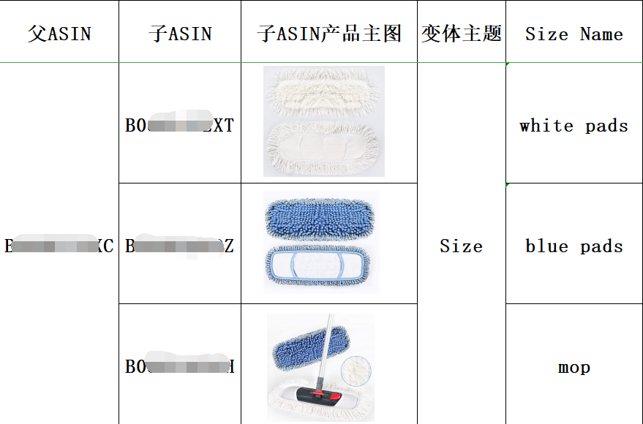
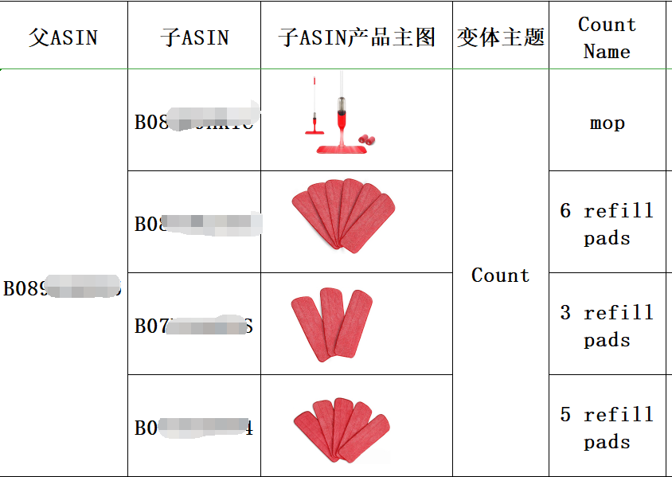
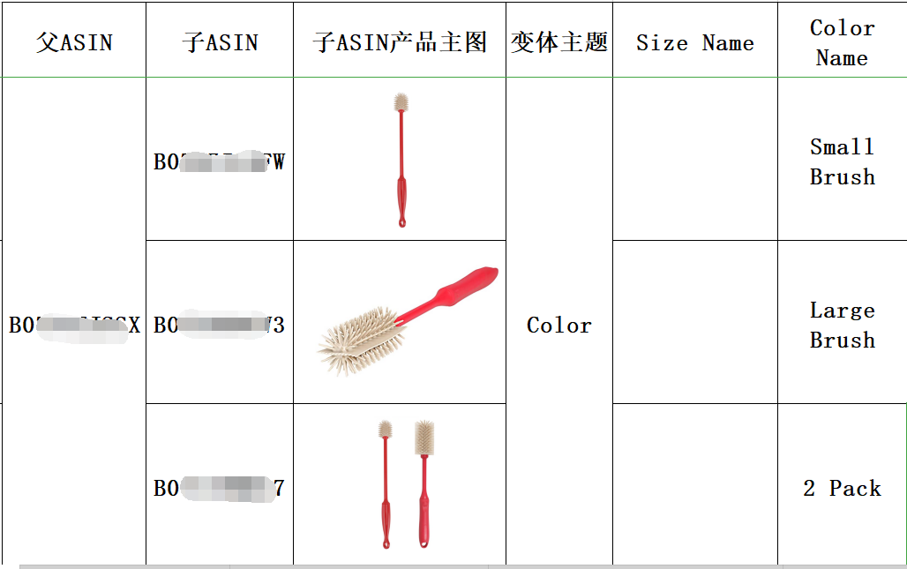

申诉模板
Dear Amazon Team,
Good day to you! Thanks for your concern about our account.
We received your message that Amazon still cannot accept our appeal because the POA we offered did not address the issue of abusing variations.
介绍情况，说明问题，做出道歉和保证。
In order to find related activities that violated Amazon's policies, here we update this New Plan of Actions for you review, we want to offer more details of the root causes and try our best to offer more effective measures to show you how we resolve the problem and prevent misuse ASIN variations similar violation in the future, please kindly check it. We promise that we will not make this mistake again. We can guarantee that we have deleted these incorrect variations. After we checked the Inventory Records and Notification Policy Warning Records, we found that our sales teams have added some children products that are not actual variations of the parent product.
分析原因，具体问题具体分析
做了哪些变体，解释说明为何是违规的。变体主题是什么，子体属性是什么？子产品与父产品的关系，各个子产品的区别与相关性。
——Greater detail on the root cause(s) for creating incorrect variations.
Here we want to apologize sincerely for our mistakes. We did the prohibited practices on Amazon as below:
-- We partial update the parent and children product detail pages in order to list some different products together.
We added the Microfiber Spray Mop (B0XXXXXX) and the Mop Pads (B0XXXXXX1, B0XXXXXX2, and B0XXXXXX3) on the same family product detail page (Parent ASIN: B0XXXXXX) , these products are related but not the same products. The products fundamentally are not the same, the parent and children products are not share the same title. We should not list different product together.
列举店铺其他变体也有相同的违规捆绑
The same issue for the parent ASIN: B0XXXXXXX, Children ASIN: B0XXXXXXX1, B0XXXXXXX2, B0XXXXXXX3. The B0XXXXXXX2, B0XXXXXXX3 are Replacement Mop Pads, but the B0XXXXXXX1 is Dust Mop. We should not add the item and the accessories together. For Example: A cell phone charging cable and a portable charger, while related, are not the same product and should not be listed on the same detail page.
--We used the variation themes incorrectly; they should only be used for their defined purpose. The Count variation theme must for the same products with different count numbers. Different items with different package quantity should not use the Count variation theme. For example, the Parent ASIN: B0XXXXXXX, and the abusive children ASIN: B0XXXXXXX1, B0XXXXXXX2，B0XXXXXXX3, B0XXXXXXX4. The B0XXXXXXX1 is Mop, but the other children products are different package quantity mop pads. We should not use the Count theme to create the incorrect variations. We need list the B0XXXXXXX1 on separate detail pages. For the different package quantity mop pads of B0XXXXXXX2，B0XXXXXXX3, B0XXXXXXX4, we could create Package Quantity theme variations.

--A color variation theme must not include any information other than color. Different size products and products with different package quantity, for example, should not be listed within a color theme.
For the Parent ASIN: B0XXXXXXXX, Abusive Children ASIN: B0XXXXXXX1, B0XXXXXXX2, B0XXXXXXX3. We created this variation with the color theme, and used the invalid words of Small Brush, Large Brush, 2 Pack for the color_name attribute. These listings are not different in color, we should not use the color theme to create the inconsistent child variations. These listings should be listed on separate detail pages.
If we used the Color name as the variation theme, the only difference for each child product should be only different in color.
分析出了具体的被警告过的违规变体情况，再次分析创建违规变体的原因。
没有认真学习和理解亚马逊产品创建政策，为了聚集评论做了违规变体。
We are sorry for that we have misused ASIN variations repeatedly or impacted customer trust through the usage of incorrect variations. We have realized our mistakes and we will not do the prohibited practices on Amazon any more. We learned the ASIN Creation Policy and Variation Policy again and again, then deleted all related listings and incorrect variation relationships from our inventory.
We did not comprehensive analysis of the main causes of the problem, and then make an effective plan to resolve the issue when we got the policy warning. We were eager to add more product comments and increase sales, and then did totally wrong things. We did not take the time to fully understand the Variation Policy, Detail Page Creation Policies and the Amazon Terms of Service agreement.
Variations are sets of products that are related to one another in different sizes (Small, Medium, and Large) or in different colors (Blue, Red, Black). But we misused variations to list different products together. We should not impact customer trust through the usage of incorrect variations. If we offer wrong information, this will make customers confused and cannot make good shopping decisions.

We promise we won’t do things like that again. We made a plan, which is not only to solve the issues, but also to prevent the similar problem from happening again in the future.
解决方案：
解绑变体，删除父ASIN，学习亚马逊政策，检查店铺其他链接，确保别的链接没有违规变体。
——Greater detail on the actions you have taken to resolve Inconsistent Child Variations issues.
1.When we receiving Amazon notification, we immediately thoroughly check our account listings, we have already deleted all the incorrect parent-child relationships, and we promise that we won’t release the listings in such stupid way. You can check our entire inventory accordingly.
2.We have reviewed our other listings in our Inventory to make sure that they follow Amazon policies. We have already checked all the listings and corrected the related listings that misuse ASIN variations. We pretty ensure that every product has an accurate product name and description to avoid customer confusion. We will strictly abide by Amazon's rules and sell high quality products in a reasonable manner.
分析产品特性，说明要如何创建变体；
对比竞争对手链接，他们是如何创建相似产品链接的，或者为何没有创建变体。
We have studied and analyzed the product features and the product details page of other similar product sellers in detail, and found that the seller's strategy is completely correct, for example:
Microfiber Mop:
https://www.amazon.com/Microfiber-Hardwood-Washable-HOMTOYOU-Stainless/dp/B07PCQ3RCS
Microfiber Mop Pads: https://www.amazon.com/Cleaning-Pads-Spray-Washable-Microfiber/dp/B07GQJXJ8S
They did not add the Microfiber Mop and the mop pads together on the same product detail page. They did not create some different products within the same family. So we should follow Amazon ASIN creation policy to create correct variation other than misusing variations. Because the particularity of the product is not suitable for variation, the wrong variation we make will cause the buyer to make the wrong purchase choice.
组织员工学习亚马逊ASIN 创建政策。
3. We have organized all our company’s staff to learn about the Amazon policy in regards to ASIN Creation Policy and Variation Relationships Policy. We researched all of Amazon’s policies and rules. For policies regarding variation relationship we found the policy details are as follows:
We have learned that:
[Variation policy]:
The following prohibited practices are misuses of variations. These practices create a negative customer experience and would result in ASIN creation or selling privileges being temporarily or permanently removed. This includes but is not limited to:
*Adding incorrect variation to ASINs you created.
*Adding products that are fundamentally different from the parent ASIN.
*Adding products that are newer versions or models of the parent ASIN.
[Product reviews and feedbacks]
It is forbidden that if we create a variation relationship between products that are not actually related to each other in order to boost a product’s star rating.
[Variation theme]:
The variation theme defines how related products differ from each other. Depending on the category chosen to list our products, variation themes also vary. We should choose the correct theme and use the valid values to show the attributes for all the variations families.
在创建父子变体时，如何保证变体是合规的：
4.When we create variations, we should double check the product information and then use the correct theme to create the variations. But we also should know that not all related products are valid variations. The following questions can help us to determine whether certain products are valid variations:
*Are the products fundamentally the same (i.e. the similarities of the ASIN’s design and function are so basic as to be hard to alter resolve, or overcome)?
*Could the products share the same title?
*Do the products vary only in a few, specific ways that do not alter the core essence and nature of the item (such as color or size)?
*Would customers expect to find these products together on a single product detail page?
We should follow above instructions to check whether we could create parent and child variations for the products we want to list on Amazon. We may only create accurate variation relationships between products are fundamentally related to one another. Newer versions or models of the same product are invalid variations.
预防措施：以后如何避免再次发生类似问题。
----Greater detail on the steps you have taken to prevent Inconsistent Child Variations going forward.
加强培训，培训内容，培训时间，参与人员，考核方式。
1.We will strengthen the company's training for all employees.
Our management staff should first enrich our knowledge, better understand Amazon's rules, and provide more comprehensive training for employees.
In the future, we will participate in the fee-based Amazon official training courses, watch Amazon official operation guidance live courses, and learn relevant policies from the seller's University and the seller's help page.
Our management staff should first enrich our knowledge, better understand Amazon's rules, and provide more comprehensive training for employees.
We will hold training and learning lessons every week and also hold an examination for our staff on Amazon policy every month, especially ASIN Creation Policy, and all other Amazon policies, includes, but not limited to : Catalog, Catalog variation guideline; avoid duplicate ASIN; parent-child relationships and so on, to fully understand the Variation policy. Aimed at knowing all prohibited practices on Amazon so that we can strictly obey these policies to make sure no any violation in the future. This activity will last half a year until our staff are full understanding.
培训过程
- . The specific process of training: We will choose some topics for how to create variations correctly, we have arranged experienced managers to prepare PPT courseware, and all our colleagues should participate in learning about Amazon policies.
培训时间
- . When to start training: We have started the training this month, we will have the training for once a week.
谁来培训
- . Who will guide this training: Our account managers with five years of experience in Amazon global business will organize training for our all sales team members.
如何确保培训有效果，考核方式及要求
4). Why this training can prevent this problem.
Through training and assessment, ensure that all employees, especially new employees, understand Amazon's policies, what’s variations are correct, and what’s kind of variations are incorrect.
We will offer some examples from Amazon market and our store listings, to let them know the variations policy completely and all of them need to pass the ASIN creation policy test. Thus they could create new listings and new parent-child relationships.
We have mentioned on the Part Two about our actions, we have arranged training for our company's employees about ASIN Creation Policy and Variation Relationships Policy, Amazon Prohibited seller activities and actions, which can ensure they are familiar with Amazon's rules and policies, as well as forbidden product behavior reviews.
以后如何创建变体，需要遵守哪些规则
2. We will strictly obey Amazon’s policy to create variations. When we create variations for some listings, they must be the true parent-child relationship products. Meanwhile, we request all staffs to comply with Amazon policies completely.
Since we are a manufacture focusing on iPad Accessories products, we have analyzed their features in detail. After more than one week’s thinking and repeated reading of Amazon's variation article, we have understood Amazon's variation policy.
1) If they are different design/model or different function products, we should not create variations with color theme or size theme and used invalid words on the color or size attribute, we need offer each ASIN separately on Amazon.
2) If they are different size products for the same design products, we could use the Size Name theme to create the correct variations.
3) If they are different color products for the same design products, we could use the color name theme to create the correct variations.
4) If they are different in size and color for the same design products, we also could use the Color name-Size name theme to create the correct variations.
创建变体之前，检查相关产品信息，是否可以创建变体，应该选择什么主题，子体属性如何确定。
3. Before we create variation relationship, we should make sure whether they are different color or different size. If they are not, we cannot create variation relationships or add child ASINs if our products are not different color or not actual variations of the parent product. We will only use the correct variations theme and correct size or color name when creating parent and child relationships.
We will follow with the Amazon ASIN creation policy to select the correct theme for our listings if they are different color or size, and use the correct color name or size name for all the children ASINs.
与供应商沟通，拿出样品分析产品检查各个产品之间的区别。
- In order to better understand the characteristics of products, we will ask suppliers to provide various samples. After receiving the physical products, we will organize all the staff of the sales department to hold a meeting to discuss whether could create variation. We will stressed with our employee that they can only create variation when products are the same, but only with different color or different size . If not, they must create different listing 100%. we must obey “ASIN Creation Policy”, to make sure a good customer experience .
主管监督各个链接的上传，检查要求和检查的内容
5. We will use the following key points to monitor the behavior of our staff .
Next time, when we plan to create variation, We will strictly follow the following standards of self inspection, and request, and require each employee and superior to sign on the form and bear the responsibility for violation of laws and regulations. If one of them broke the regulation as follows, he will be fired. We want every employee knows that we have zero tolerance about violating policy.
The key points are as below:
Is the catalog right?
Is the child really match with the parent?
Is the variation theme right?
Is the title comply with policy?
Is the product image comply with the policy
Are the products fundamentally the same (i.e. the similarities of the ASIN’s design and function are so basic as to be hard to alter resolve, or overcome)?
Could the products share the same title?
Do the products vary only in a few, specific ways that do not alter the core essence and nature of the item (such as color or size)?
Would customers expect to find these products together on a single product detail page?
运营每周检查店铺链接，确保没有违规变体。
6. We will strictly double check and inspect all listings every week.
We have set up a special inspection team by two experienced employees who are responsible for checking whether the listings are in violation of Amazon policy. All listings have to be reviewed by them before releasing. If the listings are in violation of Amazon’s policy, they will be deleted immediately. We guarantee that the similar problem won’t happen again. We believe that we can do it better with a professional, skilled, and expanded team.
如果对于创建产品链接有疑问，咨询亚马逊卖家支持团队或者招商经理。而不是学一些旁门左道。
- If we have any questions about Variation Creation, we will also contact seller support for help. We will apply for Amazon Global Selling Public offline Training Courses to let our staffs know more about the details of the Amazon seller policy.
使用CPC广告来增加订单和评论，而不是创建违规变体捆绑评论。
8.We will invest more on PPC sponsored advertisement to increase our sales instead of creating invalid variation .we must increase our sales on the basis of obey Amazon’s policy .

确保产品页面与实际产品相符，优化链接和图片来吸引客户。
- When we create new listings and sell all of our products, we won't try to merge the reviews from other ASINs. We will not manipulation product review through abusing variations from now on. We'll create a list with detailed blue points and descriptions, as well as a competitive image.
提供物美价廉的产品和更好的发货渠道（FBA），参加各种秒杀和促销活动。
使用亚马逊推荐的评论计划：早期评论人，Vine Voice.
- We will provide more competitive product price and better shipping service with FBA. Provide our customers with the best quality products and customer support. Create more and more Light Deal and Best Deal to increase our sales. We will get review via correct method that Amazon’s policy allowed such as Early Reviewer Program. We deeply realize that what we should do is to try our best to provide our valued customers with the premium products and satisfactory after-sale service, rather than manipulate customer reviews through create incorrect variation relationships.
做出承诺，请求原谅，盼尽快恢复！
Sincerely, we will try our best to give our customers pleasant experience on Amazon and hope you can give us a chance to continue to sell on Amazon. Thanks so much. Look forward to your reply.
Best regards,
XXXXXX Team

