Android Online Assessment

1. Fill in the appKey and secretKey authorized by Chivox into the following file

ChivoxDemo\app\src\main\java\com\example\chivoxdemo\Config.java

2. Update the aiengine.provison file authorized by Chivox to the following directory

ChivoxDemo\app\src\main\assets

3. Use Maven to import the sdk or download the latest version of the sdk from the official documentation, and put libaiengine.so under different CPU architecture directories in the directory ChivoxDemo\app\src\main\jniLibs;

put the chivox_android_sdk_release.jar file in the directory

ChivoxDemo\ChivoxDemo\app\libs

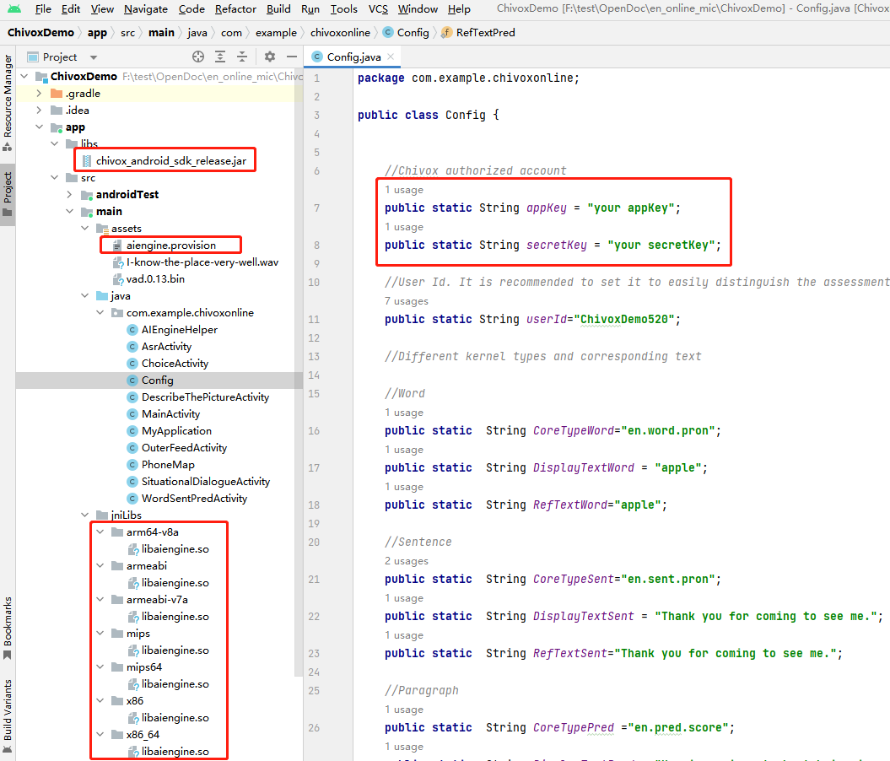

1. Run the project on your phone, you’ll see the following.

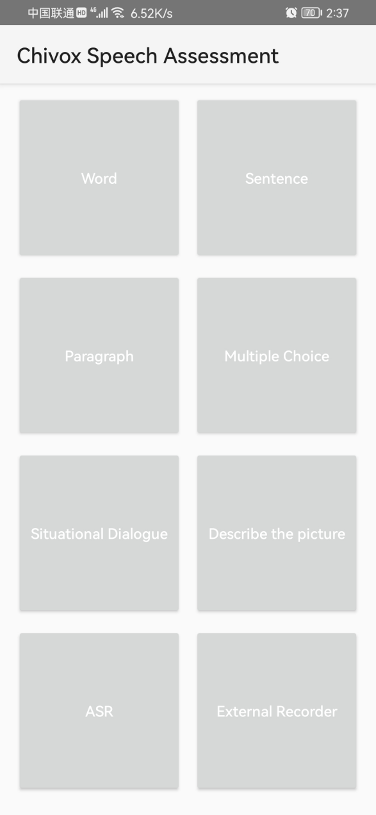

The sample code contains 7 types of question(get the real-time audio data from MIC) and the remaining one is external recorder(get the audio data from a file or other recoder). You can touch the corresponding button and try it.

Different question type has its input parameter and output dimension.

For more details about each question type, you can refer to kernel document

<https://www.chivox.com/opendoc/#/EnglishDoc/coreEn/>

The sample code also integrate the android speech assessment SDK. It include the following interface.

1. Create;
2. Start;
3. Feed;
4. Stop;
5. Callback(recevice the assessment result).
6. Destroy;

The overall process

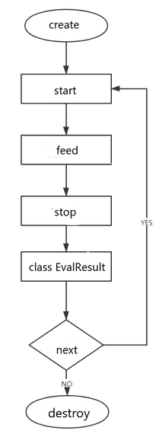

For more details about each interface, you can refer to the document

<https://www.chivox.com/opendoc/#/EnglishDoc/sdkDoc/Android-sdk>

Usually, you can refer to the sample code to call the interface in your own project.

If you want change the assessment question type, The main modified code file is here.

