JSSDK Assessment

1. Fill the appkey into the index_ Recorder.html；

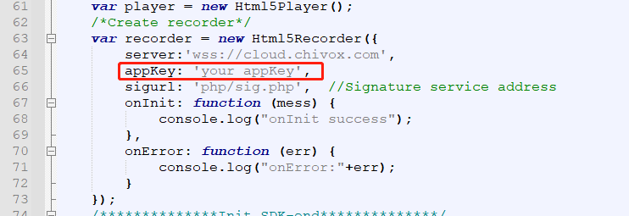

2. Fill appkey and secretkey into PHP/sig.php;

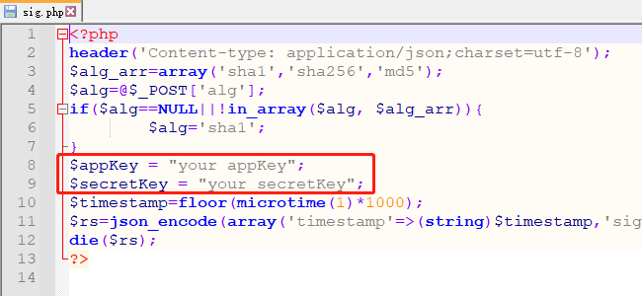

3. Deploying the entire folder in the web server with HTTPS protocol;

4. Access index_ Recorder.html to experience the scoring function;

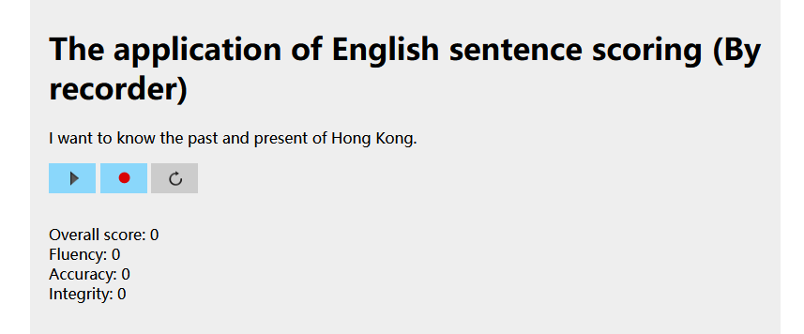

Click the red dot button to start record, and click it again to stop record,then the assessment result will show.

This sample code demonstrates a sentence assessment , the assessment result is in json format.

For more assessment type, you can refer to kernel document

<https://www.chivox.com/opendoc/#/EnglishDoc/coreEn/>

Usually, you can refer to the sample code to call the interface in your own project.

If you want change the assessment type, The main modified code file is here.

