JSSDK Assessment

1. Fill the appkey into the JSSDK_SimpleCode\index_ Recorder.html；

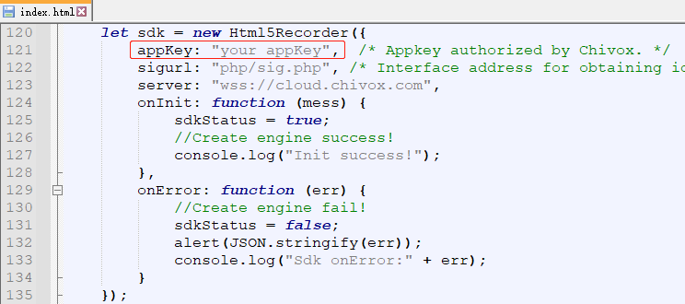

2. Fill appkey and secretkey into JSSDK_SimpleCode\PHP\sig.php;

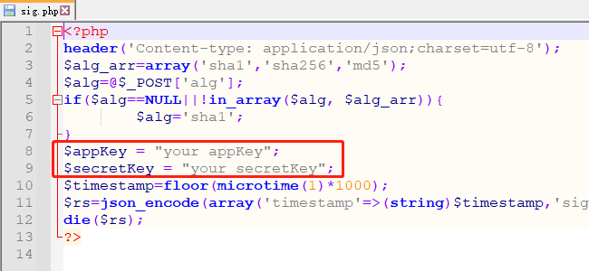

3. Deploying the entire folder in the web server with HTTPS protocol;

4. Access JSSDK_SimpleCode\index.html to experience the scoring function;

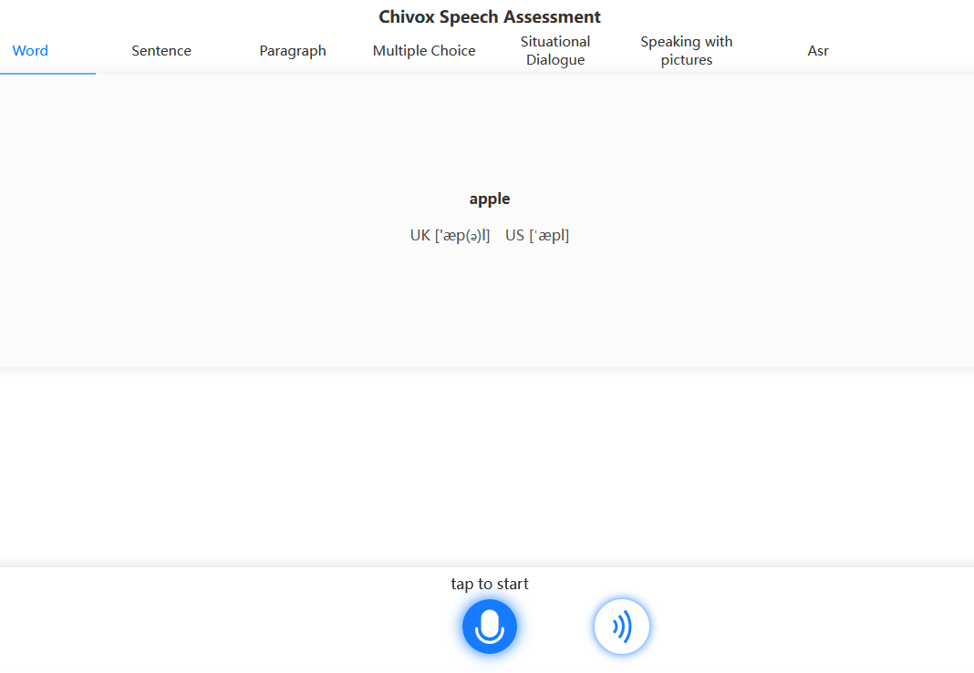

Different question type has different parameters. for more details, please refer to the document.

<https://www.chivox.com/opendoc/#/EnglishDoc/coreEn/>