1. Fill in the appKey and secretKey authorized by Chivox into the following file

UnitySampleCode\Assets\ChivoxDemo\ChivoxManger.cs

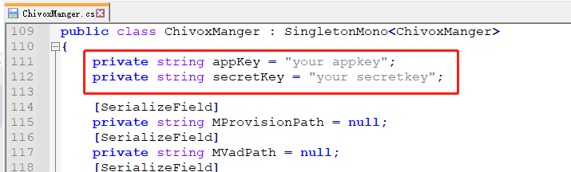

2. Update the aiengine.provison file authorized by Chivox to the following directory

UnitySampleCode\Assets\StreamingAssets

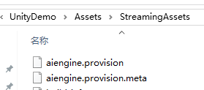

1. Run the project, you’ll see the following.

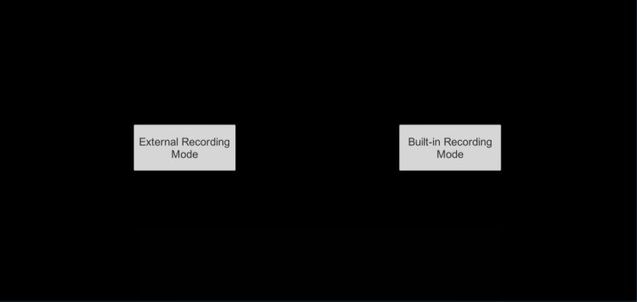

There are two mode you can choose

1. External recording mode

Sdk will Read the recorded audio data and send it to the engine to assessment.

If you choose this mode and click the “Start Assessment” button, you’ll see the following assessment result.

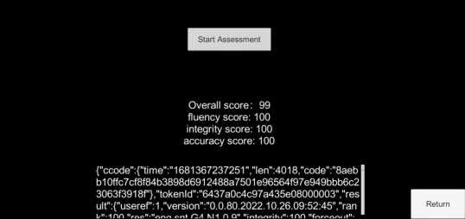

1. Build-in recording mode

Sdk will get the audio data from microphone

If you choose this mode, you’ll see the following

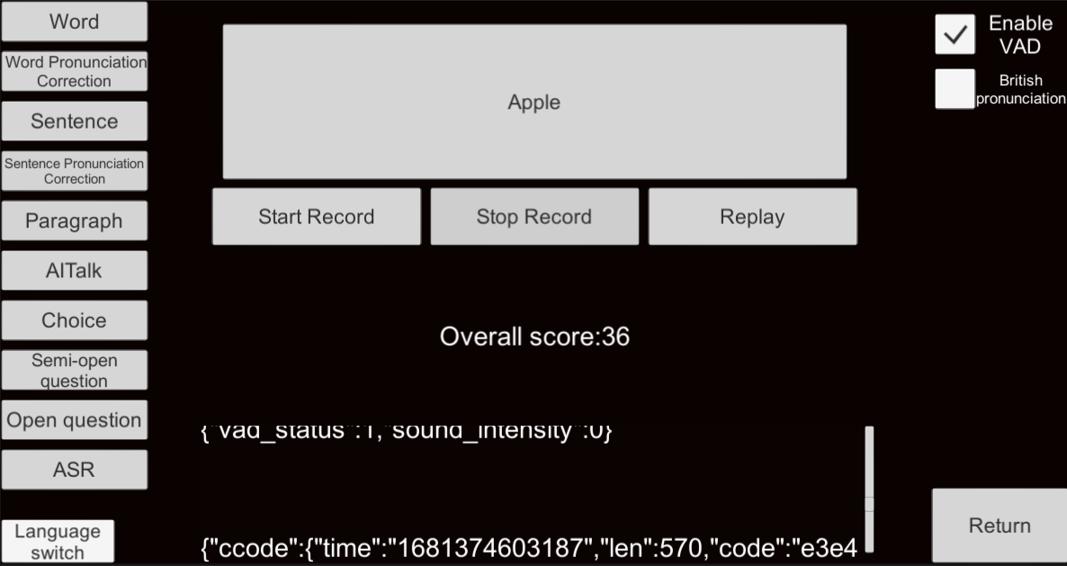

The sample code include 10 types of question. You can touch the corresponding button and try it.

Different question type has its input parameter and output dimension.

For more details about each question type, you can refer to kernel document

<https://www.chivox.com/opendoc/#/EnglishDoc/coreEn/>

The sample code also integrate the Unity speech assessment SDK. It include the following interface.

1. Create;
2. Start;
3. Feed;
4. Stop;
5. Callback(recevice the assessment result).
6. Destroy;

The overall process

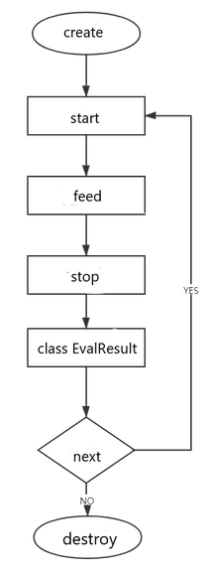

For more details about each interface, you can refer to the document

<https://www.chivox.com/opendoc/#/EnglishDoc/sdkDoc/Unity-sdk>

Usually, you can refer to the sample code to call the interface in your own project.

If you want change the assessment question type, The main modified code file is here.

