iOS Online Assessment

1. Fill in appKey, secretKey in the following files

ChivoxAssessment\ChivoxAssessment\ViewController.m

2. put aiengine.provison file in the following directory

ChivoxAssessment\ChivoxAssessment\License File\aiengine.provision

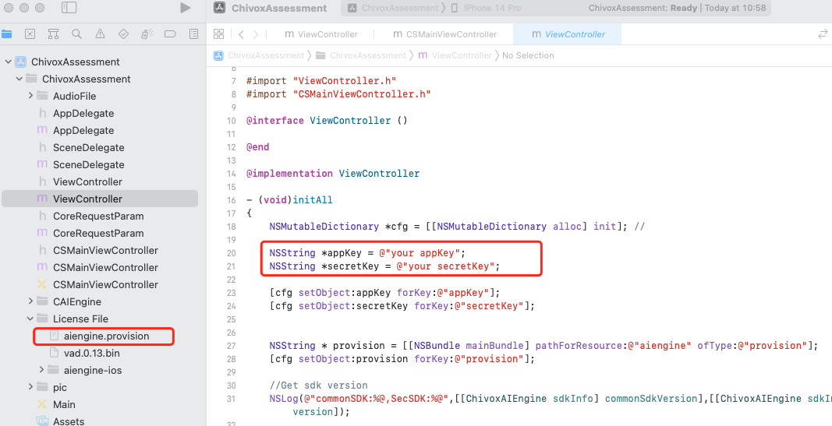

1. Use CocoaPods to import the sdk or download the latest version of the sdk from the official documentation, put libaiengine.a, libCAIEngine.a into the directory

ChivoxOfflineAssessment\ChivoxAssessment\License File\aiengine-ios;

Update the files in the CAIEngine directory to the CAIEngine directory in the project

1. Run the project, you’ll see the following.

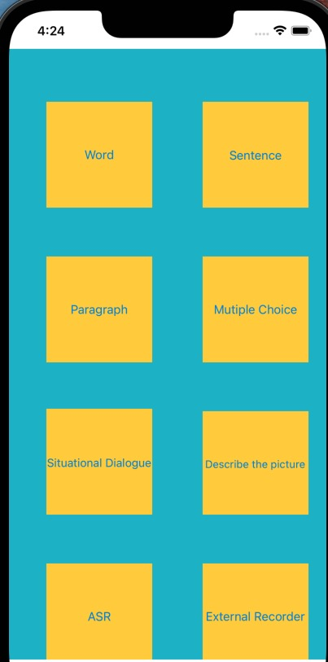

The sample code include 7 types of question and the usage of external recorder. You can touch the corresponding button and try it.

Different question type has its input parameter and output dimension.

For more details about each question type, you can refer to kernel document

<https://www.chivox.com/opendoc/#/EnglishDoc/coreEn/>

The sample code also integrate the iOS speech assessment SDK. It includes the following interface.

1. Create;
2. Start;
3. Feed;
4. Stop;
5. Callback(recevice the assessment result).
6. Destroy;

The overall process

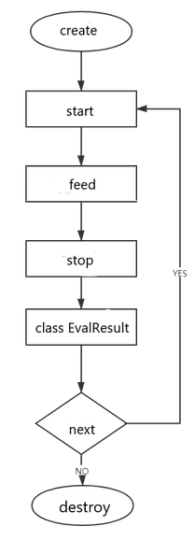

For more details about each interface, you can refer to the document

<https://www.chivox.com/opendoc/#/EnglishDoc/sdkDoc/iOS-sdk>

Usually, you can refer to the sample code to call the interface in your own project.

If you want change the assessment question type, The main modified code file is here.

