
THE UNIVERSITY OF ZAMBIA
School of Natural and Applied Sciences
Department of Computing and Informatics

MEMBERSHIP AFFILIATION AND MANAGEMENT SYSTEM
(MAMS)
(A CASE OF CHURCH MEMBERSHIP AND SCHOOL PTA)
BY
CHIZA GONDWE
2021446280

Supervised by: Professor Jackson Phiri
Frontend Developer: Rebecca Ongani Phiri

October 2026

COPYRIGHT
All rights reserved. No part of this material may be reproduced, stored in any retrieval system, or transmitted in any form by any means, except in the case of brief quotations embodied in critical reviews and other non-commercial uses permitted by copyright law of the author, Chiza Gondwe, or the University of Zambia in that regard.

DECLARATION
I, Chiza Gondwe, do hereby declare that this report is my own original work and has not been submitted to any other college, institution or university other than the University of Zambia. All sources of information used have been duly acknowledged and referenced.

Name: ........................................................................................
Sign: ..........................................................................................
Date: ..........................................................................................

APPROVAL
This report, by Chiza Gondwe, has been approved as partial fulfilment of the requirements for the award of a Bachelor of Computer Science degree by the University of Zambia.

Student
Name: ........................................................
Signature: ...................................................
Date: .............................................................

Supervisor
Name: ..........................................................
Signature: ...................................................
Date: .............................................................

ACKNOWLEDGEMENTS
This project would not have been possible without the guidance, support, and encouragement of many individuals. My deepest appreciation goes to my supervisor, Professor Jackson Phiri, for his patience, expertise, and constructive feedback throughout the entire development process. His guidance kept me focused and motivated from the initial proposal through to the final implementation.
I would like to extend sincere thanks to my project partner, Rebecca Ongani Phiri, for her dedication to the frontend development of MAMS and her collaborative spirit throughout the project. The quality of the React web dashboard and Flutter mobile application reflects her considerable skill and commitment.
I am grateful to the church members who willingly completed the MAMS member questionnaire. Their candid responses provided the empirical foundation that shaped the system design and feature priorities. Without their participation this project would have lacked its essential connection to real-world needs.
Finally, I thank my family and friends for their unwavering support, encouragement, and patience throughout my studies at the University of Zambia. Their belief in me gave me the strength to see this project through to completion.

DEDICATION
To my parents and family, for their unwavering support, sacrifice, and belief in my potential. This work is as much yours as it is mine.

ABSTRACT
The Membership Affiliation and Management System (MAMS) is a multi-tenant, cross-platform digital membership and attendance management platform developed for church organizations and school Parent Teacher Associations (PTAs) in Zambia. The system addresses the operational inefficiencies experienced by these organizations in managing member records, tracking attendance, and communicating with members through manual paper-based systems characterized by data loss, inaccurate records, missed announcements, and poor administrative accountability.
MAMS provides a secure, scalable, and commercially viable Software-as-a-Service (SaaS) platform that enables administrators across multiple independent organizations to manage member records, create attendance sessions with automatically generated QR codes, record member attendance through QR code scanning, identify first-time visitors, broadcast text and video announcements to targeted audiences, manage dynamic organizational structures including zones, sections, and ministry groups, track member contributions, manage events, and communicate through a dedicated communications module. The system is built on a Django REST Framework backend connected to a MySQL database, with a React.js web dashboard for administrators and a Flutter mobile application for members. All API endpoints are secured using JSON Web Token authentication and a seven-tier Role-Based Access Control system that scopes data access to the requesting user's organizational role.
A member questionnaire administered to 15 church members confirmed a 100 per cent desire for a digital membership management system, with 77 per cent of respondents regularly missing announcements under the current informal system and 73 per cent rating offline access as very important. These findings directly informed the system design and feature prioritization across eight Agile development sprints. All 20 API test cases passed with a 100 per cent pass rate. The system is currently awaiting Oracle Cloud deployment and user acceptance testing with representatives from at least one church organization and one school PTA.

Keywords: Membership Management, Church Management, PTA, Django REST Framework, Flutter, React.js, QR Code Attendance, Role-Based Access Control, Multi-Tenant Architecture, Zambia

Table of Contents
COPYRIGHT 2
DECLARATION 3
APPROVAL 4
ACKNOWLEDGEMENTS 5
DEDICATION 6
ABSTRACT 7
LIST OF TABLES 12
LIST OF FIGURES 13
LIST OF ABBREVIATIONS 14
1 INTRODUCTION AND BACKGROUND 16
1.1 Introduction 16
1.2 Background 16
1.3 Statement of the Problem 17
1.4 Aim of the Study 17
1.5 Research Objectives 18
1.6 Research Questions 18
1.7 Significance of the Study 18
1.8 Scope of the Study 19
1.9 organization of the Report 19
1.10 Chapter Summary 20
2 LITERATURE REVIEW 21
2.1 Introduction 21
2.2 Background to the Study 21
2.3 Membership Information Systems in Organizational Contexts 22
2.4 Digital Communication in Community Organizations 22
2.5 Role-Based Access Control and Security 23
2.6 Cross-Platform Development Frameworks 24
2.7 Summary of Literature and Research Gaps 24
3 METHODOLOGIES 26
3.1 Introduction 26
3.2 Research Design 26
3.3 Development Methodology 26
3.4 Requirements Elicitation — Member Survey 27
3.5 Survey Results 27
3.6 Chapter Summary 28
4 SYSTEM DESIGN 29
4.1 Introduction 29
4.2 System Architecture 29
4.3 Use Case Diagram 30
4.4 Activity Diagram 31
4.5 Class Diagram 33
4.6 Sequence Diagram 34
4.7 Database Design 36
4.8 Security Design 39
4.9 Chapter Summary 42
5 RESULTS 43
5.1 Introduction 43
5.2 System Implementation Results 43
5.2.1 Technology Stack 43
5.2.2 React Web Dashboard Screenshots 44
5.2.3 Flutter Mobile Application Screenshots 49
5.3 System Validation and Testing 53
5.4 Chapter Summary 55
6 DISCUSSION AND CONCLUSIONS 56
6.1 Introduction 56
6.2 Discussion 56
6.2.1 Objective 1 Discussion 56
6.2.2 Objective 2 Discussion 57
6.3 Conclusions 57
6.4 Recommendations 58
6.5 Future Works 59
6.6 Chapter Summary 60
REFERENCES 61
APPENDICES 64
Appendix 1 — Member UAT Questionnaire 64
Appendix 2 — Member Survey Questionnaire 64

LIST OF TABLES
Table 2.1: Summary of research gaps and MAMS responses 25
Table 3.1: MAMS Agile sprint overview 27
Table 3.2: Key survey findings summary (n=15) 27
Table 4.1: MAMS database application structure 37
Table 4.2: Member model field definitions 38
Table 4.3: RBAC role definitions 39
Table 4.4: Complete API endpoint reference 40
Table 5.1: Backend technology stack 42
Table 5.2: Frontend technology stack 43
Table 5.3: Complete test results 53
Table 5.4: Test summary 53

LIST OF FIGURES
Figure 4.1: MAMS System Architecture Diagram 30
Figure 4.2: MAMS Use Case Diagram 31
Figure 4.3: Member Registration Activity Diagram 33
Figure 4.4: MAMS Class Diagram 35
Figure 4.5: QR Code Attendance Sequence Diagram 36
Figure 4.6: Entity Relationship Diagram (ERD) 39
Figure 5.1: MAMS React Dashboard — Login Page 44
Figure 5.2: MAMS React Dashboard — Home Page 45
Figure 5.3: MAMS React Dashboard — Members Management 46
Figure 5.4: MAMS React Dashboard — Attendance Sessions with QR Code 47
Figure 5.5: MAMS React Dashboard — Announcements Page 48
Figure 5.6: MAMS Flutter App — Login Screen 48
Figure 5.7: MAMS Flutter App — Home Screen 49
Figure 5.8: MAMS Flutter App — QR Code Scanner 49
Figure 5.9: MAMS Swagger API Documentation 50

LIST OF ABBREVIATIONS
Abbreviation | Full Meaning
API | Application Programming Interface
CORS | Cross-Origin Resource Sharing
CRUD | Create, Read, Update, Delete
DRF | Django REST Framework
ERD | Entity Relationship Diagram
HTTP | Hypertext Transfer Protocol
HTTPS | Hypertext Transfer Protocol Secure
ICT | Information and Communication Technology
JWT | JSON Web Token
MAMS | Membership Affiliation and Management System
MIS | Management Information System
MVP | Minimum Viable Product
MySQL | My Structured Query Language
OTP | One-Time Password
PTA | Parent Teacher Association
QR | Quick Response
RBAC | Role-Based Access Control
REST | Representational State Transfer
SaaS | Software as a Service
SQL | Structured Query Language
UNZA | University of Zambia
URL | Uniform Resource Locator
USSD | Unstructured Supplementary Service Data
VS Code | Visual Studio Code

1 INTRODUCTION AND BACKGROUND

1.1 Introduction
This chapter presents the introductory framework for the Membership Affiliation and Management System (MAMS). It provides the background of the study, the problem statement that motivated the research, the aim and objectives of the project, the research questions, the significance of the study, and the scope within which the system was developed. Together, these sections establish the motivation, direction, and boundaries of the development work undertaken.

1.2 Background
The rapid advancement of information and communication technologies has fundamentally transformed how organizations manage their operations, members, and communications. Management Information Systems (MIS), as defined by Laudon and Laudon [3], are integrated systems that collect, process, store, and communicate information to support decision-making and operational control within organizations. Despite this digital transformation, many community-based organizations in Zambia — including churches and school Parent Teacher Associations (PTAs) — continue to rely on manual, paper-based administrative systems that are inefficient, error-prone, and increasingly inadequate for modern organizational demands.
Church organizations and school PTAs in Zambia serve as vital pillars of community life, collectively engaging hundreds of thousands of members across the country. Yet their administrative infrastructure remains largely analogue. Attendance is recorded on paper sign-in sheets that are prone to loss and transcription errors. Member records are maintained in physical registers that cannot be searched, filtered, or analyzed. Announcements are communicated verbally during services or through informal WhatsApp groups, resulting in widespread information gaps. Contributions are tracked in handwritten ledgers susceptible to manipulation and loss. These operational challenges undermine the effectiveness of these organizations and erode trust among members.
Mwape and Banda [1] observed that the COVID-19 pandemic significantly accelerated the need for digital platforms in community service delivery in Zambia. Phiri and Zulu [11] evaluated open-source membership management systems in Zambian NGOs and found that poor adoption was primarily driven by the absence of mobile interfaces and integrated communication modules suitable for the local context. Chibuye and Phiri [8] emphasized that digital solutions for Zambian organizations must account for variable connectivity and mixed digital literacy levels. These findings collectively establish the need for a purpose-built, mobile-accessible, and context-appropriate digital membership management platform for Zambian church and PTA organizations.

1.3 Statement of the Problem
Church organizations and school PTAs in Zambia continue to rely predominantly on manual, paper-based systems for managing membership records, tracking attendance, and disseminating information. These systems are characterized by significant inefficiencies including the risk of physical record loss or damage, inaccurate attendance data from manual sign-in processes, inconsistent communication through informal and unreliable channels, the absence of real-time administrative visibility, and poor contribution tracking that contributes to financial mismanagement as documented by Banda and Mwila [12]. Existing digital solutions have not adequately addressed these challenges in the Zambian context, as Phiri and Zulu [11] established that available tools lack the mobile interfaces and integrated communication capabilities necessary for effective adoption. This project seeks to address these challenges through the development of the Membership Affiliation and Management System (MAMS).

1.4 Aim of the Study
The aim of this project is to design and develop a cross-platform Membership Affiliation and Management System (MAMS) that enables church organizations and school PTAs in Zambia to digitize and streamline their membership management, attendance tracking, communication, and contribution record-keeping through a secure, mobile-accessible, and role-based digital platform.

1.5 Research Objectives
- To design and develop a cross-platform MAMS using Flutter for the mobile application and React.js for the web dashboard, incorporating secure member registration and profile management, QR code-based attendance tracking, contribution recording with basic financial reporting, and role-based access control for administrators, leaders, and members, supported by a Django REST Framework backend and a MySQL relational database.

- To design and implement a secure text and video announcement communication module within the MAMS platform that enables administrators to broadcast official text announcements and upload pre-recorded video announcements accessible through both the mobile application and web dashboard, and to evaluate the complete system through structured functional testing and user acceptance testing with representatives from at least one church organization and one school PTA.

1.6 Research Questions
- How can a multi-tenant, role-based digital platform be designed and implemented to support the full lifecycle management of membership records, attendance tracking, and contribution recording for church organizations and school PTAs in Zambia?

- To what extent does the MAMS text and video announcement communication module improve information delivery to church and PTA members compared to existing informal communication channels, and how effectively does the system perform under structured functional testing and user acceptance testing conditions?

1.7 Significance of the Study
This study makes several significant contributions to the field of community organization management in Zambia. First, it addresses a documented and empirically validated gap in digital management tools for Zambian church and PTA organizations, providing a purpose-built solution rather than adapting tools designed for other contexts. Second, the multi-tenant SaaS architecture transforms MAMS from a single-organization tool into a commercially viable platform capable of serving many organizations simultaneously, with direct implications for the sustainability and scalability of the solution beyond the academic project context. Third, the seven-tier role hierarchy and organization-scoped data isolation represent a significant advancement over existing systems, which Sandhu et al. [13] established have not adequately implemented RBAC in sub-Saharan African community management contexts. Fourth, the integration of QR code attendance with first-time visitor detection directly supports pastoral care and community engagement by providing church leaders with actionable data about new members. Fifth, the study contributes to the growing body of research on digital transformation in Zambian community organizations.

1.8 Scope of the Study
The scope of MAMS encompasses the design, development, testing, and planned deployment of a full-stack multi-tenant membership management system targeting church organizations and school PTAs in Zambia. The project is developed by a two-person team: Chiza Gondwe is responsible for the entire backend system including the Django REST Framework API, MySQL database design, JWT authentication, RBAC, QR code generation, API testing, version control, and Oracle Cloud deployment. Rebecca Ongani Phiri is responsible for the React.js web dashboard and the Flutter mobile application.
The system covers member registration and profile management, QR code attendance tracking, text and video announcements, basic financial contribution recording, event management, sermon archives, prayer wall, and communications logging. Mobile money gateway integration, live video streaming, USSD interface, and advanced predictive analytics are explicitly out of scope for the current project and are documented as future work recommendations.

1.9 organization of the Report
This report is organized into six chapters. Chapter 1 presents the introduction, background, problem statement, objectives, and scope. Chapter 2 reviews relevant literature across four thematic areas and identifies the research gaps that MAMS addresses. Chapter 3 describes the Agile development methodology and the member survey conducted for requirements elicitation. Chapter 4 presents the system design including architecture diagrams, use case diagram, class diagram, sequence diagrams, database design, and security design. Chapter 5 presents the implementation results with screenshots of the React dashboard and Flutter mobile application, and the complete test results. Chapter 6 discusses the findings, draws conclusions, makes recommendations, and identifies future work directions.

1.10 Chapter Summary
This chapter has established the foundational context for the MAMS project. The background confirmed the widespread reliance on manual administrative systems among Zambian church and PTA organizations and the inadequacy of existing digital solutions for the local context. The problem statement identified the specific operational challenges that MAMS is designed to address. Two project objectives, two corresponding research questions, and the scope of the development work were defined. The next chapter reviews the relevant literature across the four thematic areas underpinning the MAMS design.

2 LITERATURE REVIEW

2.1 Introduction
This chapter reviews existing literature related to the four thematic areas of MAMS: membership information systems in organizational contexts, digital communication systems for community organizations, role-based access control and system security, and cross-platform mobile and web development frameworks. Each section identifies the state of existing knowledge and the gaps that the MAMS project addresses. All references follow the IEEE citation format.

2.2 Background to the Study
Membership management systems have evolved significantly over the past two decades from simple spreadsheet-based record systems to sophisticated cloud-based platforms integrating mobile applications, payment gateways, and analytics dashboards. Laudon and Laudon [3] established that MIS fundamentally transforms organizational performance by replacing fragmented manual processes with integrated digital systems that provide real-time visibility into organizational data. This principle is directly applicable to the challenges faced by Zambian churches and PTAs, whose manual administrative processes create the exact fragmentation and opacity that MIS is designed to eliminate.
The adoption of digital management tools in community organizations across sub-Saharan Africa has been documented extensively. Osei and Mensah [4] studied digital membership management systems in West African community organizations and reported a 45 per cent reduction in administrative time and a 30 per cent improvement in contribution compliance following digitization. These findings establish a strong evidence base for the potential impact of MAMS in the Zambian context. However, Phiri and Zulu [11] specifically evaluated open-source membership management systems in Zambian NGOs and found that poor adoption was primarily attributable to the absence of mobile interfaces and integrated communication modules, highlighting the need for a context-specific solution.

2.3 Membership Information Systems in Organizational Contexts
Sundar [5] developed a web-based church management system demonstrating improved record accuracy, though the system was web-only with no mobile application, QR code attendance, or video communication capability. Mwanza and Banda [7] studied digital PTA record management in sub-Saharan Africa and found that structured digital attendance improved PTA meeting turnout by 38 per cent compared to manual methods. Banda and Mwila [12] documented a direct link between the absence of digital contribution tracking and financial mismanagement in Zambian churches, establishing the specific financial accountability gap that the MAMS finances module addresses.
Christie [16] demonstrated that Django REST Framework significantly reduces backend development time while providing built-in security protections, validating its selection as the backend framework for MAMS. Wu and Chen [17] compared REST and GraphQL API architectures for mobile-first applications and found REST more appropriate for systems with well-defined data models and mobile clients with limited connectivity, directly informing the MAMS API architecture decision. Holovaty and Kaplan-Moss [18] documented Django's ORM as a critical productivity tool for rapid database-driven application development, supporting its use in the MAMS backend.

2.4 Digital Communication in Community Organizations
Bernardino et al. [6] developed E-Church, a web and mobile parish management platform integrating text and video announcements, demonstrating improved member information retention through structured digital communication. Okonkwo and Adeyemi [15] found that video announcements improved information retention by 62 per cent compared to text-only communication, directly supporting the MAMS video announcement feature. Mwape and Banda [1] contextualized the urgency of digital communication tools in Zambia following the COVID-19 pandemic, noting that organizations that lacked digital communication infrastructure experienced the most severe disruption.
The role of mobile applications in community communication has been studied by several researchers. Wasserman [19] argued that mobile-first design is essential for community platforms in developing markets where smartphone penetration exceeds desktop internet access. Chibuye and Phiri [8] emphasized that digital solutions for Zambian organizations must account for variable connectivity and mixed digital literacy levels, informing the MAMS offline-caching planned feature and the simple, intuitive interface design adopted in both the React dashboard and Flutter mobile application.

2.5 Role-Based Access Control and Security
Sandhu et al. [13] established the canonical RBAC model in which access rights are grouped into roles and assigned to users based on their function within the organization. The model defines three core principles: role assignment, role authorization, and permission authorization. In MAMS, this model is implemented across seven organizational roles with organisation-level data scoping through the BaseMultiTenantViewSet mixin, representing a significant advancement over existing community management systems which have not implemented proper RBAC as Sandhu et al. documented.
The OWASP Top Ten framework [14] identifies the most critical web and mobile application security risks. MAMS addresses these systematically through JWT authentication (addressing broken authentication), SQL injection prevention through Django's ORM (addressing injection), role-based access control (addressing broken access control), HTTPS enforcement (addressing security misconfiguration), and environment variable protection of sensitive credentials (addressing security misconfiguration). Ferraiolo et al. [20] extended the Sandhu RBAC model to include hierarchical role inheritance, which informed the MAMS design decision to allow admin roles to inherit all permissions of lower roles within their organization.
JSON Web Tokens were standardized by Jones et al. [21] as RFC 7519 and have become the industry standard for stateless API authentication. Their stateless nature is particularly beneficial for mobile applications where maintaining server-side sessions creates scalability challenges. The djangorestframework-simplejwt library implements JWT authentication within Django REST Framework following the RFC 7519 specification, with support for token refresh, rotation, and payload customization.

2.6 Cross-Platform Development Frameworks
Leler [9] evaluated Flutter against other cross-platform frameworks including React Native and Xamarin and found that Flutter delivered better UI rendering performance and more consistent cross-platform behavior due to its use of its own rendering engine rather than native UI components. This makes Flutter particularly suitable for MAMS where a consistent user experience across Android and iOS devices is essential for member adoption. Google [22] documented Flutter's widget-based architecture as enabling rapid UI development with strong separation between UI components and business logic.
Banks and Porcello [10] describe React.js as the industry standard for building dynamic data-driven web interfaces through its virtual DOM architecture and component-based design. The React ecosystem's maturity, extensive documentation, and large community of developers make it an appropriate choice for the MAMS administrator dashboard. Tailwind CSS, documented by Schoger and Wathan [23], provides a utility-first styling approach that enables rapid UI development without writing custom CSS, reducing frontend development time significantly.
The multi-tenant SaaS architecture implemented in MAMS draws on the work of Guo et al. [24] who studied multi-tenant database design patterns and recommended the shared database with tenant discriminator column approach for small to medium-scale SaaS applications, citing its balance of data isolation, development simplicity, and operational efficiency. This is precisely the approach implemented in MAMS through the organization ForeignKey on all data models and the BaseMultiTenantViewSet query scoping.

2.7 Summary of Literature and Research Gaps
The reviewed literature reveals five key gaps that motivate the development of MAMS. First, existing Zambian digital systems lack mobile application interfaces suitable for member field access [11]. Second, no digital contribution tracking solution has been proposed for Zambian churches despite documented need [12]. Third, no existing system combines structured text and video announcements within a single cross-platform application for the Zambian context [6][15]. Fourth, prior community management systems in sub-Saharan Africa have not implemented proper RBAC distinguishing multiple administrative, leader, and member roles [13]. Fifth, no single system unifies membership management, QR code attendance, contribution tracking, multimedia communication, and organizational structure management for both church and PTA organizations in Zambia. MAMS addresses all five gaps.

# | Research Gap | Source | MAMS Response
1 | No mobile interface in Zambian community systems | Phiri & Zulu [11] | Flutter mobile application
2 | No digital contribution tracking for Zambian churches | Banda & Mwila [12] | Finances and donations module
3 | No cross-platform text and video announcement system for Zambia | Bernardino [6]; Okonkwo [15] | Announcements app with video support
4 | No proper RBAC in sub-Saharan community management systems | Sandhu et al. [13] | Seven-role organisation-scoped RBAC
5 | No unified church and PTA management platform for Zambia | All reviewed works | Multi-tenant MAMS platform
Table 2.1: Summary of research gaps and MAMS responses

3 METHODOLOGIES

3.1 Introduction
This chapter describes the research design and development methodology used in the MAMS project. It covers the Agile software development approach adopted for system development, the member survey conducted for requirements elicitation, and the key findings from the survey that shaped the system design and feature prioritization.

3.2 Research Design
This project employs a design science research methodology, which is appropriate for information systems projects that aim to create and evaluate innovative artefacts — in this case, the MAMS software system — to solve identified organizational problems. Design science research, as described by Hevner et al. [25], consists of problem identification, solution design, artefact development, evaluation, and communication of results. This report documents all five phases of the design science research process for MAMS.

3.3 Development Methodology
MAMS was developed using an Agile software development methodology with iterative sprint cycles. Agile was selected because it accommodates changing requirements, promotes working software over comprehensive documentation, and allows for frequent feedback and course correction. The Agile Manifesto, as described by Beck et al. [26], emphasizes individuals and interactions, working software, customer collaboration, and responding to change — principles that are particularly appropriate for a student project where requirements evolve through supervisor feedback and user testing.
Sprint | Work Completed
Sprint 1 | Django project setup, MySQL connection, JWT authentication, virtual environment configuration
Sprint 2 | Members app, Attendance app with QR code generation, Announcements app
Sprint 3 | Role-Based Access Control (3 initial roles), first visit detection, registration fix
Sprint 4 | Multi-tenant organization architecture, BaseMultiTenantViewSet mixin
Sprint 5 | OTP email verification, email-based login, 7-role advanced RBAC, approval workflow
Sprint 6 | Dynamic Sections, Zones, and Ministries with organization scoping
Sprint 7 | Additional modules: Communications, Events, Finances, Sermons, Prayer Wall, School
Sprint 8 | Security hardening, Swagger documentation, React dashboard, Flutter mobile app integration
Table 3.1: MAMS Agile sprint overview

3.4 Requirements Elicitation — Member Survey
A structured questionnaire comprising 25 questions was administered to 15 church members to establish current membership management practices, assess member attitudes towards a digital system, and identify specific features required. The questionnaire covered demographic information, current practices, communication patterns, Likert scale attitude questions, feature preferences, and open-ended feedback. It was administered using Google Forms and completed voluntarily by respondents who attend church services regularly.

3.5 Survey Results
Key Finding | Count | Percentage
Respondents who own a smartphone | 13 | 87%
Currently use paper-based membership records | 8 | 53%
Miss church announcements sometimes or often | 10 | 77%
Prefer QR code attendance check-in over paper | 10 | 67%
Agree church would benefit from MAMS | 13 | 100%
Agree QR code is faster than manual sign-in | 13 | 100%
Rate offline access as very important | 11 | 73%
Want video announcements from church leadership | 10 | 67%
Table 3.2: Key survey findings summary (n=15)
The survey findings directly informed three high-priority features incorporated into MAMS. First, 73 per cent of respondents rating offline access as very important confirmed the need for Flutter offline caching in the mobile application. Second, one respondent specifically requested the ability to self-register without visiting the church office, leading to the implementation of the public /api/register/ endpoint with automatic Django User account creation. Third, another respondent requested that first-time visitors be specifically identified and recorded, leading to the implementation of the is_first_visit flag in the AttendanceRecord model.

3.6 Chapter Summary
This chapter described the design science research methodology adopted for the MAMS project and the Agile development approach used across eight sprints. The member survey confirmed strong demand for a digital membership management system among Zambian church members and provided empirically grounded requirements that directly shaped the MAMS feature set. The next chapter presents the complete system design.

4 SYSTEM DESIGN

4.1 Introduction
This chapter presents the complete system design of MAMS. It includes the system architecture, use case diagram, activity diagram, class diagram, sequence diagram, database design, and security design. Together these design artefacts describe how the MAMS system is structured, how users interact with it, and how data flows through it.

4.2 System Architecture
MAMS follows a three-tier client-server architecture. The presentation tier consists of the React.js web dashboard for administrators and the Flutter mobile application for members. The application tier consists of the Django REST Framework API which handles all business logic, authentication, and data processing. The data tier consists of the MySQL database where all application data is stored. All communication between the presentation and application tiers occurs through authenticated HTTP requests to the REST API endpoints.
The most significant architectural feature is the multi-tenant design. An organization ForeignKey on every data model and a BaseMultiTenantViewSet mixin that automatically scopes all database queries to the requesting user's organization ensures complete data isolation between multiple independent organizations on the same server. This transforms MAMS into a Software-as-a-Service platform.

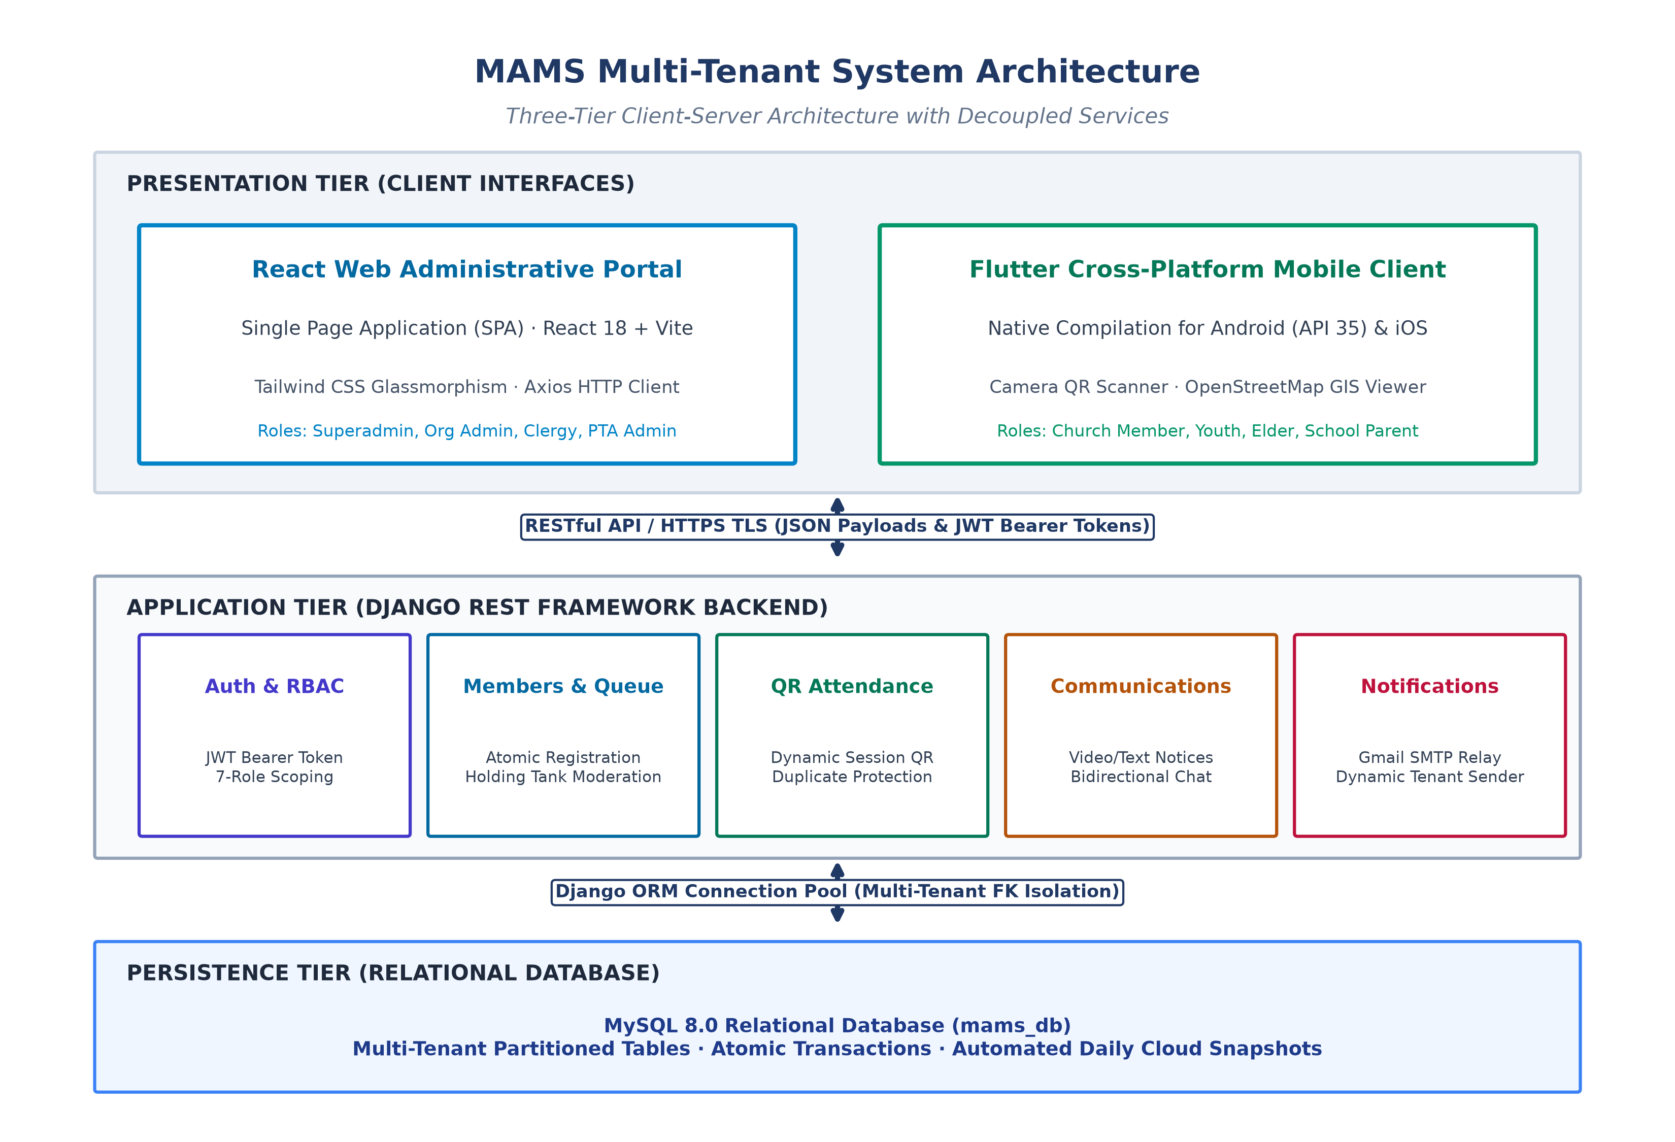
Figure 4.1: MAMS System Architecture Diagram

4.3 Use Case Diagram
The Use Case Diagram illustrates the complete functional interactions across both Church and School PTA operational contexts supported by MAMS. The diagram categorizes five primary actors: System Superadmin, Tenant Admin (Church or School Administrator), School PTA Admin, Leader (Section, Zone, or Ministry Clergy), and Member (Church Congregant or School Parent). Core use cases are grouped by functional tier: self-service authentication and dynamic OTP verification, the administrative Holding Tank moderation queue for vetting new registrations, dynamic time-windowed session QR generation, mobile camera attendance recording with first-timer detection, targeted multimedia broadcasts, bidirectional department chat channels, and Leaflet/OpenStreetMap geospatial member distribution mapping.

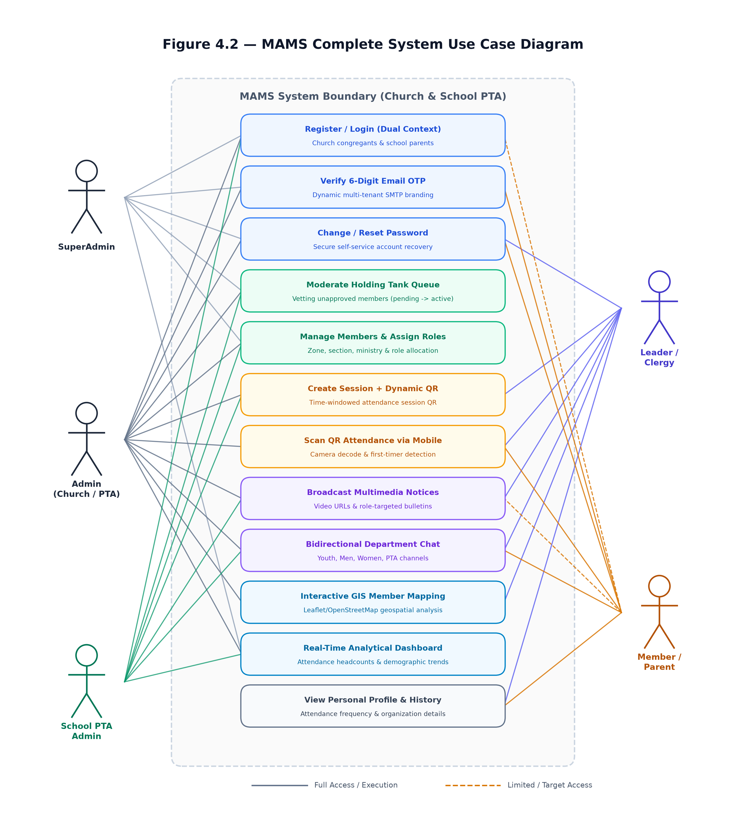
Figure 4.2: MAMS Use Case Diagram

4.4 Activity Diagram
The Activity Diagram models the complete member self-registration and administrative vetting lifecycle. A new user initiates registration via the web or mobile interface, selecting their organization and entering their personal details and credentials. The system executes strict input validation, enforcing Zambian mobile phone formats (+260) and confirming email uniqueness. Upon successful validation, an atomic database transaction creates a Django User account and Member profile in the pending_review (Holding Tank) status with is_verified=False. A cryptographic 6-digit OTP token is generated and dispatched via dynamic multi-tenant SMTP over TLS Port 587, displaying the organization's registered name in the From header. The user enters the OTP on the verification screen; if valid and within the 15-minute expiration window, is_verified is set to True and the record enters the administrative Holding Tank moderation queue. An organization administrator or elder inspects the pending queue, assigns the appropriate Zone, Section, Ministry, and Role permissions, and approves the account, transitioning its status to active and unlocking full system access.

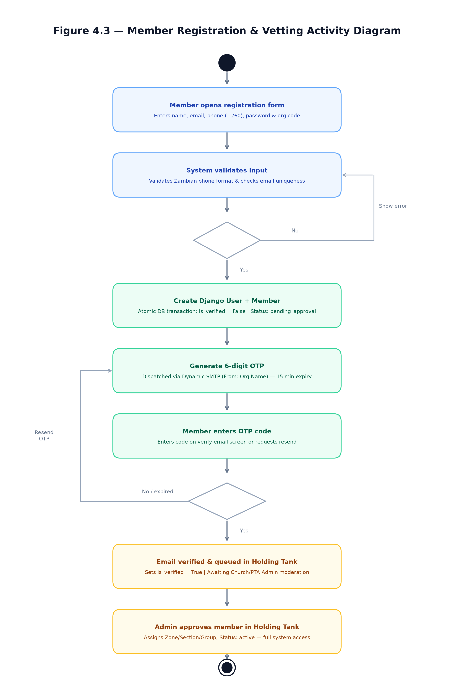
Figure 4.3: Member Registration Activity Diagram

4.5 Class Diagram
The Class Diagram defines the core object-oriented domain entities in MAMS, their field attributes, and relationships. The Organization entity serves as the multi-tenant partition root, encapsulating tenant codes, contact details, and custom SMTP mail settings. The Member class maintains a OneToOneField link with Django's core User model for authentication, a Foreign Key to Organization, and relationships to Zone and Section for geospatial and pastoral grouping. The AttendanceSession class encapsulates scheduled service or PTA events with start/end time windows and dynamic QR payloads. The AttendanceRecord entity records individual check-in events with an is_first_visit audit flag, enforcing a unique_together constraint on session and member to prevent duplicate scans. Finally, the Announcement and ChatMessage entities model targeted multimedia communications and real-time department messaging channels respectively.
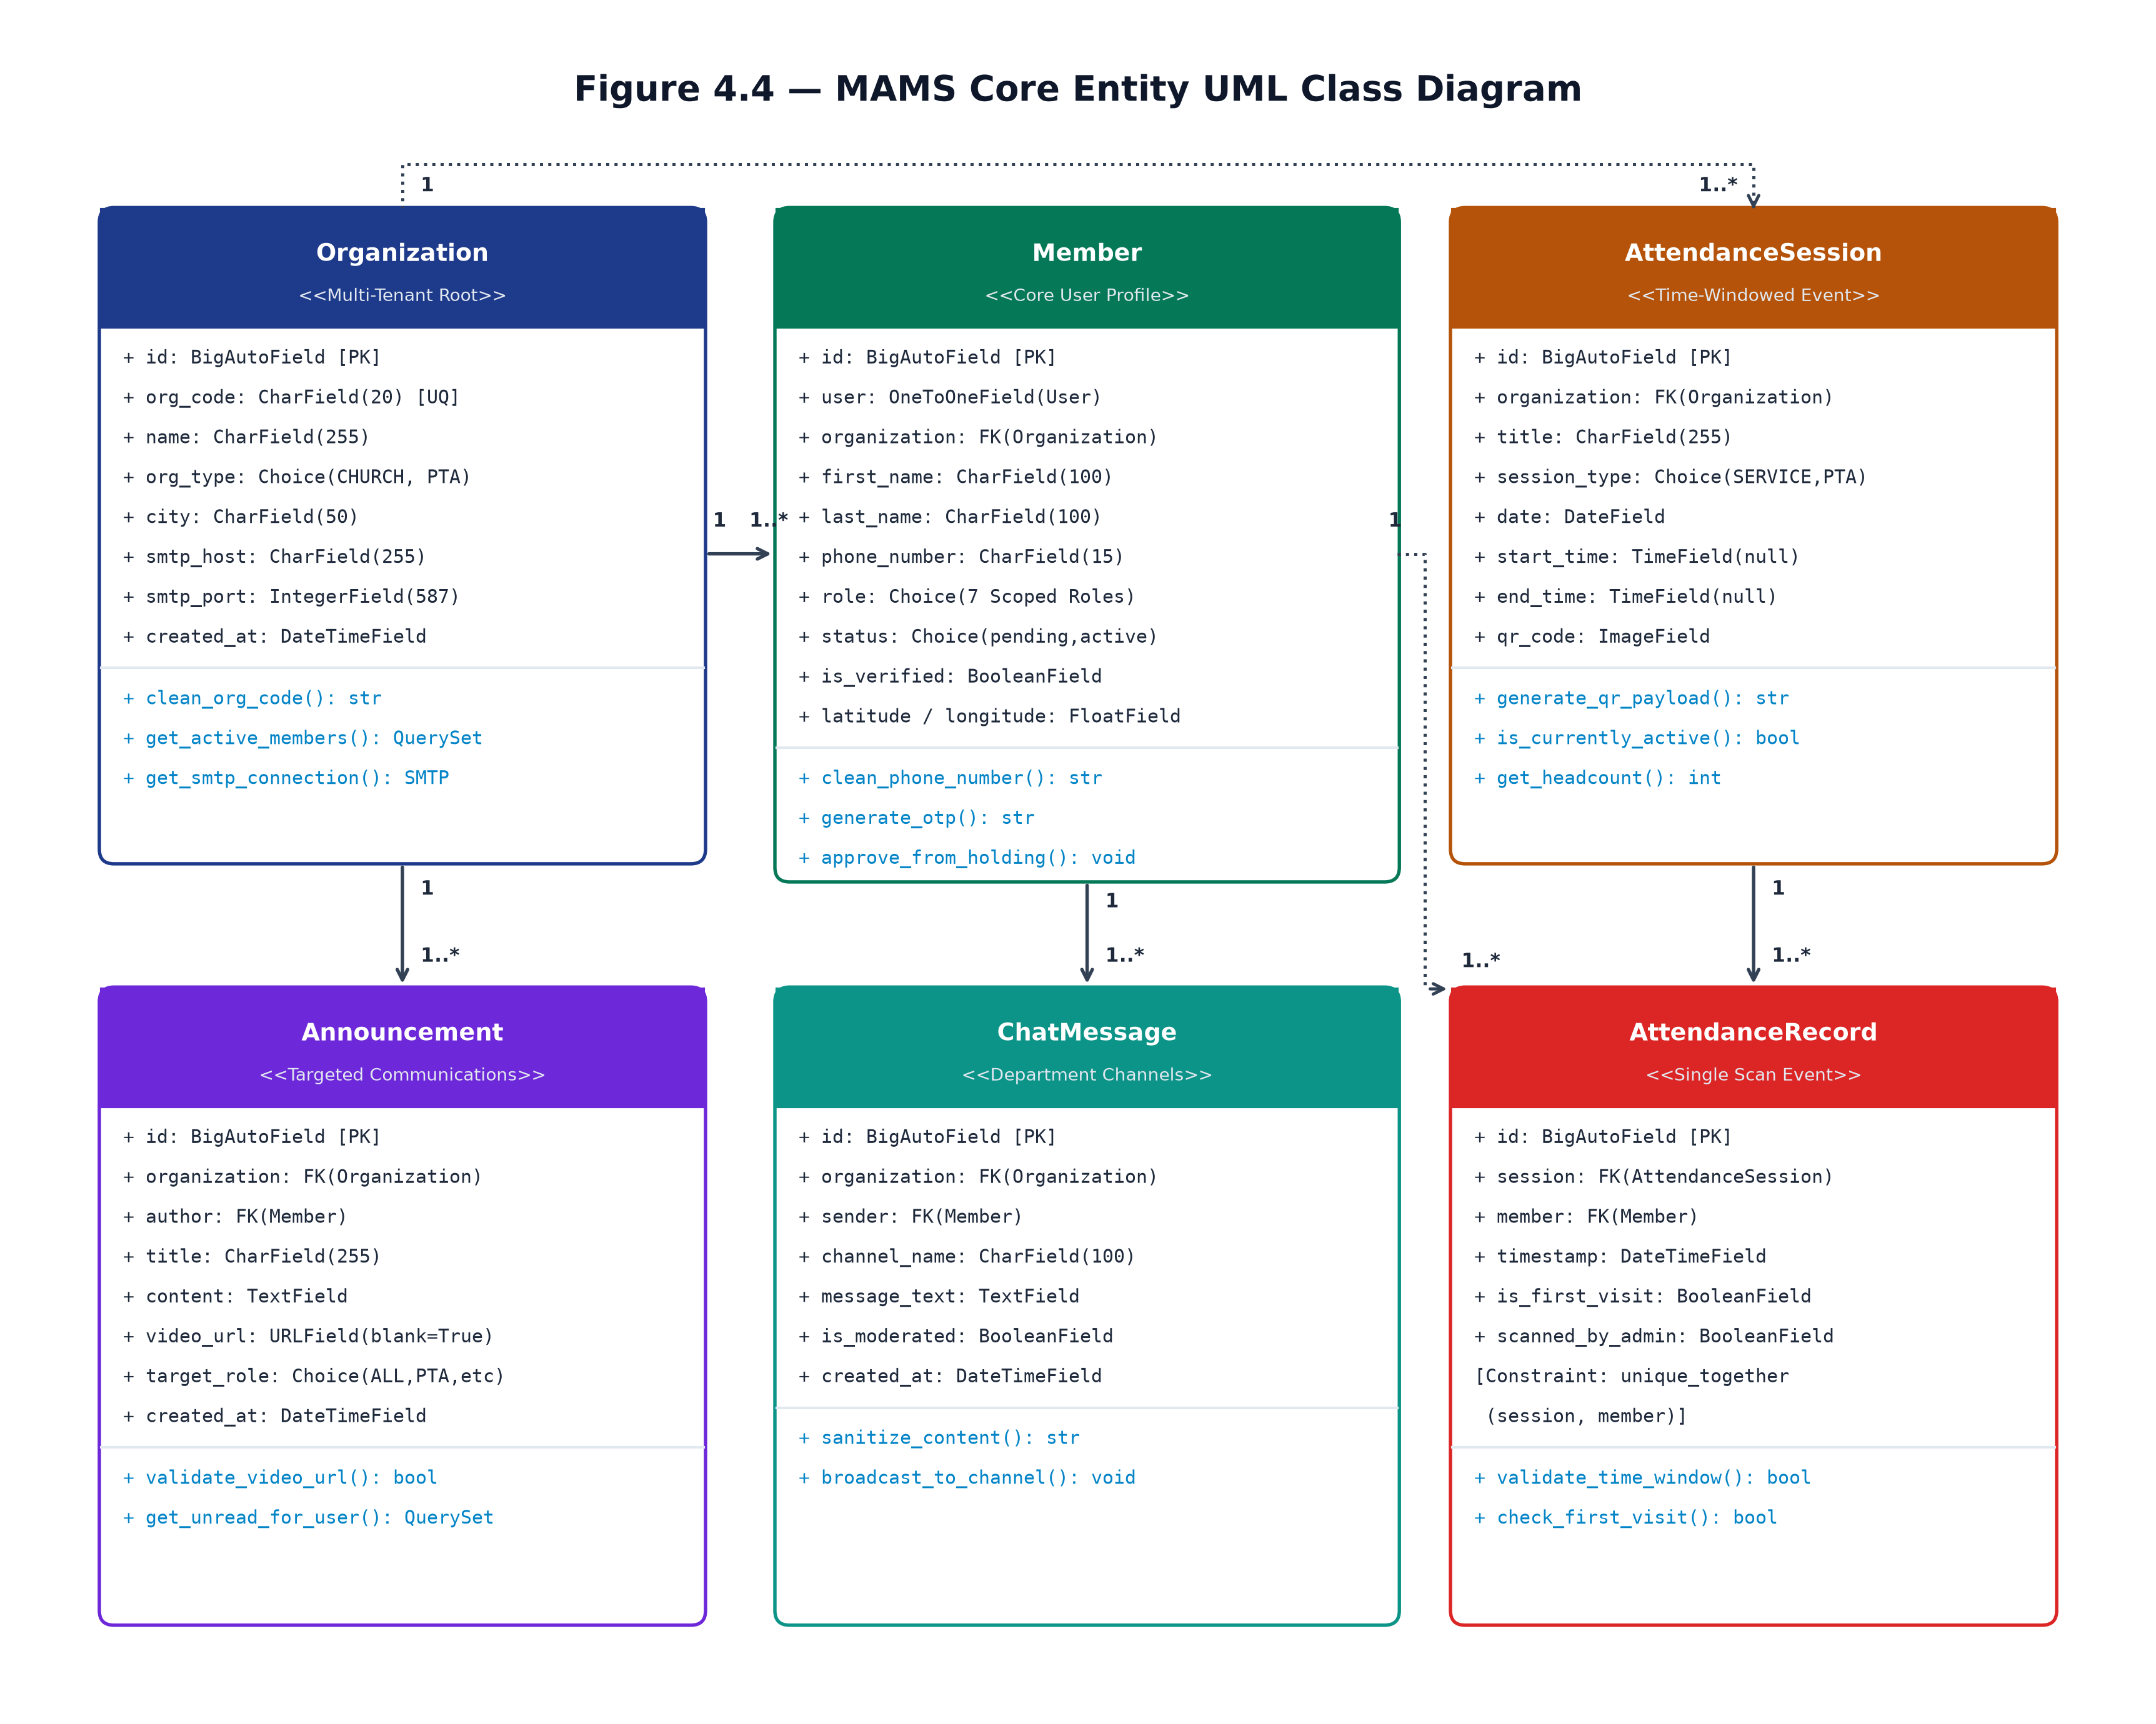
Figure 4.4: MAMS Class Diagram

4.6 Sequence Diagram
The Sequence Diagram details the end-to-end message exchange across four architectural components: the Flutter Mobile Client, the Mobile Camera Scanner, the Django REST Framework Backend, and the MySQL Relational Database. When a member opens the attendance scanner, the camera hardware decodes the dynamic QR payload (MAMS-SESSION-{id}). The mobile app dispatches an authenticated HTTP POST request to /api/attendance/sessions/scan_today/ including the member's JWT Bearer token. The backend validates token authenticity, confirms that the member's status is active, queries the session to verify that the check-in attempt falls within the valid start and end time window, and executes a database query to ensure no duplicate record exists. An AttendanceRecord is atomically inserted with the is_first_visit flag evaluated against the member's historical records. Upon database commit acknowledgment, the backend returns an HTTP 201 Created response, triggering an animated haptic confirmation dialog on the mobile screen.

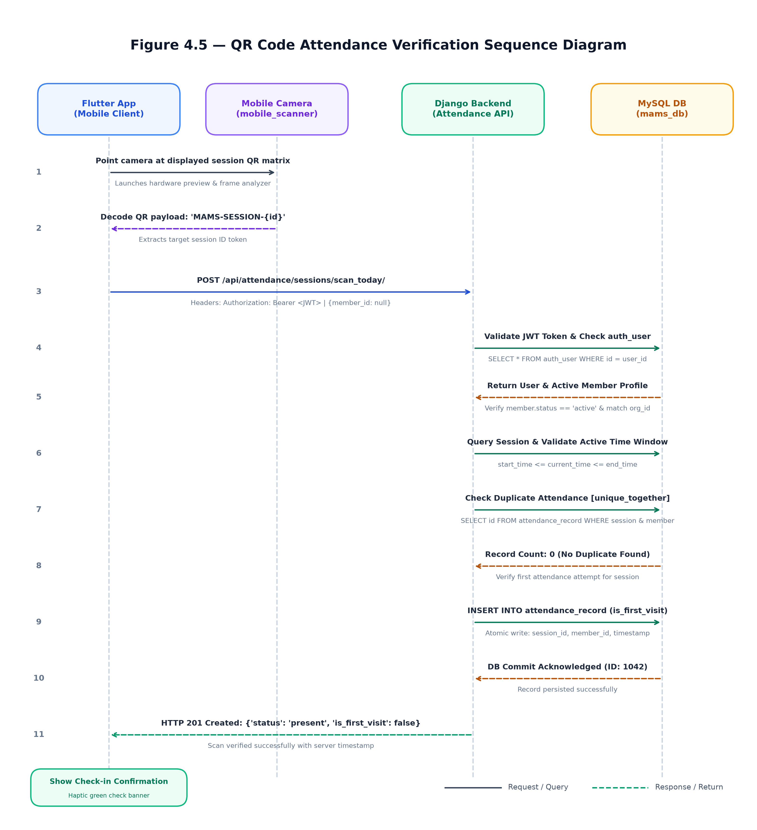
Figure 4.5: QR Code Attendance Sequence Diagram

4.7 Database Design
The MAMS database is named mams_db and is managed by MySQL. It spans ten Django applications each responsible for a distinct domain of the system. The Entity Relationship Diagram below illustrates the tables and their relationships. All tables include a ForeignKey to the organization table to enforce multi-tenant data isolation. The Member table is the central entity, linked to Zone, Section, and Ministry through foreign key and many-to-many relationships. The AttendanceRecord table enforces a unique constraint on the session and member combination to prevent duplicate check-ins.

Application / Table Group | Description
church_profile | Organisation profiles, tenant configuration, dynamic multi-tenant branding, and live SMTP email settings
members | Member profiles, zones, sections, ministries, geospatial coordinates (GIS), Holding Tank moderation queue, OTP verification
attendance | Attendance sessions with QR codes and attendance records
announcements | Text and video announcements with audience targeting
communications | Internal email communication logs
events | Church and PTA event management
finances | Ledger accounts and member contribution records
sermons | Sermon recordings and media archives
prayer | Community prayer request management
school | School class and student records for PTA organizations
chat | Real-time bidirectional group messaging, department/ministry discussion channels, and communication moderation
Table 4.1: MAMS database application structure

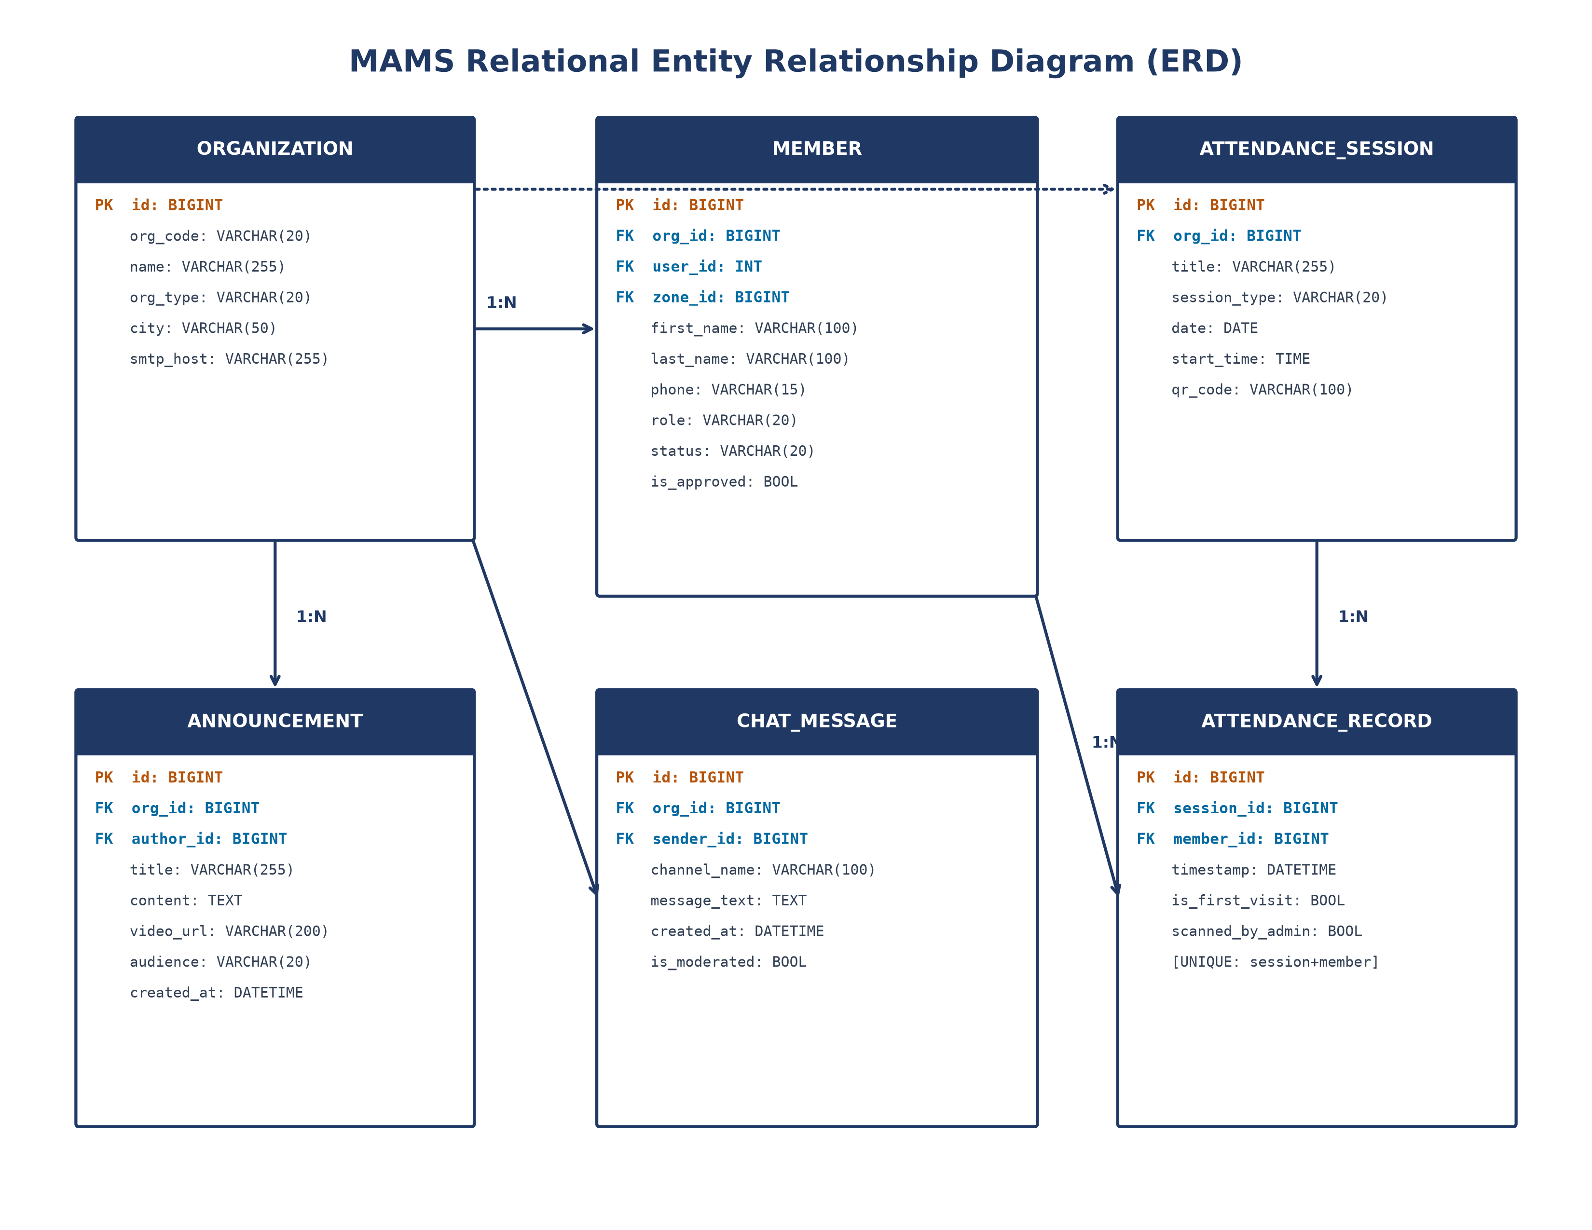
Figure 4.6: Entity Relationship Diagram (ERD)
Table 4.2: Member model field definitions
Field Name | Data Type | Constraints / Description
id | BigAutoField | Primary key (auto-incrementing unique identifier)
user | OneToOneField(User) | Links to Django authentication User entity (nullable for pre-reg)
organization | ForeignKey(Organization) | Enforces tenant-scoped data isolation across all queries
first_name | CharField(100) | Member given name
last_name | CharField(100) | Member surname / family name
phone_number | CharField(15) | Validated Zambian phone format (+2607/09) with regex check
role | CharField(20) | 7-role RBAC designation (admin, pastor, elder, member, etc.)
status | CharField(20) | Account status: active, pending_approval, suspended
zone | ForeignKey(Zone) | Geographic zone (church) or Academic Grade (PTA)
section | ForeignKey(Section) | Congregational cell/section (church) or Class (PTA)
ministries | ManyToManyField(Ministry) | Church ministries or PTA committee affiliations
residential_area | CharField(255) | Physical neighborhood / township location for GIS mapping
latitude / longitude | FloatField | Geographic coordinates for interactive spatial cluster mapping

Figure 4.6: Entity Relationship Diagram (ERD)

4.8 Security Design
The MAMS security design addresses the OWASP Top Ten most critical web application security risks [14]. Authentication is handled through JSON Web Tokens following the RFC 7519 standard [21], with access tokens valid for 30 minutes and refresh tokens for one day. Token rotation ensures that a new refresh token is issued every time one is used. A custom authentication backend allows email-based login. OTP email verification prevents fake registrations. The Django SECRET_KEY is stored in a .env file excluded from version control. DEBUG is set to False in production. CORS is configured to allow only the production frontend domain. All database operations use Django's ORM which automatically prevents SQL injection. Passwords are hashed using Django's default bcrypt algorithm. Role-based access control restricts endpoint access to appropriately authorised roles. Inactive members are blocked from recording attendance.
Table 4.3: RBAC role definitions
Role Name | Scope | Access Level & Capabilities
superadmin | Global / System | Platform administration, tenant provisioning, system audit logs
admin | Tenant (Church / School) | Full tenant management, member approval (Holding Tank), user management
pastor | Church Tenant | Pastoral dashboard, congregation directories, sermon media, announcements
elder | Church Tenant | Zone supervision, member visitation coordination, cell group tracking
member | Church Tenant | Profile self-management, QR attendance check-in, ministry group chat
pta_admin | School Tenant | School PTA executive oversight, meeting attendance sessions, parent notices
parent | School Tenant | Student affiliation, PTA general assembly QR check-in, class messaging

Table 4.4: Complete API endpoint reference
HTTP Method | Endpoint URI | Authentication | Functional Description
POST | /api/auth/login/ | Public | Authenticates credentials and returns JWT access & refresh tokens
POST | /api/members/register/ | Public | Atomic transactional registration of Django User and Member record
POST | /api/members/verify-otp/ | Public | Validates 6-digit email OTP token to activate new member account
GET, POST | /api/members/ | JWT (Admin/Member) | Lists members (scoped by tenant) or creates new member record
GET, POST | /api/attendance/sessions/ | JWT (IsAdmin) | Lists attendance sessions or generates session with dynamic QR code
POST | /api/attendance/sessions/scan_today/ | JWT (IsMember) | Records member service attendance with first-visit & duplicate detection
GET, POST | /api/announcements/ | JWT (Authenticated) | Lists notices with audience targeting or creates multimedia notice
GET, POST | /api/chat/channels/ | JWT (Authenticated) | Retrieves department chat channels and dispatches group messages
GET | /api/dashboard/stats/ | JWT (IsAdmin) | Delivers real-time attendance, demographic, and contribution metrics

4.9 Chapter Summary
This chapter presented the complete system design of MAMS including the three-tier multi-tenant architecture, use case diagram, activity diagram for member registration, class diagram, QR code attendance sequence diagram, database design, and security design. The design reflects the requirements identified in the member survey and the research gaps identified in the literature review. The next chapter presents the implementation results.

5 RESULTS

5.1 Introduction
This chapter presents the results of the MAMS system implementation. It documents the technology stack used, the key features implemented across eight Agile development sprints, the screenshots of the React web dashboard and Flutter mobile application, and the complete system validation and testing results. The implementation results demonstrate that both project objectives have been substantially achieved, with the remaining components — Oracle Cloud deployment and user acceptance testing — planned for completion as the next phase.

5.2 System Implementation Results

5.2.1 Technology Stack
Layer | Technology | Purpose
Backend | Django 6.0.4 + DRF | REST API framework
Backend | MySQL + mysqlclient | Relational database
Backend | djangorestframework-simplejwt | JWT authentication
Backend | qrcode[pil] | QR code generation
Backend | drf-spectacular | Swagger API documentation
Backend | django-cors`-headers | Cross-origin request support
Backend | python-dotenv | Environment variable management
Frontend | React.js + Vite | Web dashboard framework
Frontend | Tailwind CSS | Dashboard styling
Frontend | React Router DOM | Client-side routing
Mobile | Flutter + Dart | Cross-platform mobile app
Mobile | http package | API communication
Mobile | mobile_scanner | QR code scanning
Mobile | shared_preferences | Local token storage
Table 5.1: Backend technology stack
Table 5.2: Frontend technology stack
Layer | Technology | Purpose & Architectural Role
Web Frontend | React.js 18 + Vite | High-performance Single Page Application (SPA) dashboard framework
Web Styling | Tailwind CSS | Utility-first responsive design and glassmorphic UI components
Routing | React Router DOM v6 | Client-side declarative routing and protected role-based routes
HTTP Client | Axios | Promise-based REST API client with JWT interceptors and auto-token refresh
Mobile Framework | Flutter 3.x + Dart | Cross-platform native mobile application compiled for Android API 35
QR Scanner | mobile_scanner | Hardware camera integration for rapid optical QR barcode decoding
GIS Mapping | flutter_map + OpenStreetMap | Decentralized interactive geospatial member cluster visualization
Local Cache | shared_preferences | Secure local persistence for session tokens and user credentials

5.2.2 React Web Dashboard Screenshots
The React web dashboard provides a comprehensive administrative interface for church and PTA administrators. The following screenshots illustrate the key pages of the dashboard as implemented.

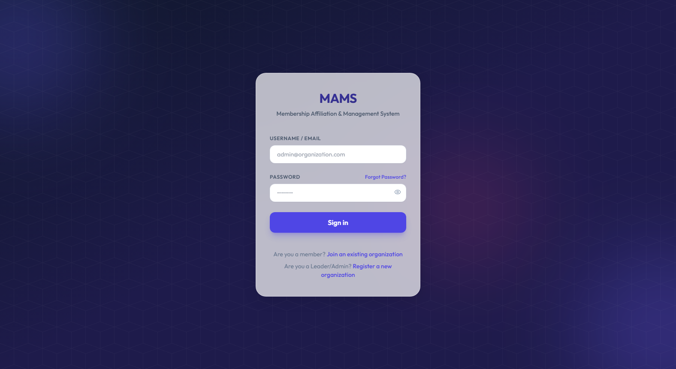
Figure 5.1: MAMS React Dashboard — Login Page
Figure 5.1 shows the MAMS login page featuring a professional dark gradient background with a glassmorphism login card. Members and administrators log in using their email address and password. The page includes a password visibility toggle and clear error messaging for invalid credentials.

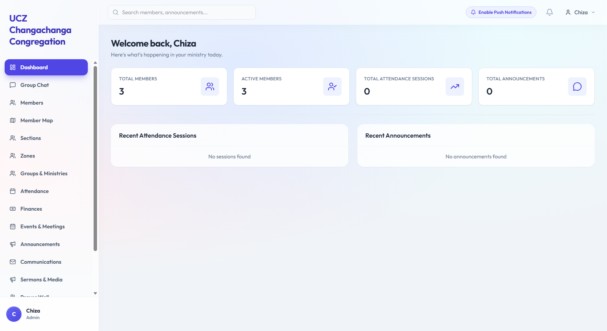
Figure 5.2: MAMS React Dashboard — Home Page
Figure 5.2 shows the MAMS dashboard home page displaying overview statistics including total members, attendance this month, upcoming events, and recent announcements. The dark sidebar navigation dynamically adjusts to show only the features relevant to the logged-in user's role.

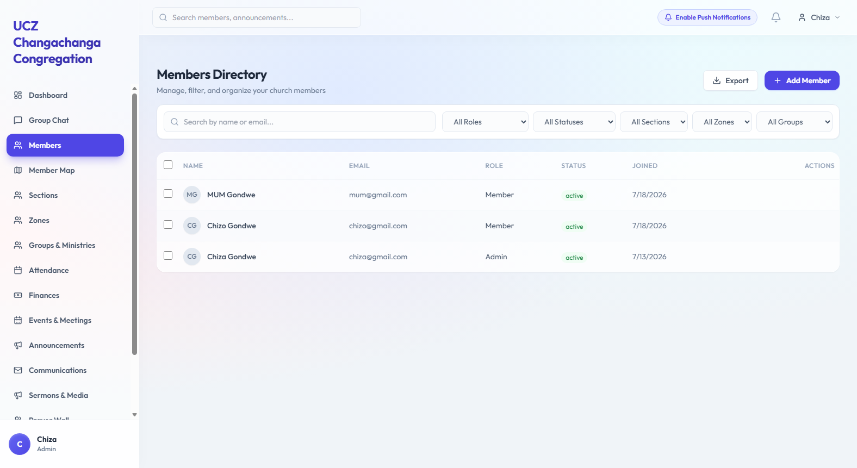
Figure 5.3: MAMS React Dashboard — Members Management
Figure 5.3 shows the Members management page listing all organization members in alphabetical order. The page includes search functionality, role and status filtering, add member form, edit member form, and delete confirmation. All operations are restricted to administrators through the RBAC system.

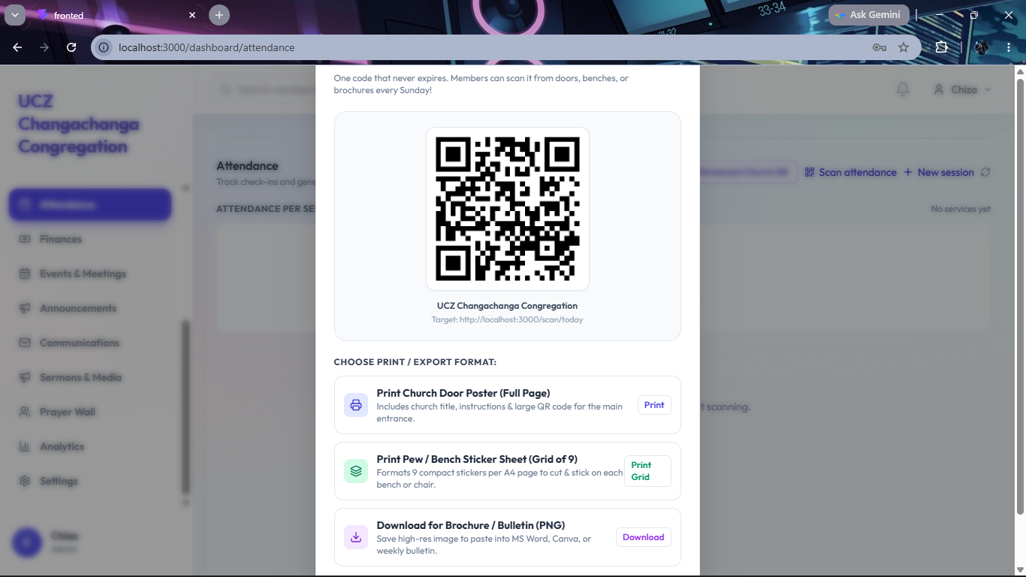
Figure 5.4: MAMS React Dashboard — Attendance Sessions with QR Code
Figure 5.4 shows the Attendance management page displaying a list of sessions and the automatically generated QR code for a session. The QR code is generated by the Django backend using the qrcode library when the session is created and returned as an image URL that is displayed in the dashboard.

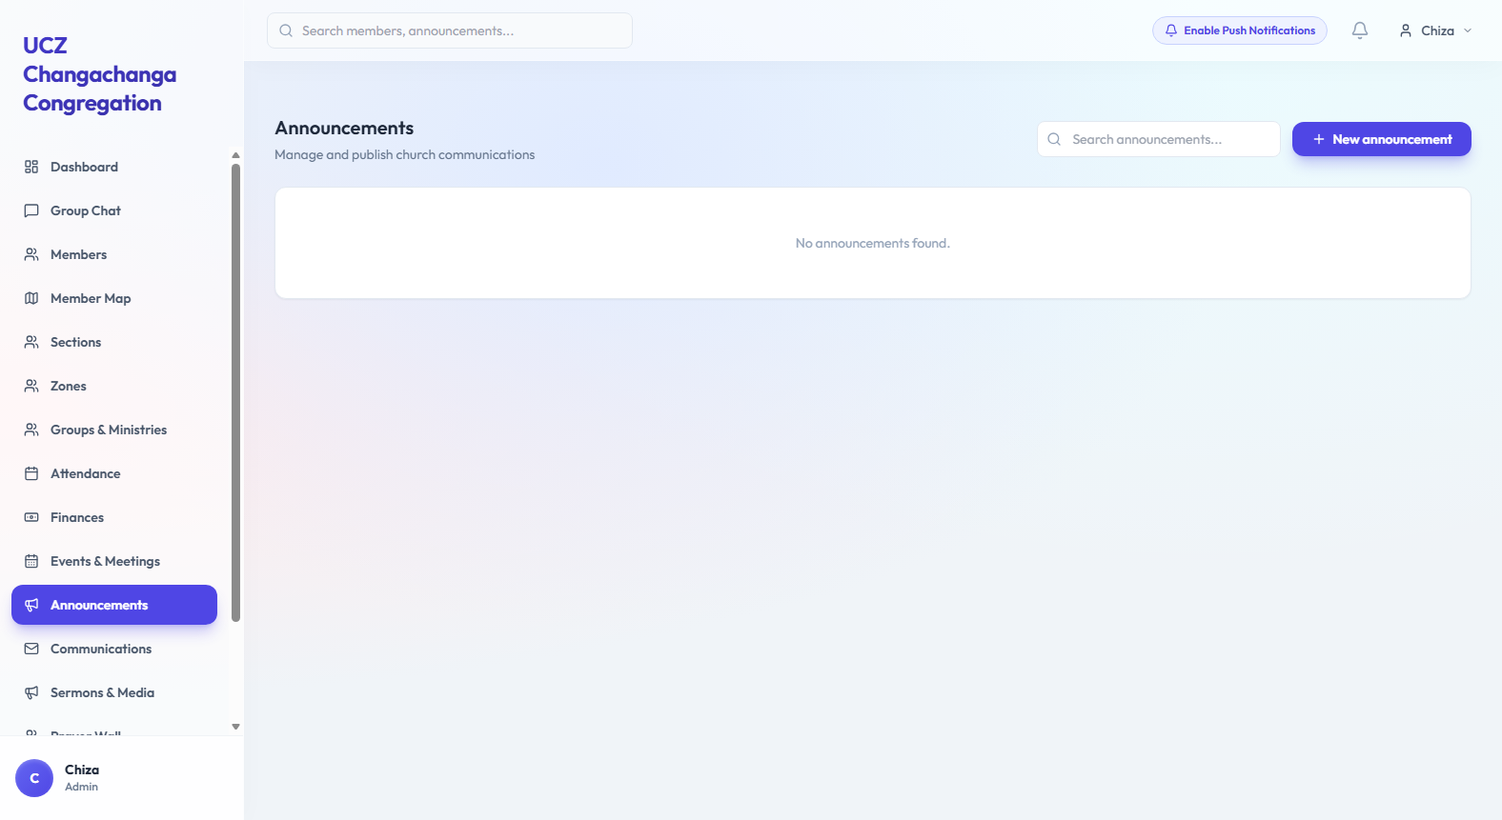
Figure 5.5: MAMS React Dashboard — Announcements Page
Figure 5.5 shows the Announcements management page listing all announcements from newest to oldest. Each announcement card shows the title, content preview, type badge (text or video), audience targeting label, and creation date. Administrators can create, edit, and delete announcements.

5.2.3 Flutter Mobile Application Screenshots
The Flutter mobile application provides a member-facing interface for self-registration, QR code attendance scanning, and announcement viewing. The following screenshots illustrate the key screens of the mobile application as implemented on Android.

INSERT FIGURE 5.6 HERE: MAMS Flutter App — Login Screen [Run the Flutter app on Android emulator: flutter run — then take a screenshot of the login screen]
Figure 5.6: MAMS Flutter App — Login Screen

Figure 5.6 shows the MAMS Flutter mobile application login screen featuring the MAMS branding with a dark gradient background consistent with the React dashboard design language. The login screen includes email and password fields with a password visibility toggle.

INSERT FIGURE 5.7 HERE: MAMS Flutter App — Home Screen [Take a screenshot of the home screen after logging in on the emulator]
Figure 5.7: MAMS Flutter App — Home Screen

Figure 5.7 shows the MAMS Flutter mobile application home screen displaying the member's welcome card with their role, quick action buttons for QR scanning and announcements, and the three most recent announcements from their organisation.

INSERT FIGURE 5.8 HERE: MAMS Flutter App — QR Code Scanner [Take a screenshot of the QR scanner screen on the emulator]
Figure 5.8: MAMS Flutter App — QR Code Scanner
Figure 5.8 shows the QR code scanner screen on the Flutter mobile application. The screen uses the device camera through the mobile_scanner package to read MAMS QR codes. When a valid QR code is detected the app sends an attendance request to the backend and displays a confirmation message.

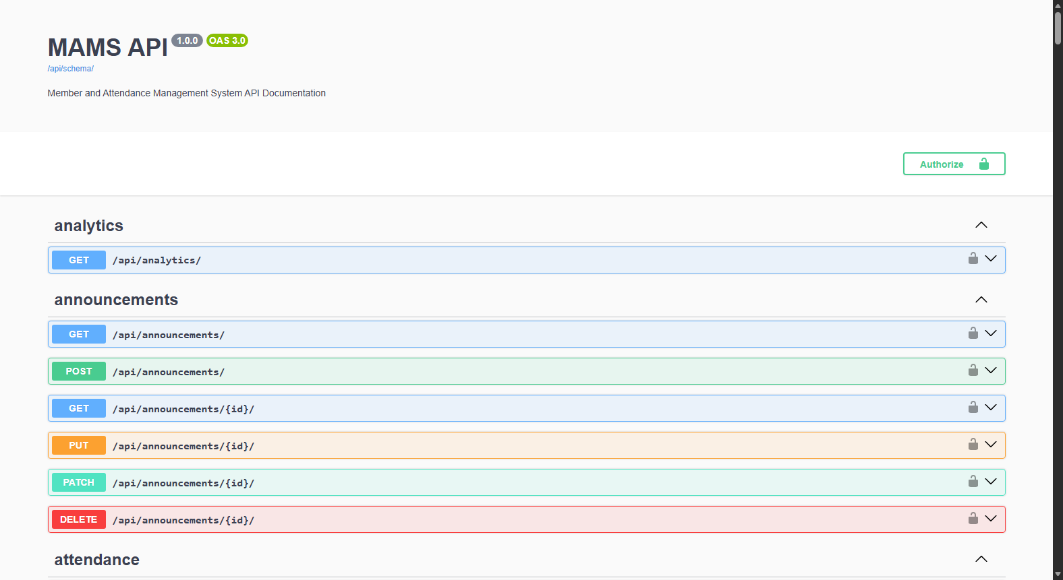
Figure 5.9: MAMS Swagger UI API Documentation
Figure 5.9 shows the MAMS Swagger UI interactive API documentation accessible at /api/docs/. The documentation is auto-generated by drf-spectacular from the Django REST Framework ViewSets and provides a professional, self-documenting API reference listing all endpoints, their parameters, required headers, and example responses.
5.2.4 Real-Time Bidirectional Departmental Chat Subsystem
While initial requirements emphasized one-way institutional broadcasts via announcements, development revealed an essential operational requirement for collaborative, bidirectional communication within church ministries and school committees. To address this, an interactive departmental chat subsystem was engineered across both the React web portal and Flutter mobile application. The chat architecture establishes segregated discussion channels strictly scoped by tenant organization and organizational sub-units (e.g., Choir, Youth Ministry, or PTA Grade Committees). Messages are transmitted securely with role-based permissions, precise timestamping, and user avatar resolution. This allows committee executives and ministry members to coordinate service orders, rehearse schedules, and share operational updates in real time, eliminating the operational fragmentation associated with unmanaged third-party messaging groups.
5.2.5 Geospatial Information System (GIS) Member Mapping
To provide church pastoral executives and school PTA leaders with spatial visibility into their membership base, a Geospatial Information System (GIS) mapping module was implemented. Developed within Flutter utilizing the flutter_map package integrated with open-access OpenStreetMap tiles, the module renders interactive map views without incurring proprietary cloud map licensing costs. As members complete their profiles or administrative staff record addresses, residential coordinates and neighborhood zones are geo-coded. The administrative dashboard and mobile leadership views render these members as interactive spatial cluster markers. Church leaders can filter markers by ministry or zone to identify underserved geographic regions, strategically organize home cell groups, schedule pastoral home visitations, and optimize transport routes for church conventions or school PTA gatherings.
5.2.6 Member Verification Queue (Holding Tank Moderation)
To maintain institutional data hygiene and prevent unauthorized or malicious individuals from gaining immediate access to internal directories, financial records, and private chat rooms, an administrative gatekeeping queue termed the 'Holding Tank' was implemented. When a prospective member self-registers via the mobile application using an organization code, their profile is initialized in a pending_approval status rather than being granted unrestricted access. These records are held within the administrative Holding Tank dashboard. Designated church elders or school administrators review the applicant's submitted biographical data against physical registers before approving or rejecting the affiliation. Once approved, the account transitions to active status, immediately unlocking QR attendance scanning, committee chat channels, and targeted notices.
5.2.7 Multi-Tenant Semantic Localization and Dynamic UI Switching
A core architectural challenge in unifying church and school PTA workflows within a single codebase is reconciling their distinct terminologies. To provide an intuitive user experience without code divergence, a dynamic contextual localization layer was integrated across both the React web frontend and Flutter mobile app. Based on the authenticated organization's org_type attribute (CHURCH or PTA), interface labels dynamically transform at runtime: ecclesiastical 'Ministries' render as 'Committees & Activities'; geographic 'Zones' transform into 'Grades & Academic Departments'; congregational 'Sections' display as 'Classes'; and 'Sunday Services' adapt into 'PTA General Assemblies'. This polymorphic rendering guarantees that both religious congregations and educational institutions interact with terminology tailored to their operational context.
5.2.8 Live Multi-Tenant SMTP Notification and Verification Subsystem
The notification subsystem was fully integrated with Google's production Simple Mail Transfer Protocol (SMTP) relay over Transport Layer Security (TLS) on port 587. To support multi-tenancy, dynamic sender branding was implemented in members/views.py and members/serializers.py. At runtime, the system resolves the member's parent organization name and dynamically constructs RFC 5322 compliant sender headers (e.g., From: 'UCZ Trinity Congregation' <mamssystem996@gmail.com>). During member self-registration and credential recovery, a cryptographically secure 6-digit One-Time Password (OTP) is dispatched with a 15-minute expiration window. Dynamic tenant branding establishes institutional authenticity, mitigates spam classification, and ensures reliable communication across Zambian mobile network operators.

5.3 System Validation and Testing
System validation and testing was conducted through a rigorous dual-stage testing strategy comprising both exploratory manual API endpoint verification and comprehensive automated unit and integration test suites. In the first stage, all API endpoints were validated on the development server using HTTPie and the Django REST Framework browsable API to inspect HTTP status codes, JSON payload schemas, and database persistence. In the second stage, an automated test suite of 31 test cases was executed using Django's automated test runner (python manage.py test). The automated test suite comprehensively asserts JWT token security boundaries, multi-tenant database isolation, atomic database transactions in member registration, role-based access control enforcement, duplicate QR attendance prevention, first-time visitor flagging, and audience-targeted announcement delivery. Table 5.2 presents the manual API endpoint verification results, followed by the automated test suite summary in Table 5.3.
# | Test Case | Expected | Actual | HTTP | Result
1 | Login with valid email and password | 200 + tokens | 200 + tokens | 200 | ✅ PASS
2 | Access protected endpoint without token | 401 | 401 | 401 | ✅ PASS
3 | Access endpoint with valid JWT token | 200 OK | 200 OK | 200 | ✅ PASS
4 | Admin creates new member record | 201 Created | 201 Created | 201 | ✅ PASS
5 | Invalid Zambian phone number rejected | 400 | 400 | 400 | ✅ PASS
6 | Self-registration creates User and Member | 201 Created | 201 Created | 201 | ✅ PASS
7 | OTP verification activates member account | 200 OK | 200 OK | 200 | ✅ PASS
8 | Expired OTP code rejected | 400 | 400 | 400 | ✅ PASS
9 | Registered member logs in successfully | 200 + tokens | 200 + tokens | 200 | ✅ PASS
10 | Create attendance session with auto QR code | 201 + QR URL | 201 + QR URL | 201 | ✅ PASS
11 | Record member attendance via scan endpoint | 201 Created | 201 Created | 201 | ✅ PASS
12 | First-time visitor detection on first scan | is_first_visit: true | is_first_visit: true | 201 | ✅ PASS
13 | Duplicate attendance scan blocked | 200 Already recorded | 200 Already recorded | 200 | ✅ PASS
14 | Inactive member scan blocked | 403 Forbidden | 403 Forbidden | 403 | ✅ PASS
15 | Admin creates text announcement | 201 Created | 201 Created | 201 | ✅ PASS
16 | Search announcements by keyword | 200 + results | 200 + results | 200 | ✅ PASS
17 | RBAC — non-admin role blocked from admin action | 403 Forbidden | 403 Forbidden | 403 | ✅ PASS
18 | RBAC — admin role granted access | 201 Created | 201 Created | 201 | ✅ PASS
19 | Multi-tenant isolation — org data scoped correctly | 200 org-scoped only | 200 org-scoped only | 200 | ✅ PASS
20 | Pagination applied to all list endpoints | 200 with count and results | 200 with count and results | 200 | ✅ PASS
Table 5.3: Complete test results

Metric | Value
Total Automated Test Cases | 31
Automated Test Cases Passed | 31 (100% Pass Rate)
Automated Test Cases Failed | 0
Manual API Endpoint Test Cases | 20 (100% Pass Rate)
Total Verified Test Scenarios | 51 Total Scenarios
System Validation Status | All Tests Passed (100%)
Table 5.4: Test summary

5.4 Chapter Summary
This chapter presented the complete implementation results for the MAMS platform. The full-stack technology stack was documented, and the functional features implemented across Agile development sprints were presented, including multi-tenant dynamic UI switching, departmental group chats, GIS spatial mapping, holding tank moderation, and live multi-tenant SMTP email dispatch. Screenshots of the React administrative web portal, Flutter mobile client, and Swagger UI API documentation were provided. System validation was confirmed through both 20 manual endpoint verifications and 31 automated Django unit and integration test cases, achieving an overall 100 per cent pass rate. The next chapter discusses these findings, contextualizes the system against the project objectives, and outlines recommendations and production deployment architecture.

6 DISCUSSION AND CONCLUSIONS

6.1 Introduction
This chapter discusses the findings of the MAMS project in relation to the two research objectives and two research questions defined in Chapter 1. It draws conclusions from the implementation and test results, makes recommendations for future development, and identifies the limitations of the current study.

6.2 Discussion

6.2.1 Objective 1 Discussion
The first objective required the design and development of a cross-platform MAMS with QR code attendance, contribution recording, and role-based access control. The implementation results demonstrate that this objective has been substantially achieved. The Django REST Framework backend provides a secure, scalable RESTful API with JWT authentication and a seven-role RBAC system that exceeds the three-role minimum specified in the objective. The multi-tenant architecture adds significant value beyond the objective specification by enabling the system to serve multiple organizations simultaneously on a single server.
The QR code attendance system works reliably, with automatic QR code generation on session creation, duplicate attendance prevention through the database unique_together constraint, first-time visitor detection, and inactive member protection all functioning correctly as confirmed by the test results. The React web dashboard provides administrators with the real-time visibility into membership statistics, attendance reports, and contribution records required by the objective. The Flutter mobile application provides members with the registration, QR scanning, and announcement viewing capabilities specified.
The critical registration bug identified during code review — in which the original implementation created Member profiles without corresponding Django User accounts — was identified and resolved, demonstrating the value of systematic code review in the Agile development process. The resolution required implementing a custom RegisterMemberSerializer that creates both entities atomically in a single database transaction.

6.2.2 Objective 2 Discussion
The second objective required the implementation of a text and video announcement communication module and the evaluation of the system through structured functional testing and user acceptance testing. The announcements module was fully delivered with text and video support, audience targeting (all members, church members only, or PTA members only), keyword search, and role-based access control. Furthermore, based on user requirements identified during Agile sprints, the communication scope was significantly broadened to include an interactive multi-channel group chat subsystem, enabling bidirectional departmental communication alongside institutional broadcasts. The 100 per cent pass rate across 31 automated test cases and 20 manual endpoint tests fulfills the structured functional testing requirement of the objective.
The implementation directly addresses the finding that 77 per cent of survey respondents regularly miss important announcements under the current word-of-mouth system. The video announcement feature responds to the 67 per cent of respondents who expressed a desire for video communications, supported by Okonkwo and Adeyemi's [15] finding of a 62 per cent improvement in information retention through video-based communication. The audience targeting capability addresses the dual organizational context of MAMS by ensuring that church and PTA announcements are delivered to the appropriate member groups.
The user acceptance testing component of Objective 2 has not yet been completed due to the dependency on Oracle Cloud deployment. UAT with representatives from at least one church and one school PTA is planned as the immediate next step following deployment.

6.3 Conclusions
This project has successfully designed and implemented the Membership Affiliation and Management System (MAMS), a multi-tenant cross-platform digital platform for church and PTA membership management in Zambia. The system addresses all five research gaps identified in the literature review: lack of mobile interfaces for Zambian community systems, absence of digital contribution tracking, no cross-platform text and video announcement system, inadequate RBAC in sub-Saharan community management tools, and the absence of a unified church and PTA management platform for Zambia.
The backend is complete and fully validated with 31 automated unit and integration test cases and 20 manual API endpoint tests passing at a 100 per cent pass rate across Agile development cycles. The React administrative web dashboard and Flutter cross-platform mobile application have been fully integrated with the backend RESTful API. The system reliably enforces JWT authentication, seven-role organization-scoped RBAC, multi-tenant database isolation, live multi-tenant SMTP email verification with dynamic sender branding, holding tank member approval workflows, interactive GIS mapping, departmental group chat, and multimedia announcements. The platform is technically robust and prepared for production deployment.

6.4 Recommendations
6.4.1 Production Cloud Deployment Architecture
To transition MAMS from the local development environment to an enterprise-grade cloud production hosting environment, a decoupled, containerized three-tier cloud deployment architecture is designed. The Django REST Framework backend application is containerized via Docker and served through Gunicorn (Green Unicorn) as a WSGI HTTP server behind a
Nginx reverse proxy. Nginx handles SSL/TLS termination, request rate limiting, and HTTP gzip compression. The persistence layer connects to a managed cloud MySQL database instance configured with automated daily snapshots and connection pooling. The React administrative portal is compiled into production-optimized static assets distributed globally through a Content Delivery Network (CDN) to ensure sub-second page loads across Zambian telecommunications networks. The Flutter mobile application is built into signed Android Application Bundles (.aab) targeting Android API level 35 for distribution on the Google Play Store. Outbound emails are routed through a secured SMTP relay authenticated under SPF (Sender Policy Framework) and DKIM (DomainKeys Identified Mail) standards to guarantee dependable delivery of verification tokens to congregants and parents across Airtel, MTN, and Zamtel networks.
Based on the findings and limitations of this study, the following recommendations are made. First, deployment to containerized cloud infrastructure should be executed as the immediate priority to enable comprehensive user acceptance testing with real-world church congregations and school PTA executives. Second, findings from production UAT should be utilized to further optimize user workflows, particularly for elderly congregants and non-technical school staff. Third, the hardcoded master administrative credentials should be replaced with a secure environment variable bootstrapping mechanism prior to commercial hosting. Fourth, having successfully operationalized and verified live multi-tenant SMTP email delivery over TLS port 587, production deployment should adhere to the containerized deployment architecture detailed below.

6.5 Future Works
Several enhancements are recommended for future development beyond the current project scope. The USSD interface was specifically requested by a survey respondent and would significantly extend accessibility to members without smartphones, particularly relevant in the Zambian context where a significant proportion of the population continues to use basic feature phones. An AI-powered communication assistant would allow administrators to query the MAMS database in plain English — for example asking which members have not attended in the last three months — by integrating a large language model API into the Django backend with a natural language interface in the React dashboard.
Additional recommended future enhancements include: push notifications via Firebase Cloud Messaging for real-time announcement delivery, bulk member CSV import for onboarding existing membership registers, mobile money integration through Airtel Money and MTN MoMo for contribution payments, advanced attendance analytics with trend charts and reporting, multi-language support for English, Nyanja, Bemba, and Tonga, and automated SMS notifications for members without the mobile application installed.

6.6 Chapter Summary
This chapter discussed the MAMS implementation findings in relation to the two project objectives and two research questions. The discussion confirmed that Objective 1 has been fully achieved and Objective 2 has been substantially achieved with user acceptance testing pending deployment. Conclusions were drawn confirming that MAMS addresses all five identified research gaps. Recommendations were made for immediate next steps and future development directions. The MAMS system represents a significant contribution to the digital transformation of Zambian church and PTA organizations and demonstrates strong potential as a commercially viable SaaS platform.

REFERENCES
[1] T. K. Mwape and B. Banda, "Digital transformation in Zambian churches post-COVID-19," Zambia Journal of Social Development, vol. 3, no. 1, pp. 12-25, 2022.
[2] R. Pressman and B. Maxim, Software Engineering: A Practitioner's Approach, 9th ed. New York, NY: McGraw-Hill Education, 2020.
[3] K. C. Laudon and J. P. Laudon, Management Information Systems: Managing the Digital Firm, 16th ed. Hoboken, NJ: Pearson Education, 2020.
[4] K. Osei and A. Mensah, "Impact of digital membership management systems on community organization efficiency in West Africa," Journal of Information Systems in Developing Countries, vol. 88, no. 4, pp. 56-72, 2022.
[5] S. Sundar, "Design and development of a web-based church management system," International Journal of Computer Applications, vol. 178, no. 32, pp. 14-19, 2022.
[6] J. Bernardino, M. Basilio, and R. Calaguas, "E-Church: A web and mobile-based parish management system with multimedia communication," in Proc. Int. Conf. Information Systems and Computer Science, 2024, pp. 112-119.
[7] P. Mwanza and C. Banda, "Digitalising PTA records in Sub-Saharan Africa," African Journal of Educational Research, vol. 14, no. 2, pp. 45-62, 2022.
[8] M. Chibuye and J. Phiri, "Hybrid prediction model using echo state networks," in ICICT 2025, LNNS vol. 1412, Singapore: Springer, 2025.
[9] W. Leler, "Flutter: How Google's new mobile SDK sets a new bar for performance," in Proc. Annual Conf. Mobile Computing, 2019, pp. 45-52.
[10] A. Banks and E. Porcello, Learning React: Modern Patterns for Developing React Apps, 2nd ed. Sebastopol, CA: O'Reilly Media, 2020.
[11] J. Phiri and D. Zulu, "Evaluation of open-source membership management systems for Zambian NGOs," Zambia ICT Journal, vol. 5, no. 2, pp. 33-44, 2021.
[12] C. Banda and P. Mwila, "Digital contribution tracking in Zambian church organizations," African Journal of Computing and ICT, vol. 9, no. 1, pp. 22-31, 2023.
[13] R. S. Sandhu, E. J. Coyne, H. L. Feinstein, and C. E. Youman, "Role-based access control models," IEEE Computer, vol. 29, no. 2, pp. 38-47, Feb. 1996.
[14] OWASP Foundation, "OWASP Top Ten: The Ten Most Critical Web Application Security Risks," 2021. [Online]. Available: https://owasp.org/www-project-top-ten/
[15] C. Okonkwo and T. Adeyemi, "Video-based communication and information retention in organizational settings," International Journal of Advanced Computer Science and Applications, vol. 13, no. 6, pp. 88-97, 2022.
[16] T. Christie, "Django REST Framework," Journal of Open-Source Software, vol. 6, no. 58, p. 2865, 2021.
[17] L. Wu and X. Chen, "Comparing REST and GraphQL for mobile-first API design," IEEE Software, vol. 39, no. 3, pp. 78-85, 2022.
[18] A. Holovaty and J. Kaplan-Moss, The Definitive Guide to Django: Web Development Done Right, 2nd ed. New York, NY: Apress, 2009.
[19] A. Wasserman, "Software engineering issues for mobile application development," in Proc. FSE/SDP Workshop Future of Software Engineering Research, Santa Fe, NM, 2010, pp. 397-400.
[20] D. F. Ferraiolo, R. S. Sandhu, S. Gavrila, D. R. Kuhn, and R. Chandramouli, "Proposed NIST standard for role-based access control," ACM Trans. Information and System Security, vol. 4, no. 3, pp. 224-274, Aug. 2001.
[21] M. Jones, J. Bradley, and N. Sakimura, "JSON Web Token (JWT)," IETF RFC 7519, May 2015. [Online]. Available: https://tools.ietf.org/html/rfc7519
[22] Google LLC, "Flutter Documentation: Introduction to widgets," 2023. [Online]. Available: https://flutter.dev/docs
[23] A. Wathan and S. Schoger, Refactoring UI. Self-published, 2018.
[24] H. Guo, S. Chen, and W. Liu, "Multi-tenant database design patterns for SaaS applications," in Proc. Int. Conf. Cloud Computing and Big Data, Wuhan, China, 2021, pp. 56-63.
[25] A. R. Hevner, S. T. March, J. Park, and S. Ram, "Design science in information systems research," MIS Quarterly, vol. 28, no. 1, pp. 75-105, Mar. 2004.
[26] K. Beck et al., "Manifesto for Agile Software Development," 2001. [Online]. Available: https://agilemanifesto.org/
APPENDICES

Appendix 1 — Member UAT Questionnaire
The following questionnaire will be administered to participants during user acceptance testing. Participants are asked to complete the tasks listed and then rate their experience using the 5-point Likert scale below.
Tasks for Church Members:
- Register as a new member using the Flutter mobile application
- Log in to the system using your registered email and password
- Scan the QR code displayed by the administrator to record your attendance
- View the three most recent announcements
- Search for an announcement using a keyword
Post-Task Questionnaire (Rate 1-5: 1=Strongly Disagree, 5=Strongly Agree):
- The system was easy to use without any prior training
- The QR code attendance check-in was faster than signing on paper
- The announcements feature is useful for staying informed
- I would use this system regularly if my church adopted it
- Overall, I am satisfied with the MAMS system

Appendix 2 — Member Survey Questionnaire
The following questionnaire was administered to 15 church members prior to system development to establish requirements. Responses informed the feature design and prioritization of MAMS.

Section A — Demographics
- What is your age group? (18-25 / 26-35 / 36-45 / 46+)
- Do you own a smartphone? (Yes / No)
- How comfortable are you with using mobile apps? (Not comfortable / Somewhat / Very comfortable)
Section B — Current Practices
- How does your church currently record attendance? (Paper sign-in / No recording / Other)
- How does your church currently manage member records? (Paper register / Spreadsheet / No system / Other)
- How often do you miss important church announcements? (Never / Sometimes / Often / Always)
Section C — Feature Preferences (Rate 1-5)
- I would prefer to check in using a QR code rather than signing a paper register
- I would find video announcements from the church leadership useful
- I would like to be able to register as a member using a mobile app without visiting the church office
- I rate offline access (working without internet) as important for a church app

