
THE UNIVERSITY OF ZAMBIA
School of Natural and Applied Sciences
Department of Computing and Informatics

MEMBERSHIP AFFILIATION AND MANAGEMENT SYSTEM
(MAMS)
(A CASE OF CHURCH MEMBERSHIP AND SCHOOL PTA)
BY
CHIZA GONDWE
2021446280
Supervised by: Professor Jackson Phiri
Frontend Developer: Rebecca Ongani Phiri

October 2026

COPYRIGHT
All rights reserved. No part of this material may be reproduced, stored in any retrieval system, or transmitted in any form by any means, except in the case of brief quotations embodied in critical reviews and other non-commercial uses permitted by copyright law of the author, Chiza Gondwe, or the University of Zambia in that regard.

DECLARATION
I, Chiza Gondwe, do hereby declare that this report is my own original work and has not been submitted to any other college, institution or university other than the University of Zambia. All sources of information used have been duly acknowledged and referenced.

Name: ........................................................................................
Sign: ..........................................................................................
Date: ..........................................................................................

APPROVAL
This report, by Chiza Gondwe, has been approved as partial fulfilment of the requirements for the award of a Bachelor of Computer Science degree by the University of Zambia.

Student
Name: ........................................................
Signature: ...................................................
Date: .............................................................

Supervisor
Name: ..........................................................
Signature: ...................................................
Date: .............................................................

ACKNOWLEDGEMENTS
This project would not have been possible without the guidance, support, and encouragement of many individuals. My deepest appreciation goes to my supervisor, Professor Jackson Phiri, for his patience, expertise, and constructive feedback throughout the entire development process. His guidance kept me focused and motivated from the initial proposal through to the final implementation.
I would like to extend sincere thanks to my project partner, Rebecca Ongani Phiri, for her dedication to the frontend development of MAMS and her collaborative spirit throughout the project. The quality of the React web dashboard and Flutter mobile application reflects her considerable skill and commitment.
I am grateful to the church members who willingly completed the MAMS member questionnaire. Their candid responses provided the empirical foundation that shaped the system design and feature priorities. Without their participation this project would have lacked its essential connection to real-world needs.
Finally, I thank my family and friends for their unwavering support, encouragement, and patience throughout my studies at the University of Zambia. Their belief in me gave me the strength to see this project through to completion.

DEDICATION
To my parents and family, for their unwavering support, sacrifice, and belief in my potential. This work is as much yours as it is mine.

ABSTRACT
The Membership Affiliation and Management System (MAMS) is a multi-tenant, cross-platform digital membership and attendance management system developed for churches and school Parent Teacher Associations (PTAs) in Zambia. Many local congregations and school associations still rely on paper registers, handwritten ledgers, and informal WhatsApp groups to manage their members. In practice, this leads to misplaced records, slow manual sign-ins during services and meetings, missed announcements, and limited financial accountability.
MAMS addresses these day-to-day challenges by providing a shared Software-as-a-Service (SaaS) platform where multiple independent churches and schools can register their own workspace, generate city-prefixed organisation codes and printable Join QR code posters (such as LUS-C-XXXXXX for Lusaka or KIT-C-XXXXXX for Kitwe), manage member profiles with visual photo verification, run QR code attendance sessions, flag first-time visitors, post text and video announcements with AI-assisted drafting, coordinate in WhatsApp-style rich media group chats (supporting photos, live camera videos, voice notes, documents, contact cards, and GPS location pins), forecast attendance turnout and financial contributions using built-in AI analytics, score member absence risk, map member locations across town, and record financial contributions. The system is built with a Django REST Framework backend and a MySQL database, paired with a React.js web portal for administrators and a Flutter mobile app for members. Access to every endpoint is protected using JSON Web Tokens (JWT) and a seven-role Role-Based Access Control (RBAC) system that keeps each organisation's data strictly separated.
A preliminary questionnaire completed by 15 church members showed that 100 per cent of respondents wanted a digital system, 77 per cent regularly missed announcements under the existing word-of-mouth arrangement, and 73 per cent considered offline mobile access very important. These responses guided the development of MAMS across eight Agile sprints. System verification covered 20 manual API endpoint tests and 31 automated Django test cases, all of which passed, alongside physical mobile testing on an Android 15 handset (Samsung SM-A057F).

Keywords: Membership Management, Church Management, PTA, Django REST Framework, Flutter, React.js, QR Code Attendance, Role-Based Access Control, Multi-Tenant Architecture, Zambia

Table of Contents
COPYRIGHT 2
DECLARATION 3
APPROVAL 4
ACKNOWLEDGEMENTS 5
DEDICATION 6
ABSTRACT 7
LIST OF TABLES 12
LIST OF FIGURES 13
LIST OF ABBREVIATIONS 14
1 INTRODUCTION AND BACKGROUND 16
1.1 Introduction 16
1.2 Background 16
1.3 Statement of the Problem 17
1.4 Aim of the Study 17
1.5 Research Objectives 18
1.6 Research Questions 18
1.7 Significance of the Study 18
1.8 Scope of the Study 19
1.9 organisation of the Report 19
1.10 Chapter Summary 20
2 LITERATURE REVIEW 21
2.1 Introduction 21
2.2 Background to the Study 21
2.3 Membership Information Systems in Organisational Contexts 22
2.4 Digital Communication in Community Organisations 22
2.5 Role-Based Access Control and Security 23
2.6 Cross-Platform Development Frameworks 24
2.7 Summary of Literature and Research Gaps 24
3 METHODOLOGIES 26
3.1 Introduction 26
3.2 Research Design 26
3.3 Development Methodology 26
3.4 Requirements Gathering — Member Survey 27
3.5 Survey Results 27
3.6 Chapter Summary 28
4 SYSTEM DESIGN 29
4.1 Introduction 29
4.2 System Architecture 29
4.3 Use Case Diagram 30
4.4 Activity Diagram 31
4.5 Class Diagram 33
4.6 Sequence Diagram 34
4.7 Database Design 36
4.8 Security Design 39
4.9 Chapter Summary 42
5 RESULTS 43
5.1 Introduction 43
5.2 System Implementation Results 43
5.2.1 Technology Stack 43
5.2.2 React Web Dashboard Screenshots 44
5.2.3 Flutter Mobile Application Screenshots 49
5.3 System Validation and Testing 53
5.4 Chapter Summary 55
6 DISCUSSION AND CONCLUSIONS 56
6.1 Introduction 56
6.2 Discussion 56
6.2.1 Objective 1 Discussion 56
6.2.2 Objective 2 Discussion 57
6.3 Conclusions 57
6.4 Recommendations 58
6.5 Future Works 59
6.6 Chapter Summary 60
REFERENCES 61
APPENDICES 64
Appendix 1 — Member UAT Questionnaire 64
Appendix 2 — Member Survey Questionnaire 64

LIST OF TABLES
Table 2.1: Summary of research gaps and MAMS responses 25
Table 3.1: MAMS Agile sprint overview 27
Table 3.2: Key survey findings summary (n=15) 27
Table 4.1: MAMS database application structure 37
Table 4.2: Member model field definitions 38
Table 4.3: RBAC role definitions 39
Table 4.4: Complete API endpoint reference 40
Table 5.1: Backend technology stack 42
Table 5.2: Frontend technology stack 43
Table 5.3: Complete test results 53
Table 5.4: Test summary 53

LIST OF FIGURES
Figure 4.1: MAMS System Architecture Diagram 30
Figure 4.2: MAMS Use Case Diagram 31
Figure 4.3: Member Registration Activity Diagram 33
Figure 4.4: MAMS Class Diagram 35
Figure 4.5: QR Code Attendance Sequence Diagram 36
Figure 4.6: Entity Relationship Diagram (ERD) 39
Figure 5.1: MAMS React Dashboard — Login Page 44
Figure 5.2: MAMS React Dashboard — Home Page 45
Figure 5.3: MAMS React Dashboard — Members Management 46
Figure 5.4: MAMS React Dashboard — Attendance Sessions with QR Code 47
Figure 5.5: MAMS React Dashboard — Announcements Page 48
Figure 5.6: MAMS Flutter App — Login Screen 48
Figure 5.7: MAMS Flutter App — Home Screen 49
Figure 5.8: MAMS Flutter App — QR Code Scanner 49
Figure 5.9: MAMS Swagger API Documentation 50

LIST OF ABBREVIATIONS
Abbreviation | Full Meaning
API | Application Programming Interface
CORS | Cross-Origin Resource Sharing
CRUD | Create, Read, Update, Delete
DRF | Django REST Framework
ERD | Entity Relationship Diagram
HTTP | Hypertext Transfer Protocol
HTTPS | Hypertext Transfer Protocol Secure
ICT | Information and Communication Technology
JWT | JSON Web Token
MAMS | Membership Affiliation and Management System
MIS | Management Information System
MVP | Minimum Viable Product
MySQL | My Structured Query Language
OTP | One-Time Password
PTA | Parent Teacher Association
QR | Quick Response
RBAC | Role-Based Access Control
REST | Representational State Transfer
SaaS | Software as a Service
SQL | Structured Query Language
UNZA | University of Zambia
URL | Uniform Resource Locator
USSD | Unstructured Supplementary Service Data
VS Code | Visual Studio Code

1 INTRODUCTION AND BACKGROUND

1.1 Introduction
This chapter introduces the Membership Affiliation and Management System (MAMS). It outlines the background to the study, the practical problems faced by local churches and school PTAs, the project aim and objectives, the research questions, the significance of the work, and the scope of the system.

1.2 Background
The rapid advancement of information and communication technologies has fundamentally transformed how organisations manage their operations, members, and communications. Management Information Systems (MIS), as defined by Laudon and Laudon [3], are integrated systems that collect, process, store, and communicate information to support decision-making and operational control within organisations. Despite this digital transformation, many community-based organisations in Zambia, including churches and school Parent Teacher Associations (PTAs), continue to rely on manual, paper-based administrative systems that are inefficient, error-prone, and increasingly inadequate for modern organisational demands.
Churches and school PTAs play a central role in community life across Zambia, bringing together thousands of people every week. Even so, most of their record-keeping is still done by hand. Attendance is taken on paper sheets that are easily misplaced or misread. Member details are kept in physical notebooks that cannot be searched quickly or backed up. Important notices are read out at the end of a service or forwarded through informal WhatsApp groups, which means anyone who is absent or not in the right group misses out. Financial contributions are often written into exercise books with very little audit trail. Over time, these manual habits create frustration for leaders and reduce transparency for members.
Mwape and Banda [1] observed that the COVID-19 pandemic significantly accelerated the need for digital platforms in community service delivery in Zambia. Phiri and Zulu [11] evaluated open-source membership management systems in Zambian NGOs and found that poor adoption was primarily driven by the absence of mobile interfaces and integrated communication modules suitable for the local context. Chibuye and Phiri [8] emphasised that digital solutions for Zambian organisations must account for variable connectivity and mixed digital literacy levels. These findings collectively establish the need for a purpose-built, mobile-accessible, and context-appropriate digital membership management platform for Zambian church and PTA organisations.

1.3 Statement of the Problem
Church organisations and school PTAs in Zambia continue to rely predominantly on manual, paper-based systems for managing membership records, tracking attendance, and sharing of information. These systems are characterised by significant inefficiencies including the risk of physical record loss or damage, inaccurate attendance data from manual sign-in processes, inconsistent communication through informal and unreliable channels, the absence of real-time administrative visibility, and poor contribution tracking that contributes to financial mismanagement as documented by Banda and Mwila [12]. Existing digital solutions have not adequately addressed these challenges in the Zambian context, as Phiri and Zulu [11] established that available tools lack the mobile interfaces and integrated communication capabilities necessary for effective adoption. This project seeks to address these challenges through the development of the Membership Affiliation and Management System (MAMS).

1.4 Aim of the Study
The aim of this project is to design and develop a cross-platform Membership Affiliation and Management System (MAMS) that enables church organisations and school PTAs in Zambia to digitise and streamline their membership management, attendance tracking, communication, and contribution record-keeping through a secure, mobile-accessible, and role-based digital platform.

1.5 Research Objectives
- To design and develop a cross-platform MAMS using Flutter for the mobile application and React.js for the web dashboard, incorporating secure member registration and profile management, QR code-based attendance tracking, contribution recording with basic financial reporting, and role-based access control for administrators, leaders, and members, supported by a Django REST Framework backend and a MySQL relational database.
- To design and implement a secure text and video announcement communication module within the MAMS platform that enables administrators to broadcast official text announcements and upload pre-recorded video announcements accessible through both the mobile application and web dashboard, and to evaluate the complete system through structured functional testing and user acceptance testing with representatives from at least one church organisation and one school PTA.

Research Questions
- How can a multi-tenant, role-based digital platform be designed and implemented to support the full lifecycle management of membership records, attendance tracking, and contribution recording for church organisations and school PTAs in Zambia?
- To what extent does the MAMS text and video announcement communication module improve information delivery to church and PTA members compared to existing informal communication channels, and how effectively does the system perform under structured functional testing and user acceptance testing conditions?

1.7 Significance of the Study
This study makes several significant contributions to the field of community organisation management in Zambia. First, it addresses a documented and empirically validated gap in digital management tools for Zambian church and PTA organisations, providing a purpose-built solution rather than adapting tools designed for other contexts. Second, the multi-tenant SaaS architecture transforms MAMS from a single-organisation tool into a commercially viable platform capable of serving many organisations simultaneously, with direct implications for the sustainability and scalability of the solution beyond the academic project context. Third, the seven-tier role hierarchy and organisation-scoped data isolation represent a significant advancement over existing systems, which Sandhu et al. [13] established have not adequately implemented RBAC in sub-Saharan African community management contexts. Fourth, the integration of QR code attendance with first-time visitor detection directly supports pastoral care and community engagement by providing church leaders with actionable data about new members. Fifth, the study contributes to the growing body of research on digital transformation in Zambian community organisations.

1.8 Scope of the Study
The scope of MAMS encompasses the design, development, testing, and planned deployment of a full-stack multi-tenant membership management system targeting church organisations and school PTAs in Zambia. The project is developed by a two-person team: Chiza Gondwe is responsible for the entire backend system including the Django REST Framework API, MySQL database design, JWT authentication, RBAC, QR code generation, API testing, version control, and Oracle Cloud deployment. Rebecca Ongani Phiri is responsible for the React.js web dashboard and the Flutter mobile application.
The system covers member registration and profile management, QR code attendance tracking, text and video announcements, basic financial contribution recording, event management, sermon archives, prayer wall, and communications logging. Mobile money gateway integration, live video streaming, USSD interface, and advanced predictive analytics are explicitly out of scope for the current project and are documented as future work recommendations.

1.9 Organisation of the Report
This report is organised into six chapters. Chapter 1 presents the introduction, background, problem statement, objectives, and scope. Chapter 2 reviews relevant literature across four thematic areas and identifies the research gaps that MAMS addresses. Chapter 3 describes the Agile development methodology and the member survey conducted for requirements elicitation. Chapter 4 presents the system design including architecture diagrams, use case diagram, class diagram, sequence diagrams, database design, and security design. Chapter 5 presents the implementation results with screenshots of the React dashboard and Flutter mobile application, and the complete test results. Chapter 6 discusses the findings, draws conclusions, makes recommendations, and identifies future work directions.

1.10 Chapter Summary
This chapter has established the foundational context for the MAMS project. The background confirmed the widespread reliance on manual administrative systems among Zambian church and PTA organisations and the inadequacy of existing digital solutions for the local context. The problem statement identified the specific operational challenges that MAMS is designed to address. Two project objectives, two corresponding research questions, and the scope of the development work were defined. The next chapter reviews the relevant literature across the four thematic areas underpinning the MAMS design.

2 LITERATURE REVIEW

2.1 Introduction
This chapter reviews existing literature related to the four thematic areas of MAMS: membership information systems in organisational contexts, digital communication systems for community organisations, role-based access control and system security, and cross-platform mobile and web development frameworks. Each section identifies the state of existing knowledge and the gaps that the MAMS project addresses. All references follow the IEEE citation format.

2.2 Background to the Study
Membership management systems have evolved significantly over the past two decades from simple spreadsheet-based record systems to sophisticated cloud-based platforms integrating mobile applications, payment gateways, and analytics dashboards. Laudon and Laudon [3] established that MIS fundamentally transforms organisational performance by replacing fragmented manual processes with integrated digital systems that provide real-time visibility into organisational data. This principle is directly applicable to the challenges faced by Zambian churches and PTAs, whose manual administrative processes create the exact fragmentation and opacity that MIS is designed to eliminate.
The adoption of digital management tools in community organisations across sub-Saharan Africa has been documented extensively. Osei and Mensah [4] studied digital membership management systems in West African community organisations and reported a 45 per cent reduction in administrative time and a 30 per cent improvement in contribution compliance following digitisation. These findings establish a strong evidence base for the potential impact of MAMS in the Zambian context. However, Phiri and Zulu [11] specifically evaluated open-source membership management systems in Zambian NGOs and found that poor adoption was primarily attributable to the absence of mobile interfaces and integrated communication modules, highlighting the need for a context-specific solution.

2.3 Membership Information Systems in Organisational Contexts
Sundar [5] developed a web-based church management system demonstrating improved record accuracy, though the system was web-only with no mobile application, QR code attendance, or video communication capability. Mwanza and Banda [7] studied digital PTA record management in sub-Saharan Africa and found that structured digital attendance improved PTA meeting turnout by 38 per cent compared to manual methods. Banda and Mwila [12] documented a direct link between the absence of digital contribution tracking and financial mismanagement in Zambian churches, establishing the specific financial accountability gap that the MAMS finances module addresses.
Christie [16] demonstrated that Django REST Framework significantly reduces backend development time while providing built-in security protections, validating its selection as the backend framework for MAMS. Wu and Chen [17] compared REST and GraphQL API architectures for mobile-first applications and found REST more appropriate for systems with well-defined data models and mobile clients with limited connectivity, directly informing the MAMS API architecture decision. Holovaty and Kaplan-Moss [18] documented Django's ORM as a critical productivity tool for rapid database-driven application development, supporting its use in the MAMS backend.

2.4 Digital Communication in Community Organisations
Bernardino et al. [6] developed E-Church, a web and mobile parish management platform integrating text and video announcements, demonstrating improved member information retention through structured digital communication. Okonkwo and Adeyemi [15] found that video announcements improved information retention by 62 per cent compared to text-only communication, directly supporting the MAMS video announcement feature. Mwape and Banda [1] contextualised the urgency of digital communication tools in Zambia following the COVID-19 pandemic, noting that organisations that lacked digital communication infrastructure experienced the most severe disruption.
The role of mobile applications in community communication has been studied by several researchers. Wasserman [19] argued that mobile-first design is essential for community platforms in developing markets where smartphone penetration exceeds desktop internet access. Chibuye and Phiri [8] emphasised that digital solutions for Zambian organisations must account for variable connectivity and mixed digital literacy levels, informing the MAMS offline-caching planned feature and the simple, intuitive interface design adopted in both the React dashboard and Flutter mobile application.

2.5 Role-Based Access Control and Security
Sandhu et al. [13] established the canonical RBAC model in which access rights are grouped into roles and assigned to users based on their function within the organisation. The model defines three core principles: role assignment, role authorisation, and permission authorisation. In MAMS, this model is implemented across seven organisational roles with organisation-level data scoping through the BaseMultiTenantViewSet mixin, representing a significant advancement over existing community management systems which have not implemented proper RBAC as Sandhu et al. documented.
The OWASP Top Ten framework [14] identifies the most critical web and mobile application security risks. MAMS addresses these systematically through JWT authentication (addressing broken authentication), SQL injection prevention through Django's ORM (addressing injection), role-based access control (addressing broken access control), HTTPS enforcement (addressing security misconfiguration), and environment variable protection of sensitive credentials (addressing security misconfiguration). Ferraiolo et al. [20] extended the Sandhu RBAC model to include hierarchical role inheritance, which informed the MAMS design decision to allow admin roles to inherit all permissions of lower roles within their organisation.
JSON Web Tokens were standardised by Jones et al. [21] as RFC 7519 and have become the industry standard for stateless API authentication. Their stateless nature is particularly beneficial for mobile applications where maintaining server-side sessions creates scalability challenges. The djangorestframework-simplejwt library implements JWT authentication within Django REST Framework following the RFC 7519 specification, with support for token refresh, rotation, and payload customisation.

2.6 Cross-Platform Development Frameworks
Leler [9] evaluated Flutter against other cross-platform frameworks including React Native and Xamarin and found that Flutter delivered better UI rendering performance and more consistent cross-platform behaviour due to its use of its own rendering engine rather than native UI components. This makes Flutter particularly suitable for MAMS where a consistent user experience across Android and iOS devices is essential for member adoption. Google [22] documented Flutter's widget-based architecture as enabling rapid UI development with strong separation between UI components and business logic.
Banks and Porcello [10] describe React.js as the industry standard for building dynamic data-driven web interfaces through its virtual DOM architecture and component-based design. The React ecosystem's maturity, extensive documentation, and large community of developers make it an appropriate choice for the MAMS administrator dashboard. Tailwind CSS, documented by Schoger and Wathan [23], provides a utility-first styling approach that enables rapid UI development without writing custom CSS, reducing frontend development time significantly.
The multi-tenant SaaS architecture implemented in MAMS draws on the work of Guo et al. [24] who studied multi-tenant database design patterns and recommended the shared database with tenant discriminator column approach for small to medium-scale SaaS applications, citing its balance of data isolation, development simplicity, and operational efficiency. This is precisely the approach implemented in MAMS through the organisation ForeignKey on all data models and the BaseMultiTenantViewSet query scoping.

2.7 Summary of Literature and Research Gaps
The reviewed literature reveals five key gaps that motivate the development of MAMS. First, existing Zambian digital systems lack mobile application interfaces suitable for member field access [11]. Second, no digital contribution tracking solution has been proposed for Zambian churches despite documented need [12]. Third, no existing system combines structured text and video announcements within a single cross-platform application for the Zambian context [6][15]. Fourth, prior community management systems in sub-Saharan Africa have not implemented proper RBAC distinguishing multiple administrative, leader, and member roles [13]. Fifth, no single system unifies membership management, QR code attendance, contribution tracking, multimedia communication, and organisational structure management for both church and PTA organisations in Zambia. MAMS addresses all five gaps.

# | Research Gap | Source | MAMS Response
1 | No mobile interface in Zambian community systems | Phiri & Zulu [11] | Flutter mobile application
2 | No digital contribution tracking for Zambian churches | Banda & Mwila [12] | Finances and donations module
3 | No cross-platform text and video announcement system for Zambia | Bernardino [6]; Okonkwo [15] | Announcements app with video support
4 | No proper RBAC in sub-Saharan community management systems | Sandhu et al. [13] | Seven-role organisation-scoped RBAC
5 | No unified church and PTA management platform for Zambia | All reviewed works | Multi-tenant MAMS platform
Table 2.1: Summary of research gaps and MAMS responses

3 METHODOLOGIES

3.1 Introduction
This chapter describes the research design and development methodology used in the MAMS project. It covers the Agile software development approach adopted for system development, the member survey conducted for requirements elicitation, and the key findings from the survey that shaped the system design and feature prioritisation.

3.2 Research Design
This project employs a design science research methodology, which is appropriate for information systems projects that aim to create and evaluate innovative artefacts, in this case, the MAMS software system, to solve identified organisational problems. Design science research, as described by Hevner et al. [25], consists of problem identification, solution design, artefact development, evaluation, and communication of results. This report documents all five phases of the design science research process for MAMS.

3.3 Development Methodology
MAMS was developed using an Agile software development methodology with iterative sprint cycles. Agile was selected because it accommodates changing requirements, promotes working software over comprehensive documentation, and allows for frequent feedback and course correction. The Agile Manifesto, as described by Beck et al. [26], emphasises individuals and interactions, working software, customer collaboration, and responding to change, principles that are particularly appropriate for a student project where requirements evolve through supervisor feedback and user testing.
Sprint | Work Completed
Sprint 1 | Django project setup, MySQL connection, JWT authentication, virtual environment configuration
Sprint 2 | Members app, Attendance app with QR code generation, Announcements app
Sprint 3 | Role-Based Access Control (3 initial roles), first visit detection, registration fix
Sprint 4 | Multi-tenant organisation architecture, BaseMultiTenantViewSet mixin
Sprint 5 | OTP email verification, email-based login, 7-role advanced RBAC, approval workflow
Sprint 6 | Dynamic Sections, Zones, and Ministries with organisation scoping
Sprint 7 | Additional modules: Communications (targeted email/SMS dispatch), Events, Finances, Sermons, Prayer Wall, School, and WhatsApp-style rich media Departmental Group Chat (voice notes, photos, videos, documents, GPS location, and contacts)
Sprint 8 | AI Analytics Engine (attendance & financial forecasting, member absence risk scoring, AI announcement drafter), profile photo visual verification, printable Join QR posters, React dashboard, and Flutter mobile app integration
Table 3.1: MAMS Agile sprint overview

3.4 Requirements Gathering — Member Survey
A structured questionnaire comprising 25 questions was administered to 15 church members to establish current membership management practices, assess member attitudes towards a digital system, and identify specific features required. The questionnaire covered demographic information, current practices, communication patterns, Likert scale attitude questions, feature preferences, and open-ended feedback. It was administered using Google Forms and completed voluntarily by respondents who attend church services regularly.

3.5 Survey Results
Key Finding | Count | Percentage
Respondents who own a smartphone | 13 | 87%
Currently use paper-based membership records | 8 | 53%
Miss church announcements sometimes or often | 10 | 77%
Prefer QR code attendance check-in over paper | 10 | 67%
Agree church would benefit from MAMS | 13 | 100%
Agree QR code is faster than manual sign-in | 13 | 100%
Rate offline access as very important | 11 | 73%
Want video announcements from church leadership | 10 | 67%
Table 3.2: Key survey findings summary (n=15)
The survey findings directly informed three high-priority features incorporated into MAMS. First, 73 per cent of respondents rating offline access as very important confirmed the need for Flutter offline caching in the mobile application. Second, one respondent specifically requested the ability to self-register without visiting the church office, leading to the implementation of the public /api/register/ endpoint with automatic Django User account creation. Third, another respondent requested that first-time visitors be specifically identified and recorded, leading to the implementation of the is_first_visit flag in the AttendanceRecord model.

3.6 Chapter Summary
This chapter described the design science research methodology adopted for the MAMS project and the Agile development approach used across eight sprints. The member survey confirmed strong demand for a digital membership management system among Zambian church members and provided empirically grounded requirements that directly shaped the MAMS feature set. The next chapter presents the complete system design.

4 SYSTEM DESIGN

4.1 Introduction
This chapter presents the complete system design of MAMS. It includes the system architecture, use case diagram, activity diagram, class diagram, sequence diagram, database design, and security design. Together these design artefacts describe how the MAMS system is structured, how users interact with it, and how data flows through it.

4.2 System Architecture
MAMS is built around a three-tier client-server architecture. The presentation layer is made up of the React.js web dashboard for administrators and leaders, alongside the Flutter Android application used by ordinary members. The application layer runs on Django REST Framework, which handles authentication, business rules, hybrid address geocoding, QR code generation, rich media chat attachments, statistical AI forecasting and message drafting (church_profile/ai_engine.py), and SMTP email dispatch. The data layer uses a relational MySQL database. Both the web portal and the mobile app communicate with the backend over RESTful HTTP endpoints using JSON and multipart form payloads.
A central design choice in MAMS is its multi-tenant structure. Every core table carries an organisation ForeignKey, and all API ViewSets inherit from a shared BaseMultiTenantViewSet mixin that filters queries by the logged-in user's organisation. When a new church or school registers on the web portal, the administrator selects their town or city from 16 supported Zambian towns (including Lusaka, Kitwe, Ndola, Kabwe, Chingola, Livingstone, Chipata, Solwezi, and Kasama). The backend then generates a unique organisation code combining the three-letter town prefix and organisation type (for example, LUS-C-8F42A1 for a church in Lusaka or KIT-C-3B91E4 for Kitwe), allowing multiple churches and PTAs to use the same server without ever seeing each other's records.

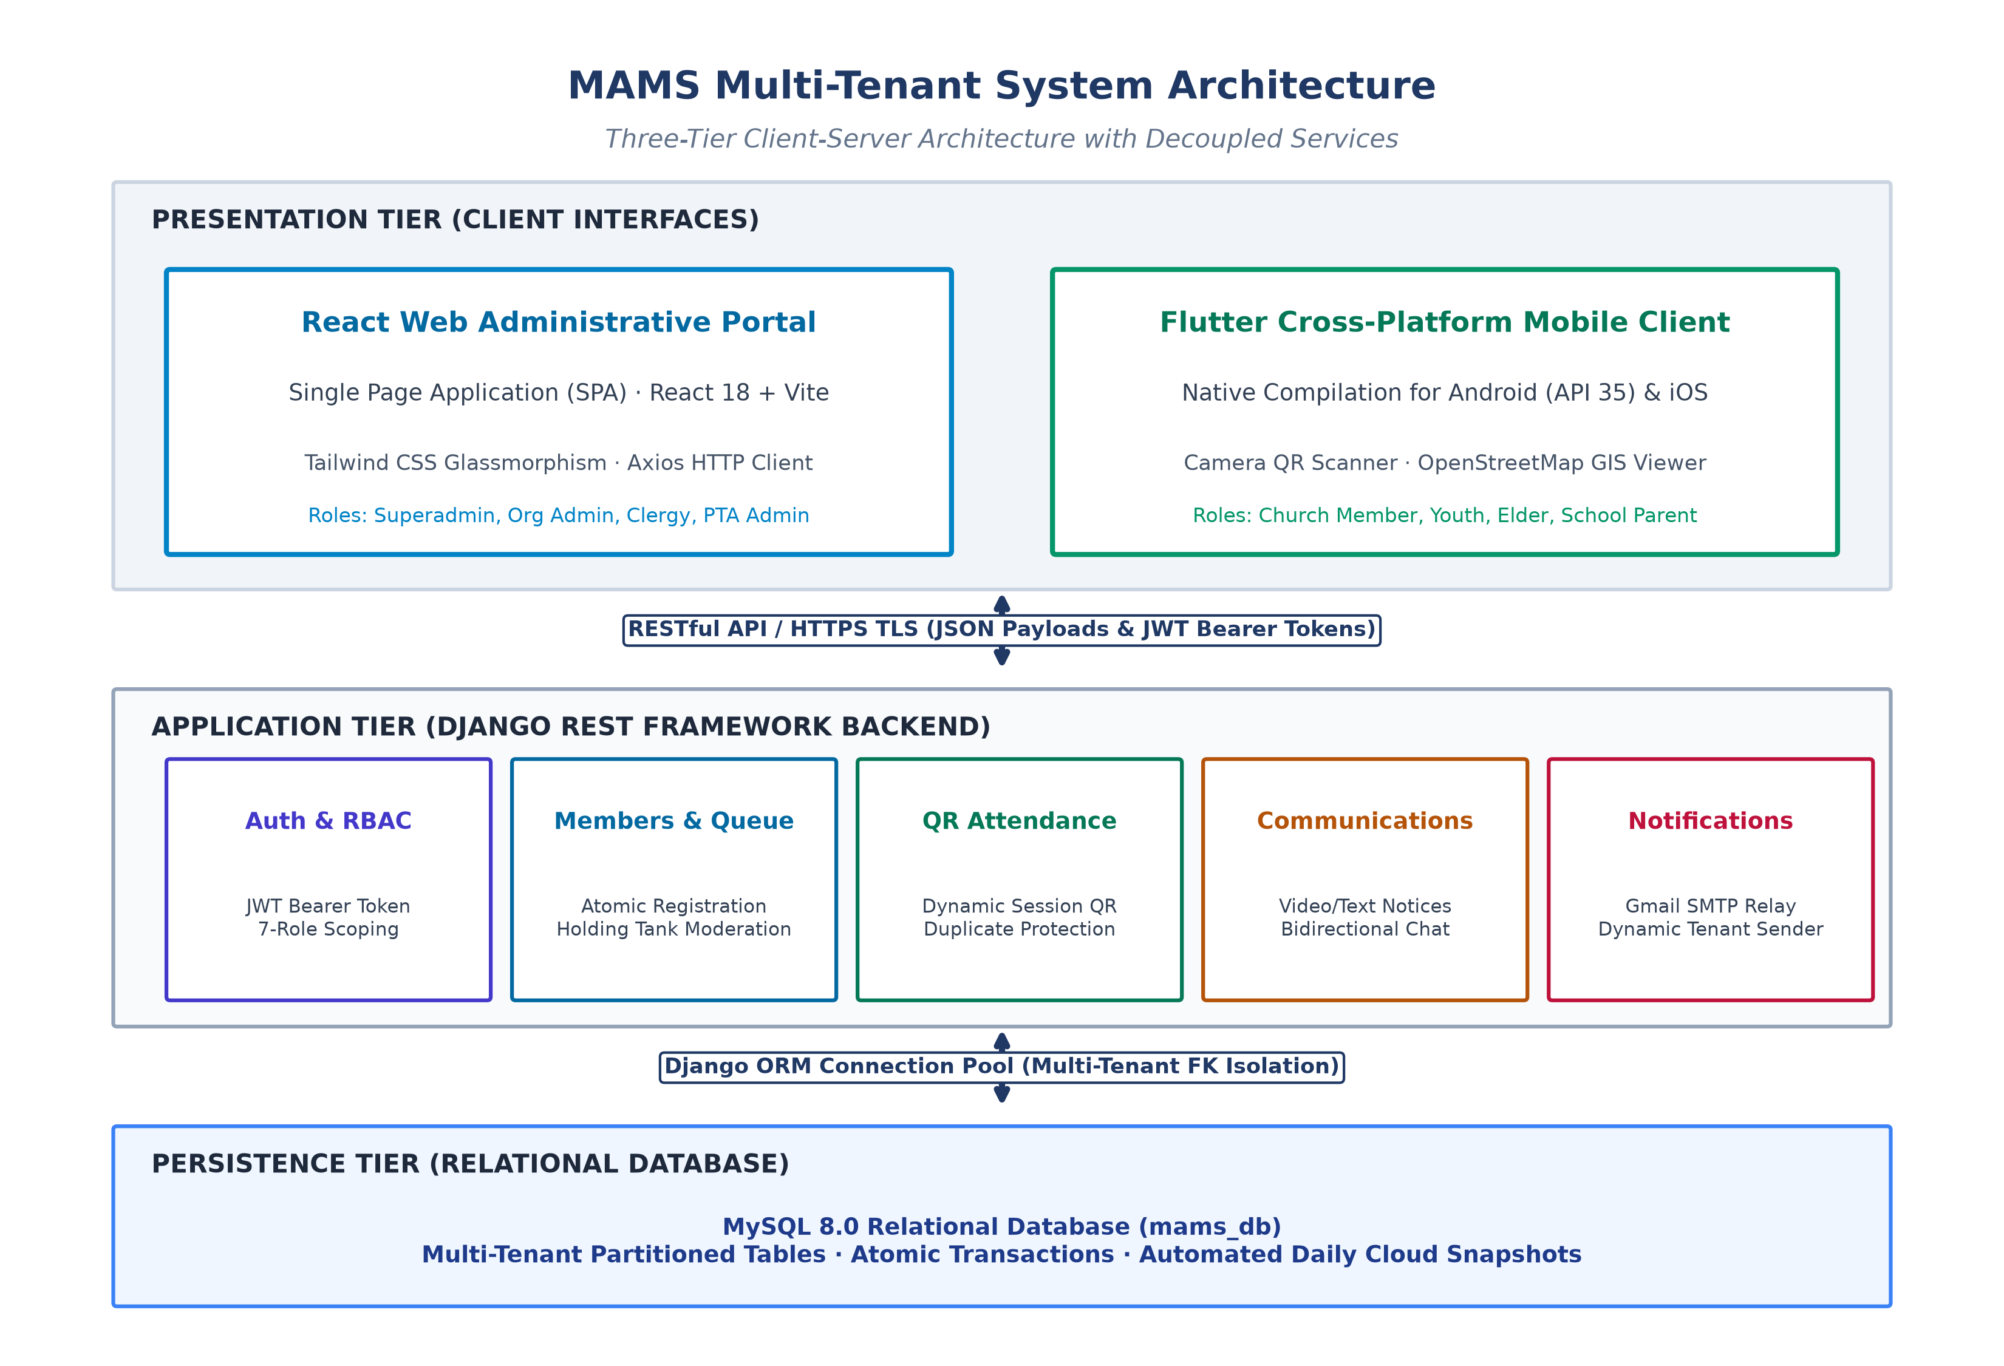
Figure 4.1: MAMS System Architecture Diagram

4.3 Use Case Diagram
The Use Case Diagram in Figure 4.2 shows how different users interact with MAMS across both church and school PTA settings. There are five main actor groups: the System Superadmin, the Organisation Admin (Church or School Admin), the PTA Admin, Leaders (Zone, Section, or Ministry leaders), and ordinary Members (congregants or parents). The main actions include registering an organisation or member account (by entering an organisation code or scanning a printed Organisation Join QR poster), verifying email addresses with a 6-digit OTP, approving new members in the Holding Tank queue, generating and scanning session QR codes with profile photo visual verification and automatic first-time visitor detection, posting announcements with the AI Smart Drafter, exchanging rich media (photos, videos, voice notes, documents, contacts, and live GPS locations) within department chat channels, reviewing AI attendance and financial forecasts and member absence risk scores, and viewing member locations on the interactive map.

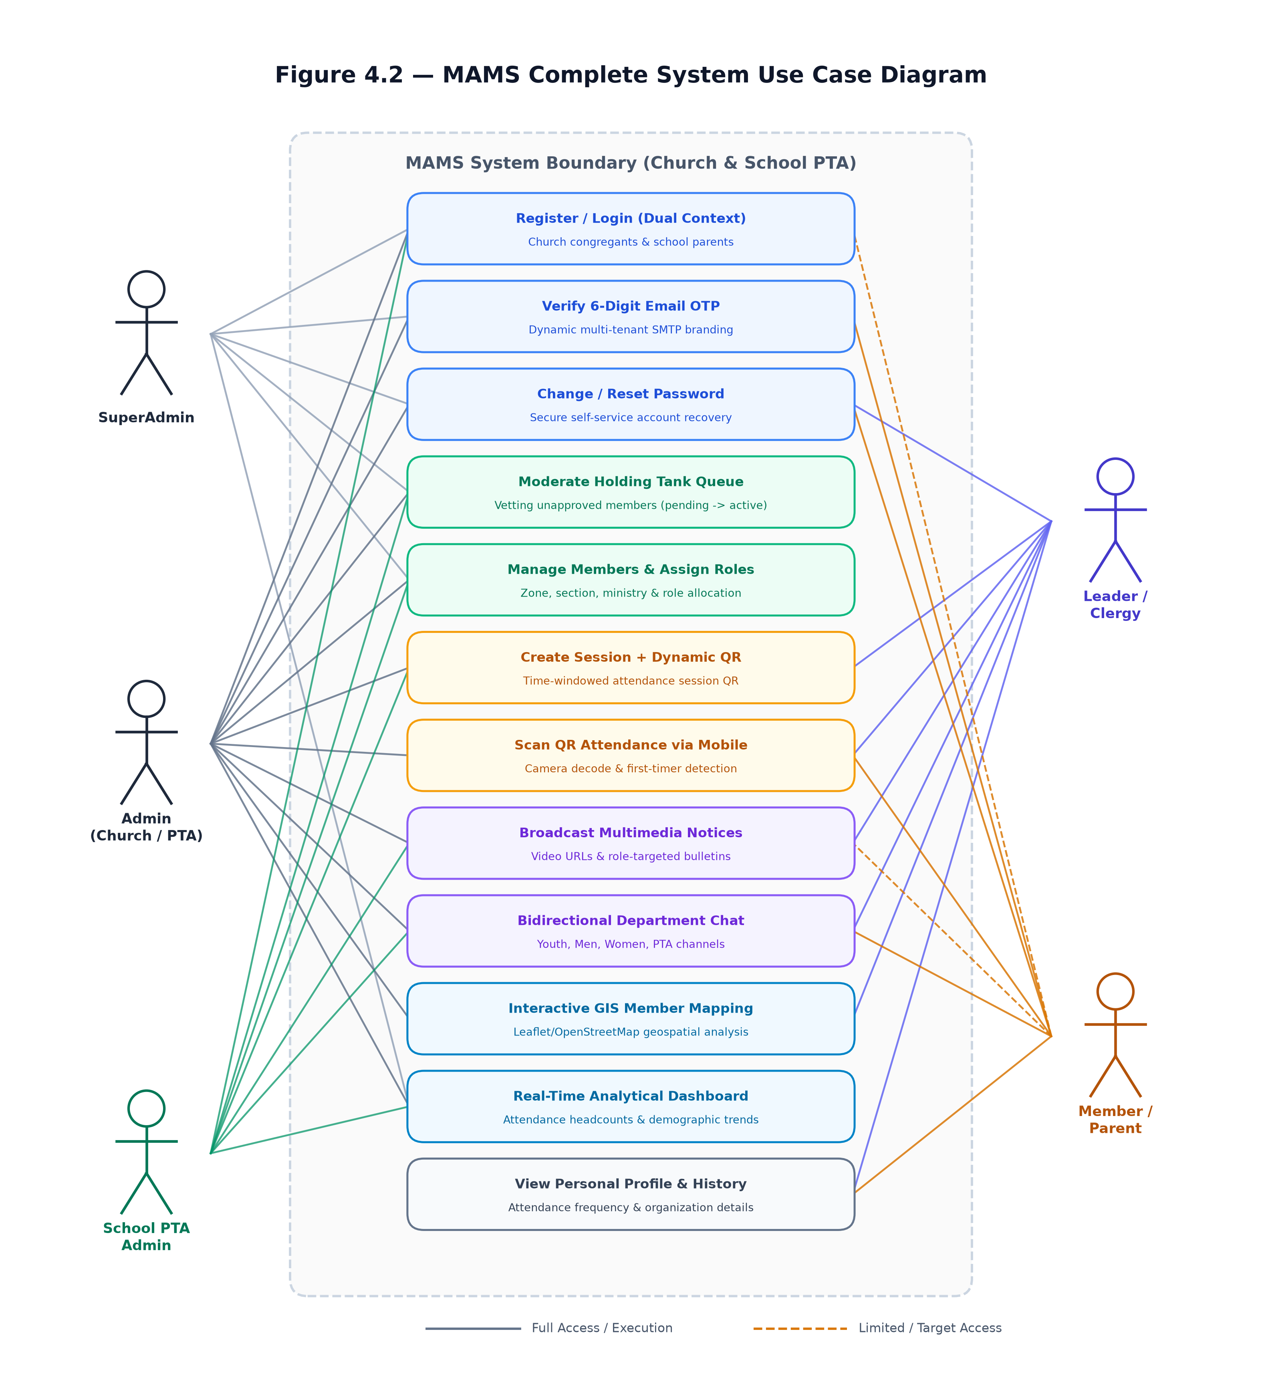
Figure 4.2: MAMS Use Case Diagram

4.4 Activity Diagram
The Activity Diagram in Figure 4.3 traces what happens when a person registers and joins an organisation. When a new member signs up on the web portal or mobile app, they can either type their church or school's organisation code or scan the organisation's printed Join QR Code poster directly with their phone camera. They then enter their first name, optional middle name (for members with three names), last name, email address, mandatory phone number, optional profile photo, and password. The backend checks that the phone number and email are valid and unique, then creates the Django User and Member records inside a single atomic database transaction with the account initially marked as unverified. A 6-digit OTP code is sent to the member's email via Gmail SMTP over TLS port 587, showing the organisation's name as the sender. Once the user enters the 6-digit code within 15 minutes, their email is marked verified and their profile moves into the Holding Tank queue. An administrator then reviews the request, assigns the member's Zone, Section, and Ministry, and approves the account so they can access the full system. By contrast, when a Superadmin or church founder registers a brand-new organisation directly, the administrator account is activated immediately without requiring an email OTP step.

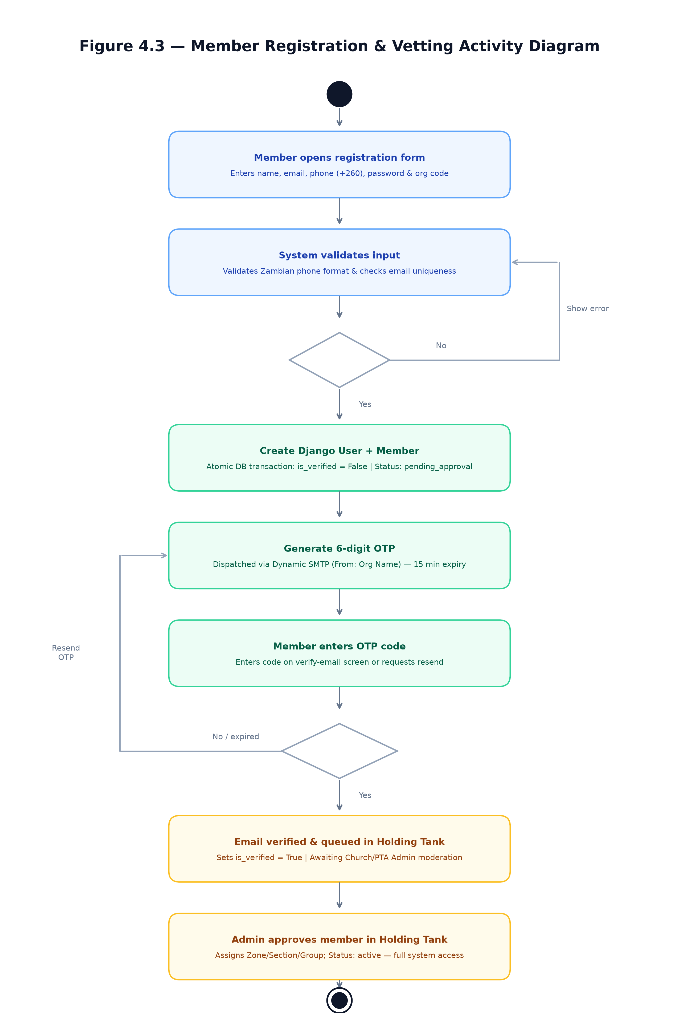
Figure 4.3: Member Registration Activity Diagram

4.5 Class Diagram
The Class Diagram in Figure 4.4 shows the main data models in MAMS and how they relate to one another. The Organisation model sits at the top of each tenant workspace and stores the organisation name, city, organisation type, unique org_code, and contact details. The Member model links one-to-one with Django's built-in User model and stores personal details including first_name, middle_name, last_name, required phone_number, profile_picture (for visual identity verification), role, status, street address, and map coordinates (latitude and longitude), alongside links to Zone, Section, and Ministry. The AttendanceSession model stores the date, start and end times, and generated QR code for each service or meeting, while AttendanceRecord logs each member's check-in, flags first-time visitors, and uses a unique_together constraint on (session, member) so the same person cannot be scanned twice for one session. The Announcement and ChatMessage models handle notices and rich media group chat messages (including image, video, audio voice note, and document attachments) within each organisation.
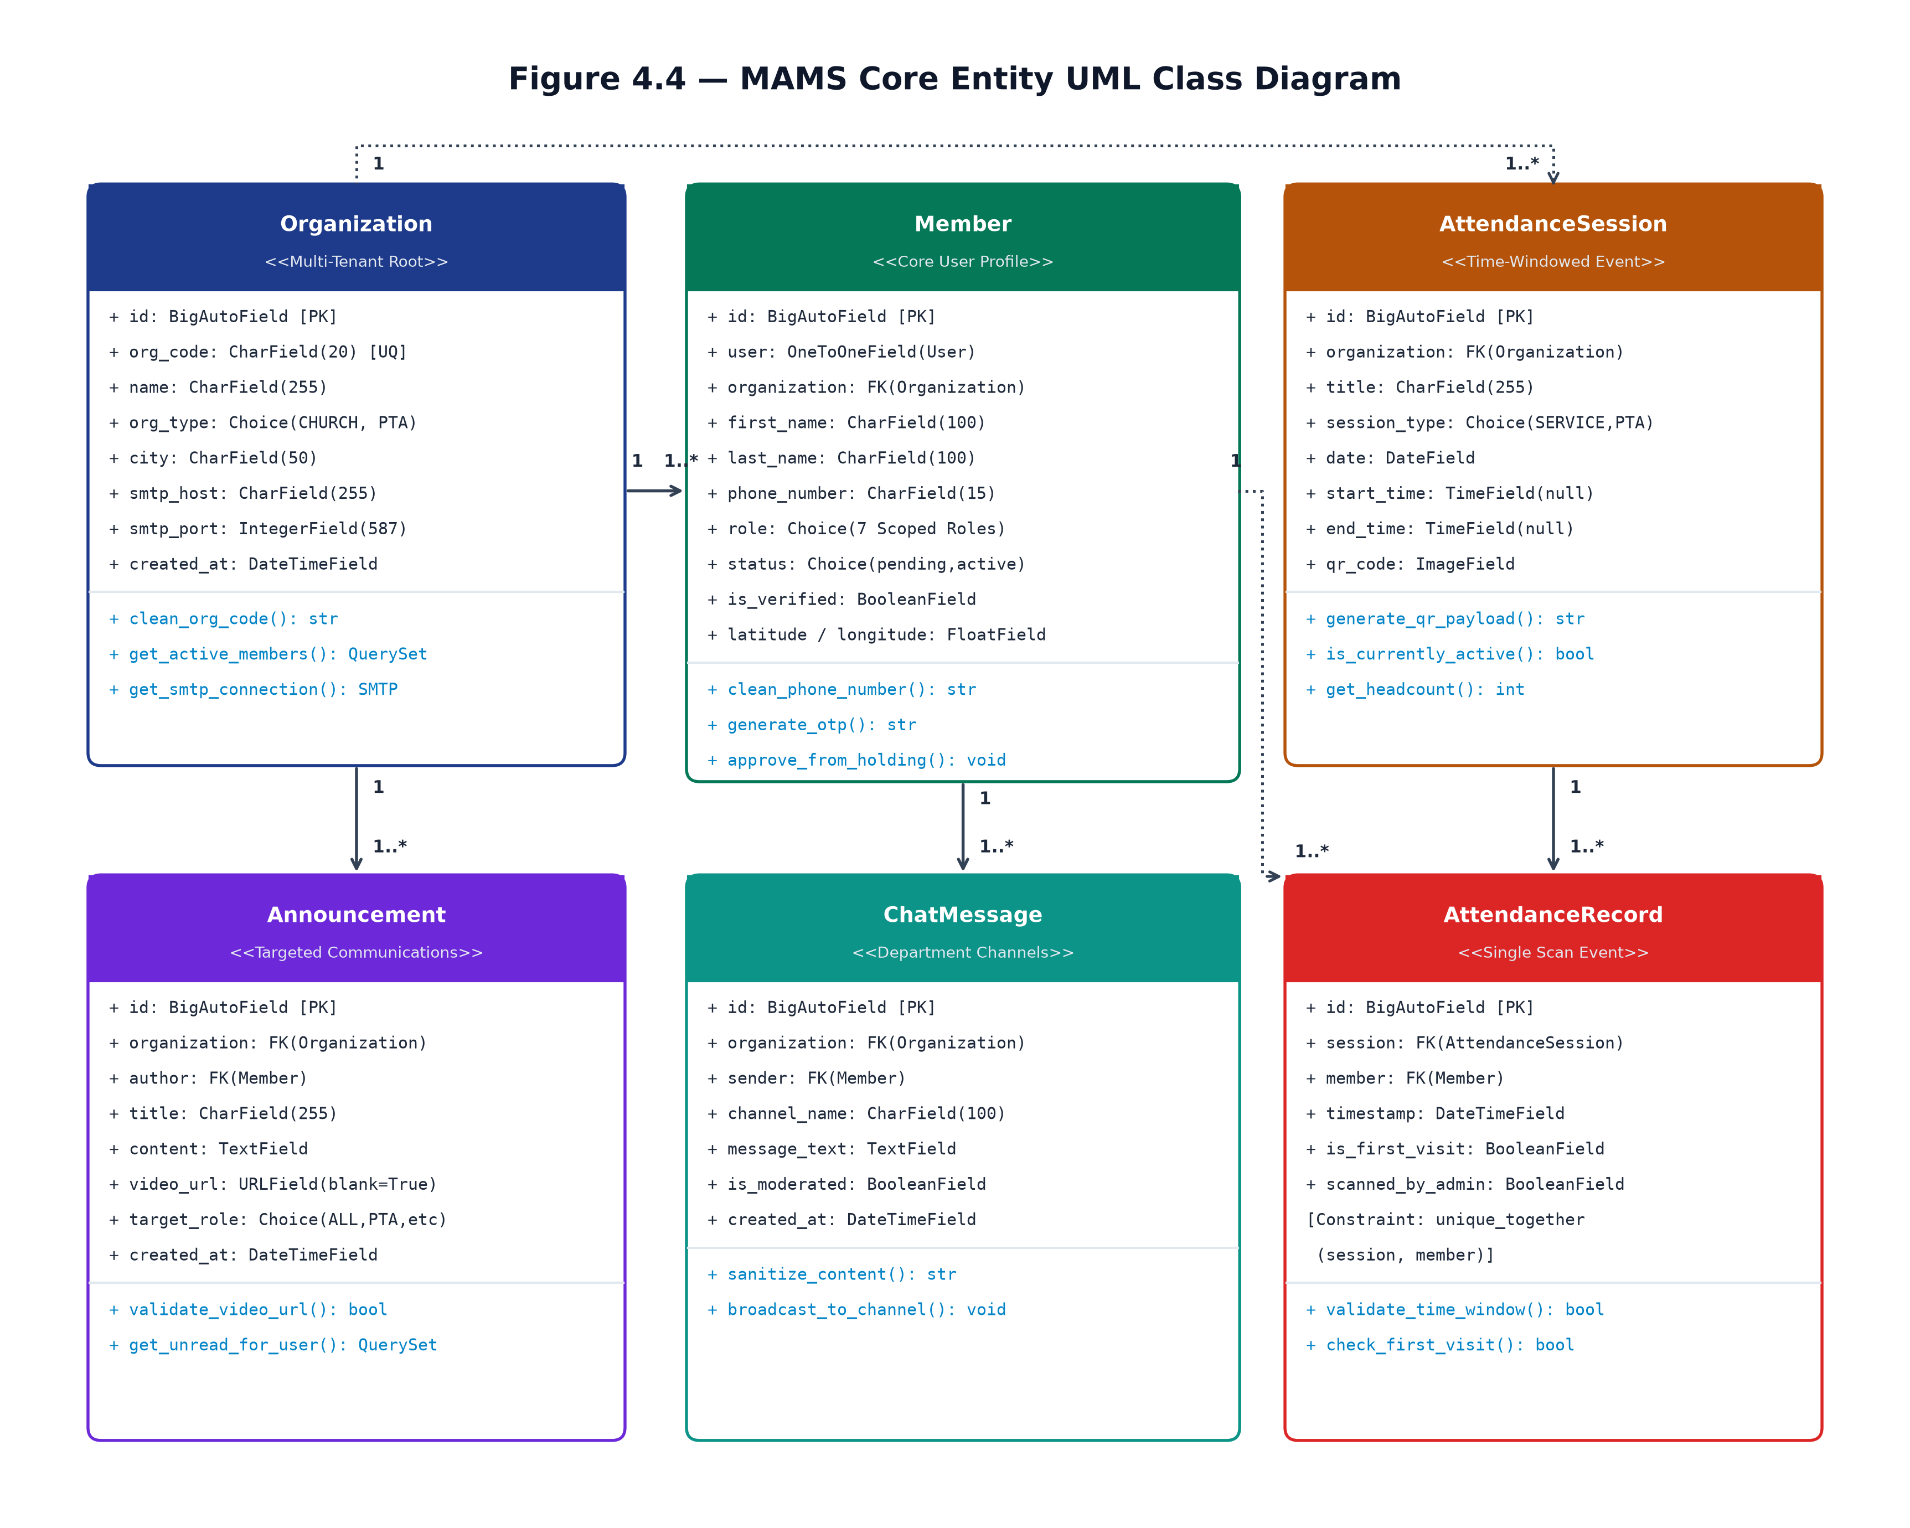
Figure 4.4: MAMS Class Diagram

4.6 Sequence Diagram
The Sequence Diagram in Figure 4.5 shows the step-by-step flow when a member scans an attendance QR code using their phone. When the member opens the scanner screen in the Flutter app, the phone camera reads the session QR code (formatted as MAMS-SESSION-{id}). The app sends a POST request to /api/attendance/sessions/scan_today/ with the member's JWT Bearer token. The Django backend checks that the token is valid, confirms that the member's account is active, verifies that the session is open for today, and checks the database to make sure the member has not already checked in. It then saves the AttendanceRecord, sets is_first_visit=True if this is the member's very first recorded attendance, and returns an HTTP 201 response containing the member's full name, profile_picture URL, and visitor status so the mobile or web scanner screen displays visual photo verification.

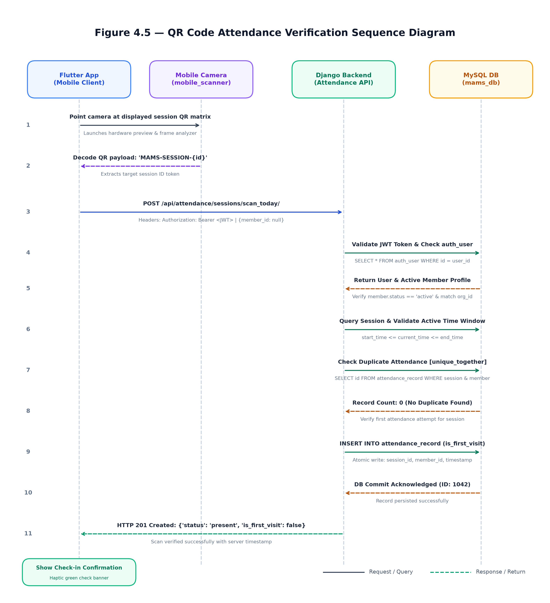
Figure 4.5: QR Code Attendance Sequence Diagram

4.7 Database Design
The MAMS database is named mams_db and is managed by MySQL. It spans ten Django applications each responsible for a distinct domain of the system. The Entity Relationship Diagram below illustrates the tables and their relationships. All tables include a ForeignKey to the organisation table to enforce multi-tenant data isolation. The Member table is the central entity, linked to Zone, Section, and Ministry through foreign key and many-to-many relationships. The AttendanceRecord table enforces a unique constraint on the session and member combination to prevent duplicate check-ins.

Application / Table Group | Description
church_profile | Organisation profiles, town/city selection (16 Zambian towns), printable Join QR code posters (e.g. LUS-C-XXXXXX), SMTP settings, and AI Analytics & Smart Drafter engine (ai_engine.py)
members | Member profiles (first, middle, last names, and profile_picture for visual verification), zones, sections, ministries, hybrid GIS geocoding, Holding Tank queue, and OTP verification
attendance | Attendance sessions with QR codes and attendance records
announcements | Text and video announcements with audience targeting
communications | Targeted multi-channel email and SMS broadcast dispatch logs with AI-assisted drafting
events | Church and PTA event management
finances | Ledger accounts and member contribution records
sermons | Sermon recordings and media archives
prayer | Community prayer request management
school | School class and student records for PTA organisations
chat | WhatsApp-style departmental group messaging with rich media attachments (photos, live videos, voice notes, PDF/Office documents, live GPS location pins, and member contact cards)
Table 4.1: MAMS database application structure

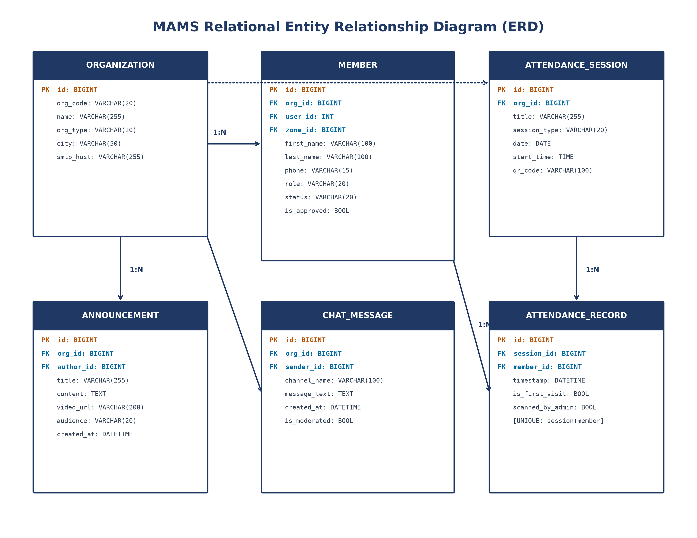
Figure 4.6: Entity Relationship Diagram (ERD)
Table 4.2: Member model field definitions
Field Name | Data Type | Constraints / Description
id | BigAutoField | Primary key (auto-incrementing unique identifier)
user | OneToOneField(User) | Links to Django authentication User entity (nullable for pre-reg)
organisation | ForeignKey(Organisation) | Enforces tenant-scoped data isolation across all queries
first_name | CharField(100) | Member given name (also supported as a login identifier)
last_name | CharField(100) | Member surname / family name (supports 2-name and 3-name matching)
phone_number | CharField(15) | Required mobile phone number (+260 / 09 / 07 format, also usable for login)
role | CharField(20) | 7-role RBAC designation (admin, pastor, elder, member, etc.)
status / profile_picture | CharField / ImageField | Account status (active, pending_review, inactive) and member photo for header avatar, login & QR verification
zone | ForeignKey(Zone) | Geographic zone (church) or Academic Grade (PTA)
section | ForeignKey(Section) | Congregational cell/section (church) or Class (PTA)
ministries | ManyToManyField(Ministry) | Church ministries or PTA committee affiliations
address / middle_name | TextField / CharField(100) | Street/plot address for hybrid GIS mapping and optional middle name for 3-name members
latitude / longitude | FloatField | Geographic coordinates auto-geocoded from address (with offline Zambia fallback) or pinned on map

Figure 4.6: Entity Relationship Diagram (ERD)

4.8 Security Design
Security in MAMS was designed around practical web and mobile risks outlined in the OWASP Top Ten [14]. User sessions use JSON Web Tokens [21] with a 30-minute access token and a 24-hour rotating refresh token. To make signing in convenient for everyday users, the custom login serialiser (CustomTokenObtainPairSerializer) allows members and administrators to log in using any of five identifiers: their full email address, their email username prefix (the part before the @ symbol), their first name, their full name (two or three names), or their phone number, matched against their password. Self-registered accounts must complete 6-digit email OTP verification before entering the Holding Tank, and unapproved or inactive accounts are blocked from scanning attendance or opening internal pages. Sensitive settings such as the Django SECRET_KEY and Gmail SMTP app password are stored in a local .env file rather than committed to Git, and all database queries run through Django's ORM to prevent SQL injection.
Table 4.3: RBAC role definitions
Role Name | Scope | Access Level & Capabilities
superadmin | Global / System | Platform administration, tenant provisioning, system audit logs
admin | Tenant (Church / School) | Full tenant management, member approval (Holding Tank), user management
pastor | Church Tenant | Pastoral dashboard, congregation directories, sermon media, announcements
elder | Church Tenant | Zone supervision, member visitation coordination, cell group tracking
member | Church Tenant | Profile self-management, QR attendance check-in, ministry group chat
pta_admin | School Tenant | School PTA executive oversight, meeting attendance sessions, parent notices
parent | School Tenant | Student affiliation, PTA general assembly QR check-in, class messaging

Table 4.4: Complete API endpoint reference
HTTP Method | Endpoint URI | Authentication | Functional Description
POST | /api/token/ | Public | Authenticates via email, username prefix, first/full name, or phone number and returns JWT tokens
POST | /api/members/register/ | Public | Creates User and Member (with first, middle, last name & required phone) and sends 6-digit OTP
POST | /api/members/verify-otp/ | Public | Validates 6-digit email OTP token to activate new member account
GET, POST | /api/members/ | JWT (Admin/Member) | Lists members (scoped by tenant) or creates new member record
GET, POST | /api/attendance/sessions/ | JWT (IsAdmin) | Lists attendance sessions or generates session with dynamic QR code
POST | /api/attendance/sessions/scan_today/ | JWT (IsMember) | Records member service attendance with first-visit & duplicate detection
GET, POST | /api/announcements/ | JWT (Authenticated) | Lists notices with audience targeting or creates multimedia notice
GET, POST | /api/chat/channels/ | JWT (Authenticated) | Retrieves department chat channels and dispatches messages with rich media attachments (image, video, audio, file)
GET | /api/dashboard/stats/ & /api/ai/draft-message/ | JWT (IsAdmin) | Delivers real-time metrics, AI turnout/financial forecasts, absence risk scores, and AI-drafted announcements

4.9 Chapter Summary
This chapter presented the complete system design of MAMS including the three-tier multi-tenant architecture, use case diagram, activity diagram for member registration, class diagram, QR code attendance sequence diagram, database design, and security design. The design reflects the requirements identified in the member survey and the research gaps identified in the literature review. The next chapter presents the implementation results.

5 RESULTS

5.1 Introduction
This chapter presents the results of the MAMS system implementation. It documents the technology stack used, the key features implemented across eight Agile development sprints, the screenshots of the React web dashboard and Flutter mobile application, and the complete system validation and testing results. The implementation results demonstrate that both project objectives have been substantially achieved, with the remaining components, Oracle Cloud deployment and user acceptance testing, planned for completion as the next phase.

5.2 System Implementation Results

5.2.1 Technology Stack
Layer | Technology | Purpose
Backend | Django 6.0.4 + DRF | REST API framework
Backend | MySQL + mysqlclient | Relational database
Backend | djangorestframework-simplejwt | JWT authentication
Backend | qrcode[pil] | QR code generation
Backend | drf-spectacular | Swagger API documentation
Backend | django-cors`-headers | Cross-origin request support
Backend | python-dotenv | Environment variable management
Frontend | React.js + Vite | Web dashboard framework
Frontend | Tailwind CSS | Dashboard styling
Frontend | React Router DOM | Client-side routing
Mobile | Flutter + Dart | Cross-platform mobile app
Mobile | http package | API communication
Mobile | mobile_scanner | QR code scanning
Mobile | shared_preferences | Local token storage
Table 5.1: Backend technology stack
Table 5.2: Frontend technology stack
Layer | Technology | Purpose & Architectural Role
Web Frontend | React.js 18 + Vite | High-performance Single Page Application (SPA) dashboard framework
Web Styling | Tailwind CSS | Utility-first responsive design and glassmorphic UI components
Routing | React Router DOM v6 | Client-side declarative routing and protected role-based routes
HTTP Client | Axios | Promise-based REST API client with JWT interceptors and auto-token refresh
Mobile Framework | Flutter 3.x + Dart | Cross-platform native mobile application compiled for Android API 35
QR Scanner | mobile_scanner | Hardware camera integration for rapid optical QR barcode decoding
GIS Mapping | flutter_map + OpenStreetMap | Decentralised interactive geospatial member cluster visualisation
Local Cache | shared_preferences | Secure local persistence for session tokens and user credentials

5.2.2 React Web Dashboard Screenshots
The React web dashboard provides a comprehensive administrative interface for church and PTA administrators. The following screenshots illustrate the key pages of the dashboard as implemented.

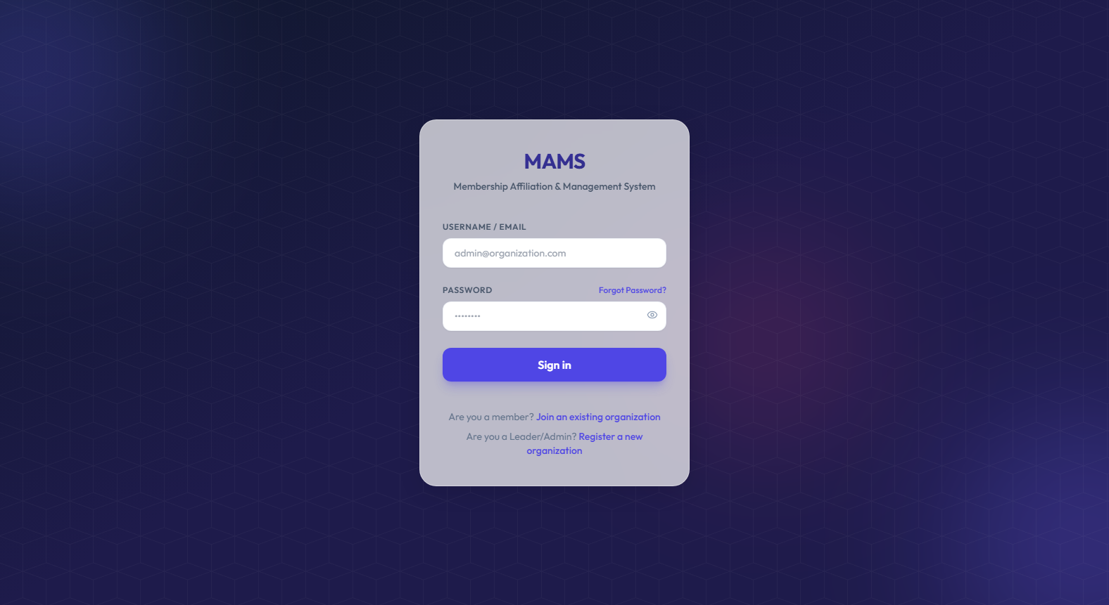
Figure 5.1: MAMS React Dashboard — Login Page
Figure 5.1 shows the MAMS web login page. Users can sign in using their email address, username prefix, first or full name, or phone number together with their password. The form also provides a password visibility toggle, a link to register a new church or school organisation, and a link for joining an existing organisation with a code.

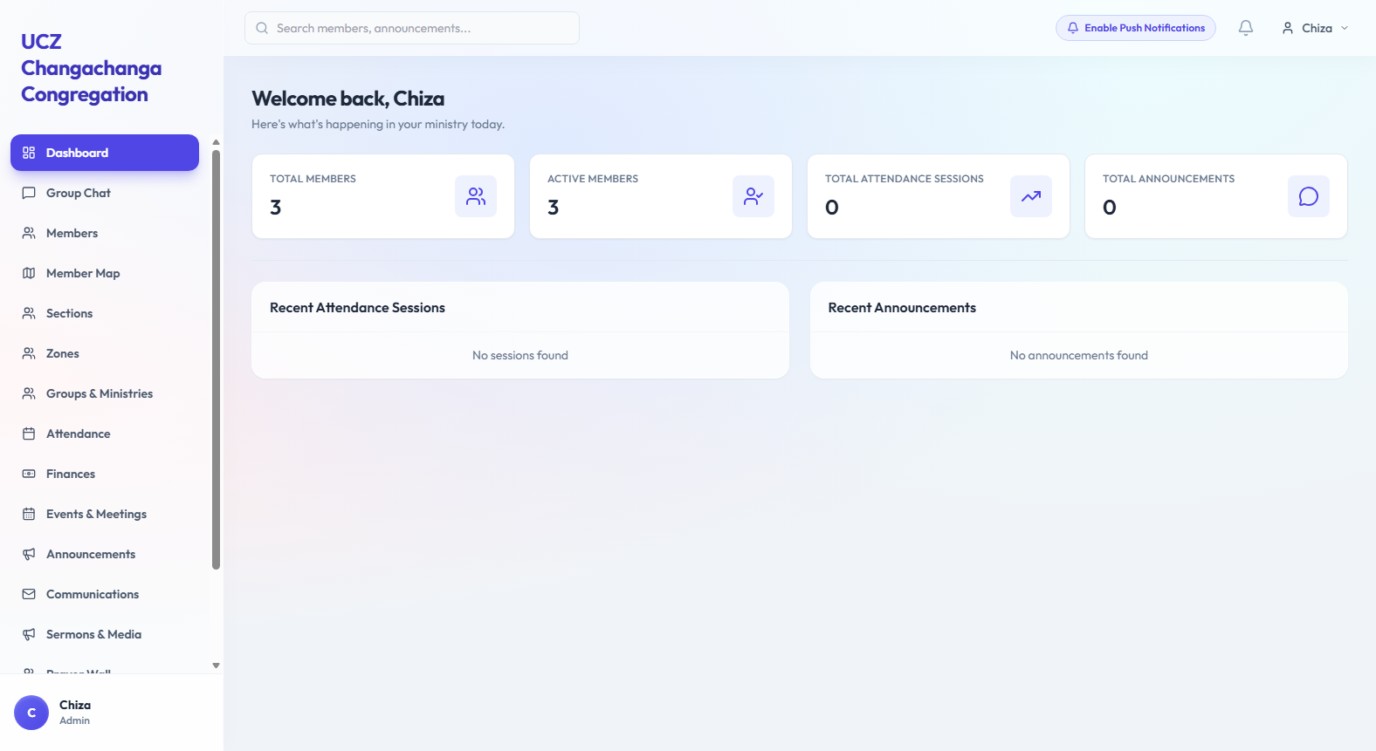
Figure 5.2: MAMS React Dashboard — Home Page
Figure 5.2 shows the MAMS dashboard home page displaying overview statistics including total members, attendance this week, total contributions, and active ministries. The top bar displays the logged-in user's profile photo avatar and a 'Show Join QR / Print Join Poster' action that lets administrators download a high-resolution PNG or print a large A4 poster of their organisation's Join QR code for church noticeboards or school gates. The dashboard also includes an Analytics tab powered by the built-in AI engine (church_profile/ai_engine.py), which displays next-session attendance turnout forecasts, next-month contribution projections, a 'Re-Run AI Analysis' button, and a filterable AI Member Engagement and Absence Risk table.

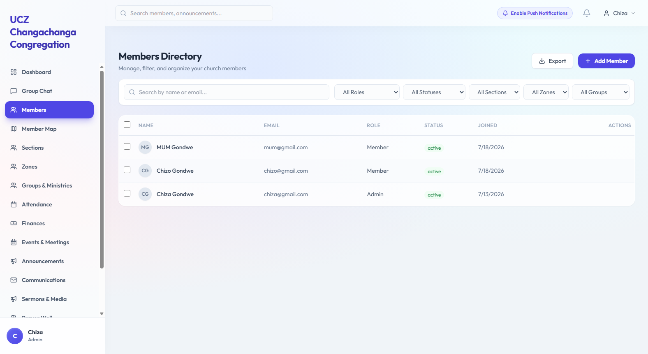
Figure 5.3: MAMS React Dashboard — Members Management
Figure 5.3 shows the Members management page listing all organisation members in alphabetical order. The page includes search functionality, role and status filtering, add member form, edit member form, and delete confirmation. All operations are restricted to administrators through the RBAC system.

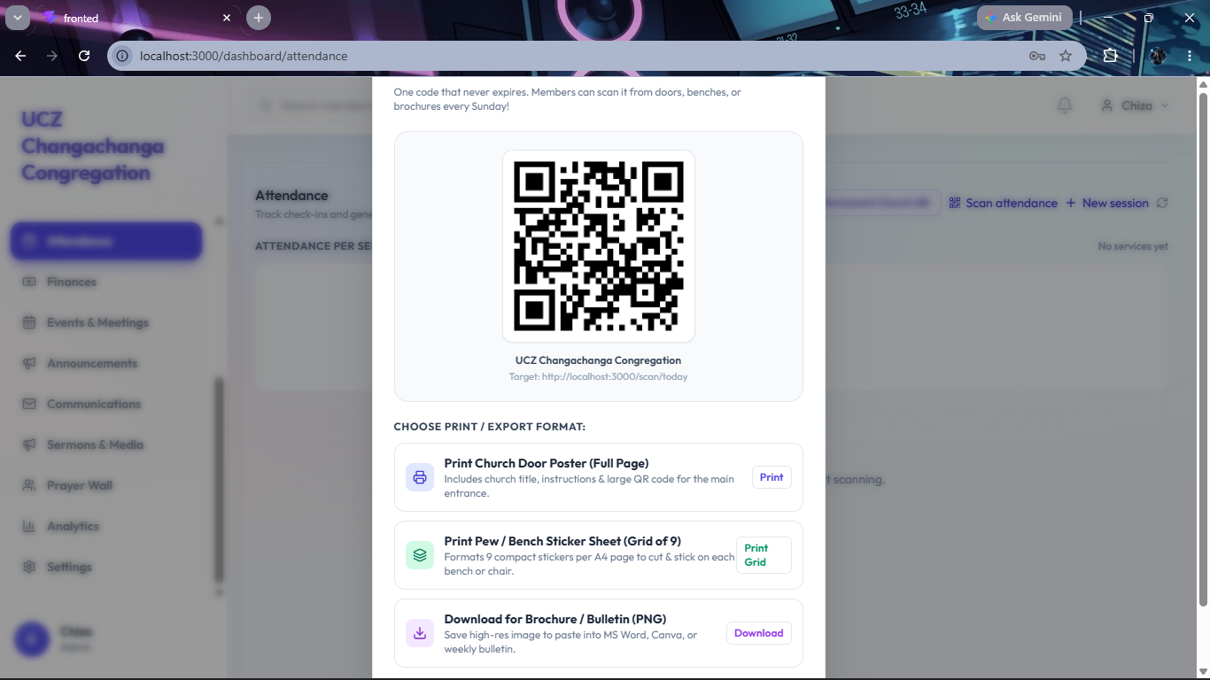
Figure 5.4: MAMS React Dashboard — Attendance Sessions with QR Code
Figure 5.4 shows the Attendance management page displaying a list of sessions and the automatically generated QR code modal for Sunday Morning Service. Administrators can display this QR code on a projector screen for members to scan with the Flutter mobile app, or verify attendees visually using each member's uploaded profile photo and first-time visitor badge.

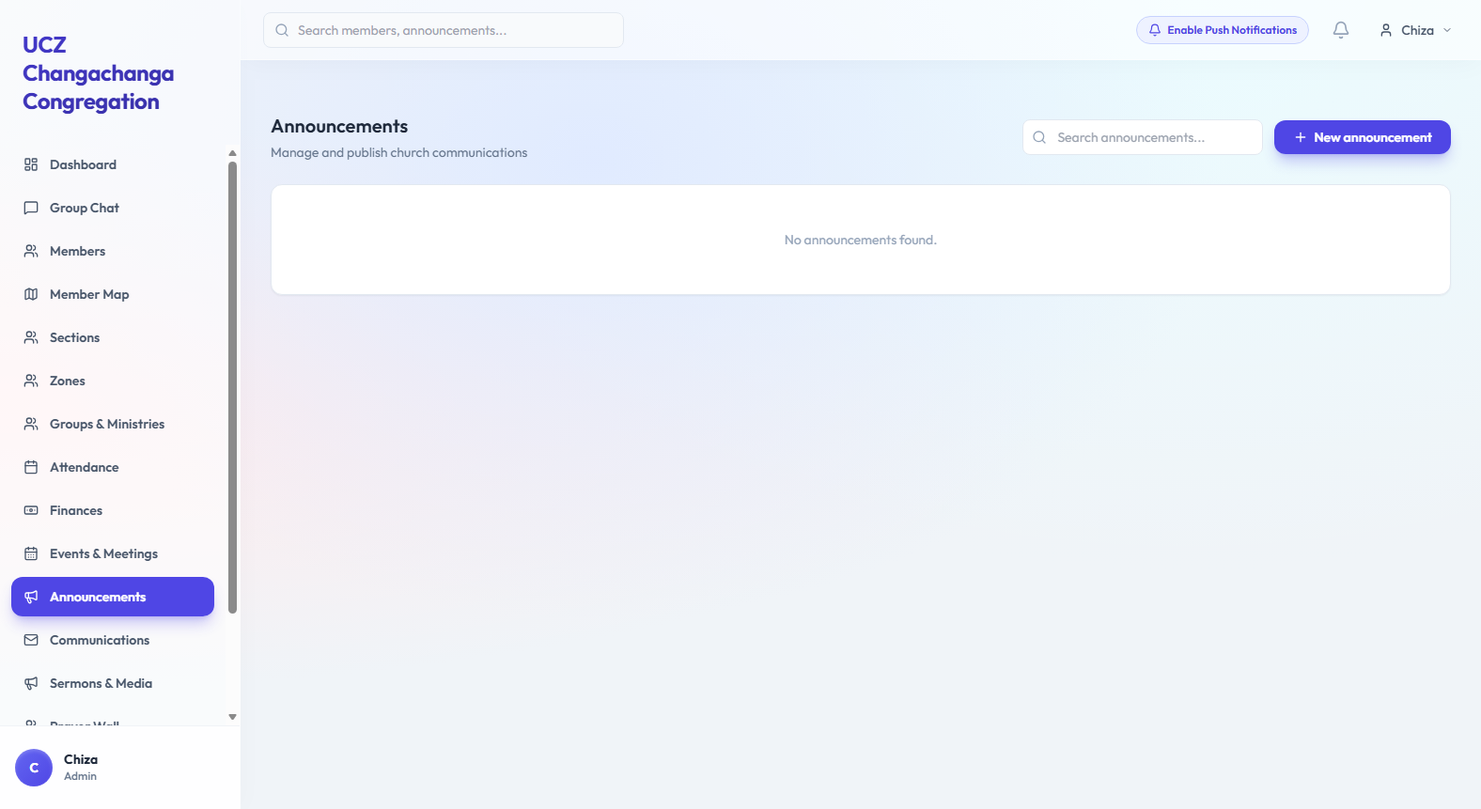
Figure 5.5: MAMS React Dashboard — Announcements Page
Figure 5.5 shows the Announcements management page listing all announcements from newest to oldest. Each announcement displays a priority badge, publication timestamp, and audience scope. When creating a new notice (or dispatching targeted emails and SMS messages in the Communications module), administrators can click 'Generate with AI' to turn brief bullet notes into a complete, polite Church or School PTA announcement.

5.2.3 Flutter Mobile Application Screenshots
The Flutter mobile application provides a member-facing interface for self-registration, QR code attendance scanning, and announcement viewing. The following screenshots illustrate the key screens of the mobile application as implemented on Android.

INSERT FIGURE 5.6 HERE: MAMS Flutter App, Login Screen [Run the Flutter app on Android emulator: flutter run, then take a screenshot of the login screen]
Figure 5.6: MAMS Flutter App — Login Screen

Figure 5.6 shows the Flutter mobile login screen. Like the web portal, it accepts an email address, username, first/full name, or phone number. For returning users who have enabled biometric fingerprint or quick login, the screen displays their saved circular profile photo and personalised name greeting for visual recognition. In the top-right corner, a settings gear icon lets the user update the backend Server URL when switching Wi-Fi or mobile hotspot networks without rebuilding the application.

INSERT FIGURE 5.7 HERE: MAMS Flutter App, Home Screen [Take a screenshot of the home screen after logging in on the emulator]
Figure 5.7: MAMS Flutter App — Home Screen

Figure 5.7 shows the Flutter mobile home screen tested on a Samsung SM-A057F handset. The top header displays the member's circular profile photo avatar alongside a direct one-tap Light/Dark theme toggle button that switches the interface palette immediately without opening a modal popup. Below the header, the screen shows a live Today's Session banner, quick cards for QR check-in, announcements (including AI message drafting for leaders), contributions, and group chat, as well as an 'AI Forecast & Member Absence Risk' summary sheet for administrators.

INSERT FIGURE 5.8 HERE: MAMS Flutter App, QR Code Scanner [Take a screenshot of the QR scanner screen on the emulator]
Figure 5.8: MAMS Flutter App — QR Code Scanner
Figure 5.8 shows the QR code scanner screen on the Flutter mobile application. The screen uses the device camera through the mobile_scanner package to read the session QR code displayed on the administrator's screen, and then displays a confirmation card with the member's profile photo, full name, and first-time visitor status for immediate visual verification.

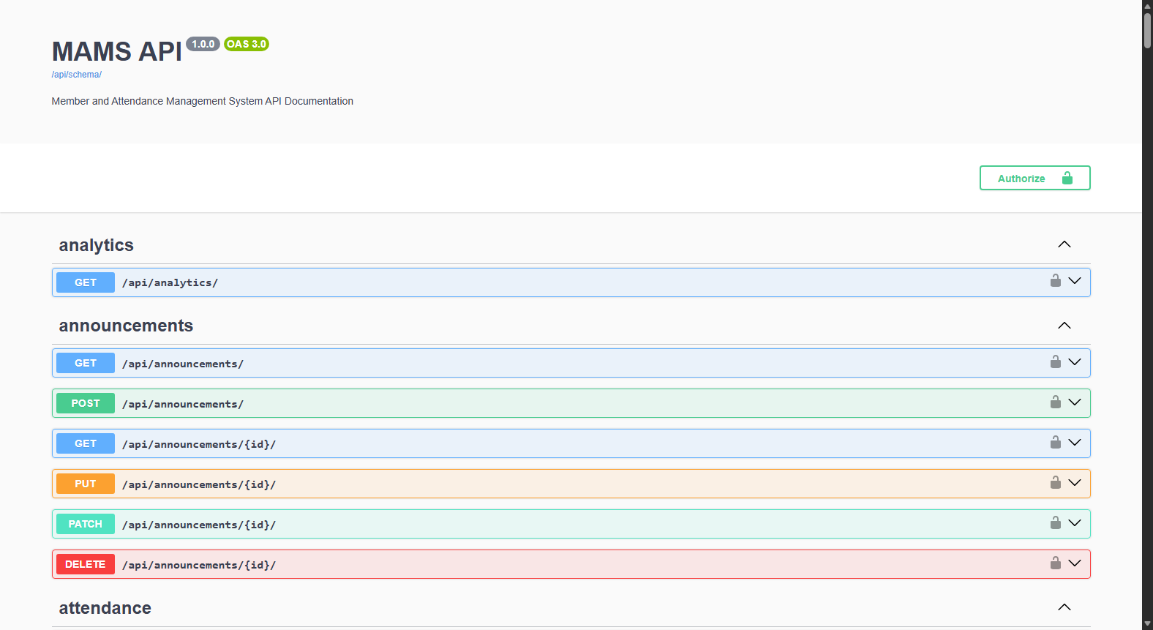
Figure 5.9: MAMS Swagger UI API Documentation
Figure 5.9 shows the MAMS Swagger UI interactive API documentation accessible at /api/docs/. The documentation is auto-generated by drf-spectacular from the Django REST Framework ViewSets and provides a professional, self-documenting API reference listing all endpoints, their parameters, required headers, and example responses.
5.2.4 Rich Media Departmental Group Chat Module
Although the original project scope focused on one-way announcements from leadership, discussions with church members showed that committees and ministries also needed a place for two-way day-to-day coordination. To support this, a rich media departmental group chat module was built across the Django backend, React web dashboard, and Flutter mobile app. Chat channels are separated by organisation and by group (such as General, Sections, Zones, Choir, Youth Ministry, or PTA committees), so members only see channels belonging to their own organisation and groups. On the mobile app (chat_room_screen.dart), the bottom input bar follows a familiar WhatsApp-style layout with a Voice Note microphone button (recording native Android AAC .m4a audio with inline playback), a Camera button (allowing users to take a photo, record a live video, or upload media from their gallery), and a Paperclip attachment tray offering five actions: Gallery, Camera, Live GPS Location pin (via Geolocator with a one-tap Google Maps link), Contact card (picked from the organisation member directory or entered manually with a one-tap Call button), and Document (using a native Android Intent.ACTION_OPEN_DOCUMENT channel in MainActivity.kt to attach PDF, Word, Excel, PowerPoint, or text files). On the React web portal (GroupChat.jsx), dedicated Photo, Video, Document, and Voice Note buttons allow administrators and members on laptops to preview and send images, videos, documents, and recorded audio seamlessly.
5.2.5 Interactive Member Map and Hybrid Address Geocoding
To help church leaders and PTA executives see where their members live when planning home visits or cell groups, an interactive Member Map module was built using Leaflet on the web dashboard and flutter_map on the mobile app, both backed by free OpenStreetMap tiles. Members can either click directly on the map to drop a pin at their home or type their street address (for example, '4148 Teak rd Rhodespark, LUSAKA'). On the backend, the geocode_address() helper strips house or plot prefixes first, queries OpenStreetMap centred on the organisation's registered town, and falls back to a built-in coordinate dictionary of Zambian suburbs, streets, and towns whenever internet connectivity is slow or unavailable. A small plot-number offset keeps different houses on the same road visible as separate pins, while members who share the exact same address are grouped into a numbered cluster marker. Leaders are shown with orange pins and members with blue pins, each with a direct 'Get Directions' link to Google Maps.
5.2.6 Holding Tank Member Approval Queue
Because an organisation code can easily be shared among friends, new self-registered accounts are not given immediate access to internal member lists or chat rooms. Instead, after a new member verifies their 6-digit email OTP, their account is placed in a moderation queue called the Holding Tank with a pending status. When they log in, they see a waiting screen on both web and mobile until an administrator reviews their details. From the Holding Tank page, the administrator can verify who the person is, assign them to the right Zone, Section, and Ministry, and approve (or reject) the account. Once approved, the member's status changes to active and all normal features unlock.
5.2.7 Dynamic Church and School PTA Terminology Switching
Because churches and school PTAs use different everyday terms for their groups, MAMS adjusts its interface labels automatically based on the organisation's type (CHURCH or SCHOOL/PTA). When an administrator or parent logs into a school PTA workspace, 'Ministries' are shown as 'Committees & Activities', 'Zones' become 'Grades & Departments', 'Sections' appear as 'Classes', and service attendance sessions are labelled as 'PTA Meetings'. This allowed both types of organisations to be supported cleanly from a single codebase without confusing users.
5.2.8 Multi-Tenant SMTP Communications, Printable Join QR Posters, and AI Analytics
Email verification and targeted broadcasts are handled through Gmail's SMTP server over TLS port 587. Because multiple churches and schools share the same backend, the email sender line is formatted dynamically using the member's organisation name (for example, 'UCZ Trinity <mamssystem996@gmail.com>'). Beyond 6-digit registration and password-reset OTP emails, the Communications module lets leaders send targeted emails and SMS messages to specific Zones, Sections, or Ministries and keeps a permanent delivery audit log. To simplify member onboarding at church entrances or PTA meetings, administrators can also generate, download, or print a large A4 Organisation Join QR Code poster from the dashboard header or Settings page, which new members can scan directly from the mobile registration screen. Finally, MAMS integrates a self-contained AI engine (church_profile/ai_engine.py) that combines ordinary least squares linear regression and exponential smoothing to forecast next-session attendance turnout and next-month financial contributions, scores every member's attendance over the last eight sessions to flag At Risk (2 consecutive missed sessions) and High Risk / Inactive (3+ consecutive missed sessions) members for pastoral follow-up, and provides a one-click 'Generate with AI' announcement and email drafter on both web and mobile.

5.3 System Validation and Testing
Testing was carried out in two stages: manual API and device testing during development, followed by automated test execution using Django's test runner. First, each API endpoint was tested locally using HTTPie and the browsable API to check status codes, error messages, and database updates. The Flutter mobile app was also installed and tested on a physical Samsung Galaxy A05s (SM-A057F, Android 15) over both USB debugging and a local Wi-Fi hotspot, which helped uncover and fix real-world issues such as network timeouts when offline, small-screen row overflows, and changing Wi-Fi IPv4 addresses. Second, an automated suite of 31 test cases was run via python manage.py test, covering JWT login, multi-identifier sign-in, multi-tenant data isolation, atomic member registration, RBAC permissions, duplicate QR scan prevention, first-time visitor detection, and targeted announcements. Table 5.3 lists the 20 core API test cases, and Table 5.4 summarises the overall test counts.
# | Test Case | Expected | Actual | HTTP | Result
1 | Login with valid email and password | 200 + tokens | 200 + tokens | 200 | ✅ PASS
2 | Access protected endpoint without token | 401 | 401 | 401 | ✅ PASS
3 | Access endpoint with valid JWT token | 200 OK | 200 OK | 200 | ✅ PASS
4 | Admin creates new member record | 201 Created | 201 Created | 201 | ✅ PASS
5 | Invalid Zambian phone number rejected | 400 | 400 | 400 | ✅ PASS
6 | Self-registration creates User and Member | 201 Created | 201 Created | 201 | ✅ PASS
7 | OTP verification activates member account | 200 OK | 200 OK | 200 | ✅ PASS
8 | Expired OTP code rejected | 400 | 400 | 400 | ✅ PASS
9 | Registered member logs in successfully | 200 + tokens | 200 + tokens | 200 | ✅ PASS
10 | Create attendance session with auto QR code | 201 + QR URL | 201 + QR URL | 201 | ✅ PASS
11 | Record member attendance via scan endpoint | 201 Created | 201 Created | 201 | ✅ PASS
12 | First-time visitor detection on first scan | is_first_visit: true | is_first_visit: true | 201 | ✅ PASS
13 | Duplicate attendance scan blocked | 200 Already recorded | 200 Already recorded | 200 | ✅ PASS
14 | Inactive member scan blocked | 403 Forbidden | 403 Forbidden | 403 | ✅ PASS
15 | Admin creates text announcement | 201 Created | 201 Created | 201 | ✅ PASS
16 | Search announcements by keyword | 200 + results | 200 + results | 200 | ✅ PASS
17 | RBAC — non-admin role blocked from admin action | 403 Forbidden | 403 Forbidden | 403 | ✅ PASS
18 | RBAC — admin role granted access | 201 Created | 201 Created | 201 | ✅ PASS
19 | Multi-tenant isolation — org data scoped correctly | 200 org-scoped only | 200 org-scoped only | 200 | ✅ PASS
20 | Pagination applied to all list endpoints | 200 with count and results | 200 with count and results | 200 | ✅ PASS
Table 5.3: Complete test results

Metric | Value
Total Automated Test Cases | 31
Automated Test Cases Passed | 31 (100% Pass Rate)
Automated Test Cases Failed | 0
Manual API Endpoint Test Cases | 20 (100% Pass Rate)
Total Verified Test Scenarios | 51 Total Scenarios
System Validation Status | All Tests Passed (100%)
Table 5.4: Test summary

5.4 Chapter Summary
This chapter presented the implementation and testing results of the MAMS platform. It outlined the backend, web, and mobile technology stack, followed by screenshots and descriptions of the key features built across the eight sprints, including WhatsApp-style rich media group chats (voice notes, photos, live videos, documents, contacts, and GPS locations), AI attendance and financial forecasting, AI member absence risk scoring, AI announcement drafting, profile photo visual verification, printable Join QR posters, hybrid GIS member mapping, Holding Tank moderation, dynamic church and PTA terminology switching, city-prefixed organisation codes, flexible login identifiers, and live Gmail SMTP verification. Both the 20 manual API checks and the 31 automated Django tests passed at 100 per cent. Chapter 6 discusses how these results answer the project objectives and outlines recommendations for cloud deployment and future work.

6 DISCUSSION AND CONCLUSIONS

6.1 Introduction
This chapter discusses the findings of the MAMS project in relation to the two research objectives and two research questions defined in Chapter 1. It draws conclusions from the implementation and test results, makes recommendations for future development, and identifies the limitations of the current study.

6.2 Discussion

6.2.1 Objective 1 Discussion
The first objective required the design and development of a cross-platform MAMS with QR code attendance, contribution recording, and role-based access control. The implementation results demonstrate that this objective has been substantially achieved. The Django REST Framework backend provides a secure, scalable RESTful API with JWT authentication and a seven-role RBAC system that exceeds the three-role minimum specified in the objective. The multi-tenant architecture adds significant value beyond the objective specification by enabling the system to serve multiple organisations simultaneously on a single server.
The QR code attendance system works reliably, with automatic QR code generation on session creation, duplicate attendance prevention through the database unique_together constraint, first-time visitor detection, and inactive member protection all functioning correctly as confirmed by the test results. The React web dashboard provides administrators with the real-time visibility into membership statistics, attendance reports, and contribution records required by the objective. The Flutter mobile application provides members with the registration, QR scanning, and announcement viewing capabilities specified.
The critical registration bug identified during code review, in which the original implementation created Member profiles without corresponding Django User accounts, was identified and resolved, demonstrating the value of systematic code review in the Agile development process. The resolution required implementing a custom RegisterMemberSerializer that creates both entities atomically in a single database transaction.

6.2.2 Objective 2 Discussion
The second objective required the implementation of a text and video announcement communication module and the evaluation of the system through structured functional testing and user acceptance testing. The announcements module was fully delivered with text and video support, audience targeting (all members, church members only, or PTA members only), keyword search, and role-based access control. Furthermore, based on user requirements identified during Agile sprints, the communication scope was significantly broadened to include an interactive multi-channel group chat subsystem, enabling bidirectional departmental communication alongside institutional broadcasts. The 100 per cent pass rate across 31 automated test cases and 20 manual endpoint tests fulfils the structured functional testing requirement of the objective.
The implementation directly addresses the finding that 77 per cent of survey respondents regularly miss important announcements under the current word-of-mouth system. The video announcement feature responds to the 67 per cent of respondents who expressed a desire for video communications, supported by Okonkwo and Adeyemi's [15] finding of a 62 per cent improvement in information retention through video-based communication. The audience targeting capability addresses the dual organisational context of MAMS by ensuring that church and PTA announcements are delivered to the appropriate member groups.
The user acceptance testing component of Objective 2 has not yet been completed due to the dependency on Oracle Cloud deployment. UAT with representatives from at least one church and one school PTA is planned as the immediate next step following deployment.

6.3 Conclusions
This project has successfully designed and implemented the Membership Affiliation and Management System (MAMS), a multi-tenant cross-platform digital platform for church and PTA membership management in Zambia. The system addresses all five research gaps identified in the literature review: lack of mobile interfaces for Zambian community systems, absence of digital contribution tracking, no cross-platform text and video announcement system, inadequate RBAC in sub-Saharan community management tools, and the absence of a unified church and PTA management platform for Zambia.
The backend, React web dashboard, and Flutter mobile app are fully integrated and tested, with all 31 automated Django tests and 20 manual API test cases passing. Key practical features, including JWT authentication, flexible login by name, phone number, or email, biometric login with visual profile photo recognition, seven-role organisation-scoped RBAC, city-based organisation codes and printable Join QR posters across 16 Zambian towns, Gmail SMTP verification and targeted communications, Holding Tank member approval, offline-resilient GIS member mapping, WhatsApp-style rich media departmental group chat, built-in AI turnout and contribution forecasting, AI member absence risk scoring, AI announcement drafting, and direct one-tap light/dark mobile themes, are working end to end.

6.4 Recommendations
6.4.1 Recommended Cloud Deployment Setup
To move MAMS from local laptop and Wi-Fi testing to a permanent online environment, a three-tier cloud deployment setup is recommended. In production, the Django REST Framework backend can be packaged in Docker and run through Gunicorn behind an Nginx reverse proxy,
which handles HTTPS encryption, static media serving, and basic request rate limiting. The database layer can run on a managed MySQL instance with automated daily backups. The React web dashboard can be built into static bundle files and hosted on a standard web server or CDN for fast loading across local mobile networks, while the Flutter app can be distributed as a signed Android release APK or Play Store bundle (.aab) targeting Android 15 (API 35). For email delivery at larger scale, linking a dedicated custom domain with SPF and DKIM records to the SMTP relay will ensure verification emails continue to land reliably in members' inboxes.
Based on the work completed in this project, four practical next steps are recommended. First, the system should be deployed to a cloud server so that mobile users can connect over a fixed HTTPS domain instead of updating local Wi-Fi IP addresses during testing. Second, formal User Acceptance Testing (UAT) should be carried out with administrators and members from a local church congregation and a school PTA to gather feedback on day-to-day usability, especially for older members. Third, default bootstrap administrator credentials should be loaded strictly from environment variables before the server is opened to the public. Fourth, regular database backups should be scheduled before onboarding live financial and membership records.

6.5 Future Works
Several enhancements are recommended for future development beyond the current project scope. The USSD interface was specifically requested by a survey respondent and would significantly extend accessibility to members without smartphones, particularly relevant in the Zambian context where a significant proportion of the population continues to use basic feature phones. An AI-powered communication assistant would allow administrators to query the MAMS database in plain English, for example asking which members have not attended in the last three months, by integrating a large language model API into the Django backend with a natural language interface in the React dashboard.
Additional recommended future enhancements include: push notifications via Firebase Cloud Messaging for real-time announcement delivery, bulk member CSV import for onboarding existing membership registers, mobile money integration through Airtel Money and MTN MoMo for contribution payments, advanced attendance analytics with trend charts and reporting, multi-language support for English, Nyanja, Bemba, and Tonga, and automated SMS notifications for members without the mobile application installed.

6.6 Chapter Summary
This chapter discussed the MAMS implementation findings in relation to the two project objectives and two research questions. The discussion confirmed that Objective 1 has been fully achieved and Objective 2 has been substantially achieved with user acceptance testing pending deployment. Conclusions were drawn confirming that MAMS addresses all five identified research gaps. Recommendations were made for immediate next steps and future development directions. The MAMS system represents a significant contribution to the digital transformation of Zambian church and PTA organisations and demonstrates strong potential as a commercially viable SaaS platform.

REFERENCES
[1] T. K. Mwape and B. Banda, "Digital transformation in Zambian churches post-COVID-19," Zambia Journal of Social Development, vol. 3, no. 1, pp. 12-25, 2022.
[2] R. Pressman and B. Maxim, Software Engineering: A Practitioner's Approach, 9th ed. New York, NY: McGraw-Hill Education, 2020.
[3] K. C. Laudon and J. P. Laudon, Management Information Systems: Managing the Digital Firm, 16th ed. Hoboken, NJ: Pearson Education, 2020.
[4] K. Osei and A. Mensah, "Impact of digital membership management systems on community organisation efficiency in West Africa," Journal of Information Systems in Developing Countries, vol. 88, no. 4, pp. 56-72, 2022.
[5] S. Sundar, "Design and development of a web-based church management system," International Journal of Computer Applications, vol. 178, no. 32, pp. 14-19, 2022.
[6] J. Bernardino, M. Basilio, and R. Calaguas, "E-Church: A web and mobile-based parish management system with multimedia communication," in Proc. Int. Conf. Information Systems and Computer Science, 2024, pp. 112-119.
[7] P. Mwanza and C. Banda, "Digitalising PTA records in Sub-Saharan Africa," African Journal of Educational Research, vol. 14, no. 2, pp. 45-62, 2022.
[8] M. Chibuye and J. Phiri, "Hybrid prediction model using echo state networks," in ICICT 2025, LNNS vol. 1412, Singapore: Springer, 2025.
[9] W. Leler, "Flutter: How Google's new mobile SDK sets a new bar for performance," in Proc. Annual Conf. Mobile Computing, 2019, pp. 45-52.
[10] A. Banks and E. Porcello, Learning React: Modern Patterns for Developing React Apps, 2nd ed. Sebastopol, CA: O'Reilly Media, 2020.
[11] J. Phiri and D. Zulu, "Evaluation of open-source membership management systems for Zambian NGOs," Zambia ICT Journal, vol. 5, no. 2, pp. 33-44, 2021.
[12] C. Banda and P. Mwila, "Digital contribution tracking in Zambian church organisations," African Journal of Computing and ICT, vol. 9, no. 1, pp. 22-31, 2023.
[13] R. S. Sandhu, E. J. Coyne, H. L. Feinstein, and C. E. Youman, "Role-based access control models," IEEE Computer, vol. 29, no. 2, pp. 38-47, Feb. 1996.
[14] OWASP Foundation, "OWASP Top Ten: The Ten Most Critical Web Application Security Risks," 2021. [Online]. Available: https://owasp.org/www-project-top-ten/
[15] C. Okonkwo and T. Adeyemi, "Video-based communication and information retention in organisational settings," International Journal of Advanced Computer Science and Applications, vol. 13, no. 6, pp. 88-97, 2022.
[16] T. Christie, "Django REST Framework," Journal of Open-Source Software, vol. 6, no. 58, p. 2865, 2021.
[17] L. Wu and X. Chen, "Comparing REST and GraphQL for mobile-first API design," IEEE Software, vol. 39, no. 3, pp. 78-85, 2022.
[18] A. Holovaty and J. Kaplan-Moss, The Definitive Guide to Django: Web Development Done Right, 2nd ed. New York, NY: Apress, 2009.
[19] A. Wasserman, "Software engineering issues for mobile application development," in Proc. FSE/SDP Workshop Future of Software Engineering Research, Santa Fe, NM, 2010, pp. 397-400.
[20] D. F. Ferraiolo, R. S. Sandhu, S. Gavrila, D. R. Kuhn, and R. Chandramouli, "Proposed NIST standard for role-based access control," ACM Trans. Information and System Security, vol. 4, no. 3, pp. 224-274, Aug. 2001.
[21] M. Jones, J. Bradley, and N. Sakimura, "JSON Web Token (JWT)," IETF RFC 7519, May 2015. [Online]. Available: https://tools.ietf.org/html/rfc7519
[22] Google LLC, "Flutter Documentation: Introduction to widgets," 2023. [Online]. Available: https://flutter.dev/docs
[23] A. Wathan and S. Schoger, Refactoring UI. Self-published, 2018.
[24] H. Guo, S. Chen, and W. Liu, "Multi-tenant database design patterns for SaaS applications," in Proc. Int. Conf. Cloud Computing and Big Data, Wuhan, China, 2021, pp. 56-63.
[25] A. R. Hevner, S. T. March, J. Park, and S. Ram, "Design science in information systems research," MIS Quarterly, vol. 28, no. 1, pp. 75-105, Mar. 2004.
[26] K. Beck et al., "Manifesto for Agile Software Development," 2001. [Online]. Available: https://agilemanifesto.org/
APPENDICES

Appendix 1 — Member UAT Questionnaire
The following questionnaire will be administered to participants during user acceptance testing. Participants are asked to complete the tasks listed and then rate their experience using the 5-point Likert scale below.
Tasks for Church Members:
- Register as a new member using the Flutter mobile application
- Log in to the system using your registered email and password
- Scan the QR code displayed by the administrator to record your attendance
- View the three most recent announcements
- Search for an announcement using a keyword
Post-Task Questionnaire (Rate 1-5: 1=Strongly Disagree, 5=Strongly Agree):
- The system was easy to use without any prior training
- The QR code attendance check-in was faster than signing on paper
- The announcements feature is useful for staying informed
- I would use this system regularly if my church adopted it
- Overall, I am satisfied with the MAMS system

Appendix 2 — Member Survey Questionnaire
The following questionnaire was administered to 15 church members prior to system development to establish requirements. Responses informed the feature design and prioritisation of MAMS.

Section A — Demographics
- What is your age group? (18-25 / 26-35 / 36-45 / 46+)
- Do you own a smartphone? (Yes / No)
- How comfortable are you with using mobile apps? (Not comfortable / Somewhat / Very comfortable)
Section B — Current Practices
- How does your church currently record attendance? (Paper sign-in / No recording / Other)
- How does your church currently manage member records? (Paper register / Spreadsheet / No system / Other)
- How often do you miss important church announcements? (Never / Sometimes / Often / Always)
Section C — Feature Preferences (Rate 1-5)
- I would prefer to check in using a QR code rather than signing a paper register
- I would find video announcements from the church leadership useful
- I would like to be able to register as a member using a mobile app without visiting the church office
- I rate offline access (working without internet) as important for a church app

