Hapit : Social Community for Sharing & Cheering Habits

**Alisher Tortay**

School of Computing

KAIST

alisher@kaist.ac.kr

**Changho Jo**

School of Computing

KAIST

altairlight@kaist.ac.kr

**Jongmin Lee**

School Computing

KAIST

brackman007@kaist.ac.kr

**Abstract**

We aim to improve the efficiency of time and effort spending on habit forming. We made a prototype called Hapit, an app let users share their goals and can remind and motivate each other. Hapit has has two main functions. 1. Register a habit. 2. Remind a friend’s habit for todady. Our works seems to be helpful when developing a new habit.

**Introduction**

It is hard to form a new habit for a person. Because it takes too much effort and time, the one easily give up soon. We found out that there are 2 key factors that disturb habit forming; Difficulties and Tedium. They are caused from the monotone process of habit forming. Reducing the total amount of effort and time is not important because habit forming is hard process indeed. However, the process could be much more dynamic and interesting.

Through the young Korean’s relationships, the *내기* or bet culture is familiar. Such as, ‘I will buy you a lunch if I don’t do 50 push-ups every day’ or ‘I will not play games during the final exam weeks or I will dance on the street.’. These bets are efficient on habits because whenever the one wants to give up the work, the bet remind the person to be back in track.

From the case, our team suggested to make these process into virtual platform so that people still can enjoy social activities online.

**Design Process: Preliminary User Study**

We first designed our service as a platform where people can share their goals and achieve together. The platform included bunch of activities that users could enjoy. To insure our goal we surveyed 50 people.

We surveyed 50 people through online research. They are mostly 18~23 years old KAIST students. Our survey consists 8 Questions.

1. How often do you THINK you need to form/break a habit? (1~5)
2. How much effort do you put to TRY to form/break a habit? (1~5)
3. How much have you SUCCEED to form/break a habit? (1~5)
4. Tell me how hard or easy to form/break a habit for you.
5. What is your recent worry that can solved by form/breaking a habit?
6. If one of your friend join your habit forming, would that be FUN? (1~5)
7. If one of your friend join your habit forming, would that be SUCCESSFUL? (1~5)

Following are the results. (A,B,C,F,G)

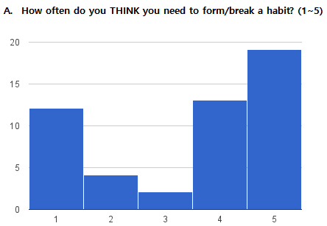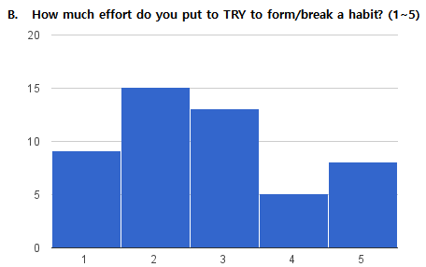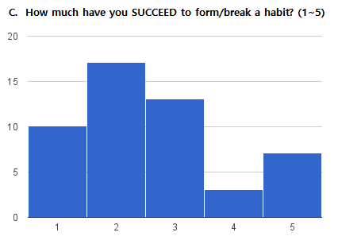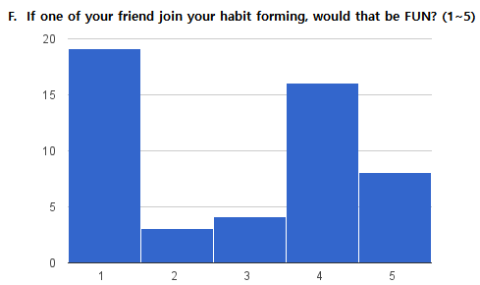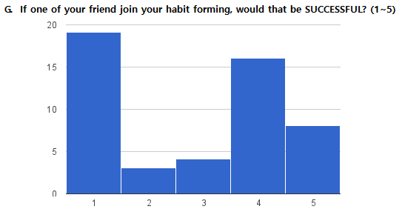

From those raw data, we need to know how much people are interested in our problem and solution set. Therefore, we set new criterion named ‘*Hapit score’*. Because each questions are not independent but related each other, Hapit score is calculated from 5 scores, (A+B-C+4)×(F+G) (scroe range from 2 to 130). High Hapit points is the case who has high desire to form a new habit(A), and tries much(B), but fails a lot(C). However, the one thinks that with the help of friends the process would be fun(F) and successful(G). The multiplier is needed to identify the people who thinks the problem is serious and also our solution is useful.

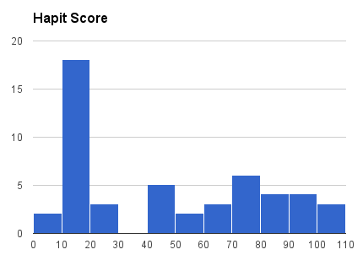

The results shows two main groups. Score (42~100), and score (2~28). The number of members of each group is 27 and 23.

We tried to focus on the previous group so that we can make what really users want. Statements below are some answers for Question ‘D. Tell me how hard or easy to form/break a habit for you.’

|  |
| --- |
| D. Tell me how hard or easy to form/break a habit for you |
| 막상 고치고 싶은 건 많은데 뜻대로 잘 안됨. |
| 무엇보다 확실한 비교대성이나, 시너지 효과를 낼 수 있는 대상이 부족해서 습관 개선이 좀 어렵다. |
| 무의식 중에 습관을 반복하고 있어 습관을 고치기 쉽지 않습니다. |
| A라는 행동을 하는 습관이 있고, 없애고 싶다고 했을 때, 습관이어서 내가 그 행동을 했는지도 모를 때가 종종 있었다. |
| 일단 개선해야겠다는 생각이 강하게 들지 않아 어려움 |
| 의지 부족으로 인해 상당히 어려움 |
| 습관은 이미 익숙해져서 나도 모르게 하고 있을 때가 많으므로 습관을 고치려면 일상생활에서 신경을 쓰고 있어야하는 것이 피곤하다. 그래서 어렵다. |
| ︙ |

In summary, our main targeted users tend to try to put some effort to change their behavior but due to lack of motivation or reminding, they fail soon. After the survey, we tried to set out primary goal to help motivating and reminding.

**Future Work**

We have not tested our service to open users yet. However, for future work we designed evaluation process. We set some key metrics that helps us to understand how our users use Hapit.

i. sign up

ii. set a first goal

iii. send reminders to friends

iv. achieve a goal in given date

v. invite friends

We will work on user studies to observe how Hapit really helps users achieve their goal both successfully and interesting.

**Conclusion**

Hapit seems to create new online system that users help their users improve themselves.