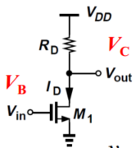 | 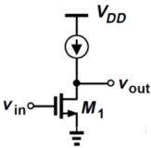 | 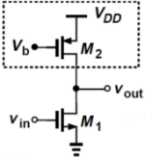 |  | 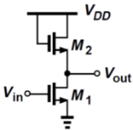$R_{in}=∞$ | 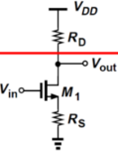
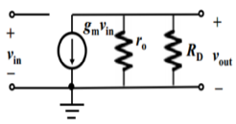 | 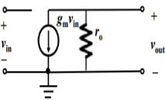 | 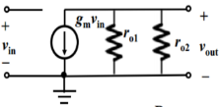 |  | 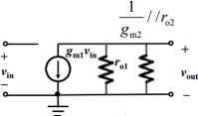 | 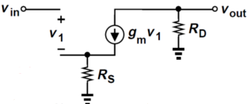
$$A=-g_{m}\left(r_{o}//R_{D}\right)$$ | $$A=-g_{m}r_{o}$$ | $$A=-g_{m}\left(r_{o1}//r_{o2}\right)$$ |  | $$A=-g_{m1}R_{out}≈-\frac{g_{m1}}{g_{m2}}$$ | $$A=\frac{-r_{o}g_{m}R_{D}}{r_{o}+r_{o}g_{m}R_{S}+R_{D}+R_{S}}≈-\frac{R_{D}}{R_{S}}=-G_{m}R_{out}$$
$R_{in}=∞$ $R_{out}=\left(r_{o}//R_{D}\right)$ | $R_{in}=∞$ $R_{out}=r_{o}$ | $R_{in}=∞$ $R_{out}=\left(r_{o1}//r_{D2}\right)$ |  | $$R_{out}=\left(r_{o1}//r_{D2}//\left(1/g_{m2}\right)\right)$$ | $$R_{out}=\left(\left(1+g_{m}r_{o}\right)R_{S}+r_{o}\right)//R_{D}$$
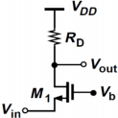 | 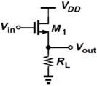 | 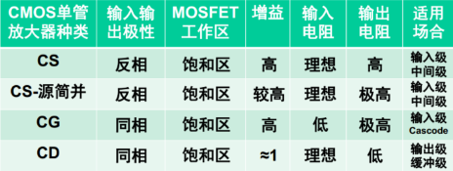 |  |  | 共源增益最大化：增加$g_{m}$（增加$W/L受限于速度，增加I_{D}受限于V_{dd}$）。增加$r_{o}（减小λ受限于工艺，减小I_{D}受限于g_{m}）$增加$R_{D}$受限于$V_{dd}$
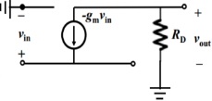 | 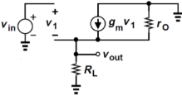 | 二极管$g_{D}=\frac{I_{D}}{V_{T}=0.026V}$ | 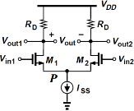共模抑制  $$CMRR=20log\left(1+2g_{m}R_{SS}\right)$$ |  | 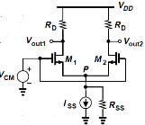 =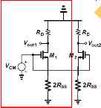
 |  | 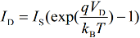
$$A=\left(R_{D}//r_{o}\right)\left(g_{m}+1/{r_{o}}\right)$$ | $$A=\frac{g_{m}\left(r_{o}//R_{L}\right)}{{1+g}_{m}\left(r_{o}//R_{L}\right)}≈1$$ | $$A\left(dB\right)=20log\left|A\right|$$ |  | 差模：$A=-g_{m}R_{D}$ | 共模：$A={g_{m}R_{D}}/{1+g_{m}R_{SS}}$半边分析
$$R_{in}=1/{g_{m}} R_{out}=R_{D}//r_{o}$$ | $$R_{out}=r_{o}//R_{L}//1/{g_{m}}$$ | $$r_{o}=1/{λI_{D}}$$ |  | $R_{outd}=r_{o}//R_{D}$， | $$R_{outd}=\left(2\left(1+g_{m}r_{o}\right)R_{SS}+r_{o}\right)//R_{D}$$
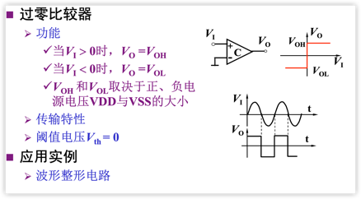
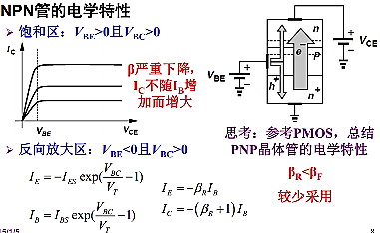

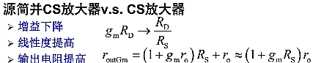
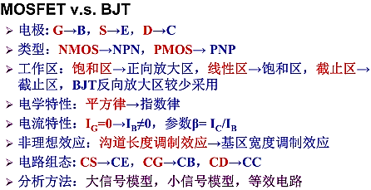
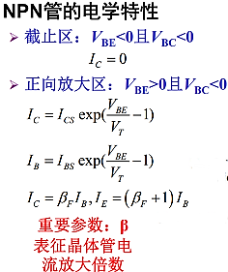
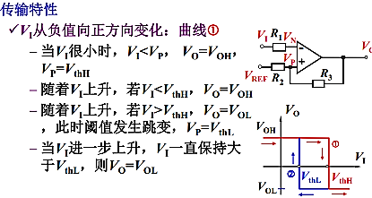
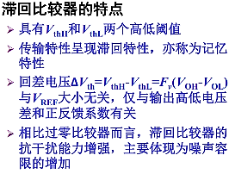
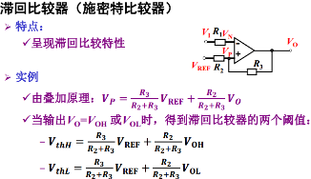
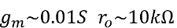
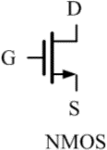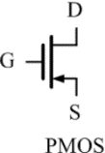

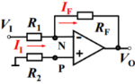 | 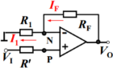 | 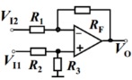
$$A=-{R_{F}}/{R_{1}}$$ | $$A=1+{R_{F}}/{R_{1}}$$ | $$A=-{V_{I2}R_{F}}/{R_{1}}+{R_{3}}/{\left(R_{2}+R_{3}\right)}\left(1+{R_{F}}/{R_{1}}\right)V_{I1}$$
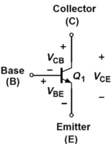
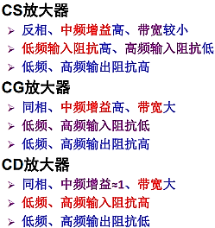
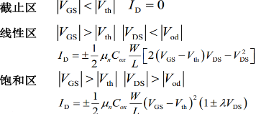
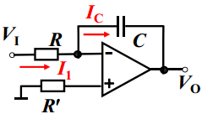 | 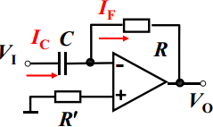
$$V_{O}=-\frac{1}{RC}\int_{0}^{t}{V\left(t\right)dt}+V_{O}\left(0\right)$$ | $$V_{O}=-RC{dV_{1}}/{dt}$$
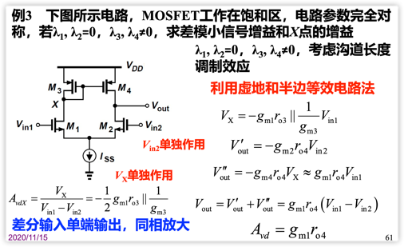
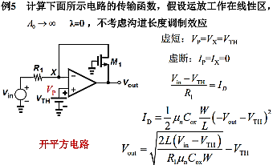
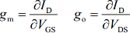
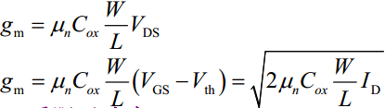

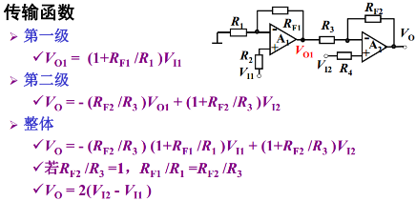
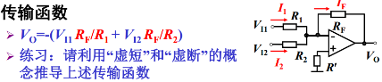
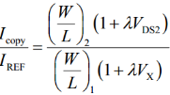
电流镜：
