AOI research:
Northwich is located in the low-lying plain of northwestern England, with a temperate maritime climate. Its annual average temperature is 10-11℃, annual precipitation is 800-900mm, and the annual humidity is relatively high, usually 70%-85%.

Definition of Extreme Temperature: Statistical outliers with low probability, exceeding the 95% confidence interval in the sequence of a region’s historical and future predicted temperatures.
The same relative threshold is adopted to judge extreme weather in Khaiwal, R and Larsen, S.H’s research.
References:
Khaiwal, R., Chauhan, P., Bhardwaj, S., Kumar, A. & Mor, S. (2026). Extreme temperature events and their relationship with excess all-cause mortality in Chandigarh, India. Scientific Reports, 16(1), 4113.
Larsen, S.H. & Nicholls, N. (2012). Addendum to Larsen and Nicholls 2012. Australian Meteorological and Oceanographic Journal, 62(2), 115.

Page1:
Extreme weather events account for approximately 5% of the total data volume.
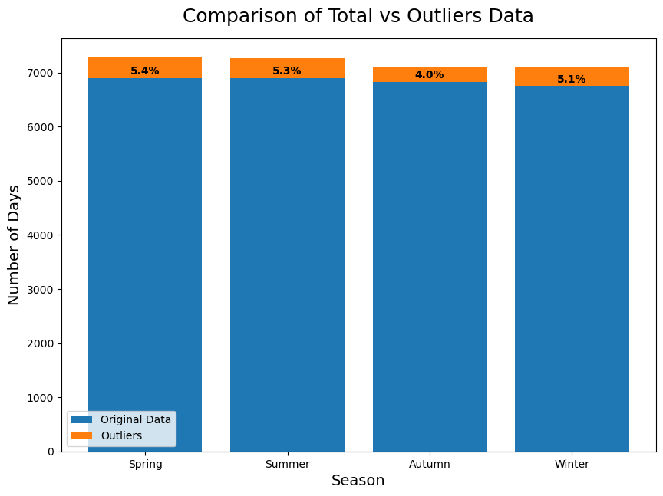
Page2:
During correlation analysis, it was found that Urban Maximum Temperature is highly correlated with Air Temperature, resulting in information redundancy. To eliminate multicollinearity, Urban Maximum Temperature was excluded to enhance the clarity of the analysis of other meteorological factors. Correlation coefficient.
- Eliminate multicollinearity
- Handle redundancy
- Enhance the clarity of analysis
Insights:
The correlation coefficients between Air Temperature and Urban Maximum Temperature are Spring>Autumn>Summer>Winte
speculated that the daily temperature range may increase.

Page3: Correlation Coefficient Heat Map
In spring, Air Temperature is highly correlated with Water Vapor Mixing Ratio and Net Solar Radiation, while it has a negative correlation with Net Longwave Radiation and Zonal Wind.
In autumn, the correlation between Air Temperature and other climate factors is similar to that in spring.
In summer, the correlation coefficient between Air Temperature and Water Vapor Mixing Ratio decreases significantly from 0.92 in spring to 0.68. It is weakly correlated with Net Solar Radiation, and Total Precipitation becomes a negative correlation factor.
In winter, Meridional Wind has an important correlation compared with other seasons, reaching 0.84, while Net Solar Radiation shows a significant negative correlation with a coefficient of -0.81. All climate factors have relatively high correlation coefficients with Air Temperature in winter, indicating that changes in these climate factors have a greater impact on winter temperatures than in other seasons.

