CampusGuard: Emergency Response Coordination
COS 214 Practical 5

Team Member Details
Full Name | Student Number
Zander Schoeman | U25097726
Chloe Larsen | U25004141
Lebogang Nxumalo | U05175552

System Description
CampusGuard is an emergency-response coordination platform for a university campus. It supports the full lifecycle of an incident, from the moment it is reported until it is resolved and closed, and coordinates the campus security, medical and facilities teams that must respond to it. The platform is responsible for:
- registering incidents and tracking their operational status as the response progresses;
- dispatching campus security, medical responders and facilities staff to an incident;
- issuing building-access actions such as locking, unlocking or restricting individual rooms as well as entire buildings;
- representing operator actions — dispatch, evacuation, alert and cancellation — as discrete, reusable requests;
- coordinating the response teams through a single point of coordination so that no team needs direct knowledge of every other team;
- integrating with the City's legacy emergency broadcast system, whose interface does not match the interface CampusGuard uses internally; and
- exposing a single high-level "lockdown" workflow that performs several subsystem operations in the correct order on behalf of the operator.
The system must behave as one coherent application: a single incident can be reported, escalated, responded to by several teams, trigger a building lockdown, and be broadcast externally, all through one consistent set of collaborating objects.

UML Class Diagram

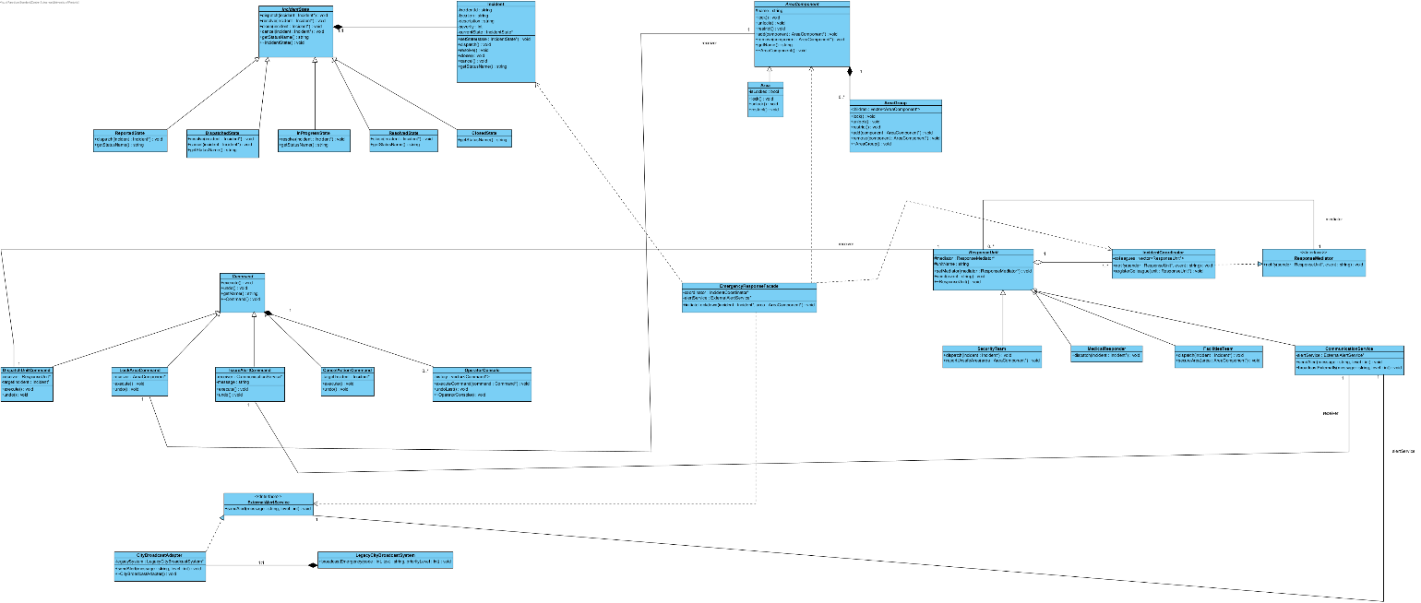

GoF Participant Mapping

1. Command
GoF Role | CampusGuard Classes
Command | Command (abstract base class)
ConcreteCommand | DispatchUnitCommand, LockAreaCommand, IssueAlertCommand, CancelActionCommand
Invoker | OperatorConsole
Receiver | ResponseUnit (SecurityTeam, MedicalResponder, FacilitiesTeam), AreaComponent, CommunicationService
Client | CampusGuardApp (creates commands and hands them to the OperatorConsole)

The OperatorConsole stores executed commands and can call undo() on the most recent one, which decouples the object that requests an action from the objects that know how to perform and reverse it.

2. Mediator
GoF Role | CampusGuard Classes
Mediator | ResponseMediator (interface)
ConcreteMediator | IncidentCoordinator
Colleague | ResponseUnit (abstract)
ConcreteColleague | SecurityTeam, MedicalResponder, FacilitiesTeam, CommunicationService

A colleague never calls another colleague directly. Instead it calls notify() on its ResponseMediator, and the IncidentCoordinator decides which other colleagues must react — for example, a SecurityTeam reporting an area as unsafe causes the coordinator to instruct FacilitiesTeam to lock the area and CommunicationService to alert other teams.

3. Adapter
GoF Role | CampusGuard Classes
Target | ExternalAlertService (interface)
Adaptee | LegacyCityBroadcastSystem
Adapter | CityBroadcastAdapter
Client | CommunicationService, EmergencyResponseFacade

LegacyCityBroadcastSystem exposes broadcastEmergency(code, text, priorityLevel), a signature that does not match the sendAlert(message, level) interface CampusGuard uses internally. CityBroadcastAdapter is an object adapter: it implements ExternalAlertService and translates each call into the equivalent call on its internal LegacyCityBroadcastSystem instance, converting the alert level into the legacy priority code and message format.

4. Facade
GoF Role | CampusGuard Classes
Facade | EmergencyResponseFacade
Subsystem classes | AreaComponent (Composite), IncidentCoordinator (Mediator), CommunicationService / ExternalAlertService (Adapter), Incident (State)
Client | CampusGuardApp / operator interface

EmergencyResponseFacade.initiateLockdown(Incident*, AreaComponent*) is the required multi-step operation: it (1) locks the given area through the Composite tree, (2) tells the IncidentCoordinator to dispatch the relevant response units, (3) transitions the Incident to its next State, and (4) sends an external alert through the Adapter. Each of these four subsystem operations remains independently callable — an operator can still lock a single room, dispatch one unit, or send one alert without going through the facade.

Two Additional GoF Patterns

5. State — Incident status
GoF Role | CampusGuard Class(es)
Context | Incident
State | IncidentState (abstract)
ConcreteState | ReportedState, DispatchedState, InProgressState, ResolvedState, ClosedState

Why State is a better choice than a simpler alternative: each ReportedState/DispatchedState/etc. object encapsulates exactly the transitions that are valid from that status and what the Incident should do when it enters or leaves that status (e.g. only a DispatchedState may transition to InProgressState). Adding a new status later means adding one new class, not editing a central conditional.
Role in the integrated workflow: commands such as DispatchUnitCommand and CancelActionCommand call incident->transitionTo(...), which delegates to the current IncidentState. The IncidentCoordinator (Mediator) is informed whenever the Incident's state changes and decides how the other colleagues should react, and EmergencyResponseFacade drives the Incident through several states in one lockdown workflow.

6. Composite — Campus areas and access control
GoF Role | CampusGuard Class(es)
Component | AreaComponent (abstract)
Leaf | Area (a single room or zone)
Composite | AreaGroup (a floor or building containing other AreaComponents)
Client | LockAreaCommand, EmergencyResponseFacade

Why Composite is a better choice than a simpler alternative: without it, client code would need to type-check whether it was holding a single room or a collection of rooms and loop accordingly wherever locking happens. Composite lets AreaGroup and Area both implement the same AreaComponent interface (lock(), unlock(), restrict()), so a LockAreaCommand or the Facade can call lock() on any node in the tree without knowing whether it is a leaf or a group; AreaGroup simply forwards the call to its children.
Role in the integrated workflow: EmergencyResponseFacade.initiateLockdown() calls lock() once on the top-level AreaComponent representing the affected building, which recursively locks every floor and room beneath it as part of the same multi-step facade operation that also involves the Mediator, the State-driven Incident, and the Adapter.

Associations, Inheritance, Multiplicities and Ownership
The table below lists every relationship that appears on the class diagram.
From | To | Relationship | Multiplicity (From : To) | Notes
ReportedState / DispatchedState / InProgressState / ResolvedState / ClosedState | IncidentState | Generalization | — | Concrete states inherit the abstract State
Incident | IncidentState | Composition | 1 : 1 | Incident owns exactly one current state and deletes it when replaced or destroyed
Area | AreaComponent | Generalization | — | Leaf inherits Component
AreaGroup | AreaComponent | Generalization | — | Composite inherits Component
AreaGroup | AreaComponent | Composition | 1 : 0..* | A group owns its children and deletes them in its destructor
DispatchUnitCommand / LockAreaCommand / IssueAlertCommand / CancelActionCommand | Command | Generalization | — | Concrete commands inherit the abstract Command
OperatorConsole | Command | Composition | 1 : 0..* | The console owns its command history and deletes executed commands it still holds
DispatchUnitCommand | ResponseUnit | Association | 1 : 1 | Command holds a pointer to its receiver, not ownership
LockAreaCommand | AreaComponent | Association | 1 : 1 | Command holds a pointer to its receiver, not ownership
IssueAlertCommand | CommunicationService | Association | 1 : 1 | Command holds a pointer to its receiver, not ownership
SecurityTeam / MedicalResponder / FacilitiesTeam / CommunicationService | ResponseUnit | Generalization | — | Concrete colleagues inherit the abstract Colleague
IncidentCoordinator | ResponseMediator | Realization | — | Concrete mediator implements the Mediator interface
IncidentCoordinator | ResponseUnit | Aggregation | 1 : 1..* | Coordinator references colleagues but does not own or create them
ResponseUnit | ResponseMediator | Association | 0..* : 1 | Every colleague holds a reference back to its mediator
CityBroadcastAdapter | ExternalAlertService | Realization | — | Adapter implements the Target interface
CityBroadcastAdapter | LegacyCityBroadcastSystem | Composition | 1 : 1 | Adapter owns and creates its own Adaptee instance
CommunicationService | ExternalAlertService | Association | 1 : 1 | Colleague forwards external alerts through the Target interface
EmergencyResponseFacade | AreaComponent | Dependency | — | Facade calls lock()/unlock() on a referenced area tree
EmergencyResponseFacade | IncidentCoordinator | Dependency | — | Facade calls the mediator to dispatch response units
EmergencyResponseFacade | Incident | Dependency | — | Facade drives the incident through its states
EmergencyResponseFacade | ExternalAlertService | Dependency | — | Facade sends an external alert as part of the workflow

Ownership summary
- Incident owns its current IncidentState and replaces/deletes it on every transition.
- AreaGroup owns the AreaComponent children added to it and deletes them in ~AreaGroup().
- OperatorConsole owns the Command objects in its history and deletes them once they are no longer needed for undo.
- CityBroadcastAdapter owns its internal LegacyCityBroadcastSystem instance (created in the adapter's constructor, deleted in its destructor).
- IncidentCoordinator does not own its ResponseUnit colleagues; they are created and owned by CampusGuardApp and only referenced by the mediator and by each other through the mediator.
- EmergencyResponseFacade owns nothing; every subsystem object it uses is created and owned elsewhere and simply passed or referenced by the facade.
- Every polymorphic base class — Command, IncidentState, AreaComponent, ResponseUnit, ResponseMediator, ExternalAlertService — declares a virtual destructor so that deleting through a base pointer correctly runs the derived destructor.

How the Six Patterns Interact
The patterns are not six independent demonstrations; they meet inside one workflow:
- An operator action is created as a Command (e.g. DispatchUnitCommand) and handed to the OperatorConsole (Invoker), which executes it against a ResponseUnit (Receiver).
- Executing that command changes an Incident's status by calling into its current IncidentState (State), which decides whether the transition is legal and what the new status is.
- Whenever a colleague's status or situation changes, it notifies the IncidentCoordinator (Mediator) rather than contacting other teams directly; the coordinator decides which other ResponseUnits or the CommunicationService must react.
- When an area must be secured, the command or the facade calls lock() on the relevant node of the AreaComponent tree (Composite); if that node is a whole building, the call recurses through every floor and room automatically.
- When an alert must leave the campus network, CommunicationService forwards it through the ExternalAlertService interface, which CityBroadcastAdapter (Adapter) translates into a call the legacy LegacyCityBroadcastSystem understands.
- EmergencyResponseFacade.initiateLockdown() ties all of this together in one call: it locks a Composite area, asks the Mediator to dispatch units, drives the Incident through its State machine, and raises an external alert through the Adapter — one facade operation coordinating four subsystem operations across four different patterns.
This means a single end-to-end scenario — an incident being reported, escalated through its states, triggering a coordinated multi-team response, a building-wide lockdown, and an external broadcast — exercises all six required and chosen patterns in one coherent execution flow, satisfying the requirement that at least one scenario involve four or more patterns together.

