Retail Sales Time Series
Statistical Diagnostic Report
January 2015 – December 2024 | 120 Monthly Observations

Executive Summary
Diagnostic Item | Result | Implication
Forecastability | Forecastable (p ≈ 0) | Strong predictable structure — worth modeling
Stationarity | Non-stationary (d = 1) | First differencing required before modeling
Seasonality | Yes — Period = 12 months | Strong annual cycle (STL strength: 0.946)
Trend | Strong increasing | Sustained upward growth (STL strength: 0.984)
Transform | None needed | Box-Cox λ ≈ 1.03, variance is stable

1. Data Overview
Metric | Value
Observations | 120
Date Range | 2015-01-01 to 2024-12-01
Frequency | Monthly
Missing Values | 0 (0%)
Mean | 87,131
Median | 88,525
Std Dev | 22,759
Min / Max | 33,927 / 134,022
Skewness | -0.09 (approximately symmetric)
Kurtosis | -0.72 (platykurtic — flatter than normal)

1.1 Time Series Plot
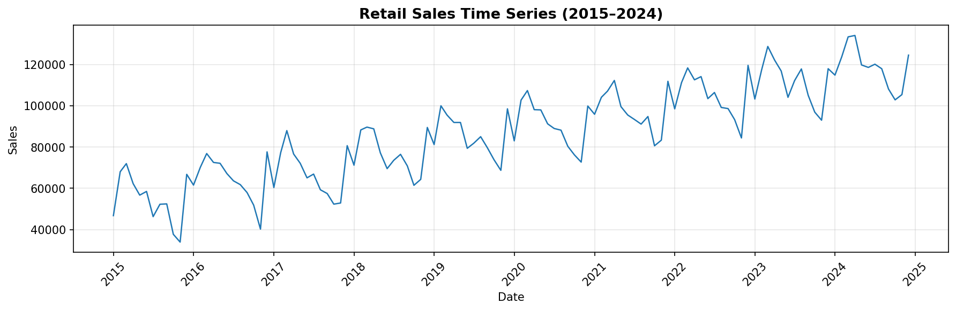
Figure 1. Monthly retail sales 2015–2024. Clear upward trend with repeating seasonal pattern.

1.2 Rolling Mean & Standard Deviation
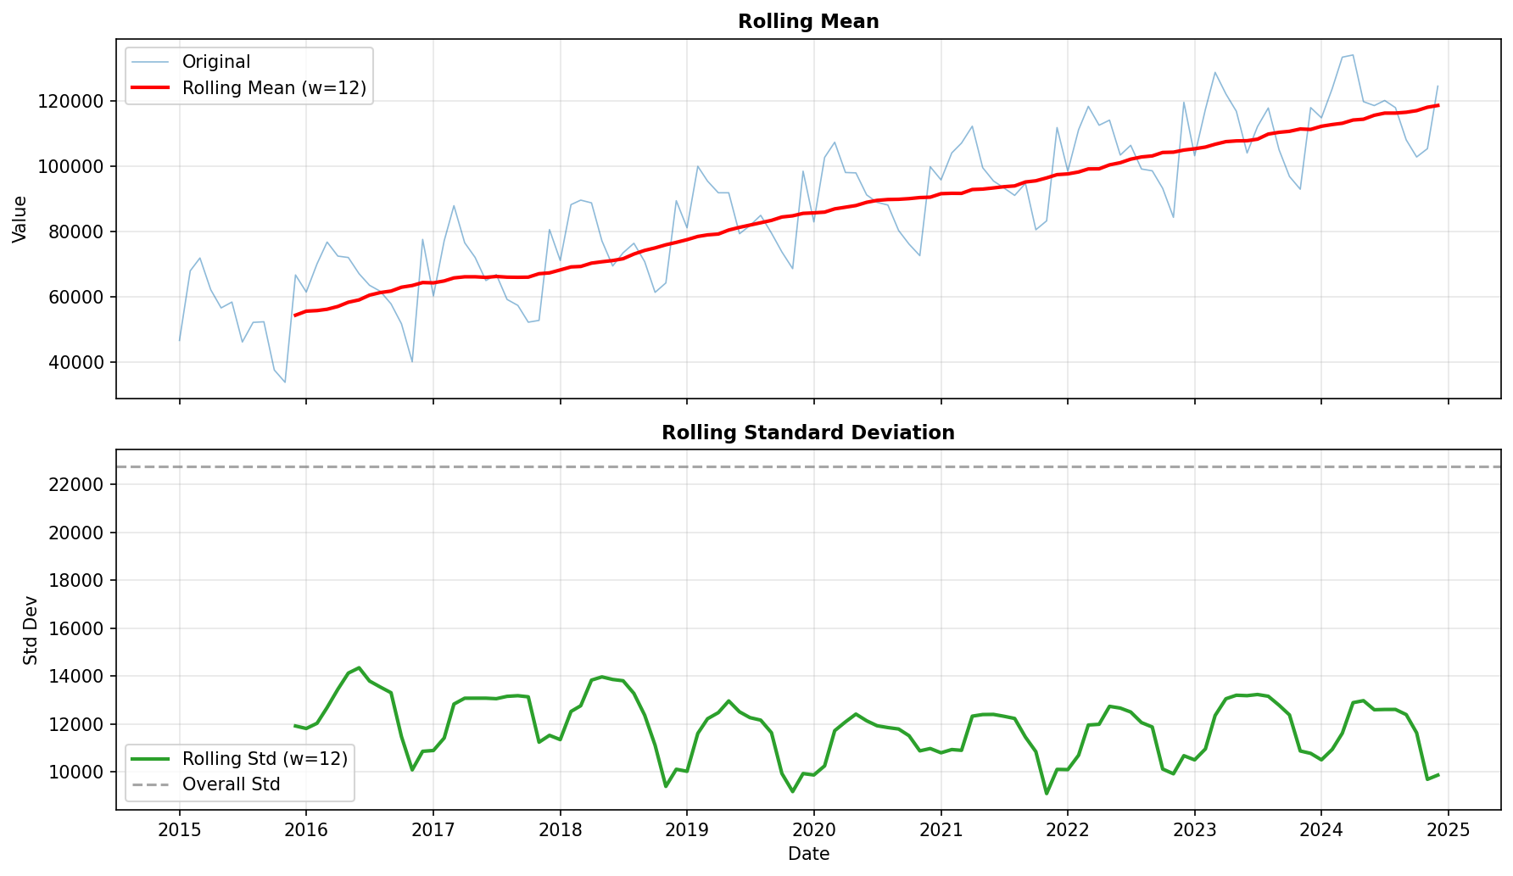
Figure 2. Rolling window = 12 months. Rolling mean rises steadily; rolling std is relatively stable — no variance instability detected.

2. Forecastability
The Ljung-Box test detects whether the (differenced) series contains any autocorrelation structure beyond white noise. A significant p-value means the series is predictable.

Lag | p-value | Conclusion
10 | < 0.0001 | Reject white noise — predictable structure
20 | < 0.0001 | Reject white noise — predictable structure
24 | < 0.0001 | Reject white noise — predictable structure

- The series is highly forecastable — all Ljung-Box p-values are essentially zero.
- Forecasting models (e.g., SARIMA, Holt-Winters, Prophet) will find meaningful structure to exploit.

3. Stationarity Analysis
Test | Statistic | p-value | Conclusion
ADF — original series | -0.6415 | 0.8613 | Non-stationary
KPSS — original series | 1.6810 | < 0.01 | Non-stationary
ADF — first difference (d=1) | Significant | < 0.05 | Stationary ✓

- Both ADF and KPSS agree: the original series is non-stationary.
- First differencing (d = 1) is sufficient to achieve stationarity — verified by ADF on the differenced series.
- ACF and PACF analysis (Section 6) was performed on the differenced series.

4. Seasonality
Metric | Value
Seasonal | Yes
Period | 12 months (annual cycle)
Seasonal Strength (STL) | 0.946 — strong

STL decomposition reveals a strong annual seasonal cycle. The seasonal component alone explains a large fraction of the month-to-month variation.

4.1 Distribution by Month
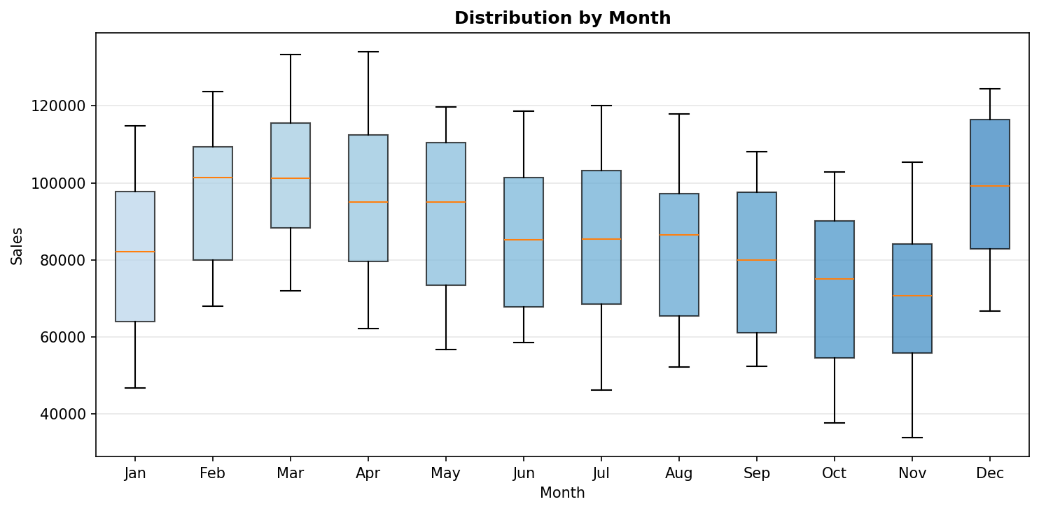
Figure 3. Monthly box plots. Sales peak in March–April and dip in October–November, consistent with a 12-month seasonal pattern.

4.2 STL Decomposition
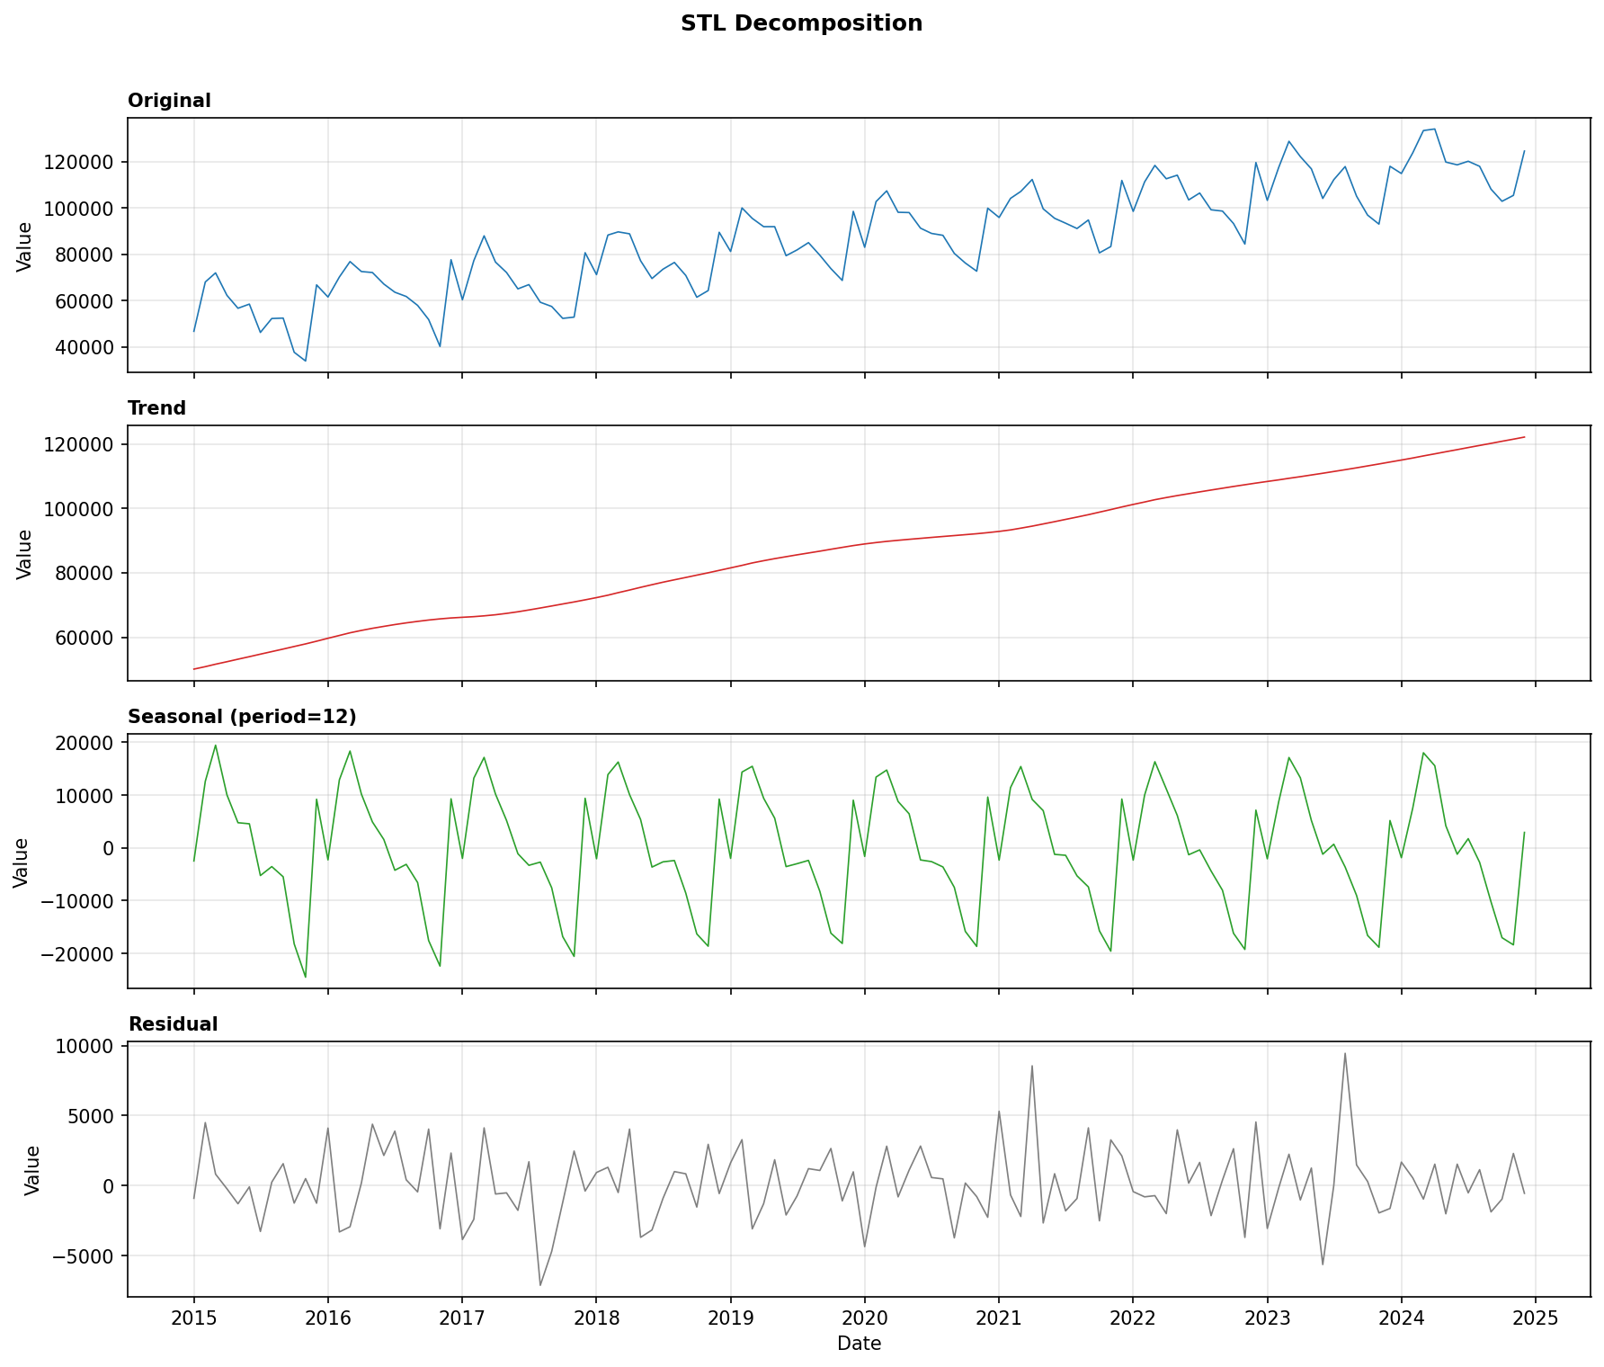
Figure 4. STL decomposition into trend, seasonal (period=12), and residual. The seasonal component is regular and consistent.

5. Trend Analysis
Metric | Value
Has Trend | Yes
Direction | Increasing
Trend Strength (STL) | 0.984 — very strong

The trend component dominates the series. Sales grew from approximately 50,000 in early 2015 to over 130,000 by late 2024 — roughly a 140% increase over the decade. The growth is steady and uninterrupted.

6. Autocorrelation Analysis (on Differenced Series)
Type | Significant Lags
ACF | 1, 6, 11, 12, 24, 30, 36
PACF | 1, 6, 7, 8, 9, 10, 11, 12, 13, 14

- ACF shows strong seasonal spikes at lags 12, 24, 36 — confirming the 12-month annual cycle.
- Non-seasonal ACF decays after lag 1–2, suggesting a low-order MA component.
- PACF cuts off at lag 1 (non-seasonal), indicating AR(1) as a reasonable starting point.
- Seasonal PACF structure around lag 12 suggests seasonal AR(1) — P = 1.

6.1 ACF and PACF Charts
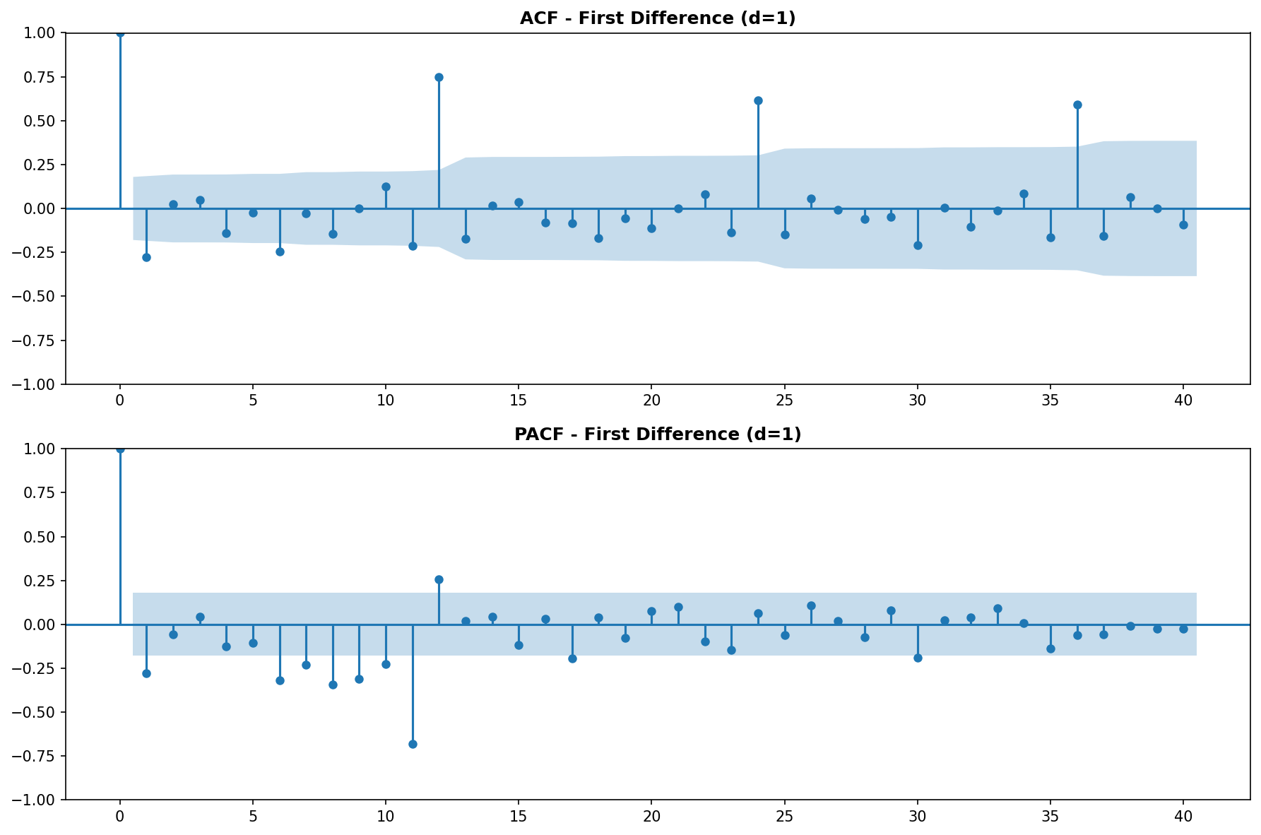
Figure 5. ACF and PACF on first-differenced series. Seasonal lags 12, 24, 36 are clearly significant in ACF.

6.2 Lag Scatter Plots
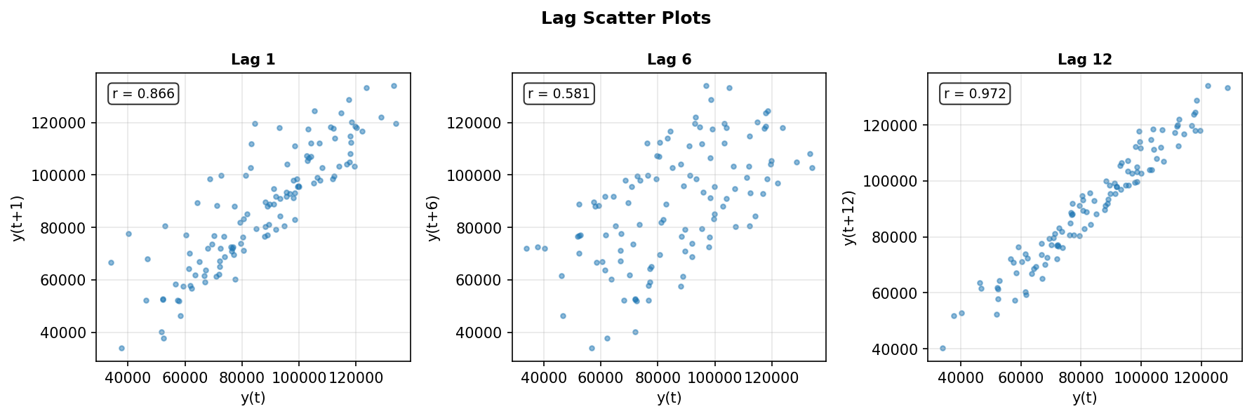
Figure 6. Lag scatter plots at lags 1, 6, and 12. Strong linear correlation at lag 12 (r = 0.89) confirms annual seasonality.

7. Transform Recommendation
Metric | Value
Box-Cox optimal λ | 1.0256
Variance stable | Yes
Recommendation | No transformation needed

Since Box-Cox λ ≈ 1, the variance is homogeneous across time. No logarithmic or square-root transformation is required. Models may be fit directly on the original scale.

8. Modeling Recommendations
Based on the full diagnostic profile — strong trend, strong 12-month seasonality, non-stationarity (d=1), forecastable structure, and stable variance — the following approaches are recommended:

- SARIMA(p, 1, q)(P, 1, Q)[12]: Canonical choice. Start with SARIMA(1,1,1)(1,1,1)[12] and refine using AIC/BIC. ACF/PACF suggest low-order AR and MA terms.
- Holt-Winters (Triple Exponential Smoothing): Additive or multiplicative seasonal version. Robust, interpretable, and well-suited for monthly business data with trend + seasonality.
- Facebook Prophet: Handles trend breaks, holidays, and seasonality automatically. Good for business forecasting with irregular patterns.
- No transformation needed: All models should be fit on the original scale. No log or sqrt pre-processing required.

Report generated using the analyzing-time-series skill. All charts produced by visualize.py (STL, ACF/PACF, rolling stats, lag scatter).

