Project Report

Travis Kelce Performance Effected by Taylor Swift

Chloe Adams & Rachel Redeker

**1. Introduction**

Taylor Swift has been spotted attending Kansas City Chief’s games among rumors of dating tight end Travis Kelce. Their new budding relationship has now been dominating pop culture and conversations everywhere. Many Swifties and football fans have been in debate on who is “bigger”, the NFL or Taylor Swift? Swifties and football fans represent a large and often mutually exclusive portions of the population.

This project aims to analyze Travis Kelce’s performance through the lens of Taylor Swift. We want to see how Taylor Swift and their relationship has motivated or changed Kelce’s performance. We also want to analyze the relationship between Arrowhead Stadium attendance and Taylor Swift popularity. Specifically, we want to analyze Kelce’s performance since they have been dating compared to the previous season, how his game performance changes when Taylor is in attendance, and how the Chief’s attendance at Arrowhead has changed when she is in attendance.

**2. Data**

This project uses four data sources:

1. Pro-Football Reference
   1. Collects game statistics on Travis Kelce
2. ESPN
   1. Collects average attendance for each stadium
3. Fooballvn
   1. Collects average attendance for Germany game stadium
4. People Magazine
   1. Contains information on the progression of Travis and Taylor’s relationship

2.1 Travis Kelce Stats

Our main data source for this analysis is [Pro-Football-Reference.com](https://www.pro-football-reference.com/players/K/KelcTr00/gamelog/2022/) which is an American football website that contains data on football players starting in the year 1920. This website contains data on the Kansas City Chiefs down to each player's stats. We used the player specific page to get the stats and performance of Travis Kelce from this current season (2023) and the past season (2022). To obtain this data, we scraped the 2023 season Travis Kelce statistics page and the 2022 Kelce statistics page individually which was done in the *2023SeasonScraping.R* and *2022SeasonScraping.R* files respectively. We were unable to crawl the data together because the pagination between the two seasons was not sequential. From the statistics page on each season, we scraped the variables of date, opponent, result, targets, receptions, catch percentage, yards, touchdowns, and the URL that took us to the individual game page. Since we grabbed the URL in the initial scrape, we also looped through each URL to get the attendance of each game and the stadium the game was played in. This scraping left us with two data frames, one consisting of the current season data (2023) and one of the past season data (2022).

The variables we collected needed some cleaning in which we removed commas and percentage signs, so we could change them into numeric values. We also split up the result column to a score variable and whether the chiefs won variable. We further renamed some of the columns and some cell values to enhance clarity, ensuring that we had the same values and column names between the 2022 and 2023 season data frames. After we finished cleaning all the data from both data frames, we created a new column in both datasets called season. This variable referenced which season the data was from, allowing us to easily differentiate between the season the stats were collected from for when we combine the 2022 and 2023 stats into one dataset. This cleaning on each data frame was further done in the *2023SeasonScraping.R* and *2022SeasonScraping.R* files. We wrote two csv files, *current_season_df.csv* and *past_season_df.csv* which contained the clean data of both the 2023 and 2022 season data on Travis Kelce.

Our data for the 2023 season was collected when there were eight games completed so far in the season. Therefore, this analysis can be easily updated by rerunning the scraping file for the 2023 season at the end of the season when all the games are completed.

2.2 Stadium Average Attendance

Our second data source came from [ESPN](https://www.espn.com/nfl/attendance). We used this source to find the average football attendance for each stadium in our analysis. Due to its complexity in not stating the stadium name but rather the home team name we collected the data manually and created a csv file with each stadium that games were played in for the 2022 and 2023 season. One trouble we faced was finding the average attendance for the Miami vs. Chiefs game this season where they played in Germany. To find the average attendance for this stadium we used the [footballvn](https://www.footballvn.org/grounds/germany/waldstadion/) website to find average attendance for the Deutsche Bank Park stadium. We considered this attendance value an outlier because it was the first NFL game ever played there suggesting that the attendance may be skewed for this reason and above the average value found for this stadium. The csv file that contains this data from ESPN and Footballvn is the file *stadium_attendance.csv*.

2.3 Combining 2022 and 2023 Season Stats and Stadium Average Attendance

After collecting all this data, we then vertically merged the 2022 and 2023 Travis Kelce season data. The merge went very smoothly as we already did the cleaning in their respective files earlier to ensure all the column names were matched. After having a combined season data frame, we then horizontally merged this data frame with the stadium attendance dataset that we obtained from ESPN and Footballvn. We merged these datasets on the stadium column which was the same for both datasets. This allowed us to obtain the average attendance column for each stadium. All this merging discussed in this paragraph took place in the *MergingSeasonData.R file*. With this newly merged data set containing all of Travis Kelce Stats and average stadium attendance, we output a csv file called *merged_football_data.csv*.

2.4 Taylor and Travis Relationship Timeline

Our final data source for this analysis was [people.com](https://people.com/taylor-swift-and-travis-kelce-relationship-timeline-7974203). We used this source to find information on Taylor and Travis’s relationship and the key moments. Through this source we found information about their relationship like when they started dating, when Taylor attended the Chief’s games, when she met Travis’s mom, and much more. Due to its non-numeric information, we manually collected and summarized findings to put in a csv file for each date that the information occurred. We put the highlights of their relationship in the date of the game it occurred before so that we could see what was happening in their relationship as we analyzed Kelce’s performance statistics. The csv file that contains this data from people.com is the file *taylortimeline.csv*.

2.5 Merging football data and Taylor and Travis Relationship Timeline

We finally merged the football data with the timeline of Taylor and Travis’s relationship to add Taylor Swift into the analysis. We did this by horizontally merging the football data with the relationship timeline data using the date column in which the two datasets have in common. By merging this data together, we got our final merged dataset that we will use in our analysis. This merging took place in the *MergingSeasonAndTaylorTimeline.R* file. We also output a csv file that contains our final dataset called the *travisandtaylor.csv.*

*Table 1 Data Dictionary*

|  |  |  |  |
| --- | --- | --- | --- |
| **Column** | **Type** | **Source** | **Description** |
| date | Date | Pro-Football Reference | Date of Kansas City Chiefs game |
| stadium | Text | Pro-Football Reference | Stadium the Kansas City Chiefs game was played in |
| opponent | Text | Pro-Football Reference | Opponent the Kansas City Chiefs played against |
| result | Text | Pro-Football Reference | Win/Loss result of the Kansas City Chiefs game |
| score | Text | Pro-Football Reference | Score of the Kansas City Chiefs game |
| targets | Numeric | Pro-Football Reference | Targets Travis Kelce had in the game |
| receptions | Numeric | Pro-Football Reference | Receptions Travis Kelce had in the game |
| catch percentage | Numeric | Pro-Football Reference | Percentage of catches Travis Kelce had in the game out of total targets |
| yards | Numeric | Pro-football Reference | Receiving yards Travis Kelce had in the game |
| touchdowns | Numeric | Pro-Football Reference | Touchdowns Travis Kelce scored in the game |
| attendance | Numeric | Pro-Football Reference | Actual attendance of the game |
| season | Text | Derived from Pro-Football Reference | Season that the game occurred (2022 or 2023) |
| average attendance | Numeric | ESPN and footballvn | Average football attendance in the stadium that the game was played as of 2023 season |
| dating | Text | People | Yes/No value stating whether Taylor and Travis are dating |
| taylor in attendance | Text | People | Yes/No value stating whether Taylor attended the game |
| timeline | Text | People | Taylor Swift and Travis Kelce timeline of events stating important points of their relationship |

**3. Analysis**

3.1 Kelce Performance Since Dating

Kelce has played in 25 games in the 2022 and 2023 seasons excluding the 2022 season playoffs, 7 of which he and Taylor have been dating for. We split up the data by if they were together or not to compare the differences in Kelce’s performance when dating Taylor.

The first factor we compared was his average receptions. His average receptions while dating Taylor was 7.6 while the average for when they weren’t dating was 6.3 receptions. While dating Taylor, Kelce’s average receptions increased by 20.6% as shown in the bar chart below.

Figure 1: Receptions When Dating Taylor

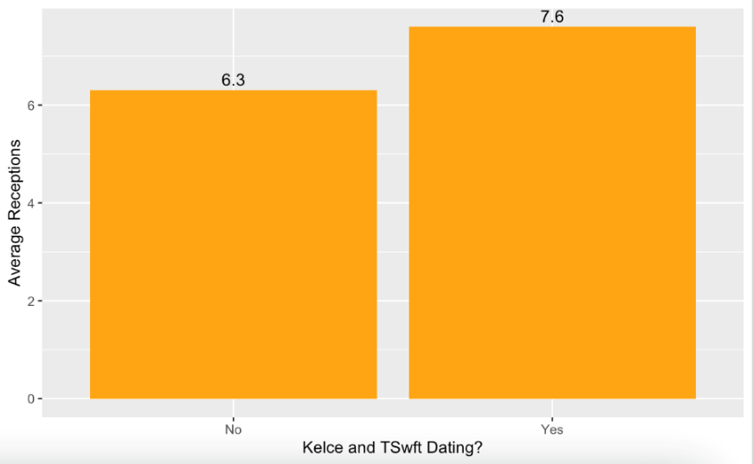

The next performance factor we analyzed was Kelce’s catch percentage when dating Taylor vs not dating Taylor. Kelce caught an average of 82.7% of the catches while dating Taylor but only caught an average of 71.3% before they were dating. Kelce’s average catch percentage performance increased by 15.9% while dating Taylor Swift as show in the boxplot below.

Figure 2: Catch Percentage When Dating Taylor

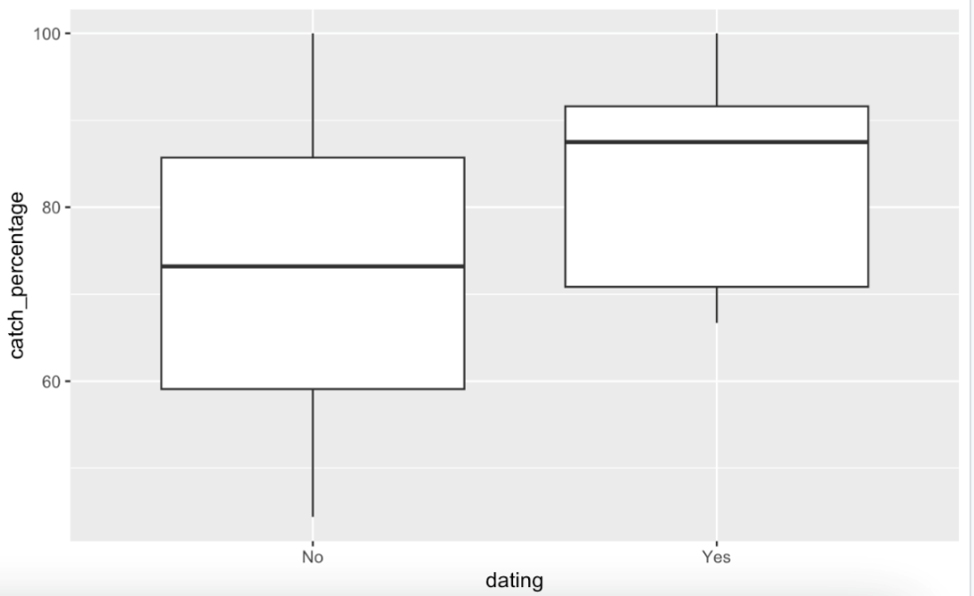

Next, we compared Kelce’s yards gained before dating Taylor and while dating Taylor. He averaged 81.6 yards while dating Taylor but only 75.8 yards before dating her. This constitutes a 5.8 increase in average yards gained when dating Taylor as visualized below.

Figure 3: Yards When Dating Taylor

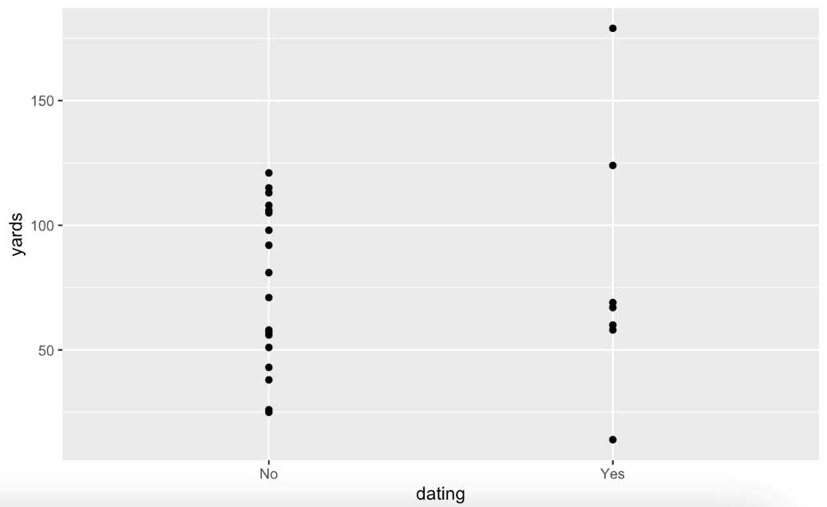

Touchdowns were the final factor we used to compare his performance before and while dating Taylor Swift. This was the only factor that showed Kelce performing better before dating Taylor. His average touchdowns were 0.7 per game before dating Taylor whereas they are 0.4 per game while dating her. The average touchdowns while and before dating Taylor are shown in the bar graph below.

Figure 4: Touchdowns While Dating Taylor  
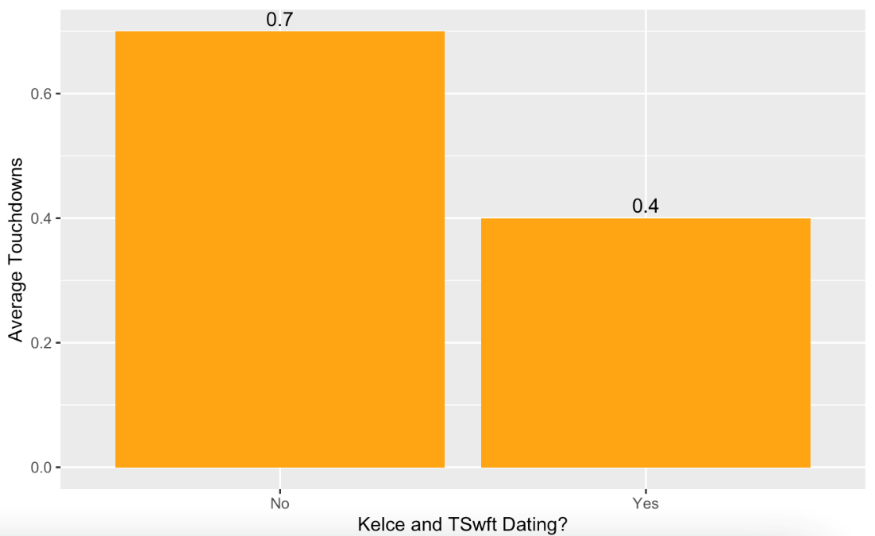

3.2 Kelce Performance when Taylor is in Attendance

Taylor Swift has attended 4 out of 8 games that the Chiefs have played so far, this 2023 season. The first Chief’s game she attended was on September 24, 2023, at Arrowhead against the Bears. This game stirred up massive attention to their new and budding relationship. For this analysis question we compared Kelce performance statistics with Taylor being in attendance vs when Taylor was not in attendance.

We will first compare his receptions without Taylor in the stadium to his receptions when Taylor was there. We created a summary table and used it to create a bar chart of his average receptions based on if Taylor was there or not. Kelce had average receptions of 8.5 when Taylor was in attendance and an average of 5.8 receptions when she wasn’t there. This constitutes a 46.55% increase in receptions between Taylor being in attendance and not being there which is shown in the bar graph below.

Figure 5: Receptions if Taylor Attended

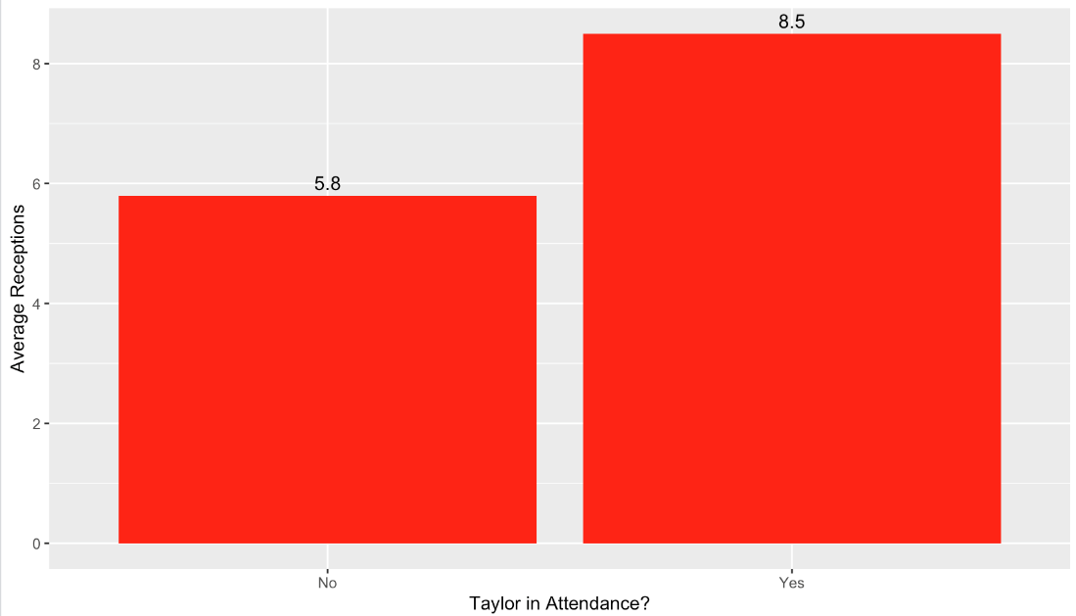

We then analyzed Kelce’s catch percentage based on if Taylor was there or not. We created a summary chart again and then used the table to create a box plot that shows his catch percentages split by if Taylor was in attendance to be able to visualize the difference in quartiles. His average catch percentage while Taylor was there was 86.6% while when she wasn’t in attendance his average catch percentage was only 69.2%, constituting a 25.14% average increase in this statistic while Taylor attended Kelce’s games.

Figure 6: Catch Percentage if Taylor Attended

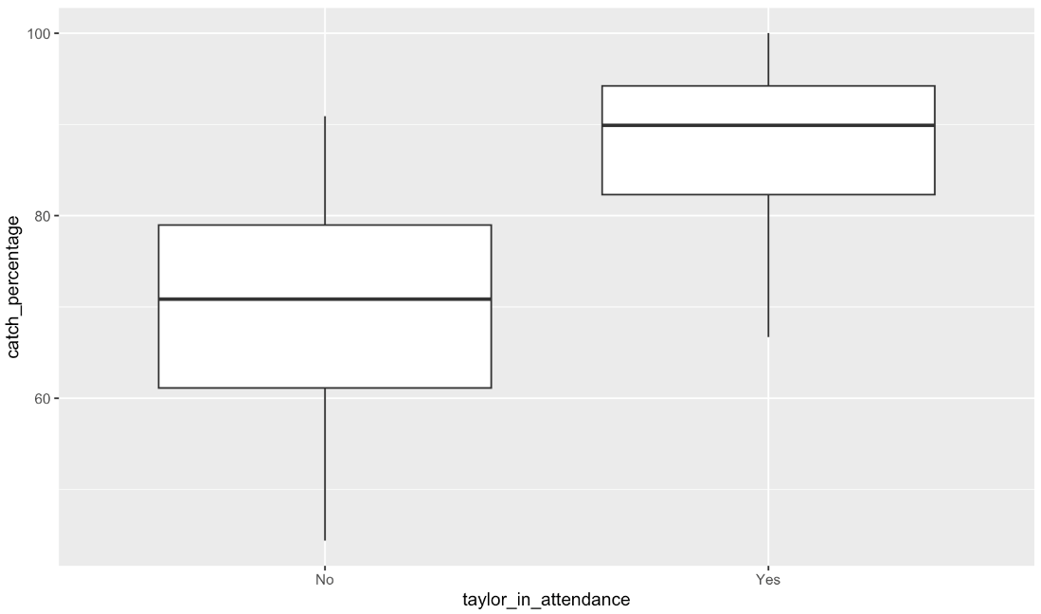

The next performance factor we analyzed was yards Travis had in the game, again based on if Taylor was in the audience or not. The average amount of yards Travis got while Taylor was there was 108 which is more than double the 41.2 average yards he had when Taylor wasn’t there as showed in the figure below.

Figure 7: Yards if Taylor Attended

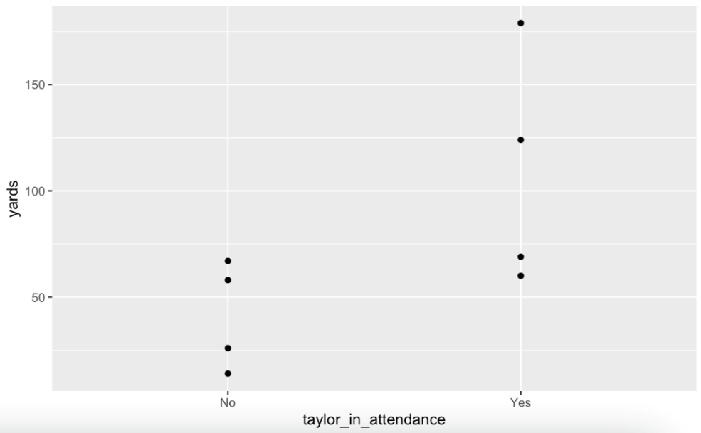

The last performance factor we analyzed was the number of touchdowns Travis scored during the games. Again, we created a summary chart which was then made into a bar chart. Kelce’s average touchdowns when Taylor was there and when Taylor was not there was 0.5 regardless of if Taylor was there or not. You can see these findings summarized in the bar graph below.

Figure 8: Touchdowns if Taylor Attended

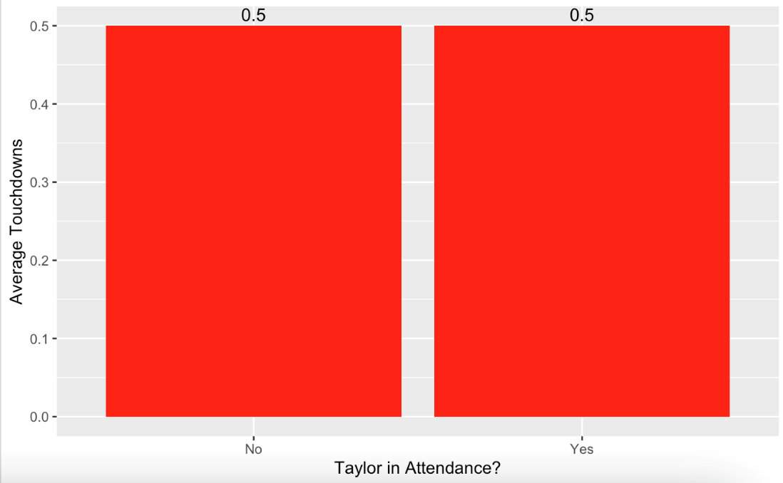

3.3 Taylor Swift effect on Arrowhead attendance when in attendance

To analyze the data for this question we compared the average attendance of Arrowhead stadium in the current season against the actual attendance for the games that Taylor attended. The average attendance was 68,855 while the attendance when Taylor is there was between 73,528 to 73,632 people. This shows that the games Taylor attended had higher stadium attendance compared to the average.

Figure 9:

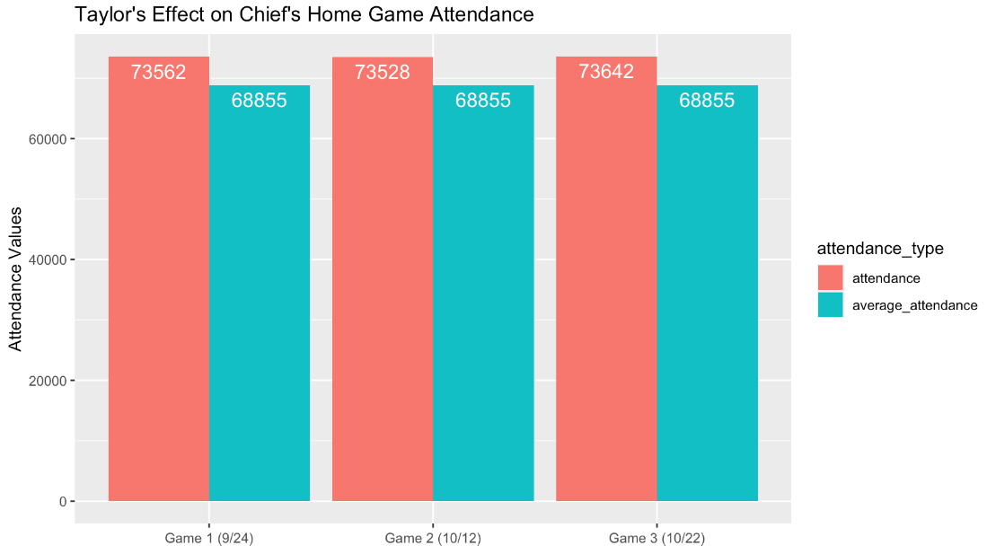

All of our visualizations were created in the r file called *Visualizations.R.*

**4. Conclusion**

In this project, we analyzed the performance of Kelce and the Chiefs through the lens of Taylor Swift. We investigated how Kelce’s performance and game statistics have changed since dating Taylor, how they have changed when Taylor is in attendance, and how Arrowhead attendance compares when Taylor is at the game. From our analysis questions, we found the following results:

1. How has Travis Kelce’s football performance changed since rumored to be dating Taylor Swift?
   1. Travis Kelce’s football performance has improved in average receptions, catch percentage, and average yards since rumored to be dating Taylor Swift. However, he has not improved in touchdowns per game, and has decreased to 0.4 per game as compared to 0.7. This suggests overall improvement in his performance while dating Taylor.
2. How has Travis Kelce’s football performance changed when Taylor Swift was in attendance?
   1. Travis Kelce’s football performance has improved in average receptions, catch percentage, and average yards while Taylor was in attendance. Average touchdowns per game is unchanged regardless of if Taylor was there. This suggests improvement in his performance when Taylor is in attendance and that she may be his good luck charm.
3. How has attendance at Arrowhead changed when Taylor Swift is in attendance?
   1. Attendance when Taylor is in attendance is at least 5,000 more people than the average attendance of the 2023 season in arrowhead suggesting that she may have impacted arrowhead attendance.

Overall, Travis Kelce’s statistics have improved since dating Taylor Swift, however, correlation does not equal causation. Our analysis suggests that Taylor might be Kelce’s good luck charm when it comes to his performance. We would need more data and evaluate other variables that may have increased Kelce’s football performance to have a better idea of how Taylor specifically impacted his performance.

Attendance has also increased at Arrowhead Stadium; however, we cannot conclude that Taylor is the exact reason that it has increased. People have mixed feelings about the attention she is bringing to the NFL, some say the attention she is bringing is detracting from the football (cameras constantly cutting to her watching the game rather than the game itself) while others believe it is helping bring more demographics to the sport.

**5. Limitations & Future Work**

This project has several limitations, including the lack of games in the 2023 season so far to analyze, the Chiefs game that was in Germany, and the inability to tie Kelce’s performance and attendance directly to Taylor. Future work on this project could include finding more sources and variables to create a more complete dataset of features that may have impacted Kelce, analyzing the online viewership of the game to see how their relationship affects viewership and not just attendance, and analyzing Kelce statistics for the whole 2023 season which gives us more information to make assumptions and see how Kelce and Taylor’s relationship more accurately have impacted Kelce’s performance.