# Portfolio/Personal website SDLC

## Requirement Analysis

* Needs to be a convenient and intuitive way to access information about me, and examples of my work
* Needs to display other personal projects that I’m proud of/want to show off, but aren’t necessarily ‘professional’, ie, my car repair album
* Want to demonstrate my knowledge of the frameworks/libraries/languages involved to the best of my ability
  + Accessibility is cool and good – the site should strive to meet accessibility standards
  + Show knowledge – use my own css and components as much as possible
* Need something fast – can improve on it later
* Need something pretty – can customise and improve in later iterations on the site
* Needs to make me look employable.
  + Demonstrate potential
* Trickle personality into design and the copy
  + Where im coming from, where I want to go
* Show I that I appreciate and have acumen for design / UI / UX.

## Planning/Design

* One page app
  + Initially displays basic info about me / blurb
* Need something fast – can improve on it later
* Need something pretty – can customise and improve in later iterations on the site
* Multiple stages, this allows the website to get off the ground fast.
  + Stage 1: Core info/functionality
  + Stage 2: Redesign aesthetics, review functionality
* I like and am familiar with react, and this will allow me to build a simple site while later iterating to make it more up to date as style trends/my tastes/and importantly my skills improve.
  + Also allows for me to use the site to build little fun components for both skills demonstrations / home projects
* Free hosting on GitHub
* Can deploy react projects to GitHub pages quickly and efficiently with ghpages npm package

## Development

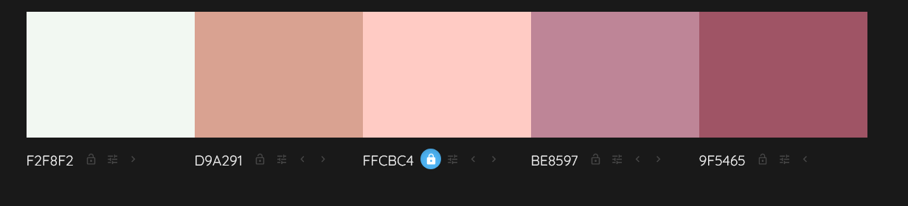

## Testing

## Deployment