Discord Message Visulization
library(RiceMessageVisualization)
library(readxl)
## Warning: package 'readxl' was built under R version 4.5.2
ProjectData <- read_excel("Data/FinalProjectData.xlsx",
sheet = "MessageHistory")

Discord Message Visualization Package
This package was developed to easily create various visualizations of message history from group chats. It is primarily aimed at data mined from Discord, which is an online messaging platform. The visualizations are created using the message Author as well as the datetime. This package can be useful for understanding server activity, including identifying which times of day and week servers are most active. It can also be used to identify which users are most active, as well as the times they are most active. This package includes 9 functions, 8 of which as visualizations generated using ggplot2
By default for all functions, user_col = "Author" and time_col = "Timestamp_clean".

Discord_TimeConvert()
Converts column from YYYY-DD-MMTHH:MM:SS.SSSSSSSSS format into a format more suitable for ggplot2 and time series plots. The original format is the default one used by discord, so it is critical to have a function to easily reformat this data.
CleanTime <- Discord_TimeConvert(ProjectData)

Discord_Record()
Allows user to select the time period to search for, and finds the record amount of messages sent for each user within that time period across the entire dataset. It then returns the results ranked with the highest record.
Discord_Record(CleanTime, search_window = 12)
## # A tibble: 35 × 3
## Username MaxMessages Rank
## <chr> <dbl> <int>
## 1 mel 6 1
## 2 machine_girl 5 2
## 3 wfmercury 5 3
## 4 derpstick 4 4
## 5 bbaited9 4 5
## 6 evergreen333 4 6
## 7 kikoni 3 7
## 8 jayolite 3 8
## 9 burgermunch 3 9
## 10 irisflower8 3 10
## # ℹ 25 more rows

Discord_TopUsers
Identifies the users with the highest total messages sent and generates a bar chart, labeling the total for each user. The number of users can be controlled with n
Discord_TopUsers(CleanTime)
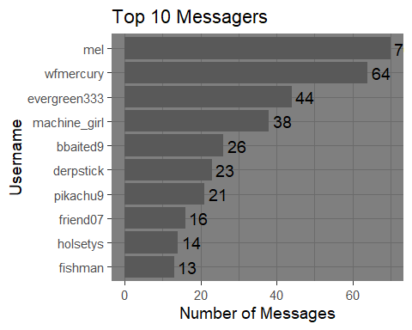

Discord_TopDays
Generates time series showing the number of total messages sent for each day.
Discord_TopDays(CleanTime, datetime_col = "Timestamp_clean")
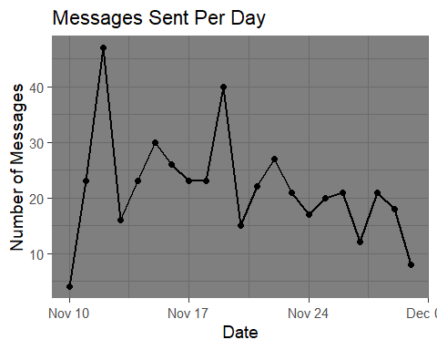

Discord_HeatMap
Generates a heat map showing the number of messages sent, organized by day of the week and hour. Can be used to identify which times and days have the most activity, and which time and days have the least activity.
Discord_HeatMap(CleanTime)
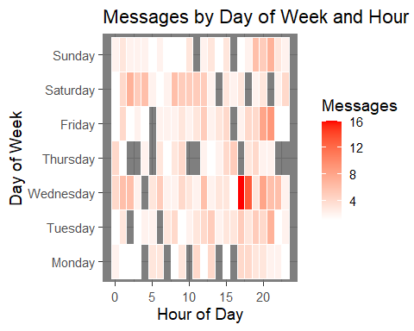 ### Discord_TopUsersCumulative Identifies the most active users, and generates a time series plot showing how each user’s total messages accumulate over time. The number of users shown can be modified. n = 10 by default.
Discord_TopUsersCumulative(CleanTime, datetime_col = "Timestamp_clean", user_col = "Author", top_n = 10, points = TRUE)
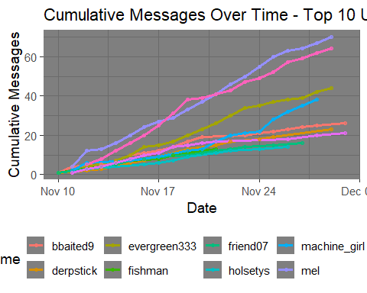

Discord_HourDensity
Generates a Smoothed 2D Density plot, visualizing which time of day experiences the most activity.
Discord_HourDensity(CleanTime, datetime_col = "Timestamp_clean")
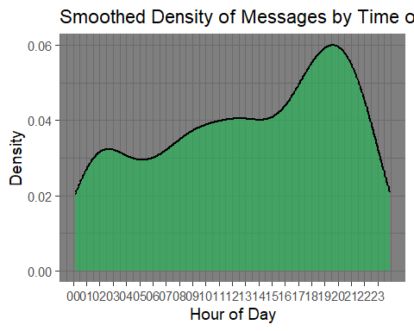

Discord_TopUserActivity
Identifies the most active users, then creates a noncumulative time series documenting their daily activity. Number of users shown can be modified with top_n.
Discord_TopUserActivity(CleanTime, top_n = 7)
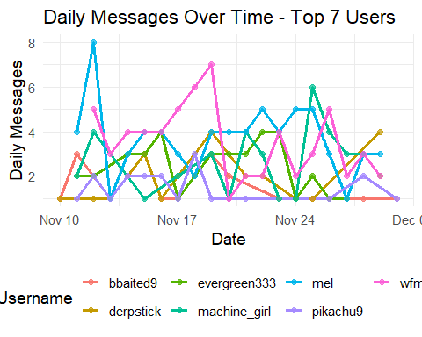

Discord_DailyTop
Identifies the top messager for each day and generates a bar chart showing how many messages that individual sent.
Discord_DailyTop(CleanTime, datetime_col = "Timestamp_clean", user_col = "Author")
