2447116 Chloy Costa 1 MCA A

Django Feedback Form

Created project using
django-admin startproject feedback_form
Changed directory using
Cd feedback_form

Created app using
Python manage.py startapp feedback

In settings.py in my project folder added my app in INSTALLED_APPS

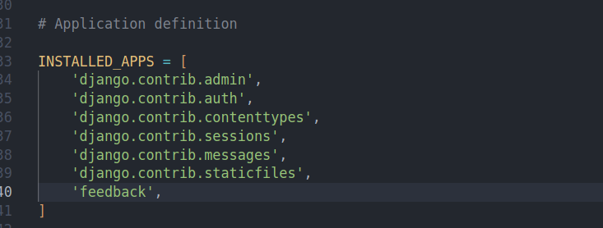
In my app feedback created file forms.py and created forms class and method to validate

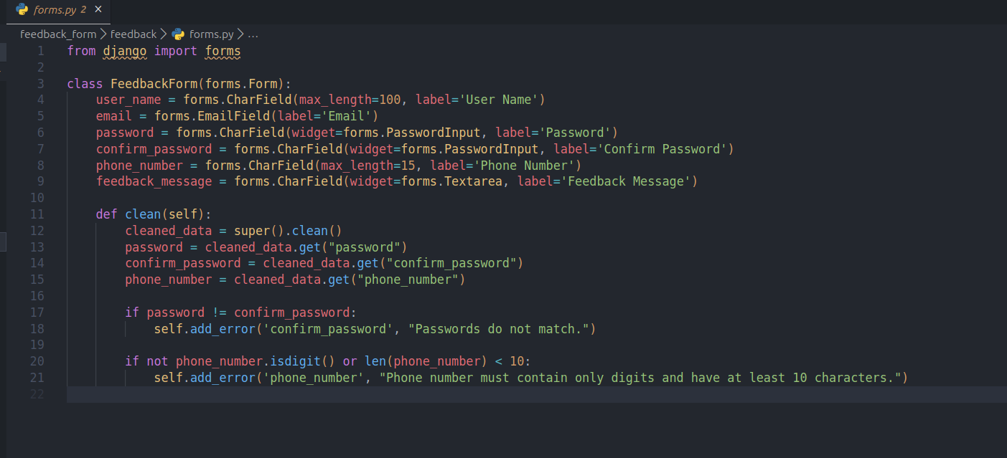
Views.py

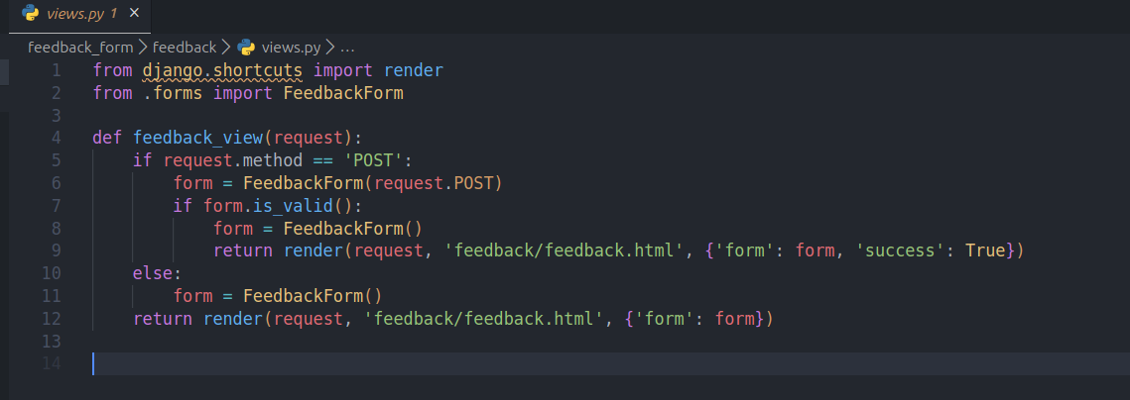
In our app folder created urls.py file
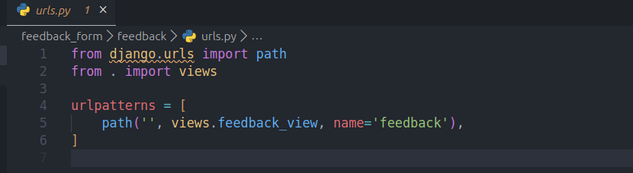
added this in project urls.py

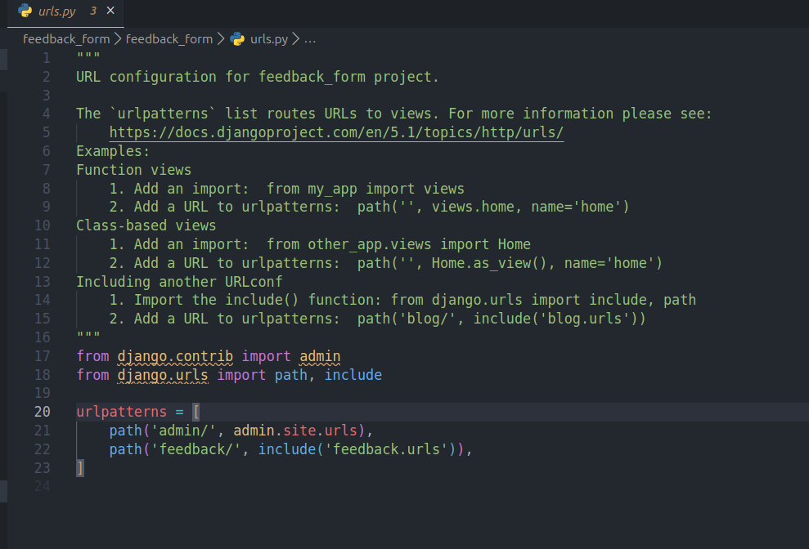
to run first used
python manage.py migration
then
python manage.py runserver

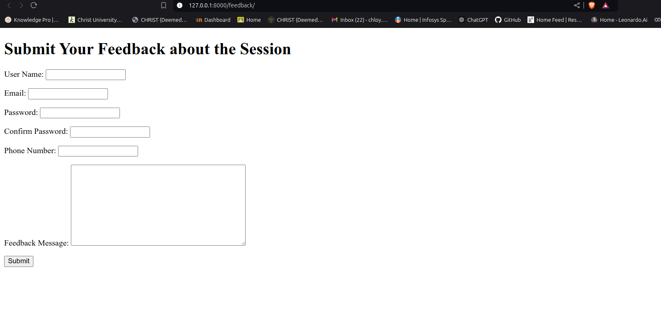
Here’s the form
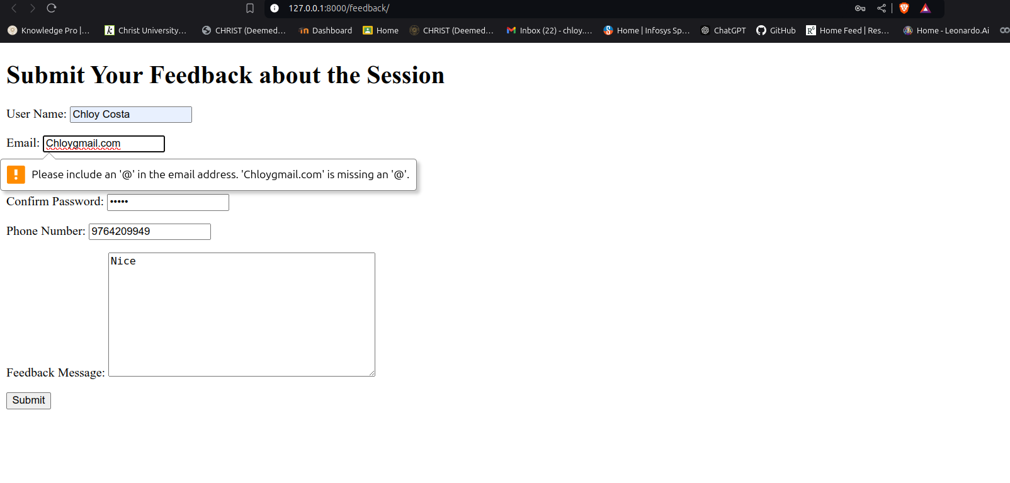
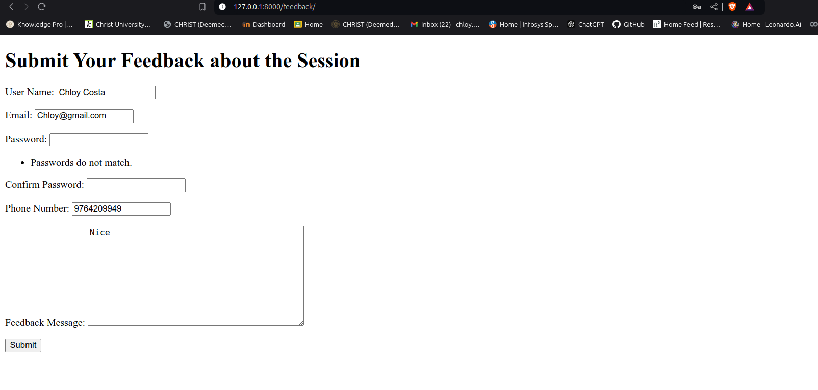
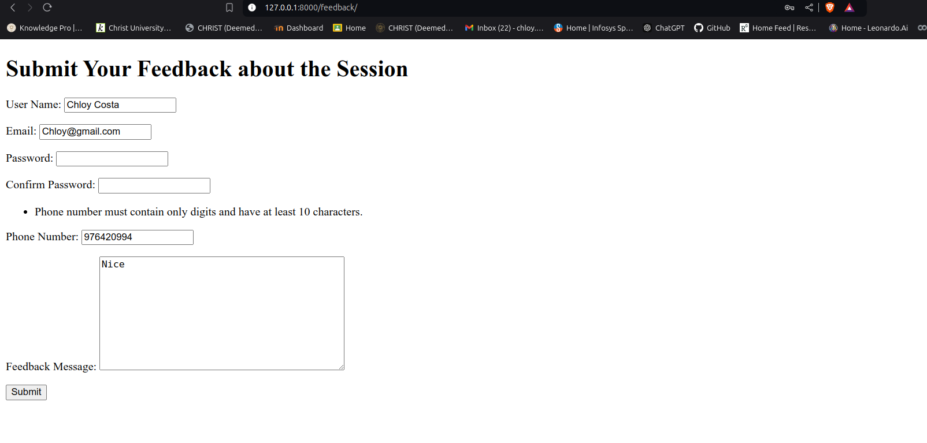
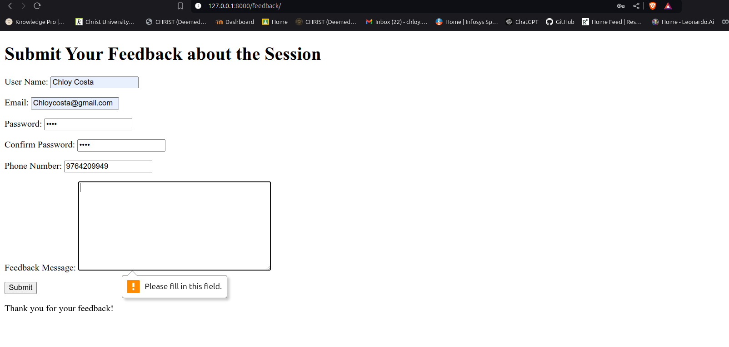
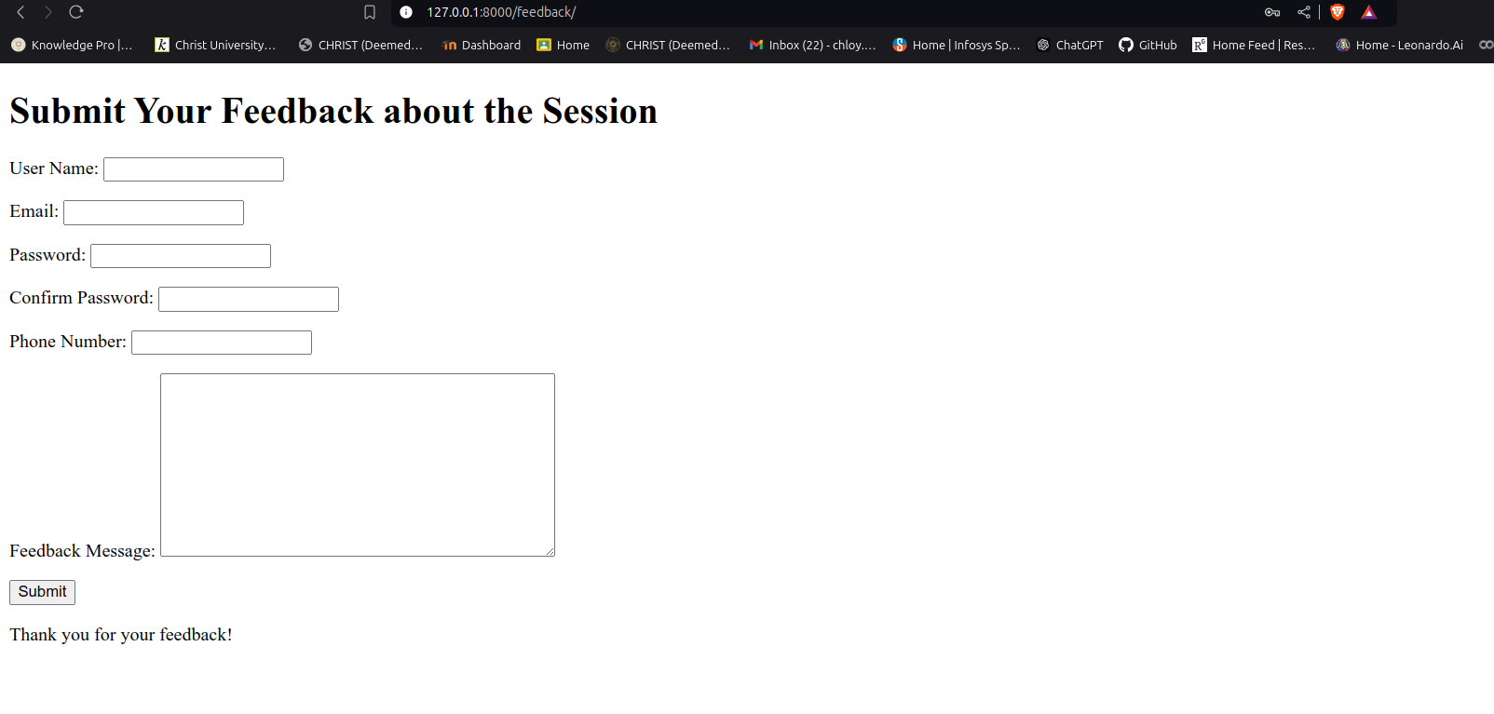

README.md file
