Q2. Plotiing graphs
Code:
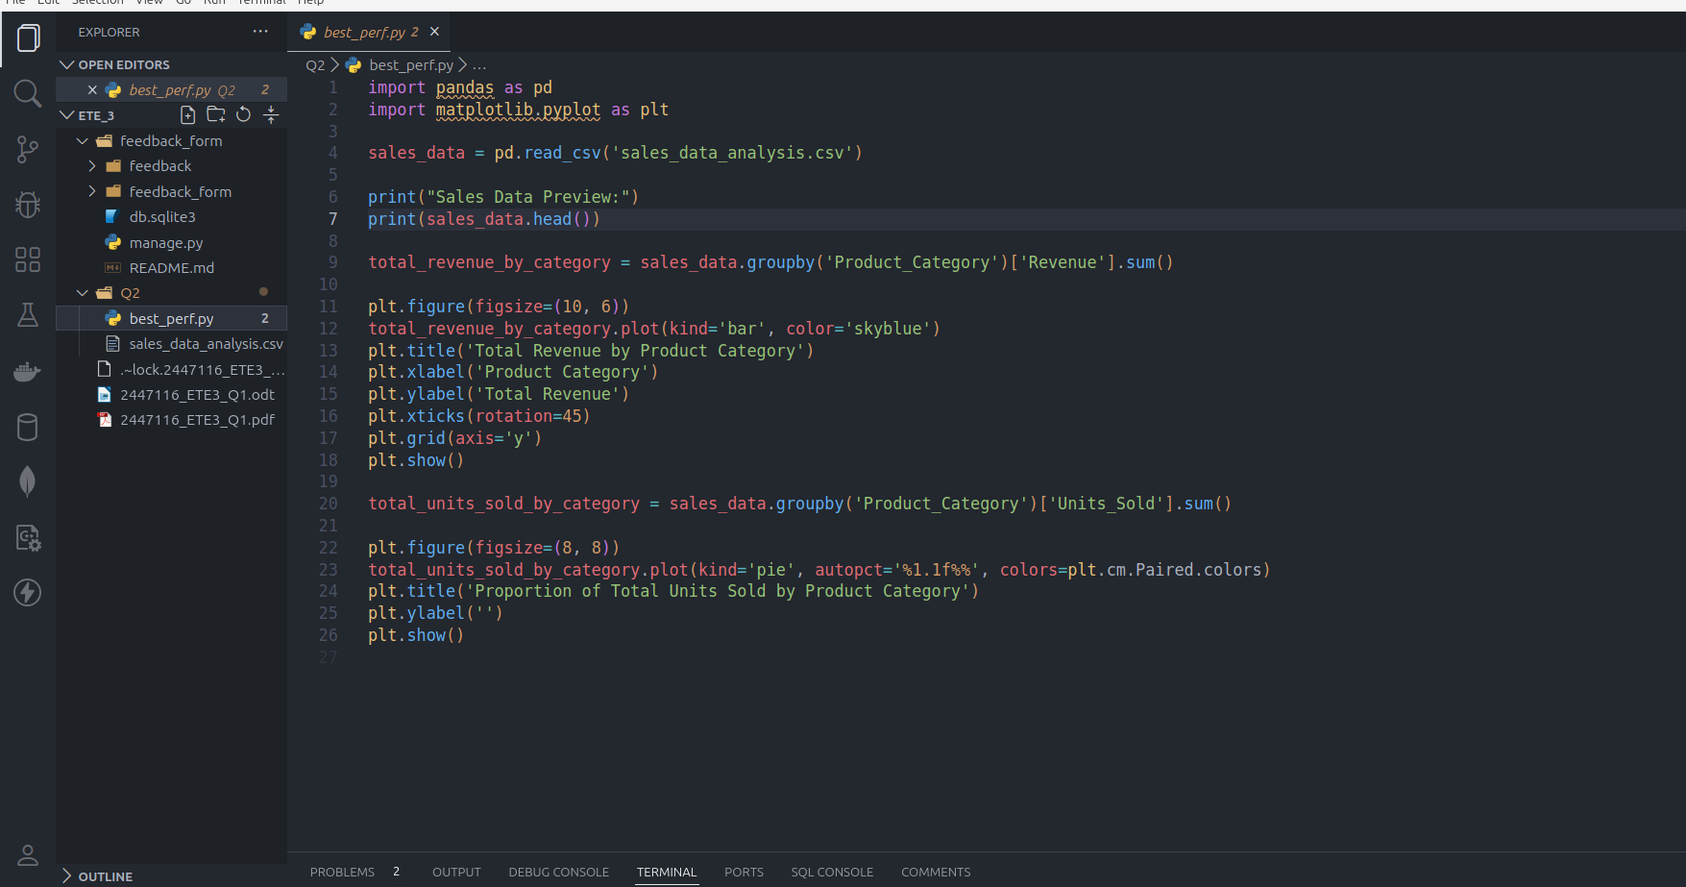

Output:
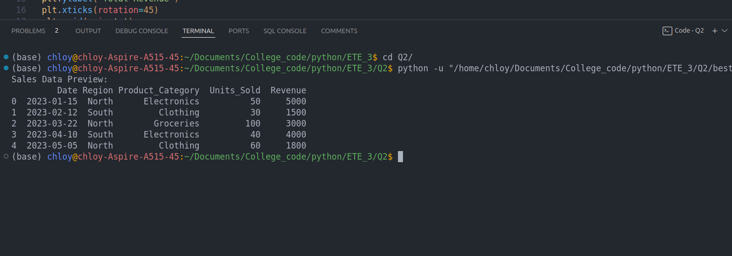

Bar graphh showing total revenue for each product category

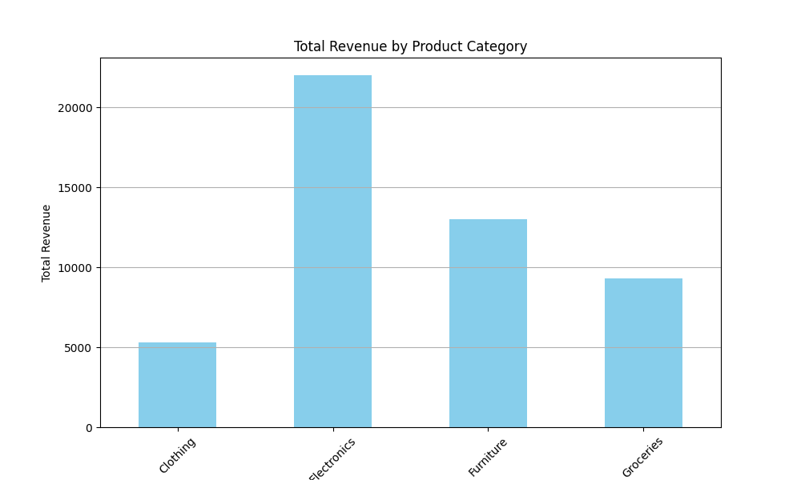

pie chart displaying the proportion of total units sold for each product category.

