Chapter 4: Results

4.1 Overview of the evaluation framework
This chapter presents the final out-of-sample results for the prediction of relative leadership among the momentum, value and quality factors in the South African equity market. Three model classes are evaluated: regularised logistic regression, a generalised additive model (GAM), and extreme gradient boosting (XGBoost). These models provide a progression from a linear specification, through additive nonlinear effects, to a flexible tree-based model capable of representing nonlinearities and interactions.

4.2 Evaluation sample and class distribution
Table 4.1 reports the realised class distribution in the common 156-week evaluation block. The three targets are reasonably balanced, although momentum leadership is slightly more common in the two momentum pairs. These counts provide the context required to interpret balanced accuracy and the confusion matrices reported below.
Table 4.1. Target distribution in the walk-forward evaluation block
Factor pair | Negative observations | Positive observations | Positive share
Momentum vs value | 71 | 85 | 54.5%
Momentum vs quality | 73 | 83 | 53.2%
Value vs quality | 82 | 74 | 47.4%

4.3 Out-of-sample predictive performance
Table 4.2 reports the complete model comparison. No single model dominates every factor pair and performance dimension. The largest ROC-AUC in the study is 0.589, indicating that the final predictive relationships are modest rather than strongly discriminative.
Table 4.2. Final out-of-sample model results
Panel A: Ranking and probability metrics
Factor pair | Model | Accuracy | ROC-AUC | PR-AUC | Log-loss
Momentum vs value | Logistic | 48.1% | 55.1% | 61.5% | 0.688
Momentum vs value | GAM | 59.0% | 58.2% | 58.7% | 1.609
Momentum vs value | XGBoost | 61.5% | 58.9% | 61.1% | 0.759
Momentum vs quality | Logistic | 51.3% | 55.0% | 57.9% | 0.687
Momentum vs quality | GAM | 48.1% | 55.7% | 55.8% | 0.932
Momentum vs quality | XGBoost | 55.1% | 57.8% | 61.6% | 0.719
Value vs quality | Logistic | 56.4% | 58.5% | 57.6% | 0.684
Value vs quality | GAM | 51.9% | 52.1% | 48.0% | 1.097
Value vs quality | XGBoost | 48.7% | 56.5% | 59.8% | 0.691
Panel B: Threshold-dependent classification metrics
Factor pair | Model | F1 | Precision | Recall | Balanced accuracy
Momentum vs value | Logistic | 0.646 | 0.514 | 0.871 | 0.442
Momentum vs value | GAM | 0.652 | 0.606 | 0.706 | 0.578
Momentum vs value | XGBoost | 0.663 | 0.634 | 0.694 | 0.608
Momentum vs quality | Logistic | 0.624 | 0.529 | 0.759 | 0.496
Momentum vs quality | GAM | 0.362 | 0.523 | 0.277 | 0.495
Momentum vs quality | XGBoost | 0.551 | 0.589 | 0.518 | 0.554
Value vs quality | Logistic | 0.564 | 0.537 | 0.595 | 0.566
Value vs quality | GAM | 0.427 | 0.491 | 0.378 | 0.512
Value vs quality | XGBoost | 0.636 | 0.479 | 0.946 | 0.510
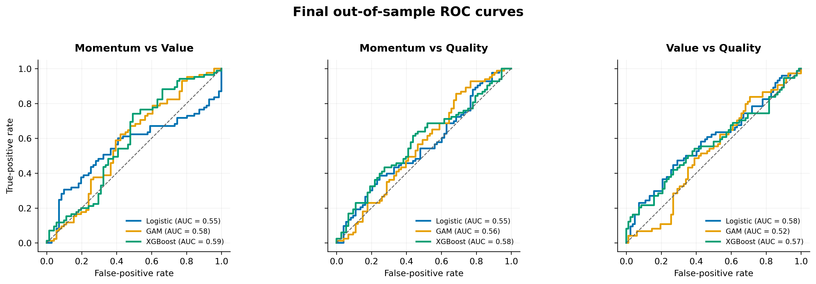
Figure 4.1. Final out-of-sample ROC curves for the three factor pairs.

4.3.1 Momentum versus value
Momentum versus value provides the strongest thresholded classification result in the study. XGBoost achieves accuracy of 61.5% and records the highest ROC-AUC (0.589) and balanced accuracy (0.608) for this pair. The GAM ranks second, with accuracy of 59.0%, ROC-AUC of 0.582 and balanced accuracy of 0.578.
The point estimates therefore indicate that nonlinear structure contributes to this factor pair. The size of the effect remains moderate because the best AUC is below 0.60. The results support a relative advantage for XGBoost within this pair, but do not indicate strong separation between momentum- and value-leadership regimes.
Logistic regression performs poorly at the fixed threshold despite a ROC-AUC of 0.551 and PR-AUC of 0.615. Its accuracy is 48.1% and its balanced accuracy is 0.442. This divergence between ranking and thresholded measures is explained by its strong tendency to predict momentum leadership.
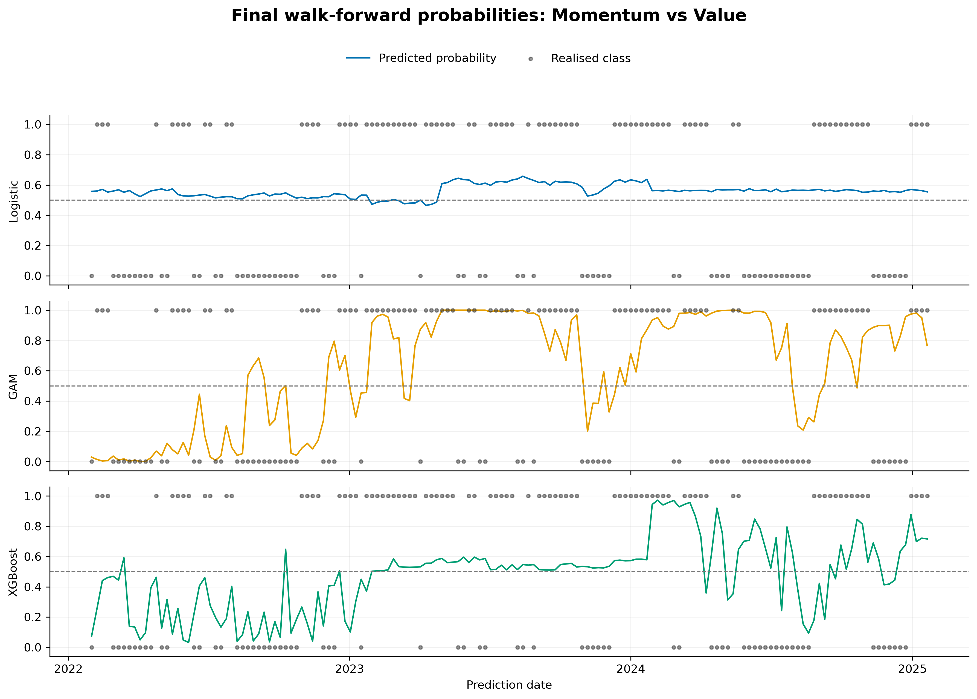
Figure 4.2. Final walk-forward probabilities and realised classes for momentum versus value.

4.3.2 Momentum versus quality
Predictive performance is weaker for momentum versus quality. XGBoost again produces the strongest overall classification results, with accuracy of 55.1%, ROC-AUC of 0.578, PR-AUC of 0.616 and balanced accuracy of 0.554. The balanced accuracy remains close to 0.50, indicating only modest separation between the two classes.
Logistic regression records the lowest log-loss, at 0.687, and high positive-class recall of 0.759. However, its accuracy is 51.3% and its balanced accuracy is 0.496. The comparatively high F1 score of 0.624 is therefore driven partly by frequent positive predictions rather than by balanced discrimination between the two regimes.
The GAM displays the opposite error pattern. Its ROC-AUC of 0.557 suggests limited ranking information, but it predicts the positive class infrequently and achieves recall of only 0.277. Consequently, its accuracy and balanced accuracy remain consistent with chance-like classification.
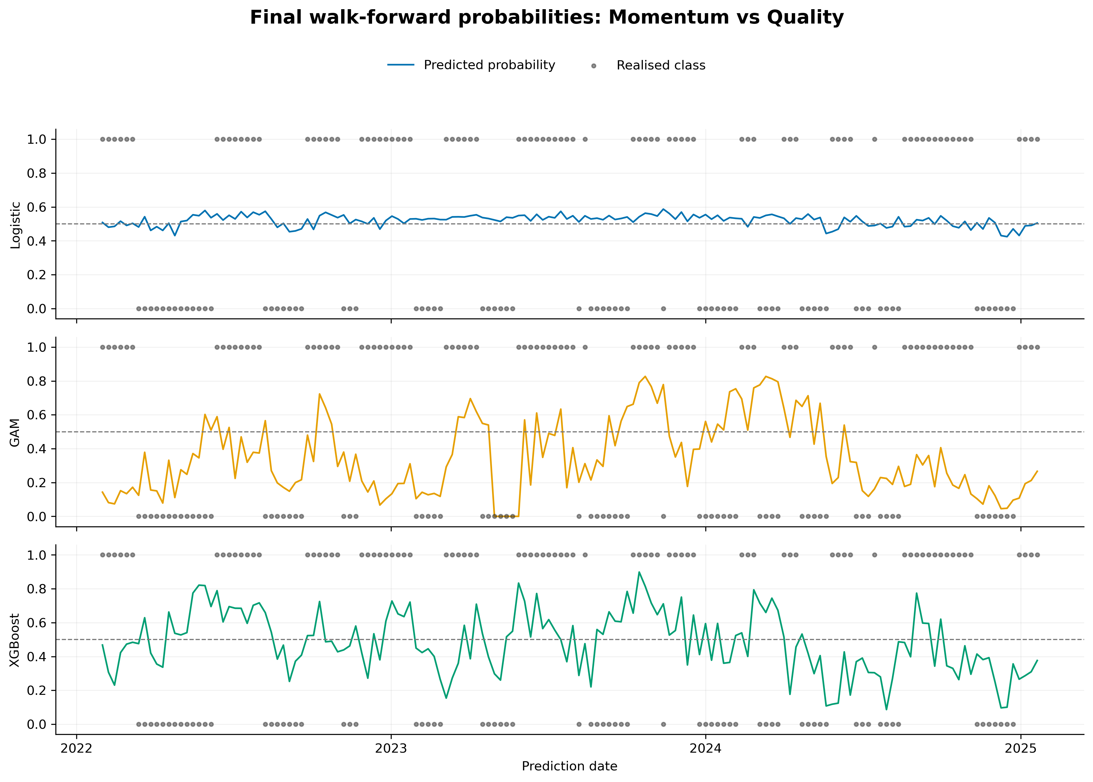
Figure 4.3. Final walk-forward probabilities and realised classes for momentum versus quality.

4.3.3 Value versus quality
Value versus quality reverses the ordering observed in the momentum pairs. Logistic regression is the strongest model, with accuracy of 56.4%, ROC-AUC of 0.585, log-loss of 0.684 and balanced accuracy of 0.566. It also generates the most balanced predictions for this pair.
XGBoost produces a ROC-AUC of 0.565 and the highest PR-AUC and F1, but these measures do not translate into useful thresholded classification. It predicts value leadership for 93.6% of the evaluation observations, despite a realised positive rate of 47.4%. This produces recall of 0.946 but specificity of only 0.073. Its accuracy is therefore 48.7%, below both logistic regression and the GAM. The result demonstrates why recall, PR-AUC or F1 should not be interpreted without the confusion matrix and balanced accuracy.
The GAM is close to chance across most measures. Its accuracy is 51.9%, ROC-AUC is 0.521 and balanced accuracy is 0.512. The evidence for predictable value-versus-quality leadership is therefore concentrated in the linear specification rather than in the more flexible models.
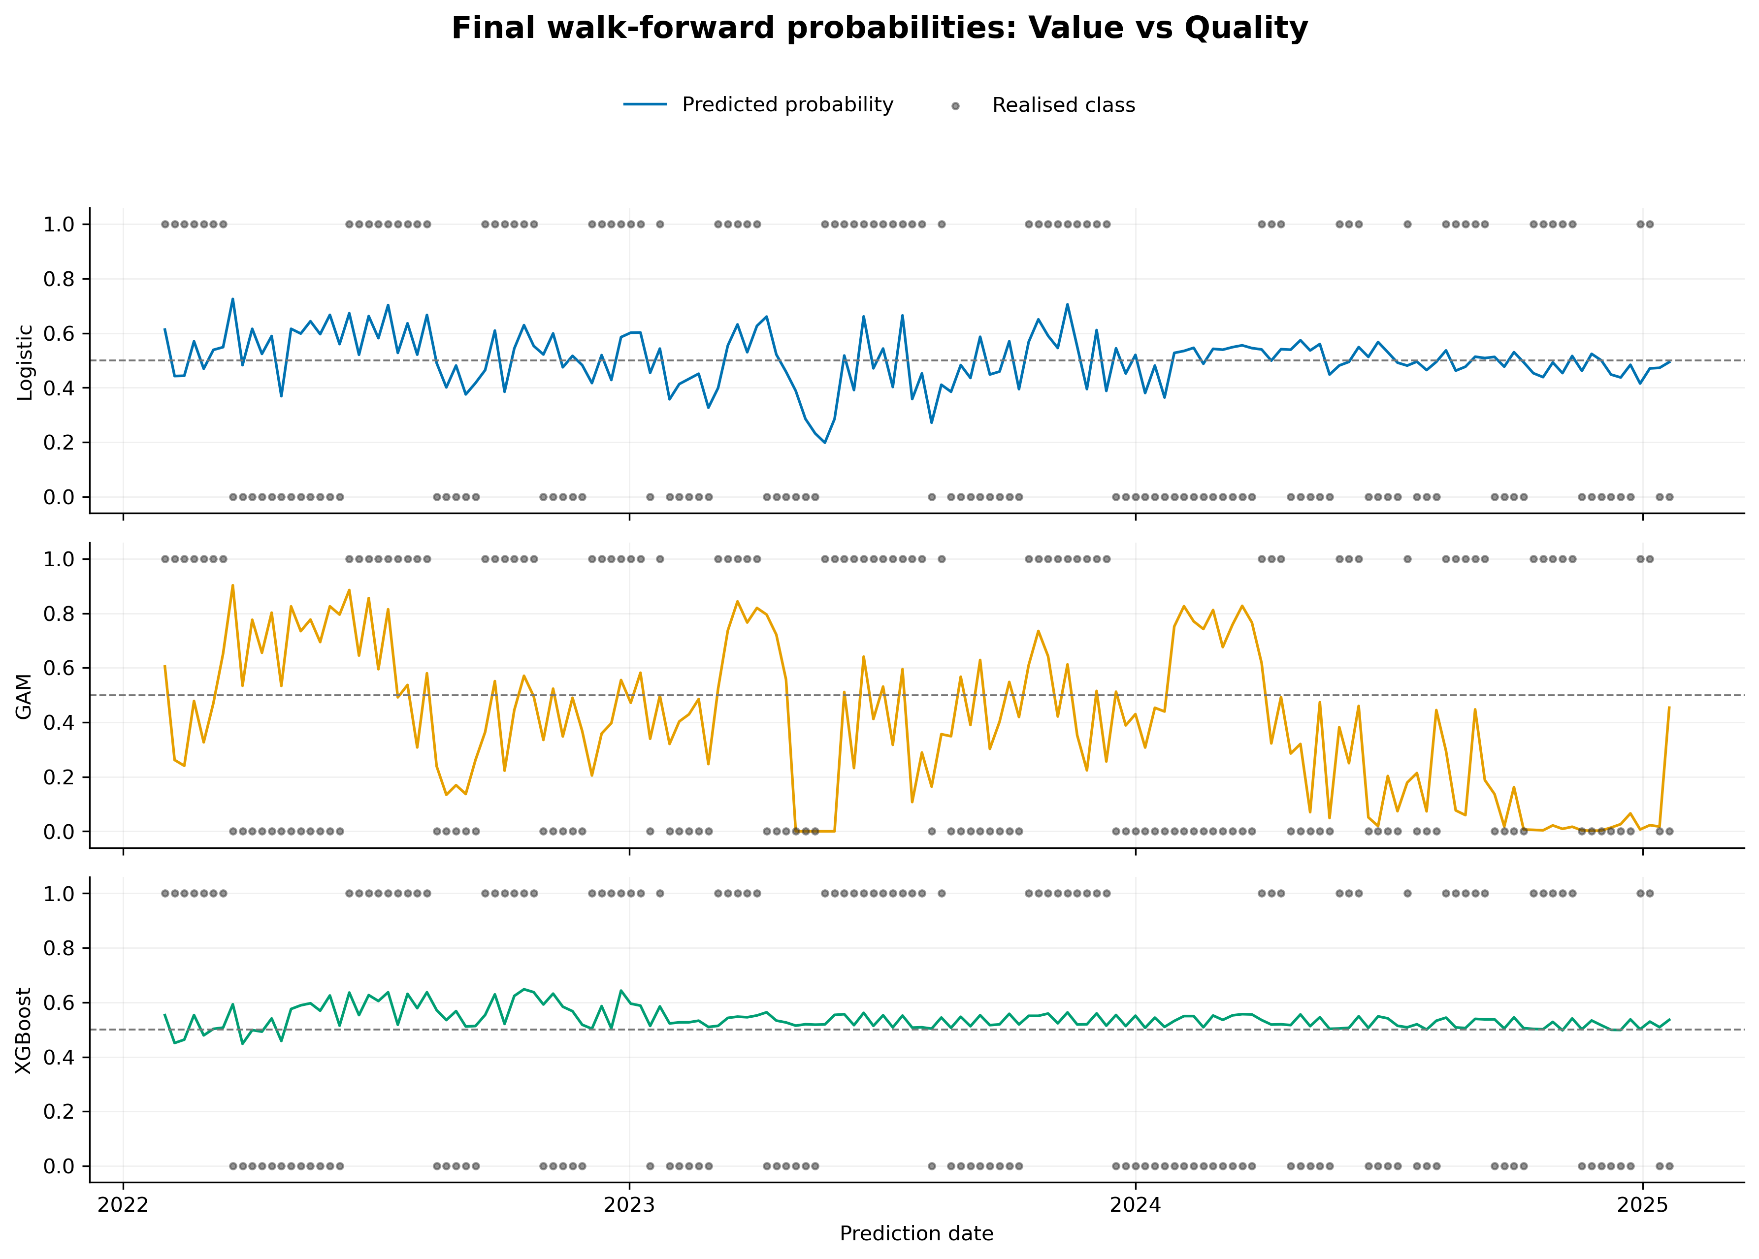
Figure 4.4. Final walk-forward probabilities and realised classes for value versus quality.

4.3.4 Cross-pair model comparison
Table 4.3 averages each metric across the three factor pairs. XGBoost records the highest mean accuracy, ROC-AUC and balanced accuracy. The average advantage is nevertheless modest, and it is not observed uniformly across the individual factor pairs. Logistic regression performs best for value versus quality and produces the lowest average log-loss, while the GAM does not lead any pair on the principal performance measures.
Table 4.3. Mean performance across the three factor pairs
Model | Mean accuracy | Mean ROC-AUC | Mean balanced accuracy | Mean log-loss
Logistic | 51.9% | 56.2% | 50.1% | 0.687
GAM | 53.0% | 55.3% | 52.8% | 1.213
XGBoost | 55.1% | 57.8% | 55.7% | 0.723
These results provide qualified evidence in favour of XGBoost: it has the strongest average discrimination and class-balanced performance, and it leads both momentum pairs. They do not establish a universal complexity advantage. Logistic regression leads value versus quality and produces substantially better probability quality than the GAM and, on average, XGBoost. The model hierarchy is therefore dependent on the target pair and the aspect of performance being evaluated.

4.4 Consolidated confusion-matrix analysis and probability quality
Table 4.4 reports the confusion-matrix counts and predicted-positive shares. These diagnostics explain several apparent inconsistencies between F1, ROC-AUC and accuracy.
Table 4.4. Confusion-matrix diagnostics at the 0.5 threshold
Factor pair | Model | TN | FP | FN | TP | Predicted positive | Actual positive
Momentum vs value | Logistic | 1 | 70 | 11 | 74 | 92.3% | 54.5%
Momentum vs value | GAM | 32 | 39 | 25 | 60 | 63.5% | 54.5%
Momentum vs value | XGBoost | 37 | 34 | 26 | 59 | 59.6% | 54.5%
Momentum vs quality | Logistic | 17 | 56 | 20 | 63 | 76.3% | 53.2%
Momentum vs quality | GAM | 52 | 21 | 60 | 23 | 28.2% | 53.2%
Momentum vs quality | XGBoost | 43 | 30 | 40 | 43 | 46.8% | 53.2%
Value vs quality | Logistic | 44 | 38 | 30 | 44 | 52.6% | 47.4%
Value vs quality | GAM | 53 | 29 | 46 | 28 | 36.5% | 47.4%
Value vs quality | XGBoost | 6 | 76 | 4 | 70 | 93.6% | 47.4%
XGBoost provides the most balanced class treatment for the two momentum pairs. For momentum versus value, it predicts the positive class in 59.6% of observations compared with an actual rate of 54.5%. For momentum versus quality, its positive prediction share is 46.8% compared with an actual rate of 53.2%. Logistic regression is most balanced for value versus quality, where its positive prediction rate is 52.6% compared with the actual rate of 47.4%.
The extreme positive-class tendencies of logistic regression for momentum versus value and XGBoost for value versus quality materially inflate their recall and F1 scores. These cases show that favourable positive-class metrics can coexist with poor specificity and weak balanced classification.
The probability results introduce a further trade-off. An uninformative forecast of 0.5 for every observation has a log-loss of approximately 0.693. Logistic regression records log-loss between 0.684 and 0.688 for all three pairs, representing only a small improvement but avoiding severe overconfidence. The GAM produces log-loss between 0.932 and 1.609, indicating that some incorrect forecasts receive excessive probability. XGBoost has stronger average ranking and thresholded performance, but its log-loss exceeds 0.693 for both momentum pairs. Thus, better discrimination does not necessarily imply better probability quality.

4.5 Global SHAP analysis
Global feature importance is measured using the mean absolute SHAP value from the saved model explanations. The values indicate which inputs exerted the greatest influence on each fitted model. They do not establish causal relationships or demonstrate that the variables contain stable out-of-sample information. This distinction is important because all final ROC-AUC values remain below 0.60. Rankings are compared more cautiously than raw SHAP magnitudes because the scale and distribution of attributions differ across model classes.

4.5.1 Momentum versus value
Table 4.5. Top five global SHAP features for momentum versus value
Rank | Logistic | GAM | XGBoost
1 | USDZARV1Y.Curncy_QS (0.034) | relvol_value_vs_quality_12 (2.720) | SA_RB_Curvature (0.211)
2 | USDZARV1M.Curncy_QS (0.032) | relvol_momentum_vs_quality_12 (2.550) | relvol_momentum_vs_value_12 (0.201)
3 | VolTermStructPC1 (0.012) | USDZAR_EntDyn (1.269) | MXWD.Index.PE.Ratio_QS (0.188)
4 | EURUSDV6M.Curncy_QS (0.004) | GlobalPropertyVol12 (1.235) | mom1m_momentum_vs_quality (0.184)
5 | JALSH_Fundamental_PC1 (0.003) | MXWD_Fundamental_PC1 (1.083) | mom1m_momentum_vs_value (0.162)
Logistic regression is dominated by currency-volatility and volatility-term-structure variables. The GAM places the greatest weight on relative-volatility measures, followed by foreign-exchange entropy, global property volatility and a global fundamental component. XGBoost draws on a broader combination of local real-yield-curve curvature, pair-specific relative volatility, global valuation and short-horizon factor momentum. The rankings suggest that the nonlinear models represent momentum-versus-value leadership using both factor-specific instability and wider market-state information.
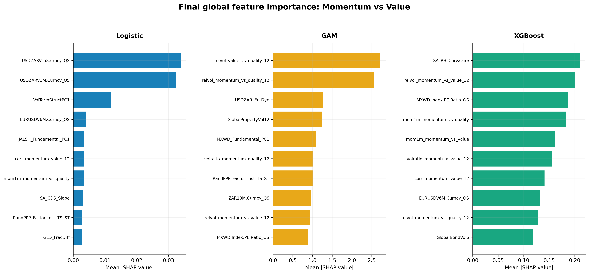
Figure 4.5. Final global SHAP importance for momentum versus value.

4.5.2 Momentum versus quality
Table 4.6. Top five global SHAP features for momentum versus quality
Rank | Logistic | GAM | XGBoost
1 | zrel_value_vs_quality_12 (0.033) | relvol_momentum_vs_quality_12 (1.891) | VolTermStructPC1 (0.203)
2 | zrel_momentum_vs_quality_12 (0.029) | relvol_value_vs_quality_12 (1.853) | TOP40.Index.Price.to.Ebitda_Diff (0.183)
3 | TOP40.Index.Price.to.Ebitda_Diff (0.024) | TOP40.Index.Price.to.Ebitda_Diff (0.600) | zrel_value_vs_quality_12 (0.145)
4 | GLD_StructBreak (0.021) | volratio_value_quality_12 (0.538) | GLD_StructBreak (0.083)
5 | mom3m_momentum_vs_quality (0.020) | MichgnConcIndx (0.456) | volratio_momentum_quality_12 (0.073)
Momentum-versus-quality predictions use a combination of standardised relative performance, relative volatility, valuation, commodity-regime and sentiment information. Relative factor variables appear prominently in all three models, while the local-versus-global EBITDA valuation differential ranks in the top three for each specification. Despite this partial overlap, the ordering differs materially across models. The evidence therefore points to multiple representations of the factor pair rather than a single stable driver.
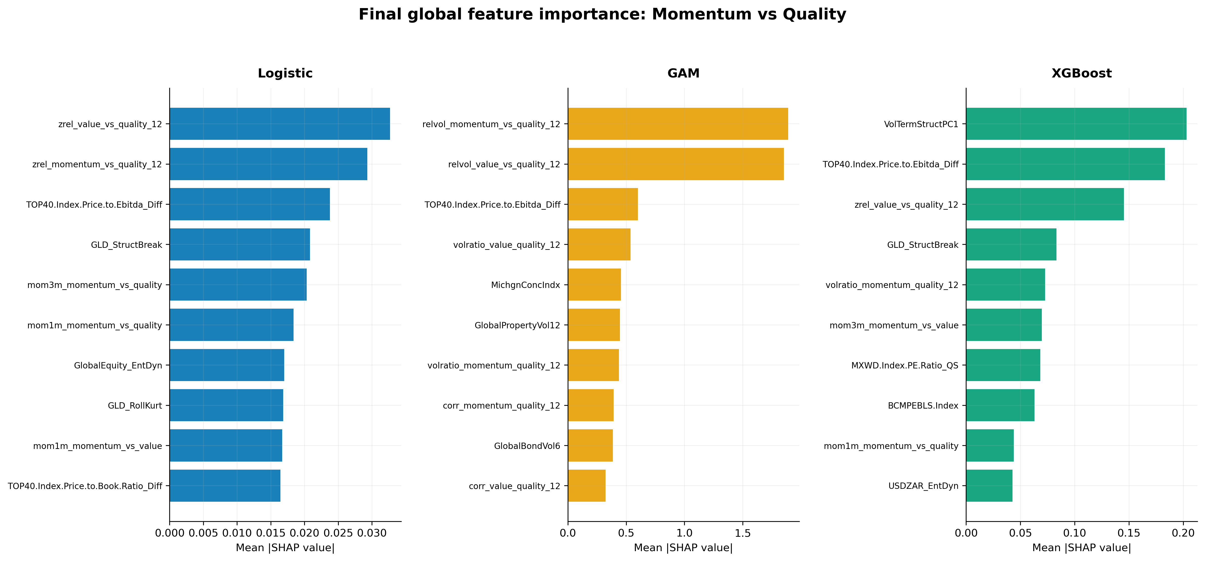
Figure 4.6. Final global SHAP importance for momentum versus quality.

4.5.3 Value versus quality
Table 4.7. Top five global SHAP features for value versus quality
Rank | Logistic | GAM | XGBoost
1 | zrel_value_vs_quality_12 (0.244) | relvol_value_vs_quality_12 (1.999) | zrel_value_vs_quality_12 (0.054)
2 | TOP40.Index.Price.to.Ebitda_Diff (0.153) | relvol_momentum_vs_quality_12 (1.910) | USDZARV1M.Curncy_QS (0.019)
3 | RandPPP_Factor_Inst_TS_ST (0.126) | GlobalPropertyVol12 (0.751) | zrel_momentum_vs_quality_12 (0.018)
4 | SA_NB_Slope (0.118) | RandPPP_Factor_Inst_TS_ST (0.650) | MichgnConcIndx (0.012)
5 | VolTermStructPC1 (0.081) | SA_NB_Slope (0.608) | GenComIndexPC1_QS (0.012)
The standardised value-versus-quality relative-performance measure ranks first for logistic regression and XGBoost, while the GAM is dominated by relative-volatility variables. Valuation, purchasing-power-parity, yield-curve, currency-volatility, sentiment and commodity variables also appear. Logistic regression is the best-performing model for this pair, but its AUC of 0.585 remains modest. The feature rankings should therefore be interpreted as a description of the fitted decision function rather than evidence of stable economic causality.
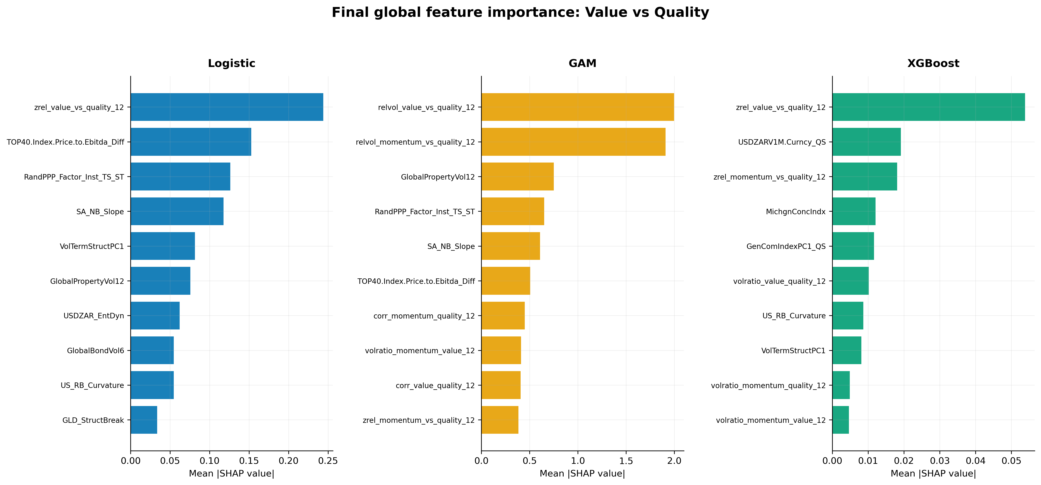
Figure 4.7. Final global SHAP importance for value versus quality.

4.5.4 Cross-pair feature synthesis
Three broad patterns emerge from the SHAP rankings. First, pair-specific relative-return and relative-volatility measures recur frequently, indicating that the models rely on the recent state and dispersion of the factor relationships. Second, market-state variables - including currency volatility, yield-curve shape, volatility-term-structure and commodity-regime indicators - contribute across several specifications. Third, the importance rankings vary by model class and factor pair. The results do not reveal a single universal economic variable that drives factor leadership across all nine fitted models.
Because the predictive performance is modest, feature attribution provides exploratory evidence about model behaviour rather than confirmation of robust forecasting mechanisms. Stability analysis across retuning windows would be required before claiming that the rankings persist through time.

4.6 Validation, reproducibility and limits of inference
The final CPCV design strengthens the internal consistency of the analysis by dividing each training sample into five chronologically ordered groups and holding out two groups per combination. The resulting ten training-validation combinations form four back-test paths. A 12-week purge before and a 12-week embargo after each CPCV test group limit overlap with the trend-scanning information horizon. The separate expanding walk-forward evaluation maintains chronological ordering, applies a 12-week pre-test purge and retunes the models every 52 predictions. The final comparison is therefore based on common target definitions, predictors, dates and validation settings.
Several limitations remain. First, the evaluation block contains only 156 weekly observations, while the trend-scanning labels display temporal persistence. Small differences in point estimates should therefore not be interpreted as statistically established without dependence-aware confidence intervals or paired tests. Second, the same evaluation period has been consulted during model development, meaning that it should not be described as a completely untouched final holdout. Third, the current saved artifacts contain the initial parameter selection, but do not preserve every parameter choice made during the two subsequent 52-week retuning events. Those retuning dates, training windows, CPCV scores and selected parameters should be exported before final submission. Fourth, the analysis evaluates statistical classification and does not establish portfolio profitability after turnover, transaction costs and implementation constraints.

4.7 Chapter conclusion
The final results provide modest and factor-pair-dependent evidence of predictability. XGBoost produces the strongest results for momentum versus value and momentum versus quality, while logistic regression performs best for value versus quality. XGBoost also records the highest mean accuracy, ROC-AUC and balanced accuracy across the three pairs. Its average advantage does not amount to uniform dominance: logistic regression has the strongest probability quality and leads the value-versus-quality pair, while several models produce strongly asymmetric classifications at the 0.5 threshold.
The findings therefore qualify the proposition that increasing model flexibility necessarily improves out-of-sample prediction. Greater flexibility is beneficial for the two momentum pairs, particularly momentum versus value, but the linear model is more effective for value versus quality. Even the best AUC is below 0.60. The evidence supports limited predictive structure rather than a strongly separable or deployment-ready factor-timing signal.
The global SHAP analysis indicates that the fitted models use a combination of relative-factor dynamics, volatility, currency conditions, valuation, yield-curve information, commodity regimes and sentiment. These patterns differ across model classes and factor pairs and should remain exploratory given the modest predictive performance.
Table 4.8. Synthesis of the research questions
Research question | Final answer
To what extent can the models predict relative factor leadership out of sample? | Predictability is modest and varies by pair. The strongest results are XGBoost for momentum versus value and logistic regression for value versus quality.
Does increasing model flexibility produce consistent improvements? | No. XGBoost leads on average and for both momentum pairs, but logistic regression leads value versus quality and provides better probability quality.
Which variables exert the greatest influence on the fitted models? | Relative-return and relative-volatility features recur, together with currency, valuation, yield-curve, volatility and sentiment indicators. The rankings are model- and pair-specific.
Overall, the study does not identify a universally superior model or a general complexity premium. It provides a more qualified conclusion: flexible machine-learning models can extract limited predictive information from some South African relative factor relationships, but performance remains close to chance in several specifications and has not yet been translated into demonstrated economic value.

