Results

Overview of the evaluation framework
This chapter presents the out-of-sample results of the three models of Section 3.7 for the 156 weekly predictions of the walk-forward evaluation (Section 3.8.2), assessed with the measures of Section 3.9. Section 4.2 compares the models on accuracy, ROC-AUC and log-loss for each factor pair and shows their ROC curves and weekly predicted probabilities. Section 4.3 examines how the classification errors are distributed between the two classes and assesses the quality of the predicted probabilities. Section 4.4 reports the features with the largest global SHAP importance in each model. Section 4.5 ranks the models across the three pairs, uses block-bootstrap intervals to assess whether their differences in mean ROC-AUC are distinguishable from zero, and considers whether the more flexible models add predictive value beyond the regularised linear benchmark.

Out-of-sample predictive performance
Table 4 reports the accuracy, ROC-AUC and log-loss of each model for the three factor pairs. XGBoost is the strongest model throughout: for every pair it has the highest accuracy and ROC-AUC and the lowest log-loss. The GAM, which adds smooth nonlinear effects to the linear specification, does not improve on logistic regression: its ROC-AUC is lower for two of the three pairs and its log-loss is the highest for all three. The predictive relationships remain modest: the highest ROC-AUC in the study is 0.664, for value versus quality (Hosmer, Lemeshow, & Sturdivant, 2013; Israel, Kelly, & Moskowitz, 2020).

Table 4: Out-of-sample accuracy, ROC-AUC and log-loss by factor pair and model
Factor pair | Model | Accuracy | ROC-AUC | Log-loss
Momentum vs value | Logistic | 50.0% | 0.489 | 1.140
 | GAM | 50.6% | 0.528 | 1.545
 | XGBoost | 62.8% | 0.625 | 0.715
Momentum vs quality | Logistic | 57.7% | 0.570 | 0.738
 | GAM | 56.4% | 0.524 | 0.959
 | XGBoost | 61.5% | 0.589 | 0.678
Value vs quality | Logistic | 53.8% | 0.598 | 0.686
 | GAM | 49.4% | 0.495 | 1.148
 | XGBoost | 60.3% | 0.664 | 0.670

The subsections that follow examine, for each pair, where the more flexible models gain or lose against the linear benchmark. Each factor pair is illustrated with two figures. The first shows the ROC curves: the vertical axis is the share of weeks led by the first factor of the pair that are classified correctly (the true-positive rate), the horizontal axis the share of weeks led by the second factor that are classified as led by the first (the false-positive rate), and each curve traces both as the classification threshold falls from one to zero. The left of each curve therefore reflects the weeks a model considers most likely to be led by the first factor, and the dashed diagonal corresponds to random classification. The second figure shows each model's weekly predicted probability that the first factor leads, with dots marking the realized class (one when the first factor led, zero when the second did) and a dashed line at the 0.5 threshold. A model is described as confidently wrong in a week when it gives the outcome that did not occur a probability above 0.9.

Momentum versus value
For momentum versus value, XGBoost is the only model with a ROC-AUC well above 0.5 (0.625), and it has the highest accuracy (62.8%), consistent with evidence that tree-based models improve style rotation on the JSE (Page, McClelland, & Auret, 2024). Logistic regression and the GAM are close to random on ROC-AUC (0.489 and 0.528), and their log-losses (1.140 and 1.545) are far above the uninformative 0.693 (Section 3.9). Leadership shifted sharply during the evaluation period: value led in 63% of the weeks of 2022, momentum in 71% of those of 2023, and the two factors about equally often in 2024.
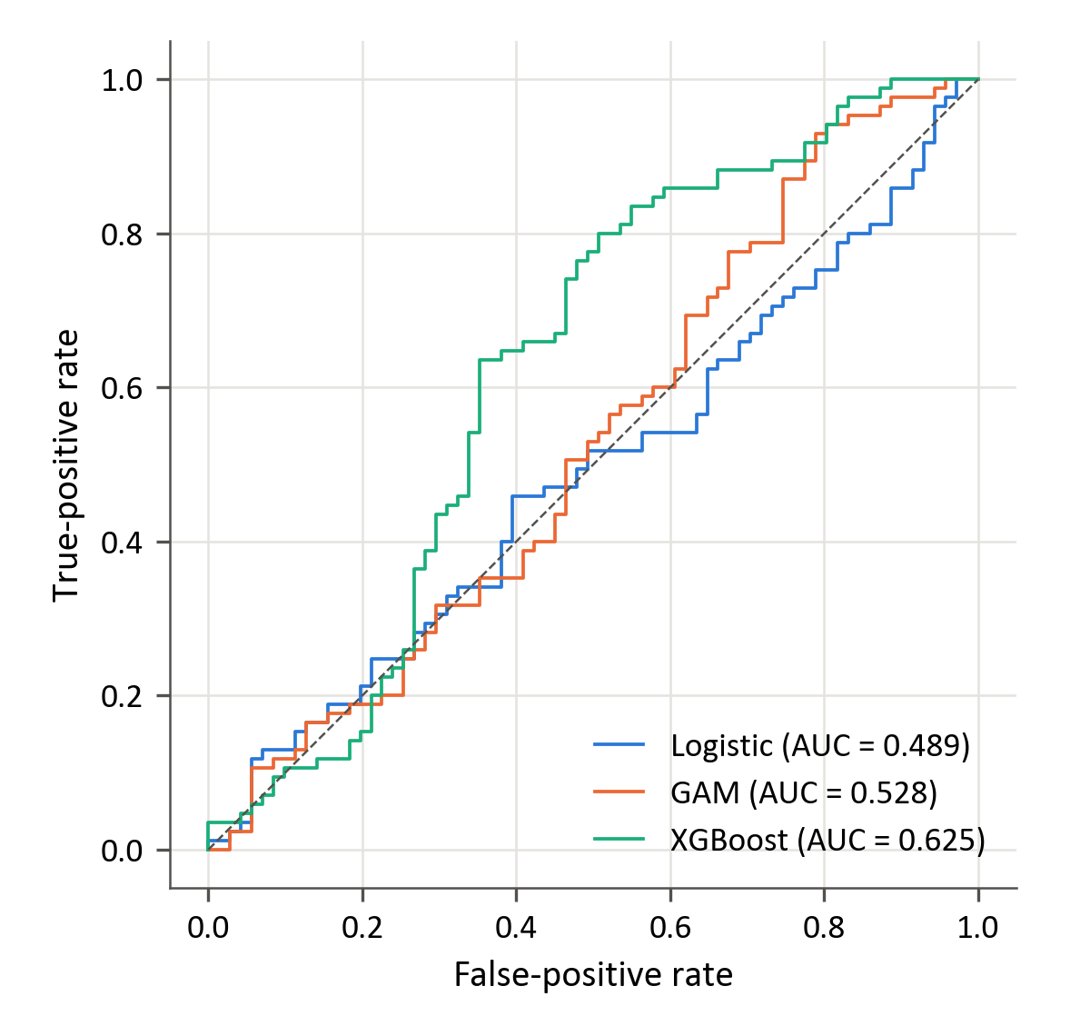
Figure 9: Out-of-sample ROC curves for momentum versus value
Figure 9 shows that XGBoost's curve is the highest over most of the range, from a false-positive rate of about 0.25 to 0.95, whereas logistic regression's lies below the diagonal over about half of it. XGBoost's advantage lies in the weeks it ranks lowest: of its 30 lowest-probability weeks, 22 fall in 2022 and 20 were led by value. Its ranking does not rest only on telling the years apart, however. Computed separately within each of the three 52-week periods between tuning points, its ROC-AUC is 0.60, 0.57 and 0.55, whereas logistic regression's is below 0.5 in all three (Fawcett, 2006).
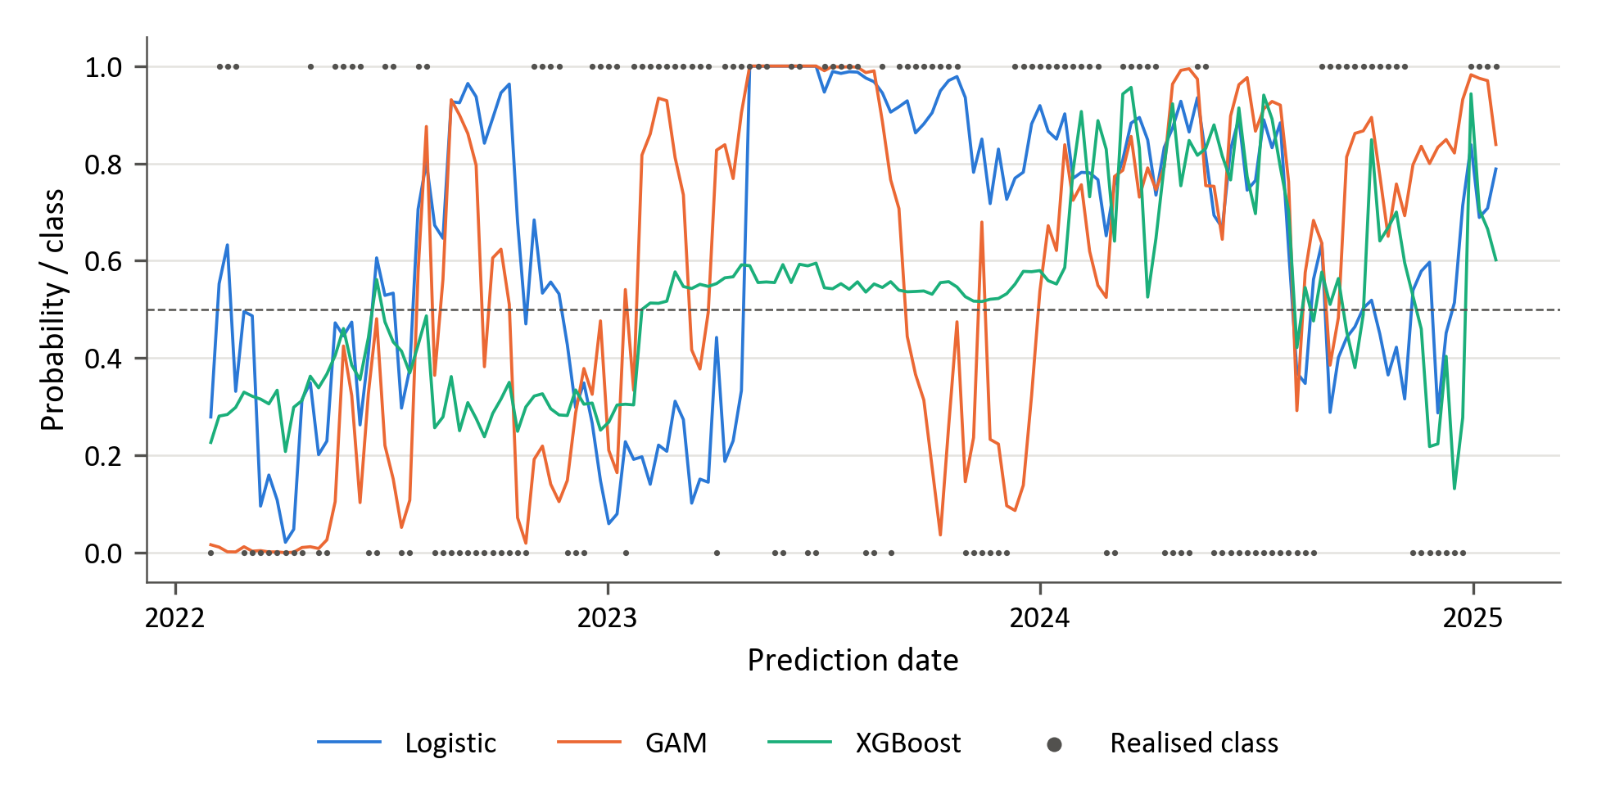
Figure 10: Walk-forward predicted probability that momentum leads value, with the realised class
Figure 10 shows how XGBoost's forecasts changed with its tuning. Until the first retune, in January 2023, it used the smallest learning rate in its grid: its probabilities stayed between 0.21 and 0.56, and it predicted value leadership in all but one week and was right in 58% of the weeks. The retune added the largest L2 penalty in its grid (Table C.6). For the following year its probabilities stayed between 0.50 and 0.60, and it predicted momentum leadership in all but one week and was right in 71%. Both were in effect constant forecasts that followed the dominant factor of the year, and XGBoost's overall accuracy of 62.8% is close to the 62.2% that would be achieved by predicting, in every week, the factor that led most often in that calendar year, a rule that requires hindsight. Only after the January 2024 retune, which selected its largest learning rate and smallest penalty, did its probabilities spread, from 0.13 to 0.96; its three confidently wrong weeks all fall in this period.
The same figure shows why logistic regression and the GAM have such poor log-loss. At every tuning point logistic regression selected the weakest penalty in its grid (λ = 0.01), which leaves its coefficients almost unshrunk (Zou & Hastie, 2005), and the GAM its most flexible setting, λ = 1 with 10 splines (Wood, 2017). The probabilities of both therefore range from close to zero to close to one, and they were confidently wrong in 17 and 22 weeks, which account for 41% and 62% of their log-loss. In four weeks of May and June 2023, for example, both gave momentum leadership a probability of almost one while value led. The validation offered little to choose between penalties: at the initial tuning point, the mean ROC-AUC over the ten CPCV combinations ranged only from 0.498 to 0.538 across the 18 logistic settings, and a penalty 10,000 times stronger (λ = 100) scored within 0.003 of the one selected. For this pair, then, the gap between XGBoost and logistic regression says more about the penalty selected on a nearly flat validation surface than about nonlinearity.

Momentum versus quality
Momentum versus quality gives the weakest support for the more flexible models. XGBoost again leads on all three measures, but its ROC-AUC (0.589) exceeds that of logistic regression (0.570) by only 0.019, and the GAM is last on all three. As for momentum versus value, leadership changed between years: quality led in 58% of the weeks of 2022 and 55% of those of 2024, momentum in 73% of those of 2023.
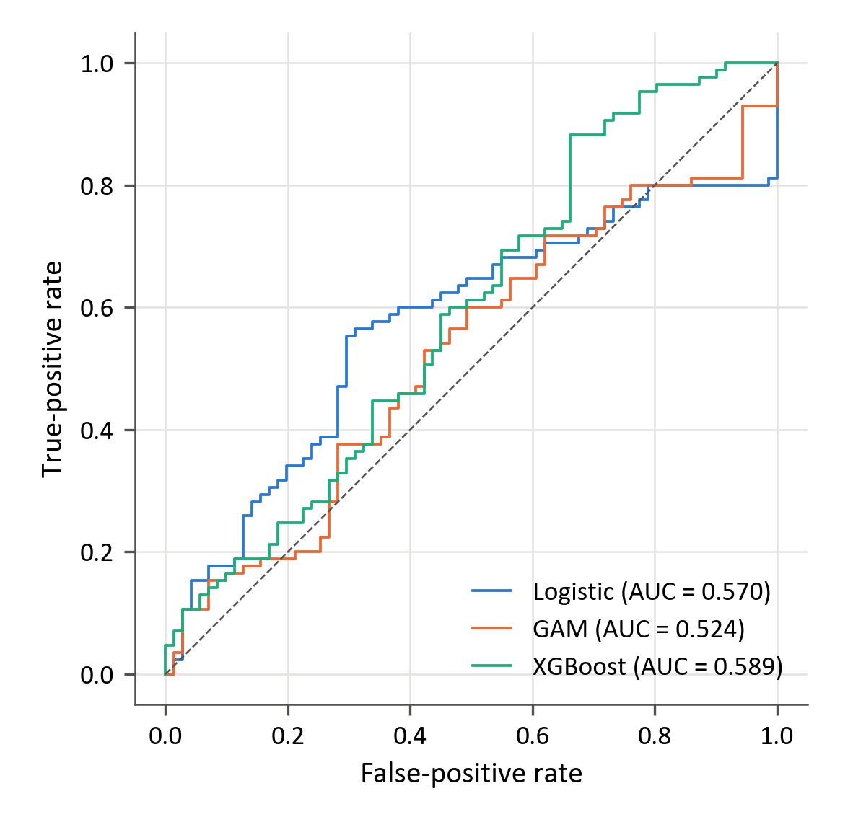
Figure 11: Out-of-sample ROC curves for momentum versus quality
Figure 11 shows that the two leading models are informative in different weeks. Logistic regression's curve is the highest at false-positive rates up to about 0.55, and 15 of its 20 highest-probability weeks were led by momentum. XGBoost's is the highest from there on, because 20 of its 30 lowest-probability weeks, most of them in 2024, were led by quality. All three models rank the weeks of the third period (from January 2024) well, with ROC-AUCs within it of 0.81 (logistic regression), 0.70 (GAM) and 0.75 (XGBoost), whereas within the second period all three are below 0.4. Most of the ranking information in this pair therefore comes from a single year.
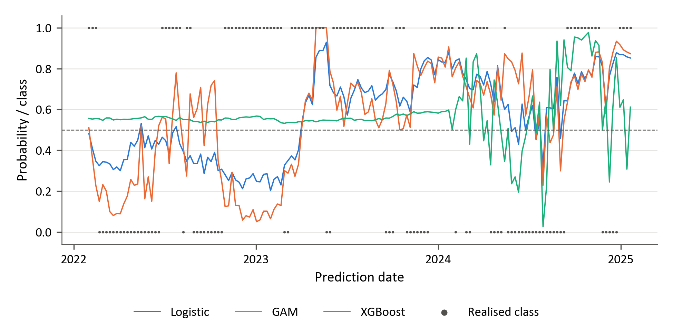
Figure 12: Walk-forward predicted probability that momentum leads quality, with the realised class
Figure 12 shows that for two of the three years XGBoost's forecast was in effect constant. At the first two tuning points it selected its smallest learning rate and largest L2 penalty (Table C.6): its probabilities stayed between 0.53 and 0.60, and it predicted momentum leadership in every week until January 2024, wrongly in most weeks of the first period and correctly in 73% of those of the second. Only after the January 2024 retune, which selected its largest learning rate and smallest penalty, did its probabilities spread, from 0.03 to 0.98. Its accuracy is therefore below logistic regression's in the first period and above it in the second, when the constant forecast matched the dominant factor, and in the third; overall (61.5%) it is again close to the hindsight rule (62.8%). Logistic regression, with a moderate penalty (λ = 10) at every tuning point, was confidently wrong only once. The GAM's probabilities follow logistic regression's but are more extreme, so that it was confidently wrong in eight weeks. It selected strong smoothing penalties (λ = 1000 or 10000), which make its terms close to linear but leave their slopes unpenalised (Wood, 2017), so that, unlike in logistic regression, nothing shrinks its estimates (Hoerl & Kennard, 1970). Here too, what separates the models is the degree of shrinkage rather than the degree of nonlinearity.

Value versus quality
Value versus quality gives the strongest evidence of predictability in the study, and it comes from the nonlinear model. XGBoost has the highest accuracy (60.3%), the highest ROC-AUC of any model and pair (0.664) and the lowest log-loss (0.670). Logistic regression is second on ROC-AUC and log-loss, and the GAM is close to random (accuracy 49.4%, ROC-AUC 0.495). Leadership swung less between years than in the momentum pairs: value led in 60% of the weeks of 2022, and quality in 54% and 57% of those of 2023 and 2024.
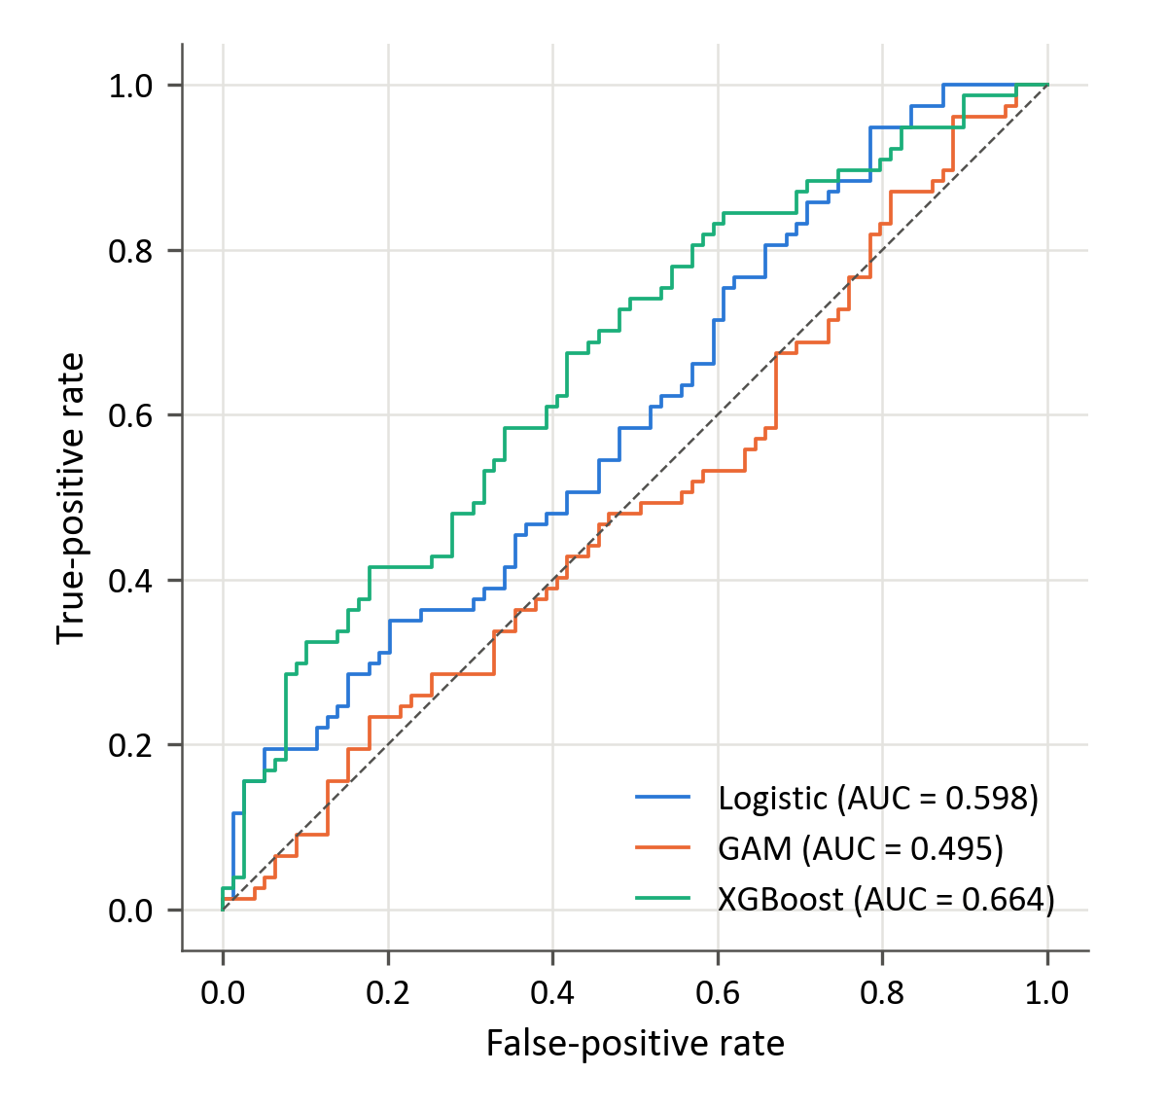
Figure 13: Out-of-sample ROC curves for value versus quality

Figure 13 shows that XGBoost's curve is the highest from a false-positive rate of about 0.08 to 0.78 and never falls below the diagonal: at a false-positive rate of 0.1 it identifies 30% of the value-led weeks, against 19% for logistic regression. Its ranking also holds within each period between tuning points, with ROC-AUCs of 0.78, 0.63 and 0.63, whereas logistic regression ranks well only in the first (0.79, against 0.44 and 0.47). The GAM's curve lies below the diagonal over about half of the range.
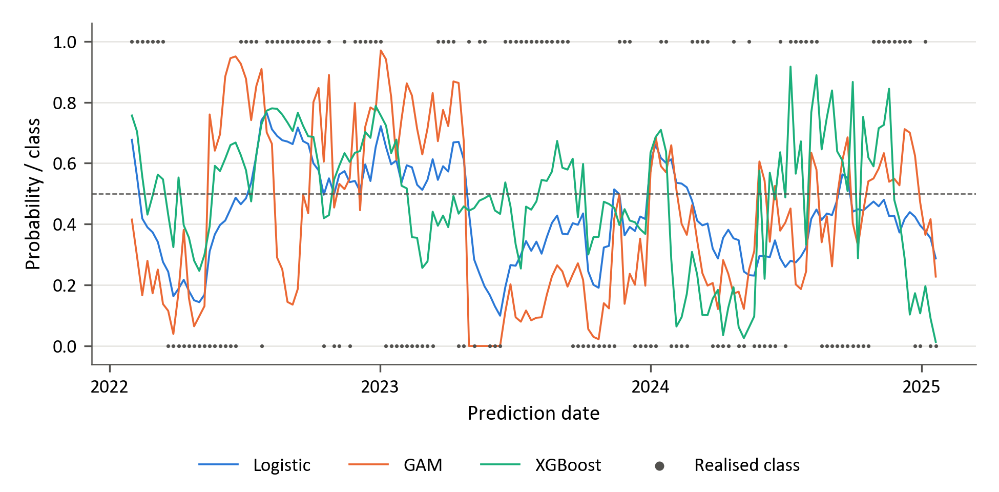
Figure 14: Walk-forward predicted probability that value leads quality, with the realised class
Figure 14 shows that, unlike in the momentum pairs, XGBoost's forecast was never constant. With the shallowest trees in its grid at every tuning point (Table C.6), its probabilities ranged from 0.25 to 0.79 in the first period and spread further after the January 2024 retune, and it was confidently wrong only once. Its accuracy of 60.3% is 3.2 points above the hindsight rule (57.1%), whereas in the momentum pairs XGBoost's accuracy was within 1.3 points of that rule. Logistic regression is never confidently wrong. The GAM was confidently wrong in 12 weeks, which account for 37% of its log-loss; eight of them fell between May and August 2023, when value led but the GAM gave value leadership a probability below 0.1, under a strong smoothing penalty (λ = 1000), as for momentum versus quality. For this pair, then, the tree ensemble ranks the weeks better than the linear and additive models within every period, the clearest indication in the study that nonlinearity adds value, whereas the GAM's smooth additive terms add none.

Consolidated confusion-matrix analysis and probability quality
Table 5 reports the realised class distribution in the common 156-week evaluation block. The three targets are reasonably balanced, although momentum leadership is slightly more common in the two momentum pairs.

Table 5: Realised class distribution in the 156-week evaluation block
Factor pair | Negative observations | Positive observations | Positive share
Momentum vs value | 71 | 85 | 54.5%
Momentum vs quality | 71 | 85 | 54.5%
Value vs quality | 79 | 77 | 49.4%

Table 6 reports the confusion-matrix counts and predicted-positive shares. These diagnostics explain several apparent inconsistencies between ROC-AUC and accuracy.
Table 6: Confusion-matrix diagnostics at the 0.5 threshold
Factor pair | Model | TN | FP | FN | TP | Predicted positive | Actual positive
Momentum vs value | Logistic | 24 | 47 | 31 | 54 | 64.7% | 54.5%
 | GAM | 28 | 43 | 34 | 51 | 60.3% | 54.5%
 | XGBoost | 38 | 33 | 25 | 60 | 59.6% | 54.5%
Momentum vs quality | Logistic | 35 | 36 | 30 | 55 | 58.3% | 54.5%
 | GAM | 27 | 44 | 24 | 61 | 67.3% | 54.5%
 | XGBoost | 14 | 57 | 3 | 82 | 89.1% | 54.5%
Value vs quality | Logistic | 55 | 24 | 48 | 29 | 34.0% | 49.4%
 | GAM | 46 | 33 | 46 | 31 | 41.0% | 49.4%
 | XGBoost | 49 | 30 | 32 | 45 | 48.1% | 49.4%

XGBoost provides the most balanced class treatment for momentum versus value and value versus quality, and logistic regression for momentum versus quality (Table 6).
The two largest imbalances illustrate these inconsistencies. XGBoost predicted momentum leadership against quality in 89.1% of weeks, the result of its constant forecast until January 2024 (Section 4.2.2), and so identified only 14 of the 71 quality-led weeks. Logistic regression predicted value leadership against quality in only 34.0% of weeks, against 49.4% realised, so that its second-highest ROC-AUC for that pair translates into an accuracy of only 53.8%.
The probability results show a clearer pattern. Only XGBoost has a log-loss below the uninformative 0.693 (Section 3.9), and only for momentum versus quality and value versus quality. Logistic regression is within 0.05 of that value for those two pairs (0.686 and 0.738), where it selected a moderate penalty, but reaches 1.140 for momentum versus value, where it selected the weakest; the GAM's log-loss lies between 0.959 and 1.545. Probability quality therefore depends more on the shrinkage each model selected than on its flexibility (Sections 4.2.1–4.2.3).

Feature importance
Figures 15–17 show the ten features with the largest global SHAP importance for each model (Section 3.10).

Momentum versus value
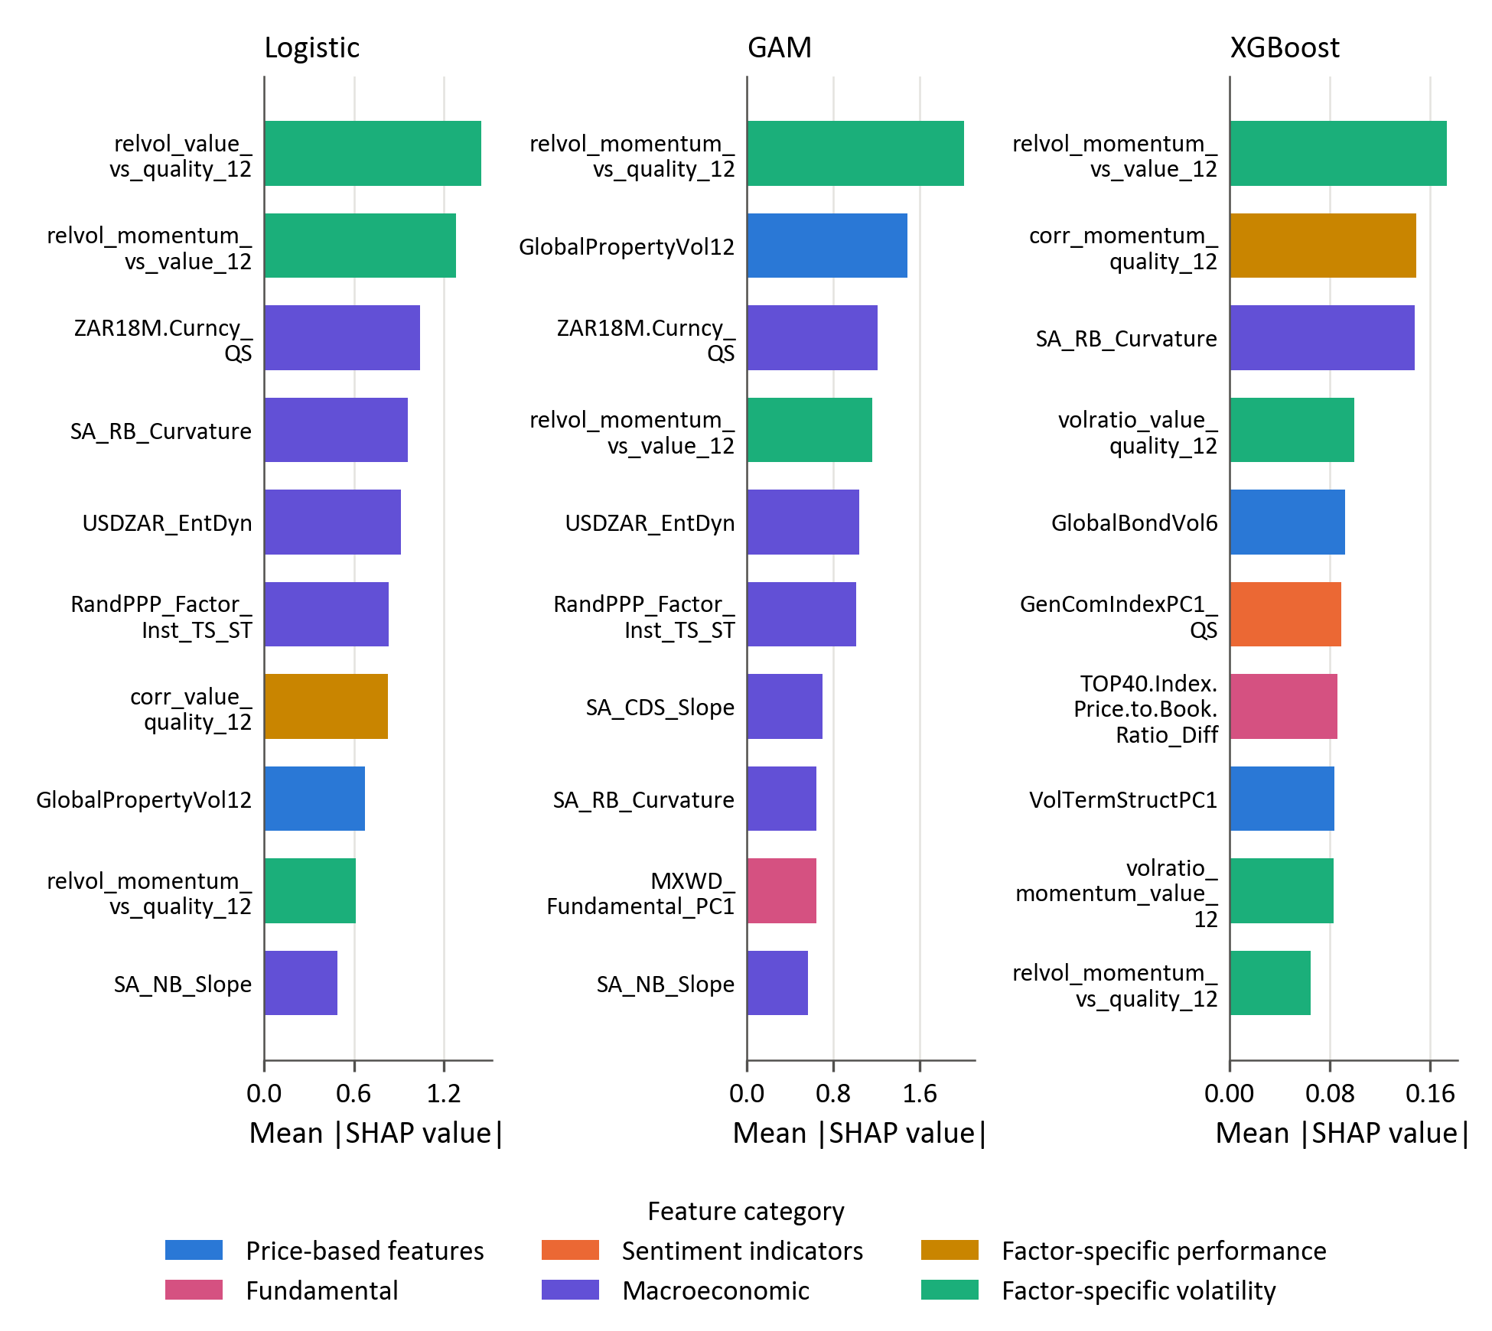
Figure 15: Final global SHAP importance for momentum versus value

A relative-volatility measure ranks first in all three models: that of momentum and value for XGBoost, of value and quality for logistic regression and of momentum and quality for the GAM. Logistic regression and the GAM then share three South African macroeconomic variables in their top six, medium-term USDZAR forward pricing, USDZAR entropy and rand PPP valuation, whereas XGBoost draws on the momentum–quality correlation, South African real-yield-curve curvature, the value–quality volatility ratio, global bond volatility and the commodity index component. The prominence of relative volatility is consistent with evidence that momentum's risk varies predictably over time and that its crashes follow volatile markets (Barroso & Santa-Clara, 2015; Daniel & Moskowitz, 2016).

Momentum versus quality

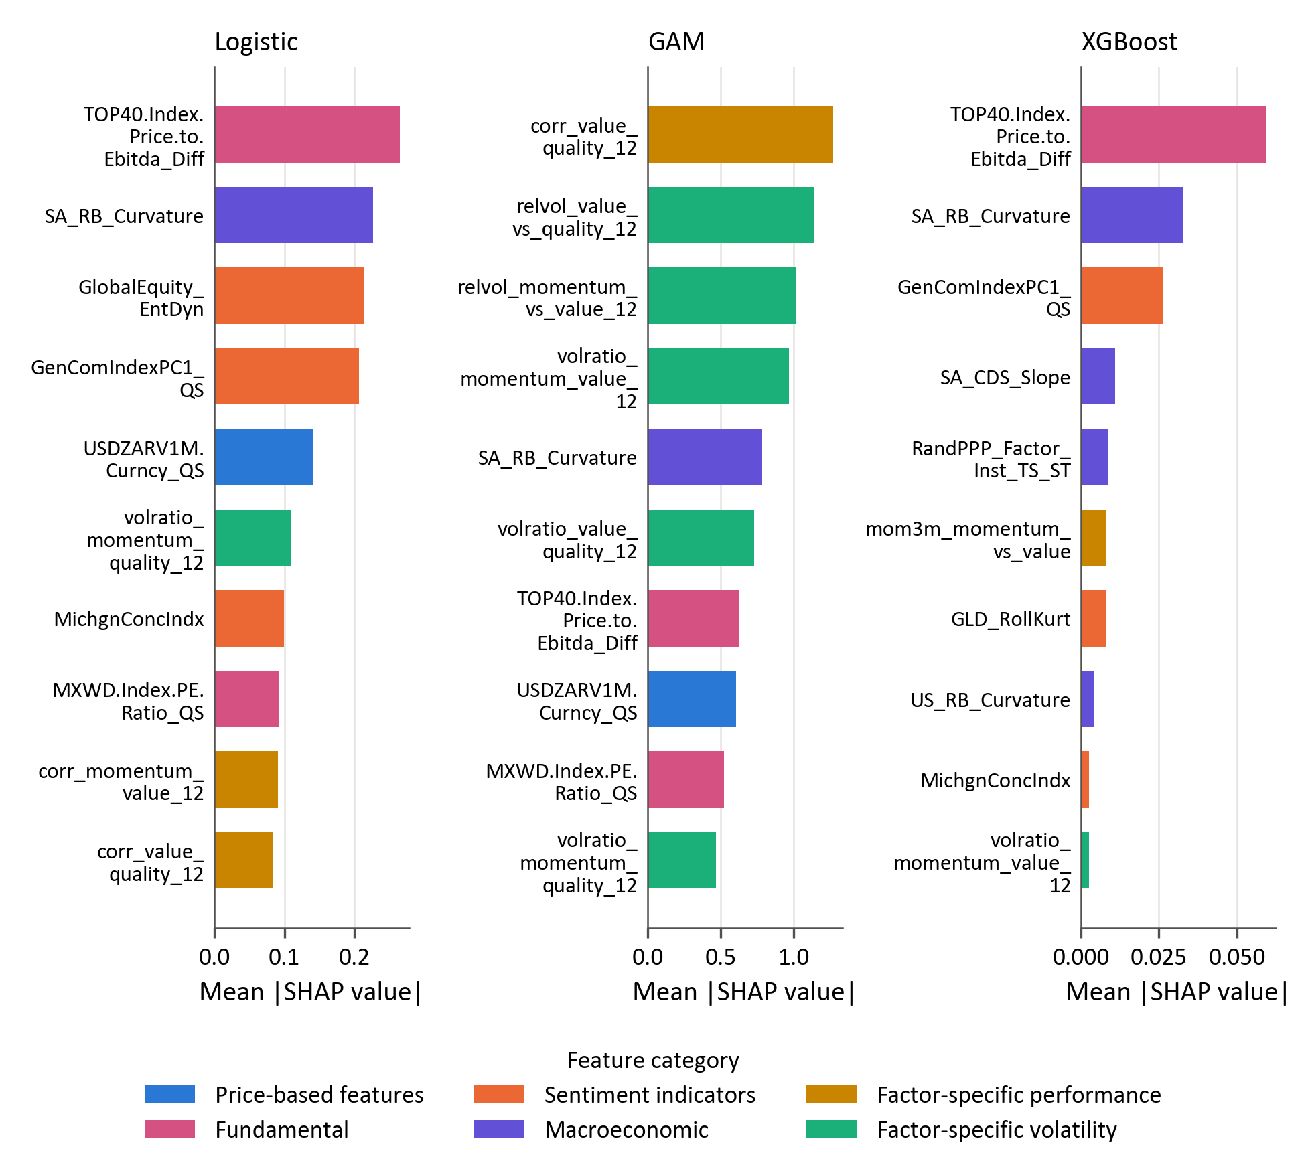
Figure 16: Final global SHAP importance for momentum versus quality

Logistic regression and XGBoost are led by the same two features, the change in the TOP40 price-to-EBITDA ratio and South African real-yield-curve curvature, and the commodity index component is in the top four of both. That a valuation measure leads both is in line with the debate on valuation-based factor timing (Arnott, Beck, Kalesnik, & West, 2016; Asness, Chandra, Ilmanen, & Israel, 2017). The GAM is led instead by factor-specific variables, the value–quality correlation and three relative-volatility measures, with the EBITDA measure seventh. XGBoost's SHAP values for this pair are small, the ten largest summing to less than a sixth of those for the other two pairs, consistent with the near-constant forecasts of its initially selected setting (Section 4.2.2).

Value versus quality

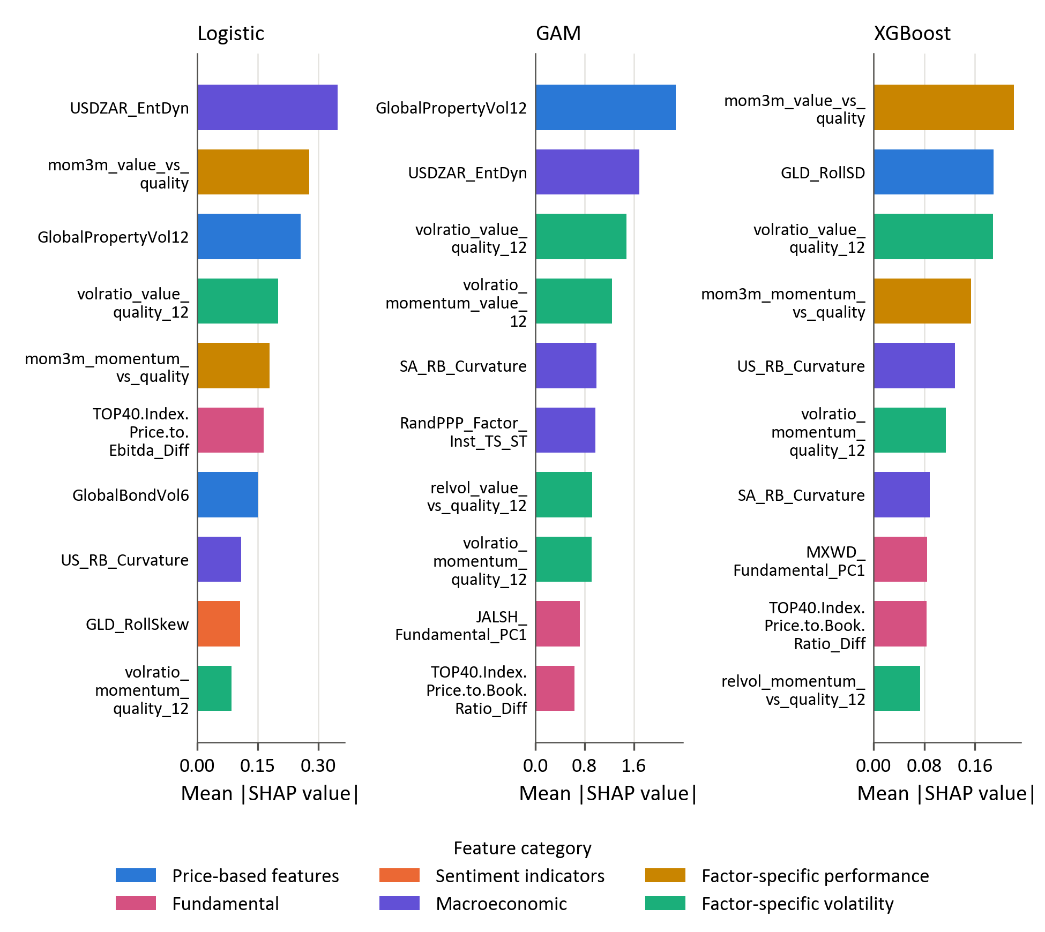
Figure 17: Final global SHAP importance for value versus quality

Recent relative performance matters most for this pair. The three-month relative return of value and quality ranks first for XGBoost and second for logistic regression, and that of momentum and quality is in the top five of both, consistent with factor momentum (Gupta & Kelly, 2019; Arnott, Kalesnik, & Linnainmaa, 2023). The value–quality volatility ratio is in the top four of all three models. Beyond these, logistic regression and the GAM share USDZAR entropy and global property volatility in their top three, whereas XGBoost draws on gold's rolling volatility and US and South African yield-curve curvature.

Chapter conclusion
The final results provide modest and factor-pair-dependent evidence of predictability. XGBoost is the strongest model for every pair and on every measure, and its mean ROC-AUC across the three pairs (0.626) exceeds those of logistic regression (0.552) and the GAM (0.516). It is the only model whose block-bootstrap 95% interval for the mean ROC-AUC excludes 0.5 (0.534 to 0.718; Section 3.9). The evidence is strongest for value versus quality, the only pair for which XGBoost's ROC-AUC interval excludes 0.5 (0.569 to 0.757) and where its ranking holds within every period between tuning points, and weakest for momentum versus quality, where its forecast was in effect constant for two of the three years.
The findings therefore qualify the proposition that increasing model flexibility necessarily improves out-of-sample prediction (Gu et al., 2020; Kelly et al., 2024). XGBoost's advantage in mean ROC-AUC over the GAM is distinguishable from zero (0.110, 95% interval 0.006 to 0.221), but its advantage over logistic regression is not (0.074, −0.045 to 0.196), so on 156 weekly observations the value of nonlinearity over a regularised linear model is not statistically established. The two flexible models also differ in more than nonlinearity: XGBoost can represent interactions between predictors, which the additive GAM cannot (Hastie & Tibshirani, 1986; Friedman, 2001), and its tuning can shrink each tree's contribution, whereas the GAM's penalty leaves the linear part of each term unpenalised (Wood, 2017). The results cannot separate these two differences, but they show that smooth nonlinearity alone adds nothing. The clearest regularity across the three models concerns regularisation: the lightly regularised specifications, logistic regression for momentum versus value and the GAM, produced overconfident probabilities and the poorest log-loss, and the validation data gave little basis for choosing between penalties. The evidence supports limited predictive structure rather than a strongly separable factor-timing signal.
The global SHAP analysis indicates that the fitted models use a combination of relative-factor dynamics, volatility, currency conditions, valuation, yield-curve information, commodity regimes and sentiment. Only South African real-yield-curve curvature is among the ten leading features of almost every model and pair (eight of the nine); otherwise, the patterns differ across model classes and factor pairs and should remain exploratory given the modest predictive performance.

Amendment log (review aid – remove before submission)
Highlighted text in the chapter marks amendments. Deletions cannot be highlighted, so they are listed here together with the reason for every change.
Section | Change | Reason / evidence
All | Every result in the chapter is replaced. The weekly Quality returns in the input data were stamped five weeks early: each week carried the Quality return of five weeks later. The series was realigned, the labels and features were rebuilt and all three models were rerun with annual retuning, unchanged otherwise. The Quality-based labels changed in about 40% of evaluation weeks (momentum vs quality and value vs quality); 12 of the 50 features changed; the momentum vs value labels did not. XGBoost now leads every pair on every measure, so the reading of the chapter changes: the text is rewritten throughout, in the structure the author gave Section 4.2. | Data correction (results/fix_quality_offset.py, rerun_pipeline.py). Because features are lagged four weeks and the offset was five, the old Quality-based features contained one week of future Quality returns. Every number is read from results/model_outputs.
4.2 | Opening rewritten for the new results: XGBoost leads every pair on every measure; the GAM does not improve on logistic regression (lower ROC-AUC for two pairs, highest log-loss for all three); the highest ROC-AUC is now 0.664. | Rerun on the corrected data (first row).
4.2 / Table 4 | Every value replaced; the best value per pair and measure in bold (XGBoost throughout). ROC-AUC shown on the zero-to-one scale (0.625) instead of as a percentage, as in the text and Section 3.9. | Rerun on the corrected data (first row).
4.2 / Table 4 | Caption added (the table had none): 'Table 4: Out-of-sample accuracy, ROC-AUC and log-loss by factor pair and model'. Tables are numbered consecutively after Chapter 3 (Tables 1–3), as the figures already are, so the class distribution becomes Table 5 (was 4.1) and the confusion matrices Table 6 (was 4.4). In the thesis, insert the captions with References > Insert Caption so that they are numbered fields and appear in the List of Tables (in this extract all caption numbers are typed text, because the fields would restart from 1 in a single chapter). | Consistency with Chapter 3.
4.2 | Reading guide after Table 4 kept as the author wrote it; one comma replaced by a colon ('The first shows the ROC curves: the vertical axis …'). | Punctuation.
4.2.1 | Opening rewritten: XGBoost is the only model with a ROC-AUC well above 0.5 for this pair; logistic regression and the GAM are close to random on ROC-AUC with log-loss far above 0.693. Deleted with the old results: 'provides the strongest classification result in the study', the GAM's accuracy, 'XGBoost's lead suggests that nonlinear structure contributes …', 'While results support … factor outperformance', 'The size of the effect remains moderate …', logistic regression's ROC-AUC and accuracy and its log-loss explanation, with the citation Hastie & Tibshirani (1986), which introduces GAMs and does not support the shrinkage claim. | Rerun on the corrected data (first row).
4.2.1 / Figure 9 | Paragraph rewritten: XGBoost's curve is highest from a false-positive rate of about 0.25; its advantage lies in the value-led weeks of 2022 it ranks lowest; its ROC-AUC within each 52-week period between tuning points is 0.55 or more, logistic regression's below 0.5 (Fawcett, 2006). | Rerun on the corrected data (first row).
4.2.1 / Figure 10 | Paragraph (styled as a caption) restyled as body text and rewritten as two paragraphs. (1) XGBoost's forecasts per tuning period: in effect constant forecasts in the first two years, so that its accuracy is close to that of predicting each calendar year's most frequent leader with hindsight (a rule defined here and referred to in Sections 4.2.2–4.2.3); its probabilities spread only after the January 2024 retune, when all its confident errors occur. (2) Logistic regression (λ = 0.01, Zou & Hastie, 2005) and the GAM (λ = 1, 10 splines; Wood, 2017) selected their weakest penalties, hence their confident errors; the CPCV surface for logistic regression was nearly flat, so the gap to XGBoost reflects the selected penalty more than nonlinearity. | Rerun on the corrected data (first row). Tuning grid: results/model_outputs/artifacts/logistic_momentum_vs_value_tuning_grid.pkl (a CSV file).
4.2.2 | Opening rewritten: XGBoost leads on all three measures but its ROC-AUC exceeds logistic regression's by only 0.019; the GAM is last. Deleted with the old results: the sentences on logistic regression as the strongest model, 'XGBoost again produces the strongest overall classification results', the log-loss of 0.687 and accuracy of 51.3%, the confusion-matrix sentence and the GAM's error pattern. | Rerun on the corrected data (first row).
4.2.2 / Figure 11 | Paragraph rewritten: logistic regression ranks best among the weeks it ranks highest, XGBoost among those it ranks lowest; all three models rank the third period well and the second poorly, so most of the information comes from one year. The bias–variance sentence and its citation (Hastie et al., 2009; Israel et al., 2020) no longer apply and are deleted. | Rerun on the corrected data (first row).
4.2.2 / Figure 12 | Paragraph restyled as body text and rewritten: XGBoost's forecast was in effect constant until January 2024; its accuracy is close to the hindsight rule; logistic regression (λ = 10) is confidently wrong once; the GAM follows logistic regression but, with its slopes unpenalised (Wood, 2017; Hoerl & Kennard, 1970), is more extreme. 'show log-loss probabilities' replaced. | Rerun on the corrected data (first row).
4.2.3 | Opening rewritten: the strongest evidence in the study, from XGBoost (highest ROC-AUC of any model and pair); logistic regression second; the GAM close to random. Deleted with the old results: logistic regression as the strongest model, XGBoost's lower accuracy and 'The evidence for predictable value versus quality … linear specification'. | Rerun on the corrected data (first row).
4.2.3 / Figure 13 | Paragraph restyled as body text and rewritten: XGBoost's curve is highest over most of the range and never below the diagonal; its ranking holds within every period, logistic regression's only in the first; the GAM's curve below the diagonal over half the range. | Rerun on the corrected data (first row).
4.2.3 / Figure 14 | Paragraph restyled as body text and rewritten: XGBoost's forecast never constant and its accuracy clearly above the hindsight rule; the GAM's confident errors, most of them in May–August 2023. The citation (Friedman, 2001; Chen, Pelger, & Zhu, 2019) belonged to the deleted sentence on XGBoost's shrinkage; Chen, Pelger and Zhu (2019) is a deep-learning paper in any case (XGBoost is Chen & Guestrin, 2016, tag Che16). | Rerun on the corrected data (first row).
4.2 / Figures 9–14 | Pictures replaced by the renders from the rerun outputs (captions highlighted; caption text unchanged). | Rerun on the corrected data (first row). build_chapter4_corrected_figures.py.
4.2 / citations | Every citation in the rewritten paragraphs is a Word citation field (Source Manager tags Hos13, Isr20, Pag241, Faw06, Zou05, Woo17, Hoe70), so the paragraphs can be copied into the thesis as they are and the reference list updates with them. | Citations.
4.1, 4.2, 4.2.1, 4.4 / headings | Headings in sentence case, as in Chapters 1 and 3: 'Overview of the evaluation framework', 'Out-of-sample predictive performance', 'Momentum versus value', 'Feature importance'. | Consistency.
4.3 / Table 5 | Momentum vs quality and value vs quality rows updated (their labels changed with the corrected Quality series). Renumbered (was 4.1) and given a caption (it had none). The sentence on balance still holds. | Rerun on the corrected data (first row).
4.3 | Deleted 'These counts provide the context required to interpret the confusion matrices reported below.' | Author: say it once.
4.3 / Table 6 | Confusion-matrix counts and predicted- and actual-positive shares replaced. Renumbered (was 4.4) in the text and the caption, which follows the thesis format 'Table N: Title'. | Rerun on the corrected data (first row).
4.3 | Most balanced model per pair updated; the shares behind it deleted from the text (they are in Table 6). | Rerun on the corrected data (first row).
4.3 | Paragraph on positive-class tendencies rewritten: the two largest imbalances are now XGBoost for momentum vs quality (its constant forecast) and logistic regression for value vs quality (too few positive predictions), as examples of the inconsistencies between ROC-AUC and accuracy that the author's preceding sentence announces. | Rerun on the corrected data (first row).
4.3 | Probability-quality paragraph rewritten: only XGBoost beats the uninformative 0.693, for two pairs; logistic regression's log-loss depends on the penalty it selected; the GAM's is the highest. Deleted: 'An uninformative forecast of 0.5 … approximately 0.693' (defined in Section 3.9) and 'better discrimination does not necessarily imply better probability quality', which no longer holds (XGBoost leads on both). | Rerun on the corrected data (first row).
4.4 | Opening reduced to a reference to Section 3.10, which explains how the figures are read (the ten leading features, ranks rather than magnitudes, colours by the feature categories of Table 1) and the limits of the interpretation. Deleted: the definition of global importance, the caveats (Kumar et al., 2020; Molnar, 2022), the comparison and colour conventions, 'This distinction is important because all final ROC-AUC values remain below 0.60' (no longer true) and the reference to 'Table 1 of Section 3.6'. | Author: say it once; Section 3.10 explains the results section.
4.4.1 | Paragraph rewritten from the new rankings (Figure 15). The citations Ehsani & Linnainmaa (2022) and Gupta & Kelly (2019) on factor momentum are dropped here, because short-horizon relative returns no longer rank among the leading features for this pair (factor momentum is now cited in Section 4.4.3). Barroso & Santa-Clara (2015) and Daniel & Moskowitz (2016) kept, as citation fields. | Rerun on the corrected data (first row).
4.4.2 | Paragraph rewritten from the new rankings (Figure 16). The EBITDA measure was described as a 'local-versus-global' differential; it is the first difference of the TOP40 price-to-EBITDA ratio (Appendix A). Arnott et al. (2016) and Asness et al. (2017) kept, as citation fields. | Rerun on the corrected data (first row). Appendix A.
4.4.3 | Paragraph rewritten from the new rankings (Figure 17): the standardised relative-performance measure no longer leads. Deleted: 'Logistic regression is the best-performing model for this pair, but its AUC of 0.585 remains modest. The feature rankings should therefore be interpreted as a description of the fitted decision function rather than evidence of stable economic causality.' (no longer true; the caveat is in Section 3.10). | Rerun on the corrected data (first row).
4.4 / Figures 15–17 | SHAP figures replaced by the renders from the rerun outputs, in the thesis colours with no title inside the figure, and renumbered (were 4.3–4.5) to follow Figures 9–14, in the caption format 'Figure N: Title' without a full stop. | Rerun on the corrected data (first row). build_chapter4_corrected_figures.py.
4.5 | Model ranking rewritten: XGBoost leads every pair on every measure; mean ROC-AUC of each model; XGBoost's bootstrap interval is the only one to exclude 0.5, and per pair only for value vs quality (results/model_outputs/bootstrap/auc_ci.csv); where the evidence is strongest and weakest. 'several models produce strongly asymmetric classifications at the 0.5 threshold' deleted (Section 4.3). | Rerun on the corrected data (first row). results/model_outputs/bootstrap/auc_mean_across_pairs.csv.
4.5 | Flexibility conclusion rewritten: bootstrap intervals for the differences in mean ROC-AUC (method in Section 3.9): XGBoost vs GAM distinguishable from zero, XGBoost vs logistic regression not; the two flexible models differ in interactions and in regularisation, which the results cannot separate; smooth nonlinearity alone adds nothing; the regularisation finding. The author's first and last sentences kept (the whole paragraph is highlighted because it now holds citation fields: Has86, JHF01, Woo17). 'Even the best AUC is below 0.60' deleted (no longer true). | Rerun on the corrected data (first row). results/model_outputs/bootstrap/auc_mean_across_pairs.csv.
4.5 | SHAP summary: South African real-yield-curve curvature added as the one feature common to almost all models and pairs (Figures 15–17). | Rerun on the corrected data (first row).
4.2–4.3 / Tables 4–6 | Each table kept on one page with its caption (its rows are kept with the next); Table 4 was split after its first row. | Layout.

The relative weights of the descriptors within each factor are proprietary to Momentum Investments and are not published, so the factor composites cannot be replicated exactly from public information.
The feature file spans 944 weeks, from 5 March 2007 to 31 March 2025; the 12-week rolling windows of the relative-factor features remove the first 11 (944 − 11 = 933), and the four-week lag removes a further four (933 − 4 = 929), so the matrix begins on 18 June 2007. Trend-scanning labels cannot be resolved for the final ten weeks, leaving 919 labelled observations per factor pair (18 June 2007 to 20 January 2025)
MI is estimated after discretising each series into 20 quantile bins and normalised by the larger of the two marginal entropies; the distance is one minus the normalised MI. The Ward clustering is applied to each feature’s profile of distances to all other features, so the cut height of 2 is measured on these profiles rather than on MI distance itself. Appendix B reports the clusters and the sensitivity of the selection to these choices.

