In Search of the Holy Grail of Factor Timing
Application of Machine Learning to the
South African Equity Market
by
Cathy Catherine Hlungwani
Research assignment presented in partial fulfilment of the requirements for the degree of MEng (Structured) (Industrial Engineering) in the Faculty of Engineering at Stellenbosch University
Supervisor Prof. Evan Gilbert
November 2026

Declaration
By submitting this research assignment electronically, I declare that the entirety of the work contained therein is my own, original work, that I am the sole author thereof (save to the extent explicitly otherwise stated), that reproduction and publication thereof by Stellenbosch University will not infringe any third party rights and that I have not previously in its entirety or in part submitted it for obtaining any qualification.
During the preparation of this research assignment, the author used artificial intelligence-assisted tool(s) to identify relevant literature, generate code, generate images, improve the readability and language of the thesis. After using the artificial intelligence-assisted tool(s), the author reviewed and edited the content and takes full responsibility for the content of the work.
Date: November 2026
Copyright © 2026 Stellenbosch University
All rights reserved
Abstract
Momentum, value and quality earn long-term premia, while their relative performance varies over time. This study compares regularised logistic regression, a generalised additive model (GAM) and XGBoost for predicting relative factor leadership in the South African equity market. Trend scanning defines binary targets. Pre-evaluation screening and mutual-information clustering, combined with relative-factor predictors, produce 47 inputs. Models are tuned by combinatorial purged cross-validation and assessed on 156 weekly walk-forward forecasts from January 2022 to January 2025, with training-specific standardisation and 12-week purges. The highest areas under the receiver operating characteristic curve (ROC-AUCs) are 0.572 for momentum versus value (XGBoost), 0.630 for momentum versus quality (XGBoost) and 0.648 for value versus quality (XGBoost). Unadjusted 95% ROC-AUC intervals exclude 0.5 for XGBoost on value versus quality. No model–pair interval excludes 0.5 after adjustment across nine estimates. Paired intervals do not establish a ROC-AUC advantage for XGBoost over logistic regression on any pair. Accuracy is assessed against the majority-class benchmark, and log-loss assesses the quality of forecast probabilities. Reference-model Shapley attributions describe the use of valuation, market, macroeconomic and relative-factor information. The results concern the selected specifications in one short evaluation period; they do not establish a general ranking of model classes or demonstrate a profitable factor-allocation strategy.
Contents
1 Introduction 1
1.1 Background 1
1.2 Problem statement 3
1.3 Scope and objectives 4
1.4 Research methodology 4
1.5 Contribution to data science 6
1.6 Research assignment outline 6
2 Literature Review 8
2.1 Machine learning in finance 8
2.2 Application of machine learning to factor timing in the global literature 13
2.3 Application of machine learning factor timing strategies in South African equity markets 19
3 Methodology 21
3.1 Research design and empirical framework 21
3.2 Factor definitions 22
3.3 Motivation for using relative factor performance 24
3.4 Data sources and pre-processing 26
3.5 Trend-scanning target label construction 27
3.6 Feature selection 29
3.7 Model training 31
3.8 Hyperparameter tuning and model validation 34
3.9 Performance evaluation 36
3.10 Feature importance 37
4 Results 38
4.1 Overview of the evaluation framework 38
4.2 Out-of-sample predictive performance 38
4.3 Confusion matrices and probability quality 43
4.4 Feature importance 45
5 Conclusion 50
5.1 Summary of key findings 50
5.2 Implications for factor timing and quantitative asset management 50
5.3 Limitations of the study 51
5.4 Recommendations for future research 52
References 53
Appendix A Feature definitions 60
A.1 Relative-factor construction conventions 63
Appendix B Feature selection and sample audit 64
B.1 Screening and estimation window 64
B.2 Cluster representatives and membership 65
B.3 Sensitivity of feature selection 68
B.4 Availability and sample reconciliation 69
Appendix C Validation and statistical inference 70
C.1 Initial chronological groups 70
C.2 Combinations and back-test paths 70
C.3 Initial tuning results and fit eligibility 71
C.4 Walk-forward schedule and selected settings 72
C.5 Block-bootstrap inference 73

List of figures
Figure 1: Rolling 12-month active returns of the momentum, value and quality factors 25
Figure 2: Rolling 36-month correlations of active returns 25
Figure 3: Trend-scanning results for momentum versus value 28
Figure 4: Trend-scanning results for value versus quality 28
Figure 5: Trend-scanning results for momentum versus quality 29
Figure 6: Hierarchical agglomerative clustering of the pre-evaluation feature space 30
Figure 7: CPCV with five chronological groups and two validation groups 35
Figure 8: Expanding-window evaluation with a 12-week purge and annual retuning 36
Figure 9: Walk-forward ROC curves for momentum versus value 39
Figure 10: Predicted probabilities and realised classes for momentum versus value 40
Figure 11: Walk-forward ROC curves for momentum versus quality 41
Figure 12: Predicted probabilities and realised classes for momentum versus quality 41
Figure 13: Walk-forward ROC curves for value versus quality 42
Figure 14: Predicted probabilities and realised classes for value versus quality 43
Figure 15: Global reference-model attributions for momentum versus value 47
Figure 16: Global reference-model attributions for momentum versus quality 48
Figure 17: Global reference-model attributions for value versus quality 49

List of tables
Table 1: The 47 modelling predictors by category 30
Table 2: Comparison of the three model classes 34
Table 3: Hyperparameter search grids 35
Table 4: Walk-forward performance with 95% block-bootstrap intervals 38
Table 5: Realised class balance in the common evaluation sample 44
Table 6: Confusion-matrix diagnostics at a threshold of 0.5 44
Table A.1: Definitions of all retained predictors 60
Table B.1: From candidate inputs to the modelling predictor set 64
Table B.2: Candidates removed by the pre-evaluation missingness screen 64
Table B.3: Cluster representatives and members at cut height two 65
Table B.4: Pre-evaluation sensitivity to clustering choices 68
Table B.5: Reconciliation of observation counts 69
Table C.1: Chronological groups in the initial tuning sample 70
Table C.2: The ten initial CPCV combinations 70
Table C.3: Selected-setting and no-feature ROC-AUC diagnostics 71
Table C.4: Purged tuning and walk-forward training schedule 72
Table C.5: Hyperparameters selected at each tuning point 72
Table C.6: Paired XGBoost-minus-logistic comparisons 73
Table C.7: ROC-AUC interval sensitivity and adjustment for nine estimates 73

List of acronyms and abbreviations
Acronym or abbreviation | Definition
AI | Artificial Intelligence
ARI | Adjusted Rand index
AUC | Area Under the Curve
CAPM | Capital Asset Pricing Model
CART | Classification and Regression Trees
CDS | Credit Default Swap
CPCV | Combinatorial Purged Cross-Validation
DXY | US Dollar Index
Diff | First-Difference Transformation
EBIT | Earnings Before Interest and Taxes
EBITDA | Earnings Before Interest, Taxes, Depreciation and Amortisation
Ent | Entropy (market uncertainty measure)
EntDyn | Change in Entropy
FNN | Feedforward neural network
FTSE | Financial Times Stock Exchange
FX | Foreign Exchange
FY1 | Financial-Year Earnings Estimate (current financial year in this study)
GAM | Generalised Additive Model
GRU | Gated Recurrent Unit
GretX | X-Month Geometric Return
JSE | Johannesburg Stock Exchange
L1 | Absolute-Value Regularisation Penalty
L2 | Squared-Value Regularisation Penalty
LASSO | Least Absolute Shrinkage and Selection Operator
LSTM | Long Short-Term Memory Network
MI | Mutual Information
ML | Machine Learning
MSCI | Morgan Stanley Capital International
NB | Nominal Bonds
NMI | Normalised mutual information
OOS | Out-of-Sample
PC1 / PC2 | First / Second Principal Component
PCA | Principal Component Analysis
PE | Price-to-Earnings Ratio
PMI | Purchasing Managers’ Index
PPP | Purchasing Power Parity
QS | Quantile-Scaled Transformation
RB | Real Bonds
RNN | Recurrent Neural Network
ROC | Receiver Operating Characteristic
ROC-AUC | Area Under the Receiver Operating Characteristic Curve
ROE | Return on Equity
ROIC | Return on Invested Capital
RV_X | X-Month Realised Volatility
SA | South Africa / South African
SB | Structural Break Indicator
SHAP | Shapley Additive Explanations
SWIX | Shareholder Weighted Index
TOP40 | FTSE/JSE Top 40 Index
TS | Time Series Level
US | United States
USD | United States Dollar
USD/ZAR | US Dollar–South African Rand Exchange Rate
VIX | Cboe Volatility Index
VolX | X-Month Rolling Volatility
XGBoost | Extreme Gradient Boosting
ZAR | South African Rand

1 Introduction
Equity factors such as momentum, value and quality earn well-documented long-term premia (Fama & French, 1993; Jegadeesh & Titman, 1993; Asness, Frazzini, & Pedersen, 2019), but their returns vary materially over time, with extended periods of strong performance interrupted by deep drawdowns (Daniel & Moskowitz, 2016; Ilmanen, Israel, Lee, Moskowitz, & Thapar, 2021). If changes in relative factor performance are partly predictable, investors could tilt their allocation towards the factor expected to outperform (Asness, Friedman, Krail, & Liew, 2000; Gupta & Kelly, 2019; Arnott, Kalesnik, & Linnainmaa, 2023). This study examines whether machine learning models can predict which of the momentum, value and quality factors will lead in the South African equity market, and whether more flexibility improves predictive accuracy.
Earlier South African research examines equity style timing (Mutooni & Muller, 2007), while recent work applies machine learning to style rotation (Makamo, 2023; Page, McClelland, & Auret, 2024). Evidence remains limited on the incremental contribution of nonlinearity and interactions under a common classification design. This study predicts trend-scanned labels for momentum versus value, momentum versus quality and value versus quality from lagged explanatory variables. Three model classes of increasing flexibility are used: regularised logistic regression as the linear benchmark, a generalised additive model (GAM) for smooth marginal effects, and XGBoost for nonlinearities and interactions. Hyperparameters are selected by combinatorial purged cross-validation, and the models are evaluated on 156 weekly walk-forward forecasts using accuracy, ROC-AUC and log-loss. Shapley attributions describe the predictors used by reference fits. Block-bootstrap intervals and paired comparisons qualify the evidence for predictability and model differences.

1.1 Background
The empirical study of equity factors developed from the recognition that market beta alone does not explain the cross-section of expected returns. The Capital Asset Pricing Model (CAPM) provided the starting point (Lintner, 1965; Sharpe, 1964), and multi-factor models subsequently identified systematic differences in expected returns associated with company characteristics known as factors (Fama & French, 1992; Fama & French, 1993). Momentum (Jegadeesh & Titman, 1993; Carhart, 1997), value (Fama & French, 1993), quality (Asness, Frazzini, & Pedersen, 2019; Piotroski, 2000), profitability (Fama & French, 2015) and low volatility (Blitz, Falkenstein, & van Vliet, 2014; Blitz & van Vliet, 2007) are widely documented sources of long-term return, with the momentum and value premia documented across markets and asset classes (Asness, Moskowitz, & Pedersen, 2013). The economic origin of these premia remains debated, straddling rational risk-based (Fama & French, 1993; Fama & French, 2015) and behavioural bias-based explanations (Lakonishok, Vishny, & Shleifer, 1994; Daniel, Hirshleifer, & Subrahmanyam, 1998), suggesting that their drivers are multifaceted and not attributable to a single, unified theory.
These premia do not offer consistent rewards. Factor returns exhibit significant cyclicality and regime dependence, with prolonged periods of outperformance, deep drawdowns and occasional crashes that challenge static, buy-and-hold factor investing (Ilmanen & Kizer, 2012; Barroso & Santa-Clara, 2015; Daniel & Moskowitz, 2016; Bessler, Taushanov, & Wolff, 2021). This time variation creates the empirical motivation for factor timing: if changes in relative factor performance are partly predictable, investors may be able to allocate capital dynamically towards the factors expected to outperform (Arnott, Beck, Kalesnik, & West, 2016; Arnott, Kalesnik, & Linnainmaa, 2023).
The evidence supporting factor timing is mixed. Several studies report that dynamic rules based on valuation, momentum or common factor signals improve risk-adjusted returns (Asness, Friedman, Krail, & Liew, 2000; Gupta & Kelly, 2019; Haddad, Kozak, & Santosh, 2020), while others find that most factor timing relationships are weak, unstable or difficult to exploit consistently out of sample, and that valuation-based timing adds little beyond a static factor allocation (Asness, Chandra, Ilmanen, & Israel, 2017; Ilmanen, Israel, Lee, Moskowitz, & Thapar, 2021). The relevant empirical question is therefore whether a specified forecasting method produces reliable out-of-sample improvement, rather than whether factor timing is theoretically possible.
Classical econometric approaches have been a source of valuable insights in generating factor timing signals, but their reliance on linearity assumptions limits their ability to capture nonlinear interactions and complex market dynamics that may underpin short-run factor rotations (Campbell, Lo, & MacKinlay, 1997; Cont, 2001). Machine learning (‘ML’ hereafter) methods can account for these complexities and offer complementary perspectives to conventional approaches (Moritz & Zimmermann, 2016; Gu, Kelly, & Xiu, 2020; Giglio, Kelly, & Xiu, 2022; Wang, 2023). However, this greater flexibility also increases the capacity to fit noise. This concern is particularly important in finance, where predictive signals are weak, samples are limited and relationships may change over time, and where backtests can overstate performance when model selection repeatedly uses the same observations or when training information overlaps with the period used for evaluation (Harvey, Liu, & Zhu, 2016; Arnott, Harvey, & Markowitz, 2019; Israel, Kelly, & Moskowitz, 2020).
These issues are especially relevant in emerging equity markets. Greater informational inefficiency may leave more exploitable structure, but shorter data histories, higher idiosyncratic risk and more frequent structural breaks increase the risk that flexible models extract spurious patterns (Leung, Lohre, Mischlich, Shea, & Stroh, 2021; Cakici, Fieberg, Metko, & Zaremba, 2023). Although ML methods have shown predictive value in emerging-market return studies, their performance is not necessarily transferable across markets (Hanauer & Kalsbach, 2023).
Value and momentum effects have long been documented on the Johannesburg Stock Exchange, and local style returns vary through time (Fraser & Page, 2000; Muller & Ward, 2013). Mutooni and Muller (2007) provide early evidence on equity style timing. Page, McClelland and Auret (2022) examine momentum-based style rotation, while their subsequent study compares machine learning methods with style-momentum signals (Page, McClelland, & Auret, 2024). These studies motivate a controlled comparison of a linear model, an additive nonlinear model and an interaction-capable tree model using identical targets, predictors and evaluation periods.

1.2 Problem statement
This study addresses whether machine learning models can identify predictive signals in the relative performance of South African equity factors. Existing local research provides limited evidence comparing models with different levels of flexibility using the same factor pairs, predictor set and time-series validation framework. This study therefore compares logistic regression, generalised additive models and XGBoost to determine whether greater model flexibility improves the out-of-sample prediction of relative momentum, value and quality performance.

1.3 Scope and objectives
The forecasting problem is defined in terms of the relative performance of three factor pairs: momentum versus value, momentum versus quality, and value versus quality, a formulation consistent with recent applications of ML to directional financial prediction (Cotturo, Liu, & Proner, 2024; Piovezan, de Andrade Junior, & Ávila, 2024). The study concentrates on statistical predictive performance rather than portfolio construction. Transaction costs, portfolio turnover, market impact and probability-based allocation rules fall outside the primary empirical scope and are identified as areas for future research.
The primary objective of this study is to determine whether machine learning models with different levels of functional flexibility can predict the relative performance of momentum, value and quality factors in the South African equity market. Within this scope, the study has the followingspecific objectives:
- Construct pairwise classifications of relative factor leadership using trend-scanning labels for momentum versus value, momentum versus quality, and value versus quality.
- Implement a validation framework that combines pre-evaluation feature selection, purged combinatorial cross-validation for hyperparameter selection and expanding-window walk-forward evaluation.
- Compare the out-of-sample predictive performance of logistic regression, generalised additive models and XGBoost, and assess whether greater model flexibility produces consistent improvements across the three factor pairs.
- Identify the features that most influence model predictions and examine how their importance varies across factor pairs and model classes.

1.4 Research methodology
The empirical design has three components. Trend scanning defines binary targets for relative factor leadership. A common predictor set supports comparison of linear, additive nonlinear and boosted-tree models. Purged cross-validation selects hyperparameters, and walk-forward evaluation measures predictive performance on later observations.
Weekly factor returns are available from April 2007 to March 2025. The corrected modelling matrix begins on 29 March 2010 after pre-inception rows are excluded and predictors are lagged. Market, macroeconomic, valuation, sentiment and relative-factor variables provide complementary information about the state in which factor returns arise (Gu, Kelly, & Xiu, 2020; Feng, Giglio, & Xiu, 2020).
Binary labels are constructed using the trend-scanning methodology proposed by López de Prado (López de Prado, 2018; López de Prado, 2020). This approach allows the labelling process to adapt to varying market dynamics without imposing a fixed prediction window. Given the high dimensionality of the feature space, an information-theoretic clustering procedure based on mutual information is employed to reduce redundancy while preserving nonlinear dependencies (López de Prado, 2018; Sulaiman & Labadin, 2016). This produces a compact and diversified predictor set appropriate for supervised learning.
To assess the incremental value of model flexibility, three progressively sophisticated model classes are compared: a linear logistic regression (Zou & Hastie, 2005; Hosmer, Lemeshow, & Sturdivant, 2013) , a semi-parametric GAM (Hastie & Tibshirani, 1986; James, Witten, Hastie, & Tibshirani, 2021), and a nonlinear tree-based method XGBoost (Friedman, 2001; Chen & Guestrin, 2016).
Hyperparameters are selected using combinatorial purged cross-validation (CPCV). Each candidate is assessed on ten training–validation combinations with a 12-week purge and embargo around validation blocks. Standardisation is fitted separately on each combination’s training observations. The initial tuning sample also ends 12 observations before the first evaluation date. The selected settings are used in an expanding walk-forward procedure and retuned after every 52 forecasts. Feature selection is fixed using data available before the evaluation period (Section 3.6).
Accuracy, ROC-AUC and log-loss measure directional correctness, discrimination and probability quality. A majority-class accuracy benchmark provides context for class imbalance. Circular moving-block bootstrap intervals account approximately for dependence between weekly labels, and paired comparisons assess XGBoost against logistic regression. Shapley attributions describe how the reference models use the selected predictors (Shapley, 1953; Lundberg & Lee, 2017).
Through this integrated framework, the study evaluates the predictive performance, stability, and interpretability of machine learning models applied to factor timing, providing evidence on whether nonlinear modelling techniques offer meaningful advantages over traditional linear approaches in forecasting relative factor performance.

1.5 Contribution to data science
This study makes three principal contributions to applied data science and financial machine learning.
First, the study makes a comparative modelling contribution: it provides a comparison of linear, semi-parametric, and nonlinear machine learning models for factor timing within the South African equity market. This hierarchical evaluation of the three different model classes applied to the same observations, predictor set and evaluation period permits a direct assessment of whether additional functional flexibility improves out-of-sample generalisation.
Second, the study integrates trend-scanned labelling, mutual-information feature clustering, CPCV and walk-forward evaluation in one reproducible empirical comparison. Feature selection precedes evaluation, pre-inception rows are excluded, and scalers are fitted on training observations. These safeguards address identifiable leakage in the modelling pipeline; they do not establish the historical availability of every supplied upstream transformation.
Third, the study uses global Shapley-value attribution to examine the information used by each fitted model. This provides an exploratory link between predictive model behaviour and economically motivated categories of market, macroeconomic, valuation, volatility, sentiment and factor-specific information.
The contribution is an empirical comparison in a specific emerging-market setting, accompanied by uncertainty estimates and an explicit account of the limits of the supplied data.

1.6 Research assignment outline
The structure of this research assignment follows a systematic progression from theoretical foundations to empirical evaluation and synthesis of findings. Each chapter builds upon the preceding discussion to ensure conceptual coherence and methodological continuity.
Chapter 1 - Introduction: This chapter establishes the context and motivation for the study. It introduces the theoretical and empirical background to equity factor premia and machine learning–based factor timing, formulates the research problem, and defines the objectives and scope of the investigation. The chapter further presents an overview of the research design and methodological framework, and articulates the study’s contribution to data science.
Chapter 2 – Literature Review: Chapter 2 situates the research within the broader academic literature. It reviews the foundational theory of factor premia and the evolution of factor timing strategies, followed by a structured examination of machine learning applications in asset pricing. Particular attention is given to empirical evidence from developed and emerging markets, methodological challenges such as nonlinearity and regime dependence, and concerns regarding overfitting and economic interpretability. The chapter concludes by identifying the research gap addressed by this study, particularly in the context of the South African equity market.
Chapter 3 presents factor construction, relative factor targets, data preparation, feature selection, the three model specifications, CPCV tuning and walk-forward evaluation. It also defines performance metrics, block-bootstrap inference and Shapley attribution. The chapter distinguishes the safeguards implemented in the modelling pipeline from limitations in the historical provenance of supplied features.
Chapter 4 – Research Results: This chapter presents the out-of-sample results. It compares the three models on accuracy, ROC-AUC and log-loss for each factor pair, with their ROC curves and predicted probabilities, examines how the classification errors are distributed between the two classes and the quality of the predicted probabilities, reports the features with the largest global SHAP importance, and assesses whether the more flexible models add predictive value beyond the regularised linear benchmark.
Chapter 5 – Conclusions and Recommendations: The final chapter synthesises the principal findings of the study and evaluates whether machine learning methods enhance the timing of relative factor performance in the South African equity market. It summarises the key empirical insights, reflects on the incremental value of model complexity, and discusses the broader implications for quantitative asset management and emerging market applications. The chapter concludes by outlining the study’s limitations and proposing directions for future research, including portfolio implementation considerations and regime-sensitive model extensions.

2 Literature Review

2.1 Machine learning in finance
ML is a branch of artificial intelligence (‘AI’ hereafter) concerned with algorithms whose performance on a task improves with experience, that is, with exposure to data, rather than through explicitly programmed rules (Mitchell, 1997; Bishop, 2006). While traditional econometric approaches rely on pre-specified functional forms, ML methods emphasise flexible function approximation, statistical learning theory, and generalisation to unseen data (Bishop, 2006; James, Witten, Hastie, & Tibshirani, 2021). These properties have motivated their growing adoption in financial economics. The central econometric challenge in factor timing is modelling the dynamic, and potentially nonlinear, relationship between predictive signals (macroeconomic, valuation, or sentiment indicators) and the future returns of a factor style portfolio (Cotturo, Liu, & Proner, 2024; Cochrane, 2011). The choice of model family fundamentally determines what kind of relationships can be uncovered. ML literature commonly categorises learning paradigms according to the nature of the available information and the learning objective (Bishop, 2006; Hastie, Tibshirani, & Friedman, 2009; Sutton & Barto, 2018):
- Supervised learning refers to a family of predictive modelling techniques in which algorithms learn a mapping from input variables (predictors) to an output variable (label) using historical data. Formally grounded in statistical learning theory, supervised learning is framed as a risk minimisation problem in which model parameters are estimated by minimising an expected loss function, often subject to regularisation to control model complexity and improve generalisation (Hastie, Tibshirani, & Friedman, 2009; Vapnik, 1999). The parameters are estimated from historical examples of inputs and outcomes and then used to predict outcomes for new inputs (James, Witten, Hastie, & Tibshirani, 2021).
- Unsupervised learning, by contrast, involves algorithms that learn patterns and structures from input data without any labelled outcomes or supervision (Jain, Murty, & Flynn, 1999; Bishop, 2006). Rather than predicting a response variable, these methods aim to model the underlying distribution, geometry, or dependency structure of the input space. Typical tasks include clustering and dimensionality reduction (Jain, Murty, & Flynn, 1999).
- Reinforcement learning represents a distinct goal-oriented learning paradigm where an autonomous agent learns to make decisions by performing actions in an environment to maximise a cumulative reward signal (Sutton & Barto, 2018). The agent learns a policy, a rule that maps states to actions, by trial and error. Reinforcement learning is particularly suited to control and sequential decision problems but is typically more complex and data-intensive than supervised or unsupervised approaches.
Within supervised learning, the literature distinguishes between model families according to their functional flexibility, interpretability, and capacity to capture nonlinear interactions. Regularised linear models, semi-parametric methods, tree-based ensembles, and deep learning architectures occupy distinct positions along this spectrum, reflecting trade-offs between transparency, robustness, and expressive power (Bishop, 2006; Gu, Kelly, & Xiu, 2020). This body of work provides the conceptual foundation for the model families considered in this study.

2.1.1 Regularised and semi-parametric models
A central concern in empirical return prediction is the instability of parameter estimates in the presence of high-dimensional and strongly correlated predictors, a feature that is particularly pronounced in macro-financial datasets (Hastie, Tibshirani, & Friedman, 2009). Statistical literature addresses this challenge through regularisation, which constrains model complexity by penalising large coefficient estimates, thereby reducing variance and improving out-of-sample generalisation (Vapnik, 1999).
Ridge regression introduced an L2 penalty that stabilises linear models under multicollinearity by shrinking coefficients toward zero without eliminating predictors (Hoerl & Kennard, 1970). The LASSO extended this framework by applying an L1 penalty that induces sparsity by setting some coefficients exactly to zero, facilitating variable selection and interpretability (Tibshirani, 1996). Subsequent research highlighted limitations of pure L1 regularisation in environments with highly correlated predictors, motivating the elastic net, which combines L1 and L2 penalties to balance sparsity and stability (Zou & Hastie, 2005).
While regularisation addresses estimation instability, linear models remain limited by their global linear functional form. This limitation motivated the development of semi-parametric models, such as Generalised Additive Models (GAMs), which extend linear predictors by replacing fixed coefficients with smooth, data-driven functions of individual covariates (Hastie & Tibshirani, 1986). By allowing nonlinear marginal effects while preserving additivity, GAMs capture economically intuitive relationships without resorting to fully nonparametric complexity. Penalised regression splines are used to control smoothness and prevent overfitting, positioning GAMs as an intermediate class between linear and fully nonlinear models (Wood, 2017). As such, GAMs provide an interpretable yet flexible framework for modelling gradual, regime-dependent dynamics in financial time series.

2.1.2 Tree-based models
Within supervised learning, tree-based models represent a further departure from parametric and semi-parametric specifications by learning nonlinear decision rules through recursive partitioning of the predictor space (Breiman, Friedman, Olshen, & Stone, 1984; Hastie, Tibshirani, & Friedman, 2009). The aim is to create partitions that are as pure as possible with respect to the target variable, typically evaluated using measures such as Gini impurity or entropy. These models construct interactions and threshold effects endogenously from the data, allowing for locally adaptive relationships between predictors and outcomes. This flexibility makes tree-based methods particularly well suited to capturing regime shifts and higher-order interactions that are difficult to model using linear or additive frameworks.
Early studies documented that single decision trees suffer from high variance and limited out-of-sample robustness, often fitting noise rather than persistent structure (Breiman, Friedman, Olshen, & Stone, 1984). To address these shortcomings, the literature developed ensemble methods that aggregate information across multiple trees. Random forests employ bootstrap aggregation and random feature selection to decorrelate individual trees, yielding more stable and robust predictions (Breiman, 2001). Gradient boosting methods construct trees sequentially, with each iteration focusing on correcting the errors of the existing ensemble through gradient-based optimisation of a loss function (Friedman, 2001). Subsequent innovations such as XGBoost and LightGBM introduced regularisation, shrinkage, and computational optimisations that significantly improved performance and scalability, leading to their widespread adoption in empirical finance and asset pricing research (Chen & Guestrin, 2016; Ke, et al., 2017).
Within the empirical asset-pricing literature, tree-based ensemble methods are frequently characterised by competitive predictive performance in some settings and ability to model complex nonlinear interactions, albeit at the cost of reduced interpretability and increased sensitivity to model tuning relative to linear and semi-parametric approaches (Gu, Kelly, & Xiu, 2020).

2.1.3 Deep learning and hybrid models
Deep learning architectures extend nonlinear function approximation through multiple layers and can represent complex relationships in high-dimensional data (Goodfellow, Bengio, & Courville, 2016). Unlike earlier model classes, deep neural networks employ multiple layers of nonlinear transformations that allow features to be learned hierarchically from the data, rather than being manually specified or implicitly constructed through tree splits. This expressive capacity has driven their increasing adoption in empirical finance, particularly in settings characterised by weak signals, evolving regimes, and complex interaction structures (Gu, Kelly, & Xiu, 2020).
Feedforward neural networks (FNNs) constitute the foundational deep learning architecture and represent a direct extension of nonlinear function approximation within supervised learning (Goodfellow, Bengio, & Courville, 2016). In empirical finance, this flexibility has made neural networks attractive tools for modelling nonlinear predictor interactions and high-dimensional return structures in asset pricing and return prediction problems. Recent studies report that neural network architectures can capture complex interactions among firm characteristics, macroeconomic variables, and style factors that traditional linear models fail to identify (Gu, Kelly, & Xiu, 2020; Chen, Pelger, & Zhu, 2019; Feng, He, Polson, & Xu, 2024). However, because FNNs treat observations as conditionally independent, they do not explicitly model temporal dependence, and their effectiveness in time-series applications often hinges on the quality of engineered lagged inputs or summary features (Goodfellow, Bengio, & Courville, 2016).
To address the inability of feedforward architectures to model temporal dependence directly, the literature introduced recurrent neural networks (RNNs), which incorporate feedback connections that allow information to persist across time steps (Rumelhart, Hinton, & Williams, 1986). This architectural feature enables RNNs to model sequential dependence and dynamic evolution, making them conceptually well suited to financial time series and factor premia that exhibit persistence, reversals, and regime shifts (Gu, Kelly, & Xiu, 2020; Fischer & Krauss, 2018). Early empirical studies, however, documented practical limitations of standard RNNs arising from vanishing and exploding gradient problems, which impede learning of long-horizon dependencies (Bengio, Simard, & Frasconi, 1994).
Subsequent advances addressed these limitations through gated architectures such as Long Short-Term Memory (LSTM) networks (Hochreiter & Schmidhuber, 1997) and Gated Recurrent Units (GRUs) (Chung, Gulcehre, Cho, & Bengio, 2014). By introducing gating mechanisms that regulate information flow and memory retention, these models significantly improve the ability to learn long-range temporal dependencies. Within the financial literature, LSTM and GRU architectures have been applied to persistence and nonlinear dynamics in asset returns, although their performance is context dependent and their complexity reduces interpretability relative to simpler learners (Fischer & Krauss, 2018; Krauss, Do, & Huck, 2017; Sirignano & Cont, 2019; Lim & Zohren, 2021).
More recently, transformer architectures have emerged as a powerful alternative to recurrent models for sequence modelling (Vaswani, et al., 2017). Transformers replace recurrence with self-attention mechanisms that explicitly quantify the relevance of past observations when forming predictions. This design enables the modelling of long-range dependencies and complex interaction structures while allowing for parallel computation, substantially improving training efficiency. Although initially developed for natural language processing, transformers have increasingly been applied in financial forecasting and market prediction tasks, where they offer a mechanism for representing nonlocal temporal relationships and cross-feature interactions (Lim & Zohren, 2021).
Alongside advances in deep learning, the literature has emphasised the value of hybrid and ensemble learning frameworks that combine the strengths of multiple model classes. Model combination approaches aggregate predictions from heterogeneous learners to improve predictive robustness and reduce sensitivity to model-specific assumptions (Dietterich, 2000; Sagi & Rokach, 2018). Stacked generalisation, in particular, integrates heterogeneous base learners, ranging from linear and semi-parametric models to tree-based and neural architectures, through a meta-learner that optimally combines their predictions (Wolpert, 1992).
The diversity of modelling approaches discussed above reflects the broader econometric challenge of forecasting time-varying factor premia in the presence of high-dimensional and potentially nonlinear predictive signals. While traditional linear asset pricing models provide a useful benchmark, growing evidence suggests that the drivers of factor returns may exhibit complex interaction effects, regime dependence, and nonlinear responses to macro-financial conditions (Cochrane, 2011; Gu, Kelly, & Xiu, 2020). These characteristics have motivated a growing body of research that applies machine learning techniques to the problem of factor timing, where predictive models forecast changes in relative factor performance using economic and market information.

2.2 Application of machine learning to factor timing in the global literature

2.2.1 Challenges in factor timing
Although the time variation in factor premia provides a clear rationale for factor timing as presented in Section 1.1, exploiting it in practice has proved difficult, whichever forecasting method is used. We outline some of the common challenges encountered when attempting to generate factor timing signals.
The first challenge is identifying which premia are genuine. Asset pricing research has uncovered a rapidly expanding set of cross-sectional return predictors, described as a “zoo” of factors (Cochrane, 2011), and subsequent work attributes much of this proliferation to insufficiently stringent statistical standards. Many proposed factors lack economic justification and fail to replicate out of sample (Harvey, Liu, & Zhu, 2016; Feng, Giglio, & Xiu, 2020). Even genuine premia shrink once they are published, as investors trade on them (Mclean & Pontiff, 2016). Timing a factor whose premium is spurious cannot add value. A small core set of factors nevertheless remains widely used in research and practice (Asness, Moskowitz, & Pedersen, 2013; Fama & French, 2015), and the three factors in this study, value, momentum and quality, belong to it.
The second challenge is that the economic drivers of the premia are uncertain. Section 1.1 noted that risk-based and behavioural explanations both have empirical support, and the two point to different predictors. If the premia compensate for risk, they should vary with business conditions, as expected returns on stocks and bonds do (Fama & French, 1989); on the JSE, size and momentum premia have been found to vary with the business cycle (Kapche Fotso, 2019). If they reflect investor biases, they should be largest when mispricing is hardest to arbitrage away, since real-world constraints limit arbitrage (Shleifer & Vishny, 1997). Without a settled theory, a timing model cannot draw its predictors from a single explanation, and factor returns appear to be influenced by a multifaceted set of variables that extends beyond economic fundamentals.
The third challenge is the length of factor cycles. An equal allocation across factors is a demanding benchmark, because equal weighting is difficult to beat out of sample when allocating across assets (DeMiguel, Garlappi, & Uppal, 2009). Yet value crashes and growth rallies recur, and even a diversified factor portfolio can endure multi-year underperformance (Asness, Friedman, Krail, & Liew, 2000; Arnott, Beck, Kalesnik, & West, 2016). Because factor cycles are asynchronous, dynamic reallocation could improve on static diversification (Ilmanen & Kizer, 2012), but cycles that last several years also mean that a sample of a few decades contains few independent episodes from which a timing model can learn, a limitation that has been addressed by examining a century of data (Ilmanen, Israel, Lee, Moskowitz, & Thapar, 2021).
The fourth challenge is that reported timing gains are fragile. Section 1.1 noted that the evidence on factor timing is mixed, and several features of the problem explain why. The predictable component of factor returns is small relative to their noise (Israel, Kelly, & Moskowitz, 2020), and return predictors that perform well over a full sample often fail out of sample and in later subperiods, as has been shown for the equity premium (Welch & Goyal, 2008). Because many predictors and specifications are tested on the same data, the best reported result is biased upwards unless the search itself is taken into account (White, 2000). Results are also sensitive to the predictor, evaluation period, benchmark and treatment of implementation costs (Ilmanen, Israel, Lee, Moskowitz, & Thapar, 2021): relative valuations have been found useful for timing factors (Arnott, Beck, Kalesnik, & West, 2016), but value timing adds little beyond a static allocation (Asness, Chandra, Ilmanen, & Israel, 2017), and volatility-managed portfolios do not systematically outperform their unmanaged counterparts out of sample (Cederburg, O’Doherty, Wang, & Yan, 2020).
The fifth challenge is the complexity of the relationship between predictors and factor returns. The drivers of factor premia may operate over different horizons (Cotturo, Liu, & Proner, 2024), the relationship between predictors and factor performance may be nonlinear and interactive (Leung, Lohre, Mischlich, Shea, & Stroh, 2021; Bryzgalova, Pelger, & Zhu, 2023), and these relationships can change across market states (Ilmanen, Israel, Lee, Moskowitz, & Thapar, 2021). The set of candidate predictors is also large relative to the available sample (Rapach & Zhou, 2013; Feng, He, Polson, & Xu, 2024). These difficulties have led recent research to the machine learning methods reviewed in Section 2.1 (Gu, Kelly, & Xiu, 2020). Their ability to approximate nonlinear relationships does not, however, imply that the most flexible model will forecast best, which motivates the comparison of models with different levels of functional flexibility.

2.2.2 Model complexity trade-offs
The challenges set out above bear directly on the choice of model, because short samples, relationships that change over time and a low signal-to-noise ratio are the conditions in which a flexible model most readily fits noise rather than persistent structure (Israel, Kelly, & Moskowitz, 2020). Complex models such as LSTMs offer substantial functional flexibility for capturing intricate nonlinear and temporal dependencies (Krauss, Do, & Huck, 2017; Ma, Liao, & Jiang, 2023). However, the practical implementation of highly complex models in investment strategies introduces several challenges. These models can be sensitive to tuning and sample variation. Their trading signals and unstable predictions may also increase turnover and transaction costs (Panda, Gharanchaei, Chen, & Lyu, 2024). Furthermore, their performance is highly sensitive to market microstructures, such as data quality, liquidity, and idiosyncratic risk, making them less robust across diverse global markets (Cakici, Fieberg, Metko, & Zaremba, 2023; Leung, Lohre, Mischlich, Shea, & Stroh, 2021).
Tree-based models such as random forests and XGBoost provide a different trade-off between flexibility and robustness. They can represent nonlinearities and interactions without the parameter count associated with many deep-learning architectures. Empirical studies report competitive performance in some factor-timing applications, but the results remain dependent on the market, sample, tuning procedure and evaluation design (Panda, Gharanchaei, Chen, & Lyu, 2024; Cakici, Fieberg, Metko, & Zaremba, 2023).
More broadly, combination methods represent a pragmatic solution to the complexity-robustness trade-off inherent in financial prediction problems. By combining multiple models, they aggregate diverse predictive patterns, potentially improving out-of-sample robustness and mitigating the risk of over-reliance on any single, potentially unstable, complex model (Krauss, Do, & Huck, 2017; Cakici, Fieberg, Metko, & Zaremba, 2023). In environments characterised by weak and unstable predictive signals, such as factor return forecasting, this aggregation can improve out-of-sample robustness by reducing variance and mitigating overfitting (Dietterich, 2000; Gu, Kelly, & Xiu, 2020).
Consequently, the marginal benefits of increasingly complex models may diminish, or even turn negative, in practical portfolio applications. Empirical evidence suggests that simpler ensemble approaches, or even well-specified linear models, can sometimes match or exceed the net performance of more complex architectures on a genuinely out-of-sample basis and when implementation frictions such as transaction costs and turnover are considered (Israel, Kelly, & Moskowitz, 2020; Noguer i Alonso, Zoonekynd, & Srivastava, 2022). From a portfolio management perspective, the optimal modelling framework is therefore not necessarily the most complex, but the one that most effectively balances predictive power, robustness, and practical implementation.

2.2.3 Market-specific performance patterns
Empirical evidence shows that the performance of ML models in factor timing varies systematically across geographic markets, reflecting differences in data quality, market microstructure, and the stability of return-generating processes (Cakici, Fieberg, Metko, & Zaremba, 2023). Studies conducted in developed markets, particularly the United States, Europe, and Japan, report improvements in predictive accuracy and economic performance relative to traditional linear benchmarks (Chen, Pelger, & Zhu, 2019; Gu, Kelly, & Xiu, 2020; Krauss, Do, & Huck, 2017). However, the reported gains depend on the sample, prediction target and evaluation design. Within this literature, tree-based ensemble methods are often competitive (Krauss, Do, & Huck, 2017; Gu, Kelly, & Xiu, 2020).
Findings in emerging markets are more heterogeneous. Evidence indicates that machine-learning gains depend on market structure, sample depth, liquidity and predictor availability (Cakici, Fieberg, Metko, & Zaremba, 2023; Hanauer & Kalsbach, 2023; Leippold, Wang, & Zhou, 2022). These results do not establish that tree-based or deep-learning models will generalise uniformly across emerging markets. Market microstructure characteristics also play an important role in determining the effectiveness of machine learning models in factor timing. Predictive performance tends to be stronger in markets with deeper liquidity, faster reporting cycles, and larger cross-sections of firms, whereas environments dominated by state-owned enterprises, smaller firms, or infrequent trading exhibit weaker and more unstable factor signals (Wang, 2023; Leippold, Wang, & Zhou, 2022).
Overall, the evidence suggests that machine-learning performance is market contingent and that no model class is uniformly superior. Market structure, data availability and the evaluation design can all affect the apparent value of additional model flexibility. This variation motivates market-specific out-of-sample comparison rather than transferring results directly from developed to emerging markets.

2.2.4 Predictive accuracy and economic value generation
Despite the growing body of evidence documenting the potential of ML techniques to enhance factor timing strategies, the literature also raises several substantive critiques regarding their robustness, economic validity, and practical implementation (Harvey, Liu, & Zhu, 2016; Leung, Lohre, Mischlich, Shea, & Stroh, 2021; Israel, Kelly, & Moskowitz, 2020). These criticisms do not dispute the functional flexibility of ML models, but rather question whether reported predictive gains translate into reliable and economically meaningful performance once real-world constraints are considered.
A central criticism concerns overfitting and model instability, particularly in high-complexity architectures. While flexible models such as deep neural networks and boosted ensembles are capable of capturing intricate nonlinear relationships, numerous studies caution that these gains often reflect sensitivity to noise rather than persistent structure in factor returns (Leung, Lohre, Mischlich, Shea, & Stroh, 2021; Cakici, Fieberg, Metko, & Zaremba, 2023). Overfitting is more likely in emerging markets, where shorter data histories, higher idiosyncratic risk, and structural breaks increase the risk of spurious pattern extraction (Lim & Zohren, 2021; Page, McClelland, & Auret, 2024).
A second line of criticism relates to economic interpretability and theoretical coherence. Traditional asset pricing frameworks emphasise economic intuition, risk-based explanations, and behavioural mechanisms to justify factor premia. In contrast, many ML-based timing strategies operate as black boxes, offering limited insight into the economic drivers of their predictions (Gu, Kelly, & Xiu, 2020; Kelly, Pruitt, & Su, 2019). Critics argue that without interpretability, it becomes difficult to assess whether ML models are capturing genuine mispricing, time-varying risk premia, or transient statistical artefacts. This opacity complicates model validation, weakens confidence in long-horizon stability, and poses challenges for governance and risk oversight in institutional investment settings. Interpretability also affects adoption in practice. Investment managers must be able to explain a strategy to their clients, and a model whose forecasts cannot be explained is difficult to defend when it underperforms. Explanation methods such as Shapley additive explanations (Lundberg & Lee, 2017) partly address this by attributing each forecast to the predictors that produced it.
Transaction costs and portfolio turnover represent another major source of scepticism. Several studies report that ML-driven factor timing strategies generate frequent signal changes, leading to elevated trading activity that materially erodes gross returns (Panda, Gharanchaei, Chen, & Lyu, 2024). While many papers demonstrate statistically significant predictive improvements, fewer incorporate realistic transaction cost assumptions, liquidity constraints, or market impact effects. When such frictions are explicitly modelled, the economic advantage of complex ML strategies often diminishes substantially, and in some cases disappears entirely (Cakici, Fieberg, Metko, & Zaremba, 2023; Noguer i Alonso, Zoonekynd, & Srivastava, 2022). This has led to concerns that reported performance gains may overstate real-world investment results.
A related critique concerns data snooping. The flexibility of ML models adds feature selection, hyperparameter tuning and model selection to the specification search described above, increasing the risk of fitting sample-specific artefacts (Leippold, Wang, & Zhou, 2022; Harvey, Liu, & Zhu, 2016). Although recent studies increasingly adopt robust validation frameworks such as rolling windows, cross-validation, and out-of-sample testing, critics argue that many results remain sensitive to design choices, predictor availability, and evaluation horizons. This concern is particularly salient in factor timing, where signals are inherently weak and regime-dependent.
Finally, the literature questions the generalisability and persistence of ML-based factor timing strategies. Evidence indicates that model performance often varies substantially across markets, factor definitions, and time periods, challenging the notion of universally superior ML architectures (Cakici, Fieberg, Metko, & Zaremba, 2023; Wang, 2023). Even within developed markets, periods of strong ML outperformance tend to cluster around specific volatility or liquidity regimes, raising doubts about long-term persistence. As a result, the evidence supports treating ML as complementary to economic reasoning, with effectiveness depending on market structure, data quality and disciplined implementation.

2.3 Application of machine learning factor timing strategies in South African equity markets
International evidence indicates that machine learning can improve return prediction in some settings, although results vary across models, markets and evaluation designs (Cakici, Fieberg, Metko, & Zaremba, 2023; Gu, Kelly, & Xiu, 2020; Israel, Kelly, & Moskowitz, 2020).
The trade-off between model flexibility and robustness is relevant to South Africa, given the dependence of predictive gains on market structure, sample depth and liquidity reviewed in Section 2.2.3. The concerns in Section 2.2.4 require transparent validation, uncertainty estimates and an assessment of whether additional complexity improves on a linear benchmark.
Local evidence provides a foundation for the timing question. Fraser and Page (2000) document value and momentum strategies on the JSE. Muller and Ward (2013) examine style effects through a graphical time-series approach, showing that the performance of investment styles must be considered over time. These studies establish the relevance of local style premia without implying that a particular machine learning timing rule will succeed.
Mutooni and Muller (2007) consider equity style timing. Page, McClelland and Auret (2022) find that momentum-based style rotation is strongest over short estimation and holding periods, while factor-spanning results become less persuasive when momentum and quality exposures are included. Their 2024 study compares random forests, XGBoost and LightGBM with one- and three-month style momentum, includes trading costs, and reports superior risk-adjusted performance for the advanced predictors. It also finds that adding price momentum to spanning regressions removes the statistical significance of many alphas (Page, McClelland, & Auret, 2024). These results support careful separation of predictive performance, factor exposure and implementable economic value.
Makamo (2023) investigates LSTM forecasts of local factor and sector returns. Taken together, the local studies motivate a comparison that includes a transparent linear benchmark and an additive nonlinear model alongside boosted trees. The present study compares these three classes on common pairwise targets, predictors and forecast dates. Trend scanning allows the label horizon to vary; CPCV limits overlap between training and validation labels; and walk-forward evaluation uses purged expanding training windows. These design choices facilitate comparison within this study. They do not establish general superiority over the validation designs of the earlier literature.

3 Methodology

3.1 Research design and empirical framework
The study frames relative factor leadership as binary classification for three pairs: momentum versus value, momentum versus quality and value versus quality. Logistic regression, a GAM and XGBoost provide progressively greater functional flexibility. Their comparison uses the same predictors and evaluation weeks.
The forecasting problem is formulated as a binary classification task; momentum versus value, momentum versus quality, and value versus quality. A positive label favours the first-named factor in each pair. Rather than predicting return magnitudes, the objective is to identify periods of relative factor outperformance. This reframing is consistent with recent evidence suggesting that classification approaches are better suited to noisy, heavy-tailed financial return environments than direct return regression (Dixon, Klabjan, & Bang, 2017; Piovezan, de Andrade Junior, & Ávila, 2024). Binary labels are constructed using the trend-scanning methodology of López de Prado (López de Prado, 2020), which identifies dominant forward-looking trends without imposing a fixed prediction horizon. By scanning across multiple horizons and selecting the trend with the largest absolute slope t-statistic, this approach mitigates arbitrary window selection. Because the labels are forward-looking by construction, the overlap they create with later observations is handled by purging during validation (López de Prado, 2018; López de Prado, 2020).
The supplied feature file contains 359 candidate predictors. Missingness and variation are assessed on pre-evaluation data; 326 eligible candidates are clustered into 29 groups, retaining one representative per group. Eighteen relative-factor features are then added, giving 47 predictors. The same 47 inputs are used by every model and pair.
Hyperparameters are selected with CPCV on purged training samples. Predictive performance is then measured on 156 weekly forecasts from 31 January 2022 to 20 January 2025. Every walk-forward fit uses only observations before its 12-week purge boundary, and hyperparameters are retuned after the 52nd and 104th forecasts. The selected parameters are inputs to the subsequent walk-forward fits.
Performance is evaluated using three complementary measures, accuracy, ROC-AUC and log-loss, supplemented by confusion matrices that show how classification errors are distributed between the two classes. Feature importance is analysed using Shapley values derived from cooperative game theory (Shapley, 1953; Lundberg & Lee, 2017; Molnar, 2022).
This common design supports comparison of the model specifications and their selected regularisation. Dependence-aware intervals, paired comparisons and the validation diagnostics qualify the interpretation of differences between models.

3.2 Factor definitions
The factor definitions employed in this study are grounded in established academic asset-pricing theory and adapted for institutional implementation within the South African equity market. Momentum, value, and quality represent three of the most extensively documented style premia in the empirical finance literature . Their persistence across markets and economic regimes motivates their selection as predictive targets for timing analysis. A 2025 review of South African factor portfolios by Momentum Investments reached the same conclusion. Momentum, value and quality were retained as the most persistent and distinctive factors on the JSE, whereas size, growth and low volatility were set aside because they did not outperform consistently or, in the case of growth, overlapped heavily with momentum .
The factor return series used in this study were supplied by Momentum Investments and follow the construction set out in that review (Masongweni, 2025). Three features of the South African market shape the design: high sector concentration in mining, financials and consumer goods; limited liquidity outside the largest shares; and cyclical earnings in resource-heavy sectors, which can distort factor signals. The portfolios are therefore built in four steps:
Universe: The universe is restricted to the 80 largest shares by weight in the FTSE/JSE Capped SWIX All Share Index. Excluding smaller, illiquid shares keeps the portfolios investable for institutional investors and limits the transaction costs that price impact would otherwise impose.
Descriptor scores: Each factor is defined by several descriptors rather than a single measure, which reduces noise and the influence of outliers, cyclical distortions and sector biases. Every descriptor is calculated for each company in the universe and standardised so that different metrics are comparable.
Factor scores: A company's score for a factor is the weighted average of its standardised descriptor scores, with each descriptor weighted according to its theoretical relevance and practical impact.
Portfolio construction: The factor portfolios are rebuilt monthly. Rather than the equally weighted portfolios common in academic studies, they are constructed relative to the market-capitalisation index and optimised to maximise the overall factor score within each sector, subject to practical constraints. This keeps each portfolio diversified across sectors, so that its returns reflect the factor rather than a concentrated sector position.
The momentum factor captures the tendency for stocks with strong recent performance to continue outperforming in the near term (Jegadeesh & Titman, 1993). It combines 6-month and 12-month price momentum with FY1 earnings revisions, the changes in analysts' consensus earnings forecasts for the current financial year. Price momentum alone is backward-looking. Adding earnings revisions brings in forward-looking information about changing expectations of company fundamentals, which keeps the measure responsive in a volatile market (Masongweni, 2025; Daniel, Hirshleifer, & Subrahmanyam, 1998).
The value factor reflects the tendency for relatively undervalued companies to outperform over longer horizons (Fama & French, 1993; Lakonishok, Vishny, & Shleifer, 1994). It combines five valuation ratios: book-to-price, earnings yield, cash-flow yield, sales-to-price and dividend yield. Using several ratios captures different dimensions of undervaluation and limits the effect of sector biases and company-specific anomalies on any single measure (Fama & French, 2015; Masongweni, 2025).
The quality factor captures the performance of firms with strong and sustainable profitability. It combines four descriptors: return on equity (ROE) and return on invested capital (ROIC), which measure financial strength and the efficient use of capital; free cash-flow conversion, which measures operational efficiency; and earnings stability, which rewards consistent earnings over time. The definition is adapted to South Africa. Momentum Investments' global definition relies on long-term measures such as the 10-year EBIT margin, but ten-year histories are often unavailable for smaller South African companies, and cyclical, resource-heavy sectors make profitability more variable than in diversified developed markets. The local definition therefore emphasises financial strength, cash conversion and earnings stability, while remaining broadly aligned with the 'Quality Minus Junk' framework (Asness, Frazzini, & Pedersen, 2019; Masongweni, 2025).

3.3 Motivation for using relative factor performance
Although momentum, value, and quality are individually well-documented return premia, their economic distinctness and time-varying interactions provide the primary motivation for relative factor-timing analysis. Empirical research demonstrates that style factors exhibit imperfect and regime-dependent correlations, with periods of convergence and divergence driven by macroeconomic conditions, investor sentiment, and risk appetite (Ilmanen & Kizer, 2012; Asness, Moskowitz, & Pedersen, 2013; Arnott, Kalesnik, & Linnainmaa, 2023).
Momentum strategies tend to perform strongly during sustained trending markets but are vulnerable during sharp reversals and market rebounds (Daniel & Moskowitz, 2016). Value strategies, by contrast, often outperform during economic recoveries and periods of mean reversion but may underperform in prolonged growth or speculative environments (Lakonishok, Vishny, & Shleifer, 1994). Quality typically exhibits defensive characteristics, performing relatively well during risk-off environments and periods of heightened uncertainty (Asness, Frazzini, & Pedersen, 2019). Because these factors are exposed to different underlying economic mechanisms, behavioural biases, risk compensation, and profitability persistence, their relative performance is inherently cyclical rather than static. Importantly, correlations between factors are not constant. During crisis periods, style premia often converge due to broad market deleveraging and liquidity shocks, while in expansionary environments they may diverge as distinct risk channels dominate (Bartram, Lohre, Pope, & Ranganathan, 2021; Ilmanen & Kizer, 2012).
Figure 1 describes the factor portfolios using a separate monthly series from February 2007 to May 2025. It plots rolling 12-month active returns. This descriptive monthly sample differs from the weekly inputs used for trend scanning and modelling. Leadership changes repeatedly; over the monthly sample, annualised active returns are 2.2% for momentum and −0.1% for both value and quality, with tracking errors between 5.2% and 6.2%.
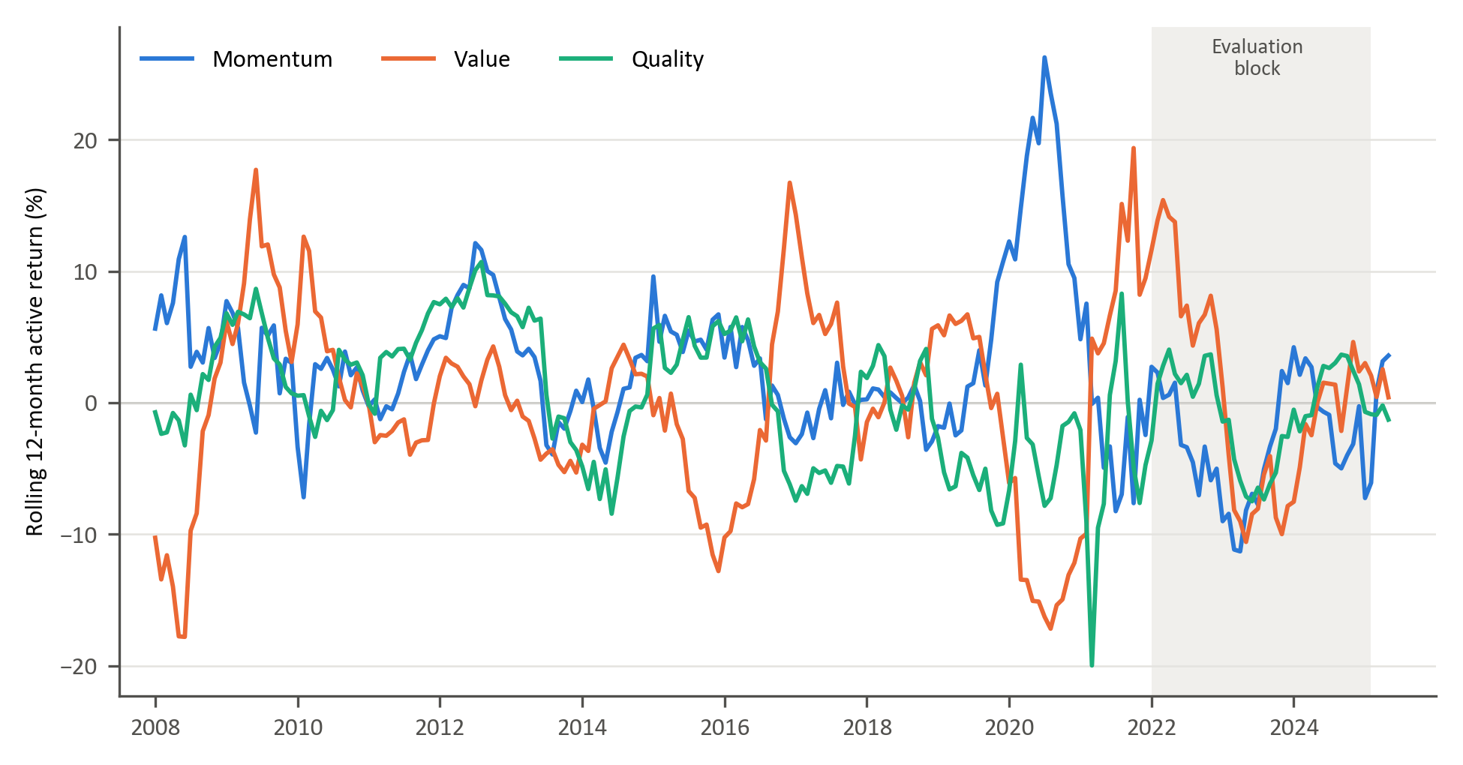
Figure 1: Rolling 12-month active returns of the momentum, value and quality factors
Figure 2 shows that these relationships are not stable. The 36-month correlation between momentum and value active returns ranges from −0.69 to 0.42, and the correlations involving quality range from −0.59 to 0.66 and change sign repeatedly.
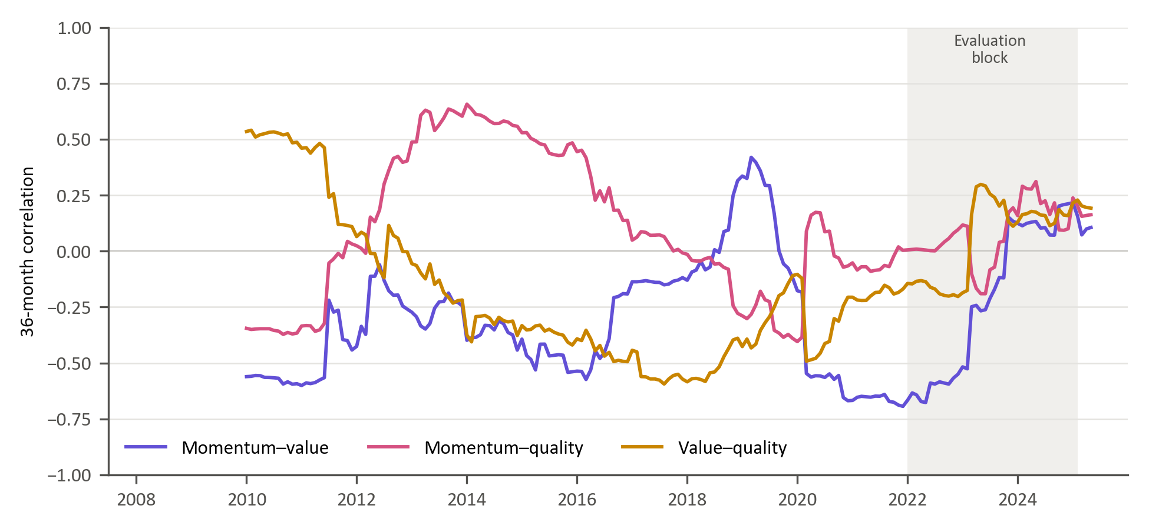
Figure 2: Rolling 36-month correlations of active returns
This time-varying correlation structure implies that absolute factor forecasting may obscure economically relevant rotation dynamics. Instead, modelling the relative performance between factor pairs directly captures style rotation. By focusing on pairwise relative returns (momentum vs value, momentum vs quality, value vs quality), the empirical framework isolates structural transitions in market leadership.
In addition to economic distinctness, modelling relative factor performance offers potential statistical advantages. Because style factors share exposure to common market-wide shocks, differencing factor returns may partially attenuate systematic noise components, isolating cross-style rotation dynamics. This relative performance-based representation is conceptually aligned with long-short factor construction in asset-pricing theory and empirical evidence that relative valuation spreads and factor momentum exhibit cyclical persistence (Fama & French, 1993; Arnott, Kalesnik, & Linnainmaa, 2023) . Consequently, relative factor series may exhibit more stable regime-dependent structure than absolute factor returns, potentially enhancing predictability.
Accordingly, the pairwise timing framework adopted in this study is grounded in the economic premise that style factors represent distinct yet interacting sources of return whose relative dominance evolves over time. The objective is therefore not to forecast aggregate market returns, but to identify transitions in factor leadership within a dynamically shifting economic environment. Predicting which factor is likely to outperform can inform the direction of a tilt between styles without requiring a precise forecast of either factor’s return over the investment period. The study therefore focuses on identifying changes in relative factor leadership as an input to allocation decisions.

3.4 Data sources and pre-processing
The supplied candidate feature file contains 944 weekly dates from 5 March 2007 to 31 March 2025. The factor return file contains 939 observations from 9 April 2007 to 31 March 2025. Relative-factor features are calculated from these weekly returns. The monthly series in Figures 1 and 2 is used only for descriptive analysis. Appendix A defines every predictor retained for modelling.
Candidate screening and clustering use observations dated no later than 1 November 2021, the end of the initial purged training window. Candidates with more than 30% missing values over that pre-evaluation history are removed before filling. Remaining values are carried forward from earlier observations only; no back-filling is used. Ten features that are constant in the complete pre-evaluation clustering sample are excluded. These choices are fixed before the 2022–2025 evaluation block.
The 29 selected representatives are joined to the 18 relative-factor features. All 47 predictors are lagged by four weekly observations. Rows for which any lagged predictor remains unavailable are excluded, rather than filled from a future observation. This produces 784 complete predictor rows from 29 March 2010 to 31 March 2025. The final ten weeks have unresolved forward labels, leaving 774 labelled observations through 20 January 2025. Of these, 156 form the evaluation block; the first purged training window contains 606 observations.
The supplied market and macroeconomic transformations are treated as inputs. The four-week lag does not by itself verify publication lags, data revisions, or the historical estimation of upstream PCA and quantile transformations. Their point-in-time provenance is a limitation of the data (Section 5.3). Standardisation within this study is estimated exclusively on the relevant training observations and applied unchanged to validation or prediction observations.

3.5 Trend-scanning target label construction
Trend scanning converts relative factor returns into binary leadership labels (López de Prado, 2020). For factors i and j, the weekly relative return is the difference between their returns. The cumulative relative series compounds that spread:
$R_{i,j,t} = R_{i,t} - R_{j,t}$ (1)
${CR}_{i,j,t} = \prod_{τ≤t}{(1 + R_{i,j,τ})} - 1$ (2)
At each starting date t, the implementation considers windows containing up to H = 11 weekly observations, including the starting observation. The longest window therefore ends at t + 10 weeks. Windows with undefined slope statistics are ignored when choosing the largest absolute t-statistic. For a window of h observations, the within-window index is s = 0, …, h − 1:
${CR}_{i,j,t+s} = α_{t,h} + β_{t,h}s + ε_{t,h,s}$ (3)
The selected window maximises the absolute t-statistic of its slope. A positive fitted slope gives label one, indicating leadership by the first factor; a negative slope gives label zero:
$Y_{i,j,t} = 1\{β_{t,h*} > 0\}, h_{t}^{*} = arg maxₕ |t(β_{t,h})|$ (4)
The final ten dates cannot supply a complete maximum window and are left unlabelled. The 12-week purge used throughout tuning and forecasting exceeds this ten-week forward span. Trend scanning is applied to the cumulative relative series, rather than to rolling 12-week returns. The 12-week windows used for some predictors are a separate construction (Appendix A).
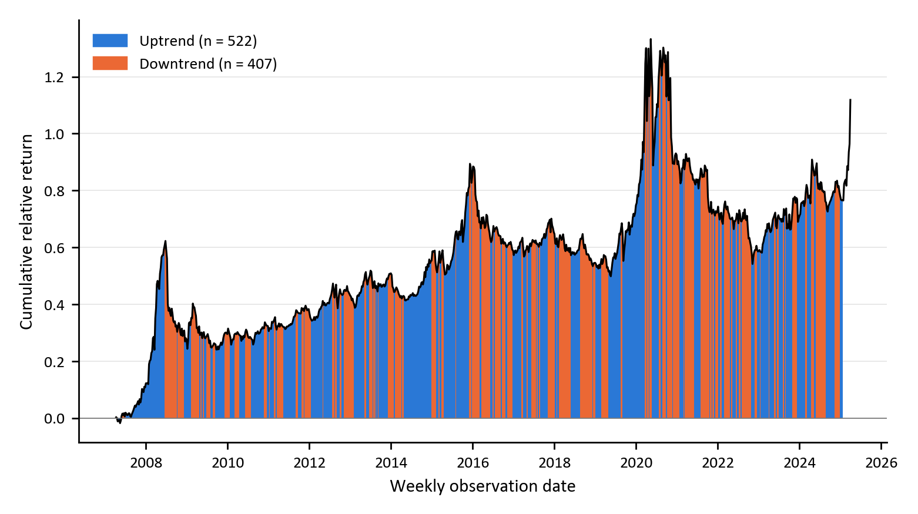
Figure 3: Trend-scanning results for momentum versus value
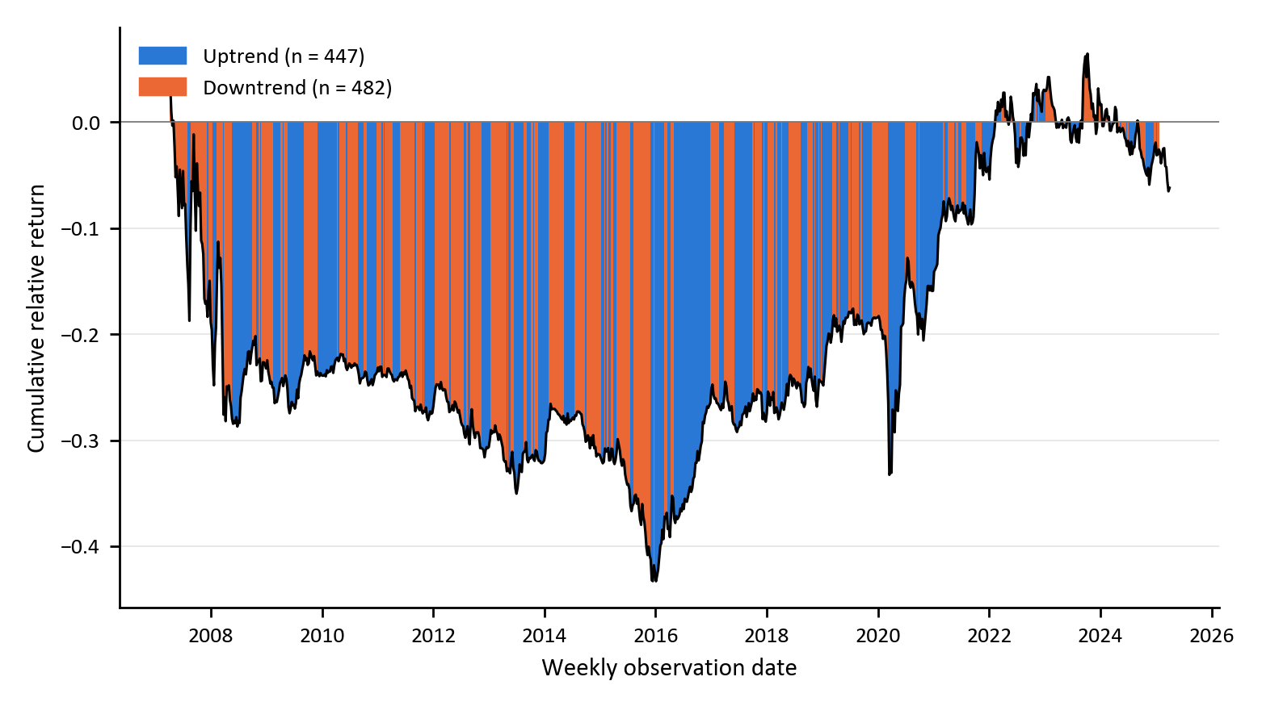
Figure 4: Trend-scanning results for value versus quality
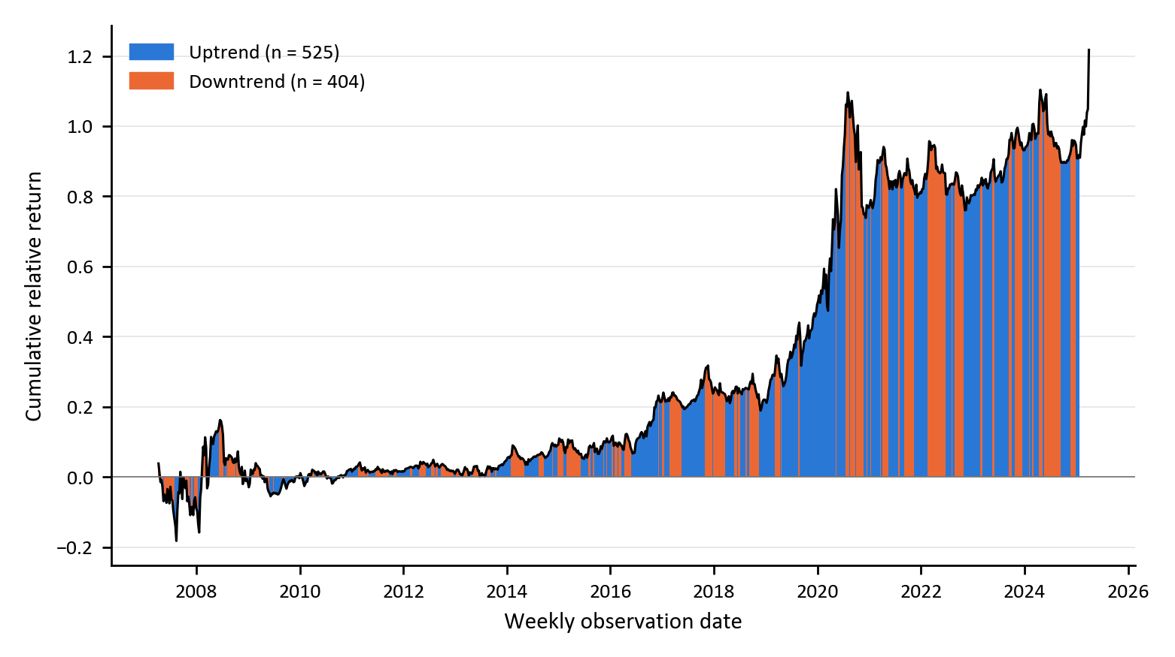
Figure 5: Trend-scanning results for momentum versus quality
Figures 3–5 show the cumulative relative returns and their trend labels for the three pairs. The labels use future returns to define the forecasting target; those future returns are excluded from the information used to fit a forecast at date t.

3.6 Feature selection
The factor-zoo concern in Section 2.2.1 and the estimation instability under correlated predictors in Section 2.1.1 motivate feature reduction. The candidate universe is screened without using evaluation-period observations. Of 359 candidates, 23 fail the pre-evaluation missing-value screen and ten are constant in the complete clustering sample, leaving 326. The clustering sample contains 548 complete weekly observations from 9 May 2011 to 1 November 2021 (Appendix B).
Each eligible series is discretised into 20 quantile bins fitted on that pre-evaluation sample. Pairwise mutual information is divided by the larger marginal entropy to obtain normalised mutual information (NMI); distance is one minus NMI. Ward linkage is applied to each feature’s vector of distances to all other eligible features. The cut height of two therefore refers to distances between these profiles. It is not a threshold of two on the underlying MI distance, whose range is zero to one.
The resulting 29 clusters each contribute the feature with the lowest mean distance to the other members. This unsupervised rule does not use target labels. Its estimation window ends before evaluation; the absence of target labels alone would not prevent look-ahead if evaluation-period predictors were included. The representatives remain fixed throughout walk-forward evaluation. Appendix B reports membership and sensitivity to the cut height and number of bins; these are descriptive feature-selection checks, not additional model-selection criteria.
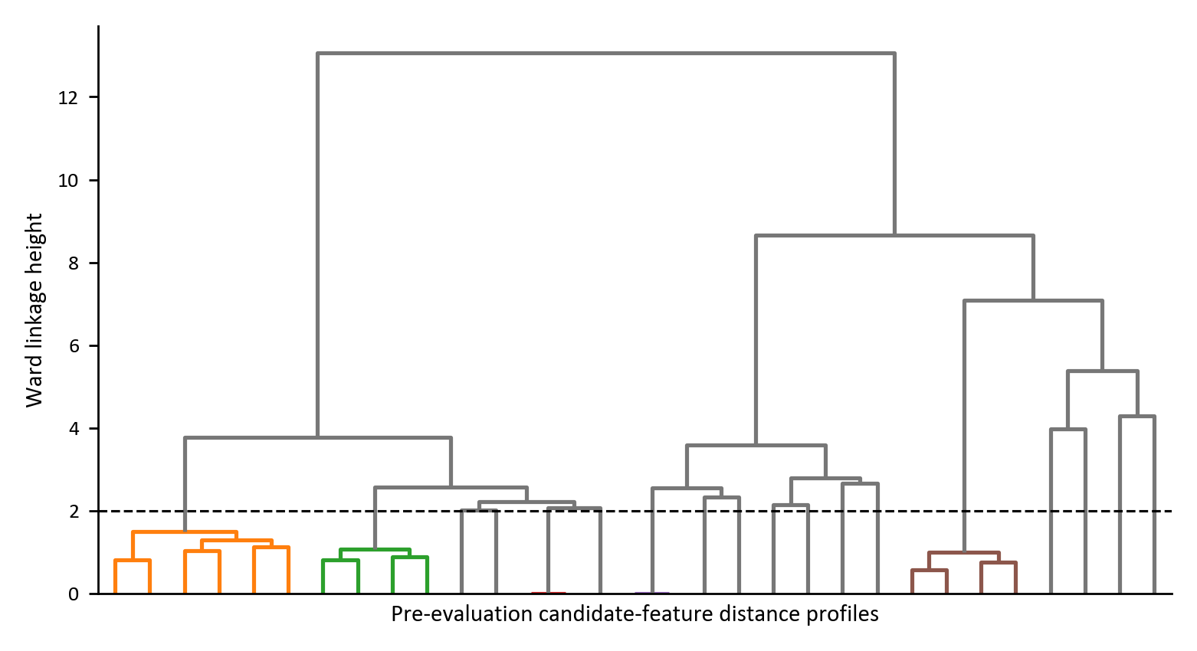
Figure 6: Hierarchical agglomerative clustering of the pre-evaluation feature space
Eighteen relative-factor predictors are added by design: four- and 12-week relative momentum, 12-week correlation and standardised relative return, and 12-week relative volatility and volatility ratio for each pair. The final set contains 47 predictors. Table 1 summarises their categories, and Appendix A identifies them by their exact input-file names.
Table 1: The 47 modelling predictors by category
Category | Predictors | Economic role
Macroeconomic | 8 | Business-cycle, rates, currency and sovereign conditions
Fundamental valuation | 5 | Local and global valuation conditions
Sentiment and risk appetite | 9 | Confidence and changing market conditions
Price-based indicators | 7 | Market returns and uncertainty
Factor relative performance | 12 | Recent relative returns and co-movement
Factor relative volatility | 6 | Relative risk and instability

3.7 Model training

3.7.1 The objective function
For a vector of predictors Xₜ, the models estimate the probability that the first factor leads. A threshold τ = 0.5 converts probabilities into class predictions:
$p_{t} = P(Y_{t} = 1 | X_{t})$ (5)
$0 ≤ p_{t} ≤ 1$ (6)
$Ŷ_{t} = 1\{p_{t} ≥ τ\}, τ = 0.5$ (7)

3.7.2 Logistic regression
The simplicity and direct interpretability of linear models have contributed to their significance in finance. Logistic regression provides a transparent economic interpretation of how each predictor influences the likelihood of factor outperformance. The model assumes a linear relationship between the log-odds of the outcome and the predictor variables (Hosmer, Lemeshow, & Sturdivant, 2013; James, Witten, Hastie, & Tibshirani, 2021). The model assumes that the log-odds of a binary outcome are a linear function of the predictors:
$logit\left(P\left(y_{t} | X_{t}\right)\right)=\ln\left(\frac{P\left(y_{t} | X_{t}\right)}{1-P\left(y_{t} | X_{t}\right)}\right)= β_{0}+X_{t}^{T}β$ (8)
Here, $β_{0}$ is the intercept term and $β∈R^{p}$ is a vector of coefficients measuring linear impact of each feature on the log-odds. To obtain a predicted probability from the linear predictor, the inverse of the logit, known as the logistic (sigmoid) function, is used:
${\hat{p}}_{t}=σ\left(β_{0}+X_{t}^{T}β\right)= \frac{1}{1+e^{-(β_{0}+X_{t}^{T}β)}}$ (9)
Model parameters $\left(β_{0}, β\right)$are estimated by minimising the penalised log-likelihood function.
$L(β)=\sum_{t∈D_{train}}{w_{t}}\left[-y_{t}\log{{\hat{p}}_{t}}-\left(1-y_{t}\right)\log{(1-{\hat{p}}_{t})}\right]+ λ\left(α∥β∥_{1}+\frac{1-α}{2}∥β∥_{2}^{2}\right)$ (10)
where $λ≥0$ controls overall regularisation strength and $α∈[0,1]$, sets the mix of LASSO $\left(L1\right)$ and ridge $\left(L2\right)$ penalties. This elastic-net penalty, common in financial applications, limits overfitting, mitigates multicollinearity and stabilises the estimates (Zou & Hastie, 2005; Tibshirani, 1996; Gu, Kelly, & Xiu, 2020).
The model is fitted with the elastic-net logistic regression of the scikit-learn Python library (Pedregosa, et al., 2011), which minimises Equation (10) with unit observation weights, C = 1/λ and L1_ratio = α. Predictors are standardised with a scaler fitted on the training window only. The solver settings and the grid for α and λ are given in Table 3.

3.7.3 Generalised additive models (GAMs)
Generalised Additive Models (GAMs) introduced by (Hastie & Tibshirani, 1986) extend generalised linear models by introducing nonlinear transformations of the original predictors as new additive terms in an otherwise linear model. This model enables nonlinearity while maintaining transparency. The GAM specification for binary classifications structurally resembles that of the logistic regression. Using the logit transformation, the conditional probability of outperformance is given by:
$g\left(P\left(y_{t}=1|X_{t}\right)\right)= β_{0}+\sum_{i=1}^{p}{s_{i}(X_{t,i})}$ (11)
$β_{0}$ is the intercept term and each $s_{i}(.)$ is a smooth, potentially nonlinear function capturing the marginal effect of predictor $(X_{t,i})$ (Hastie & Tibshirani, 1986). The predicted probability for classification is given by:
${\hat{p}}_{t}=σ\left(β_{0}+ \sum_{i=1}^{p}{s_{i}\left(x_{t,i}\right)}\right)$ (12)
Each smooth $s_{i}(.)$ is represented via a basis expansion: $s_{i}\left(x\right)=B_{i}{(x)}^{T}θ_{i}, B_{i}\left(x\right)∈R^{k_{i}}$,
$B_{i}\left(x\right)$ is a vector of spline basis functions, which control the functional relationship between a predictor variable and a conditional response, whose coefficients $\left\{θ_{i}\right\}$ must be estimated. The size of the basis expansion limits the smoothing spline’s potential complexity with a larger set of basis functions allowing greater flexibility. We use cubic splines with $k_{i}$ basis functions per smooth term. Given that each spline $s_{i}(.)$ can be visualised independently, spline bases enable GAMs to model nonlinearity while maintaining additive interpretability (James, Witten, Hastie, & Tibshirani, 2021). The number of basis functions is common to all smooth terms and is selected from {4, 5, 7, 10} (Table 3).
We estimate the coefficients $\left\{θ_{i}\right\}$ and $β_{0}$ by minimising:
$L\left(S\right)=\sum_{t∈D_{train}}{w_{t}\left[{-y}_{t}\log{{\hat{ p}}_{t}}-\left(1-y_{t}\right)\log{(1-{\hat{p}}_{t})}\right]}+ \sum_{i=1}^{p}{λ_{i}θ_{i}^{T}S_{i}θ_{i}}$ (13)
The smoothness of the spline is controlled by a smoothing penalty $(λ_{i})$ and ${(S}_{i})$ is the spline penalty matrix (Hastie & Tibshirani, 1986). We use the pyGAM library in Python to implement this GAM model. In the implementation, a single smoothing penalty λ is applied to all smooth terms and selected by cross-validation, and predictors are standardised within each training window, as for logistic regression.

3.7.4 Extreme gradient boost (XGBoost)
Tree-based ML models are non-parametric and use logic that departs markedly from traditional econometric models to capture nonlinearities within the data. These models build on the concept of decision trees, where binary groups are created by grouping observations with similar characteristics. They use a hierarchical tree structure that partitions the predictor space by recursively selecting features and splits that maximise a set improvement criterion such as information gain, entropy reduction, Gini reduction, or variance reduction depending on the task (Breiman, Friedman, Olshen, & Stone, 1984; Hastie, Tibshirani, & Friedman, 2009). This process ensures that the most informative features for predicting the target are placed higher in the tree structure.
Although decision trees are intuitive, single classification and regression trees (CART) easily overfit (Hastie, Tibshirani, & Friedman, 2009; Breiman, Friedman, Olshen, & Stone, 1984; Gu, Kelly, & Xiu, 2020). Ensemble methods like bagging and boosting address this shortcoming by combining multiple weak learners (Friedman, 2001; Breiman, 1996). This study uses boosting, in which the weak learners are added sequentially. XGBoost constructs an additive model of the form:
$F_{M}\left(X_{t}\right)=\sum_{m=1}^{M}{f_{m}\left(X_{t}\right), } f_{m}∈F$ (14)
where each $f_{m}$ is a single CART (Chen & Guestrin, 2016). For binary classification, the ensemble output is mapped to probabilities using the logistic sigmoid function given by:
${\hat{p}}_{t}= σ\left(F_{M}\left(X_{t}\right)\right), σ\left(x\right)= \frac{1}{(1+e^{-x})}$ (15)
At each boosting iteration $(m)$, we aim to minimise:
$L^{(m)} = \sum_{t∈Dtrain}{w_{t} l(y_{t}, σ(F^{(m-1)}(X_{t}) + f_{m}(X_{t})))} + Ω(f_{m})$ (16)
where the logistic loss function is defined as:
$l\left(y,p\right)=-y\log{p}-\left(1-y\right)\log{(1-p)}$ (17)
and tree regularisation function given by:
$Ω(f) = γT + (λ/2) \sum_{j=1}^{T}{v_{j}^{2}}$ (18)
T is the number of leaves and vⱼ is the score assigned to leaf j; wₜ denotes the observation weight in the loss. Trees are fitted to first- and second-order derivatives of the logistic loss. The implementation uses 500 boosting rounds and the binary logistic objective, with random seed zero and one thread. Predictors are not standardised for XGBoost. Table 3 gives the search grid (Chen & Guestrin, 2016).
Table 2: Comparison of the three model classes
Model | Functional form | Regularisation and main limitation
Logistic regression | Linear in log-odds | Elastic-net penalty; cannot represent nonlinear marginal effects or interactions without engineered terms.
GAM | Additive smooth functions in log-odds | Spline penalty and basis size; permits nonlinear marginal effects but excludes interactions between smooth terms.
XGBoost | Additive ensemble of decision trees | Shrinkage, tree depth, minimum child weight, subsampling and L2 penalty; flexible interactions increase sensitivity to tuning.

3.8 Hyperparameter tuning and model validation
CPCV selects hyperparameters within the currently available purged training sample. Walk-forward evaluation then measures performance at later forecast dates. The initial search and subsequent retuning searches use the same 12-week boundary purge, and every training–validation combination fits its own scaler for logistic regression and the GAM.

3.8.1 Combinatorial purged cross-validation
Each tuning sample is divided into N = 5 chronological groups. Every combination holds out k = 2 groups, giving ten training–validation combinations and four back-test paths:
$C(N,k) = N! / [k!(N-k)!] = C(5,2) = 10$ (19)
$φ(N,k) = (k/N) C(N,k) = C(N-1,k-1) = 4$ (20)
For each held-out group, the 12 observations immediately before and after it are removed from training. A candidate is disqualified if it cannot be fitted and scored on all ten combinations. Hyperparameters are selected by the mean of the ten combination-level ROC-AUCs. The four paths pool held-out predictions across combinations and are reported as diagnostics; they do not determine the selected setting.
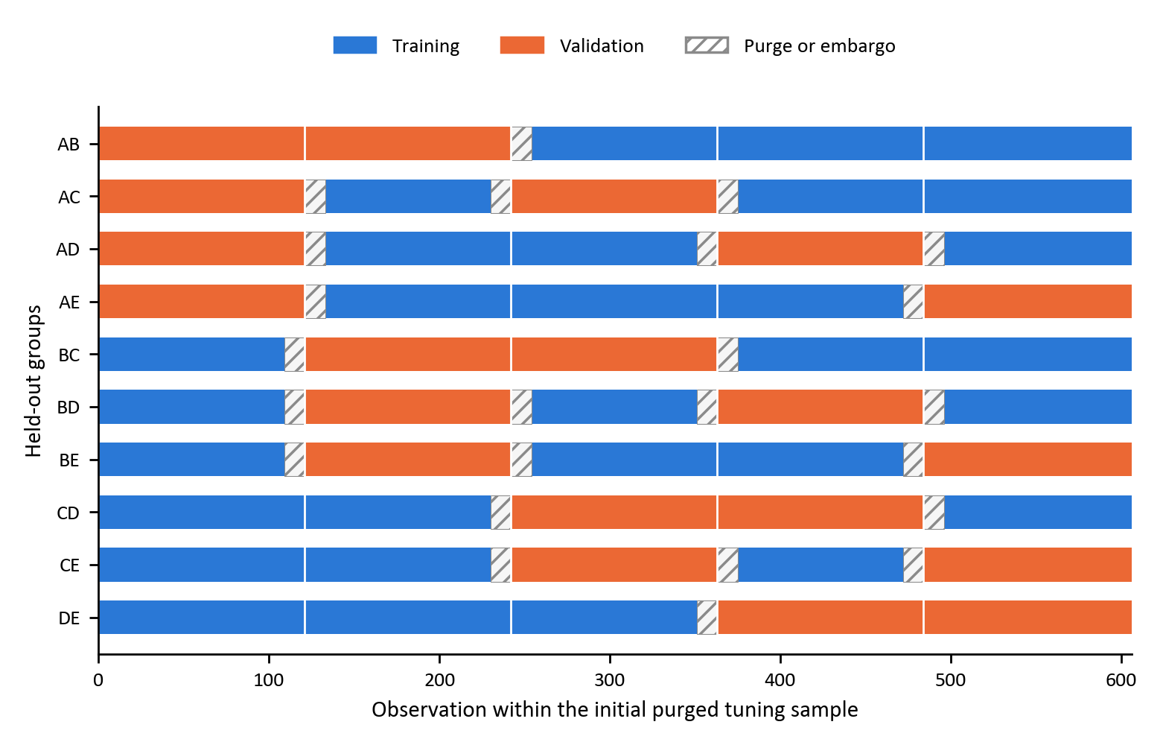
Figure 7: CPCV with five chronological groups and two validation groups
The first search uses 606 observations from 29 March 2010 to 1 November 2021. It excludes the 12 observations between that training boundary and the first forecast on 31 January 2022. Standardisation is fitted separately on each CPCV training fold. Later searches use the expanded purged windows available after forecasts 52 and 104. Table 3 reports the unchanged search grids; Appendix C records combination and path diagnostics and the selected settings.
Table 3: Hyperparameter search grids
Model | Settings | Parameters and candidate values
Logistic | 18 | α ∈ {0, 0.5, 1}; λ ∈ {0.01, 0.1, 1, 10, 100, 1000}. SAGA solver, tolerance 10⁻⁶ and maximum 100,000 iterations.
GAM | 20 | Splines per term ∈ {4, 5, 7, 10}; λ ∈ {1, 10, 100, 1000, 10000}. Cubic splines, common smoothing penalty, intercept and maximum 1,000 iterations.
XGBoost | 216 | Learning rate ∈ {0.01, 0.03, 0.1}; depth ∈ {2, 3, 4}; minimum child weight ∈ {5, 10, 20}; L2 penalty ∈ {1, 10, 100, 1000}; subsample ∈ {0.6, 0.8}. 500 boosting rounds.

3.8.2 Walk-forward validation
Each forecast refits the model on an expanding window ending before a 12-week purge. The first fit has 606 training observations and the last has 761. Hyperparameters are selected before the first forecast and retuned after forecasts 52 and 104, using 658 and 710 observations respectively. Settings are then held fixed for the following 52 forecasts. This produces 156 weekly predictions from 31 January 2022 to 20 January 2025.
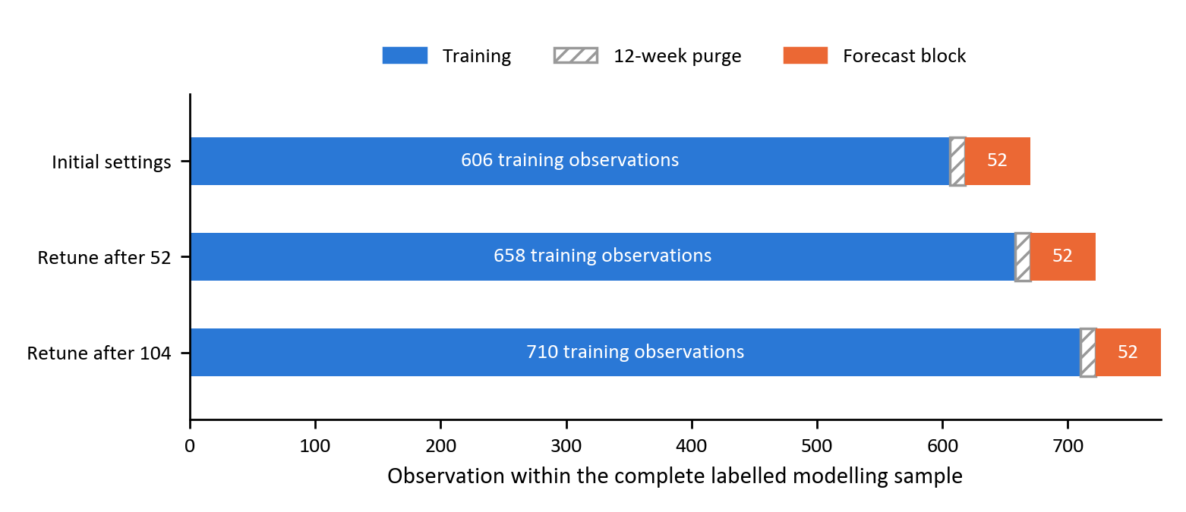
Figure 8: Expanding-window evaluation with a 12-week purge and annual retuning

3.9 Performance evaluation
Accuracy is the proportion of correct labels at τ = 0.5. Confusion matrices report true negatives, false positives, false negatives and true positives, and compare predicted-positive shares with realised class shares. A retrospective majority-class accuracy benchmark is max(n₀,n₁)/156. It describes the class imbalance of the evaluation sample and is not an implementable forecasting rule selected in advance.
ROC-AUC measures the ranking of positive versus negative observations independently of a decision threshold. A constant score has ROC-AUC 0.5. Log-loss measures probability quality and penalises confident errors. A constant probability of 0.5 has log-loss ln 2 ≈ 0.693; this provides an uninformative probability benchmark (Fawcett, 2006; Good, 1952; Gneiting & Raftery, 2007; Bishop, 2006; Murphy, 1973).
Uncertainty is estimated by a circular moving-block bootstrap with 10,000 resamples, 12-week blocks and seed zero. Each resample draws contiguous blocks with replacement, wrapping at the sample end and truncating to 156 observations. The same resampled dates are used for all models, preserving pairing. The 2.5th and 97.5th percentiles give 95% intervals for accuracy, ROC-AUC and model differences. Sensitivity to block lengths of six and 24 weeks is reported in Appendix C. This block length is a modelling choice intended to accommodate label persistence (Künsch, 1989).
XGBoost is compared with logistic regression using paired ROC-AUC differences and mean weekly log-loss differences. Approximate two-sided bootstrap tests centre the resampled differences at the observed difference to represent the null of zero difference. Interval and test results are exploratory; they are conditional on the fitted forecasting procedure and do not incorporate a rerun of model selection within each bootstrap resample. Bonferroni-adjusted ROC-AUC intervals additionally account for the nine reported model–pair estimates. Statistical discrimination is assessed separately from investment profitability.

3.10 Feature importance
Attributions are calculated for reference models fitted on the initial 606-observation purged training sample using the initially selected hyperparameters. The ten largest global mean absolute attributions are shown for each model and pair. The reference fits do not aggregate explanations from the successive walk-forward models (Shapley, 1953; Lundberg & Lee, 2017).
For logistic regression, each exact contribution is the fitted coefficient multiplied by the deviation of its standardised predictor from the training mean. For the additive GAM, each smooth term is evaluated and centred on its training-sample mean; these exact additive contributions sum, with the mean model score, to the fitted log-odds. These calculations require no sampling of feature orderings. For XGBoost, Tree SHAP decomposes the raw model score (Lundberg et al., 2020).
Figures 15–17 colour predictors by the categories in Table 1. Attributions describe the model’s use of information and do not identify causal effects or establish stable predictive value. Cross-model comparisons emphasise rankings; different background conventions and model output distributions limit comparisons of absolute attribution magnitudes (Molnar, 2022; Kumar et al., 2020).

4 Results

4.1 Overview of the evaluation framework
This chapter reports the walk-forward evaluation of three models across three factor pairs. All nine forecasts use the same 156 weekly dates and the same 47 lagged predictors. Section 4.2 compares accuracy, ROC-AUC and log-loss with bootstrap uncertainty. Section 4.3 examines class decisions and forecast confidence. Section 4.4 interprets the reference-model attributions. Appendix C supplies the tuning and inference diagnostics.

4.2 Out-of-sample predictive performance
Table 4 reports point estimates alongside 95% intervals from the paired 12-week block bootstrap. The highest point-estimate ROC-AUC belongs to XGBoost for momentum versus value, XGBoost for momentum versus quality and XGBoost for value versus quality. These rankings must be assessed against interval width and the paired model comparisons, rather than interpreted as established differences between the model classes.
Table 4: Walk-forward performance with 95% block-bootstrap intervals
Factor pair | Model | Accuracy  95% CI | ROC-AUC  95% CI | Log-loss | Majority accuracy
Momentum versus value | Logistic | 55.1%  [44.2, 65.4] | 0.553  [0.422, 0.680] | 0.798 | 54.5%
 | GAM | 53.2%  [42.3, 63.5] | 0.519  [0.373, 0.670] | 0.921 | 54.5%
 | XGBoost | 53.8%  [40.4, 66.7] | 0.572  [0.388, 0.746] | 0.809 | 54.5%
Momentum versus quality | Logistic | 54.5%  [42.3, 66.0] | 0.553  [0.402, 0.708] | 0.725 | 54.5%
 | GAM | 48.1%  [35.9, 60.3] | 0.482  [0.316, 0.658] | 0.893 | 54.5%
 | XGBoost | 64.1%  [53.2, 74.4] | 0.630  [0.478, 0.752] | 0.677 | 54.5%
Value versus quality | Logistic | 59.0%  [48.1, 68.6] | 0.606  [0.480, 0.729] | 0.684 | 50.6%
 | GAM | 55.1%  [44.9, 64.7] | 0.560  [0.427, 0.697] | 0.963 | 50.6%
 | XGBoost | 58.3%  [47.4, 69.9] | 0.648  [0.508, 0.768] | 0.665 | 50.6%

Notes: 156 predictions per model; τ = 0.5; 10,000 circular moving-block bootstrap resamples with 12-week blocks and seed zero. Intervals are unadjusted percentile intervals. The majority column uses the observed evaluation-period class balance and is a descriptive benchmark. Log-loss below 0.693 improves on a constant 50% probability forecast. Appendix C reports paired comparisons, multiplicity-adjusted ROC-AUC intervals and sensitivity to block length.

4.2.1 Momentum versus value
XGBoost has the highest point-estimate ROC-AUC for this pair, 0.572 [0.388, 0.746]. Its accuracy is 53.8%, compared with a majority-class benchmark of 54.5%. Its ROC-AUC interval includes 0.5, so the ranking result does not establish discrimination beyond chance at the unadjusted 95% level.
Probability quality favours Logistic, with log-loss 0.798; the other models have log-losses of 0.809 (XGBoost) and 0.921 (GAM). All three losses exceed 0.693, the constant 50% probability benchmark. A higher ROC-AUC therefore need not imply more useful probability levels.
The paired XGBoost-minus-logistic ROC-AUC difference is 0.019 [-0.182, 0.244]. The interval includes zero, so this comparison does not establish an XGBoost advantage. The approximate two-sided centred-bootstrap p-value is 0.869.
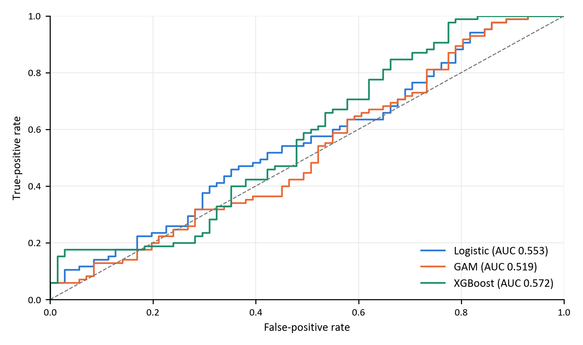
Figure 9: Walk-forward ROC curves for momentum versus value
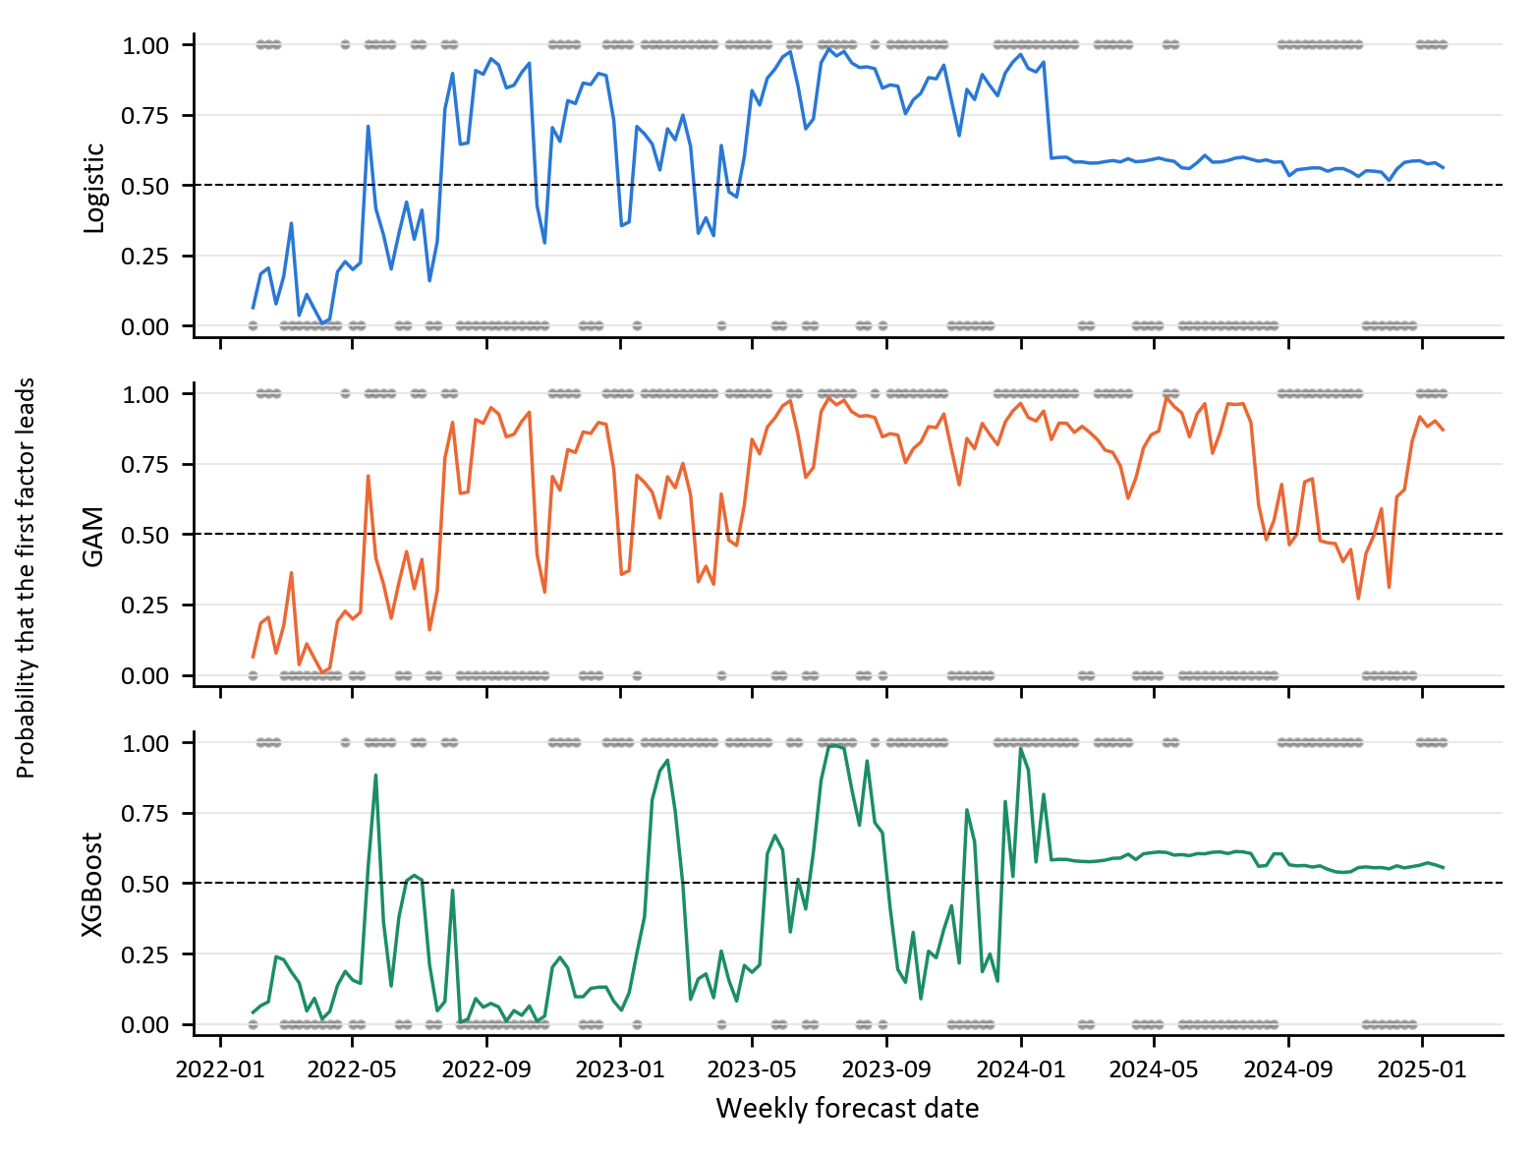
Figure 10: Predicted probabilities and realised classes for momentum versus value

4.2.2 Momentum versus quality
XGBoost has the highest point-estimate ROC-AUC for this pair, 0.630 [0.478, 0.752]. Its accuracy is 64.1%, compared with a majority-class benchmark of 54.5%. Its ROC-AUC interval includes 0.5, so the ranking result does not establish discrimination beyond chance at the unadjusted 95% level.
Probability quality favours XGBoost, with log-loss 0.677; the other models have log-losses of 0.725 (Logistic) and 0.893 (GAM). The lowest loss is below 0.693, the constant 50% probability benchmark.
The paired XGBoost-minus-logistic ROC-AUC difference is 0.077 [-0.046, 0.194]. The interval includes zero, so this comparison does not establish an XGBoost advantage. The approximate two-sided centred-bootstrap p-value is 0.215.
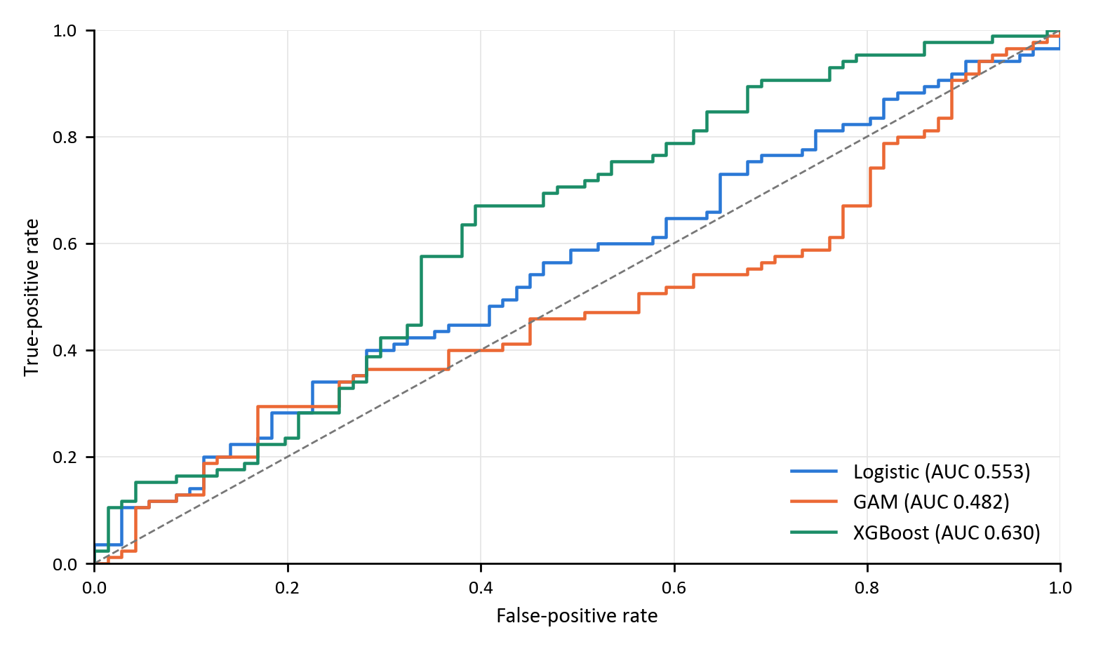
Figure 11: Walk-forward ROC curves for momentum versus quality
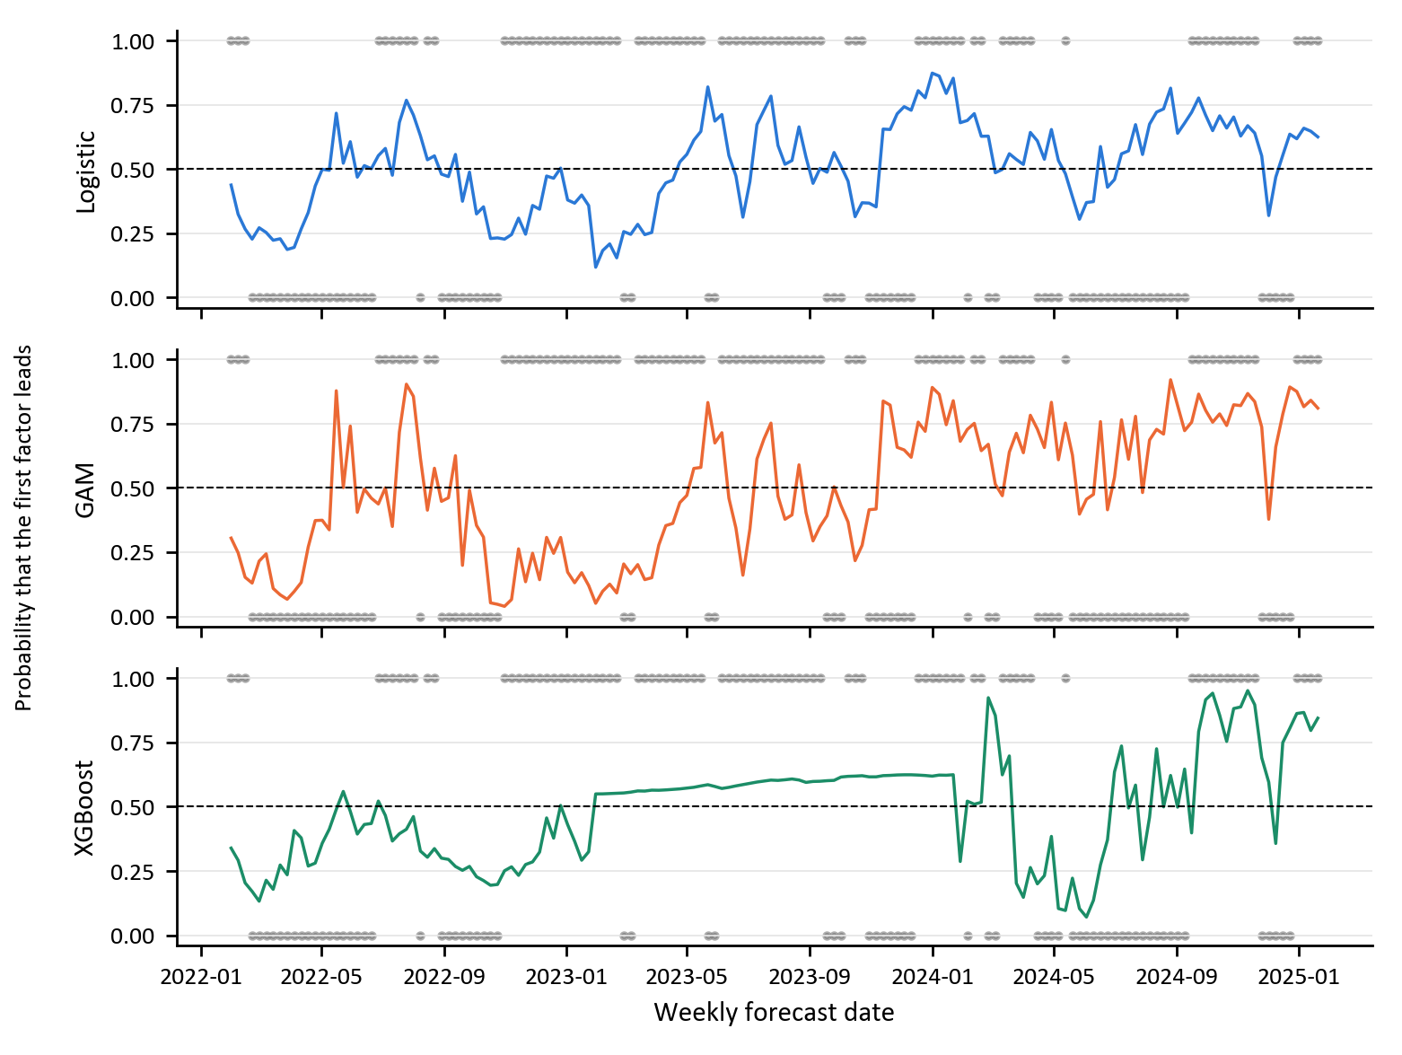
Figure 12: Predicted probabilities and realised classes for momentum versus quality

4.2.3 Value versus quality
XGBoost has the highest point-estimate ROC-AUC for this pair, 0.648 [0.508, 0.768]. Its accuracy is 58.3%, compared with a majority-class benchmark of 50.6%. The ROC-AUC interval excludes 0.5 at the unadjusted 95% level.
Probability quality favours XGBoost, with log-loss 0.665; the other models have log-losses of 0.684 (Logistic) and 0.963 (GAM). The lowest loss is below 0.693, the constant 50% probability benchmark.
The paired XGBoost-minus-logistic ROC-AUC difference is 0.042 [-0.036, 0.114]. The interval includes zero, so this comparison does not establish an XGBoost advantage. The approximate two-sided centred-bootstrap p-value is 0.289.
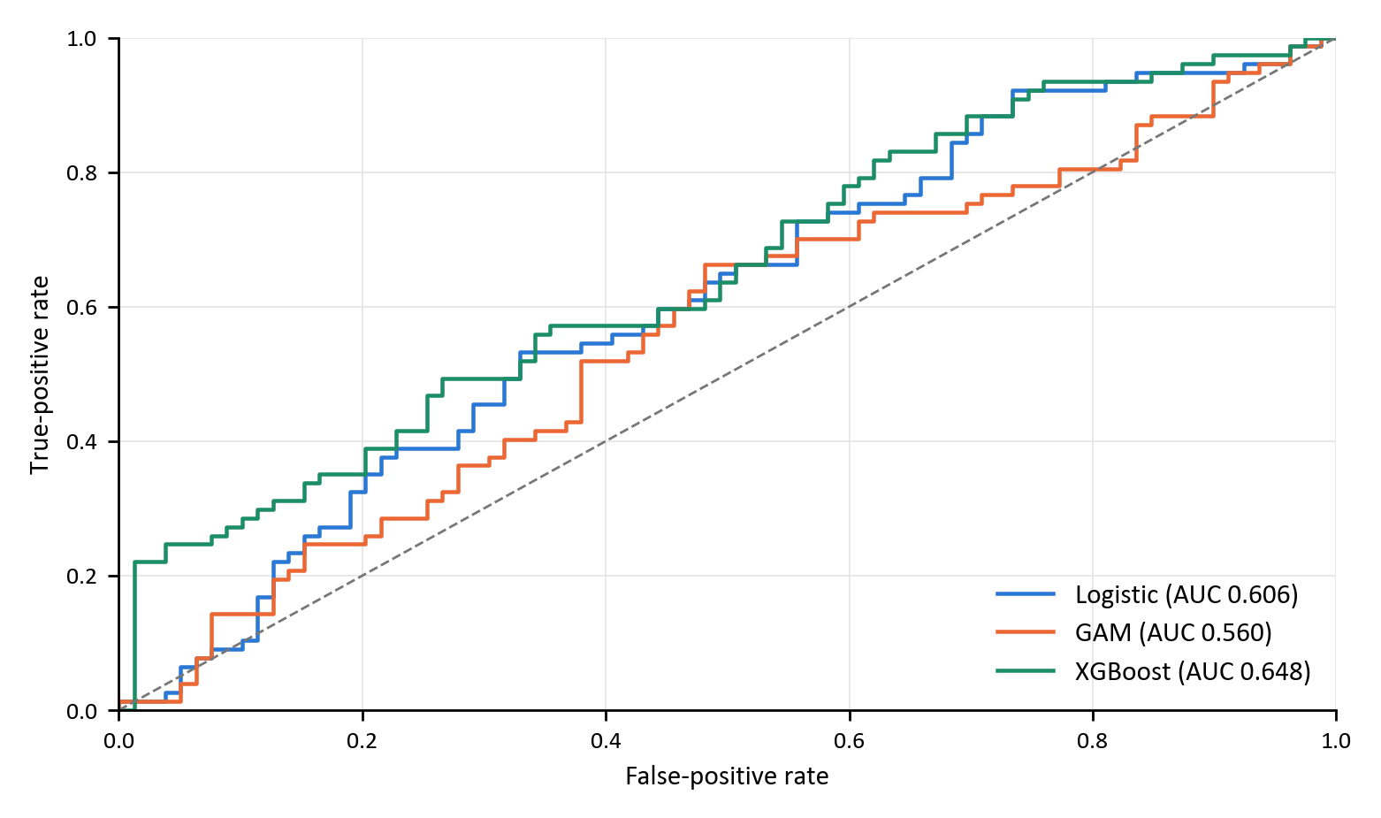
Figure 13: Walk-forward ROC curves for value versus quality
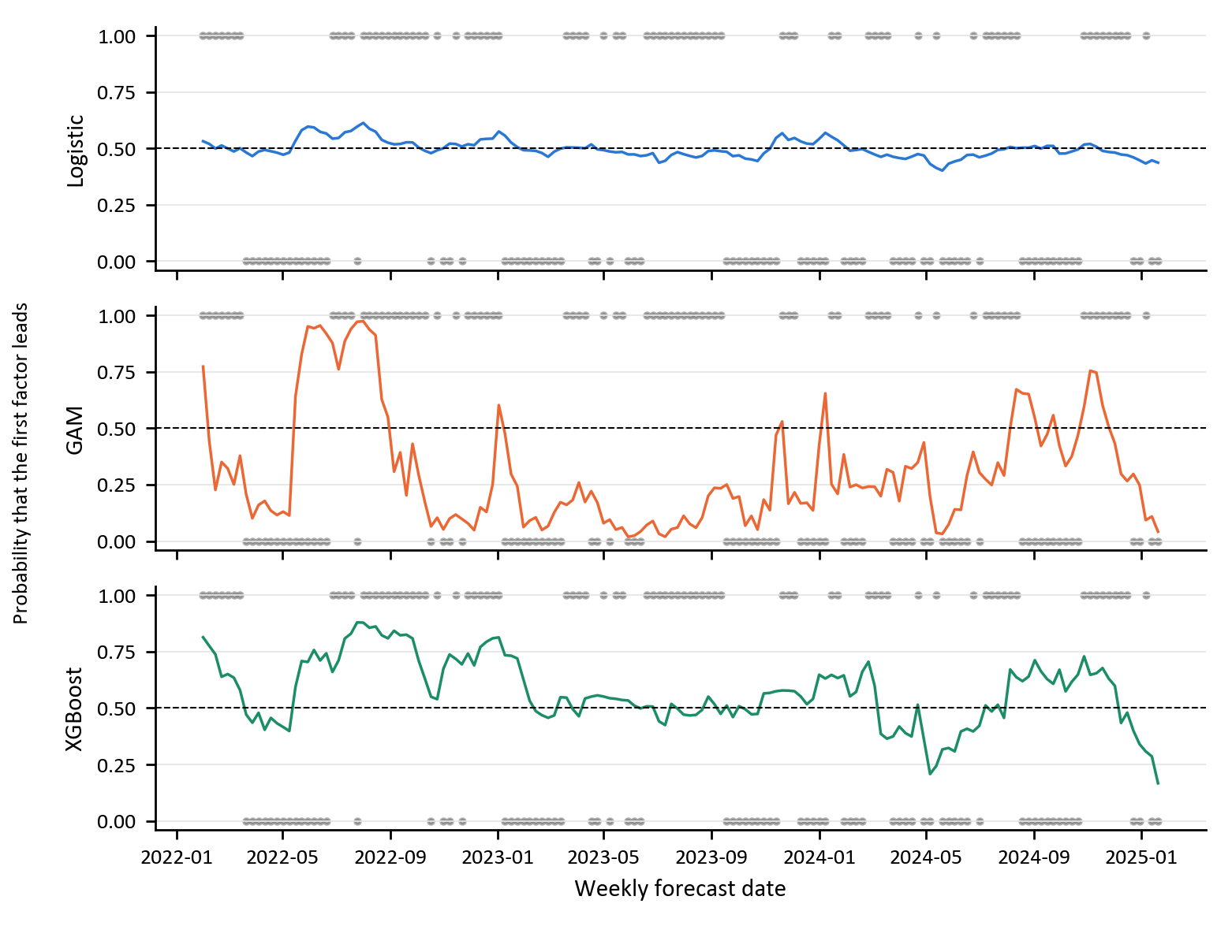
Figure 14: Predicted probabilities and realised classes for value versus quality
The initial CPCV diagnostics do not necessarily reproduce the evaluation-period ordering. For the selected XGBoost settings, the mean combination ROC-AUCs are 0.524 for momentum versus value, 0.517 for momentum versus quality and 0.551 for value versus quality. Table C.3 also reports the four pooled path ROC-AUCs and a no-feature base-rate benchmark. A stronger evaluation result following a weak tuning-period result is consistent with period dependence; it does not show that CPCV identified a persistently superior forecasting relationship. Path results are diagnostics and were not used to select hyperparameters.

4.3 Confusion matrices and probability quality
Table 5 reports the realised class balance. The two momentum targets both contain 71 negative and 85 positive observations, but the label sequences differ in 34 of the 156 weeks. The equal totals are therefore verified rather than copied. Table 6 shows whether a model’s accuracy reflects recognition of both leadership states or a preference for one class.
Table 5: Realised class balance in the common evaluation sample
Factor pair | Negative | Positive | Positive share
Momentum versus value | 71 | 85 | 54.5%
Momentum versus quality | 71 | 85 | 54.5%
Value versus quality | 79 | 77 | 49.4%

Table 6: Confusion-matrix diagnostics at a threshold of 0.5
Pair | Model | TN | FP | FN | TP | Predicted positive | Actual positive
Momentum versus value | Logistic | 17 | 54 | 16 | 69 | 78.8% | 54.5%
 | GAM | 21 | 50 | 23 | 62 | 71.8% | 54.5%
 | XGBoost | 36 | 35 | 37 | 48 | 53.2% | 54.5%
Momentum versus quality | Logistic | 35 | 36 | 35 | 50 | 55.1% | 54.5%
 | GAM | 35 | 36 | 45 | 40 | 48.7% | 54.5%
 | XGBoost | 43 | 28 | 28 | 57 | 54.5% | 54.5%
Value versus quality | Logistic | 53 | 26 | 38 | 39 | 41.7% | 49.4%
 | GAM | 67 | 12 | 58 | 19 | 19.9% | 49.4%
 | XGBoost | 33 | 46 | 19 | 58 | 66.7% | 49.4%

For momentum versus value, XGBoost correctly recognises 48 of the 85 momentum-led weeks and 36 of the 71 value-led weeks. Its predicted-positive share is 53.2%, against an actual share of 54.5%. These counts provide more information about the allocation direction implied by the classifier than aggregate accuracy alone.
For momentum versus quality, XGBoost correctly recognises 57 of the 85 momentum-led weeks and 43 of the 71 quality-led weeks. Its predicted-positive share is 54.5%, against an actual share of 54.5%. These counts provide more information about the allocation direction implied by the classifier than aggregate accuracy alone.
For value versus quality, XGBoost correctly recognises 58 of the 77 value-led weeks and 33 of the 79 quality-led weeks. Its predicted-positive share is 66.7%, against an actual share of 49.4%. These counts provide more information about the allocation direction implied by the classifier than aggregate accuracy alone.
The largest log-loss is 0.963, for GAM on value versus quality. Its saved probabilities contain 20 confidently wrong forecasts, defined as assigning more than 90% probability to the outcome that does not occur. AUC-based tuning optimises ranking, not calibration or log-loss. Weak penalties and a large spline basis can produce overconfident probabilities even when their ranking score is preferred by CPCV. With 47 predictors, ten splines per predictor introduce approximately 470 basis coefficients before accounting for penalisation and identifiability. The comparison therefore concerns these grids and selected regularisation levels, and does not establish an inherent failure of smooth nonlinear effects.

4.4 Feature importance
Figures 15–17 describe the reference fits on the initial purged training sample. Attributions are in log-odds units. Their mean absolute values measure how strongly a fitted model uses a predictor over this sample, while their magnitudes omit the direction of that use. They do not establish causal mechanisms or explain every subsequent walk-forward forecast.

4.4.1 Momentum versus value
Logistic places the greatest mean absolute attribution on relvol_momentum_vs_value_12 and ZAR18M.Curncy_QS. GAM places the greatest mean absolute attribution on relvol_momentum_vs_value_12 and ZAR18M.Curncy_QS. XGBoost places the greatest mean absolute attribution on relvol_value_vs_quality_12 and corr_momentum_value_12.
The leading features span factor relative performance, factor relative volatility, macroeconomic and sentiment and risk appetite. Agreement on an input category indicates common information use by these reference fits, rather than evidence that the category produces stable out-of-sample gains. Exact feature definitions and the distinction between supplied transformations and features constructed in this study are given in Appendix A.

4.4.2 Momentum versus quality
Logistic places the greatest mean absolute attribution on GlobalEquity_EntDyn and TOP40.Index.Price.to.Ebitda_Diff. GAM places the greatest mean absolute attribution on volratio_momentum_value_12 and volratio_value_quality_12. XGBoost places the greatest mean absolute attribution on TOP40.Index.Price.to.Ebitda_Diff and CONCCONF.Index.
The leading features span factor relative volatility, fundamental valuation, price-based indicators and sentiment and risk appetite. Agreement on an input category indicates common information use by these reference fits, rather than evidence that the category produces stable out-of-sample gains. Exact feature definitions and the distinction between supplied transformations and features constructed in this study are given in Appendix A.
The initial XGBoost reference setting uses learning rate η = 0.01 and L2 penalty λ = 1. During the first 52 forecasts its probabilities range from 0.132 to 0.559. The attribution scale must be interpreted together with the selected regularisation and the probability range, rather than compared across pairs as a measure of economic importance.

4.4.3 Value versus quality
Logistic places the greatest mean absolute attribution on volratio_value_quality_12 and mom3m_momentum_vs_quality. GAM places the greatest mean absolute attribution on relvol_momentum_vs_quality_12 and USDZAR_EntDyn. XGBoost places the greatest mean absolute attribution on US_NB_Curvature and mom3m_value_vs_quality.
The leading features span factor relative performance, factor relative volatility, macroeconomic and price-based indicators. Agreement on an input category indicates common information use by these reference fits, rather than evidence that the category produces stable out-of-sample gains. Exact feature definitions and the distinction between supplied transformations and features constructed in this study are given in Appendix A.
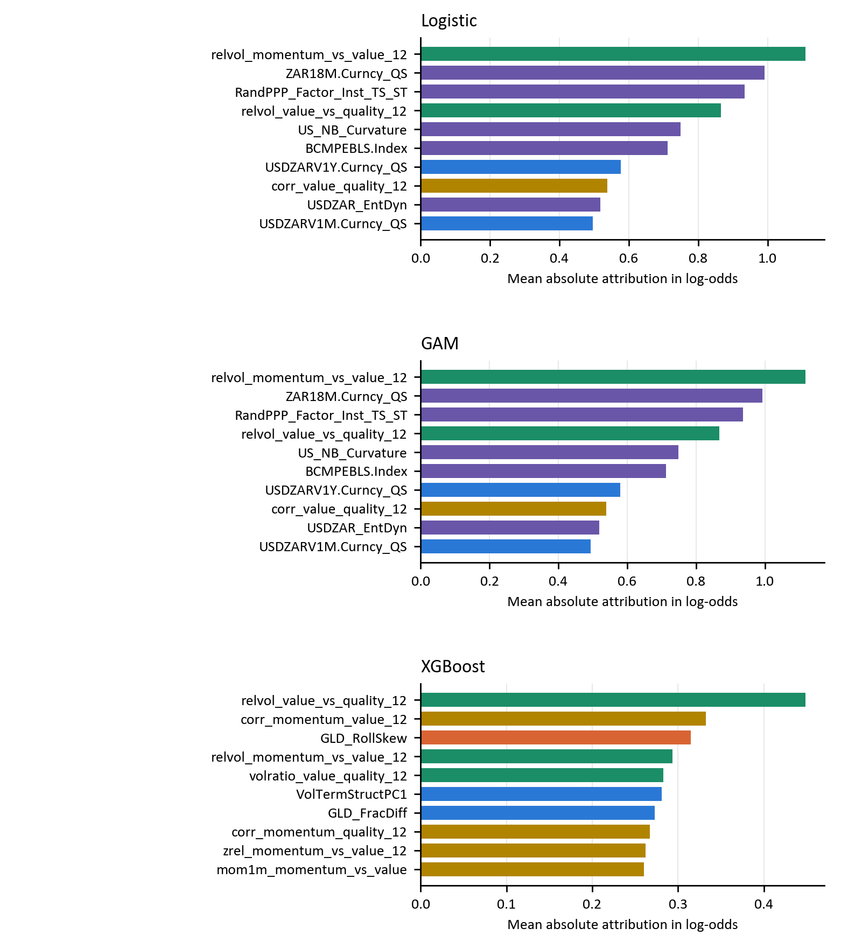
Figure 15: Global reference-model attributions for momentum versus value
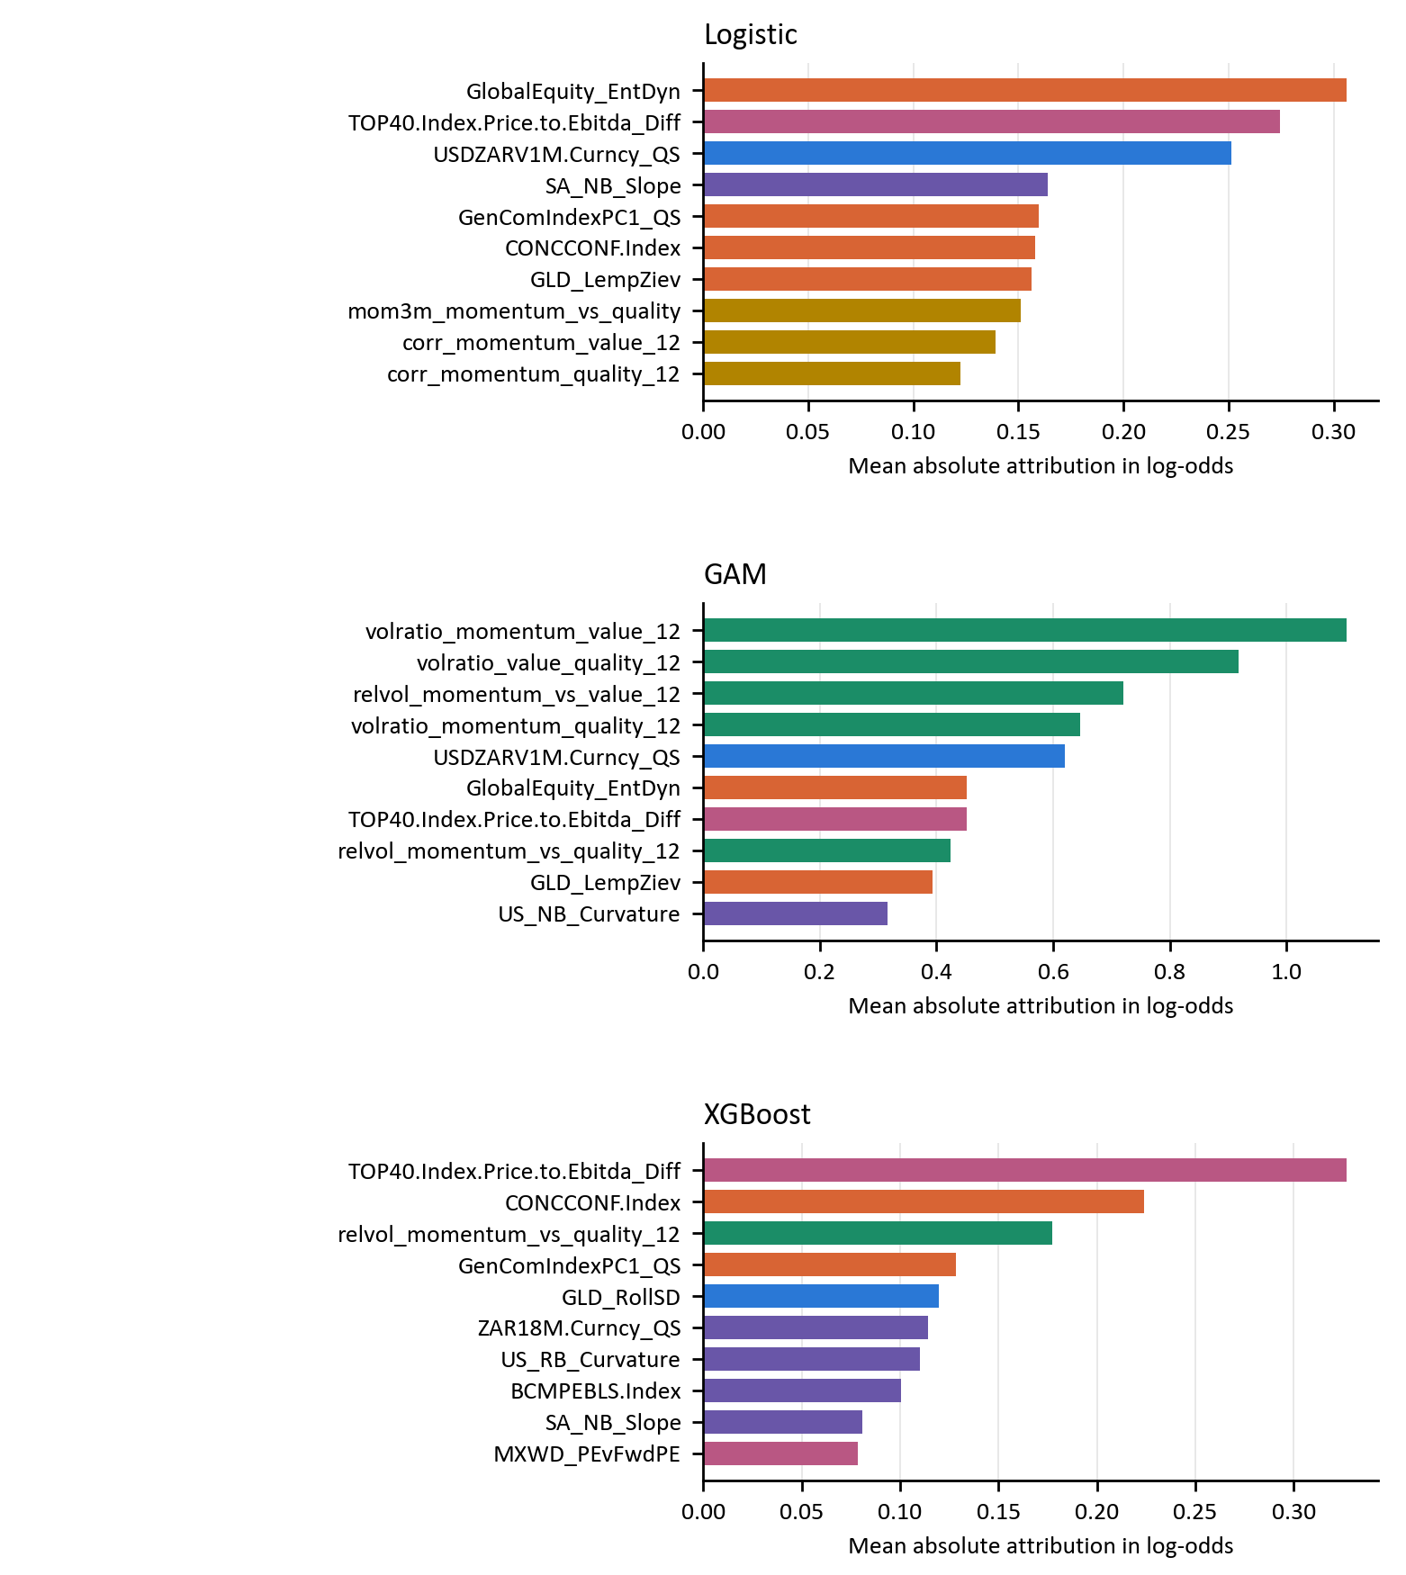
Figure 16: Global reference-model attributions for momentum versus quality
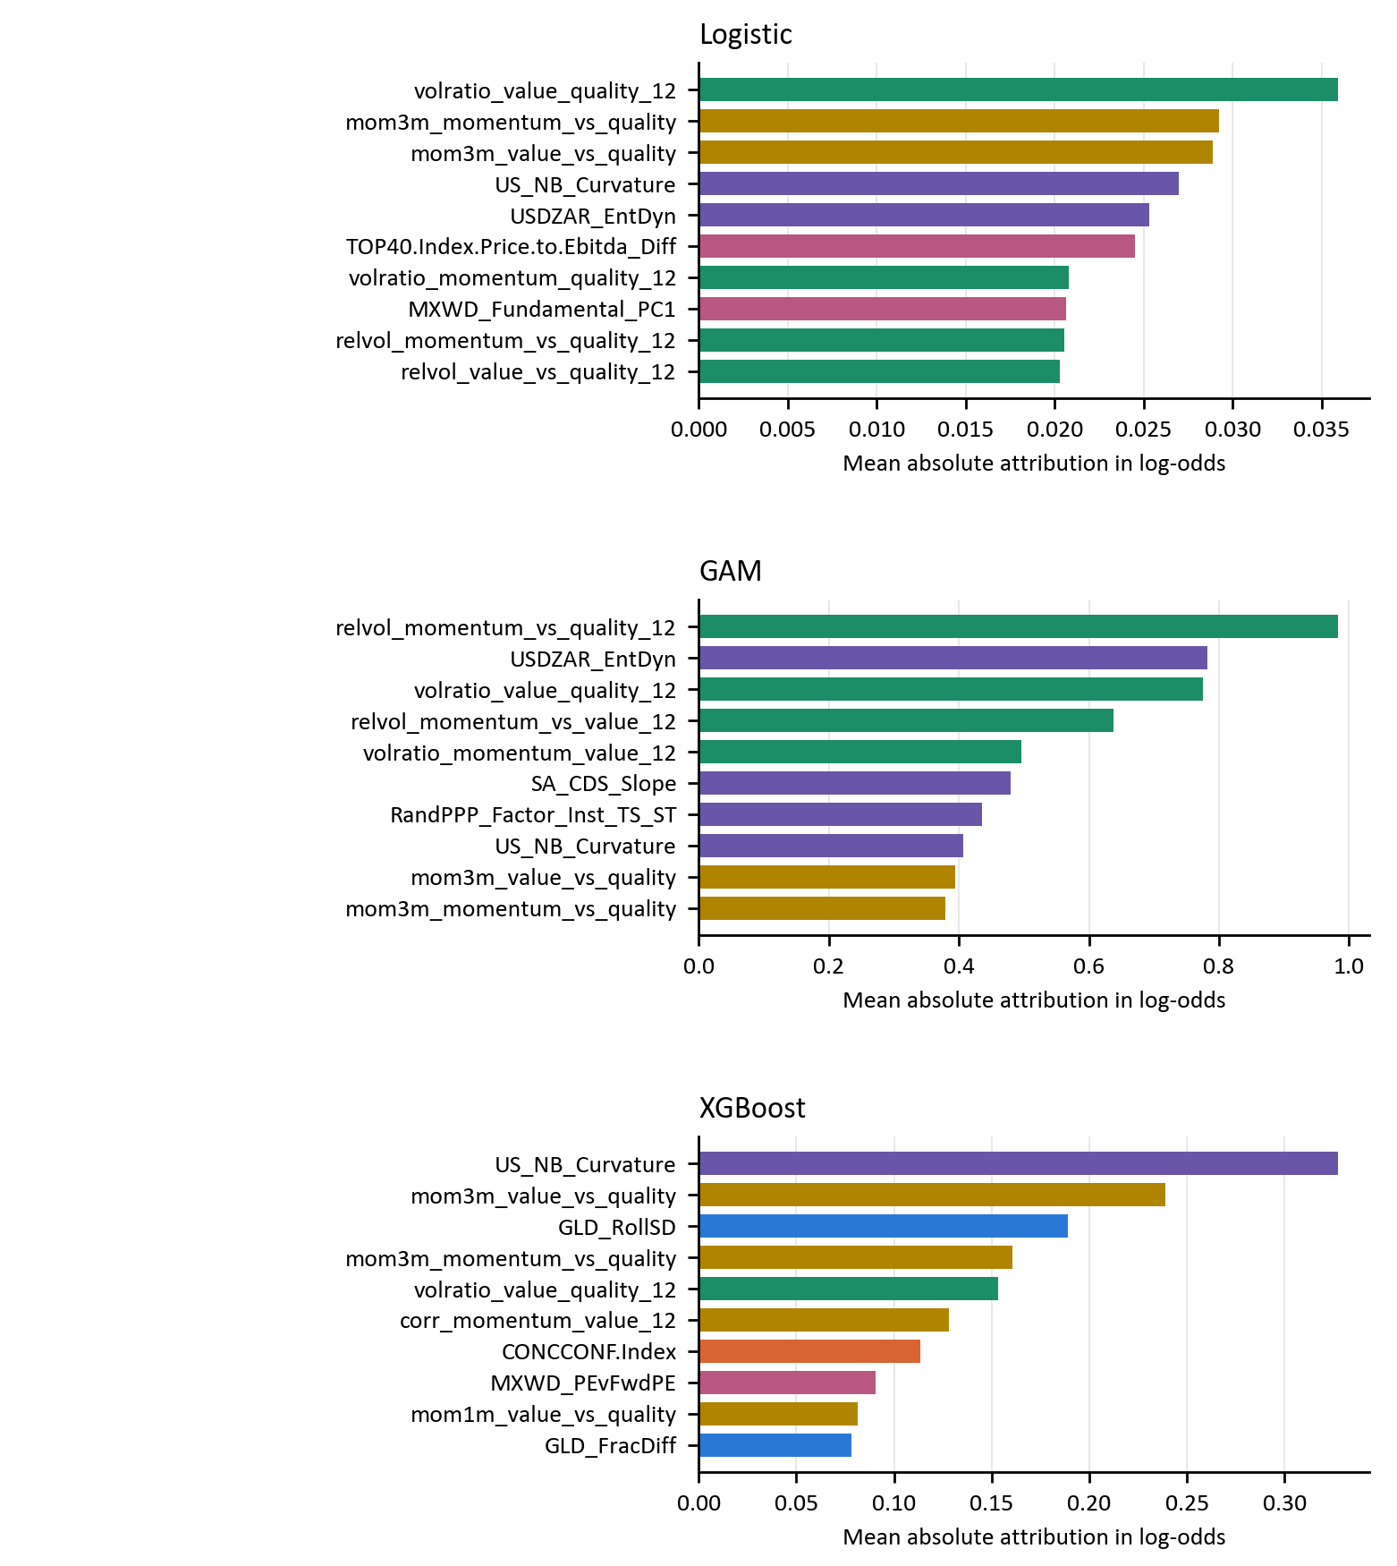
Figure 17: Global reference-model attributions for value versus quality

5 Conclusion

5.1 Summary of key findings
The evidence of relative factor predictability is confined to particular model–pair results. Unadjusted 95% ROC-AUC intervals exclude 0.5 for XGBoost on value versus quality. None remains above 0.5 using the Bonferroni-adjusted intervals for nine model–pair results. These results are conditional on the specified models and one short evaluation period.
Greater functional flexibility does not have a general, monotonic relationship with predictive performance. The highest ROC-AUCs in the evaluation are 0.572 for XGBoost on momentum versus value, 0.630 for XGBoost on momentum versus quality and 0.648 for XGBoost on value versus quality. Every paired XGBoost-minus-logistic 95% ROC-AUC interval includes zero. A common input set permits comparison, but selected penalties and basis sizes remain part of the model specification.
Ranking, class decisions and probability quality give different perspectives. XGBoost on momentum versus quality, Logistic on value versus quality and XGBoost on value versus quality improve on the constant 50% probability log-loss benchmark. A classifier that favours the more frequent leadership state can achieve reasonable accuracy while missing changes in the other direction. These distinctions limit what aggregate prediction scores imply for allocation decisions.
The reference-model attribution rankings identify economically interpretable inputs, but their use varies across models and pairs. They describe how the fitted functions use valuation, market, macroeconomic and factor-relative information. They neither identify causal effects nor demonstrate that a highly ranked input explains an out-of-sample performance advantage.

5.2 Implications for factor timing and quantitative asset management
Relative factor forecasts should be evaluated pair by pair and compared with simple benchmarks before they inform an allocation. The present results support treating such forecasts as hypotheses for further testing. A usable probability-weighted tilt requires reliable probabilities and an explicit portfolio rule, rather than a high ROC-AUC alone.
Regularised logistic regression remains a useful benchmark. More complex specifications should demonstrate an improvement that is robust to dependence-aware uncertainty and to reasonable model-development choices. The GAM results must be interpreted in the context of spline size, smoothing penalties, convergence and the choice to tune on AUC. They do not justify a general rejection of additive nonlinear modelling.
Validation documentation is part of the empirical contribution. Feature selection must precede evaluation, transformations fitted within the modelling pipeline must use training data, and label overlap must be purged at the initial boundary as well as during retuning. CPCV paths expose variation in pooled forecasts, while the mean combination AUC determines selection. Neither diagnostic can establish stability over market regimes that are absent from the evaluation sample.

5.3 Limitations of the study
The evaluation spans 156 weeks in one market. Labels persist and overlap in their forward information, so estimates are sensitive to the block length used for inference. The block bootstrap approximates dependence within the observed sequence, does not reproduce unknown future regimes and does not rerun feature or hyperparameter selection in every resample. Paired intervals and tests are therefore conditional and exploratory.
The final predictor set is one unsupervised selection. The pre-evaluation cut height and bin sensitivity checks show that alternative choices produce different representatives (Appendix B). Those alternatives have not been selected using evaluation performance, and their full forecasting performance is not estimated here. Small silhouette scores also caution against treating the clusters as sharply separated economic groups.
Although back-filling and evaluation-period feature selection are removed from the modelling pipeline, the supplied feature matrix has incomplete point-in-time provenance. Upstream PCA estimation windows, quantile-scaling histories, the detailed rolling-window recipes of some market statistics and macroeconomic publication vintages are not independently reconstructed. A four-week lag cannot establish historical availability where revised or retrospectively transformed inputs are supplied. The results therefore do not support an unqualified claim that every raw input is free of look-ahead bias.
Factor portfolios follow proprietary institutional definitions. Descriptor weights cannot be reproduced exactly from public information, and alternative factor definitions or markets may produce different labels and predictive relationships. The findings also concern three styles; they do not cover size, growth or low volatility.
The study evaluates forecasts rather than a traded portfolio. Transaction costs, turnover, liquidity constraints, market impact and a probability-to-position rule are not incorporated. Statistical forecast performance consequently does not establish economic profitability or justify a live allocation recommendation.

5.4 Recommendations for future research
A priority is to rebuild the upstream predictors from dated source observations and documented transformation windows. A subsequent prospective or genuinely untouched evaluation period would permit a stronger test of the corrected forecasting procedure. Nested feature selection and alternative target definitions would further assess sensitivity without selecting specifications on the current evaluation block.
Further work should compare stronger probability regularisation and calibration methods within the training process, with any calibration fit separated from its evaluation data. Regime-dependent performance and alternative feature subsets should be tested on additional observations, rather than inferred from the best settings in the current sample.
Portfolio implementation should then define a position rule and evaluate net returns, turnover, drawdowns and liquidity-aware costs against static factor allocations. These steps would determine whether the statistical information is sufficient to improve an implementable factor tilt.

References
Arnott, R. D., Beck, N., Kalesnik, V., & West, J. (2016). How can "smart beta" go horribly wrong? SSRN Electronic Journal. https://doi.org/10.2139/ssrn.3040949
Arnott, R. D., Harvey, C. R., & Markowitz, H. (2019). A backtesting protocol in the era of machine learning. The Journal of Financial Data Science, 1(1), 64-74. https://doi.org/10.3905/jfds.2019.1.064
Arnott, R. D., Kalesnik, V., & Linnainmaa, J. T. (2023). Factor momentum. The Review of Financial Studies, 36(8), 3034-3070. https://doi.org/10.1093/rfs/hhad006
Asness, C. S., Frazzini, A., & Pedersen, L. H. (2019). Quality minus junk. Review of Accounting Studies, 24(1), 34-112. https://doi.org/10.1007/s11142-018-9470-2
Asness, C. S., Friedman, J. A., Krail, R. J., & Liew, J. M. (2000). Style Timing - Value versus Growth. The Journal of Portfolio Management, 26(3), 50-60. https://doi.org/10.3905/jpm.2000.319724
Asness, C. S., Moskowitz, T. J., & Pedersen, L. H. (2013). Value and momentum everywhere. The Journal of Finance, 68(3), 929-985. https://doi.org/10.1111/jofi.12021
Asness, C., Chandra, S., Ilmanen, A., & Israel, R. (2017). Contrarian factor timing is deceptively difficult. The Journal of Portfolio Management, 43(5), 72-87. https://doi.org/10.3905/jpm.2017.43.5.072
Barroso, P., & Santa-Clara, P. (2015). Momentum has its moments. Journal of Financial Economics, 116(1), 111-120. https://doi.org/10.1016/j.jfineco.2014.11.010
Bartram, S. M., Lohre, H., Pope, P. F., & Ranganathan, A. (2021). Navigating the factor zoo around the world: an institutional investor perspective. Journal of Business Economics, 91(5), 655-703. https://doi.org/10.1007/s11573-021-01035-y
Bengio, Y., Simard, P., & Frasconi, P. (1994). Learning long-term dependencies with gradient descent is difficult. IEEE Transactions on Neural Networks, 5(2), 157-166. https://doi.org/10.1109/72.279181
Bessler, W., Taushanov, G., & Wolff, D. (2021). Factor investing and asset allocation strategies: A comparison of factor versus sector optimization. Journal of Asset Management, 22(6), 488-506. https://doi.org/10.1057/s41260-021-00225-1
Bishop, C. M. (2006). Pattern Recognition and Machine Learning (1st ed.). New York: Springer.
Blitz, D. C., & van Vliet, P. (2007). The volatility effect: Lower risk without lower return. The Journal of Portfolio Management, 34(1), 102-113. https://doi.org/10.3905/jpm.2007.698039
Blitz, D., Falkenstein, E., & van Vliet, P. (2014). Explanations for the Volatility Effect: An Overview Based on the CAPM Assumptions. The Journal of Portfolio Management, 40(3), 61-76. https://doi.org/10.3905/jpm.2014.40.3.061
Breiman, L. (1996). Bagging Predictors. Machine Learning, 24(2), 123-140. https://doi.org/10.1007/bf00058655
Breiman, L. (2001). Random Forests. Machine Learning, 45(1), 5-32. https://doi.org/10.1023/a:1010933404324
Breiman, L., Friedman, J. H., Olshen, R. A., & Stone, C. J. (1984). Classification and Regression Trees (1st ed.). New York: Chapman and Hall/CRC.
Bryzgalova, S., Pelger, M., & Zhu, J. (2023). Forest Through the Trees: Building Cross-Sections of Stock Returns. London: S&P Market Intelligence.
Cakici, N., Fieberg, C., Metko, D., & Zaremba, A. (2023). Machine learning goes global: Cross-sectional return predictability in international stock markets. Journal of Economic Dynamics and Control, 155, 104725. https://doi.org/10.1016/j.jedc.2023.104725
Campbell, J. Y., Lo, A. W., & MacKinlay, A. C. (1997). The Econometrics of Financial Markets (1st ed.). Princeton: Princeton University Press.
Carhart, M. M. (1997). On Persistence in Mutual Fund Performance. The Journal of Finance, 52(1), 57-82. https://doi.org/10.1111/j.1540-6261.1997.tb03808.x
Cederburg, S., O’Doherty, M. S., Wang, F., & Yan, X. S. (2020). On the performance of volatility-managed portfolios. Journal of Financial Economics, 138(1), 95-117. https://doi.org/10.1016/j.jfineco.2020.04.015
Chen, L., Pelger, M., & Zhu, J. (2019). Deep Learning in Asset Pricing. SSRN Electronic Journal, 1-76. https://doi.org/10.2139/ssrn.3350138
Chen, T., & Guestrin, C. (2016). XGBoost: A Scalable Tree Boosting System. San Francisco: ACM Digital Library.
Chung, J., Gulcehre, C., Cho, K., & Bengio, Y. (2014). Empirical Evaluation of Gated Recurrent Neural Networks on Sequence Modeling. arXiv. https://arxiv.org/abs/1412.3555
Cochrane, J. H. (2011). Presidential address: Discount rates. The Journal of Finance, 66(4), 1047-1108. https://doi.org/10.1111/j.1540-6261.2011.01671.x
Cont, R. (2001). Empirical Properties of Asset Returns: Stylized Facts and Statistical Issues. Quantitative Finance, 1(2), 223-236. https://doi.org/10.1080/713665670
Cotturo, P., Liu, F., & Proner, R. (2024). Multi-Factor Timing with Deep Learning. SSRN. https://doi.org/10.2139/ssrn.4698640
Daniel, K., & Moskowitz, T. J. (2016). Momentum crashes. Journal of Financial Economics, 122(2), 221-247. https://doi.org/10.1016/j.jfineco.2015.12.002
Daniel, K., Hirshleifer, D., & Subrahmanyam, A. (1998). Investor Psychology and Security Market Under and Overreactions. The Journal of Finance, 53(6), 1839-1885. https://doi.org/10.1111/0022-1082.00077
DeMiguel, V., Garlappi, L., & Uppal, R. (2009). Optimal versus Naive Diversification: How Inefficient Is the 1/N Portfolio Strategy?. The Review of Financial Studies, 22(5), 1915-1953. https://doi.org/10.1093/rfs/hhm075
Dietterich, T. G. (2000). Ensemble Methods in Machine Learning. Berlin: Springer.
Dixon, M. F., Klabjan, D., & Bang, J. (2017). Classification-based Financial Markets Prediction using Deep Neural Networks. Algorithmic Finance, 6(3-4), 67-77. https://doi.org/10.3233/af-170176
Fama, E. F., & French, K. R. (1993). Common risk factors in the returns on stocks and bonds. Journal of Financial Economics, 33(1), 3-56. https://doi.org/10.1016/0304-405x(93)90023-5
Fama, E. F., & French, K. R. (1992). The Cross-Section of Expected Stock Returns. The Journal of Finance, 47(2), 427-465. https://doi.org/10.1111/j.1540-6261.1992.tb04398.x
Fama, E. F., & French, K. R. (2015). A five-factor asset pricing model. Journal of Financial Economics, 116(1), 1-22. https://doi.org/10.1016/j.jfineco.2014.10.010
Fama, E. F., & French, K. R. (1989). Business conditions and expected returns on stocks and bonds. Journal of Financial Economics, 25(1), 23-49. https://doi.org/10.1016/0304-405x(89)90095-0
Fawcett, T. (2006). An introduction to ROC analysis. Pattern Recognition Letters, 27(8), 861-874. https://doi.org/10.1016/j.patrec.2005.10.010
Feng, G., Giglio, S., & Xiu, D. (2020). Taming the Factor Zoo: A Test of New Factors. The Journal of Finance, 75(3), 1327-1370. https://doi.org/10.1111/jofi.12883
Feng, G., He, J., Polson, N. G., & Xu, J. (2024). Deep Learning in Characteristics-Sorted Factor Models. Journal of Financial and Quantitative Analysis, 59(7), 3001-3036. https://doi.org/10.1017/s0022109023000893
Fischer, T., & Krauss, C. (2018). Deep learning with long short-term memory networks for financial market predictions. European Journal of Operational Research, 270(2), 654-669. https://doi.org/10.1016/j.ejor.2017.11.054
Fraser, E., & Page, M. (2000). Value and momentum strategies: Evidence from the Johannesburg Stock Exchange. Investment Analysts Journal, 29(51), 25-35. https://doi.org/10.1080/10293523.2000.11082404
Friedman, J. H. (2001). Greedy function approximation: A gradient boosting machine. The Annals of Statistics, 29(5), 1189-1232. https://doi.org/10.1214/aos/1013203451
Giglio, S., Kelly, B., & Xiu, D. (2022). Factor models, machine learning, and asset pricing. Annual Review of Financial Economics, 14(1), 337-368. https://doi.org/10.1146/annurev-financial-101521-104735
Gneiting, T., & Raftery, A. E. (2007). Strictly proper scoring rules, prediction, and estimation. Journal of the American Statistical Association, 102(477), 359-378. https://doi.org/10.1198/016214506000001437
Good, I. J. (1952). Rational decisions. Journal of the Royal Statistical Society Series B: Statistical Methodology, 14(1), 107-114. https://doi.org/10.1111/j.2517-6161.1952.tb00104.x
Goodfellow, I., Bengio, Y., & Courville, A. (2016). Deep learning. MA: MIT Press.
Gu, S., Kelly, B., & Xiu, D. (2020). Empirical Asset Pricing via Machine Learning. The Review of Financial Studies, 33(5), 2223-2273. https://doi.org/10.1093/rfs/hhaa009
Gupta, T., & Kelly, B. (2019). Factor momentum everywhere. The Journal of Portfolio Management, 45(3), 13-36. https://doi.org/10.3905/jpm.2019.45.3.013
Haddad, V., Kozak, S., & Santosh, S. (2020). Factor Timing. The Review of Financial Studies, 33(5), 1980-2018. https://doi.org/10.1093/rfs/hhaa017
Hanauer, M. X., & Kalsbach, T. (2023). Machine learning and the cross-section of emerging market stock returns. Emerging Markets Review, 55, 101022. https://doi.org/10.1016/j.ememar.2023.101022
Harvey, C. R., Liu, Y., & Zhu, H. (2016). and the Cross-Section of Expected Returns. Review of Financial Studies, 29(1), 5-68. https://doi.org/10.1093/rfs/hhv059
Hastie, T., & Tibshirani, R. (1986). Generalized Additive Models. Statistical Science, 1(3), 297-310. https://doi.org/10.1214/ss/1177013604
Hastie, T., Tibshirani, R., & Friedman, J. (2009). The Elements of Statistical Learning (2nd ed.). New York: Springer.
Hochreiter, S., & Schmidhuber, J. (1997). Long Short-Term Memory. Neural Computation, 9(8), 1735-1780. https://doi.org/10.1162/neco.1997.9.8.1735
Hoerl, A. E., & Kennard, R. W. (1970). Ridge regression: Biased estimation for nonorthogonal problems. Technometrics, 12(1), 55-67. https://doi.org/10.1080/00401706.1970.10488634
Hosmer, D. W., Lemeshow, S., & Sturdivant, R. (2013). Applied Logistic Regression (3rd ed.). Hoboken: Wiley.
Ilmanen, A., & Kizer, J. (2012). The death of diversification has been greatly exaggerated. The Journal of Portfolio Management, 38(3), 15-27. https://doi.org/10.3905/jpm.2012.38.3.015
Ilmanen, A., Israel, R., Lee, R., Moskowitz, T. J., & Thapar, A. (2021). How do factor premia vary over time? A century of evidence. Journal of Investment Management, 19(4), 15-57. https://www.aqr.com/-/media/AQR/Documents/Journal-Articles/JOIM_How-Do-Factor-Premia-Vary-Over-Time.pdf
Israel, R., Kelly, B., & Moskowitz, T. J. (2020). Can Machines “Learn” Finance?. Journal of Investment Management, 18(2), 23-36.
Jain, A. K., Murty, M. N., & Flynn, P. J. (1999). Data clustering: A review. ACM Computing Surveys, 31(3), 264-323. https://doi.org/10.1145/331499.331504
James, G., Witten, D., Hastie, T., & Tibshirani, R. (2021). An Introduction to Statistical Learning (2nd ed.). New York: Springer.
Jegadeesh, N., & Titman, S. (1993). Returns to buying winners and selling losers: Implications for stock market efficiency. The Journal of Finance, 48(1), 65-91. https://doi.org/10.1111/j.1540-6261.1993.tb04702.x
Kapche Fotso, H. M. (2019). Cyclicality of size, value and momentum on the Johannesburg Stock Exchange. Cape Town: University of the Western Cape.
Ke, G., Meng, Q., Finley, T., Wang, T., Chen, W., Ma, W., Ye, Q., & Liu, T. Y. (2017). Lightgbm: A highly efficient gradient boosting decision tree. Advances in Neural Information Processing Systems, 30. https://proceedings.neurips.cc/paper_files/paper/2017/hash/6449f44a102fde848669bdd9eb6b76fa-Abstract.html
Kelly, B., Pruitt, S., & Su, Y. (2019). Characteristics are covariances: A unified model of risk and return. Journal of Financial Economics, 134(3), 501-524. https://doi.org/10.1016/j.jfineco.2019.05.001
Krauss, C., Do, X. A., & Huck, N. (2017). Deep neural networks, gradient-boosted trees, random forests: Statistical arbitrage on the S&P 500. European Journal of Operational Research, 259(2), 689-702. https://doi.org/10.1016/j.ejor.2016.10.031
Kumar, I. E., Venkatasubramanian, S., Scheidegger, C., & Friedler, S. A. (2020). Problems with Shapley-value-based explanations as feature importance measures. PMLR.
Kunsch, H. R. (1989). The jackknife and the bootstrap for general stationary observations. The Annals of Statistics, 17(3), 1217-1241. https://doi.org/10.1214/aos/1176347265
Lakonishok, J., Vishny, R., & Shleifer, A. (1994). Contrarian investment, extrapolation, and risk. The Journal of Finance, 49(5), 1541-1578. https://doi.org/10.1111/j.1540-6261.1994.tb04772.x
Leippold, M., Wang, Q., & Zhou, W. (2022). Machine Learning in the Chinese Stock Market. Journal of Financial Economics, 145(2), 64-82. https://doi.org/10.1016/j.jfineco.2021.08.017
Leung, E., Lohre, H., Mischlich, D., Shea, Y., & Stroh, M. (2021). The Promises and Pitfalls of Machine Learning for Predicting Stock Returns. Lancaster: SSRN.
Lim, B., & Zohren, S. (2021). Time-series forecasting with deep learning: a survey. Philosophical Transactions of the Royal Society A: Mathematical, Physical and Engineering Sciences, 379(2194), 20200209. https://doi.org/10.1098/rsta.2020.0209
Lintner, J. (1965). The valuation of risk assets and the selection of risky investments in stock portfolios and capital budgets. The Review of Economics and Statistics, 47(1), 13-37. https://doi.org/10.2307/1924119
Lundberg, S. M., & Lee, S. I. (2017). A unified approach to interpreting model predictions. Advances in Neural Information Processing Systems, 30. https://proceedings.neurips.cc/paper_files/paper/2017/hash/8a20a8621978632d76c43dfd28b67767-Abstract.html
Lundberg, S. M., Erion, G., Chen, H., DeGrave, A., Prutkin, J. M., Nair, B., Katz, R., Himmelfarb, J., Bansal, N., & Lee, S. I. (2020). From local explanations to global understanding with explainable AI for trees. Nature Machine Intelligence, 2(1), 56-67. https://doi.org/10.1038/s42256-019-0138-9
López de Prado, M. M. (2018). Advances in Financial Machine Learning (1st ed.). New York: John Wiley & Sons.
López de Prado, M. M. (2020). Machine Learning for Asset Managers (1st ed.). Cambridge: Cambridge University Press.
Ma, T., Liao, C., & Jiang, F. (2023). Timing the factor zoo via deep learning: Evidence from China. Accounting & Finance, 63(1), 485-505. https://doi.org/10.1111/acfi.13033
Makamo, S. (2023). Predicting Style Factor Returns and Group/sector Returns Using Long and Short-term Memory ('LSTM') Deep Learning Neural Networks. Johannesburg: SSRN.
Masongweni, V. (2025). Redefining factor portfolios in SA and global equity markets: Their existence and relevance. Momentum Investments.
Mclean, R. D., & Pontiff, J. (2016). Does academic research destroy stock return predictability?. The Journal of Finance, 71(1), 5-32. https://doi.org/10.1111/jofi.12365
Mitchell, T. M. (1997). Machine Learning (1st ed.). New York: McGraw-Hill.
Molnar, C. (2022). Interpretable Machine Learning. Munich: Leanpub.
Moritz, B., & Zimmermann, T. (2016). Tree-Based Conditional Portfolio Sorts: The Relation Between Past and Future Stock Returns. SSRN Electronic Journal. https://doi.org/10.2139/ssrn.2740751
Muller, C., & Ward, M. (2013). Style-based effects on the Johannesburg Stock Exchange: A graphical time-series approach. Investment Analysts Journal, 42(77), 1-16. https://doi.org/10.1080/10293523.2013.11082552
Murphy, A. H. (1973). A new vector partition of the probability score. Journal of Applied Meteorology, 12(4), 595-600. https://doi.org/10.1175/1520-0450(1973)012<0595:anvpot>2.0.co;2
Mutooni, R., & Muller, C. (2007). Equity style timing. Investment Analysts Journal, 36(65), 15-24. https://doi.org/10.1080/10293523.2007.11082485
Noguer i Alonso, M., Zoonekynd, V., & Srivastava, S. (2022). Equity Machine Factor Models. SSRN.
Page, D., McClelland, D., & Auret, C. (2022). Style rotation on the JSE. Finance Research Letters, 46(B), 102504. https://doi.org/10.1016/j.frl.2021.102504
Page, D., McClelland, D., & Auret, C. (2024). Machine learning style rotation – evidence from the Johannesburg Stock Exchange. Cogent Economics & Finance, 12(1), 2402893. https://doi.org/10.1080/23322039.2024.2402893
Panda, P. P., Gharanchaei, M. K., Chen, X., & Lyu, H. (2024). APPLICATION OF DEEP LEARNING FOR FACTOR TIMING IN ASSET MANAGEMENT. Pennsylvania: Arxiv.
Pedregosa, F., Varoquaux, G., Gramfort, A., Michel, V., Thirion, B., Grisel, O., Blondel, M., Prettenhofer, P., Weiss, R., Dubourg, V., Vanderplas, J., Passos, A., Cournapeau, D., Brucher, M., Perrot, M., & Duchesnay, É. (2011). Scikit-learn: Machine Learning in Python. Journal of Machine Learning Research, 12, 2825-2830. https://www.jmlr.org/papers/v12/pedregosa11a.html
Piotroski, J. D. (2000). Value Investing: The Use of Historical Financial Statement Information to Separate Winners from Losers. Journal of Accounting Research, 38(Supplement), 1-41. https://doi.org/10.2307/2672906
Piovezan, R. P. B., de Andrade Junior, P. P., & Ávila, S. L. (2024). Machine Learning Method for Return Direction Forecast of Exchange Traded Funds (ETFs) Using Classification and Regression models. Computational Economics, 63(5), 1827-1852. https://doi.org/10.1007/s10614-023-10385-4
Rapach, D. E., & Zhou, G. (2013). Forecasting stock returns. Amsterdam: Elsevier.
Rumelhart, D. E., Hinton, G. E., & Williams, R. J. (1986). Learning representations by back-propagating errors. Nature, 323(6088), 533-536. https://doi.org/10.1038/323533a0
Sagi, O., & Rokach, L. (2018). Ensemble learning: A survey. WIREs Data Mining and Knowledge Discovery, 8(4), e1249. https://doi.org/10.1002/widm.1249
Shapley, L. S. (1953). A value for n-person games. Contributions to the Theory of Games (AM-28), Volume II, 307-318. https://doi.org/10.1515/9781400881970-018
Sharpe, W. F. (1964). Capital asset prices: A theory of market equilibrium under conditions of risk. The Journal of Finance, 19(3), 425-442. https://doi.org/10.1111/j.1540-6261.1964.tb02865.x
Shleifer, A., & Vishny, R. W. (1997). The limits of arbitrage. The Journal of Finance, 52(1), 35-55. https://doi.org/10.1111/j.1540-6261.1997.tb03807.x
Sirignano, J., & Cont, R. (2019). Universal Features of Price Formation in Financial Markets: Perspectives from Deep Learning. Quantitative Finance, 19(9), 1449-1459. https://doi.org/10.1080/14697688.2019.1622295
Sulaiman, M. A., & Labadin, J. (2016). Improved Feature Selection Based on Mutual Information for Regression Tasks. Journal of IT in Asia, 6(1), 11-24. https://doi.org/10.33736/jita.330.2016
Sutton, R. S., & Barto, A. G. (2018). Reinforcement Learning: An Introduction (2nd ed.). Massachusetts: MIT Press.
Tibshirani, R. (1996). Regression shrinkage and selection via the lasso. Journal of the Royal Statistical Society Series B: Statistical Methodology, 58(1), 267-288. https://doi.org/10.1111/j.2517-6161.1996.tb02080.x
Vapnik, V. N. (1999). An Overview of Statistical Learning Theory. IEEE Transactions on Neural Networks, 10(5), 988-999. https://doi.org/10.1109/72.788640
Vaswani, A., Shazeer, N., Parmar, N., Uszkoreit, J., Jones, L., Gomez, A. N., Kaiser, , & Polosukhin, I. (2017). Attention is all you need. Advances in Neural Information Processing Systems, 30. https://proceedings.neurips.cc/paper/2017/hash/3f5ee243547dee91fbd053c1c4a845aa-Abstract.html
Wang, W. (2023). A comparative study of traditional linear models and nonlinear neural network model on asset pricing. China: Proceedings of the 4th International Conference on Economic Management and Model Engineering.
Welch, I., & Goyal, A. (2008). A comprehensive look at the empirical performance of equity premium prediction. Review of Financial Studies, 21(4), 1455-1508. https://doi.org/10.1093/rfs/hhm014
White, H. (2000). A reality check for data snooping. Econometrica, 68(5), 1097-1126. https://doi.org/10.1111/1468-0262.00152
Wolpert, D. H. (1992). Stacked Generalization. Neural Networks, 5(2), 241-259. https://doi.org/10.1016/s0893-6080(05)80023-1
Wood, S. N. (2017). Generalized Additive Models - An Introduction with R (2nd ed.). New York: Chapman and Hall/CRC.
Zou, H., & Hastie, T. (2005). Regularization and variable selection via the elastic net. Journal of the Royal Statistical Society Series B: Statistical Methodology, 67(2), 301-320. https://doi.org/10.1111/j.1467-9868.2005.00503.x

Appendix A Feature definitions
Table A.1 identifies all 47 modelling predictors using the exact column names of the modelling input matrix. The first 29 are cluster representatives; the remaining 18 are constructed from the weekly factor returns. Every predictor is lagged by four weekly observations before modelling.
The suffix Diff denotes a first difference and QS denotes an upstream quantile-scaled input. PC denotes a principal component. Descriptions of supplied inputs identify their economic meaning; they do not imply that upstream transformations were re-estimated inside this study. Detailed provider recipes, including PCA loadings, some rolling-window lengths and point-in-time scaling histories, constrain exact replication as discussed in Section 5.3.
Table A.1: Definitions of all retained predictors
Exact feature name | Definition | Category
BCMPEBLS.Index | US business-cycle index. | Macroeconomic
MXWD_Fundamental_PC1 | First principal component of the supplied MSCI World fundamental valuation indicators. | Fundamental valuation
SA_CDS_Slope | Slope factor of the South African sovereign credit-default-swap term structure. | Macroeconomic
US_NB_Curvature | Curvature factor of the US nominal government bond yield curve. | Macroeconomic
RandPPP_Factor_Inst_TS_ST | Short-term time-series measure of the institutional rand purchasing-power-parity valuation factor. | Macroeconomic
CONCCONF.Index | US Conference Board Consumer Confidence Index. | Sentiment and risk appetite
USDZAR_EntDyn | Change in the supplied entropy measure of the USD/ZAR exchange-rate series. | Macroeconomic
GLD_LempZiev | Supplied Lempel–Ziv complexity measure of the gold price series. | Sentiment and risk appetite
GlobalEquity_EntDyn | Change in the supplied entropy measure of the global equity series. | Sentiment and risk appetite
GLD_RollKurt | Rolling kurtosis of the supplied gold series. | Sentiment and risk appetite
GLD_RollSkew | Rolling skewness of the supplied gold series. | Sentiment and risk appetite
GLD_FracDiff | Fractionally differenced gold price series. | Price-based indicators
GLD_StructBreak | Supplied structural-break statistic for the gold price series. | Sentiment and risk appetite
GlobalEquityGret1 | One-month geometric return of the supplied global equity series. | Price-based indicators
GenComIndexPC2 | Second principal component of the supplied broad commodity indicator set. | Sentiment and risk appetite
GenComIndexPC1_QS | Quantile-scaled first principal component of the supplied broad commodity indicator set. | Sentiment and risk appetite
TOP40.Index.Price.to.Book.Ratio_Diff | First difference of the FTSE/JSE Top 40 price-to-book ratio. | Fundamental valuation
ZAR18M.Curncy_QS | Quantile-scaled 18-month USD/ZAR forward-points series. | Macroeconomic
TOP40.Index.Price.to.Ebitda_Diff | First difference of the FTSE/JSE Top 40 price-to-EBITDA ratio. | Fundamental valuation
MXWD.Index.Price.to.Sales.Ratio_Diff | First difference of the MSCI World price-to-sales ratio. | Fundamental valuation
SA_NB_Slope | Slope factor of the South African nominal government bond yield curve. | Macroeconomic
GlobalEquityTS | Level of the supplied global equity index time series. | Sentiment and risk appetite
VolTermStructPC1 | First principal component of the supplied equity implied-volatility term structure. | Price-based indicators
US_RB_Curvature | Curvature factor of the US real government bond yield curve. | Macroeconomic
GLD_RollSD | Rolling standard deviation of the supplied gold series. | Price-based indicators
MXWD_PEvFwdPE | Supplied comparison of the MSCI World current and forward price-to-earnings ratios. | Fundamental valuation
EURUSDV6M.Curncy_QS | Quantile-scaled six-month EUR/USD option-implied volatility. | Price-based indicators
USDZARV1Y.Curncy_QS | Quantile-scaled one-year USD/ZAR option-implied volatility. | Price-based indicators
USDZARV1M.Curncy_QS | Quantile-scaled one-month USD/ZAR option-implied volatility. | Price-based indicators
zrel_momentum_vs_value_12 | Current weekly momentum versus value return spread minus its trailing 12-week mean, divided by its trailing 12-week sample standard deviation. | Factor relative performance
relvol_momentum_vs_value_12 | Trailing 12-week sample standard deviation of the weekly momentum versus value return spread. | Factor relative volatility
corr_momentum_value_12 | Trailing 12-week Pearson correlation of the weekly momentum and value returns. | Factor relative performance
volratio_momentum_value_12 | Trailing 12-week sample standard deviation of momentum returns divided by that of value returns. | Factor relative volatility
mom1m_momentum_vs_value | Compounded momentum return over the trailing 4 weeks minus the compounded value return over the same weeks. | Factor relative performance
mom3m_momentum_vs_value | Compounded momentum return over the trailing 12 weeks minus the compounded value return over the same weeks. | Factor relative performance
zrel_momentum_vs_quality_12 | Current weekly momentum versus quality return spread minus its trailing 12-week mean, divided by its trailing 12-week sample standard deviation. | Factor relative performance
relvol_momentum_vs_quality_12 | Trailing 12-week sample standard deviation of the weekly momentum versus quality return spread. | Factor relative volatility
corr_momentum_quality_12 | Trailing 12-week Pearson correlation of the weekly momentum and quality returns. | Factor relative performance
volratio_momentum_quality_12 | Trailing 12-week sample standard deviation of momentum returns divided by that of quality returns. | Factor relative volatility
mom1m_momentum_vs_quality | Compounded momentum return over the trailing 4 weeks minus the compounded quality return over the same weeks. | Factor relative performance
mom3m_momentum_vs_quality | Compounded momentum return over the trailing 12 weeks minus the compounded quality return over the same weeks. | Factor relative performance
zrel_value_vs_quality_12 | Current weekly value versus quality return spread minus its trailing 12-week mean, divided by its trailing 12-week sample standard deviation. | Factor relative performance
relvol_value_vs_quality_12 | Trailing 12-week sample standard deviation of the weekly value versus quality return spread. | Factor relative volatility
corr_value_quality_12 | Trailing 12-week Pearson correlation of the weekly value and quality returns. | Factor relative performance
volratio_value_quality_12 | Trailing 12-week sample standard deviation of value returns divided by that of quality returns. | Factor relative volatility
mom1m_value_vs_quality | Compounded value return over the trailing 4 weeks minus the compounded quality return over the same weeks. | Factor relative performance
mom3m_value_vs_quality | Compounded value return over the trailing 12 weeks minus the compounded quality return over the same weeks. | Factor relative performance

A.1 Relative-factor construction conventions
For factors a and b, the weekly spread is Rₐ,ₜ − Rᵦ,ₜ. A relative momentum predictor is the difference between their individually compounded returns, not the compounded return of the spread. The one-month and three-month names denote four and 12 weekly observations respectively. All names ending in 12 use 12 weeks, not 12 months.
Rolling standard deviations use the sample convention with one degree of freedom removed, matching pandas rolling standard deviation. Relative volatility is the standard deviation of the spread; the volatility ratio divides the first factor’s standard deviation by the second factor’s. The standardised relative return subtracts the trailing spread mean from the current spread and divides by the trailing spread standard deviation. Correlation is calculated from the two factor return series over the same 12-week window.
Gold, global equity, currency and valuation series retain the labels in the supplied feature file. BCMPEBLS.Index denotes a US business-cycle index.

Appendix B Feature selection and sample audit

B.1 Screening and estimation window
Screening and clustering use data no later than 1 November 2021. Missingness is measured before any filling. Eligible series are forward-filled and complete rows are used to estimate dependence. The resulting estimation sample has 548 weeks from 9 May 2011 to 1 November 2021. No evaluation-period observation is used in the screen, discretisation, distance estimation, clustering or representative choice.
Table B.1: From candidate inputs to the modelling predictor set
Step | Predictors
Candidates in the supplied file | 359
Removed because pre-evaluation missingness exceeds 30% | 23
Retained after missingness screen | 336
Removed because constant in the complete selection sample | 10
Eligible features clustered | 326
Cluster representatives at cut height two | 29
Relative-factor predictors added by design | 18
Final modelling predictors | 47

Table B.2: Candidates removed by the pre-evaluation missingness screen
Feature | Missing share | First raw observation
OVXStructBreak | 34.1% | 2012-03-05
SA_CDS_Level_QS | 34.5% | 2012-03-26
SA_CDS_Slope_QS | 34.5% | 2012-03-26
SA_CDS_Curvature_QS | 34.5% | 2012-03-26
SA_CDS_Lambda_QS | 34.5% | 2012-03-26
SA_CDS_R2_QS | 34.5% | 2012-03-26
USDZAR_Vol_Level | 33.6% | 2012-02-06
USDZAR_Vol_Slope | 33.6% | 2012-02-06
USDZAR_Vol_QS_Level | 59.5% | 2015-11-30
USDZAR_Vol_QS_Slope | 59.5% | 2015-11-30
SAImplYld_Level | 53.5% | 2015-01-12
SAImplYld_Slope | 53.5% | 2015-01-12
SAImplYld_QS_Level | 79.5% | 2018-11-05
SAImplYld_QS_Slope | 79.5% | 2018-11-05
ZARI2M.Curncy_QS | 40.3% | 2013-02-04
ZARI2W.Curncy_QS | 40.3% | 2013-02-04
ZARI2Y.Curncy_QS | 40.3% | 2013-02-04
ZARI3M.Curncy_QS | 40.3% | 2013-02-04
ZARI3Y.Curncy_QS | 40.3% | 2013-02-04
ZARI4M.Curncy_QS | 40.3% | 2013-02-04
ZARI4Y.Curncy_QS | 40.3% | 2013-02-04
ZARI5M.Curncy_QS | 40.3% | 2013-02-04
ZARI5Y.Curncy_QS | 40.3% | 2013-02-04

B.2 Cluster representatives and membership
Table B.3 lists every representative and all members of its cluster. The representative minimises mean MI distance to the members. Ward linkage acts on distance profiles; cluster membership therefore does not mean that every pair has MI distance below the cut height.
Table B.3: Cluster representatives and members at cut height two
Representative | Size | Other members
BCMPEBLS.Index | 14 | MichgnConcIndx; SACWC_YoY; OEZAKLAF_YoY; LEI.TOTL.Index; SACWC.Index_QS; LocalEquityVol12; LocalBondsVol12; LocalPropertyVol12; GlobalEquityVol1; GlobalEquityVol12; GlobalBondVol12; GlobalPropertyVol12; SA_RB_Level
MXWD_Fundamental_PC1 | 5 | MXWD.Index.PE.Ratio_Diff; MXWD.Index.PE.Ratio.Next.FY.Aggregated_Diff; MXWD.Index.Price.to.Ebitda_Diff; MXWD.Index.Forward.PE_Diff
SA_CDS_Slope | 4 | SA_CDS_Level; SA_CDS_Curvature; SA_CDS_R2
US_NB_Curvature | 43 | DXY_RV_12; JALSH_RV_12_TS; RandPPP_Factor_Inst; ZAR_FwdPts_PC2_TS; ZAR_FwdPts_PC1_TS; DXY_TS; GE_GB_Corr; LE_LB_Corr; SubIndex_PC1; BCMPEBLS.Index_QS; LocalEquityVol6; LocalBondsVol6; LocalPropertyGret12; LocalPropertyVol6; GlobalEquityVol6; GlobalPropertyVol6; USDZARVol12; SA_NB_Curvature; SA_RB_Slope; SA_RB_Curvature; SA_RB_R2; SA_RB_Level_QS; SA_RB_Slope_QS; SA_RB_Curvature_QS; SA_RB_R2_QS; SA_RB_Level_TS; SABreakEvenInflPC_1; US_NB_Slope; US_NB_R2; US_NB_Curvature_QS; US_NB_R2_QS; US_RB_Slope_TS; SAFwdPtsl_Level; SAFwdPts_Slope; JALSH.Index.PE.Ratio_QS; JALSH.Index.Forward.PE_QS; JALSH.Index.PE.Ratio_Diff; JALSH.Index.Forward.PE_Diff; JALSH_Fundamental_PC1; JALSH_Fundamental_PC2; JALSH_PEvFwdPE; JALSH_PEvAgrgtPE_1FY
RandPPP_Factor_Inst_TS_ST | 2 | RandPPP_Factor_Inst_TS_LT
CONCCONF.Index | 8 | SAPMI_YoY; EPUCCUSM.Index; CONCCONF.Index_QS; CONSSENT.Index_QS; EPUCCUSM.Index_QS; SSICCONF.Index_QS; SAPMI.Index_QS
USDZAR_EntDyn | 2 | LocalBonds_EntDyn
GLD_LempZiev | 2 | XAULempZiev
GlobalEquity_EntDyn | 11 | LEI.TOTL.Index_QS; LA1LempZiev; USDZAR_Ent; MultiAssetEnt; LocalBonds_Ent; GlobalBonds_EntDyn; GlobalBonds_Ent; LocalEquity_EntDyn; LocalEquity_Ent; GlobalEquity_Ent
GLD_RollKurt | 2 | XAURollKurt
GLD_RollSkew | 2 | XAURollSkew
GLD_FracDiff | 2 | XAUFracDiff
GLD_StructBreak | 2 | XAUStructBreak
GlobalEquityGret1 | 12 | OPCVTPCR.Index; AAIIBEAR.Index_QS; AAIIBULL.Index_QS; OPCVTPCR.Index_QS; LA1StructBreak; LocalEquityGret1; LocalBondsGret1; LocalPropertyGret1; GlobalBondGret1; GlobalPropertyGret1; USDZARGret1
GenComIndexPC2 | 35 | SA_PMI_TS; TINSALNL.Index; TINSALNL.Index_QS; HG1.Comdty_Diff_QS; XAU.Curncy_Diff_QS; GenComIndexPC2_QS; USNomBndStructBreak_Level; USNomBndStructBreak_Slope; USRealBndStructBreak_Level; USRealBndStructBreak_Slope; SANomBndStructBreak_Level; SANomBndStructBreak_Slope; MOVEStructBreak; LocalEquityGret3; LocalEquityGret6; LocalEquityVol1; LocalEquitySB; LocalBondsGret3; LocalBondsGret6; LocalBondsVol1; LocalBondsSB; LocalPropertyVol1; LocalPropertySB; GlobalEquityGret3; GlobalEquitySB; GlobalBondGret3; GlobalBondVol1; GlobalBondSB; GlobalPropertyGret3; GlobalPropertyVol1; GlobalBondSB.1; USDZARGret3; USDZARVol1; USDZARSB
GenComIndexPC1_QS | 4 | LA1.Comdty_Diff_QS; GenComIndexPC1; LA1FracDiff
TOP40.Index.Price.to.Book.Ratio_Diff | 8 | JALSH.Index.Price.to.Sales.Ratio_QS; TOP40.Index.Price.to.Sales.Ratio_QS; JALSH.Index.Price.to.Book.Ratio_QS; TOP40.Index.Price.to.Book.Ratio_QS; JALSH.Index.Price.to.Sales.Ratio_Diff; TOP40.Index.Price.to.Sales.Ratio_Diff; JALSH.Index.Price.to.Book.Ratio_Diff
ZAR18M.Curncy_QS | 9 | SAFwdPts_QS_Level; ZAR10M.Curncy_QS; ZAR12M.Curncy_QS; ZAR15M.Curncy_QS; ZAR21M.Curncy_QS; ZAR2Y.Curncy_QS; ZAR3Y.Curncy_QS; ZAR5Y.Curncy_QS
TOP40.Index.Price.to.Ebitda_Diff | 10 | JALSH.Index.PE.Ratio.Next.FY.Aggregated_QS; TOP40.Index.PE.Ratio.Next.FY.Aggregated_QS; JALSH.Index.Price.to.Ebitda_QS; TOP40.Index.Price.to.Ebitda_QS; TOP40.Index.Forward.PE_QS; JALSH.Index.PE.Ratio.Next.FY.Aggregated_Diff; TOP40.Index.PE.Ratio.Next.FY.Aggregated_Diff; JALSH.Index.Price.to.Ebitda_Diff; TOP40.Index.Forward.PE_Diff
MXWD.Index.Price.to.Sales.Ratio_Diff | 8 | MXWD.Index.PE.Ratio_QS; MXWD.Index.PE.Ratio.Next.FY.Aggregated_QS; MXWD.Index.Price.to.Ebitda_QS; MXWD.Index.Price.to.Sales.Ratio_QS; MXWD.Index.Forward.PE_QS; MXWD.Index.Price.to.Book.Ratio_QS; MXWD.Index.Price.to.Book.Ratio_Diff
SA_NB_Slope | 14 | RandPPP_QuantileScale; InflGrowthSurpPC1; InflGrowthSurpPC1_QS; BCMPUSIF.Index_QS; USDZARTS; USDZARGret6; USDZARGret12; SA_NB_Level; SA_NB_R2; SA_NB_Level_QS; SA_NB_Slope_QS; SA_NB_R2_QS; SABreakEvenInflPC_2
GlobalEquityTS | 55 | VolTermStructPC2; VolTermStructPC1_QS; VolTermStructPC2_QS; VIX.Index; VixMoveSpread; ACWI_RV_3_TS; LEI.Totl_TS; AAII_Bull_TS; MichgnConcIndx_QuantileScale; MichgnConcIndx_TS; DXY_QuantScale; SubIndex_PC1_TS; AAIIBULL.Index; AAIIBEAR.Index; BASPCAAA.Index_QS; BICLB10Y.Index_QS; DXY.Curncy_QS; ECSURPUS.Index_QS; XAG.Curncy_Diff_QS; NG1.Comdty_Diff_QS; LA1RollSD; LA1RollSkew; LA1RollKurt; RepSouCDSStructBreak; VIXStructBreak; LocalEquityTS; LocalEquityGret12; LocalBondsTS; LocalBondsGret12; LocalPropertyGret3; GlobalEquityGret6; GlobalEquityGret12; GlobalBondTS; GlobalBondGret6; GlobalBondGret12; GlobalBondVol3; GlobalPropertyTS; GlobalPropertyGret6; GlobalPropertyGret12; USDZARVol3; LE_LB_Corr.1; GE_GB_Corr.1; GE_LE_Corr; GB_LB_Corr; SA_NB_Curvature_QS; SABreakEvenInflPC_3; US_RB_R2; US_RB_R2_QS; USDEUR_Vol_Slope; USDEUR_Vol_QS_Slope; SAFwdPts_QS_Slope; MXWD_Fundamental_PC2; LocalGlobalPESpreadQS; LocalGlobalPEFwdSpreadQS
VolTermStructPC1 | 4 | VIX3M.Index; VIX6M.Index; VIX1Y.Index
US_RB_Curvature | 4 | US_RB_Slope; US_RB_Slope_QS; US_RB_Curvature_QS
GLD_RollSD | 2 | XAURollSD
MXWD_PEvFwdPE | 41 | VolSpread6M; DXY_RV_3; WOG1_Ent_TS; ACWI_Ent_TS; JALSH_Ent_TS; ACWI_RV_12_TS; JALSH_RV_3_TS; LB_GB_Corr; SubIndex_PC2; InflGrowthSurpPC2; InflGrowthSurpPC2_QS; BCMPUSGR.Index_QS; OEZAKLAF.Index_QS; LocalEquityVol3; LocalBondsVol3; LocalPropertyTS; LocalPropertyGret6; LocalPropertyVol3; GlobalEquityVol3; GlobalBondVol6; GlobalPropertyVol3; USDZARVol6; SA_NB_Level_TS; SA_NB_Slope_TS; SA_RB_Slope_TS; SABreakEvenInflPCA_TS; SABreakEvenInflPCA_TS.1; US_NB_Level; US_NB_Level_QS; US_NB_Slope_QS; US_NB_Level_TS; US_NB_Slope_TS; US_RB_Level; US_RB_Level_QS; US_RB_Level_TS; USDZARV3Y.Curncy_QS; USDZARV4Y.Curncy_QS; TOP40.Index.PE.Ratio_QS; TOP40.Index.PE.Ratio_Diff; MXWD_PEvAgrgtPE_1FY
EURUSDV6M.Curncy_QS | 10 | USDEUR_Vol_Level; USDEUR_Vol_QS_Level; EURUSDV1M.Curncy_QS; EURUSDV1W.Curncy_QS; EURUSDV1Y.Curncy_QS; EURUSDV2M.Curncy_QS; EURUSDV2W.Curncy_QS; EURUSDV3M.Curncy_QS; EURUSDV9M.Curncy_QS
USDZARV1Y.Curncy_QS | 5 | USDZARV18M.Curncy_QS; USDZARV2Y.Curncy_QS; USDZARV6M.Curncy_QS; USDZARV9M.Curncy_QS
USDZARV1M.Curncy_QS | 6 | USDZARV1W.Curncy_QS; USDZARV2M.Curncy_QS; USDZARV3M.Curncy_QS; USDZARV3W.Curncy_QS; USDZARVON.Curncy_QS

B.3 Sensitivity of feature selection
Table B.4 changes either the Ward cut height or the number of quantile bins while keeping the pre-evaluation sample fixed. Representative overlap counts names retained from the 29-feature baseline; the adjusted Rand index (ARI) compares memberships on the same eligible feature universe. Silhouette scores are calculated from the MI distance matrix. The baseline score of 0.052 indicates weak separation, so the clusters should be treated as a pragmatic reduction rule rather than distinct economic groups. No alternative is selected using evaluation-period model performance.
Table B.4: Pre-evaluation sensitivity to clustering choices
Choice | Value | Clusters | Shared representatives | ARI | Silhouette
Ward cut height | 1.5 | 54 | 24 | 0.455 | 0.084
Ward cut height | 1.75 | 38 | 25 | 0.740 | 0.070
Ward cut height | 2 | 29 | 29 | 1.000 | 0.052
Ward cut height | 2.25 | 23 | 21 | 0.876 | 0.037
Ward cut height | 2.5 | 17 | 14 | 0.785 | 0.008
Quantile bins | 10 | 39 | 20 | 0.366 | 0.093
Quantile bins | 30 | 19 | 11 | 0.511 | 0.022

B.4 Availability and sample reconciliation
Forward filling uses only earlier observations. Pre-inception gaps are never back-filled, and lagged rows with an unavailable selected input are dropped. Zero cells in the modelling matrix are created by back-filling. The retained feature set is fixed before evaluation, and all models use the common sample in Table B.5.
Table B.5: Reconciliation of observation counts
Dataset or step | Observations | Dates or explanation
Candidate feature file | 944 | 5 March 2007–31 March 2025
Weekly factor return file | 939 | 9 April 2007–31 March 2025
Relative-factor features after 12-week rolling windows | 928 | The first 11 factor observations do not supply complete windows.
Complete 47-feature matrix after four-week lag | 784 | 29 March 2010–31 March 2025; pre-inception rows excluded.
Rows without a resolvable forward label | 10 | The final ten weeks are excluded.
Complete labelled modelling observations | 774 | 29 March 2010–20 January 2025
Observations before the evaluation block | 618 | Through 24 January 2022
Initial boundary purge | 12 | 8 November 2021–24 January 2022
Initial tuning and first walk-forward training window | 606 | Through 1 November 2021
Evaluation block | 156 | 31 January 2022–20 January 2025
Final walk-forward training window | 761 | Expands by one observation per forecast.

Appendix C Validation and statistical inference
The initial purged tuning sample contains 606 weekly observations from 29 March 2010 to 1 November 2021. The same split design is applied to the expanded samples at the two retuning points. Hyperparameters are selected by mean combination ROC-AUC; pooled path results are reported as diagnostics.

C.1 Initial chronological groups
Table C.1: Chronological groups in the initial tuning sample
Group | Dates | Observations | Momentum vs value positive | Momentum vs quality positive | Value vs quality positive
A | 29 Mar 2010–16 Jul 2012 | 121 | 66.1% | 59.5% | 34.7%
B | 23 Jul 2012–10 Nov 2014 | 121 | 61.2% | 54.5% | 41.3%
C | 17 Nov 2014–06 Mar 2017 | 121 | 52.1% | 61.2% | 52.1%
D | 13 Mar 2017–01 Jul 2019 | 121 | 47.1% | 56.2% | 55.4%
E | 08 Jul 2019–01 Nov 2021 | 122 | 53.3% | 68.0% | 54.9%

C.2 Combinations and back-test paths
Table C.2: The ten initial CPCV combinations
Validation groups | Training observations | Validation observations | Path assignments
AB | 352 | 242 | A: P1, B: P1
AC | 328 | 242 | A: P2, C: P1
AD | 328 | 242 | A: P3, D: P1
AE | 339 | 243 | A: P4, E: P1
BC | 340 | 242 | B: P2, C: P2
BD | 316 | 242 | B: P3, D: P2
BE | 327 | 243 | B: P4, E: P2
CD | 340 | 242 | C: P3, D: P3
CE | 327 | 243 | C: P4, E: P3
DE | 351 | 243 | D: P4, E: P4

Each group contributes predictions from a different held-out combination to each of the four paths. Because path predictions pool models trained on different subsets, shifts in their intercepts or probability levels can affect path AUC. A no-feature model that predicts the training sample’s positive share has combination AUC 0.5 but need not have path AUC 0.5. This baseline separates the pooling effect from predictive information.

C.3 Initial tuning results and fit eligibility
Table C.3: Selected-setting and no-feature ROC-AUC diagnostics
Pair | Model | Mean combination | P1 | P2 | P3 | P4 | Mean path
Momentum versus value | No-feature | 0.500 | 0.430 | 0.444 | 0.428 | 0.431 | 0.433
 | Logistic | 0.525 | 0.516 | 0.506 | 0.505 | 0.554 | 0.520
 | GAM | 0.556 | 0.556 | 0.503 | 0.474 | 0.497 | 0.507
 | XGBoost | 0.524 | 0.502 | 0.506 | 0.556 | 0.530 | 0.523
Momentum versus quality | No-feature | 0.500 | 0.465 | 0.458 | 0.456 | 0.482 | 0.465
 | Logistic | 0.569 | 0.518 | 0.584 | 0.513 | 0.521 | 0.534
 | GAM | 0.532 | 0.511 | 0.523 | 0.487 | 0.527 | 0.512
 | XGBoost | 0.517 | 0.474 | 0.495 | 0.475 | 0.522 | 0.491
Value versus quality | No-feature | 0.500 | 0.418 | 0.449 | 0.415 | 0.412 | 0.424
 | Logistic | 0.584 | 0.554 | 0.585 | 0.532 | 0.521 | 0.548
 | GAM | 0.511 | 0.483 | 0.524 | 0.482 | 0.561 | 0.512
 | XGBoost | 0.551 | 0.546 | 0.540 | 0.563 | 0.506 | 0.539

A setting is eligible only if its solver converges, its probabilities are finite and it is scored on every combination. Disqualified settings occur in the following searches: GAM, momentum versus value, forecast step 0: 3 of 20 settings; GAM, momentum versus value, forecast step 52: 4 of 20 settings; GAM, momentum versus value, forecast step 104: 5 of 20 settings; GAM, momentum versus quality, forecast step 0: 4 of 20 settings; GAM, momentum versus quality, forecast step 52: 5 of 20 settings; GAM, momentum versus quality, forecast step 104: 5 of 20 settings; GAM, value versus quality, forecast step 0: 2 of 20 settings; GAM, value versus quality, forecast step 52: 7 of 20 settings; GAM, value versus quality, forecast step 104: 5 of 20 settings. The saved grid records retain the failure reasons. Comparisons concern the defined search grids, rather than the best possible implementation of each model family.

C.4 Walk-forward schedule and selected settings
Table C.4: Purged tuning and walk-forward training schedule
Selection point | Forecasts | Forecast dates | Tuning observations | Training observations per forecast
Initial | 1–52 | 31 Jan 2022–23 Jan 2023 | 606 | 606–657
After forecast 52 | 53–104 | 30 Jan 2023–22 Jan 2024 | 658 | 658–709
After forecast 104 | 105–156 | 29 Jan 2024–20 Jan 2025 | 710 | 710–761

Table C.5: Hyperparameters selected at each tuning point
Pair | Model | Initial | After forecast 52 | After forecast 104
Momentum versus value | Logistic | α = 0, λ = 0.01 | α = 0, λ = 0.01 | α = 0, λ = 1000
 | GAM | λ = 10000, 10 splines | λ = 10000, 10 splines | λ = 10, 7 splines
 | XGBoost | η 0.1; d 4; c 5; λ 10; s 0.8 | η 0.1; d 3; c 5; λ 10; s 0.6 | η 0.01; d 3; c 5; λ 1000; s 0.8
Momentum versus quality | Logistic | α = 0.5, λ = 10 | α = 0, λ = 10 | α = 0.5, λ = 10
 | GAM | λ = 1000, 7 splines | λ = 10000, 4 splines | λ = 1000, 4 splines
 | XGBoost | η 0.01; d 2; c 5; λ 1; s 0.8 | η 0.01; d 2; c 5; λ 1000; s 0.8 | η 0.1; d 2; c 20; λ 1; s 0.6
Value versus quality | Logistic | α = 0, λ = 1000 | α = 0, λ = 1000 | α = 0, λ = 1000
 | GAM | λ = 10000, 7 splines | λ = 1, 5 splines | λ = 1000, 4 splines
 | XGBoost | η 0.01; d 2; c 20; λ 1; s 0.8 | η 0.01; d 2; c 20; λ 100; s 0.8 | η 0.01; d 2; c 20; λ 1; s 0.6

For XGBoost, d denotes maximum depth, c minimum child weight and s the subsample fraction. For logistic regression, λ is the inverse of C and α is the L1/L2 mixing ratio. GAM λ is a common smoothing penalty and the spline count applies to every predictor. The grids and fixed solver settings are in Table 3.

C.5 Block-bootstrap inference
Section 3.9 defines the paired block bootstrap. Table C.6 reports XGBoost-minus-logistic differences: positive AUC and negative log-loss differences favour XGBoost. Null-centred two-sided p-values and Holm adjustments across the three pairs accompany the intervals.
Table C.6: Paired XGBoost-minus-logistic comparisons
Pair | ROC-AUC difference and 95% CI | AUC p / Holm p | Log-loss difference and 95% CI | Loss p / Holm p
Momentum versus value | 0.019 [-0.182, 0.244] | 0.869 / 0.869 | 0.010 [-0.266, 0.235] | 0.939 / 1.000
Momentum versus quality | 0.077 [-0.046, 0.194] | 0.215 / 0.644 | -0.048 [-0.151, 0.061] | 0.378 / 1.000
Value versus quality | 0.042 [-0.036, 0.114] | 0.289 / 0.644 | -0.019 [-0.084, 0.041] | 0.549 / 1.000

Table C.7: ROC-AUC interval sensitivity and adjustment for nine estimates
Pair | Model | 6 weeks | 12 weeks | 24 weeks | 12 weeks Bonferroni
Momentum versus value | Logistic | [0.418, 0.686] | [0.422, 0.680] | [0.408, 0.678] | [0.372, 0.728]
 | GAM | [0.381, 0.659] | [0.373, 0.670] | [0.349, 0.684] | [0.315, 0.721]
 | XGBoost | [0.415, 0.724] | [0.388, 0.746] | [0.369, 0.753] | [0.325, 0.807]
Momentum versus quality | Logistic | [0.406, 0.696] | [0.402, 0.708] | [0.410, 0.715] | [0.345, 0.767]
 | GAM | [0.334, 0.632] | [0.316, 0.658] | [0.315, 0.684] | [0.252, 0.727]
 | XGBoost | [0.492, 0.757] | [0.478, 0.752] | [0.471, 0.743] | [0.397, 0.790]
Value versus quality | Logistic | [0.478, 0.728] | [0.480, 0.729] | [0.510, 0.696] | [0.426, 0.771]
 | GAM | [0.418, 0.693] | [0.427, 0.697] | [0.451, 0.668] | [0.380, 0.748]
 | XGBoost | [0.516, 0.766] | [0.508, 0.768] | [0.499, 0.762] | [0.443, 0.812]

Columns 3–5 give 95% intervals; the last uses Bonferroni tails 0.05/(2 × 9) across nine AUCs. These conditional estimates have the limitations described in Sections 3.9 and 5.3.

The relative weights of the descriptors within each factor are proprietary to Momentum Investments and are not published, so the factor composites cannot be replicated exactly from public information.

