- 3

Methodology
Review note: Yellow highlighting identifies amendments and additions to the submitted Chapter 3. Unhighlighted wording is retained from the submitted chapter. Equations, tables and figures are preserved or corrected in place. The reference appendix contains only additions and corrections; the amendment log records deletions and reasons. This separate review copy does not alter the submitted thesis. Version 2 (25 October 2026) follows the author’s later edits to Sections 3.1, 3.3 and 3.5 of the thesis, rewrites Section 3.2 from the Mindfields publication the supervisor referred to, adds the Section 3.3 active-return analysis, shows the trend-scanning labels as one figure per factor pair, restructures Sections 3.4 and 3.6 in response to the supervisor’s comments, moves the detailed feature table to Appendix B (Table B.8, reproduced at the end of this document) and adds a response to each supervisor comment. New tables are marked by highlighted captions.

Research design and empirical framework
This study evaluates whether machine learning models can predict changes in the relative leadership of momentum, value and quality factors in the South African equity market. The empirical design compares regularised logistic regression, a generalised additive model (GAM) and extreme gradient boosting (XGBoost) using the same predictors, labels and evaluation dates. These models provide progressively greater functional flexibility, so the comparison shows whether nonlinear structure adds predictive value beyond a regularised linear benchmark (Gu, Kelly, & Xiu, 2020; Giglio, Kelly, & Xiu, 2022).
The forecasting problem is formulated as a binary classification task for three factor pairs: momentum versus value, momentum versus quality, and value versus quality. A positive label favours the first-named factor in each pair. Classification is preferred to return regression because it is better suited to noisy, heavy-tailed financial returns (Dixon, Klabjan, & Bang, 2017; Piovezan & de Andrea Jr., 2022). Binary labels are constructed using the trend-scanning methodology of López de Prado (2020), which identifies dominant forward-looking trends without imposing a fixed prediction horizon. Because the labels are forward-looking by construction, the overlap they create with later observations is handled by purging during validation (Section 3.8) (López de Prado, 2018; López de Prado, 2020).
The modelling dataset comprises weekly factor returns from 2007 to 2025 and market, macroeconomic, sentiment, valuation and volatility indicators, lagged to limit forward information leakage. The initial feature universe includes 359 candidate predictors (Gu, Kelly, & Xiu, 2020; Feng, Giglio, & Xiu, 2020). To reduce redundancy while preserving nonlinear dependencies, feature selection is performed using mutual-information-based hierarchical clustering (López de Prado, 2018; Sulaiman & Labadin, 2016). The procedure retains 32 representative predictors, which are combined with 18 relative-factor features added separately on theoretical grounds, yielding a final set of 50 predictors used in the study.
Model hyperparameters are optimised using combinatorial purged cross-validation (CPCV), a procedure designed for financial time series to limit temporal leakage and overlapping information sets (López de Prado, 2018). Predictive performance is then measured over 156 weekly observations using expanding-window walk-forward validation, ensuring that models are always trained on past data and evaluated on future observations (Campbell, Lo, & MacKinlay, 1997; López de Prado, 2018). The parameters selected by CPCV are carried into the walk-forward validation and re-tuned after every 52 weekly predictions (approximately annually) to account for evolving market regimes.
Performance is evaluated using three complementary measures, accuracy, ROC-AUC and log-loss, supplemented by confusion matrices that show how classification errors are distributed between the two classes. Feature importance is analysed using Shapley values derived from cooperative game theory (Shapley, 1953; Lundberg & Lee, 2017; Molnar, 2022).
By combining trend-scanned labelling, information-theoretic feature selection, hierarchical model benchmarking, purged cross-validation, walk-forward testing and Shapley-based interpretability, the methodology is designed to address common criticisms of machine learning applications in asset pricing, including overfitting, data leakage and lack of economic interpretability (López de Prado, 2018; Harvey, Liu, & Zhu, 2016; Gu, Kelly, & Xiu, 2020).

Factor definitions
The factor definitions employed in this study are grounded in established academic asset-pricing theory and adapted for institutional implementation within the South African equity market. Momentum, value, and quality represent three of the most extensively documented style premia in the empirical finance literature (Fama & French, 1993; Fama & French, 1992; Asness, Moskowitz, & Pedersen, 2013; Asness, Frazzini, & Pedersen, 2019). Their persistence across markets and economic regimes motivates their selection as predictive targets for timing analysis. A 2024 review of South African factor portfolios by Momentum Investments reached the same conclusion. Momentum, value and quality were retained as the most persistent and distinctive factors on the JSE, whereas size, growth and low volatility were set aside because they did not outperform consistently or, in the case of growth, overlapped heavily with momentum (Masongweni, 2025; Gilbert, 2025).
The factor return series used in this study were supplied by Momentum Investments and follow the construction set out in that review (Masongweni, 2025). Three features of the South African market shape the design: high sector concentration in mining, financials and consumer goods; limited liquidity outside the largest shares; and cyclical earnings in resource-heavy sectors, which can distort factor signals. The portfolios are therefore built in four steps:
- Universe: The universe is restricted to the 80 largest shares by weight in the FTSE/JSE Capped SWIX All Share Index. Excluding smaller, illiquid shares keeps the portfolios investable for institutional investors and limits the transaction costs that price impact would otherwise impose.
- Descriptor scores: Each factor is defined by several descriptors rather than a single measure, which reduces noise and the influence of outliers, cyclical distortions and sector biases. Every descriptor is calculated for each company in the universe and standardised so that different metrics are comparable.
- Factor scores: A company’s score for a factor is the weighted average of its standardised descriptor scores, with each descriptor weighted according to its theoretical relevance and practical impact.
- Portfolio construction: The factor portfolios are rebuilt monthly. Rather than the equally weighted portfolios common in academic studies, they are constructed relative to the same index, which serves as their benchmark, and optimised to maximise the overall factor score within each sector, subject to practical constraints. This keeps each portfolio diversified across sectors, so that its returns reflect the factor rather than a concentrated sector position.
The momentum factor captures the tendency for stocks with strong recent performance to continue outperforming in the near term (Jegadeesh & Titman, 1993). It combines 6-month and 12-month price momentum with FY1 earnings revisions, the changes in analysts’ consensus earnings forecasts for the current financial year. Price momentum alone is backward-looking; adding earnings revisions brings in forward-looking information about changing expectations of company fundamentals, which keeps the measure responsive in a volatile market (Daniel, Hirshleifer, & Subrahmanyam, 1998; Masongweni, 2025).
The value factor reflects the tendency for relatively undervalued companies to outperform over longer horizons (Fama & French, 1993; Lakonishok, Shleifer, & Vishny, 1994). It combines five valuation ratios: book-to-price, earnings yield, cash-flow yield, sales-to-price and dividend yield. Using several ratios captures different dimensions of undervaluation and limits the effect of sector biases and company-specific anomalies on any single measure (Fama & French, 2015; Masongweni, 2025).
The quality factor captures the performance of firms with strong and sustainable profitability. It combines four descriptors: return on equity (ROE) and return on invested capital (ROIC), which measure financial strength and the efficient use of capital; free cash-flow conversion, which measures operational efficiency; and earnings stability, which rewards consistent earnings over time. The definition is adapted to South Africa. Momentum Investments’ global definition relies on long-term measures such as the 10-year EBIT margin, but ten-year histories are often unavailable for smaller South African companies, and cyclical, resource-heavy sectors make profitability more variable than in diversified developed markets. The local definition therefore emphasises financial strength, cash conversion and earnings stability, while remaining broadly aligned with the ‘Quality Minus Junk’ framework (Asness, Frazzini, & Pedersen, 2019; Masongweni, 2025).
The factor returns are those of these monthly-rebalanced portfolios. This study uses them at weekly frequency to construct the pairwise relative returns described in Section 3.5.

Motivation for using relative factor performance
Although momentum, value, and quality are individually well-documented return premia, their economic distinctness and time-varying interactions provide the primary motivation for relative factor-timing analysis. Empirical research demonstrates that style factors exhibit imperfect and regime-dependent correlations, with periods of convergence and divergence driven by macroeconomic conditions, investor sentiment, and risk appetite (Ilmanen & Kizer, 2012; Asness, Moskowitz, & Pedersen, 2013; Arnott, Kalesnik, & Linnainmaa, 2023).
Momentum strategies tend to perform strongly during sustained trending markets but are vulnerable during sharp reversals and market rebounds (Daniel & Moskowitz, 2016). Value strategies, by contrast, often outperform during economic recoveries and periods of mean reversion but may underperform in prolonged growth or speculative environments (Lakonishok, Shleifer, & Vishny, 1994). Quality typically exhibits defensive characteristics, performing relatively well during risk-off environments and periods of heightened uncertainty (Asness, Frazzini, & Pedersen, 2019).
Because these factors are exposed to different underlying economic mechanisms, behavioural biases, risk compensation, and profitability persistence, their relative performance is inherently cyclical rather than static. During crisis periods, style premia often converge due to broad market deleveraging and liquidity shocks, while in expansionary environments they may diverge as distinct risk channels dominate (Bartram, Lohre, Pope, & Ranganathan, 2021; Ilmanen & Kizer, 2012).
Figure 1 illustrates this rotation for the three factors studied here. It plots rolling 12-month active returns relative to the factor portfolios’ benchmark (Section 3.2), measured as the compounded 12-month factor return less the compounded 12-month benchmark return. Leadership changes repeatedly. Momentum earns a positive 12-month active return in 65.1% of windows, value in 53.6% and quality in 50.7%, and 12-month active returns range from −20.0% to 26.3%. Over the full sample, the annualised active return is 2.2% for momentum, −0.1% for value and −0.1% for quality, with tracking errors of 5.2% to 6.2%.
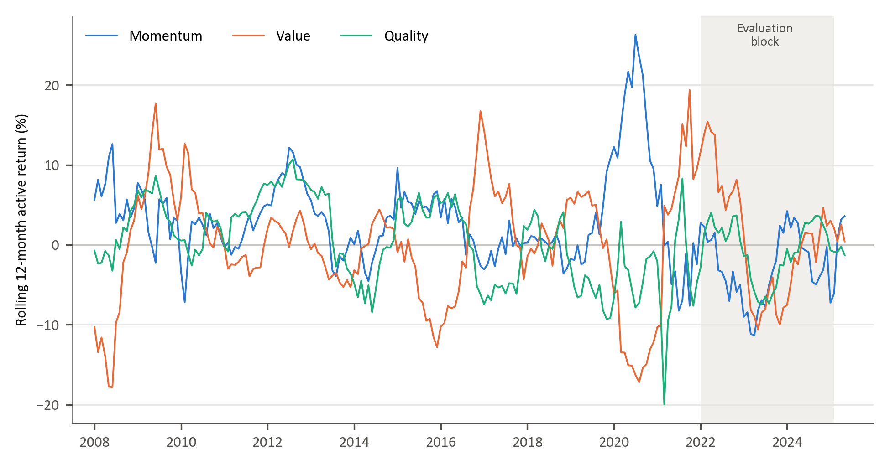
Figure 1: Rolling 12-month active returns of the momentum, value and quality factors
Table 1 reports the correlations of monthly returns. In raw terms the three factors are highly correlated (0.79 to 0.87), because each is a long-only portfolio that shares the market’s exposure (correlations of 0.91 to 0.93 with the benchmark). Measured against the benchmark, the correlations fall to between −0.37 and 0.02: momentum and value active returns are negatively correlated (−0.37), while quality is close to uncorrelated with both. Figure 2 shows that these relationships are not stable. The 36-month correlation between momentum and value active returns ranges from −0.69 to 0.42, and the correlations involving quality range from −0.59 to 0.66 and change sign repeatedly. Splitting the sample by the sign of the benchmark return (84 of 220 months are negative) changes the correlations little, so the convergence of styles in falling markets described above is not evident in these monthly South African data.
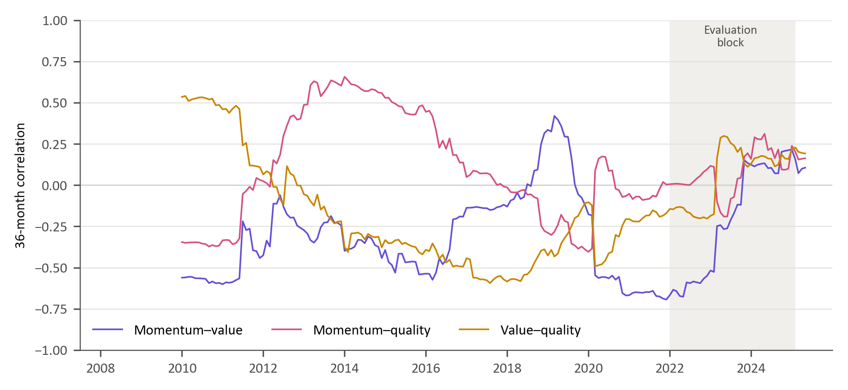
Figure 2: Rolling 36-month correlations of active returns
Table 1: Correlations of monthly factor returns
Factor pair | Raw returns | Active returns | Active, benchmark down | Active, benchmark up | Rolling 36-month range (active)
Momentum–value | 0.79 | −0.37 | −0.39 | −0.35 | −0.69 to 0.42
Momentum–quality | 0.84 | 0.02 | 0.00 | 0.02 | −0.40 to 0.66
Value–quality | 0.87 | −0.04 | −0.06 | −0.02 | −0.59 to 0.54
Note: monthly data, February 2007 to May 2025; the models use weekly data (Section 3.4). Down and up months are defined by the sign of the monthly benchmark return. In Figures 1 and 2, the shaded period is the walk-forward evaluation block.
This time-varying correlation structure implies that absolute factor forecasting may obscure economically relevant rotation dynamics. Modelling the relative performance of factor pairs instead captures style rotation directly and isolates structural transitions in market leadership.
In addition to economic distinctness, modelling relative factor performance offers potential statistical advantages. Because style factors share exposure to common market-wide shocks, differencing factor returns may partially attenuate systematic noise components, isolating cross-style rotation dynamics. This relative performance based representation is conceptually aligned with long-short factor construction in asset-pricing theory and empirical evidence that relative valuation spreads and factor momentum exhibit cyclical persistence (Fama & French, 1993; Arnott, Kalesnik, & Linnainmaa, 2023) . Consequently, relative factor series may exhibit more stable regime-dependent structure than absolute factor returns, potentially enhancing predictability.
For investment managers, predicting which factor is likely to outperform can inform the direction of a tilt between styles without requiring a precise forecast of either factor’s return over the investment period. The study therefore focuses on identifying changes in relative factor leadership as an input to allocation decisions.

Data sources
The empirical analysis uses weekly observations from 5 March 2007 to 31 March 2025, a total of 944 weeks. The modelling targets are derived from the weekly relative returns of the three factor pairs, computed from the factor returns defined in Section 3.2. The candidate predictors span market-based, macroeconomic and fundamental data. Section 3.6 describes how they are screened and selected, and Appendix A defines each feature.

Trend-scanning target label construction
Relative factor timing aims to identify periods in which one factor outperforms the other, which makes it a binary classification task. This framing helps mitigate statistical challenges inherent in financial time-series data. In particular, financial returns are typically characterised by heavy-tailed distributions and low signal-to-noise ratios, conditions under which classification-based approaches can provide more stable predictive performance than direct return regression (Cotturo, Liu, & Proner, 2024; Dixon, Klabjan, & Bang, 2017).
To convert the relative return series into binary targets, we apply the trend-scanning method introduced by López de Prado (2020). Trend scanning identifies trends over the target variable by scanning forward across a range of time horizons to fit a regression line that identifies the dominant price movement. A key advantage of trend scanning is that it does not impose an arbitrary, fixed prediction horizon. A critical limitation in fixed horizons is the implicit assumption that the most significant points occur exactly at the end of the fixed interval, missing important information occurring between the set points (López de Prado, 2020).
We start the trend-scanning procedure by transforming weekly returns into a relative return series for each factor pair. For each distinct pair of factors $i$and $j,$the weekly relative return series is defined as:
$$R_{i,j,τ}= R_{i,τ}-R_{j,τ}$$ | ( 1 )
To extract meaningful directional trends, the returns are compounded to form a cumulative relative performance series:
$${CR}_{i,j,t}= \prod_{τ≤t}{\left(1+R_{i,j,τ}\right)}$$ | ( 2 )
For each observation date, a range of forward windows $h ∈\left[1,H\right]$ is evaluated. There is no prescriptive method to pick the maximum lookahead period. For our analysis, we set the maximum look-ahead window at $H=11$weekly observations. The choice was balanced on two considerations: economic relevance, where we ensure that the window is large enough to capture meaningful price trends avoiding excessively short-term, noisy signals; and data preservation given that longer look-ahead windows reduce the sample size during model training once purging is applied to prevent look-ahead bias. Each candidate window starts at the observation date t and contains h weekly observations, so the longest window uses cumulative relative returns up to t + 10. Windows with fewer than three observations do not provide a defined slope t-statistic; invalid statistics are replaced by zero for endpoint selection.
For each candidate horizon, a linear regression is estimated on the cumulative relative return series over the forward window:
$$C_{i,j,t+h}=α+ β_{h}t+ ε$$
The dominant trend is defined by the look-ahead window ${(h}_{t}^{*})$that yields the highest absolute t-statistic of the regression slope$(β_{h})$. The binary label is then assigned according to the sign of the slope at the optimal horizon:
$$Y_{i,j,t}=\left\{\begin{aligned}1, &if {\hat{β}}_{t,h_{t}^{*}}>0 \\ 0, &if {\hat{β}}_{t,h_{t}^{*}}<0 \end{aligned}\right.$$ | ( 3 )
We apply this to each factor pair, so that every observation with a resolved trend receives a binary label for the dominant relative trend at that point in time.
Because the labels look ahead, the information sets of training and evaluation samples can overlap. Section 3.8 describes the 12-week purge and embargo that limit this leakage, and the one exception at the initial tuning boundary (López de Prado, 2018). Labels that cannot be resolved because the sample ends inside the look-ahead window (the final ten weekly observations) are discarded rather than forward-filled.

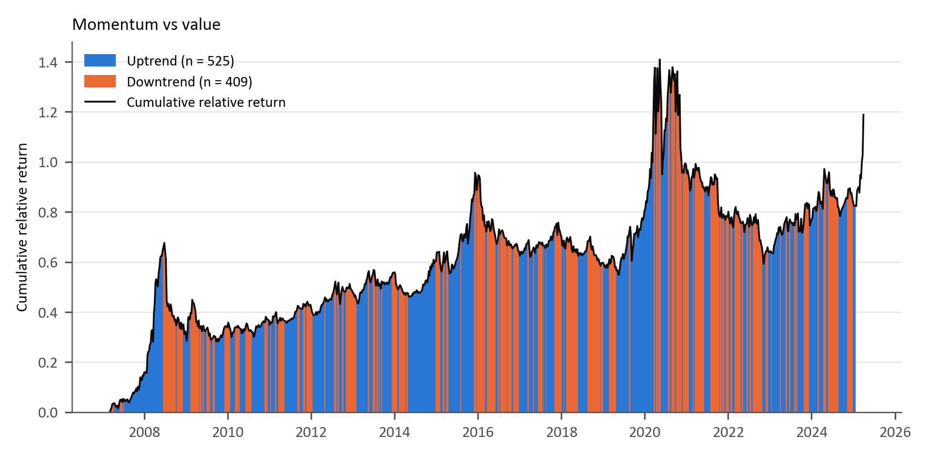
Figure 3: Trend-scanning labels for momentum versus value
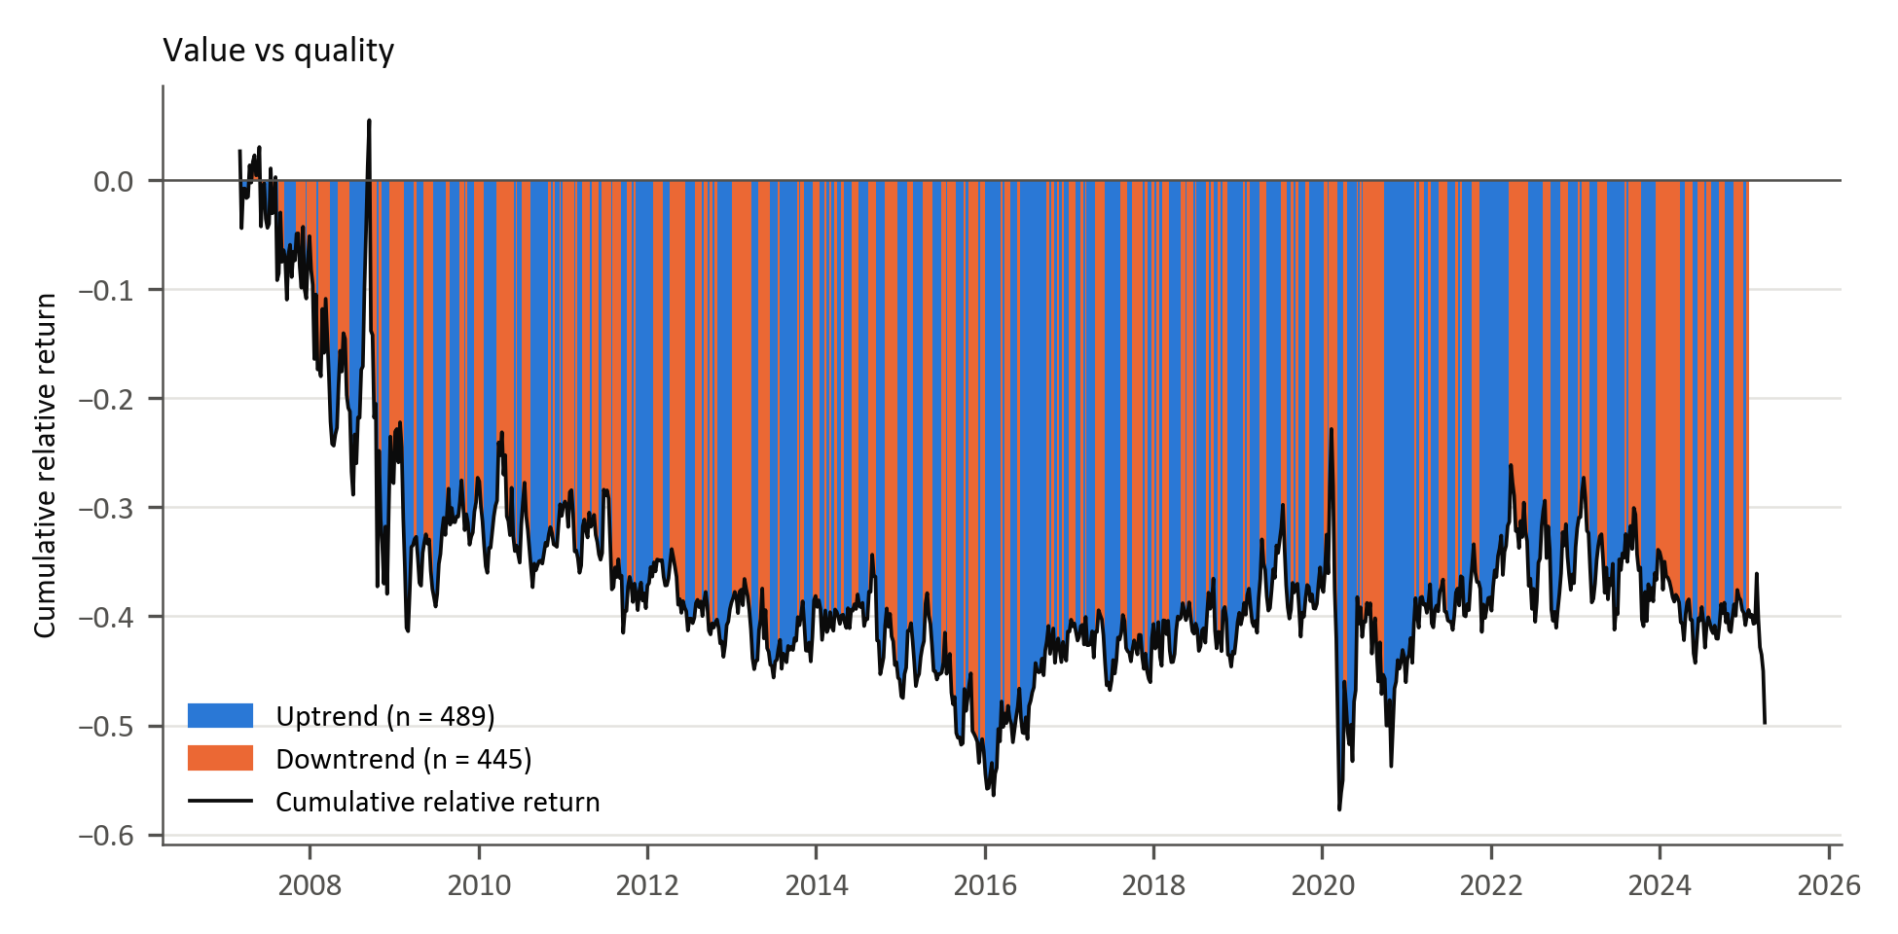
Figure 4: Trend-scanning labels for value versus quality
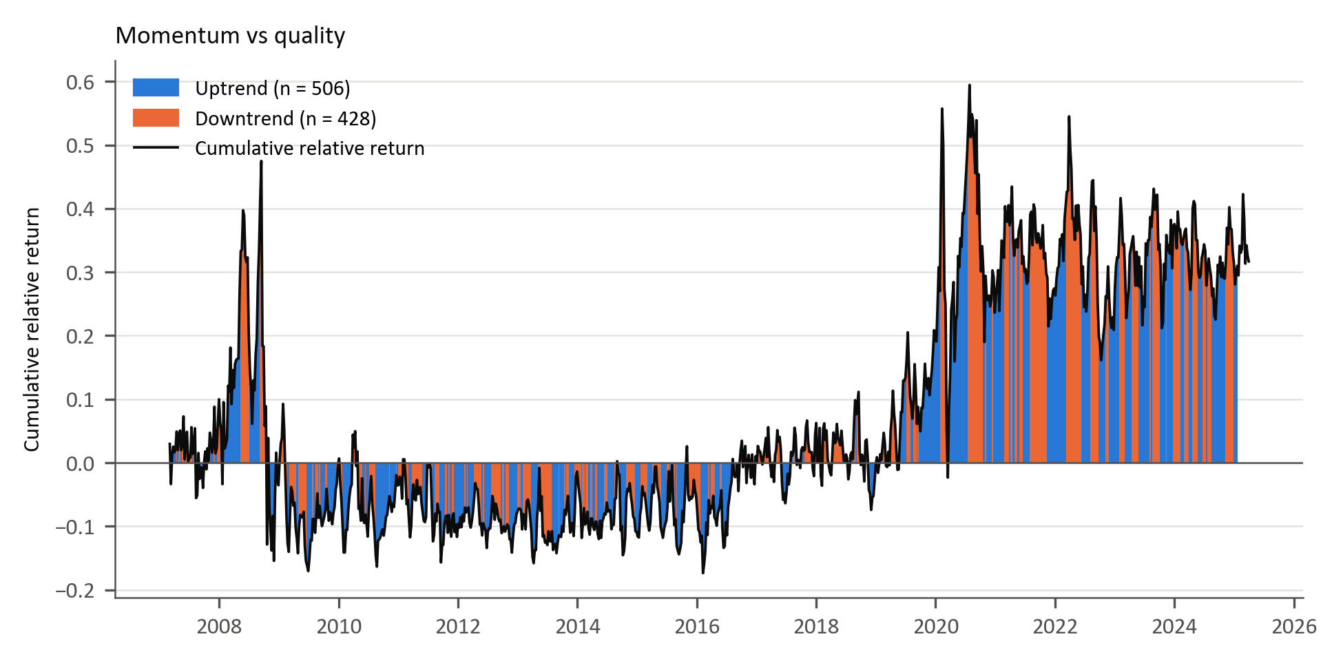
Figure 5: Trend-scanning labels for momentum versus quality
Figures 3 to 5 show the labels on the cumulative relative return of each pair (Equation 2), the series to which trend scanning is applied; the final weeks, whose labels cannot be resolved, are unshaded.

Feature selection
Section 2.1 noted that the proliferation of proposed predictors, the ‘factor zoo’ (Cochrane, 2011), raises the risk of redundant and spurious signals, and Section 2.2 that many correlated predictors make estimates unstable. The candidate set in this study contains 359 features in the categories summarised in Table 2, chosen on the basis of prior evidence (Gu, Kelly, & Xiu, 2020; Han, 2024; Cakici, Fieberg, Metko, & Zaremba, 2023; Fang, Chen, & Ren, 2022; Saetia & Yokrattanasak, 2022). This is too many to estimate reliably from 919 labelled weekly observations per factor pair, so the set is reduced in two steps: a missing-value screen and mutual-information clustering.
The missing-value screen removes the 15 candidates with more than 30% of weekly observations missing, mainly rand implied-yield and implied-volatility series that begin between 2013 and 2018, leaving 344 (Appendix B, Tables B.1 and B.2). The clustering routine treats the final column of the feature file as a target and so omits one of these, LocalGlobalPEFwdSpreadQS; 343 features are therefore clustered. Including it changes one of the 32 selected representatives (Appendix B, Tables B.5 and B.6), and the models were not re-estimated with the omission corrected.
The clustering is based on the mutual information (MI) between every pair of features: how much knowing one reduces uncertainty about the other, a measure that, unlike correlation, also captures nonlinear dependence (Kraskov, Stögbauer, & Grassberger, 2004; Cover & Thomas, 2006; Peng, Long, & Ding, 2005; Guyon & Elisseeff, 2003). Each pairwise MI value is converted to a distance, so that features carrying similar information lie close together, and these distances are then used twice. First, the features are grouped by hierarchical clustering with Ward linkage, which merges features and clusters step by step while keeping the variation within each cluster small (Ward, 1963; Hastie, Tibshirani, & Friedman, 2009). Like k-means, this produces compact clusters, but the number of clusters follows from where the resulting tree is cut rather than being fixed in advance; cutting the tree in Figure 6 at a height of 2 gives 32 clusters. Second, one representative is kept from each cluster: the feature with the lowest average MI distance to the other members, that is, the most central predictor in the cluster.
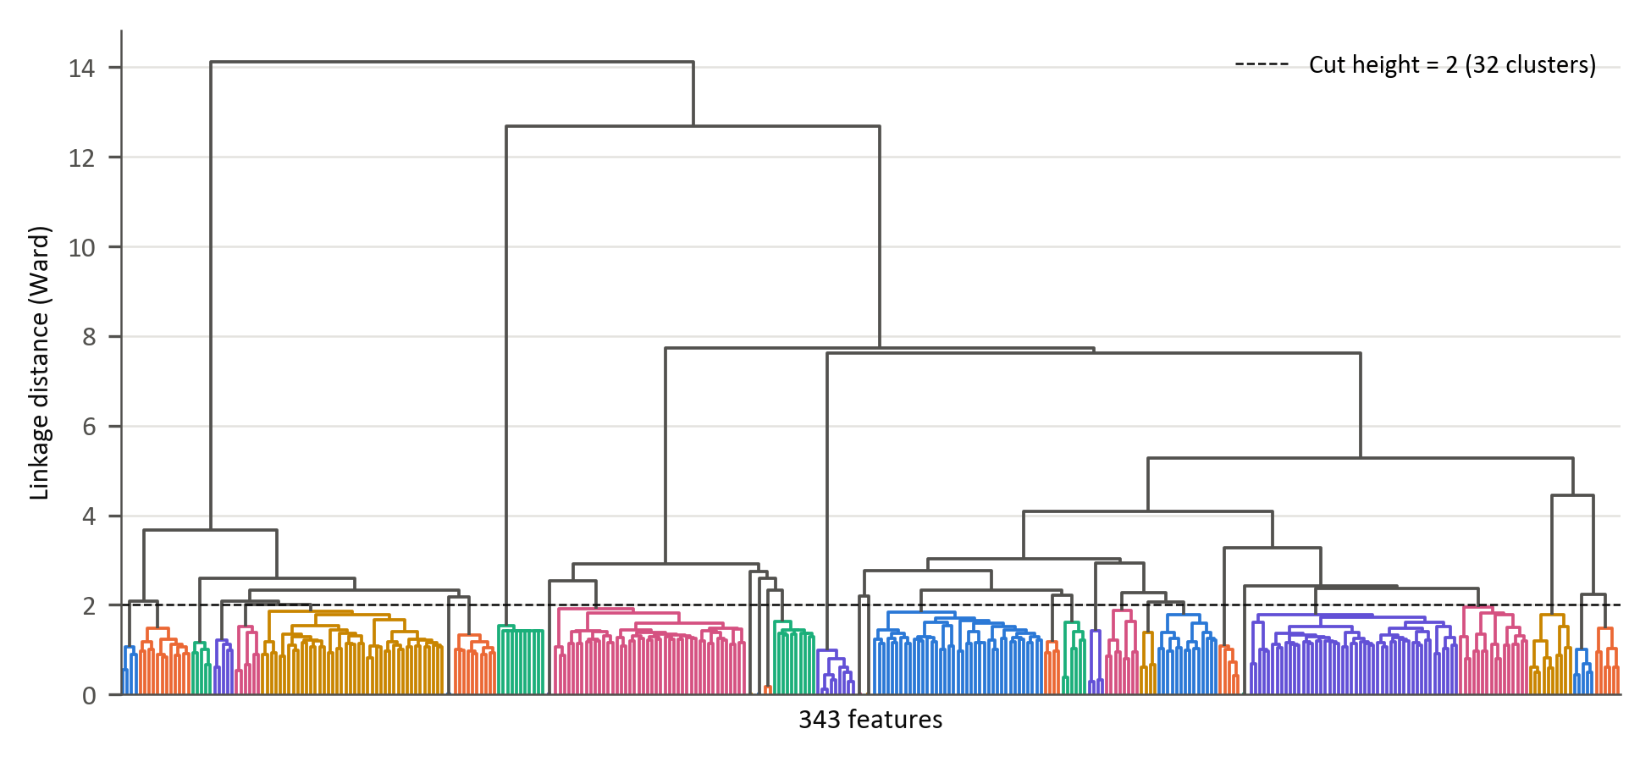
Figure 6: Hierarchical agglomerative clustering applied to the feature space
The selection uses no information about the classification labels. It is not fully real-time, however: the MI distances are estimated once, on the 680 weekly observations from 26 March 2012 to 31 March 2025 for which all screened features are available. Because this window includes the evaluation period, the fixed selection reflects the later distribution of the predictors.
To the 32 representatives, 18 relative-factor features are added by design. They measure the pairwise relative performance, co-movement and relative volatility of the three factors, which bear directly on the timing objective, so they are kept rather than pruned for redundancy. This gives the 50 predictors summarised by category in Table 2.
Table 2: Summary of the 50 modelling features by category
Feature category | Features | Examples | Economic rationale | Evidence
Price-based features | 9 | Volatility term-structure components; USDZAR and EURUSD implied volatility; global bond and property volatility; gold price measures | Uncertainty and risk-on/risk-off conditions | Gu et al. (2020); Daniel & Moskowitz (2016)
Fundamental | 6 | JSE and MSCI World fundamental components; TOP40 price-to-book and price-to-EBITDA; JSE price-to-sales; MSCI World price-to-earnings | Valuation spreads and expected mean reversion | Cakici et al. (2023)
Sentiment indicators | 8 | US consumer confidence; commodity index component; gold structural-break, complexity, skewness and kurtosis measures; global equity trend and entropy | Investor risk appetite and shifts in uncertainty | Saetia & Yokrattanasak (2022)
Macroeconomic | 9 | SA and US yield-curve curvature; SA yield-curve slope; SA CDS slope; rand PPP valuation; energy prices; USDZAR forward pricing and entropy | Growth expectations, policy stance and sovereign risk | Fang et al. (2022)
Factor-specific performance | 12 | 1- and 3-month relative momentum, 12-week correlation and standardised 12-week relative return, each for the three pairs | Persistence and rotation in style leadership | Gu et al. (2020); Daniel & Moskowitz (2016)
Factor-specific volatility | 6 | 12-week relative volatility and volatility ratio, each for the three pairs | Instability in relative performance | Gu et al. (2020); Daniel & Moskowitz (2016)
Total | 50 | 32 cluster representatives (first four rows) and 18 relative-factor features added by design (last two rows)
Note: Appendix A defines each feature, and Table B.8 in Appendix B lists every feature with its rationale and supporting evidence.

Data pre-processing
The 50 selected features are prepared for modelling in three steps, following established practice in empirical finance and financial machine learning (Campbell, Lo, & MacKinlay, 1997; López de Prado, 2018):
- Lagging: To limit forward information leakage, all features are lagged by four weekly observations (approximately one month) relative to the target.
- Temporal alignment: Monthly macroeconomic and fundamental series are aligned to the most recent prior weekly date and carried forward within the month.
- Imputation: Remaining gaps are forward-filled; gaps before a series’ first observation are back-filled.
The resulting feature matrix contains 929 weekly observations. Of the 944 weeks in the sample (Section 3.4), the 12-week rolling windows of the relative-factor features remove the first 11 (944 − 11 = 933), and the four-week lag removes a further four (933 − 4 = 929), so the matrix begins on 18 June 2007. Trend-scanning labels cannot be resolved for the final ten weeks, leaving 919 labelled observations per factor pair (18 June 2007 to 20 January 2025). These steps limit, but do not eliminate, forward information leakage: the lag does not establish when each value was published, the source data may contain later revisions, and back-filling uses later values at the start of some series.

Model training

The objective function
All three models classify whether the first-named factor in each pair will outperform the second, given prevailing market and economic conditions. Each model estimates the conditional probability of relative factor outperformance defined as:
$$P(y_{t}=1|X_{t})$$ | ( 4 )
This is achieved by producing a probability score between zero and one:
$${\hat{p}}_{t}∈[0,1]$$ | ( 5 )
A factor timing signal is generated when the probability is at least a threshold $(τ)$, fixed at 0.5 for all models and factor pairs rather than calibrated:
$${\hat{y}}_{t}=1\{{\hat{p}}_{t}≥τ\}$$ | ( 6 )

Logistic regression
The simplicity and direct interpretability of linear models have contributed to their significance in finance. Logistic regression provides a transparent economic interpretation of how each predictor influences the likelihood of factor outperformance. The model assumes that the log-odds of a binary outcome are a linear function of the predictors (Hosmer, Lemeshow, & Sturdivant, 2013; James, Witten, Hastie, & Tibshirani, 2021):
$$logit\left(P\left(y_{t} | X_{t}\right)\right)=\ln\left(\frac{P\left(y_{t} | X_{t}\right)}{1-P\left(y_{t} | X_{t}\right)}\right)= β_{0}+X_{t}^{T}β$$ | ( 7 )
Here, $β_{0}$ is the intercept term and $β∈R^{p}$ is a vector of coefficients measuring linear impact of each feature on the log-odds. To obtain a predicted probability from the linear predictor, the inverse of the logit, known as the logistic (sigmoid) function, is used:
$${\hat{p}}_{t}=σ\left(β_{0}+X_{t}^{T}β\right)= \frac{1}{1+e^{-(β_{0}+X_{t}^{T}β)}}$$ | ( 8 )

Model parameters $\left(β_{0}, β\right)$are estimated by minimizing the penalized log-likelihood function.
$$L(β)=\sum_{t∈D_{train}}{w_{t}}\left[-y_{t}\log{{\hat{p}}_{t}}-\left(1-y_{t}\right)\log{(1-{\hat{p}}_{t})}\right]+ λ\left(α∥β∥_{1}+\frac{1-α}{2}∥β∥_{2}^{2}\right)$$ | ( 9 )
where $λ≥0$ controls overall regularization strength and $α∈[0,1]$ sets the mix of LASSO (L1) and ridge (L2) penalties. This elastic-net penalty, common in financial applications, limits overfitting, mitigates multicollinearity and stabilises the estimates (Zou & Hastie, 2005; Tibshirani, 1996; Gu, Kelly, & Xiu, 2020).
The model is fitted with the elastic-net logistic regression of the scikit-learn Python library (Pedregosa et al., 2011), which minimises Equation (9) with unit observation weights, C = 1/λ and l1_ratio = α, without penalising the intercept. Coefficients are estimated with the saga solver, which supports the elastic-net penalty (Defazio, Bach, & Lacoste-Julien, 2014), and every fit converged within the iteration limit. Predictors are standardised with a scaler fitted on the training window only. The solver settings and the grid for α and λ are given in Table 4.

Generalized additive models (GAMs)
Generalized Additive Models (GAMs) introduced by (Hastie & Tibshirani, 1986) extend generalised linear models by introducing nonlinear transformations of the original predictors as new additive terms in an otherwise linear model. The GAM specification for binary classifications structurally resembles that of the logistic regression. Using the logit transformation, the conditional probability of outperformance is given by:
$$g\left(P\left(y_{t}=1|X_{t}\right)\right)= β_{0}+\sum_{i=1}^{p}{s_{i}(X_{t,i})}$$ | ( 10)
$β_{0}$ is the intercept term and each $s_{i}(.)$ is a smooth, potentially nonlinear function capturing the marginal effect of predictor $(X_{t,i})$ (Hastie & Tibshirani, 1986). The predicted probability for classification is given by:
$${\hat{p}}_{t}=σ\left(β_{0}+ \sum_{i=1}^{p}{s_{i}\left(x_{t,i}\right)}\right)$$ | (11)
Each smooth $s_{i}(.)$ is represented via a basis expansion: $s_{i}\left(x\right)=B_{i}{(x)}^{T}θ_{i}, B_{i}\left(x\right)∈R^{k_{i}}$,
$B_{i}\left(x\right)$ is a vector of spline basis function, which control the functional relationship between a predictor variable and a conditional response, whose coefficients $\left\{θ_{i}\right\}$ must be estimated. The size of the basis expansion limits the smoothing spline’s potential complexity with a larger set of basis functions allowing greater flexibility. We use cubic splines with $k_{i}$ basis functions per smooth term. Given that each spline $s_{i}(.)$ can be visualised independently, spline bases enable GAMs to model nonlinearity while maintaining additive interpretability (James, Witten, Hastie, & Tibshirani, 2021). The number of basis functions is common to all smooth terms and is selected from {4, 5, 7, 10} (Table 4).
We estimate the coefficients $\left\{θ_{i}\right\}$ and $β_{0}$ by minimizing:
$$L\left(S\right)=\sum_{t∈D_{train}}{w_{t}\left[{-y}_{t}\log{{\hat{ p}}_{t}}-\left(1-y_{t}\right)\log{(1-{\hat{p}}_{t})}\right]}+ \sum_{i=1}^{p}{λ_{i}θ_{i}^{T}S_{i}θ_{i}}$$ | (12)

The smoothness of the spline is controlled by a smoothing penalty $(λ_{i})$ and ${(S}_{i})$ is the spline penalty matrix (Hastie & Tibshirani, 1986). We use the pygam library from python to implement this GAM model. In the implementation, a single smoothing penalty λ is applied to all smooth terms and selected by cross-validation, and predictors are standardised within each training window, as for logistic regression.

Extreme gradient boost (XGBoost)
Tree-based ML models are non-parametric and use logic that departs markedly from traditional econometric models to capture nonlinearities within the data. These models build on the concept of decision trees, where binary groups are created by grouping observations with similar characteristic. They use a hierarchical tree structure that partitions the predictor space by recursively selecting features and splits that maximize a set improvement criterion such as information gain, entropy reduction, Gini reduction, or variance reduction depending on the task (Breiman, Friedman, Olshen, & Stone, 1984; Hastie, Tibshirani, & Friedman, 2009). This process ensures that the most informative features for predicting the target are placed higher in the tree structure.
Although decision trees are intuitive, single classification and regression trees (CART) easily overfit (Hastie, Tibshirani, & Friedman, 2009; Breiman, Friedman, Olshen, & Stone, 1984; Gu, Kelly, & Xiu, 2020). Ensemble methods like bagging and boosting address this shortcoming by combining multiple weak learners (Friedman, 2001; Breiman, 1996). This study uses boosting, in which the weak learners are added sequentially. XGBoost constructs an additive model of the form:

$$F_{M}\left(X_{t}\right)=\sum_{m=1}^{M}{f_{m}\left(X_{t}\right), } f_{m}∈F$$ | (13)
where each $f_{m}$ is a single CART (Chen & Guestrin, 2016). For binary classification, the ensemble output is mapped to probabilities using the logistic sigmoid function given by:
$${\hat{p}}_{t}= σ\left(F_{M}\left(X_{t}\right)\right), σ\left(x\right)= \frac{1}{(1+e^{-x})}$$ | (14)

At each boosting iteration $(m)$, we aim to minimize:
$$L^{(m)}=\sum_{t∈D_{train}}{w_{t}}l\left(y_{t},{\hat{p}}_{t}^{\left(m-1\right)}+f_{m}\left(X_{t}\right)\right)+Ω\left(f_{m}\right)$$ | (15)
Where the logistic loss function defined as:
$$l\left(y,p\right)=-y\log{p}-\left(1-y\right)\log{(1-p)}$$ | (16)
and tree regularization function given by:
$$Ω\left(f\right)=γT+\frac{λ}{2}\sum_{j=1}^{T}{w_{j}^{2}}$$ | (17)
$(T)$ is the number of leaves and ${(w}_{j})$ the leaf weight. Each tree is trained to fit the residuals of the previous iteration, allowing the ensemble to progressively correct its errors. In this study, the XGBoost model is trained using the xgboost Python library with 500 boosting rounds and the binary logistic objective. Because tree splits are unaffected by monotonic transformations, predictors are not standardised for XGBoost. This implementation executes the theoretical additive tree-boosting framework described (Chen & Guestrin, 2016).

Table 3: Model comparison
Model | Model Complexity | Interpretability | Strengths | Limitations / Risks | Key Hyperparameters | References
Logistic Regression | Low | High | Transparent coefficients (economic interpretability); | Misses nonlinearities; | Maximum iterations (max_iter) | (Hosmer, Lemeshow, & Sturdivant, 2013);  (Zou & Hastie, 2005)
Logistic Regression | Low | High | Efficient with small samples; | Sensitive to multicollinearity; | Regularization strength (λ)
Logistic Regression | Low | High | Robust to noise with regularization | Limited predictive power in complex regimes | L1/L2 mixing ratio (α)
Logistic Regression | Low | High |  |  | Solver tolerance (tol)
Generalized Additive Model (GAM) | Moderate | Moderate–High | Captures smooth nonlinear effects; | Cannot easily model interactions; | Number of splines (n_splines) | (Hastie & Tibshirani, 1986);  GAM formulation  (Wood, 2017);  (Gu, Kelly, & Xiu, 2020)
Generalized Additive Model (GAM) | Moderate | Moderate–High | Retains partial interpretability; | Computationally heavier; | Smoothness penalty (λ_i)
Generalized Additive Model (GAM) | Moderate | Moderate–High | Controls overfitting via smoothing penalty | Requires careful selection of smoothing parameters | Maximum iterations (max_iter)
Extreme Gradient Boosting (XGBoost) | High | Low | Captures high-order nonlinearities and interactions; | Reduced interpretability; | Learning rate (η) | (Friedman, 2001);  (Chen & Guestrin, 2016);  (Krauss, Do, & Huck, 2017)
Extreme Gradient Boosting (XGBoost) | High | Low | Inherent feature selection via splits | Prone to overfitting without tuning; | Maximum tree depth (max_depth)
Extreme Gradient Boosting (XGBoost) | High | Low |  | Sensitive to hyperparameter configuration | Subsample ratio (subsample)
Extreme Gradient Boosting (XGBoost) | High | Low |  |  | Minimum child weight (min_child_weight)
Extreme Gradient Boosting (XGBoost) | High | Low |  |  | L2 regularisation (λ)

Hyperparameter tuning and model validation
Robust evaluation of predictive performance in financial time series requires validation procedures that explicitly account for temporal dependence, non-stationarity, and overlapping information sets (Campbell, Lo, & MacKinlay, 1997; Gu, Kelly, & Xiu, 2020). Conventional k-fold cross-validation assumes independent and identically distributed observations and therefore risks severe information leakage when applied to time-ordered financial data (Bergmeir & Benítez, 2012; López de Prado, 2018). To address these challenges, model tuning and evaluation are implemented using a two-stage validation architecture. Firstly, combinatorial purged cross-validation (CPCV) is used exclusively for hyperparameter optimisation within the training windows (López de Prado, 2018; López de Prado, 2020). Then, the optimised parameter set is used in the walk-forward validation to assess out-of-sample predictive performance.

Combinatorial purged cross-validation
The choice of hyperparameters controls the model’s complexity, limiting the potential for overfitting.
CPCV generates multiple unique combinations of training and validation splits, ensuring that each split is used for validation the same number of times. The combinatorial equation is used to calculate the exact number of training/validation combinations required to construct a set of back-testing paths. A back-testing path chronologically orders the validation predictions from the different CPCV combinations to form one continuous out-of-sample time series. In our case, the number of validation splits and the total number of splits are given by $k=2$ and $N=5$ respectively.

CN,k= Nk | (18)

ϕN,k=kNNN-k | (19)
With N = 5 and k = 2, Equation (18) gives C(5, 2) = 10 training–validation combinations. Each split is used for validation in four of them, and Equation (19) gives φ[5, 2] = 4 back-test paths: path j takes, for every split, the validation predictions from the j-th combination in which that split is used for validation (Figure 7). Hyperparameters are selected on the mean ROC-AUC of the ten combinations, each computed from the predictions of a single fitted model; the ROC-AUCs of the four paths are reported in Appendix C and are not used for selection.
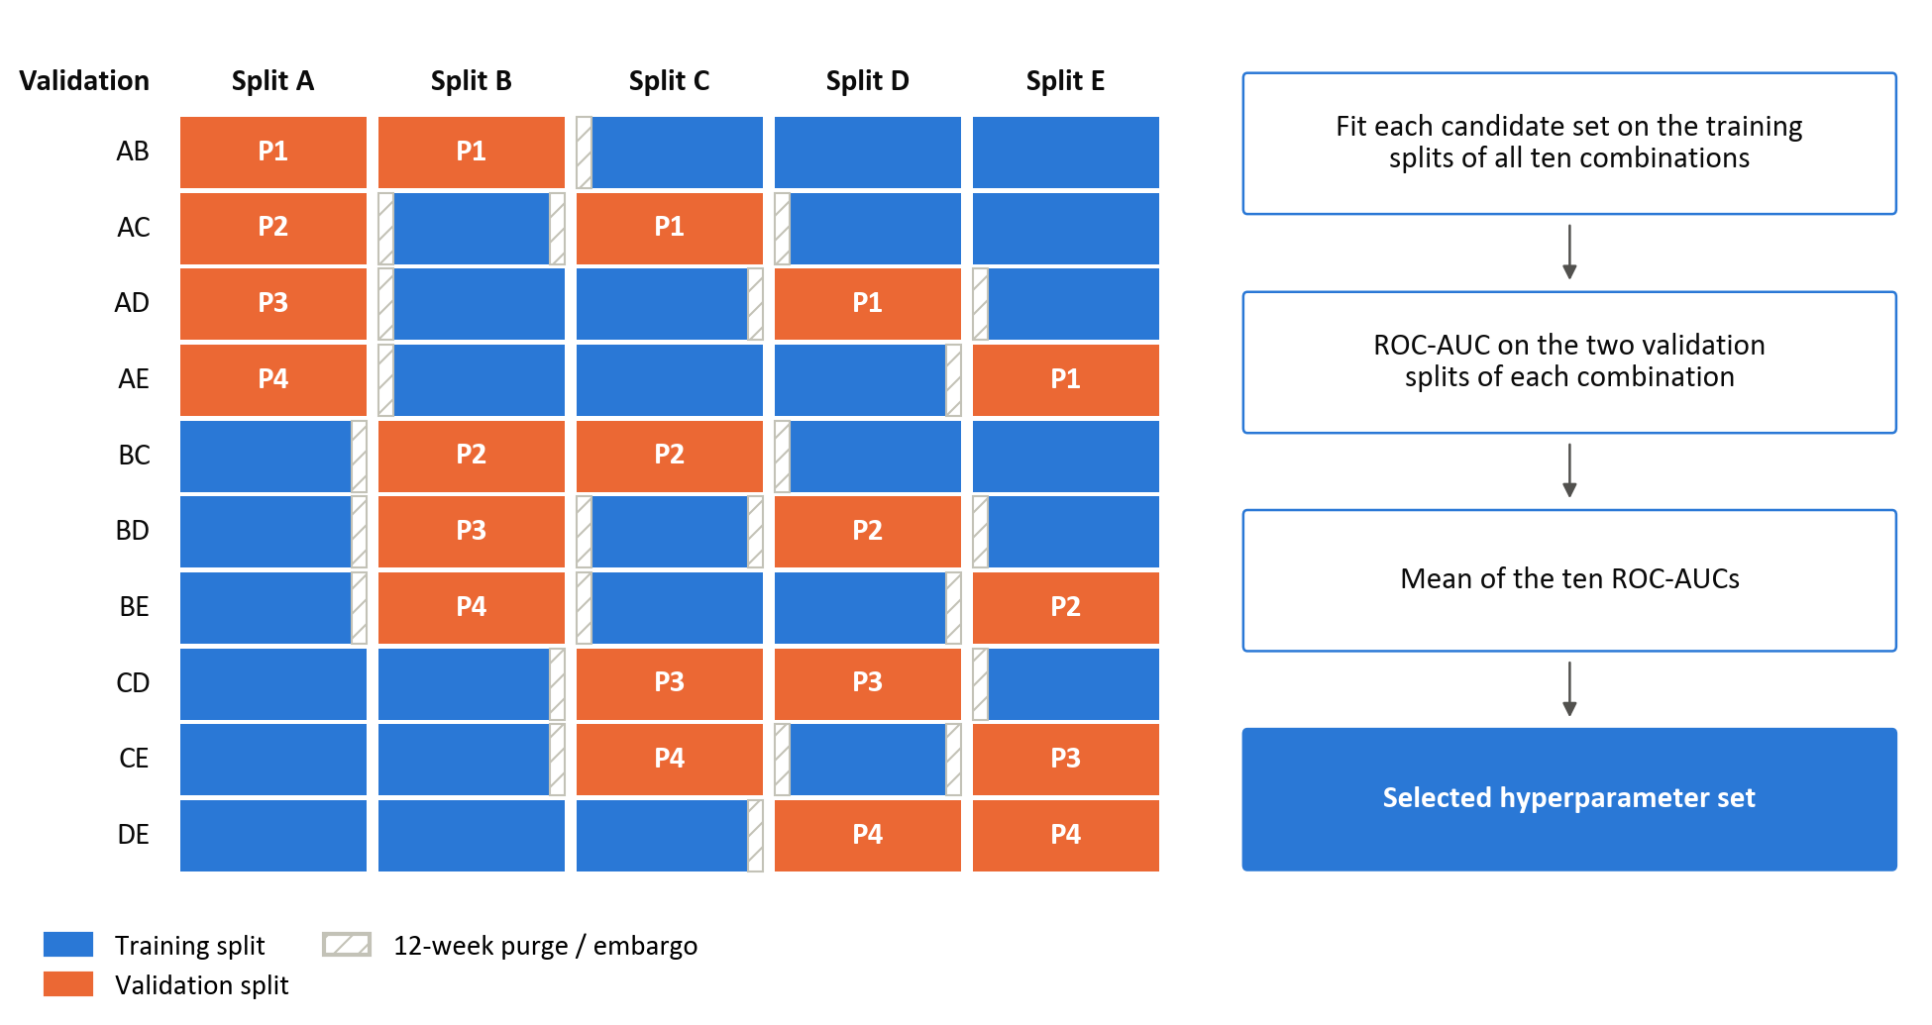
Figure 7: CPCV with N = 5 chronological splits and k = 2 validation splits, giving ten combinations and four back-test paths
In Figure 7, each row is one combination: the orange blocks are its two validation splits, the blue blocks its training splits, and the hatched strips the 12-week purge and embargo around each validation split. The label on each validation split gives the back-test path (P1 to P4) to which its predictions are assigned; path P1, for example, takes splits A and B from combination AB, split C from AC, split D from AD and split E from AE.
To ensure that the validation set performance is still a good proxy for the performance on unseen data, samples in the validation set need to be reasonably independent from those in the training set. López de Prado (2018) addresses this by removing any training data whose information horizon overlaps with the validation set (i.e. purging). A 12-week purge before each validation split and a 12-week embargo after it exceed the ten-week label horizon (Section 3.5). A candidate set that cannot be fitted on all ten combinations is excluded (Appendix C). The initial search uses the 763 observations before the evaluation block, with predictors standardised on the whole sample and no purge at its boundary, so the labels of its last ten observations may draw on the first weeks of the evaluation block. Later searches use the purged training window then available (Section 3.8.2).
Table 4: Hyperparameter search grids
Model | Parameter combinations | Key hyperparameters | Tuning parameter grid
Logistic | 18 | L1/L2 mixing ratio (α) | [ 0 , 0.5 , 1 ]
Logistic | 18 | Regularisation strength (λ) | [ 0.01 , 0.1 , 1 , 10 , 100 , 1000 ]
Logistic | 18 | Solver | saga (fixed)
Logistic | 18 | Maximum iterations | 100,000 (fixed)
Logistic | 18 | Convergence tolerance | 10⁻⁶ (fixed)
GAM | 20 | Number of splines | [ 4 , 5 , 7 , 10 ]
GAM | 20 | Smoothness penalty (λ) | [1, 10, 100, 1000, 10000]
GAM | 20 | Spline order | 3, cubic (fixed)
GAM | 20 | Maximum iterations | 1000 (fixed)
XGBoost | 216 | Learning rate (η) | [ 0.01 , 0.03 , 0.1 ]
XGBoost | 216 | Maximum tree depth | [ 2 , 3 , 4 ]
XGBoost | 216 | Minimum child weight | [ 5 , 10 , 20 ]
XGBoost | 216 | L2 regularisation (λ) | [ 1 , 10 , 100 , 1000 ]
XGBoost | 216 | Subsample ratio | [ 0.6 , 0.8 ]
Note: grids are searched exhaustively. XGBoost uses 500 boosting rounds, the binary logistic objective and a fixed random seed in every configuration.

Walk-forward validation
While CPCV reduces overlap between training and validation labels during hyperparameter selection, it does not fully replicate real-time deployment. Final performance is therefore assessed using an expanding-window walk-forward framework. Walk-forward validation repeatedly trains a model on past data and evaluates it on the observations that follow, which limits leakage and gives a more realistic assessment of forecasting ability.
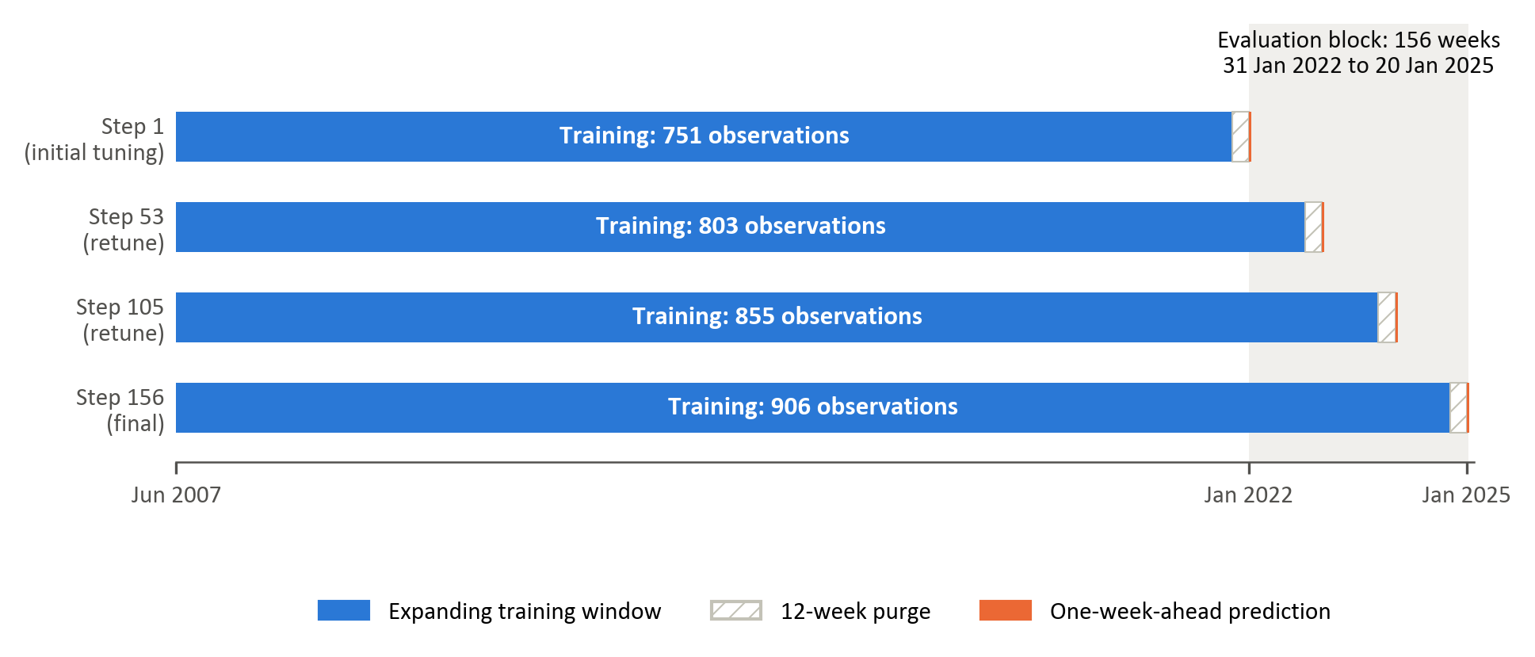
Figure 8: Expanding-window walk-forward validation with a 12-week purge and retuning every 52 predictions
At each iteration, models are trained on an expanding window containing every labelled observation up to 12 weeks before the prediction date, and then predict the forward trend label at the next evaluation date. The training window grows from 751 observations at the first prediction to 906 at the last. Hyperparameters are re-optimised every 52 predictions, balancing adaptation to structural changes in market conditions against sensitivity to transient fluctuations. They are therefore selected three times, before the first prediction and after the 52nd and 104th predictions, producing 156 weekly forecasts of variable-horizon trend labels from 31 January 2022 to 20 January 2025.

Performance evaluation
Model performance is evaluated along three complementary dimensions, directional accuracy, ranking ability and probability quality, supplemented by confusion-matrix analysis of classification errors. In financial settings characterised by heavy tails, regime shifts, and low signal-to-noise ratios, reliance on a single performance measure can be misleading. A multi-metric framework therefore improves robustness and interpretability (Dixon, Klabjan, & Bang, 2017; James, Witten, Hastie, & Tibshirani, 2021).

Directional accuracy, the proportion of correct classifications, reflects whether the model correctly identifies the leading factor within each pair (James, Witten, Hastie, & Tibshirani, 2021). While intuitive and directly interpretable from an allocation perspective, accuracy alone does not account for prediction confidence or ranking quality.
Accuracy is complemented by the confusion matrix, which cross-tabulates predicted and realised classes into true negatives (TN), false positives (FP), false negatives (FN) and true positives (TP) at the 0.5 threshold (Fawcett, 2006). The matrix shows whether errors are concentrated in one class. This matters here because a model that assigns most observations to one class can attain respectable accuracy while having little ability to identify the other. The share of observations predicted positive is therefore compared with the realised positive share, and confusion matrices are reported for every model and factor pair in Chapter 4.

To assess discrimination ability independently of any fixed decision threshold, the Receiver Operating Characteristic (ROC) curve is employed. The ROC curve evaluates the model’s capacity to assign higher predicted probabilities to periods of genuine outperformance than to underperformance periods. The Area Under the ROC Curve (ROC-AUC) summarises this discriminatory power on a scale between zero and one, where 0.5 corresponds to random classification (James, Witten, Hastie, & Tibshirani, 2021; Fawcett, 2006). Because it is also robust to moderate class imbalance, ROC-AUC is the selection criterion in the CPCV search (Section 3.8.1).

In addition to classification correctness and ranking ability, the quality of predicted probabilities is evaluated using log-loss. Log-loss penalises confident but incorrect predictions more heavily than uncertain misclassifications, thereby assessing overall probability quality rather than only the binary decision (Good, 1952; Gneiting & Raftery, 2007). Log-loss is not a pure calibration measure. Since the modelling framework produces probabilistic forecasts of relative factor outperformance, calibration quality is economically meaningful. Well-calibrated probabilities allow for flexible allocation rules, such as probability-weighted exposure adjustments, rather than simple binary switching between styles (Gneiting & Raftery, 2007; Dixon, Klabjan, & Bang, 2017; López de Prado, 2018). A constant forecast of 0.5 yields a log-loss of ln 2 ≈ 0.693, which serves as an uninformative reference value.

Improvements across all three measures provide stronger evidence of genuine predictive structure than improvements in any single metric alone. Nevertheless, statistical performance does not automatically imply economic profitability. A further translation of predictive signals into portfolio outcomes can be evaluated separately through risk-adjusted performance analysis, which falls outside the scope of this study. Because the evaluation block contains only 156 weekly observations and the labels are persistent, small differences in these point estimates are interpreted with caution.
Uncertainty in ROC-AUC and paired differences between models is assessed using a circular moving-block bootstrap of the saved labels and probabilities. The analysis uses 10,000 replications, blocks of 12 successive weeks and a random seed of zero. The same sampled dates are applied to every model and factor pair, preserving paired comparisons. The 2.5th and 97.5th percentiles of valid estimates form pointwise 95% intervals; single-class resamples have undefined AUC. Sensitivity checks use block lengths of 1, 6, 12 and 24 weeks. Models are not refitted in the bootstrap, so the intervals are conditional on the fitted pipeline and do not capture the full uncertainty from feature and parameter selection. Bootstrap proportions above a reference value are not automatically null-calibrated p-values.

Feature importance
The feature-importance analysis examines which predictors drive each model’s forecasts, whether the leading predictors belong to the economically motivated categories of Table 2, and whether the three models, and the three factor pairs, rely on the same information. Importance is measured with Shapley values from cooperative game theory (Shapley, 1953), as implemented in the SHAP framework (Lundberg & Lee, 2017; Lundberg et al., 2020).
Shapley values decompose each prediction into additive contributions from the features, relative to the model’s average prediction. A feature’s contribution is its marginal effect on the prediction, averaged over all combinations of the other features, so nonlinear and interaction effects are attributed to the features involved (Štrumbelj & Kononenko, 2010). Unlike split gain in tree models or the size of a regression coefficient, the measure is defined in the same way for every model (Joseph, 2019; Joseph, 2024).
The values are computed in log-odds space, the scale on which all three models produce their score before the logistic link is applied. They are computed once for each model and factor pair, for a model refitted with the initially selected hyperparameters on the 763 observations of the initial tuning sample (Section 3.8.1), and every observation of that sample is explained; the values therefore describe these refits rather than the 156 walk-forward models. For logistic regression they are exact: each contribution is the coefficient multiplied by the deviation of the standardised feature from its sample mean. For XGBoost, exact tree Shapley values are obtained with TreeSHAP (Lundberg et al., 2020). For the GAM, which has no specialised explainer, they are permutation estimates against 100 background observations drawn from the training sample, and so carry some approximation error (Štrumbelj & Kononenko, 2010).
A feature’s global importance is its mean absolute Shapley value over the explained sample: the average size of its contribution, regardless of direction. For each model and factor pair, the ten features with the largest global importance are reported, coloured by their category in Table 2. Because the explainers and the spread of the attributions differ between model classes, the models are compared by the ranking of their features rather than by the size of the values, and a feature that ranks highly in several models is treated as stronger evidence than one that leads a single model.

The attributions describe how the fitted models use the features, not causal effects, and a high ranking does not show that a feature carries stable out-of-sample information (Kumar et al., 2020; Molnar, 2022). Correlated features can share or exchange attribution, so closely related features, such as the two rand implied-volatility measures, are read together rather than as separate signals. For these reasons the rankings are interpreted as exploratory.

Reference additions and corrections
These entries support the highlighted citation corrections and additions. They supplement the submitted reference list; unchanged sources are retained in the thesis bibliography.
Cakici, N., Fieberg, C., Metko, D., & Zaremba, A. (2023). Machine learning goes global: Cross-sectional return predictability in international stock markets. Journal of Economic Dynamics and Control, 155, Article 104725. https://doi.org/10.1016/j.jedc.2023.104725.
Cochrane, J. H. (2011). Presidential address: Discount rates. The Journal of Finance, 66(4), 1047–1108. https://doi.org/10.1111/j.1540-6261.2011.01671.x
Daniel, K., & Moskowitz, T. J. (2016). Momentum crashes. Journal of Financial Economics, 122(2), 221–247.
Defazio, A., Bach, F., & Lacoste-Julien, S. (2014). SAGA: A fast incremental gradient method with support for non-strongly convex composite objectives. In Advances in Neural Information Processing Systems 27 (pp. 1646–1654). Curran Associates.
Fama, E. F., & French, K. R. (1993). Common risk factors in the returns on stocks and bonds. Journal of Financial Economics, 33(1), 3–56.
Fama, E. F., & French, K. R. (2015). A five-factor asset pricing model. Journal of Financial Economics, 116(1), 1–22.
Fawcett, T. (2006). An introduction to ROC analysis. Pattern Recognition Letters, 27(8), 861–874.
Gilbert, E. (2025). Factor fusion: Crafting the future of equity solutions. Mindfields: Factor fusion – Key elements for robust performance (February 2025), 20–27. Momentum Investments. https://sls-fresco.momentum.co.za/files/documents/invest/updates-and-news/from-the-experts/general/mindfields-february-2025.pdf
Gneiting, T., & Raftery, A. E. (2007). Strictly proper scoring rules, prediction, and estimation. Journal of the American Statistical Association, 102(477), 359–378.
Good, I. J. (1952). Rational decisions. Journal of the Royal Statistical Society: Series B, 14(1), 107–114.
Hastie, T., Tibshirani, R., & Friedman, J. (2009). The elements of statistical learning: Data mining, inference, and prediction (2nd ed.). Springer.
Hosmer, D. W., Lemeshow, S., & Sturdivant, R. X. (2013). Applied logistic regression (3rd ed.). Wiley.
Kumar, I. E., Venkatasubramanian, S., Scheidegger, C., & Friedler, S. (2020). Problems with Shapley-value-based explanations as feature importance measures. In Proceedings of the 37th International Conference on Machine Learning (Vol. 119, pp. 5491–5500). PMLR.
López de Prado, M. (2018). Advances in financial machine learning. Wiley.
López de Prado, M. (2020). Machine learning for asset managers. Cambridge University Press. https://doi.org/10.1017/9781108883658.
Lundberg, S. M., & Lee, S.-I. (2017). A unified approach to interpreting model predictions. In Advances in Neural Information Processing Systems 30. Curran Associates. https://proceedings.neurips.cc/paper_files/paper/2017/hash/8a20a8621978632d76c43dfd28b67767-Abstract.html
Lundberg, S. M., Erion, G., Chen, H., DeGrave, A., Prutkin, J. M., Nair, B., Katz, R., Himmelfarb, J., Bansal, N., & Lee, S.-I. (2020). From local explanations to global understanding with explainable AI for trees. Nature Machine Intelligence, 2(1), 56–67. https://doi.org/10.1038/s42256-019-0138-9.
Masongweni, V. (2025). Redefining factor portfolios in SA and global equity markets: Their existence and relevance. Mindfields: Factor fusion – Key elements for robust performance (February 2025), 6–14. Momentum Investments. https://sls-fresco.momentum.co.za/files/documents/invest/updates-and-news/from-the-experts/general/mindfields-february-2025.pdf
Molnar, C. (2022). Interpretable machine learning: A guide for making black box models explainable (2nd ed.). https://christophm.github.io/interpretable-ml-book/.
Pedregosa, F., Varoquaux, G., Gramfort, A., Michel, V., Thirion, B., Grisel, O., Blondel, M., Prettenhofer, P., Weiss, R., Dubourg, V., Vanderplas, J., Passos, A., Cournapeau, D., Brucher, M., Perrot, M., & Duchesnay, É. (2011). Scikit-learn: Machine learning in Python. Journal of Machine Learning Research, 12, 2825–2830.
Tibshirani, R. (1996). Regression shrinkage and selection via the lasso. Journal of the Royal Statistical Society: Series B, 58(1), 267–288.
Material for Appendix B: detailed feature classification
This is Table 1 of the submitted chapter, moved here at the supervisor’s suggestion; Section 3.6 now contains the summary in Table 2. It should be added to Appendix B as Table B.8, in a new section after B.5. Its content is unchanged except for the description of ZAR18M.Curncy_QS (highlighted), which is a forward-points series rather than an implied-volatility series.
Table B.8: Economic classification of the 50 modelling features
Feature Category | Feature | Economic Rationale | Empirical Findings
Price-based features | VolTermStructPC1 | - Captures level of volatility term structure - captures future uncertainty | (Gu et al., 2020)  Volatility consistently ranks among the most important ML predictors.  (Daniel & Moskowitz, 2016)  Momentum payoffs vary with market conditions.
Price-based features | VolTermStructPC2
Price-based features | GLD_FracDiff | - Local volatility provides a good signal for risk-on/risk-off environments.
Price-based features | GLD_RollSD
Price-based features | USDZARV1M.Curncy_QS
Price-based features | USDZARV1Y.Curncy_QS
Price-based features | GlobalBondVol6 | - Global volatility spills over across international markets.
Price-based features | GlobalPropertyVol12
Price-based features | EURUSDV6M.Curncy_QS
Fundamental | MXWD_Fundamental_PC1 |  | (Cakici, et al., 2023)  Value followed by momentum prove to be a crucial driver of stock prices globally
Fundamental | JALSH_Fundamental_PC1 | - Fundamental valuation measures (P/E, P/B, sales) capture expected mean-reversion in prices.
Fundamental | TOP40.Index.Price.to.Book.Ratio_Diff | - Book-to-price differentials identify undervalued vs overvalued stocks.
Fundamental | MXWD.Index.PE.Ratio_QS | - Sales-to-price ratio identifies cyclical undervaluation.
Fundamental | TOP40.Index.Price.to.Ebitda_Diff
Fundamental | JALSH.Index.Price.to.Sales.Ratio_Diff
Sentiment indicators | MichgnConcIndx | - Reflects household expectations and overall risk sentiment. | (Saetia & Yokrattanasak, 2022)  Technical financial indicators and sentiment indicators showed stronger predictive power than macro-economic indicators.
Sentiment indicators | GenComIndexPC1_QS | - Commodity PCA reflects global risk appetite, growth expectations, and inflation pressure.
Sentiment indicators | GLD_StructBreak | - Structural breaks in gold prices signal major shifts in global uncertainty.
Sentiment indicators | GLD_LempZiev
Sentiment indicators | GLD_RollSkew
Sentiment indicators | GLD_RollKurt
Sentiment indicators | GlobalEquityTS | - Captures momentum in investor optimism/pessimism.
Sentiment indicators | GlobalEquity_EntDyn | - Captures momentum in investor optimism/pessimism.
Macroeconomic | SA_RB_Curvature | - Yield curve curvature and slope reflects growth expectations and monetary policy stance (local and global) | (Fang, et al., 2022)  Factor predictability is macro-state dependent.
Macroeconomic | US_RB_Curvature
Macroeconomic | SA_NB_Slope
Macroeconomic | SA_CDS_Slope | - Credit spread slope proxies’ sovereign risk, economic stress, and funding conditions.
Macroeconomic | RandPPP_Factor_Inst_TS_ST | - Tracks widening and narrowing of rand valuation
Macroeconomic | PPP.ZA.Index_QS | - Rand valuation sits relative to its 5-year history.
Macroeconomic | BCMPEBLS.Index | - Captures global energy price dynamics
Macroeconomic | ZAR18M.Curncy_QS | - Captures medium-term USDZAR forward pricing, which reflects the rand–dollar interest-rate differential.
Macroeconomic | USDZAR_EntDyn | - Information content in FX markets
Factor-specific performance | mom1m_momentum_vs_quality | - Assets that have performed well in recent past tend to continue performing. | (Gu et al., 2020)  Momentum signals remain among the strongest predictors in both ML and traditional frameworks.  (Daniel & Moskowitz, 2016)  Momentum payoffs vary with market conditions.
Factor-specific performance | mom1m_momentum_vs_value
Factor-specific performance | mom1m_value_vs_quality
Factor-specific performance | mom3m_momentum_vs_quality
Factor-specific performance | mom3m_momentum_vs_value
Factor-specific performance | mom3m_value_vs_quality
Factor-specific performance | corr_momentum_quality_12 | - Measures co-movement between factors identifies convergence/divergence regimes.
Factor-specific performance | corr_momentum_value_12
Factor-specific performance | corr_value_quality_12
Factor-specific performance | zrel_value_vs_quality_12 | - Standardised relative performance useful for detecting style rotation.
Factor-specific performance | zrel_momentum_vs_quality_12
Factor-specific performance | zrel_momentum_vs_value_12
Factor-specific volatility | relvol_momentum_vs_quality_12 | - Identifies instability in factor relative performance
Factor-specific volatility | relvol_momentum_vs_value_12 | - Identifies instability in factor relative performance
Factor-specific volatility | relvol_value_vs_quality_12 | - Identifies instability in factor relative performance
Factor-specific volatility | volratio_momentum_quality_12 | - Measures volatility differential driving factor rotations.
Factor-specific volatility | volratio_momentum_value_12 | - Measures volatility differential driving factor rotations.
Factor-specific volatility | volratio_value_quality_12 | - Measures volatility differential driving factor rotations.

Amendment log for the submitted chapter
Highlighted text in the chapter marks amendments. Deletions cannot be highlighted, so they are listed here together with the reason for every change. Additional highlighted corrections in this review align citations with the supplied reference document, qualify remaining leakage and SHAP claims, restore the pairwise-definition symbols, correct the XGBoost grid count to 216 and document the saved block-bootstrap method. Reference entries are added or corrected separately above.
Section | Change | Reason / evidence
3.1 | Replaced 'to ensure statistical robustness and economic relevance'. | The design limits bias; it cannot ensure robustness, and economic value is not tested.
3.1 | Removed the claim that trend scanning reduces look-ahead bias. | Trend-scanning labels use future returns; leakage is controlled by purging, not by the labelling.
3.1 | Candidate feature count 'more than 450' changed to 359. | featureset.csv contains 359 candidate variables; Section 3.6 already says 'over 300'.
3.1 | Rolling window corrected to expanding window; retuning stated as every 52 predictions. | Final configuration (lookback=None, retune_every=52) in all three model notebooks.
3.1 | Added confusion matrices to the evaluation summary. | Supervisor comment; Chapter 4 reports them.
3.1 | Removed 'economic' dimension and softened 'directly addresses'. | No portfolio or after-cost test is performed (Section 3.9 states this is out of scope).
3.3 | Added the investment-management rationale for a directional target. | Supervisor comment.
3.4.1 | Candidate count (359) and modelling sample (919 per pair) made exact. | featureset.csv; labelled sample after dropping unresolved end labels.
3.4 | Removed empty paragraphs and an empty sub-heading left by an earlier move. | They would print as a blank numbered heading.
3.5 | Maximum window corrected from H = 12 to H = 11 observations (returns up to t + 10). | trend_scanning.ipynb uses span = (1, 12), i.e. windows of 1 to 11 observations.
3.5 | Purge/embargo description aligned with the code; unresolved end-of-sample labels now stated as dropped. | PURGE_GAP = 12 in CV and walk-forward; load_data() drops unlabelled rows.
3.5 | Figure 1 regenerated from the labels used by the models; cross-reference corrected (was 'Figure 2'). | Old figure showed 944 labels including forward-filled end labels; supervisor asked about rolling returns.
3.6 | Ward linkage described as applied to MI-distance profiles; threshold stated as a linkage height. | cluster_features() passes the square matrix to scipy linkage(), which treats rows as observations.
3.6 | Cross-reference corrected (was 'Figure 3'); disclosed that clustering uses the full 2012–2025 common sample of the candidate features. | feature_selection.ipynb forward-fills and then drops incomplete rows, leaving 680 weeks from 26 March 2012 (corrected in version 2).
3.6 / Figure 6 | Dendrogram redrawn in the thesis palette without the title; links below the cut height are coloured by cluster. The clustering is unchanged (Ward linkage, cut height 2, 32 clusters). | Consistent figure colours (user request). build_chapter3_figures.py, using the clustering code of appendix_b_feature_selection.py, which reproduces representatives.csv.
3.6.1 | Stated that the 30% missing-value screen precedes clustering and removed 15 features. | Supervisor question. featureset.csv has 15 columns above the 30% threshold (e.g. the ZARI*.Curncy_QS series), so the reply in the comment thread ('no features dropped') should be revisited.
3.6.1 | Explained how 929 is obtained and added the 919-observation modelling sample. | Supervisor question 'How did you calculate this value?'.
3.7.1 | Target described as pairwise (first-named vs second factor). | Each model is fitted to one factor pair, not one factor against the other two.
3.7.1 | Threshold stated as fixed at 0.5. | predict(threshold=0.5) in all three pipelines.
3.7.2 | Logistic regression re-estimated with scikit-learn’s elastic-net logistic regression (saga solver) in place of the custom gradient-descent function; solver settings stated, Table 4 updated and the earlier validation against scikit-learn removed. Pedregosa et al. (2011) and Defazio et al. (2014) added. | Supervisor request. logistic_classifier_roc.ipynb now calls sklearn.linear_model.LogisticRegression. The custom function’s L1 step could not set coefficients exactly to zero, which changed the selected settings at three of the nine tuning points (Chapter 4).
3.7.3 | GAM implementation details (common basis size and penalty, standardisation). | gam.ipynb.
3.7 / Table 2 | XGBoost key hyperparameters updated (minimum child weight and L2 penalty replace boosting rounds and λ, γ). | Revised XGBoost grid; boosting rounds are fixed at 500 and γ is not tuned.
3.8.1 | CPCV arithmetic corrected and stated explicitly (10 combinations, 4 paths). Path construction is described and the four back-test paths are now assembled; their ROC-AUCs are reported in Appendix C, while selection stays on the mean ROC-AUC of the ten combinations, because the path ROC-AUC penalises base-rate shifts between splits (a predictor without features scores 0.43–0.45). Equation (19) corrected (lower entry N − k) and cited for the path count; 'each split is used for validation the same number of times' replaces the training-set wording. Terminology aligned with Figure 7: the five blocks are 'splits', those held out are 'validation splits' and the ten pairings are 'combinations'. | User decisions after the CPCV review: implement the paths, then keep selection on the ten combinations after scoring an intercept-only predictor on the paths. backtest_paths() and path_aucs() in all three notebooks; tuning-grid columns mean_path_auc and path_aucs.
3.8.1 | Figure 7 caption corrected (was k = 1) and worded in splits. Figure redrawn from the implementation: purge and embargo drawn to scale, path labels on the validation splits, and the selection flow ending in the mean of the ten ROC-AUCs. The path labels are explained in a new paragraph below the caption rather than in the legend. No title inside the figure; the path ROC-AUCs are left to Appendix C. | User request. build_chapter3_figures.py (chapter3_final_figures/figure_cpcv_implementation.png); colours from thesis_style.py.
3.8.1 | Purge/embargo, selection criterion, tuning sample and retuning schedule stated as implemented. The GAM exclusion is stated as 'at least one combination': the code stops at a setting's first failure, and the momentum-vs-value initial tune failed on two. | tune_hyperparameters() and run_pipeline() in all three notebooks. A GAM setting that fails on any combination is now disqualified (previously it was averaged over the remaining ones). *_walkforward_params.json holds the parameters of all three tuning points. X_train_full = X[:-156] has no boundary purge.
3.8.1 / Table 3 | Table 3 replaced with the grids actually searched (18, 20 and 216 configurations). | Old table showed superseded grids (e.g. XGBoost learning rate [5, 7, 10]).
3.8.2 | Rolling 773-week window replaced by the expanding window (751 to 906 observations); Figure 4 redrawn. | lookback=None in walk_forward_validation(); 919 − 156 − 12 = 751.
3.9 | New paragraph on confusion matrices. | Supervisor comment 'Why not use the confusion matrix?'.
3.10 | Stated the sample and explainer used for each model; removed the claim that SHAP is computed within each walk-forward iteration. | compute_shap_importance() fits once on the pre-evaluation sample in each notebook.
3.10 | Local/global distinction explained with an example; local (regime-conditional) analysis paragraph deleted. | Supervisor comment; Chapter 4 reports global mean |SHAP| only.
All | Version 2: figures renumbered 1–8 and tables 1–4 after adding the Section 3.3 figures and table and splitting the trend-scanning figure. Captions are Word fields; select all and press F9 after transplanting. | Keeps numbering consistent with the thesis, which already shows the trend-scanning labels as Figures 3–5.
All / Figures 1–8 | All figures redrawn with thinner lines and one shade of blue and orange (no transparency); the trend-scanning labels are drawn as weekly bars, which removes the white gaps at label changes. Captions highlighted so the thesis images can be replaced. | User request. thesis_style.py (palette and line widths); build_chapter3_figures.py and build_active_returns_insert.py.
3.1 | Replaced by the author’s condensed overview from the thesis. The bulleted model list and the ‘structured benchmarking’ paragraph are removed; unfinished sentences are completed. The feature counts (32 representatives plus 18 relative-factor features, giving 50) use the author’s wording. | Author’s tracked edits in the thesis (25 October 2026); supervisor asked what ‘structured’ meant.
3.2 | Rewritten to describe how the factors are constructed: universe, standardised descriptor scores, weighted factor scores, monthly sector-diversified portfolios and the South African quality adaptation. ‘Equally weighted’ (value) and ‘sector neutrality’ removed. Footnote 1 states that the descriptor weights are proprietary and unpublished. The Capped SWIX is named as the portfolios’ benchmark. | Supervisor comments; Masongweni (2025) and Gilbert (2025), Mindfields February 2025, added to the references. The publication does not report the descriptor weights, and it does not describe the value composite as equally weighted.
3.3 | Added rolling 12-month active returns (Figure 1), rolling 36-month active-return correlations (Figure 2) and a correlation table (Table 1), with discussion. Footnote 2 compares the correlations with those reported by Masongweni (2025). | Supervisor request; build_active_returns_insert.py. Benchmark identified as the FTSE/JSE Capped SWIX: the workbook benchmark’s maximum drawdown (−36.99%, February 2007 to February 2024) matches Masongweni (2025), Exhibit 4a. The v1 paragraph on raw versus active targets remains removed.
3.4 | Heading shortened to ‘Data sources’ and the duplicate ‘Data sources’ sub-heading removed. The feature-universe paragraph is merged into the opening of Section 3.6. ‘Annexure A’ corrected to Appendix A. | Supervisor: the section is repetitive and should be combined; pre-processing now sits in Section 3.6.1.
3.5 | Trend-scanning figure split into Figures 3–5, one per pair; text relates the cumulative series to Figure 1. | Author’s thesis edit; supervisor asked why cumulative rather than rolling returns are shown.
3.6 | Opening combines the factor-zoo rationale with the candidate universe (Cochrane, 2011, added). The missing-value screen is described before clustering, with the omitted LocalGlobalPEFwdSpreadQS column (343 clustered) and the 680-week clustering sample. Repetition removed: background already given in Chapters 1 and 2 (the factor zoo, many correlated predictors, the purpose of MI clustering) is cross-referenced rather than restated; MI, the cut threshold, the unsupervised nature of the selection and the 18 added features are each described once. The clustering is explained in two plain steps (grouping by Ward clustering on MI distances; keeping the most central feature of each cluster), with the technical details in footnote 3. | Supervisor comments on repetition and on when the exclusion happened. feature_selection.ipynb; Appendix B, Tables B.1, B.2, B.5 and B.6.
3.6 | Detailed Table 1 replaced by summary Table 2 and moved to Appendix B as Table B.8. ZAR18M.Curncy_QS described as forward pricing rather than implied volatility. | Supervisor: ‘pity it’s so big’. ZAR18M is a forward-points ticker; volatility tickers use USDZARV.
3.6.1 | Introduction shortened and list items tightened (missing-data item replaced by imputation); the leakage limitations are stated once, after the step-by-step derivation of the 929 observations. | Supervisor: ‘How did you calculate this value?’
3.1 | Overview shortened where it repeated later sections. Deleted: 'Rather than predicting return magnitudes, the objective is to identify periods of relative factor outperformance'; 'By scanning across multiple horizons … mitigates arbitrary window selection'; 'Unlike correlation filtering, mutual information captures … diversified predictor set'; and the sentence describing Shapley attribution. The classification rationale is kept in one shorter sentence. | Repetition (author: 'limit repetition as much as possible'); each point is made in Sections 3.5, 3.6 and 3.10.
3.3 | Deleted 'Importantly, correlations between factors are not constant' (stated in the preceding paragraph); the active-return definition in the note to Table 1 (given with Figure 1); the list of pairs and a sentence restating style rotation; and 'Accordingly, the pairwise timing framework recognises that style factors are distinct but interacting sources of return whose relative leadership changes over time'. | Repetition.
3.4 | List of the three pairs removed. | Repetition: listed in Sections 3.1 and 3.5.
3.5 | Opening tightened ('binary classification' once). Deleted the first two sentences of the procedure paragraph ('We then proceed to generate binary labels … across multiple candidate horizons'), which repeated the previous paragraph. Labelling sentence merged without the pair list. Purge description shortened to a reference to Section 3.8, where it is given in full. Figure description: pair list (in the captions) and t-statistic rule (above Equation 3) removed; the shading is described as lying between the curve and zero, as drawn. | Repetition; the description now matches the redrawn figures.
3.6 | Deleted the Appendix A pointer (also in Section 3.4 and the note to Table 2), the Table B.8 pointer (in the note to Table 2) and 'MI is computed only between predictors, never with the target' (the next paragraph states that the selection uses no label information). Sample dates in Section 3.6.1 replaced by a reference to Section 3.4. 'Fridman' corrected to 'Friedman'. | Repetition; citation typo.
3.7 | Objective no longer repeats 'rather than predicting return magnitudes'. Section 3.7.2: the duplicated log-odds sentence merged; the elastic-net explanation, which named the LASSO/ridge mix and the penalised likelihood twice each, reduced to one sentence. Section 3.7.3: 'This model enables nonlinearity while maintaining transparency' deleted (stated with the spline bases); basis size stated once. Section 3.7.4: CART defined once; the sentence on boosting no longer repeats the previous one; typos 'tress' and 'construct' corrected. | Repetition.
3.8 | Deleted 'Applying the foundational framework of López de Prado (2018), model hyperparameters are optimized via combinatorial purged cross-validation' (stated in the section introduction). The selection rule is stated once, with Figure 7; the purge paragraph refers to Section 3.5 for the label horizon and to Section 3.8.2 for retuning. Walk-forward: the two sentences defining it merged, and the two justifying 52-week retuning merged. | Repetition.
3.9 | Deleted 'These measures capture distinct aspects of classification quality and jointly provide a comprehensive assessment of predictive performance', the sentence on classification metrics that repeated Section 3.5, 'Accordingly, it is complemented by ROC-AUC and log-loss …' and 'Taken together, … capture complementary dimensions of predictive performance'. The selection criterion refers to Section 3.8.1. Random classification written as 0.5 (was 50%), matching the zero-to-one scale. | Repetition; consistency.
3.10 | Deleted the list of feature categories (Section 3.6). The log-odds paragraph, which described the additive log-odds decomposition three times, rewritten in two sentences. Global importance defined in one sentence. | Repetition.
3.6 / Table 2, Table B.8 | Feature categories given one set of names in Table 2, Table B.8 and the Chapter 4 SHAP legends: Price-based features, Fundamental, Sentiment indicators, Macroeconomic, Factor-specific performance and Factor-specific volatility. Table 2 had used new names for the same six groups (e.g. 'Price-based volatility', 'Sentiment and risk appetite'); Table B.8's spelling made consistent. | Consistency; the groups and their members are unchanged.
3.3 | Benchmark referred to as the factor portfolios’ benchmark (its full name is given in Section 3.2); the data period is left to the note below Table 1. | Author: say it once.
3.5 | Figures 3–5 described in one sentence. Deleted: the shading colours (shown in the legends), 'The cumulative series is shown, rather than rolling 12-week relative returns, because it is the series to which trend scanning is applied, so each label can be read against the trend it summarises' (now a clause) and 'Rolling 12-month active returns of the individual factors are shown in Figure 1'. 'Suitable for binary classification' and the ten-week look-ahead are no longer restated. | Author: the figure paragraphs were too descriptive; say it once.
3.6 | '(the dotted line)' deleted: the legend of Figure 6 identifies the cut, which is drawn dashed. | Author: say it once; accuracy.
3.7.2 | Implementation paragraph shortened. Deleted: the citations already given with Equations (7) and (9) (Hosmer et al., 2013; James et al., 2021; Zou & Hastie, 2005), the application of the scaler to the prediction-date observation (implied by fitting it on the training window) and the solver tolerance, iteration limit and seed (given in Table 4). This paragraph replaces the thesis paragraph beginning 'We implement the logistic regression function using Sci-kit Learn', whose remaining sentence ('performs gradient descent with optional elastic-net regularization') describes the former custom function. | Author: logistic regression replaced by scikit-learn; say it once.
3.8.1 / 3.9 | Deleted 'XGBoost predictors are not standardised' (Section 3.7.4), 'measured by average accuracy … relative to total predictions' and the second 'threshold-independent' in the ROC-AUC paragraph. | Author: say it once.
3.8.1 | Figure 7 description rewritten to say what the rows, colours, hatching and path labels show. Purge paragraph shortened. Deleted: 'The set with the highest mean ROC-AUC (Figure 7) is carried into the walk-forward phase' (stated in the section introduction); the GAM details of the exclusion (now in Appendix C, Table C.4); 'XGBoost predictors are not standardised' (Section 3.7.4); and 'the parameter sets selected at all three tuning points are saved' (Appendix C, Table C.6). | Author: shorten; say it once.
3.10 | Section rewritten so that it explains everything Section 4.4 uses: the questions it answers, how Shapley values are defined and computed for each model (the GAM explainer is now described exactly: permutation estimates against 100 background observations), which sample is explained, how global importance is reported (the ten leading features, coloured by Table 2 category), why models are compared by rank rather than magnitude, the treatment of correlated features, and the limits of the interpretation. Deleted: the recapitulation of Section 3.6, the 'best practices … regulatory compliance' sentence, the currency-volatility example of a local decomposition and the list of three functions with its citations (Fama & French, 1993; Asness, Moskowitz, & Pedersen, 2013; Cakici et al., 2023; Gu, Kelly, & Xiu, 2020). Citations in the new text are plain text and need linking to the Source Manager when transplanted. | Author: Section 3.10 should explain every aspect of the feature-importance results without excess length.
3.10 | References to Chapter 4 removed: the section describes the method, and Chapter 4 refers back to it. | Author.
3.10 | Deleted 'Global importance summarises the whole sample, whereas a local decomposition explains a single week’s forecast; observation-level decompositions were not retained, so regime-specific interpretation is left for future work.' Only global importance is used. The reply to the supervisor’s local/global comment updated to match. | Author: describe only what the study uses.
Responses to Prof Gilbert’s Chapter 3 comments
Suggested replies for the comment threads in the thesis. Comments that Word duplicated when text was moved are answered once.
Section | Comment | Response
3.1 | What do you mean by structured (exactly)? | The word has been removed. The overview now states which three models are compared and that they use the same predictors, labels and evaluation dates.
3.2 | Reference the Mindfields publication … expand this section to be 100% clear on how these portfolios are constructed. | Done: Section 3.2 now cites Masongweni (2025) and Gilbert (2025) in Mindfields (February 2025) and sets out the universe, descriptor scoring, factor scores and monthly portfolio construction.
3.2 | Give the relative weights (momentum). Give more detail including the weights (quality). | More detail added for all three factors. The Mindfields publication says the descriptors are combined as a weighted average but does not report the weights, so a footnote in Section 3.2 now states that they are proprietary to Momentum Investments and unpublished. If you are able to share them, I will add them.
3.3 | Insert a graph of rolling 1 year active returns for the actual factors and then include a correlation analysis as well. | Added Figure 1 (rolling 12-month active returns), Figure 2 (rolling 36-month correlations of active returns) and Table 1 (correlations of raw and active monthly returns, also split by up and down benchmark months). Active returns are measured against the FTSE/JSE Capped SWIX, the benchmark for the factor portfolios.
3.3 | Note that this is a good enough signal from an investment management perspective. | Added to the closing paragraph of Section 3.3: knowing which factor is likely to lead sets the direction of a tilt between styles without a forecast of either factor’s return.
3.4 | I would delete this as you cover it far more effectively below. | Deleted.
3.4 / 3.6 | This section needs to be combined with the opening part of the paper. It’s repetitive and doesn’t flow well. | Combined and tightened: Section 3.6 now refers back to Chapter 2 for the background (the factor zoo and the problem of many correlated predictors) instead of repeating it, and describes each step of the selection once. Section 3.1 keeps a short overview.
3.5 | Why don’t you show the rolling 12 relative returns instead of the cumulative ones? | Trend scanning is applied to the cumulative series, so the shading can only be read against that series. Rolling 12-month active returns are now shown in Figure 1.
3.6 | I really like this table – pity it’s so big. | The chapter now has a summary by category (Table 2); the full table moves to Appendix B as Table B.8.
3.6.1 | I would put this after the feature list and selection process is explained. | Done: pre-processing follows the selection procedure and the feature summary.
3.6.1 | When did this exclusion happen – before the mutual-information subsetting process or afterwards? | Before the mutual-information clustering. My earlier reply was wrong on one point: the screen does remove features, 15 of the 359 candidates (Appendix B, Table B.2). It is now described as the first step of the selection.
3.6.1 | How did you calculate this value? (929) | 944 weekly observations (5 March 2007 to 31 March 2025), less 11 weeks needed to fill the 12-week rolling windows of the relative-factor features, less 4 weeks lost to the lag, gives 929. Removing the final 10 weeks, whose labels cannot be resolved, leaves 919 for modelling. The derivation is now in the text.
3.7.2 | Why did you build a custom function? … Have/can you checked the outputs against an open-source package? | I built it because I believed scikit-learn could not include the L1/L2 mixing ratio in my tuning grid. That was wrong: scikit-learn’s elastic-net logistic regression takes the mixing ratio as a parameter (l1_ratio), so it can be tuned in the same CPCV grid. As you suggested, the model has been re-estimated with scikit-learn (Section 3.7.2), with α and λ tuned over the same grid as before. The rerun also exposed a weakness of my function: its L1 step could not set coefficients exactly to zero, so some strongly penalised settings were selected on residual noise. The selected settings changed for the two momentum pairs, and Chapter 4 is updated accordingly; value versus quality is unchanged.
3.7.3 | Did you use another custom function or a package? | A package: pyGAM.
3.9 | Why not use the confusion matrix? | Added: Section 3.9 describes the confusion matrix, and Chapter 4 reports one for every model and pair.
3.10 | I don’t really follow this local/global distinction … am I correct in saying global = contributions over the entire period, while local = contributions in a specific time period? | Broadly, yes. Global importance is a feature’s average absolute contribution over all weeks in the explanation sample (the 763 pre-evaluation weeks); a local contribution explains the forecast for a single week. Only global importance is used, so Section 3.10 now describes it alone and does not discuss local contributions.

The relative weights of the descriptors within each factor are proprietary to Momentum Investments and are not published, so the factor composites cannot be replicated exactly from public information. The weights reported by Gilbert (2025) are allocations across whole factors in a combined local and global equity portfolio, not descriptor weights.
Masongweni (2025) reports active-return correlations of −0.62 between momentum and value, 0.02 between momentum and quality and 0.10 between value and quality for February 2007 to February 2024. Over the same period, the series used here give −0.39, 0.02 and −0.06. Both show a clearly negative momentum–value correlation and near-zero correlations involving quality; the remaining differences indicate that the series used in this study differ in detail from the published portfolios.
MI is estimated after discretising each series into 20 quantile bins and normalised by the larger of the two marginal entropies; the distance is one minus the normalised MI. The Ward clustering is applied to each feature’s profile of distances to all other features, so the cut height of 2 is measured on these profiles rather than on MI distance itself. Appendix B reports the clusters and the sensitivity of the selection to these choices.

