Research assignment presented in partial fulfilment for the requirements for the degree of MEng (Structured) (Industrial Engineering) in the Faculty of Engineering at Stellenbosch University
Supervisor: Prof. Evan Gilbert
December 2026

In Search of the Holy Grail of Factor Timing:
by
Cathy Catherine Hlungwani
Application of Machine Learning to the South African Equity Market

Declaration
By submitting this research assignment electronically, I declare that the entirety of the work contained therein is my own, original work, that I am the sole author thereof (save to the extent explicitly otherwise stated), that reproduction and publication thereof by Stellenbosch University will not infringe any third party rights and that I have not previously in its entirety or in part submitted it for obtaining any qualification.
During the preparation of this research assignment, the author used artificial Intelligent-assisted tool(s) to identify relevant literature, generate code, generate images, improve the readability and language of the thesis. After using the artificial intelligence-assisted tool(s), the author reviewed and edited the content and takes full responsibility for the content of the work.
Date: March 2026

Copyright © 2026 Stellenbosch University
All rights reserved
Abstract
This study investigates whether machine learning (ML) techniques can improve the timing of equity style factors in the South African equity market. The analysis focuses on three widely documented factors, momentum, value, and quality, and models their relative performance as a binary classification problem predicting relative factor outperformance. The classification target is constructed using trend-scanning labels, while the predictor feature set comprises market indicators, macroeconomic variables, sentiment proxies, and valuation measures. To address the high dimensionality, mutual-information-based clustering is applied to reduce redundancy among predictors. Model effectiveness is evaluated within a hierarchical modelling framework progressing from logistic regression to generalised additive models (GAMs) and extreme gradient boosting (XGBoost), allowing comparison across increasing levels of model flexibility. Hyperparameters are optimised using purged combinatorial cross-validation (CPCV), while out-of-sample predictive performance is evaluated under a rolling walk-forward validation framework.
The results demonstrate the superiority of XGBoost in generating predictive signals for factor leadership transitions. However predictive performance gains are factor pair dependent. Nonlinear models deliver the strongest gains in factor pairs characterised by instability and dispersion dynamics, while improvements are more limited where factor relationships are structurally persistent and valuation-driven. Feature importance analysis shows distinct economic drivers across factor pairs, with factor dispersion dynamics emerging as a common nonlinear component of factor interactions. While XGBoost provides the strongest discrimination and ranking ability, logistic regression produces more stable probability calibration.

Acknowledgements
xxxx

Contents
- Introduction 9
1.1 Background 10
1.2 Problem statement 12
1.3 Scope and objectives 12
1.4 Research methodology 13
1.5 Contribution to data science 14
1.6 Research assignment outline 15
- Literature Review 17
2.1 Foundational framework on factor timing 17
2.2 Machine Learning in Finance 20
2.3 Application of ML in factor timing strategies – Global context 26
2.4 Application of ML factor timing strategies – South African equity markets 30
- Methodology 32
3.1 Research design and empirical framework 32
3.2 Factor definitions 34
3.3 Motivation for using relative factor performance 35
3.4 Data sources and pre-processing 37
3.5 Trend-scanning target label construction 38
3.6 Feature selection 41
3.7 Model training 45
3.8 Hyperparameter tuning and model validation 51
3.9 Performance evaluation 54
3.10 Feature importance 56
- Results 58
4.1 Overview of the Evaluation Framework 58
4.2 The structure and dynamics of local style factors 58
4.3 Out-of-Sample predictive power 63
4.4 Feature Importance 73
4.5 Validation methodology impact 80
- Conclusion 87
- References 93
- Appendix A: Features Definitions 100
A.1: Market Data Feature Definitions 100
A.2: Fundamental Data Feature 101
A.3: Economic Data Feature Definitions 102
A.4. Relative Factor Interaction Metrics 103
- Appendix B: Feature Selection 104
B.1. Clusters and Cluster Representatives: 104
- Appendix C: CPCV and Walk-forward Formulation 105

List of Figures
Figure 1: Trend-scanning results each factor pairs 40
Figure 2: Hierarchical agglomeration clustering applied to the features space 42
Figure 3: CPCV back-test path, k=1 validation set, N=5 cv splits 52
Figure 4: Walk-forward validation with rolling look-back window 54
Figure 5: Cumulative factor returns 60
Figure 6: 12-month rolling factor returns 61
Figure 7: 52-week rolling correlations between factor pairs 63

List of Tables
Table 1: Classification of representative features with associated economic rationale and supporting empirical evidence 43
Table 2 Model comparison 50
Table 3: Key hyperparameters 52
Table 4: Spearman’s correlation 62
Table 5: Kendall’s tau 62
Table 6: OOS results for Momentum vs Value pairing 64
Table 7: Momentum vs Value - ROC-AUC across the three model specifications 65
Table 8: Momentum vs Value - Walk-forward predicted probabilities and realised outcomes 66
Table 9: OOS results for Momentum vs Quality pairing 67
Table 10: Momentum vs Quality - ROC-AUC across the three model specifications 68
Table 11: Momentum vs Quality - Walk-forward predicted probabilities and realised outcomes 69
Table 12: OOS results for Quality vs Value pairing 70
Table 13: Table 14: Value vs Quality - ROC-AUC across the three model specifications 71
Table 15: Value vs Quality - Walk-forward predicted probabilities and realised outcomes 72
Table 16: Comparative performance gains from machine learning models across factor pairs 73
Table 17: Comparative feature importance across model classes for momentum vs value 75
Table 18: Comparative feature importance across model classes for momentum vs quality 76
Table 19: Comparative feature importance across model classes for value vs quality 78
Table 20: Logistic - Best parameter combination set across walk-forward segments 81
Table 21: GAM - Best parameter combination set across walk-forward segments 83
Table 22: XGBoost - Best parameter combination set across walk-forward segments 84

List of acronyms and abbreviations
AI | Artificial Intelligence
AUC | Area Under the Curve
BRICS | Brazil, Russia, India, China, and South Africa
CAPM | Capital Asset Pricing Model
CART | Classification and Regression Trees
CPCV | Combinatorial Purged Cross-Validation
FY1 | Forward One-Year Earnings Estimate
GAM | Generalised Additive Model
GRU | Gated Recurrent Unit
LASSO | Least Absolute Shrinkage and Selection Operator
LSTM | Long Short-Term Memory Network
MAE | Mean Absolute Error
MI | Mutual Information
ML | Machine Learning
MSE | Mean Squared Error
NB | Nominal Bonds
OOS | Out-of-Sample
PC1 / PC2 | First / Second Principal Component
PR-AUC | Precision-Recall Area Under the Curve
QS | Quantile-Scaled Transformation
RB | Real Bonds
RMSE | Root Mean Squared Error
ROE | Return on Equity
ROIC | Return on Invested Capital
ROC | Receiver Operating Characteristic
ROC-AUC | Area Under the Receiver Operating Characteristic Curve
RNN | Recurrent Neural Network
SB | Structural Break Indicator
SHAP | Shapley Additive Explanations
TS | Time Series Level
XGBoost | Extreme Gradient Boosting
Ent | Entropy (market uncertainty measure)
EntDyn | Change in entropy
GretX | X-month geometric return
VolX | X-month rolling volatility
RV_X | X-month realised volatility

Introduction
Traditional asset pricing models have identified a few company characteristics, known as factors, that drive the cross-section of equity returns (Fama & French, 1992; Fama & French, Common risk factors in the returns on stocks and bonds., 1993; Harvey, Liu, & Zhu, 2016). Factors such as momentum, value, size, quality, profitability, and low volatility are widely documented sources of long-term return (Carhart, On Persistence in Mutual Fund Performance, 1997; Asness, Moskowitz, & Pedersen, 2013; Asness, Frazzini, & Pedersen, 2019; Piotroski, 2000). However, short-term performance is highly cyclical, creating opportunities for factor timing strategies that seek to dynamically allocate capital towards factors expected to outperformance (Arnott, Kalesnik, & Linnainmaa, Factor momentum, 2023; Blitz, Falkenstein, & van Vliet, 2014).
Classical econometric approaches have been a source of valuable insights into long-term factor premia, but their reliance on linearity assumptions limits their ability to capture nonlinear interactions and complex market dynamics that underpin short-run factor rotations (Cont, 2001; Campbell, Lo, & MacKinlay, 1997). In contrast, Machine Learning (‘ML’ hereafter) methodologies can account for these complexities and offer complementary perspectives to conventional approaches (Gu, Kelly, & Xiu, 2020; Giglio, Kelly, & Xiu, 2022; Wang, 2023; Moritz & Zimmermann, 2016).
While ML-based factor timing has been explored in developed equity markets, its application in emerging markets remains limited. The potential benefits of ML capturing complex, non-linear dynamics may be even more pronounced in emerging markets, which are often characterized by greater informational inefficiencies, higher idiosyncratic risk, and unique market microstructures (Cakici, Fieberg, Metko, & Zaremba, 2023; Leung, Lohre, Mischlich, Shea, & Stroh, 2021). Consequently, the South African equity market provides a compelling case for testing ML model robustness.
The study investigates the application of ML models for timing style factors specifically momentum, value, and quality within the South African equity market. The objective is to model the factors’ relative performance to assess whether nonlinear interactions in factor dynamics are a potential source of predictive gain (Gu, Kelly, & Xiu, 2020). To demonstrate the incremental benefits of flexibility in model specification, we assess three model classes. Firstly, a logistic regression model which is grounded in economic intuition and statistical interpretability. Generalised Additive Models (‘GAM’ hereafter) relax the linearity assumption by introducing smooth nonlinear transformations of individual predictors. These models retain additive transparency by allowing inspection of how each variable influences the probability of outperformance while capturing curvature that linear models fail to identify. Building on prior evidence that shows that tree-based models outperform simpler approaches within the South African markets (Page, McClelland, & Auret, 2024), we use Extreme Gradient Boosting (‘XGBoost’ hereafter) trees which represents a fully non-parametric approach, capable of modelling complex interactions and high-order nonlinearities present in local equity markets. The strong predictive capabilities stem from its ability to exploit residual information missed by simpler models.
Together, these models provide a hierarchy of complexity: from interpretable linear relationships to flexible smooth effects and, finally, to data-driven nonparametric inference. This layered design allows for a structured evaluation of whether increasing model complexity yields meaningful economic value in predicting relative factor.
The remainder of this chapter continues with a background sketch, the research problem and an introduction to the research design. This is followed by an overview of the research methodology. Lastly, reference is made to the contribution of the research results and an orientation towards the rest of the study concludes this chapter.

Background
The literature establishes a clear trajectory from the identification of persistent factor premia to the complex challenge of dynamically harvesting them. Foundational models like the Capital Asset Pricing Model (CAPM) provided a starting point (Lintner, 1965; Sharpe, 1964) to understanding the drivers of persistent equity returns. The subsequent expansion to multi-factor models confirmed that equity returns are driven by multiple sources of risk and return, including value, momentum, and quality (Fama & French, 1992; Fama & French, A five-factor asset pricing model., 2015; Carhart, On Persistence in Mutual Fund Performance, 1997). The economic origin of these premia remains debated, straddling rational risk-based (Fama & French, Common risk factors in the returns on stocks and bonds., 1993; Fama & French, A five-factor asset pricing model., 2015) and behavioural bias-based explanations (Lakonishok, Shleifer, & Vishny, 1994; Daniel, Hirshleifer, & Subrahmanyam, Investor Psychology and Security Market Under and Overreactions, 1998), suggesting that their drivers are multifaceted and not attributable to a single, unified theory (Asness, Friedman, Krail, & Liew, 2000; Gupta & Kelly, 2019).
Empirically, such factors are not static rewards but exhibit significant cyclicality and regime-dependent, leading to prolonged periods of outperformance and deep drawdowns that challenge static, buy-and-hold factor investing (Ilmanen & Kizer, 2012; Daniel & Moskowitz, Momentum crashes, 2016; Bessler, 2021). The volatility in factor premia underpins the appeal of factor timing as a strategy to enhance returns (Arnott, Beck, Kalesnik, & West, 2016). Previous studies have demonstrate that even simple dynamic rules based on signals like valuation and momentum can yield substantial improvements in risk-adjusted returns (Asness, Friedman, Krail, & Liew, 2000; Gupta & Kelly, 2019; Huang, Li, Wang, & Zhou, 2020).
Literature also highlights the structural difficulty of predicting factor premia cycles. Their determinants appear nonlinear, high-dimensional, and sensitive to shifting macro-financial conditions (Cotturo, Liu, & Proner, 2024; Gu, Kelly, & Xiu, 2020; Leung, Lohre, Mischlich, Shea, & Stroh, 2021). Traditional linear models are ill-suited to capturing such interactions, especially when predictor spaces are large relative to available historical samples (Feng, Giglio, & Xiu, 2020). Moreover, factor behaviour evolves across time in ways that favour more flexible and adaptive modelling techniques (Ilmanen, Israel, Lee, Moskowitz, & Thapar, 2021; Huang, Li, Wang, & Zhou, 2020). These structural limitations have created a compelling case for the application of ML techniques (Gu, Kelly, & Xiu, 2020; Leung, Lohre, Mischlich, Shea, & Stroh, 2021). These models have the ability to approximate complex functional forms without pre-specification, handle high-dimensional data, and adapt to evolving market regimes (Ilmanen, Israel, Lee, Moskowitz, & Thapar, 2021; Feng, Giglio, & Xiu, 2020) positions it as a promising framework for advancing the practice of factor timing. Therefore, the literature logically culminates in the proposition that ML methods are a natural and potent tool for navigating the high-dimensional, and nonlinear factor return prediction problem (Cotturo, Liu, & Proner, 2024).

Problem statement
This study addresses whether ML models can extract robust and economically meaningful predictive signals from South African factor dynamics in order to improve the tactical timing of relative factor performance. By applying a well-disciplined validation framework to mitigate some of the structural inefficiencies, we aim to show meaningful predictive capacity of ML in the South African equity market.

Scope and objectives
This study is scoped to the analysis of momentum, value and quality style factors within the South African equity market, focusing specifically on forecasting the relative performance between each pair of factors, a formulation consistent with recent applications of ML to directional financial prediction (Cotturo, Liu, & Proner, 2024; Piovezan & de Andrea Jr., 2022). The empirical design draws on a broad data universe comprising historical market information, macroeconomic indicators, and factor-specific time-series inputs, reflecting evidence that both price-based and macro-state variables can influence factor premia (Gu, Kelly, & Xiu, 2020; Feng, Giglio, & Xiu, 2020). While the present investigation concentrates on statistical model evaluation, practical considerations such as transaction-cost, and implementation risk are intentionally left for future research.
Within this scope, the study has three primary objectives. First, to compare the predictive performance of linear (logistic regression), semi-parametric (GAMs) and nonlinear (XGBoost) model classes for timing factor outperformance. Secondly, to determine whether greater model flexibility translates into improved predictive accuracy. Lastly, to evaluate the robustness of the resulting predictive signals using purged combinatorial cross-validation and rolling walk-forward evaluation, both widely regarded as appropriate techniques for mitigating look-ahead bias and non-stationarity in financial time-series modelling (Lopez de Prado M. , 2018; Lopez de Prado M. , 2020).

Research methodology
The research methodology follows a structured supervised learning framework. The empirical design consists of three primary methodological components. Firstly, a sophisticated target labelling technique appropriate for financial datasets. Secondly, hierarchical comparison of model architectures. Lastly, a cross-validation methodology that preserves temporal ordering of data. The predictive task is formulated as a binary classification problem. We focus on predicting relative outperformance between factor pairs rather than return magnitudes.
The empirical analysis uses weekly factor return data spanning 2007–2025. These returns are combined with a broad set of lagged explanatory variables drawn from market, macroeconomic, valuation, sentiment, and volatility indicators. The inclusion of multi-domain predictors reflects evidence that factor premia are state-dependent and influenced by both price-based and macroeconomic conditions (Gu, Kelly, & Xiu, 2020; Feng, Giglio, & Xiu, 2020).
Binary labels are constructed using the trend-scanning methodology proposed by López de Prado (Lopez de Prado M. , 2018; Lopez de Prado M. , 2020). This approach allows the labelling process to adapt to varying market dynamics without imposing a fixed prediction window. Given the high dimensionality of the feature space, an information-theoretic clustering procedure based on mutual information is employed to reduce redundancy while preserving nonlinear dependencies (Lopez de Prado M. , 2018; Sulaiman & Labadin, 2016). This produces a compact and diversified predictor set appropriate for supervised learning.
To assess the incremental value of model flexibility, three progressively sophisticated model classes are compared: a linear logistic regression (Zou & Hastie, 2005; Hosmer, Lemeshow, & Sturdivant, 2013) , a semi-parametric GAM (Hastie & Tibshirani, 1986; James, Witten, Hastie, & Tibshirani, 2021), and a nonlinear tree-based method XGBoost (Friedman, 2001; Chen & Guestrin, 2016).
Model validation follows a two-stage framework designed specifically for financial time-series data. Hyperparameters are first optimised using Combinatorial Purged Cross-Validation (CPCV) (Lopez de Prado M. , 2020). This technique addresses the risk of data leakage by generating multiple, distinct train/test splits. Crucially, for each split, it purges any training observations whose information horizon overlaps with the test set, ensuring that the model is never tested on data influenced by information used during training. The selected parameter configuration is then evaluated using a rolling walk-forward procedure that simulates real-time portfolio implementation by training models on historical data and generating predictions on subsequent unseen observations (Campbell, Lo, & MacKinlay, 1997).
Model performance is assessed using a set of complementary classification metrics, including average accuracy, the area under the receiver operating characteristic curve (ROC-AUC), and log-loss. Together these measures capture directional accuracy (average accuracy), ranking ability (ROC-AUC), and probability calibration (log-loss) (James, Witten, Hastie, & Tibshirani, 2021).
To further understand the structural drivers of model predictions, feature importance is analysed using Shapley value decompositions, which quantify the marginal contribution of each predictor while accounting for nonlinear interactions (Shapley, 1953). This approach has been widely applied in finance to enhance model interpretability and identify the most influential predictors across various applications (Lundberg & Lee, 2017; Molnar, 2022).
Through this integrated framework, the study evaluates the predictive performance, stability, and interpretability of machine learning models applied to factor timing, providing evidence on whether nonlinear modelling techniques offer meaningful advantages over traditional linear approaches in forecasting relative factor performance.

Contribution to data science
This study contributes to the fields of data science along three interrelated dimensions.
First, comparative modelling contribution. The study provides comparison of linear, semi-parametric, and nonlinear ML models for factor timing within the South African equity market. A great deal of attention has been devoted to researching the contributions of ML in developed markets, but emerging markets remain largely unexplored. This hierarchical evaluation of the three different model classes, establishes an empirical benchmark for algorithm performance in emerging markets. This hierarchical approach contributes to the broader data science literature by identifying when incremental model complexity translates to predictive gains.
Second, methodological contribution by integrating advanced techniques such as trend-scanned binary labelling, mutual-information based clustering for feature selection, and Shapley-based interpretability within modelling framework.
Third, validation framework contribution. The study implements a two-stage validation framework combining CPCV with rolling walk-forward evaluation. This framework operationalising purging, annual hyperparameter re-tuning, and forward-only evaluation, to produce robust performance across the different model classes. This validation framework contributes towards empirical factor timing research but also to best-practice standards in when modelling financial data series.
Collectively, these contributions extend the international discourse on ML-driven dynamic allocation strategies while grounding the analysis in a methodologically disciplined framework.

Research assignment outline
The structure of this research assignment follows a systematic progression from theoretical foundations to empirical evaluation and synthesis of findings. Each chapter builds upon the preceding discussion to ensure conceptual coherence and methodological continuity.
Chapter 1 - Introduction: This chapter establishes the context and motivation for the study. It introduces the theoretical and empirical background to equity factor premia and machine learning–based factor timing, formulates the research problem, and defines the objectives and scope of the investigation. The chapter further presents an overview of the research design and methodological framework, and articulates the study’s contribution to data science

Chapter 2 – Literature Review: Chapter 2 situates the research within the broader academic literature. It reviews the foundational theory of factor premia and the evolution of factor timing strategies, followed by a structured examination of machine learning applications in asset pricing. Particular attention is given to empirical evidence from developed and emerging markets, methodological challenges such as nonlinearity and regime dependence, and concerns regarding overfitting and economic interpretability. The chapter concludes by identifying the research gap addressed by this study, particularly in the context of the South African equity market.
Chapter 3 – Methodology: We presents the empirical framework and modelling strategy adopted in the study. It details the construction of the momentum, value, and quality factors, and motivates the relative factor timing formulation. The chapter further outlines the data sources, preprocessing procedures, trend-scanning label construction, and mutual-information–based feature selection process. The specifications of the three model classes are formally introduced, followed by a description of the hyperparameter optimisation procedure using CPCV and the rolling walk-forward evaluation framework. Performance metrics and Shapley-based interpretability analysis are also defined. Collectively, this chapter establishes the statistical safeguards implemented to mitigate look-ahead bias, temporal leakage, and overfitting.
Chapter 4 – Research Results: This chapter presents the out-of-sample empirical findings. It begins with an analysis of the dynamics and dependence structure of the selected style factors. Thereafter, the comparative predictive performance of the three modelling approaches is evaluated using complementary classification metrics. The chapter further examines robustness across validation windows and investigates feature importance to assess structural model behaviour. The findings are interpreted in light of economic significance and the trade-off between model flexibility and generalisation.
Chapter 5 – Conclusions and Recommendations: The final chapter synthesises the principal findings of the study and evaluates whether machine learning methods enhance the timing of relative factor performance in the South African equity market. It summarises the key empirical insights, reflects on the incremental value of model complexity, and discusses the broader implications for quantitative asset management and emerging market applications. The chapter concludes by outlining the study’s limitations and proposing directions for future research, including portfolio implementation considerations and regime-sensitive model extensions.

Literature Review

Foundational framework on factor timing
The foundation of equity factor research lies in the Capital Asset Pricing Model (CAPM), developed by (Lintner, 1965) and (Sharpe, 1964) which attributes equity returns solely to market risk, positing that investors earn a premium for bearing undiversifiable risk. Subsequently, empirical anomalies demonstrated that while influential, single-factor models could not adequately explain persistence patterns in returns. While (Fama & French, 1992) acknowledges market risk as a driver of returns, they introduced size and value premia to augment the market risk factor. They demonstrated that smaller firms (size factor) and stocks with high book-to-market ratios (value stocks) earn higher returns, unexplained by the CAPM model. Following the findings of (Jegadeesh & Titman, 1993) who showed that stocks with strong recent performance tend to continue outperforming, (Carhart, On Persistence in Mutual Fund Performance, 1997) incorporated the momentum factor to the Fama-French 3-factor model. Fama & French would later extend the 3-factor model to include profitability and investment factors, reflecting corporate fundamentals linked to long-horizon expected returns (Fama & French, A five-factor asset pricing model., 2015). Over the last decade, asset pricing research continued to uncover a rapidly expanding set of cross-sectional return predictors. This proliferation of factors (i.e. the factor zoo), is partially attributed to insufficiently stringent statistical controls in academic testing, with many factors lacking economic justification and fail to replicate in out-of-sample testing (Feng, Giglio, & Xiu, 2020). Nevertheless, a core set of factors—value, size, momentum, profitability, low-risk, and investment—are widely regarded as academically validated (Harvey, Liu, & Zhu, 2016) and economically interpretable (Fama & French, A five-factor asset pricing model., 2015; Jegadeesh & Titman, 1993; Blitz D. C., 2007). This study focuses on three of these academically validated factors: value, momentum, and quality.
Although the empirical existence of factor premia is well established, their economic origin remains contested. The persistence of factor returns has been explained through two competing, yet mutually exclusive theories. Rational finance perspective postulates that factor premia compensate investors for bearing fundamental, non-diversifiable macroeconomic risks (Fama & French, Common risk factors in the returns on stocks and bonds., 1993; Fama & French, A five-factor asset pricing model., 2015). On the other hand, behavioural finance perspective attributes these premia to systematic investor biases such as overreaction or extrapolation, that cause behavioural premia to persist (Lakonishok, Shleifer, & Vishny, 1994; Daniel, Hirshleifer, & Subrahmanyam, Investor Psychology and Security Market Under and Overreactions, 1998). The critical mechanism allowing these behavioural anomalies to persist stem from limitations to arbitrage, where real-world constraints prevent the efficient elimination of mispricing (Shleifer & Vishny, 1997). If these two empirically supported explanations exist, factor premia are unlikely to have a single unified origin. While some premia may be largely compensatory for macroeconomic risks (Fama & French, A five-factor asset pricing model., 2015), others may be more strongly influenced by persistent behavioural biases (Daniel, Hirshleifer, & Subrahmanyam, Investor Psychology and Security Market Under and Overreactions, 1998). Regardless of the origins of factor premia, it is clear that factor returns are driven by complex and multi-faceted variables that extend beyond economic fundamentals (Asness, Friedman, Krail, & Liew, 2000; Gupta & Kelly, 2019; Huang, Li, Wang, & Zhou, 2020).
Although the theoretical underpinnings of factor premia remain contested, their documented persistence in empirical research has spurred significant interest in constructing portfolios to harvest these risk premia. A naïve diversification strategy where capital is allocated equally across factors could potentially harvest long-term premia (DeMiguel, Garlappi, & Uppal, 2009). However, factor returns tend to be highly cyclical, exhibiting prolonged periods of outperformance and underperformance, often lasting several years and not straightforwardly attributable to macro-economic cycles (Ilmanen & Kizer, 2012; Bessler, 2021; Daniel & Moskowitz, Momentum crashes, 2016). The recurrence of value crashes and growth rallies in empirical history suggests that even a diversified factor portfolio can endure multi-year underperformance depending on regime shift (Asness, Friedman, Krail, & Liew, 2000; Arnott, Beck, Kalesnik, & West, 2016). While factors are regime dependant and predisposed to multi-year drawdowns, their cycles are typically asynchronous, suggesting that dynamic reallocation across factors could improve risk-return outcomes relative to static diversification (Ilmanen & Kizer, 2012).
This insight underpins the concept of factor timing. Dynamically overweighting factors expected to outperform in the near future while simultaneously underweighting underperformers, can potentially enhance returns and, crucially, mitigate the deep, regime-dependent drawdowns that plague static portfolios (Arnott, Beck, Kalesnik, & West, 2016).
Empirical evidence shows that even relatively simple linear timing rules can deliver economically meaningful improvements to static allocations. Earlier work by (Asness, Friedman, Krail, & Liew, 2000) and 2007 established a simple valuation-based signal for timing the value factor, yielding substantially higher returns. (Gupta & Kelly, 2019) systematically quantified the performance gains from timing a broad set of factors. Their key result was that a timing strategy based on factor momentum and valuation measures generated substantial alpha and superior Sharpe ratios compared to a static factor portfolio. They showed that these predictors were not just statistically significant but delivered economically meaningful forecasting ability, directly translating into enhanced risk-adjusted returns. Similarly, (Huang, Li, Wang, & Zhou, 2020) showed that that applying a dynamic weighting scheme to time-series momentum could significantly improve the strategy's Sharpe ratio and reduce its severe drawdowns. Collectively, these findings suggest that factor timing may enhance long-term returns and serve as an effective risk-management tool.
However, timing factor premia is inherently challenging. As synthesized by (Cotturo, Liu, & Proner, 2024) these challenges are fourfold; Firstly, the fundamental drivers of factor returns are not fully understood and likely comprise a complex set of financial and macro-economic variables. Secondly, the uncertainty surrounding the underlying functional relationship between factor premia and their determinants. This relationship is likely to be highly nonlinear and shaped by complex interactions among multiple predictors (Gu, Kelly, & Xiu, 2020; Leung, Lohre, Mischlich, Shea, & Stroh, 2021). Thirdly, factors are inherently dynamic with their performance contingent on a complex interplay between long- and short-term macroeconomic and financial conditions (Ilmanen, Israel, Lee, Moskowitz, & Thapar, 2021). These challenges motivate for approaches capable of capturing nonlinear interactions, adapting to evolving market states, and exploiting high-dimensional information. Finally,
The structural challenges inherent in timing factor premia have led recent research to explore the use of Machine Learning (ML) methods. ML approaches do not require the pre-specification of a functional form, allowing them to approximate complex, nonlinear relationships between predictors and asset returns (Gu, Kelly, & Xiu, 2020). A growing body of evidence shows that factor returns are influenced by interaction effects and nonlinear dynamics that linear models struggle to capture (Leung, Lohre, Mischlich, Shea, & Stroh, 2021; Bryzgalova, Pelger, & Zhu, 2023). ML methods are also designed to operate effectively in high-dimensional environments, where the number of potential predictors may be large relative to the sample size (Feng et al., 2018; Rapach & Zhou, 2013). Furthermore, several studies find that market conditions and factor behaviour evolve over time in ways that favour more flexible, adaptive modelling frameworks (Huang, Li, Wang, & Zhou, 2020; Ilmanen, Israel, Lee, Moskowitz, & Thapar, 2021). Considering these empirical findings, ML techniques have emerged as a natural candidate for modelling the nonlinear, high-dimensional and regime-dependent features that characterise factor timing problems (Cotturo, Liu, & Proner, 2024).

Machine Learning in Finance
ML emerged at the intersection of computer science, data science and artificial intelligence (‘AI’ hereafter) as a framework for constructing data-driven models that improve predictive performance through exposure to data rather than explicit rule-based programming (Mitchell, 1997; Bishop, 2006). In contrast to traditional econometric approaches that rely on pre-specified functional forms, ML methods emphasise flexible function approximation, statistical learning theory, and generalisation to unseen data (Bishop, 2006; James, Witten, Hastie, & Tibshirani, 2021). These properties have motivated their growing adoption in financial economics, where return-generating processes are widely documented to be noisy, nonlinear, and regime-dependent. The central econometric challenge in factor timing is modelling the dynamic, and potentially nonlinear, relationship between predictive signals (macroeconomic, valuation, or sentiment indicators) and the future returns of a factor style portfolio (Cotturo, Liu, & Proner, 2024; Cochrane, 2011). The choice of model family fundamentally determines what kind of relationships can be uncovered. ML literature commonly categorises learning paradigms according to the nature of the available information and the learning objective (Bishop, 2006; Hastie, Tibshirani, & Friedman, 2009; Sutton & Barto, 2018):
- Supervised learning refers to a family of predictive modelling techniques in which algorithms learn a mapping from input variables (predictors) to an output variable (label) using historical data. Formally grounded in statistical learning theory, supervised learning is framed as a risk minimisation problem in which model parameters are estimated by minimising an expected loss function, often subject to regularisation to control model complexity and improve generalisation (Hastie & Friedman, The Elements of Statisitcal Learning, 2009; Vapnik, 1999). As input data is fed into the machine learning algorithm, it adjusts its parameters until the model has been fitted appropriately (James, Witten, Hastie, & Tibshirani, 2021).
- Unsupervised learning, by contrast, involves algorithms that learn patterns and structures from input data without any labelled outcomes or supervision (Jain, Murty, & Flynn, 1999; Bishop, 2006). Rather than predicting a response variable, these methods aim to model the underlying distribution, geometry, or dependency structure of the input space. The goal is to model the underlying structure or distribution in the data to learn more about it, often through clustering or dimensionality reduction.
- Reinforcement learning represents a distinct goal-oriented learning paradigm where an autonomous agent learns to make decisions by performing actions in an environment to maximize a cumulative reward signal (Sutton & Barto, 2018). Through a process of trial-and-error, the agent discovers which actions yield the greatest rewards, learning an optimal policy for achieving its long-term goal. Reinforcement learning is particularly suited to control and sequential decision problems but is typically more complex and data-intensive than supervised or unsupervised approaches.
Within supervised learning, literature distinguishes between model families according to their functional flexibility, interpretability, and capacity to capture nonlinear interactions. Regularised linear models, semi-parametric methods, tree-based ensembles, and deep learning architectures occupy distinct positions along this spectrum, reflecting trade-offs between transparency, robustness, and expressive power (Bishop, 2006; Gu, Kelly, & Xiu, 2020). This body of work provides the conceptual foundation for the model families considered in this study.

Regularised & Semi-Parametric models
A central concern in empirical return prediction is the instability of parameter estimates in the presence of high-dimensional and strongly correlated predictors, a feature that is particularly pronounced in macro-financial datasets (Hastie & Friedman, The Elements of Statisitcal Learning, 2009). Statistical literature addresses this challenge through regularisation, which constrains model complexity by penalising large coefficient estimates, thereby reducing variance and improving out-of-sample generalisation (Vapnik, 1999).
Early contributions such as ridge regression introduced an ℓ₂ penalty which stabilise linear models under multicollinearity by shrinking coefficients toward zero without eliminating predictors (Hoerl & Kennard, 1970). There was an extension to this framework through the LASSO, which applies an ℓ₁ penalty that induces sparsity by setting some coefficients exactly to zero, facilitating variable selection and interpretability (Tibshirina, 1996). Subsequent research highlighted limitations of pure ℓ₁ regularisation in environments with highly correlated predictors, motivating the elastic net, which combines ℓ₁ and ℓ₂ penalties to balance sparsity and stability (Zou & Hastie, 2005).
While regularisation addresses estimation instability, linear models remain limited by their global linear functional form. This limitation motivated the development of semi-parametric models, such as Generalised Additive Models (GAMs), which extend linear predictors by replacing fixed coefficients with smooth, data-driven functions of individual covariates (Hastie & Tibshirani, 1986). By allowing nonlinear marginal effects while preserving additivity, GAMs capture economically intuitive relationships without resorting to fully nonparametric complexity. Penalised regression splines are used to control smoothness and prevent overfitting, positioning GAMs as an intermediate class between linear and fully nonlinear models (Wood, 2017). As such, GAMs provide an interpretable yet flexible framework for modelling gradual, regime-dependent dynamics in financial time series.

Tree-Based Models
Within supervised learning, tree-based models represent a further departure from parametric and semi-parametric specifications by learning nonlinear decision rules through recursive partitioning of the predictor space (Panda, Gharanchaei, Chen, & Lyu, 2024). The aim is to create partitions that are as pure as possible with respect to the target variable, typically evaluated using measures such as Gini impurity or entropy. These models construct interactions and threshold effects endogenously from the data, allowing for locally adaptive relationships between predictors and outcomes. This flexibility makes tree-based methods particularly well suited to capturing regime shifts and higher-order interactions that are difficult to model using linear or additive frameworks.
Early studies documented that single decision trees suffer from high variance and limited out-of-sample robustness, often fitting noise rather than persistent structure (Breiman, Friedman, Olshen, & Stone, 1984). To address these shortcomings, the literature developed ensemble methods that aggregate information across multiple trees. Random forests employ bootstrap aggregation and random feature selection to decorrelate individual trees, yielding more stable and robust predictions (Breiman L. , 2001). Gradient boosting methods construct trees sequentially, with each iteration focusing on correcting the errors of the existing ensemble through gradient-based optimisation of a loss function (Friedman, 2001). Subsequent innovations such as XGBoost and LightGBM introduced regularisation, shrinkage, and computational optimisations that significantly improved performance and scalability, leading to their widespread adoption in empirical finance and asset pricing research (Chen & Guestrin, 2016; Ke, et al., 2017).
Within the factor timing literature, tree-based ensemble methods are frequently characterised by their strong predictive performance and ability to model complex nonlinear interactions, albeit at the cost of reduced interpretability and increased sensitivity to model tuning relative to linear and semi-parametric approaches (Gu, Kelly, & Xiu, 2020).

Deep learning and hybrid models
As supervised learning research progressed, limitations in both additive semi-parametric models and tree-based ensembles motivated the development of deep learning architectures capable of representing highly complex, nonlinear, and dynamic relationships in high-dimensional data (Goodfellow, Bengio, & Courville, 2016). Unlike earlier model classes, deep neural networks employ multiple layers of nonlinear transformations that allow features to be learned hierarchically from the data, rather than being manually specified or implicitly constructed through tree splits. This expressive capacity has driven their increasing adoption in empirical finance, particularly in settings characterised by weak signals, evolving regimes, and complex interaction structures (Gu, Kelly, & Xiu, 2020).
Feedforward neural networks (FNNs) constitute the foundational deep learning architecture and represent a direct extension of nonlinear function approximation within supervised learning (Goodfellow, Bengio, & Courville, 2016). In empirical finance, this flexibility has made neural networks attractive tools for modelling nonlinear predictor interactions and high-dimensional return structures in asset pricing and return prediction problems. Recent studies demonstrate that neural network architectures can capture complex interactions among firm characteristics, macroeconomic variables, and style factors that traditional linear models fail to identify (Gu, Kelly, & Xiu, 2020; Chen, Pelger, & Zhu, 2019; Feng, He, Polson, & Xu, 2023). However, because FNNs treat observations as conditionally independent, they do not explicitly model temporal dependence, and their effectiveness in time-series applications often hinges on the quality of engineered lagged inputs or summary features (Goodfellow, Bengio, & Courville, 2016).
To address the inability of feedforward architectures to model temporal dependence directly, the literature introduced recurrent neural networks (RNNs), which incorporate feedback connections that allow information to persist across time steps (Rumelhart, Hinton, & Williams, 1986). This architectural feature enables RNNs to model sequential dependence and dynamic evolution, making them conceptually well suited to financial time series and factor premia that exhibit persistence, reversals, and regime shifts (Gu, Kelly, & Xiu, 2020; Fischer & Krauss, 2018). Early empirical studies, however, documented practical limitations of standard RNNs arising from vanishing and exploding gradient problems, which impede learning of long-horizon dependencies (Bengio, Simard, & Frasconi, 1994).
Subsequent advances addressed these limitations through gated architectures such as Long Short-Term Memory (LSTM) networks (Hochreiter & Schmidhuber, 1997) and Gated Recurrent Units (GRUs) (Chung, Gulcehre, Cho, & Bengio, 2014). By introducing gating mechanisms that regulate information flow and memory retention, these models significantly improve the ability to learn long-range temporal dependencies. Within the financial literature, LSTM and GRU architectures are frequently cited as particularly effective for modelling persistence, regime transitions, and nonlinear dynamics in asset returns and factor performance, albeit at the cost of increased model complexity and reduced interpretability relative to simpler supervised learners (Fischer & Krauss, 2018; Krauss, Do, & Huck, 2017; Sirignano & Cont, 2019; Lim & Zohren, 2021).
More recently, transformer architectures have emerged as a powerful alternative to recurrent models for sequence modelling (Vaswani, et al., 2017). Transformers replace recurrence with self-attention mechanisms that explicitly quantify the relevance of past observations when forming predictions. This design enables the modelling of long-range dependencies and complex interaction structures while allowing for parallel computation, substantially improving training efficiency. Although initially developed for natural language processing, transformers have increasingly been applied in financial forecasting and market prediction tasks, where they demonstrate strong performance in capturing nonlocal temporal relationships and cross-feature interactions (Lim & Zohren, 2021).
Alongside advances in deep learning, the literature has emphasised the value of hybrid and ensemble learning frameworks that combine the strengths of multiple model classes. Model combination approaches aggregate predictions from heterogeneous learners to improve predictive robustness and reduce sensitivity to model-specific assumptions (Dietterich, 2000; Sagi & Rokach, 2018). Stacked generalisation, in particular, integrates heterogeneous base learners, ranging from linear and semi-parametric models to tree-based and neural architectures, through a meta-learner that optimally combines their predictions (Wolpert, 1992).
The diversity of modelling approaches discussed above reflects the broader econometric challenge of forecasting time-varying factor premia in the presence of high-dimensional and potentially nonlinear predictive signals. While traditional linear asset pricing models provide a useful benchmark, growing evidence suggests that the drivers of factor returns may exhibit complex interaction effects, regime dependence, and nonlinear responses to macro-financial conditions (Cochrane, 2011; Gu, Kelly, & Xiu, 2020). These characteristics have motivated a growing body of research that applies machine learning techniques to the problem of factor timing, where predictive models are used to dynamically allocate across style factors based on evolving economic and market information.

Application of ML in factor timing strategies – Global context

Model complexity trade-offs
The selection of an ML model for factor timing involves a critical trade-off between predictive sophistication and practical utility. Complex models like deep neural networks such as LSTMs offer high theoretical predictive accuracy by capturing intricate nonlinear and temporal dependencies (Krauss, Do, & Huck, 2017; Ma, Liao, & Jiang, 2023). However, the practical implementation of highly complex models in investment strategies introduces several challenges. These models often exhibit parameter instability, leading to high portfolio turnover that can erode net returns through transaction costs (Panda, Gharanchaei, Chen, & Lyu, 2024). Furthermore, their performance is highly sensitive to market microstructures, such as data quality, liquidity, and idiosyncratic risk, making them less robust across diverse global markets (Cakici, Fieberg, Metko, & Zaremba, 2023; Leung, Lohre, Mischlich, Shea, & Stroh, 2021).
In contrast, tree-based models like Random Forests and XGBoost provide a more balanced compromise between flexibility and robustness. They capture essential nonlinear interactions without the extreme sensitivity of deep learning architectures. Empirical studies have therefore documented that tree-based models frequently generate more stable factor timing signals and improved risk-adjusted performance relative to purely linear specifications (Panda, Gharanchaei, Chen, & Lyu, 2024; Simonian, Wu, Itano, & Narayanam, 2019).
More broadly, combination methods represent a pragmatic solution to the complexity-robustness trade-off inherent in financial prediction problems. By combining multiple models, they aggregate diverse predictive patterns, enhancing out-of-sample robustness and mitigating the risk of over-reliance on any single, potentially unstable, complex model (Krauss, Do, & Huck, 2017; Cakici, Fieberg, Metko, & Zaremba, 2023). In environments characterised by weak and unstable predictive signals such as factor return forecasting this aggregation can improve out-of-sample robustness by reducing variance and mitigating overfitting (Dietterich, 2000; Gu, Kelly, & Xiu, 2020).
Consequently, the marginal benefits of increasingly complex models may exhibit diminishing returns in practical portfolio applications. Empirical evidence suggests that simpler ensemble approaches, or even well-specified linear models, can sometimes match or exceed the net performance of more complex architectures once implementation frictions such as transaction costs and turnover are considered (Israel, Kelly, & Moskowitz, 2020; Noguer i Alonso, Zoonekynd, & Srivastava, 2022). From a portfolio management perspective, the optimal modelling framework is therefore not necessarily the most complex, but the one that most effectively balances predictive power, robustness, and practical implementation.

Market-Specific Performance Patterns
Empirical evidence shows that the performance of ML models in factor timing varies systematically across geographic markets, reflecting differences in data quality, market microstructure, and the stability of return-generating processes (Cakici, Fieberg, Metko, & Zaremba, 2023). Studies conducted in developed markets, particularly the United States, Europe, and Japan, generally find that machine learning models deliver improvements in predictive accuracy and economic performance relative to traditional linear benchmarks (Chen, Pelger, & Zhu, 2019; Gu, Kelly, & Xiu, 2020; Krauss, Do, & Huck, 2017). These markets benefit from deeper datasets, lower idiosyncratic noise, and more liquid trading environments, enabling ML models to better capture nonlinear relationships and interaction effects among predictors. Within this literature, tree-based ensemble methods are frequently identified as strong performers (Ma, Liao, & Jiang, 2023; Ke, et al., 2017; Chen & Guestrin, 2016).
In contrast, results in emerging markets are more heterogeneous. While ML models generally outperform traditional econometric approaches, the magnitude of outperformance is smaller and more sensitive to market structural characteristics. Evidence from China, India, South Africa, and broader BRICS markets shows that deep learning and other high-complexity models can suffer from parameter instability and elevated turnover, reducing the realised economic value once transaction costs are incorporated (Cakici, Fieberg, Metko, & Zaremba, 2023; Lim & Zohren, 2021; Panda, Gharanchaei, Chen, & Lyu, 2024). Tree-based models tend to generalise more reliably in these markets, owing to their robustness to noise and lower sensitivity to sample limitations.
Market microstructure characteristics also play an important role in determining the effectiveness of machine learning models in factor timing. Predictive performance tends to be stronger in markets with deeper liquidity, faster reporting cycles, and larger cross-sections of firms, whereas environments dominated by state-owned enterprises, smaller firms, or infrequent trading exhibit weaker and more unstable factor signals (Wang, 2023; Leippold, Wang, & Zhou, 2021).
Overall, the literature demonstrates that ML model performance is inherently market contingent. Developed markets offer conditions in which complex architectures realise their full potential, whereas emerging markets favour more parsimonious or ensemble-based approaches that balance flexibility with robustness. These differences underscore the importance of aligning model complexity with market structure, data availability, and implementation constraints when developing factor timing strategies.

Predictive accuracy and economic value generation
Despite the growing body of evidence documenting the potential of machine learning techniques to enhance factor timing strategies, the literature also raises several substantive critiques regarding their robustness, economic validity, and practical implementation. These criticisms do not dispute the theoretical expressive power of ML models, but rather question whether reported predictive gains translate into reliable and economically meaningful performance once real-world constraints are considered.
A central criticism concerns overfitting and model instability, particularly in high-complexity architectures. While flexible models such as deep neural networks and boosted ensembles are capable of capturing intricate nonlinear relationships, numerous studies caution that these gains often reflect sensitivity to noise rather than persistent structure in factor returns (Leung, Lohre, Mischlich, Shea, & Stroh, 2021; Cakici, Fieberg, Metko, & Zaremba, 2023). Empirical evidence suggests that highly parameterised models frequently exhibit strong in-sample performance but suffer from degradation out-of-sample, especially when applied across different market regimes or geographies. This instability is further exacerbated in emerging markets, where shorter data histories, higher idiosyncratic risk, and structural breaks increase the risk of spurious pattern extraction (Lim & Zohren, 2021; Page, McClelland, & Auret, 2024).
A second line of criticism relates to economic interpretability and theoretical coherence. Traditional asset pricing frameworks emphasise economic intuition, risk-based explanations, and behavioural mechanisms to justify factor premia. In contrast, many ML-based timing strategies operate as black boxes, offering limited insight into the economic drivers of their predictions (Gu, Kelly, & Xiu, 2020; Kelly, Pruitt, & Su, 2019). Critics argue that without interpretability, it becomes difficult to assess whether ML models are capturing genuine mispricing, time-varying risk premia, or transient statistical artefacts. This opacity complicates model validation, weakens confidence in long-horizon stability, and poses challenges for governance and risk oversight in institutional investment settings.
Transaction costs and portfolio turnover represent another major source of scepticism. Several studies report that ML-driven factor timing strategies generate frequent signal changes, leading to elevated trading activity that materially erodes gross returns (Panda, Gharanchaei, Chen, & Lyu, 2024). While many papers demonstrate statistically significant predictive improvements, fewer incorporate realistic transaction cost assumptions, liquidity constraints, or market impact effects. When such frictions are explicitly modelled, the economic advantage of complex ML strategies often diminishes substantially, and in some cases disappears entirely (Cakici, Fieberg, Metko, & Zaremba, 2023; Noguer i Alonso, Zoonekynd, & Srivastava, 2022). This has led to concerns that reported performance gains may overstate real-world investment results.
A related critique highlights data-snooping and research design biases. The flexibility of ML models allows for extensive feature exploration, hyperparameter tuning, and model selection, increasing the risk of inadvertently fitting to sample-specific artefacts (Leippold, Wang, & Zhou, 2021; Harvey, Liu, & Zhu, 2016). Although recent studies increasingly adopt robust validation frameworks such as rolling windows, cross-validation, and out-of-sample testing, critics argue that many results remain sensitive to design choices, predictor availability, and evaluation horizons. This concern is particularly salient in factor timing, where signals are inherently weak and regime-dependent.
Finally, the literature questions the generalizability and persistence of ML-based factor timing strategies. Evidence indicates that model performance often varies substantially across markets, factor definitions, and time periods, challenging the notion of universally superior ML architectures (Cakici, Fieberg, Metko, & Zaremba, 2023; Wang, 2023). Even within developed markets, periods of strong ML outperformance tend to cluster around specific volatility or liquidity regimes, raising doubts about long-term persistence. As a result, some authors argue that ML should be viewed not as a replacement for economic reasoning, but as a complementary tool whose effectiveness depends critically on market structure, data quality, and disciplined implementation.

Application of ML factor timing strategies – South African equity markets
Machine learning techniques have been applied in factor timing using a wide range of models, providing substantial improvement in the predictive accuracy of factor signals over linear methods. These approaches are effective in capturing nonlinearities and regime changes, with some studies suggesting improved performance even in complex or volatile markets.
This global evidence highlights a critical trade-off between the high potential performance of complex models and the practical robustness of simpler, ensemble-based approaches, a trade-off that is likely to be even more pronounced in an emerging market context like South Africa. Taken together, criticisms against ML techniques do not undermine the relevance of machine learning for factor timing, but rather highlight the necessity of disciplined model design, rigorous validation, and economically grounded evaluation. The literature increasingly emphasises that predictive gains must be assessed within frameworks that explicitly address look-ahead bias, overfitting, class imbalance, and transaction cost sensitivity, particularly in emerging market contexts characterised by structural noise and regime instability. These considerations motivate the methodological choices adopted in this study, which prioritise robust label construction, parsimonious yet flexible model classes, and validation procedures designed to approximate real-world implementation.
Against the backdrop of international research findings, we extend the analysis to the South African context. In South Africa, the existing evidence is promising but limited in scope. (Makamo, 2023) demonstrates the feasibility of LSTM networks in predicting factor and sector returns in the local equity market, reporting low in-sample prediction errors, suggesting that deep neural network architectures can capture nonlinear relationships in local financial data. This work provides an important proof of concept for the application of advanced deep learning techniques in the South African market and highlights the potential for future research to further explore deep neural architectures within this context.
(Page, McClelland, & Auret, 2024) provide complementary evidence by evaluating tree-based machine learning models for factor timing strategies in the South African equity market. Using twelve years of monthly data, the study trains random forest, gradient boosted trees, and extreme gradient boost models on macroeconomic, technical, and lagged factor variables. The XGBoost model achieved the lowest out-of-sample prediction errors (i.e. RMSE, MSE and MAE), demonstrating that nonlinear interactions between macro-financial indicators and style returns can be exploitable for predictive allocation.
Together, these studies illustrate the potential of machine learning models to improve the prediction of factor returns in the local equity market while also highlighting the diversity of modelling approaches that can be applied to this problem. While these studies provide valuable evidence that machine learning techniques can capture nonlinear dynamics in South African equity returns, they remain limited in scope and methodological design. Existing work typically focuses on a single model class, relatively short sample periods, or evaluation frameworks that do not fully account for the challenges of financial time-series prediction. As a result, the broader question of how different machine learning model classes perform in predicting relative factor dynamics in the South African equity market remains largely unexplored.
Building on these contributions, the present study evaluates a set of modelling approaches that span different levels of functional flexibility, from regularised linear models to semi-parametric and tree-based machine learning models, in order to assess their relative effectiveness in predicting factor dynamics in the South African equity market. By comparing model classes with varying levels of complexity within a consistent validation framework, the study seeks to provide further evidence on the robustness and practical applicability of machine learning–based factor timing strategies in an emerging market setting.

Methodology

Research design and empirical framework
This study adopts a structured supervised learning framework to evaluate the feasibility of machine learning–based timing of momentum, value, and quality factors within the South African equity market. The empirical design integrates advanced labelling techniques, hierarchical model comparison, and time-series-consistent validation procedures to ensure statistical robustness and economic relevance.
The forecasting problem is formulated as a binary classification task. Rather than predicting return magnitudes, the objective is to identify periods of relative factor outperformance. This reframing is consistent with recent evidence suggesting that classification approaches are better suited to noisy, heavy-tailed financial return environments than direct return regression (Dixon, Klabjan, & Bang, 2017; Piovezan & de Andrea Jr., 2022). Binary labels are constructed using the trend-scanning methodology of López de Prado (Lopez de Prado M. , 2020), which identifies dominant forward-looking trends without imposing a fixed prediction horizon. By scanning across multiple horizons and selecting the most statistically significant trend, this approach mitigates arbitrary window selection and reduces look-ahead bias (Lopez de Prado M. , 2018; Lopez de Prado M. , 2020).
The modelling dataset comprises weekly factor returns from 2007 to 2025 combined with market, macroeconomic, sentiment, valuation, and volatility indicators to prevent forward information leakage. The initial feature universe includes more than 450 economically motivated predictors spanning market-based, macroeconomic, and fundamental domains, consistent with recent asset-pricing machine learning studies (Gu, Kelly, & Xiu, 2020; Feng, Giglio, & Xiu, 2020). To reduce redundancy while preserving nonlinear dependencies, feature selection is performed using mutual-information–based hierarchical clustering (Lopez de Prado M. , 2018; Sulaiman & Labadin, 2016). Unlike correlation filtering, mutual information captures both linear and nonlinear associations, producing a compact yet diversified predictor set.
To evaluate the incremental value of model complexity, three progressively sophisticated model classes are compared:
- Logistic regression with elastic-net regularisation to address multicollinearity and high-dimensional shrinkage (Zou & Hastie, 2005; Hosmer, Lemeshow, & Sturdivant, 2013).
- GAMs which extend linear models by incorporating smooth nonlinear functions while retaining additive interpretability (Hastie & Tibshirani, 1986; James, Witten, Hastie, & Tibshirani, 2021).
- XGBoost a non-parametric ensemble method capable of modelling high-order nonlinearities and feature interactions (Friedman, 2001; Chen & Guestrin, 2016).
This hierarchical comparison follows recent financial ML literature advocating structured benchmarking against simpler models before adopting complex architectures (Gu, Kelly, & Xiu, 2020; Giglio, Kelly, & Xiu, 2022).
Hyperparameters are optimised using CPCV, a procedure specifically designed for financial time series to eliminate temporal leakage and overlapping information sets (Lopez de Prado M. , 2018). Final model performance is evaluated using a rolling walk-forward validation framework, ensuring that models are always trained on past data and evaluated on future observations (Campbell, Lo, & MacKinlay, 1997; Lopez de Prado M. , 2018). Parameters are re-tuned annually to account for evolving market regimes.
Performance is evaluated using three complementary measures: Average accuracy (directional accuracy), ROC-AUC (ranking quality), and Log-Loss (probability calibration). This multi-metric framework reflects best practice in classification-based financial prediction, where discrimination, calibration, and directional correctness capture distinct aspects of predictive performance (James, Witten, Hastie, & Tibshirani, 2021; Dixon, Klabjan, & Bang, 2017).
To further evaluate structural validity, feature importance is analysed using Shapley values derived from cooperative game theory (Shapley, 1953; Lundberg & Lee, 2017). Shapley-based attribution measures each feature’s marginal contribution to model predictions, accounting for nonlinearities and interactions. This approach aligns with emerging standards in interpretable financial machine learning (Molnar, 2022; Lundberg, et al., 2020). Importance is computed in log-odds space to ensure comparability across the three models, thereby isolating differences attributable to model structure rather than scaling effects.
Collectively, this integrated framework evaluates predictive performance along statistical, economic, and structural dimensions. By combining trend-scanned labelling, information-theoretic feature selection, hierarchical model benchmarking, purged cross-validation, walk-forward testing, and Shapley-based interpretability, the methodology directly addresses common criticisms of machine learning applications in asset pricing — including overfitting, data leakage, and lack of economic interpretability (Lopez de Prado M. , 2018; Harvey, Liu, & Zhu, 2016; Gu, Kelly, & Xiu, 2020).

Factor definitions
The factor definitions employed in this study are grounded in established academic asset-pricing theory and adapted for institutional implementation within the South African equity market. Momentum, value, and quality represent three of the most extensively documented style premia in the empirical finance literature (Fama & French, Common risk factors in the returns on stocks and bonds., 1993; Fama & French, 1992; Asness, Moskowitz, & Pedersen, 2013; Asness, Frazzini, & Pedersen, 2019). Their persistence across markets and economic regimes motivates their selection as predictive targets for timing analysis.
The empirical implementation follows a structured composite framework developed by Momentum Investments, which integrates factor theory with market-specific adjustments reflecting the structural characteristics of the South African equity market. In contrast to large developed markets, South Africa exhibits higher concentration, lower liquidity breadth, and greater sector dominance. Accordingly, factor construction emphasises diversification across multiple descriptors and sector neutrality to mitigate unintended concentration effects.
The momentum factor captures the tendency for stocks with strong recent performance to continue outperforming in the near term. It is constructed by a combination of medium-term price momentum measures (6- and 12-month) and complemented by forward-looking FY1 earnings revisions incorporate changes in market expectations. This combined specification reflects an integrated view of momentum that incorporates both realised price dynamics and forward-looking information (Jegadeesh & Titman, 1993; Daniel, Hirshleifer, & Subrahmanyam, 1998).
The value factor reflects the tendency for relatively undervalued companies to outperform over longer horizons. It is defined using a diversified set of valuation ratios, including book-to-price, earnings yield, cash-flow yield, sales-to-price, and dividend yield. The composite design captures multiple dimensions of relative undervaluation and mitigates structural distortions in earnings-heavy sectors (Fama & French, 2015; Lakonishok, Shleifer, & Vishny, 1994; Fama & French, Common risk factors in the returns on stocks and bonds., 1993).
The quality factor captures the performance of firms with strong and sustainable profitability characteristics. It is defined using measures of financial strength and earnings sustainability, namely return on equity (ROE), return on invested capital (ROIC), free cash-flow conversion, and earnings stability. This definition broadly aligns with the ‘Quality Minus Junk’ framework, which emphasises profitability, stability, and capital efficiency as key determinants of firm quality (Asness, Frazzini, & Pedersen, 2019).

Motivation for using relative factor performance
Although momentum, value, and quality are individually well-documented return premia, their economic distinctness and time-varying interactions provide the primary motivation for relative factor-timing analysis. Empirical research demonstrates that style factors exhibit imperfect and regime-dependent correlations, with periods of convergence and divergence driven by macroeconomic conditions, investor sentiment, and risk appetite (Ilmanen & Kizer, 2012; Asness, Moskowitz, & Pedersen, 2013; Arnott, Kalesnik, & Linnainmaa, Factor momentum, 2023).
Momentum strategies tend to perform strongly during sustained trending markets but are vulnerable during sharp reversals and market rebounds (Daniel & Moskowitz, Momentum crashes, 2016). Value strategies, by contrast, often outperform during economic recoveries and periods of mean reversion but may underperform in prolonged growth or speculative environments (Lakonishok, Shleifer, & Vishny, 1994). Quality typically exhibits defensive characteristics, performing relatively well during risk-off environments and periods of heightened uncertainty (Asness, Frazzini, & Pedersen, 2019).
Because these factors are exposed to different underlying economic mechanisms, behavioural biases, risk compensation, and profitability persistence, their relative performance is inherently cyclical rather than static. Importantly, correlations between factors are not constant. During crisis periods, style premia often converge due to broad market deleveraging and liquidity shocks, while in expansionary environments they may diverge as distinct risk channels dominate (Bartram, Lohre, Pope, & Ranganathan, 2021; Ilmanen & Kizer, 2012).
This time-varying correlation structure implies that absolute factor forecasting may obscure economically relevant rotation dynamics. Instead, modelling the relative performance between factor pairs directly captures style rotation. By focusing on pairwise relative returns (momentum vs value, momentum vs quality, value vs quality), the empirical framework isolates structural transitions in market leadership.
In addition to economic distinctness, modelling relative factor performance offers potential statistical advantages. Because style factors share exposure to common market-wide shocks, differencing factor returns may partially attenuate systematic noise components, isolating cross-style rotation dynamics. This relative performance based representation is conceptually aligned with long-short factor construction in asset-pricing theory and empirical evidence that relative valuation spreads and factor momentum exhibit cyclical persistence (Fama & French, Common risk factors in the returns on stocks and bonds., 1993; Arnott, Kalesnik, & Linnainmaa, Factor momentum, 2023) . Consequently, relative factor series may exhibit more stable regime-dependent structure than absolute factor returns, potentially enhancing predictability.
Accordingly, the pairwise timing framework adopted in this study is grounded in the economic premise that style factors represent distinct yet interacting sources of return whose relative dominance evolves over time. The objective is therefore not to forecast aggregate market returns, but to identify transitions in factor leadership within a dynamically shifting economic environment.

Data sources and pre-processing

Data sources
The empirical analysis is conducted using weekly observations spanning January 2007 to March 2025. The primary target variables are the weekly relative returns of the momentum, value, and quality factors (i.e. momentum vs value, momentum vs quality, value vs quality). These are supplemented with a comprehensive feature set spanning market-based indicators, macro-economic indicators, and fundamental data with a full list of features and definitions contained in Annexure A. The initial feature universe contains 359 candidate predictors. Following the information-based feature selection process, this universe is reduced to a compact set of 32 representative features. In addition to these features, feature set also includes 18 factor-specific relative indicators capturing performance spreads, volatility dispersion, correlations, and short-term momentum differentials between the momentum, value, and quality factors. Including such features allows the models to identify periods of factor dispersion and relative dominance, improving the detection of changing factor regime (Fama & French, 1992; Asness, Moskowitz, & Pedersen, 2013; Gu, Kelly, & Xiu, 2020).

Data pre-processing
The data preprocessing procedures adopted in this study follow established practices in empirical financial modelling and financial machine learning (Campbell, Lo, & MacKinlay, 1997; Lopez de Prado M. , 2018).
- Lagging of features: To prevent forward information leakage, all explanatory variables are lagged by one month relative to the target variable. This ensures that only information available at the prediction date is used to forecast subsequent relative factor performance.
- Forward filling and temporal alignment: Because factor returns are measured weekly, monthly macroeconomic and fundamental variables are aligned to the nearest prior observation and forward-filled (last observation carried forward) within the month to preserve real-time availability. This approach maintains temporal consistency while avoiding the incorporation of future revisions.
- Missing data: Features with more than 30% missing observations are excluded to prevent excessive imputation bias and reduce instability in model estimation. Remaining missing values are imputed using forward filling.
After applying these preprocessing steps and the subsequent feature-selection procedure, the final modelling dataset contains 929 weekly observations. This framework ensures that the modelling pipeline is constructed using only information that would have been observable in real time, thereby eliminating forward information leakage.

Trend-scanning target label construction
We conceptualize the challenge of generating relative factor timing signals as a binary classification task. The aim is to identifying periods when a factor outperforms or underperforms relative to other style factors. Reframing the forecasting task as a binary classification problem helps mitigate statistical challenges inherent in financial time-series data. In particular, financial returns are typically characterised by heavy-tailed distributions and low signal-to-noise ratios, conditions under which classification-based approaches can provide more stable predictive performance than direct return regression (Cotturo, Liu, & Proner, 2024; Dixon, Klabjan, & Bang, 2017).
To convert continuous series of relative factor returns into target variables suitable for binary classification we apply the trend scanning method introduced by Lopez de Prado (Lopez de Prado M. , 2020). Trend scanning identifies trends over the target variable by scanning forward across a range of time horizons to fit a regression line that identifies the dominant price movement. A key advantage of trend scanning is that it does not impose an arbitrary, fixed prediction horizon. A critical limitation in fixed horizons is the implicit assumption that the most significant points occur exactly at the end of the fixed interval, missing important information occurring between the set points (Lopez de Prado M. , 2020).
We start the trend-scanning procedure by transforming weekly returns into a relative return series for each factor pair. For each distinct pair of factors $i$and $j,$the weekly returns series is defined as:
$$R_{i,j,τ}= R_{i,τ}-R_{j,τ}$$ | ( 1 )
To extract meaningful directional trends, the returns are compounded to form a cumulative relative performance series:
$${CR}_{i,j,t}= \prod_{τ≤t}{\left(1+R_{i,j,τ}\right)}$$ | ( 2 )
We then proceed to generate binary labels using the trend-scanning methodology by Lopez de Prado (Lopez de Prado M. , 2020). Unlike fixed-horizon labelling, which imposes an arbitrary prediction window, trend scanning identifies the statistically dominant forward-looking trend by scanning across multiple candidate horizons. For each observation date, a range of forward windows $h ∈\left[1,H\right]$ is evaluated. There is no prescriptive method to pick the maximum lookahead period. For our analysis, we set the maximum look-ahead window at $H=12$weeks. The choice was balanced on two considerations: economic relevance, where we ensure that the window is large enough to capture meaningful price trends avoiding excessively short-term, noisy signals; and data preservation given that longer look-ahead windows reduce the sample size during model training once purging is applied to prevent look-ahead bias.
For each candidate horizon, a linear regression is estimated on the cumulative relative return series over the forward window:
$$C_{i,j,t+h}=α+ β_{h}t+ ε$$
The dominant trend is defined by the look-ahead window ${(h}_{t}^{*})$that yields the highest absolute t-statistic of the regression slope$(β_{h})$. The binary label is then assigned according to the sign of the slope at the optimal horizon:
$$Y_{i,j,t}=\left\{\begin{aligned}1, &if {\hat{β}}_{t,h_{t}^{*}}>0 \\ 0, &if {\hat{β}}_{t,h_{t}^{*}}<0 \end{aligned}\right.$$ | ( 3 )
We apply this across all factor pairs, momentum vs value, momentum vs quality, value vs quality, capturing the dominant relative factor trend at each point in time.
Because labels incorporate forward-looking information up to 12 weeks, overlapping information sets may arise between training and validation samples. To eliminate leakage, a purge gap of 12 weeks is imposed during cross-validation, ensuring that no training observation contains information overlapping with the validation window (Lopez de Prado M. , 2018).

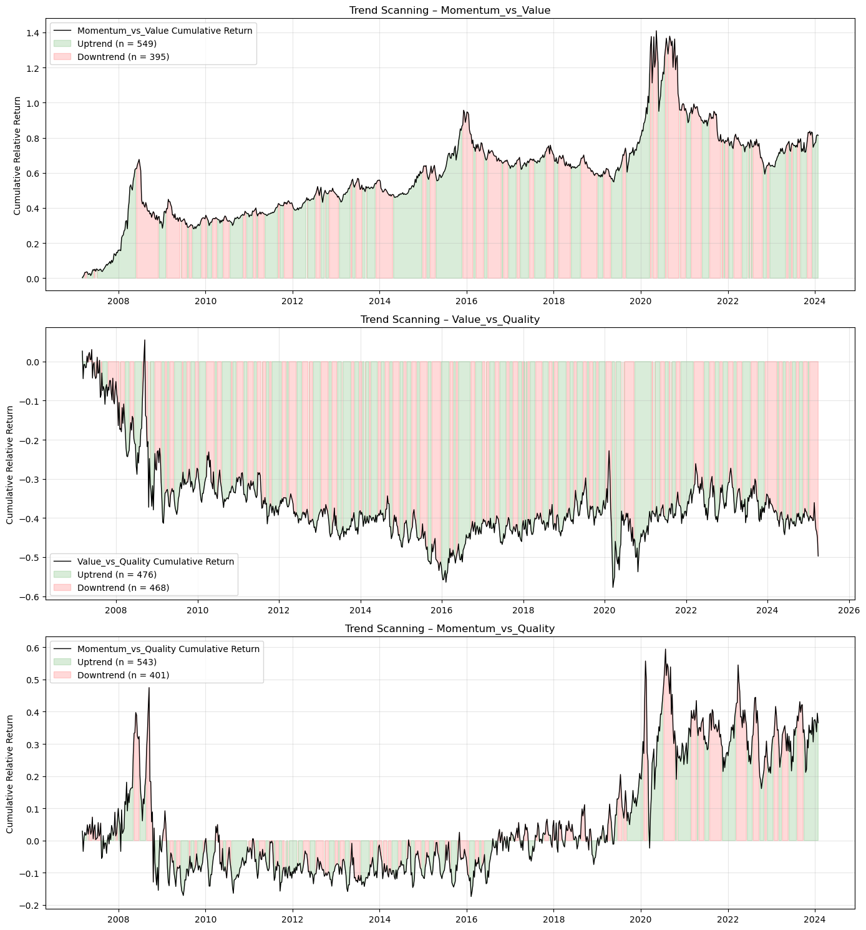
Figure 1: Trend-scanning results each factor pairs

Figure 2 The black line plots the cumulative compounded relative return between the two factors in each pair: momentum and value (top), value and quality (middle), and momentum and quality (bottom). The background shading indicates the trend label obtained from trend scanning. Uptrend (green) and downtrend (red) are assigned based on the maximum absolute t-statistic of the regression slope across candidate forward horizons.

Feature selection
The asset-pricing literature offers limited consensus regarding a unified framework for identifying predictors of time-varying factor performance. Although market-based indicators, macroeconomic variables, valuation spreads, sentiment measures, and volatility metrics have been shown to possess predictive relevance, the large number of potential predictors introduces significant dimensionality challenges. This proliferation of signals, commonly referred to as the ‘factor zoo’, raises concerns regarding multicollinearity, redundancy, and overfitting, particularly in financial time-series samples (Gu, Kelly, & Xiu, 2020; Feng, Giglio, & Xiu, 2020; Harvey, Liu, & Zhu, 2016).
To balance economic motivation with statistical discipline, the initial feature universe is constructed using theory-informed variables spanning market dynamics, macroeconomic conditions, valuation and fundamental spreads, sentiment proxies, commodity indicators, and factor-specific relative performance measures (Gu, Kelly, & Xiu, 2020; Han, 2024; Cakici, Fieberg, Metko, & Zaremba, 2023; Fang, Chen, & Ren, 2022; Saetia & Yokrattanasak, 2022). This results in a candidate set of over 300 predictors. Given the limited sample size available for model estimation (i.e. 929 weekly observation), dimensionality reduction is necessary to preserve statistical reliability and prevent spurious inference.
Feature reduction is implemented using mutual information (MI), an information-theoretic measure of statistical dependence. Unlike Pearson correlation, which captures only linear relationships, mutual information quantifies both linear and nonlinear associations between variables (Kraskov, Stögbauer, & Grassberger, 2004; Cover & Thomas, 2006). It measures the degree to which knowledge of one variable reduces uncertainty about another. In the context of feature selection, MI is used to identify redundancy between predictors. High mutual information between two variables indicates that they convey similar informational content, even if their linear correlation is weak (Peng, Long, & Ding, 2005; Guyon & Elisseeff, 2003). This property is particularly important in financial datasets, where nonlinear dependencies and regime-dependent relationships are common (Lopez de Prado M. , 2018; Sulaiman & Labadin, 2016). By capturing nonlinear redundancy, MI-based filtering provides a more robust alternative to simple correlation-based screening.
An MI matrix is computed for all pairwise combinations of candidate predictors. This matrix is normalised and transformed into a distance metric such that features exhibiting high informational similarity correspond to smaller distances. Hierarchical agglomerative clustering is then applied using Ward linkage, which merges clusters in a manner that minimises within-cluster variance at each step (Ward, 1963; Hastie, Tibshirani, & Friedman, 2009). Ward linkage is selected due to its tendency to form compact and well-separated clusters, thereby avoiding elongated or chain-like groupings.
A maximum cluster distance threshold is imposed to determine the final partition of the feature space. This procedure groups the initial feature universe into 32 informationally distinct clusters.
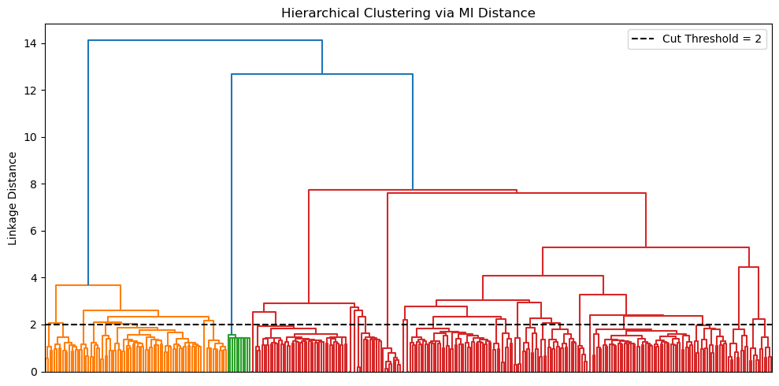
Figure 2: Hierarchical agglomeration clustering applied to the features space

Figure 2 Represents the entire feature space. The ward linkage function is selected for its robustness against elongated clusters. The maximum distance for clusters selection is set at 2, resulting in a total of 32 clusters. Within each cluster, the feature exhibiting the lowest average distance to other members is retained. This criterion identifies the most informationally central variable within each group. Importantly, this selection is unsupervised and does not rely on predictive performance relative to the target variable. As a result, feature reduction is conducted independently of the classification task, avoiding look-ahead bias and preventing inadvertent target leakage.
In addition to this clustered set, a further 18 relative-factor features were included by design. These variables capture pairwise relative performance, co-movement, and relative volatility dynamics that are directly aligned with the study’s factor-timing objective and were therefore treated as structurally relevant inputs rather than candidates for redundancy pruning. The final modelling matrix therefore consists of 50 predictors: 32 representative features selected via mutual-information clustering plus 18 relative-factor features retained on theoretical grounds.
Table 1: Classification of representative features
Feature Category | Feature | Economic Rationale | Empirical Findings
Price-based features | VolTermStructPC1 | - Captures level of volatility term structure - captures future uncertainty | (Gu et al., 2020)  Volatility consistently ranks among the most important ML predictors.  (Kelly, Pruitt & Su, 2019)  Volatility shocks predict style divergence and regime changes.
Price-based features | VolTermStructPC2
Price-based features | GLD_FracDiff | - Local volatility provides a good signal for risk-on/risk-off environments.
Price-based features | GLD_RollSD
Price-based features | USDZARV1M.Curncy_QS
Price-based features | USDZARV1Y.Curncy_QS
Price-based features | GlobalBondVol6 | - Global volatility spills over across international markets.
Price-based features | GlobalPropertyVol12
Price-based features | EURUSDV6M.Curncy_QS
Fundamental | MXWD_Fundamental_PC1 |  | (Cakici, et al., 2023)  Value followed by momentum prove to be a crucial driver of stock prices globally
Fundamental | JALSH_Fundamental_PC1 | - Fundamental valuation measures (P/E, P/B, sales) capture expected mean-reversion in prices.
Fundamental | TOP40.Index.Price.to.Book.Ratio_Diff | - Book-to-price differentials identify undervalued vs overvalued stocks.
Fundamental | MXWD.Index.PE.Ratio_QS | - Sales-to-price ratio identifies cyclical undervaluation.
Fundamental | TOP40.Index.Price.to.Ebitda_Diff
Fundamental | JALSH.Index.Price.to.Sales.Ratio_Diff
Sentiment Indicators | MichgnConcIndx | - Reflects household expectations and overall risk sentiment. | (Saetia & Yokrattanasak, 2022)  Technical financial indicators and sentiment indicators showed stronger predictive power than macro-economic indicators.
Sentiment Indicators | GenComIndexPC1_QS | - Commodity PCA reflects global risk appetite, growth expectations, and inflation pressure.
Sentiment Indicators | GLD_StructBreak | - Structural breaks in gold prices signal major shifts in global uncertainty.
Sentiment Indicators | GLD_LempZiev
Sentiment Indicators | GLD_RollSkew
Sentiment Indicators | GLD_RollKurt
Sentiment Indicators | GlobalEquityTS | - Captures momentum in investor optimism/pessimism.
Sentiment Indicators | GlobalEquity_EntDyn | - Captures momentum in investor optimism/pessimism.
Macro-economic | SA_RB_Curvature | - Yield curve curvature and slope reflects growth expectations and monetary policy stance (local and global) | (Fang, et al., 2022)  Factor predictability is macro-state dependent.
Macro-economic | US_RB_Curvature
Macro-economic | SA_NB_Slope
Macro-economic | SA_CDS_Slope | - Credit spread slope proxies’ sovereign risk, economic stress, and funding conditions.
Macro-economic | RandPPP_Factor_Inst_TS_ST | - Tracks widening and narrowing of rand valuation
Macro-economic | PPP.ZA.Index_QS | - Rand valuation sits relative to its 5-year history.
Macro-economic | BCMPEBLS.Index | - Captures global energy price dynamics
Macro-economic | ZAR18M.Curncy_QS | - Captures medium-term USDZAR implied volatility relative to, indicating currency risk conditions.
Macro-economic | USDZAR_EntDyn | - Information content in FX markets
Factor specific performance | mom1m_momentum_vs_quality | - Assets that have performed well in recent past tend to continue performing. | (Gu et al., 2020)  Momentum signals remain among the strongest predictors in both ML and traditional frameworks.  (Kelly, Pruitt & Su, 2019)  Volatility shocks predict style divergence and regime changes.
Factor specific performance | mom1m_momentum_vs_value
Factor specific performance | mom1m_value_vs_quality
Factor specific performance | mom3m_momentum_vs_quality
Factor specific performance | mom3m_momentum_vs_value
Factor specific performance | mom3m_value_vs_quality
Factor specific performance | corr_momentum_quality_12 | - Measures co-movement between factors identifies convergence/divergence regimes.
Factor specific performance | corr_momentum_value_12
Factor specific performance | corr_value_quality_12
Factor specific performance | zrel_value_vs_quality_12 | - Standardised relative performance useful for detecting style rotation.
Factor specific performance | zrel_momentum_vs_quality_12
Factor specific performance | zrel_momentum_vs_value_12
Factor specific volatility | relvol_momentum_vs_quality_12 | - Identifies instability in factor relative performance
Factor specific volatility | relvol_momentum_vs_value_12 | - Identifies instability in factor relative performance
Factor specific volatility | relvol_value_vs_quality_12 | - Identifies instability in factor relative performance
Factor specific volatility | volratio_momentum_quality_12 | - Measures volatility differential driving factor rotations.
Factor specific volatility | volratio_momentum_value_12 | - Measures volatility differential driving factor rotations.
Factor specific volatility | volratio_value_quality_12 | - Measures volatility differential driving factor rotations.

Model training

The objective function
Rather than predicting exact return magnitudes, all three models aim to classify whether a factor is expected to lead or lag the other two factors, based on prevailing market and economic conditions. Each model estimates the conditional probability of relative factor outperformance defined as:
$$P(y_{t}=1|X_{t})$$ | ( 4 )
This is achieved by producing a probability score between zero and one:
$${\hat{p}}_{t}∈[0,1]$$ | ( 5 )
A factor timing signal is generated when the probability exceeds a calibrated threshold $(τ)$:
$${\hat{y}}_{t}=1\{{\hat{p}}_{t}≥τ\}$$ | ( 6 )

Logistic regression
The simplicity and direct interpretability of linear models have contributed to their significance in finance. Logistic regression provides a transparent economic interpretation of how each predictor influences the likelihood of factor outperformance. The model assumes a linear relationship between the log-odds of the outcome and the predictor variables (Hosmer, Lemeshow, & Sturdivant, 2013; James, Witten, Hastie, & Tibshirani, 2021). The model imposes the assumes that the log-odds of a binary outcome are a linear function of the predictor:
$$logit\left(P\left(y_{t} | X_{t}\right)\right)=\ln\left(\frac{P\left(y_{t} | X_{t}\right)}{1-P\left(y_{t} | X_{t}\right)}\right)= β_{0}+X_{t}^{T}β$$ | ( 7 )
Here, $β_{0}$ is the intercept term and $β∈R^{p}$ is a vector of coefficients measuring linear impact of each feature on the log-odds. To obtain a predicted probability from the linear predictor, the inverse of the logit, known as the logistic (sigmoid) function, is used:
$${\hat{p}}_{t}=σ\left(β_{0}+X_{t}^{T}β\right)= \frac{1}{1+e^{-(β_{0}+X_{t}^{T}β)}}$$ | ( 8 )

Model parameters $\left(β_{0}, β\right)$are estimated by minimizing the penalized log-likelihood function.
$$L(β)=\sum_{t∈D_{train}}{w_{t}}\left[-y_{t}\log{{\hat{p}}_{t}}-\left(1-y_{t}\right)\log{(1-{\hat{p}}_{t})}\right]+ λ\left(α∥β∥_{1}+\frac{1-α}{2}∥β∥_{2}^{2}\right)$$ | ( 9 )
where $λ≥0$ controls overall regularization strength and $α∈[0,1]$ trades off LASSO and Ridge penalties. To prevent overfitting and enhance model robustness we penalize the log-likelihood function. The elastic-net regularization is a common feature in financial analysis, which is a hybrid between LASSO and Ridge shrinkage. It mitigates multicollinearity and stabilizes estimates (Zou & Hastie, 2005; Tibshirina, 1996; Gu, Kelly, & Xiu, 2020):
We implement the logistic regression function using a custom logistic regression function written in Python. The implementation structure follows the theoretical formulation of (Hosmer, Lemeshow, & Sturdivant, 2013; James, Witten, Hastie, & Tibshirani, 2021). The model computes the logistic (sigmoid) mapping, evaluates the penalized log-likelihood, and performs gradient descent with optional elastic-net regularization (Zou & Hastie, 2005).

Generalized additive models (GAMs)
Example Generalized Additive Models (GAMs) introduced by (Hastie & Tibshirani, 1986) extend generalised linear models by introducing nonlinear transformations of the original predictors as new additive terms in an otherwise linear model. This model enables nonlinearity while maintaining transparency. The GAM specification for binary classifications structurally resembles that of the logistic regression. Using the logit transformation, the conditional probability of outperformance is given by:
$$g\left(P\left(y_{t}=1|X_{t}\right)\right)= β_{0}+\sum_{i=1}^{p}{s_{i}(X_{t,i})}$$ | ( 10)
$β_{0}$ is the intercept term and each $s_{i}(.)$ is a smooth, potentially nonlinear function capturing the marginal effect of predictor $(X_{t,i})$ (Hastie & Tibshirani, 1986). The predicted probability for classification is given by:
$${\hat{p}}_{t}=σ\left(β_{0}+ \sum_{i=1}^{p}{s_{i}\left(x_{t,i}\right)}\right)$$ | (11)
Each smooth $s_{i}(.)$ is represented via a basis expansion: $s_{i}\left(x\right)=B_{i}{(x)}^{T}θ_{i}, B_{i}\left(x\right)∈R^{k_{i}}$,
$B_{i}\left(x\right)$ is a vector of spline basis function, which control the functional relationship between a predictor variable and a conditional response, whose coefficients $\left\{θ_{i}\right\}$ must be estimated. The size of the basis expansion limits the smoothing spline’s potential complexity with a larger set of basis functions allowing greater flexibility. We use cubic splines with $k_{i}$ controlling the flexibility of each smoothing term. Given that each spline $s_{i}(.)$ can be visualised independently, spline bases enable GAMs to model nonlinearity while maintaining additive interpretability (James, Witten, Hastie, & Tibshirani, 2021).
We estimate the coefficients $\left\{θ_{i}\right\}$ and $β_{0}$ by minimizing:
$$L\left(S\right)=\sum_{t∈D_{train}}{w_{t}\left[{-y}_{t}\log{{\hat{ p}}_{t}}-\left(1-y_{t}\right)\log{(1-{\hat{p}}_{t})}\right]}+ \sum_{i=1}^{p}{λ_{i}θ_{i}^{T}S_{i}θ_{i}}$$ | (12)

The smoothness of the spline is controlled by a smoothing penalty $(λ_{i})$ and ${(S}_{i})$ is the spline penalty matrix (Hastie & Tibshirani, 1986).

Extreme gradient boost (XGBoost)
Tree-based ML models are non-parametric and use logic that departs markedly from traditional econometric models to capture nonlinearities within the data. These models build on the concept of decision trees, where binary groups are created by grouping observations with similar characteristic. They use a hierarchical tree structure that partitions the predictor space by recursively selecting features and splits that maximize a set improvement criterion such as information gain, entropy reduction, Gini reduction, or variance reduction depending on the task (Breiman, Friedman, Olshen, & Stone, 1984; Hastie & Friedman, The Elements of Statisitcal Learning, 2009). This process ensures that the most informative features for predicting the target are placed higher in the tree structure.
Although decision trees are intuitive, single CART (classification and regression tress) easily overfit (Hastie & Friedman, The Elements of Statisitcal Learning, 2009; Breiman, Friedman, Olshen, & Stone, 1984; Gu, Kelly, & Xiu, 2020). Ensemble methods like bagging and boosting address this shortcoming by combining multiple weak learners (Friedman, 2001; Breiman L. , 1996). This study focuses specifically on a boosting ensemble that build a strong predictive model by sequentially combining many weak learners. XGBoost construct an additive model of the form:

$$F_{M}\left(X_{t}\right)=\sum_{m=1}^{M}{f_{m}\left(X_{t}\right), } f_{m}∈F$$ | (13)
where each $f_{m}$ is a classification and regression trees (CART) (Chen & Guestrin, 2016). For binary classification, the ensemble output is mapped to probabilities using the logistic sigmoid function given by:
$${\hat{p}}_{t}= σ\left(F_{M}\left(X_{t}\right)\right), σ\left(x\right)= \frac{1}{(1+e^{-x})}$$ | (14)

At each boosting iteration $(m)$, we aim to minimize:
$$L^{(m)}=\sum_{t∈D_{train}}{w_{t}}l\left(y_{t},{\hat{p}}_{t}^{\left(m-1\right)}+f_{m}\left(X_{t}\right)\right)+Ω\left(f_{m}\right)$$ | (15)
Where the logistic loss function defined as:
$$l\left(y,p\right)=-y\log{p}-\left(1-y\right)\log{(1-p)}$$ | (16)
and tree regularization function given by:
$$Ω\left(f\right)=γT+\frac{λ}{2}\sum_{j=1}^{T}{w_{j}^{2}}$$ | (17)
$(T)$ is the number of leaves and ${(w}_{j})$ the leaf weight. Each tree is trained to fit the residuals of the previous iteration, allowing the ensemble to progressively correct its errors. In study, XGBoost model is trained using the xgboost python library. This implementation executes the theoretical additive tree-boosting framework described (Chen & Guestrin, 2016).

Table 2 Model comparison
Model | Model Complexity | Interpretability | Strengths | Limitations / Risks | Key Hyperparameters | References
Logistic Regression | Low | High | Transparent coefficients (economic interpretability); | Misses nonlinearities; | Maximum iterations (max_iter) | (Hosmer, Lemeshow, & Sturdivant, 2013);  (Zou & Hastie, 2005)
Logistic Regression | Low | High | Efficient with small samples; | Sensitive to multicollinearity; | Regularization strength (λ)
Logistic Regression | Low | High | Robust to noise with regularization | Limited predictive power in complex regimes | L1/L2 mixing ratio (α)
Logistic Regression | Low | High |  |  | Solver tolerance (tol)
Generalized Additive Model (GAM) | Moderate | Moderate–High | Captures smooth nonlinear effects; | Cannot easily model interactions; | Number of splines (n_splines) | (Hastie & Tibshirani, 1986);  GAM formulation  (Wood, 2017);  (Gu, Kelly, & Xiu, 2020)
Generalized Additive Model (GAM) | Moderate | Moderate–High | Retains partial interpretability; | Computationally heavier; | Smoothness penalty (λ_i)
Generalized Additive Model (GAM) | Moderate | Moderate–High | Controls overfitting via smoothing penalty | Requires careful selection of smoothing parameters | Maximum iterations (max_iter)
Extreme Gradient Boosting (XGBoost) | High | Low | Captures high-order nonlinearities and interactions; | Reduced interpretability; | Learning rate (η) | (Friedman, 2001);  (Chen & Guestrin, 2016);  (Krauss, Do, & Huck, 2017)
Extreme Gradient Boosting (XGBoost) | High | Low | Inherent feature selection via splits | Prone to overfitting without tuning; | Maximum tree depth (max_depth)
Extreme Gradient Boosting (XGBoost) | High | Low |  | Sensitive to hyperparameter configuration | Subsample ratio (subsample)
Extreme Gradient Boosting (XGBoost) | High | Low |  |  | Number of boosting rounds (n_estimators)
Extreme Gradient Boosting (XGBoost) | High | Low |  |  | Regularization (λ, γ)

Hyperparameter tuning and model validation
Robust evaluation of predictive performance in financial time series requires validation procedures that explicitly account for temporal dependence, non-stationarity, and overlapping information sets (Campbell, Lo, & MacKinlay, 1997; Gu, Kelly, & Xiu, 2020). Conventional k-fold cross-validation assumes independent and identically distributed observations and therefore risks severe information leakage when applied to time-ordered financial data (Bergmeir & Benítez, 2012; Lopez de Prado M. , 2018). To address these challenges, model tuning and evaluation are implemented using a two-stage validation architecture. Firstly, Combinatorial Cross-Purged Validation is used exclusively for hyperparameter optimization within the training windows (Lopez de Prado M. , 2018; Lopez de Prado M. , 2020). Then, the optimised parameter set is used in the walk-forward validation to assesses out-of-sample predictive performance.

Combinatorial cross-purged validation
The choice of hyperparameters controls the model’s complexity, limiting the potential for overfitting. Applying the foundational framework of Lopez de Prado (Lopez de Prado M. , 2018), model hyperparameters are optimized via combinatorial purged cross-validation.
CPCV generates multiple unique combinations of training and testing sets, ensuring that each block of samples appears the same number of times in the training set. The combinatoric equation is used the calculate exact number of training/test combinations sets required to construct a set of back-testing paths. A back-testing path chronologically orders the validation predictions from the different CPCV splits to form one continuous out-of-sample time series. In our case, the test and training sets are given by $k=1$ and $N=5$ respectively.
$$ϕ\left(N,k\right)=\frac{k}{N}\left({N \atop N-k}\right)$$ | (18)
Thus, the number of back-test paths is $ϕ\left(5,1\right)=1$.
Figure 3: CPCV back-test path, k=1 validation set, N=5 cross validation splits
To ensure that the validation set performance is still a good proxy for the performance on unseen data, samples in the validation set need to be reasonably independent from those in the training set. (Lopez de Prado M. , 2018) achieves this by removing any training data whose information horizon overlaps with the validation set (i.e. purging). For our analysis, we used a maximum look-ahead window of 12 weeks when assigning trend labels to our target variable, meaning that the purge gap should be at least the size of the look-ahead window to mitigate look-ahead bias. Parameters are then optimized on the generated blocks. We select the parameter set with the highest predictive score on the unseen validation set as input to the walk-forward validation phase. To accommodate evolving market regimes and non-stationarity, parameters are re-tuned annually.
Table 3: Key hyperparameters
Model | Parameter combinations | Key hyperparameters | Tuning parameter grid
Logistic | 243 | Learning rate (η) | [ 0.01 , 0.05 , 0.10 ]
Logistic | 243 | Maximum iterations | [ 500 ,1000 , 2000 ]
Logistic | 243 | Regularization strength (λ) | [ 0 , 0.1 , 0.01 ]
Logistic | 243 | L1/L2 mixing ratio (α) | [ 0 , 0.5 , 1 ]
Logistic | 243 | Base score | [ 0.5 , 0.6 , 0.7 ]
GAM | 12 | Number of splines | [ 3 , 7 , 8 ]
GAM | 12 | Smoothness penalty (λ) | [ 0.1 , 1 , 10 , 25 ]
GAM | 12 | Fit intercept | TRUE
GAM | 12 | Maximum iterations | [ 200 ]
XGBoost | 243 | Learning rate (η) | [ 5 , 7 , 10 ]
XGBoost | 243 | Maximum tree depth | [ 3 , 6 , 10 ]
XGBoost | 243 | Subsample ratio | [ 0.6 , 0.8 , 1 ]
XGBoost | 243 | Regularization (λ, γ) | [ 0.6 , 0.8 , 1 ]
XGBoost | 243 | Base score | [ 0.5 ,0.6 , 0.7 ]

Walk forward Cross-Validation
While CPCV provides a leakage-free mechanism for hyperparameter selection, it does not fully replicate real-time deployment. Final performance is therefore assessed using a rolling walk-forward framework. Walk-forward validation involves iteratively training a model on historical data and then evaluate its performance on subsequent data that lies chronologically after the training data. It ensures that the model is always trained on past data and evaluated on future data, preventing data leakage and providing a more realistic assessment of forecasting ability.
Figure 4: Walk-forward validation with rolling look-back window
At each iteration, models are trained on a rolling look-back window of 773 weeks. To balance adaptability with parameter stability, hyperparameters are re-optimised every 52 weeks within the rolling walk-forward framework. This frequency allows the model to adjust to structural changes in market conditions while avoiding excessive sensitivity to transient fluctuations. The procedure is repeated three times to produces a sequence of out-of-sample forecasts spanning the full 156-week evaluation horizon.

Performance evaluation
Model performance is evaluated along three complementary dimensions, directional accuracy, ranking ability, and probability calibration. These measures capture distinct aspects of classification quality and jointly provide a comprehensive assessment of predictive performance. Because the objective of the study is to identify transitions in relative factor leadership rather than forecast return magnitudes, classification-based metrics are appropriate. In financial settings characterised by heavy tails, regime shifts, and low signal-to-noise ratios, reliance on a single performance measure can be misleading. A multi-metric framework therefore improves robustness and interpretability (Dixon, Klabjan, & Bang, 2017; James, Witten, Hastie, & Tibshirani, 2021).

Directional accuracy, measured by average accuracy, determines the proportion of correct classifications relative to total predictions and reflects whether the model correctly identifies the leading factor within each pair (James, Witten, Hastie, & Tibshirani, 2021). While intuitive and directly interpretable from an allocation perspective, accuracy alone does not account for prediction confidence or ranking quality. Accordingly, it is complemented by ROC-AUC and log-loss, which provide additional insight into ranking ability and probability calibration.

To assess discrimination ability independently of any fixed decision threshold, the Receiver Operating Characteristic (ROC) curve is employed. The ROC curve evaluates the model’s capacity to assign higher predicted probabilities to periods of genuine outperformance than to underperformance periods. The Area Under the ROC Curve (ROC-AUC) summarises this discriminatory power on a scale between zero and one, where 50% corresponds to random classification (James, Witten, Hastie, & Tibshirani, 2021; Fawcett, 2006). Because ROC-AUC is threshold-independent and robust to moderate class imbalance, it serves as the primary metric for hyperparameter optimisation within the CPCV framework.

In addition to classification correctness and ranking ability, the quality of predicted probabilities is evaluated using log-loss. Log-loss penalises confident but incorrect predictions more heavily than uncertain misclassifications, thereby assessing probability calibration rather than binary outcome (Bishop, 2006; Murphy, 1973). Since the modelling framework produces probabilistic forecasts of relative factor outperformance, calibration quality is economically meaningful. Well-calibrated probabilities allow for flexible allocation rules, such as probability-weighted exposure adjustments, rather than simple binary switching between styles (Murphy, 1973; Dixon, Klabjan, & Bang, 2017; Lopez de Prado M. , 2018).

Taken together, directional accuracy, ROC–AUC, and log-loss capture complementary dimensions of predictive performance. Improvements across all three measures provide stronger evidence of genuine predictive structure than improvements in any single metric alone. Nevertheless, statistical performance does not automatically imply economic profitability. A further translation of predictive signals into portfolio outcomes can be evaluated separately through risk-adjusted performance analysis, which falls outside the scope of this study.

Feature importance
Section 3.5 outlined the construction of the feature universe, guided by economic theory and empirical evidence. The resulting predictor set spans market-based indicators, valuation spreads, macroeconomic variables, volatility measures, liquidity proxies, and sentiment indicators. While theoretical reasoning motivates the inclusion of these predictors, empirical validation requires assessing whether the trained models meaningfully utilise these features in generating out-of-sample forecasts. The objective is to determine which predictors materially contribute to model decisions, whether economically motivated variables dominate predictive behaviour, and whether feature relevance varies systematically across factor pairs.
Feature importance is evaluated using Shapley values derived from cooperative game theory (Shapley, 1953), implemented via the SHAP framework of Lundberg & Lee (Lundberg & Lee, 2017; Lundberg, et al., 2020; Štrumbelj & Kononenko, 2010). Shapley values decompose each model prediction into additive contributions from individual features relative to a baseline expectation. Unlike heuristic measures such as tree split gain or coefficient magnitude alone, Shapley-based attribution reflects each feature’s marginal contribution to the model’s predictive output, accounting for nonlinearities and interactions (Joseph, 2019; Štrumbelj & Kononenko, 2010; Joseph, 2024). Importance is therefore measured in terms of predictive influence rather than structural characteristics of the algorithm. This approach aligns with best practices in financial machine learning, where model interpretability is critical for both regulatory compliance and risk management (Molnar, 2022) .
To ensure methodological consistency across model classes, Shapley values are computed for all classification models in log-odds space. For probabilistic classifiers, such as logistic regression, GAMs, and gradient boosted trees, predictions are naturally expressed in log-odds prior to transformation through the logistic link function. Computing Shap values in this space preserves linear additivity, ensuring that the sum of feature contributions exactly reconstructs the model prediction before the probability transformation (Lundberg, et al., 2020; Štrumbelj & Kononenko, 2010). By computing feature importance in the same output space and over the same training window within each walk-forward iteration, the analysis guarantees that differences in importance reflect model structure rather than scale inconsistencies.

Feature importance is evaluated using both global and local Shapley decompositions. Presenting both decompositions provides complementary insights. Global importance identifies which predictors are structurally influential to the model, while the local distribution of Shapley values reveals how these predictors operate across different market environments and feature values. This dual representation facilitates comparison across model classes and enables evaluation of whether nonlinear models extract additional conditional structure from the feature universe.
Global feature importance is defined as the mean absolute Shapley value across observations within each walk-forward training window. This metric captures the average magnitude of predictive influence exerted by each feature, irrespective of direction (Lundberg, et al., 2020; Molnar, 2022; Štrumbelj & Kononenko, 2010). Within the context of this study, global importance serves three functions. First, it evaluates whether features motivated by theoretical literature rank among the most influential predictors (Fama & French, Common risk factors in the returns on stocks and bonds., 1993; Asness, Moskowitz, & Pedersen, 2013; Cakici, Fieberg, Metko, & Zaremba, 2023). Second, it also facilitates assessment of the relative contribution of broader feature categories including market, macroeconomic, sentiment, and valuation variables (Gu, Kelly, & Xiu, 2020). Third, it enables comparison across model classes to determine whether nonlinear specifications extract additional information from the feature universe, a key consideration when evaluating the incremental value of complex models over simpler benchmarks (Gu, Kelly, & Xiu, 2020).
Beyond aggregate ranking, Shapley values permit local decomposition of individual predictions within each walk-forward period allowing predictive features to be studied under different market environment. This framework provides us with the opportunity to evaluate possible market scenarios such as whether volatility and liquidity variables dominate during crisis regimes (Adrian & Brunnermeier, 2016), whether valuation spreads gain influence during recovery phases (Fama & French, Business conditions and expected returns on stocks and bonds, 1989), and whether macroeconomic indicators exhibit regime-dependent relevance (Brunnermeier & Oehmke, 2013).

Results

Overview of the Evaluation Framework
The empirical findings presented in this chapter assess whether increasing model flexibility yields incremental predictive value in timing the relative performance of momentum, value, and quality factors in the South African equity market.
The evaluation is conducted in five distinct stages. Initially, the behaviour and dependence structure of the selected factors are analysed to establish the empirical environment in which factor timing is attempted. Subsequently, the out-of-sample predictive performance results for each factor pair are assessed across various model classes. Next, structural drivers of model behaviour are analysed utilizing Shapley-based feature importance. Lastly, the implications of the validation framework on performance credibility are considered by evaluating the stability of the optimized parameter set across walk-forward segments is examined to determine its robustness throughout validation segment.
This layered evaluation framework guarantees that comparisons between models are performed under similar information constraints and chronological order is adhered to. This ensuring that observed variations in performance can be ascribed to model architecture rather than validation artifacts. Consequently, the results accurately depict incremental differences in functional adaptability and interaction modelling capacity within a consistent empirical framework.

The structure and dynamics of local style factors
Before evaluating predictive performance, it is essential to characterize the behaviour of the momentum, value, and quality factors in the South African equity market. Empirical evidence reveals significant dispersion in long-run performance paths, substantial time variation in volatility and return dynamics, and regime-dependent inter-factor dependence. These patterns suggest that factor premiums are not static. They shift with market conditions and the risks that happen to be in favour at the time. That points to a conditional approach, one that adapts as regimes changes.

Unconditional factor returns
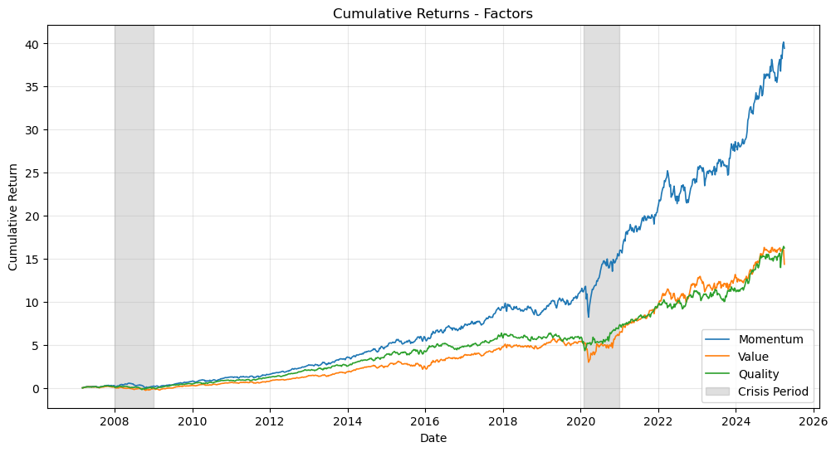
Figure 5: Cumulative factor returns

Figure 5 Shows the cumulative returns for momentum, value, and quality factors over the full period. Momentum has the highest long-term returns, but also experiences occasional declines. Quality and value have more moderate returns, with quality generally being more stable than value. These results show that all factors have periods of both strong performance and losses, especially momentum and value. This means that looking only at average long-term results can hide important changes that happen within shorter time frames. As a result, unconditional performance does not fully reflect how these factors really behave.

Time-varying volatility and return dispersion
While cumulative returns summarize long-run outcomes, Figure 6 illustrates the evolution of 12-month rolling returns, offering insight into the variability of factor performance. All three factors exhibit pronounced time variation in returns.

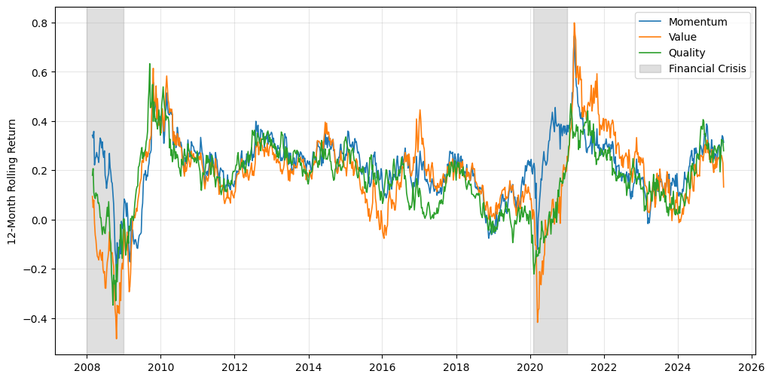
Figure 6: 12-month rolling factor returns
Figure 5 shows the long-term trend of cumulative return pattern highlighting the distinct patterns of factor performance over time. Value often experiences the largest drawdowns, with deep negative rolling returns during crisis periods followed by sharp recoveries (Fama & French, 1992; Lakonishok, Shleifer, & Vishny, 1994; Asness, Moskowitz, & Pedersen, 2013).
For most of the sample, momentum and quality have similar levels of volatility overall. Both fluctuate less than value, and outside of crisis periods their return patterns tend to move together. The difference shows up when conditions deteriorate. During stressed market conditions, momentum's downturns are generally less severe. This is because momentum profits derive from trend persistence, an effect that has held across many markets and time periods (Jegadeesh & Titman, 1993; Daniel & Moskowitz, Momentum crashes, 2016). Quality, however, experiences deep drawdowns and slower recoveries. Although quality is defensive in nature, it is not immune to broad market declines. (Asness, Frazzini, & Pedersen, 2019).

Factor co-movement and stability of co-relationships
Beyond individual factor dynamics, the joint behaviour of momentum, value, and quality, factor co-movement is neither constant nor negligible over time.

Table 4: Spearman’s correlation | Table 5: Kendall’s tau
   | Momentum | Value | Quality
  Momentum | 1.000 | 0.805 | -0.039
  Value | 0.805 | 1.000 | -0.043
  Quality | -0.039 | -0.043 | 1.000
   | Momentum | Value | Quality
  Momentum | 1.000 | 0.637 | -0.027
  Value | 0.637 | 1.000 | -0.030
  Quality | -0.027 | -0.030 | 1.000

Evidence from the full sample correlation in Table 4 a strong positive relationship between momentum and value, while quality appears almost entirely uncorrelated with either factor. This pattern is confirmed in Table 5. Correlation between momentum and value weakness but remains materially positive, while quality shows near-zero dependence.
While these rank correlations provide a useful summary of average co-dependence, rolling correlation in Figure 7 the dynamic nature of these relationships.

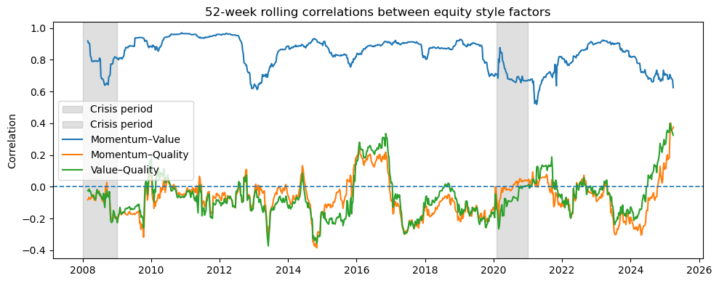
Figure 7: 52-week rolling correlations between factor pairs

Momentum and value correlation is persistently positive but fluctuation over time. There are periods where the two move tightly together and others where the link loosens noticeably. These shifts often line up with market stress or turning points in the cycle, suggesting the connection between momentum and value depends on the state of the market rather than reflecting a fixed structural tie (Daniel & Moskowitz, Momentum crashes, 2016; Asness, Moskowitz, & Pedersen, 2013; Ilmanen & Kizer, 2012).
In contrast, both the quality and value/momentum correlations drift around zero for most of the sample period, switching signs frequently and showing little persistence. Occasionally they turn positive for short stretches, but these episodes fade quickly. This pattern fits the view that quality captures something distinct, fundamental strength like profitability and solid balance sheets, rather than the price-driven dynamics that drive momentum and value (Asness, Frazzini, & Pedersen, 2019).
Even though static correlations give a useful summary, they smooth over the variation that matters for investors. In the South African market, the way these factors co-move shifts over time, sometimes gradually, sometimes abruptly. The strength of the momentum and value relationship changes with market conditions, while quality remains largely detached from both.

In the context of multi-factor portfolio allocations, the assumption of fixed relationships may vulnerable when those relationships shift. The evidence here points toward a more flexible approach with factor exposures that adapt as market conditions change, rather than remaining fixed over time (Lopez de Prado M. , 2018; Gu, Kelly, & Xiu, 2020; Ang & Timmermann, 2012).

Out-of-Sample predictive power
This section evaluates the predictive performance of the three model classes within the rolling walk-forward framework. Performance is assessed strictly out-of-sample using three complementary metrics, directional accuracy, ROC-AUC, and log-loss. The analysis proceeds by factor pair, reflecting the study’s focus on relative factor timing.

Momentum vs Value - Strong predictive gains with model complexity
Among the three factor pairings examined, the momentum vs value pair exhibits the most pronounced nonlinear structure.
Table 6: OOS results for Momentum vs Value pairing
 | Logistic | GAM | XGBoost
Average Accuracy | 59.6% | 64.1% | 71.8%
ROC-AUC | 51.1% | 68.8% | 76.8%
Log-loss | 0.71 | 0.93 | 0.94

Logistic regression achieves the lowest average accuracy of 59.6%, modestly above the 50% random guess benchmark. The GAM provides a moderate improvement in accuracy to 64%, suggesting that smooth nonlinear transformations capture meaningful predictive information. XGBoost substantially outperforms both alternatives, with accuracy exceeding 70%. This suggests that momentum vs value dynamics are governed by interaction effects and regime-dependent patterns that linear and additive models cannot accommodate.

Table 7: Momentum vs Value - ROC-AUC across the three model specifications
Logistic | GAM | XGBoost
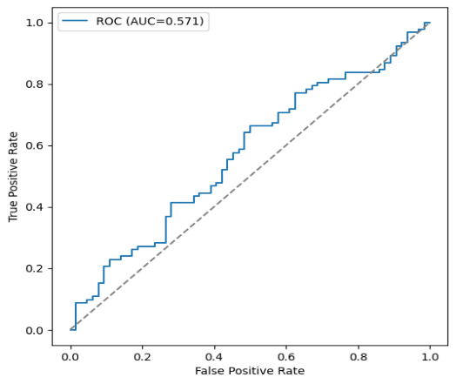 | 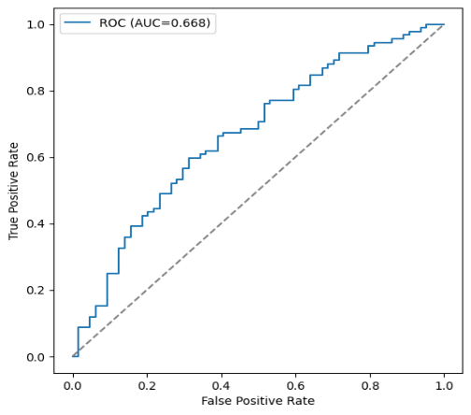 | 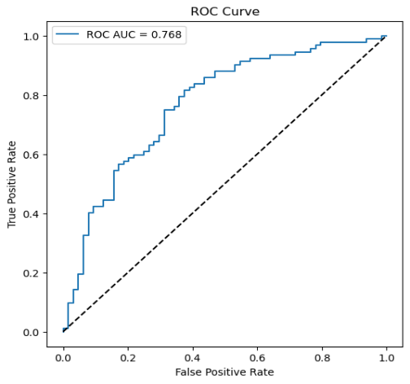

The ROC analysis reinforces this hierarchy. Logistic regression achieves an AUC of 57.1% with the ROC curve remaining near the diagonal, reflecting moderate ranking ability. GAM increases AUC to 66.8%, confirming that nonlinear marginal effects enhance regime classification, though gradual ROC separation suggests boundaries remain partially obscured. However, the ROC curve still shows gradual separation, implying that regime boundaries are only partially captured. XGBoost attains 76.8% AUC with pronounced early steepness in the curve, representing strong discrimination at low false positive rates. This property is essential for allocation decisions where incorrect regime classification carries meaningful costs.
Log-loss presents a more nuanced picture. Despite weaker discrimination, logistic regression achieves superior calibration (0.71), while GAM and XGBoost record higher values (0.93 and 0.94). This divergence reflects the inherent tension between discrimination and calibration documented by (Niculescu-Mizil & Caruana, 2005). XGBoost's decisiveness improves ranking but exacerbates penalization when predictions miss the mark. Logistic regression, by contrast, produces probability estimates concentrated in intermediate ranges—trading reduced extremity for weaker separation.

Table 8: Momentum vs Value - Walk-forward predicted probabilities and realised outcomes
Logistic | 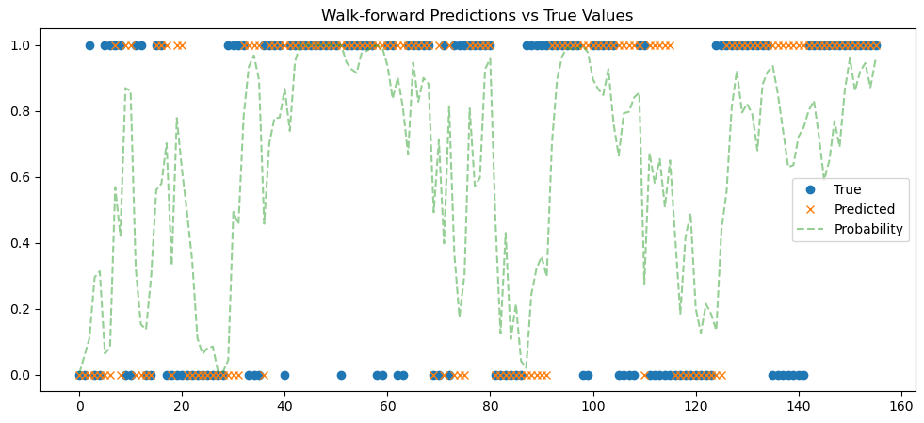
GAM | 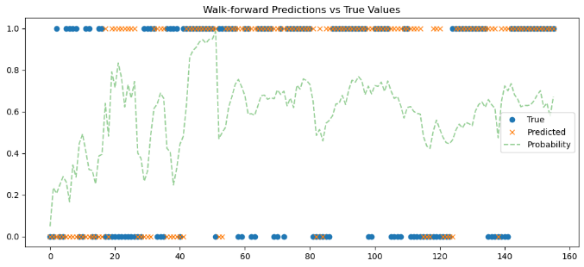
XGBoost | 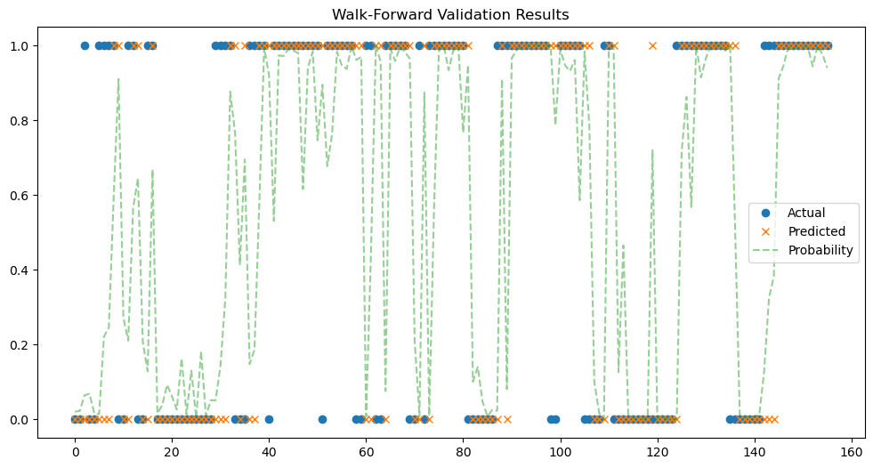

The momentum and value relationship is shaped by cyclical valuation dynamics, crowding effects, and abrupt regime shifts consistent with the literature on momentum crashes and value cycles (Daniel & Moskowitz, Momentum crashes, 2016; Arnott, Beck, Kalesnik, & West, 2016). These results suggest such dynamics resist linear separation. Tree-based segmentation in XGBoost is particularly suited to capturing these context-dependent boundaries (Chen & Guestrin, 2016; Friedman, 2001). Additive smooths in GAM offer only marginal improvement, while logistic regression remains structurally constrained by its inability to model higher-order interactions.

Momentum vs Quality - Moderate Improvements with increasing model complexity
Even though nonlinear specifications continue to deliver measurable improvements, the momentum vs quality presents a predictive structure distinct from the momentum vs value pairing.
Table 9: OOS results for Momentum vs Quality pairing
 | Logistic | GAM | XGBoost
Average Accuracy | 59.0% | 59.0% | 69.9%
ROC-AUC | 61.4% | 64.5% | 73.3%
Log-loss | 0.67 | 0.818 | 0.96

Logistic regression modestly improves upon a random guess benchmark, suggesting the presence of linear signals in the momentum vs quality dynamics, albeit relatively weak. The GAM produces similar results, suggesting that smooth nonlinear transformations do not provide any additional insights. The XGBoost continues to deliver superior directional accuracy, improving to just below 70%. Although the magnitude of improvement is smaller than in the momentum vs value pairing, this result also suggests that interaction effects play a meaningful role in the dynamics between momentum and quality.

Table 10: Momentum vs Quality - ROC-AUC across the three model specifications
Logistic | GAM | XGBoost
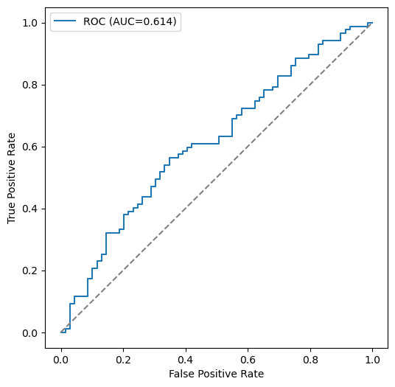 | 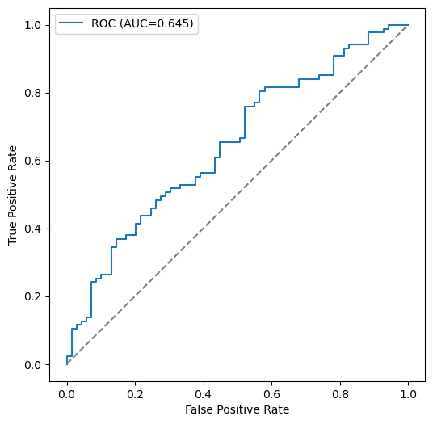 | 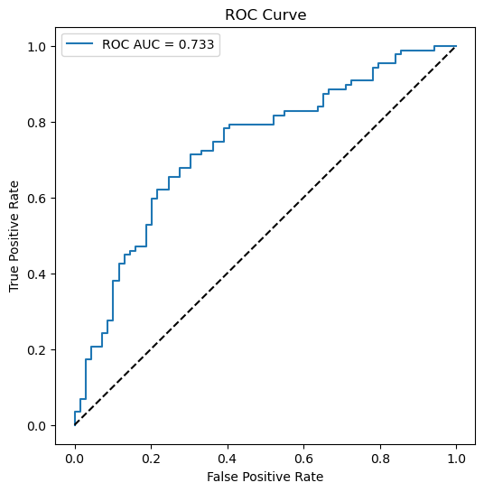

The ROC-AUC numbers tell a similar story. Logistic regression is just above 60%, showing modest skill. The ROC curve does not shift far from the diagonal, showing marginal improvement from momentum vs value pair, which is satisfactory, but could be improved. The GAM improves to 64.5%, a sign that nonlinear adjustments help with ranking, even if they don’t meaningfully contribute to accuracy. The curve gets a bit more shape, hinting that nonlinear patterns are at play. XGBoost again leads with a 73.3% AUC. Its ROC curve rises faster at low false-positive rates, meaning it’s better at spotting true outperformance early. Still, compared to momentum vs value, the curvature is not as pronounced.

Table 11: Momentum vs Quality - Walk-forward predicted probabilities and realised outcomes
Logistic | 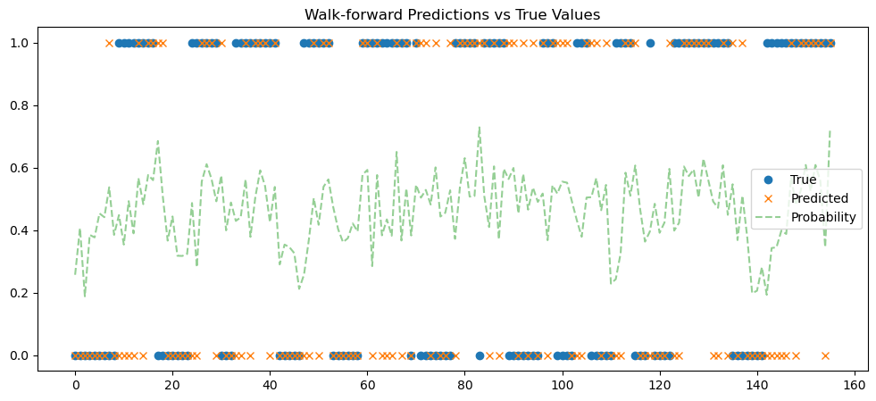
GAM | 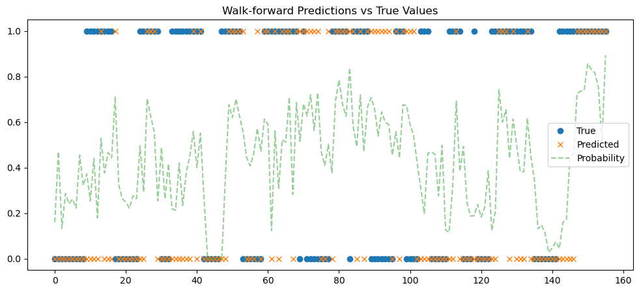
XGBoost | 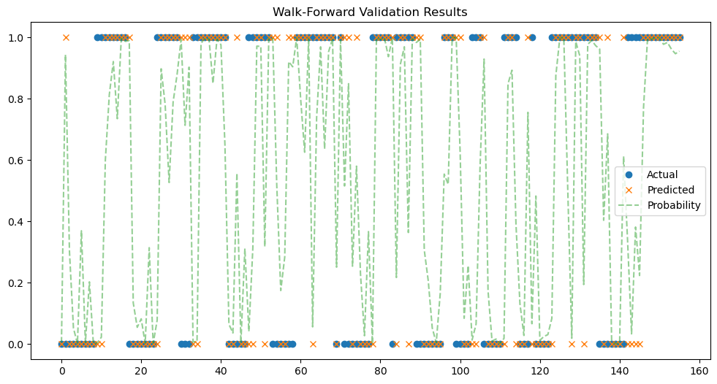

There is a recurrent theme in the Log-loss numbers. Reflecting a trade-off where better discrimination often comes with worse calibration. Logistic regression has the lowest log-loss (0.67), meaning its probabilities are fairly well balanced, even though accuracy is not particularly exceptional. The GAM’s log-loss increases to 0.818, showing that nonlinear transformations increase the probability of overconfident predictions that are often incorrect. XGBoost has the highest log-loss at 0.96. Despite improved accuracy, the XGBoost makes overconfident predictions. When they are incorrect, they miss by a wider margin and are penalized more heavily.
Based in literature ad empirical evidence, momentum is known for being regime-dependent and prone to sharp reversals (Daniel & Moskowitz, Momentum crashes, 2016). While quality strategies, by contrast, tend to be more defensive, rooted in fundamentals like profitability and strong balance sheets (Asness, Frazzini, & Pedersen, 2019). For this factor pair, more flexible models still add modestly less value than with momentum and value. Rather it provides better discrimination and sharper signals, but at the cost of losing calibration as complexity rises.

Value vs Quality - Ranking improvements with limited accuracy gains
The value vs quality pairing exhibits a markedly different predictive profile from the factor pairs involving momentum. This factor pair highlights that the underlying predictive structure plays a role in model predictive gains.
Table 12: OOS results for Quality vs Value pairing
 | Logistic | GAM | XGBoost
Average Accuracy | 66.0% | 62.2% | 71.2%
ROC-AUC | 64.2% | 65.0% | 73.1%
Log-loss | 0.65 | 0.82 | 0.95

Logistic regression achieves an impressive 66.0% directional accuracy, representing the strongest performance from the linear model across the three factor pairings. These results show that the underlying predictive structure is dominated by linear relationships. The GAM, which tries to add smooth curves to the predictive structure performs worse than the logistic regression. Th extra flexibility is potentially adding noise, obscures the model from uncovering any hidden structure. Even though the XGBoost achieves gains above 70%, it is only a modest improvement from the 66% achieved by the logistic regression. This suggests that, while complex interactions are present, the predictive structure between quality and value is dominated by linear relationships.

Table 13: Table 14: Value vs Quality - ROC-AUC across the three model specifications
Logistic | GAM | XGBoost
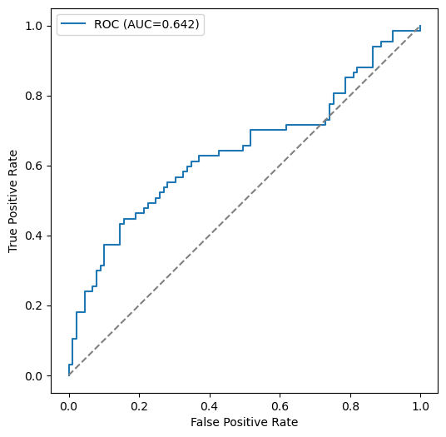 | 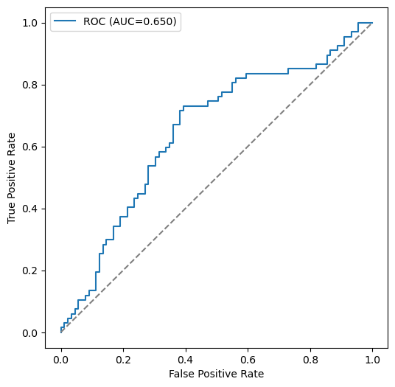 | 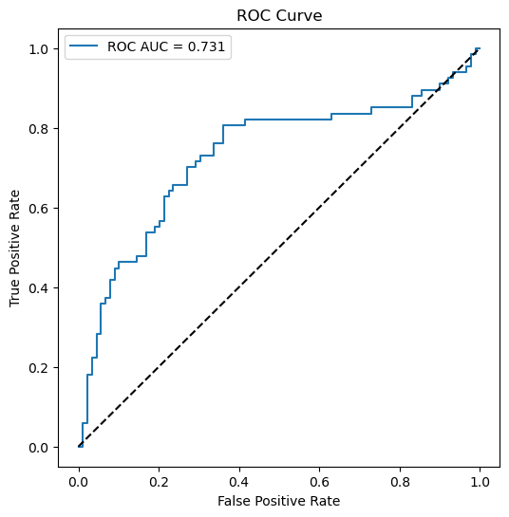

Again, for the value vs quality pair the logistic regression shows the most improvement in ranking across factor pairs with an AUC of 64.2%. Despite its linear specifications, the can decently separate distinct periods of factor leadership transition between value and quality. The GAM AUC score is only marginally above the logistic regression. The marginal stronger curvature provides evidence that smooth transformations provide limited incremental benefit to the ranking ability of the model. This further reinforces evidence from directional accuracy.
XGBoost still delivers superior performance. The earl steepness in the ROC curve emphasises the model’s ability to rank periods of genuine relative outperformance

Table 15: Value vs Quality - Walk-forward predicted probabilities and realised outcomes
Logistic | 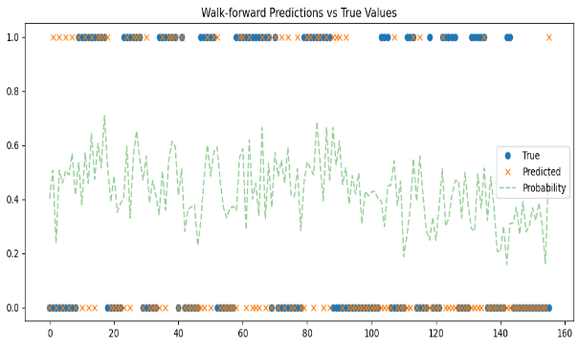
GAM | 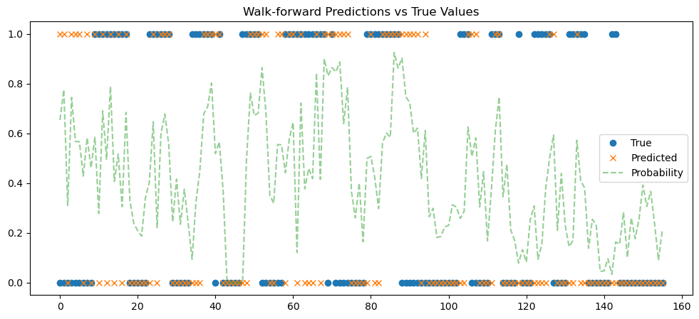
XGBoost | 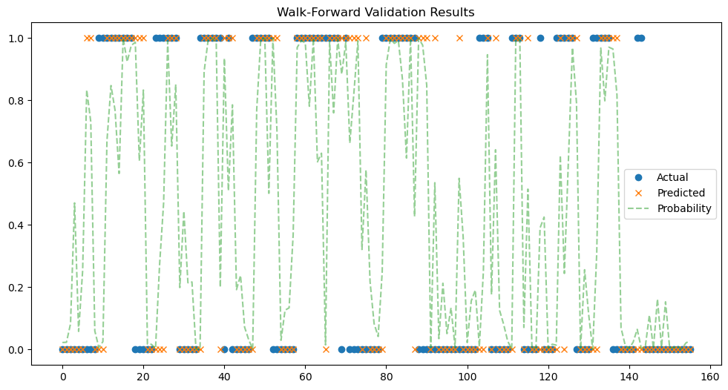

The discrimination-calibration narrative is maintained in the value vs quality factor pair as well. XGBoost excels in ranking but is overconfident, while logistic regression is well calibrated but less discriminative. Lastly, the GAM offers a modest, balanced improvement over the logistic regression.

Conclusion: XGBoost as the dominant model with factor-pair dependent gains
Predictive gains are strongly conditioned on the structural properties of the underlying factor spread. The structural relationship between the factors dictates whether model flexibility provides incremental predictive gains.
Table 16: Comparative performance gains from machine learning models across factor pairs
Factor Pair | Accuracy Gain from ML | ROC Gain from ML | Calibration Trade-Off
Momentum vs Value | Large | Large | Moderate
Momentum vs Quality | Moderate | Large | Strong
Value vs Quality | Small | Moderate | Strong

Three central patterns emerge. First, the benefits of nonlinear modeling are not uniformly distributed across factor relationships, gains in directional accuracy vary sharply by pairing. The momentum vs value pair shows the largest predictive gains, with XGBoost clearly outperforming the other models (Chen & Guestrin, 2016). Momentum vs quality shows moderate gains, while value vs quality benefits the least from the added complexity. This hierarchy highlights deeper differences in how these factors interact, suggesting that the relationship between momentum and value is far more fragmented and nonlinear than the comparatively stable dynamic between value and quality.
Second, ranking improvements are more consistent. While accuracy gains are uneven, there is a general improvement in ranking ability with complexity. XGBoost achieves the highest AUC in every single pairing. The jump is especially large for momentum vs value and, interestingly, for value vs quality. This evidence suggests that a complex model can significantly improve the ordering of predictions (separating high-probability from low-probability cases) even when its final binary classification accuracy is only slightly better (Fawcett, 2006). For the value vs quality pair, XGBoost provides much sharper probability estimates, helping to segment different regimes.
Third, increased discrimination is consistently accompanied by calibration trade-offs. This increased sharpness comes at a cost. Across the board, the more flexible the model, the worse its calibration. Logistic regression consistently produces the most reliable probability scores, as shown by its lower log-loss. XGBoost, while excellent at ranking, tends to be overconfident, pushing probabilities toward 0 or 1 more aggressively. This finding echoes a well-known machine learning trade-off: models optimised for discrimination often sacrifice calibration (Niculescu-Mizil & Caruana, 2005).
These patterns are not random but rather they stem from the inherent dynamics of the factors involved. Momentum-driven relationships are usually unstable. They are marked by sudden regime shifts, volatility clusters, and crowded trades unravelling quickly. This unstructured, nonlinear environment is where non-parametric models like XGBoost excels. It can uncover intricate decision boundaries missed by linear approaches. In contrast, the value vs quality relationship is more structured. It evolves with the broader macroeconomic cycle, exhibiting steadier co-movement. Here, the underlying relationship is more linear and persistent, so a simple model captures much of the signal, leaving less marginal gain for a complex one to exploit.
The practical takeaway is conditional. Complex machine learning models add the most value when dealing with factor pairs characterised by nonlinear, shifting interactions. For more stable, persistent relationships, a simpler, well-calibrated model is often adequate.

Feature Importance
To understand what drives each model's predictions, we used both global and local SHAP values as described in Section 3.10. SHAP provides a consistent way to measure how much each feature contributes to a model's output. For each of our three factor pairs, we identified the key predictors and interpreted their economic meaning in light of existing research.

Momentum vs Value – Factor instability and dispersion dominate
The momentum vs value pairing exhibits the clearest shift in predicative feature categories as model flexibility increases. Across the different models features describing relative dispersion and instability between the factors are the most prominent. As we move from simpler to more complex models, variables that capture differences in volatility, unstable correlations, and the spread between the factors become increasingly dominant. This makes intuitive sense. The relationship between momentum and value is known to be volatile (Daniel & Moskowitz, 2016; Kelly, Pruitt, & Su, 2019).

Table 17: Comparative feature importance across model classes for momentum vs value
 | Logistic | GAM | XGBoost
SHAP Global Feature Importance | 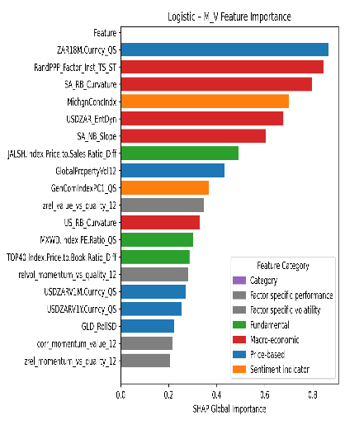 | 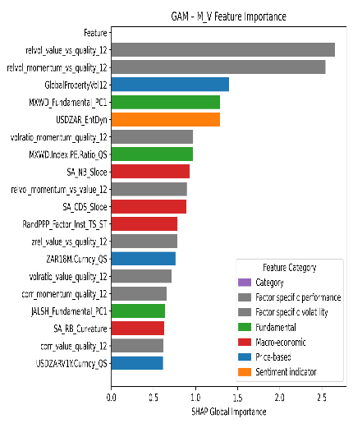 | 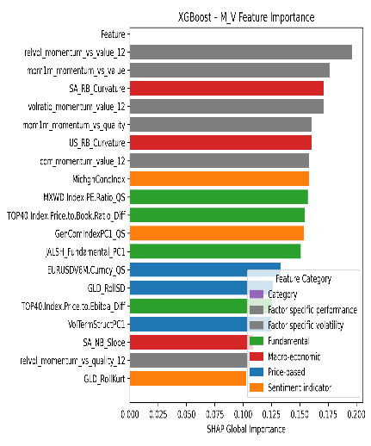
SHAP Local Decompositions | 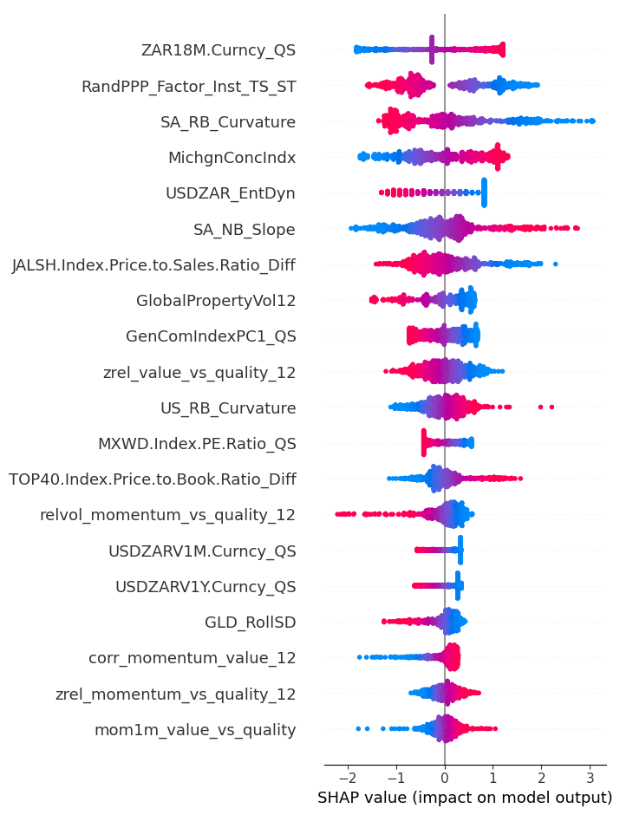 | 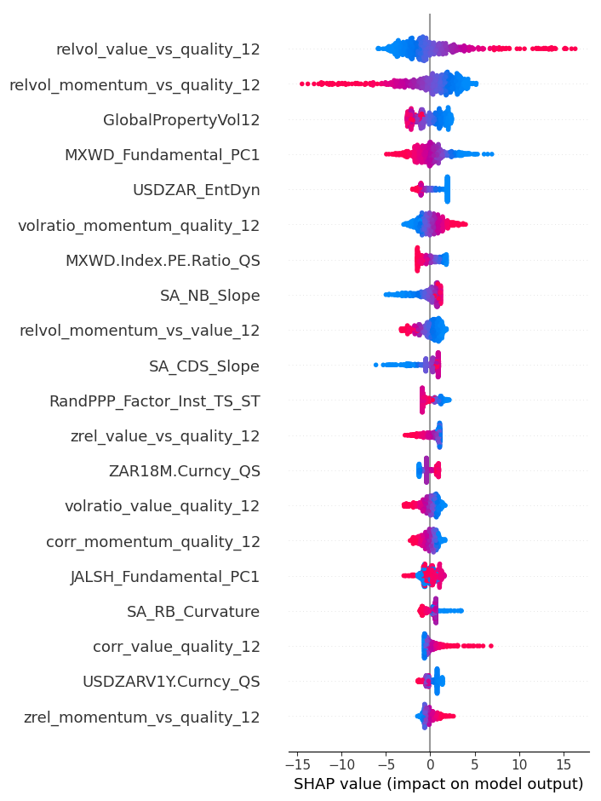 | 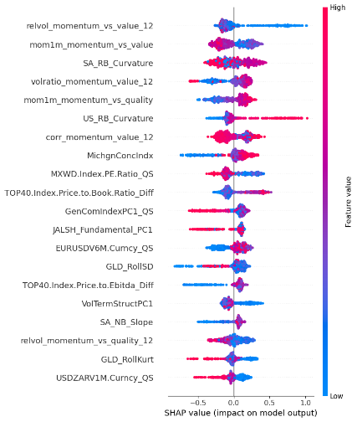

In the logistic regression specification, features with the strongest predictive power come from macroeconomic variables. The linear model seems to interpret the competition between momentum and value as being driven mostly by the overall financial regime. With the introduction of nonlinear effects in the GAM, the predictive structure shifts. Measures of relative volatility and factor dispersion rise to the top, while macro variables become somewhat less prominent. This suggests that nonlinearity allows the model to give more weight to the internal dynamics of the factor pair. These results indicate that nonlinear marginal effects amplify the predictive role of dispersion signals within the factor spread. The XGBoost model strengthens this pattern further. The most important features are almost exclusively factor-specific instability metrics, such as correlation shifts, volatility ratios, and momentum spreads. Macroeconomic variables are still present in the model, but they appear to play a secondary role.

Momentum vs Quality –Interaction between internal factor dynamics and macro environment
While internal dispersion between the factors is still important for the momentum and value pair, their influence appears to be heavily shaped by the broader market environment. Factor leadership transitions depend on both internal factor dynamics and the overall market risk environments.
Table 18: Comparative feature importance across model classes for momentum vs quality
 | Logistic | GAM | XGBoost
SHAP Global Feature Importance | 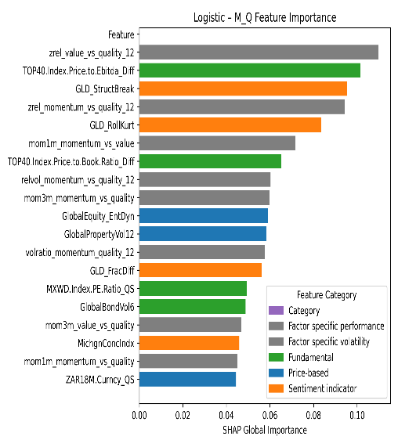 | 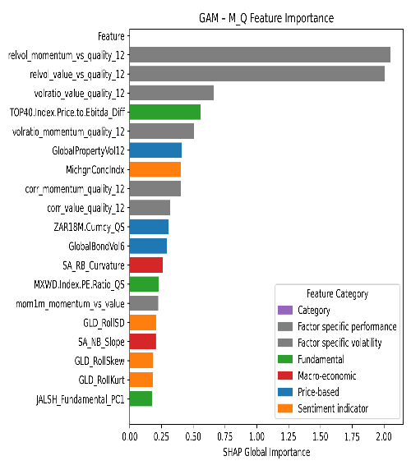 | 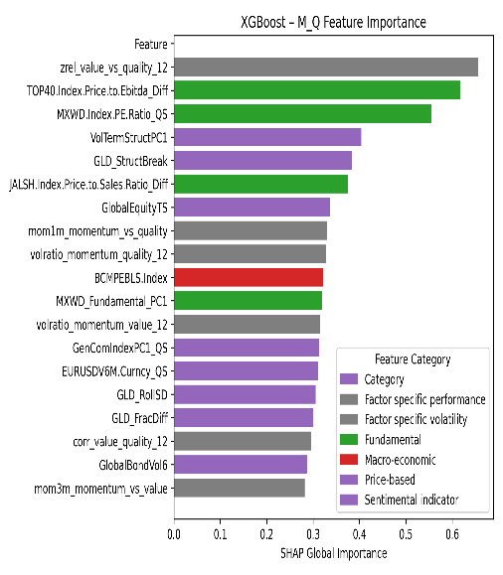
SHAP Local Decompositions | 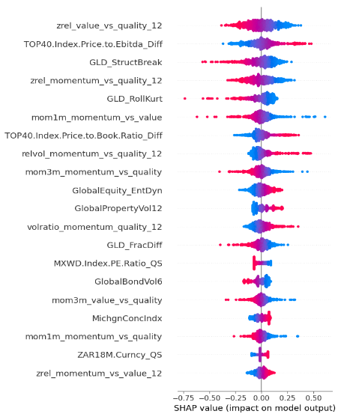 | 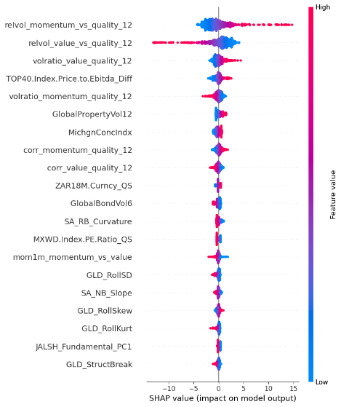 | 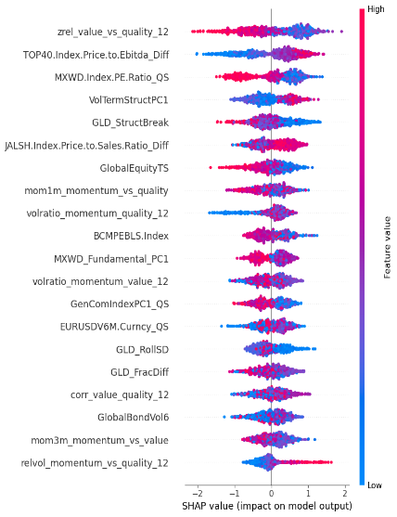

In the logistic regression model, the main predictors are relative valuation and dispersion between the two factors, with several valuation and sentiment indicators also among the important variables. This indicates that, even in a linear framework, the model picks up both relative factor dynamics and broader market signals that influence when one factor starts to outperform the other. This aligns with evidence that factor performance often reflects interactions between internal factor characteristics and evolving market conditions (Koijen, Moskowitz, Pedersen, & Vrugt, 2018).
When we introduce smooth nonlinearity with GAMs, the influence of relative factor dynamics grows while market-related indicators such as global volatility and macroeconomic variables play a secondary role. This suggests that the predictive value of factor dispersion changes may be conditioned by prevailing market environments. In other words, dispersion signals remain central, but their effectiveness depends on the current risk environment (Hastie, Tibshirani, & Friedman, 2009). This indicates that the GAM captures a more complex relationship where the effectiveness of a dispersion signal depends on the market's state.
The XGBoost reveals a more complex predictive landscape. It still prioritises factor dispersion and relative valuation indicators, but it also includes cross-asset signals like currency and commodity variables, along with broader macroeconomic indicators. Instead of replacing factor-specific signals, these variables interact with them, pointing to market conditions under which dispersion becomes most informative. This interaction-driven structure is typical of tree-based ensemble models, which are effective at detecting nonlinear interactions across diverse predictors (Chen & Guestrin, 2016). The model learns that the internal factor dynamics are most predictive when viewed through the lens of these broader market conditions.

Value vs quality – Valuation dominates across all models
The competition between value and quality factors is more straightforward and stable than the pairings involving momentum. The results point to a clear and intuitive driver, valuation gaps. Across all model types, the most significant predictors consistently measure the difference in pricing between value and quality. Simply put, when the valuation spread between them widens or narrows, it strongly signals which factor will lead. This core finding aligns perfectly with foundational research on how valuation levels drive factor returns (Fama & French, Common risk factors in the returns on stocks and bonds., 1993; Asness, Moskowitz, & Pedersen, 2013; Cakici, Fieberg, Metko, & Zaremba, 2023).

Table 19: Comparative feature importance across model classes for value vs quality
 | Logistic | GAM | XGBoost
SHAP Global Feature Importance | 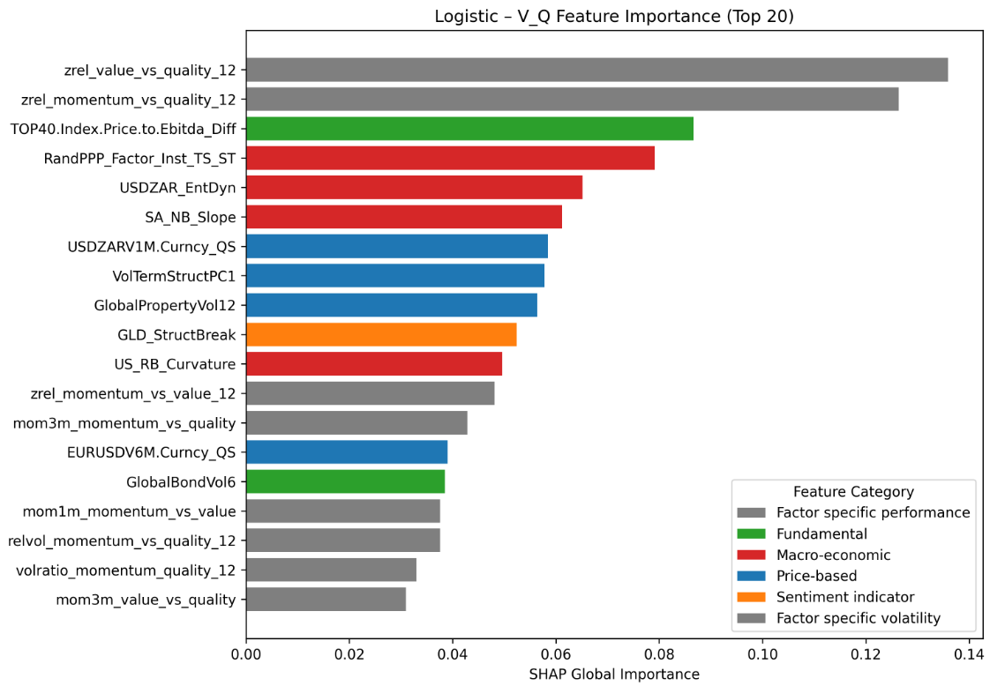 | 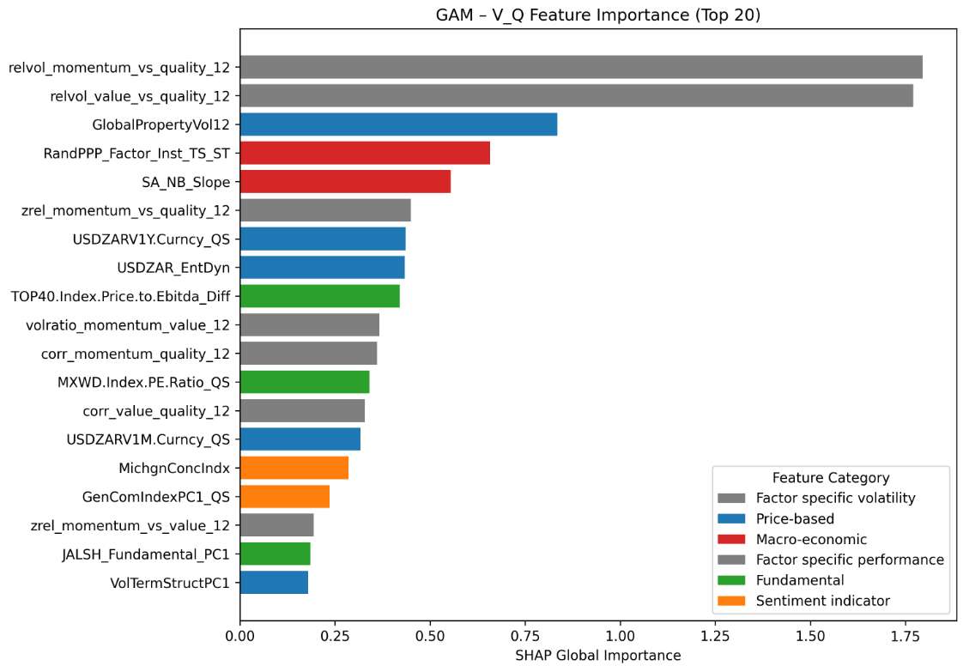 | 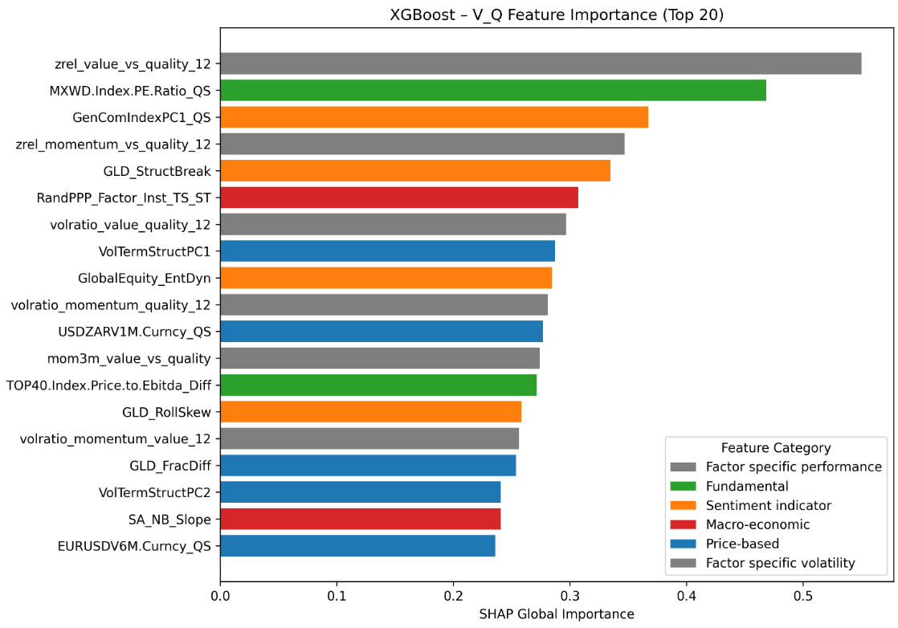
SHAP Local Decompositions | 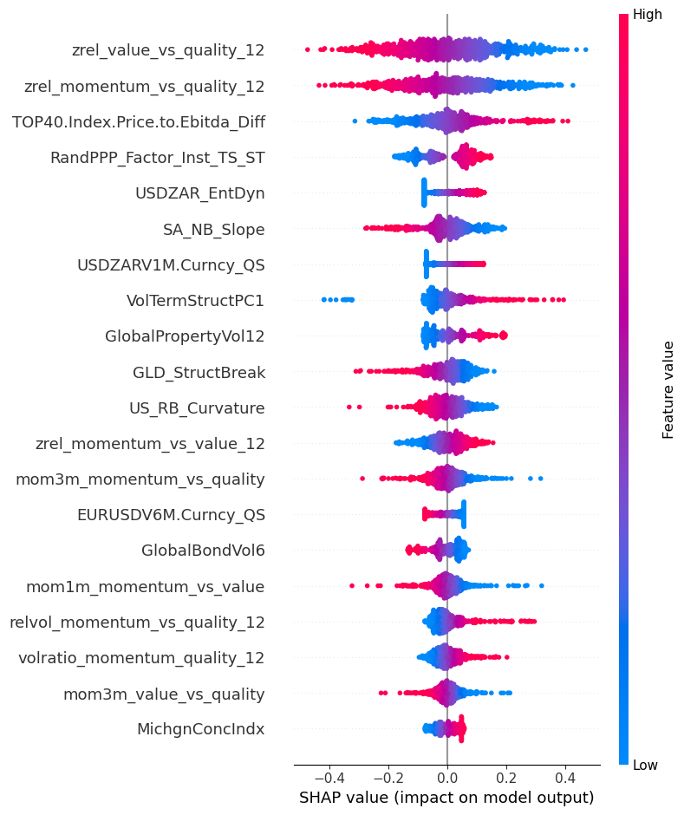 | 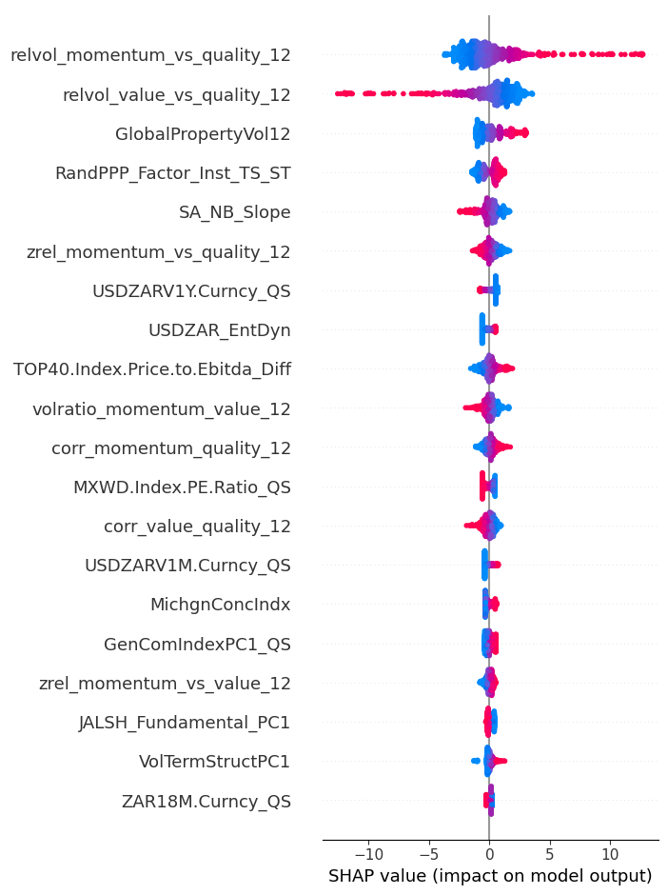 | 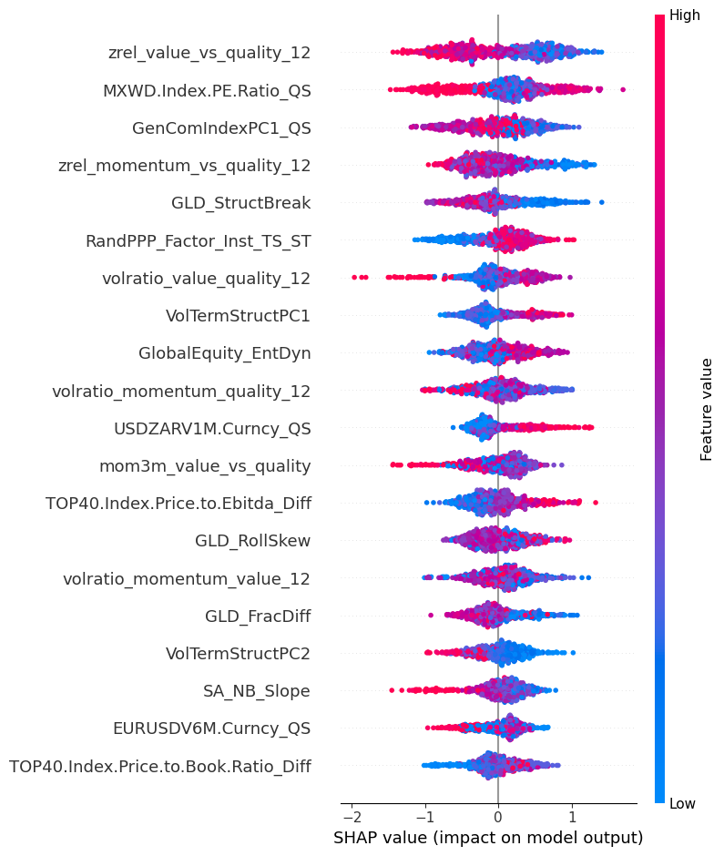

While additional predictors appear in the nonlinear specifications, they generally play a secondary role relative to valuation measures. Dispersion and volatility-related features contribute explanatory power but do not displace the primary importance of relative pricing indicators.
The logistic regression results attribute most of the predictive strength directly to structural pricing differences between value and quality. Relative valuation and momentum spread between value and quality factors emerge among the most important predictors. Cross-market indicators, including commodity-related variables and broader volatility measures, also contribute but remain less significant. The linear approach attribute most predictive strength directly to structural pricing differences.
The GAM specification reveals an additional dimension of the value vs quality relationship. measures of relative volatility between value and quality become more important. The SHAP analysis shows these features have strong, curved effects. This means the predictive power of a valuation gap isn't constant, it can be amplified or weakened by how volatile the two factors are relative to each other. Valuation is still key, but its signal is conditioned by the stability of the relationship.
Global valuation ratios and cross-sectional pricing indicators remain the dominant features even in the flexible model. Volatility and cross-asset variables are still present, but they act as contextual signals, fine tuning the prediction rather than driving it. The persistence of valuation as the top driver, even when the model has every chance to prioritize something else, reinforces the notion that relative pricing differences form the structural core of the value vs quality factor interaction.

Conclusion: Distinct drivers across factor pairs with consistent nonlinear dispersion dynamics
The feature importance analysis across the three factor pairings shows that each spread has distinct primary drivers, while also sharing some common nonlinear patterns.
For the momentum vs value spread, factor instability and dispersion measures are the dominant predictors. As models become more flexible, relative volatility and correlation instability gain prominence, reflecting the well-documented cyclical and unstable nature of this relationship (Daniel & Moskowitz, Momentum crashes, 2016; Kelly, Pruitt, & Su, 2019). The momentum vs quality spread shows a hybrid structure. Internal dispersion signals remain important but interact with broader market conditions, suggesting leadership shifts depend partly on the macro environment, with dispersion providing timing cues and market variables acting as conditioners. In contrast, the value vs quality spread is anchored in valuation differentials. Across all models, relative pricing gaps consistently rank as the most influential predictors, indicating a structural, economically intuitive driver (Fama & French, Common risk factors in the returns on stocks and bonds., 1993; Asness, Moskowitz, & Pedersen, 2013; Cakici, Fieberg, Metko, & Zaremba, 2023). Dispersion and volatility variables here play a secondary, conditioning role.
A recurring pattern across all three pairings is the prominence of volatility and dispersion measures in nonlinear models. This suggests dispersion dynamics represent a common nonlinear component of factor interactions, even when the primary economic drivers differ. Flexible modelling approaches are particularly useful for capturing these effects, revealing periods where shifts in dispersion alter the likelihood of leadership transitions. The comparison highlights that more flexible models do not merely add complexity. Instead, they allow distinct structural mechanisms for each spread to emerge while also uncovering shared nonlinear dynamics in how factors interact.

Validation methodology impact
This section evaluates how the validation framework described in Chapter 3 influences the robustness and credibility of the empirical results. The models are assessed using a rolling walk-forward procedure combined with periodic hyperparameter optimisation via combinatorial purged cross-validation (CPCV), which is specifically designed for financial time-series with overlapping information sets and temporal dependence (Lopez de Prado M. , 2018; Gu, Kelly, & Xiu, 2020).
In each iteration, models are estimated using a 773-week rolling training window and evaluated over a strictly out-of-sample horizon of 156 weeks. Within this horizon, hyperparameters are re-optimised every 52 weeks using CPCV, after which the updated configuration is applied to the subsequent prediction segment. This design preserves chronological separation between training and evaluation data while allowing model parameters to adjust gradually to evolving market conditions.
Tables 20 to 22 report the optimal hyperparameter configurations selected at each retuning interval together with the corresponding out-of-sample ROC AUC. These results provide insight into two key properties of the validation framework which are the stability of predictive performance across successive unseen segments and the degree to which model complexity adapts under CPCV discipline.

Logistic Regression - Structural stability under CPCV retuning
Under the sliding-window architecture, logistic regression continues to exhibit a high degree of structural stability across retuning cycles.

Table 20: Logistic - Best parameter combination set across walk-forward segments
 | Walk-forward Period |  | Best Parameter Combinations
 | Start | End | ROC AUC | L1/L2 mixing ratio (α) | Base score | Regularization strength (λ) | Learning rate | Iterations
Momentum vs Value | 2022-04-11 | 2023-04-10 | 0.550 | 0 | 0.7 | 0.01 | 0.1 | 2000
Momentum vs Value | 2023-04-10 | 2024-04-08 | 0.483 | 0 | 0.5 | 0.1 | 0.01 | 500
Momentum vs Value | 2024-04-08 | 2025-04-07 | 0.546 | 1 | 0.7 | 0.1 | 0.01 | 500
Momentum vs Quality | 2022-04-11 | 2023-04-10 | 0.525 | 1 | 0.5 | 0.1 | 0.01 | 500
Momentum vs Quality | 2023-04-10 | 2024-04-08 | 0.564 | 1 | 0.5 | 0.1 | 0.01 | 500
Momentum vs Quality | 2024-04-08 | 2025-04-07 | 0.588 | 0 | 0.7 | 0 | 0.01 | 500
Value vs Quality | 2022-04-11 | 2023-04-10 | 0.552 | 1 | 0.5 | 0.1 | 0.01 | 500
Value vs Quality | 2023-04-10 | 2024-04-08 | 0.551 | 0 | 0.5 | 0.1 | 0.01 | 1000
Value vs Quality | 2024-04-08 | 2025-04-07 | 0.612 | 0.5 | 0.5 | 0.1 | 0.01 | 100

The optimal parameter combinations vary modestly across windows, but the core configuration of the model remains broadly consistent. In particular, the regularisation strength (λ) and learning rate converge to similar values across most windows, with λ generally stabilising around 0.1 and learning rates settling at 0.01 after the initial retuning cycle.
The CPCV procedure selects a mixture of ridge, lasso, and elastic-net penalties across the different factor pairings. For the momentum vs value, the model alternates between ridge andLASSO regularisation across the three walk-forward windows. Momentum vs quality exhibits a slightly stronger preference for L1-type shrinkage in the earlier windows before reverting to ridge regularisation in the final period. In the value vs quality pairing, CPCV selects ridge, lasso, and elastic-net penalties across the windows, indicating modest variation in the optimal shrinkage structure. Despite these shifts in the L1/L2 mix ratio, the overall parameter space explored by the model remains narrow. Regularisation strength varies little across windows, and the number of boosting iterations converges toward approximately 500 iterations in most cases. This suggests that while CPCV occasionally adjusts the shrinkage structure to accommodate evolving data conditions, the underlying linear specification remains fundamentally stable.

Generalised Additive Models – Factor dependant tuning structure
The generalized additive model exhibits a stable but factor-dependent retuning structure across the walk-forward windows. While the optimal parameter combinations vary slightly across windows, the spline complexity and smoothness penalties selected by CPCV remain relatively consistent within each factor pairing. This pattern suggests that the nonlinear structure captured by the GAM is persistent but varies in strength depending on the economic relationship between the factors.
Table 21: GAM - Best parameter combination set across walk-forward segments
 | Walk-forward Period |  | Best Parameter Combinations
 | Start | End | ROC AUC | No. of splines | Smoothness penalty (λ) | Maximum iterations
Momentum vs Value | 2022-04-11 | 2023-04-10 | 0.582 | 10 | 1 | 200
Momentum vs Value | 2023-04-10 | 2024-04-08 | 0.573 | 10 | 1 | 500
Momentum vs Value | 2024-04-08 | 2025-04-07 | 0.548 | 7 | 1 | 200
Momentum vs Quality | 2022-04-11 | 2023-04-10 | 0.491 | 5 | 100 | 200
Momentum vs Quality | 2023-04-10 | 2024-04-08 | 0.528 | 5 | 100 | 200
Momentum vs Quality | 2024-04-08 | 2025-04-07 | 0.538 | 5 | 100 | 200
Value vs Quality | 2022-04-11 | 2023-04-10 | 0.536 | 5 | 1 | 200
Value vs Quality | 2023-04-10 | 2024-04-08 | 0.565 | 7 | 1 | 200
Value vs Quality | 2024-04-08 | 2025-04-07 | 0.594 | 7 | 10 | 500

For the momentum vs value pair, CPCV consistently selects relatively flexible spline structures, with 10 splines in the first two windows and 7 splines in the final window, while maintaining a smoothness penalty of λ = 1 across all retuning periods. This configuration indicates that the model allows moderate nonlinear curvature while avoiding excessive overfitting. The stability of the smoothness parameter suggests that the nonlinear dispersion dynamics identified earlier in the feature importance analysis remain structurally consistent across regimes.
The momentum vs quality pair displays a markedly different parameter profile. In this case, CPCV consistently selects five splines combined with a very strong smoothness penalty (λ = 100) across all windows. This combination effectively constrains the GAM toward a near-linear structure. The high penalty indicates that the model detects limited nonlinear curvature in the relationship between predictors and the momentum vs quality spread, reinforcing earlier findings that this pairing exhibits a hybrid structure where dispersion signals interact with broader market conditions rather than producing strong nonlinear regime boundaries.
For the value vs quality pair, the GAM selects moderate spline complexity, with the number of splines increasing from five to seven in the later windows. The smoothness penalty remains low in the first two windows (λ = 1) before increasing modestly in the final period (λ = 10). This pattern suggests the presence of mild nonlinear relationships, though considerably less pronounced than those observed in the momentum vs value pair.
Taken together, the GAM retuning results reveal a clear structural hierarchy across factor pairings. The momentum vs value factor pair exhibits the strongest nonlinear structure, requiring greater spline flexibility to capture feature dynamics. Momentum vs quality displays much weaker curvature, leading CPCV to impose strong smoothing constraints. Value vs quality lies between these extremes, with moderate nonlinear effects that remain relatively stable across retuning windows.

XGBoost - Adaptive interaction structure with parameter stability
The XGBoost model displays a more adaptive retuning structure than the linear and additive models, reflecting the greater flexibility of tree-based learning. While the optimal parameter combinations vary across walk-forward windows, several parameters converge toward stable values, suggesting that the interaction structure captured by the model remains broadly consistent across regimes.

Table 22: XGBoost - Best parameter combination set across walk-forward segments
 | Walk-forward Period |  | Best Parameter Combinations
 | Start | End | ROC AUC | Base score | Colsample_bytree | Learning rate | Max depth | Subsample
Momentum vs Value | 2022-04-11 | 2023-04-10 | 0.584 | 0.6 | 0.8 | 0.1 | 3 | 0.6
Momentum vs Value | 2023-04-10 | 2024-04-08 | 0.571 | 0.7 | 0.6 | 0.5 | 6 | 1
Momentum vs Value | 2024-04-08 | 2025-04-07 | 0.572 | 0.5 | 0.6 | 0.5 | 3 | 0.6
Momentum vs Quality | 2022-04-11 | 2023-04-10 | 0.558 | 0.5 | 1 | 0.5 | 10 | 0.6
Momentum vs Quality | 2023-04-10 | 2024-04-08 | 0.544 | 0.5 | 0.6 | 0.5 | 6 | 0.6
Momentum vs Quality | 2024-04-08 | 2025-04-07 | 0.602 | 0.5 | 1 | 0.5 | 10 | 0.6
Value vs Quality | 2022-04-11 | 2023-04-10 | 0.547 | 0.5 | 1 | 0.5 | 10 | 0.8
Value vs Quality | 2023-04-10 | 2024-04-08 | 0.570 | 0.5 | 0.8 | 0.5 | 6 | 1
Value vs Quality | 2024-04-08 | 2025-04-07 | 0.575 | 0.6 | 1 | 0.5 | 10 | 0.8

Across all factor pairings, the learning rate stabilises at 0.5 after the initial retuning cycle, indicating that the model converges toward a relatively aggressive boosting configuration once the training process stabilises. Feature subsampling parameters also remain within a narrow range, generally varying between 0.6 and 1.0, suggesting that the model consistently relies on a broad subset of predictors rather than a small specialised set.
For the momentum vs value pair, the optimal tree depth varies between 3 and 6 levels across the walk-forward windows. This relatively shallow structure indicates that while nonlinear interactions are present, they can largely be captured through a limited number of hierarchical decision boundaries. Subsampling parameters fluctuate modestly across windows, reflecting some sensitivity to evolving market regimes but without large structural shifts in the model configuration.
The momentum vs quality spread exhibits a noticeably deeper tree structure. CPCV selects tree depths of 6 to 10 levels, indicating a more complex interaction architecture. This deeper structure suggests that the predictive relationships within the momentum vs quality pair involve multiple interacting predictors rather than a small number of dominant thresholds. The need for deeper trees is consistent with the hybrid feature importance structure identified earlier, where internal factor dispersion interacts with macro-financial conditioning variables.
For the value vs quality pair, the optimal parameter combinations are broadly similar to those observed for momentum vs quality. Tree depths range between 6 and 10 levels, while feature subsampling remains relatively high. This pattern suggests that while the underlying predictive signal may be anchored in valuation dispersion, the interaction structure through which this signal manifests in the data still benefits from hierarchical segmentation.
Taken together, the XGBoost retuning results indicate that tree-based models capture interaction structures that differ across factor pairings but remain relatively stable across time. Momentum vs value dynamics require only moderate interaction depth, while momentum vs quality and value vs quality benefit from deeper trees capable of modelling more complex predictor interactions. These findings reinforce the earlier results from the feature importance analysis, which highlighted differing structural drivers across factor spreads while also identifying nonlinear dispersion dynamics as a common component of factor interactions.

Conclusion: Stable predictive performance across walk-forward segments
Examining predictive discrimination across the walk-forward evaluation segments reveals that model performance evolves gradually rather than exhibiting abrupt shifts following parameter retuning. Across all model classes, ROC–AUC values vary moderately between successive 52-week prediction segments within each 156-week evaluation horizon. These changes reflect evolving market conditions and factor dynamics rather than instability in the validation procedure.
For the logistic regression specification, predictive discrimination remains broadly stable across retuning intervals. ROC–AUC values fluctuate modestly across walk-forward segments for each factor pairing, but the changes occur gradually rather than immediately following retuning points. This pattern indicates that the CPCV-based recalibration adjusts model parameters incrementally in response to evolving data conditions rather than fitting transient patterns in the training sample. As noted by (Gu, Kelly, & Xiu, 2020), disciplined validation procedures tend to compress performance dispersion while improving the reliability of out-of-sample estimates.
The GAM specification exhibits a comparable stability pattern. Although the model allows nonlinear relationships through spline functions, predictive discrimination evolves smoothly across successive evaluation segments. Changes in ROC–AUC occur alongside modest adjustments in spline complexity and smoothing penalties but do not display abrupt increases following parameter updates. Under weaker validation schemes, nonlinear models often exhibit exaggerated fold-to-fold variability due to implicit information leakage or repeated reuse of overlapping observations (Lopez de Prado M. , 2018). The absence of such volatility in the present results suggests that the sliding-window CPCV framework successfully moderates the variance typically associated with flexible nonlinear models while still allowing them to adapt to changing market structures.
A similar pattern is observed for the XGBoost specification, despite its substantially greater structural flexibility. Tree depth, learning rates, and subsampling ratios adjust across retuning intervals, reflecting evolving interaction structures among the predictors. Nevertheless, predictive performance evolves gradually across successive walk-forward segments rather than displaying abrupt increases following hyperparameter recalibration. This behaviour indicates that the CPCV retuning mechanism limits the boosting algorithm from exploiting short-term noise while still enabling the model to adjust to shifts in factor relationships.

Conclusion

Overview of the study
This study investigated whether machine learning methods can enhance the timing of equity style factors in the South African equity market. The empirical analysis focused on three widely documented factors, momentum, value, and quality, and evaluated the feasibility of forecasting their relative performance using supervised learning techniques.
Motivated by the cyclical and regime-dependent nature of factor premia, the study framed the timing problem as a binary classification task predicting the relative outperformance between factor pairs. The modelling framework incorporated several methodological safeguards to ensure statistical robustness. Binary labels were constructed using the trend-scanning procedure proposed by López de Prado, which identifies statistically dominant forward-looking trends without imposing a fixed prediction horizon. The feature universe combined market indicators, macroeconomic variables, sentiment proxies, and valuation measures, reflecting the multidimensional drivers of factor returns documented in the asset pricing literature.
To manage the high dimensionality of the predictor space, mutual-information-based clustering was applied to reduce redundancy while preserving nonlinear dependencies between variables. The predictive performance of three model classes was then evaluated. Hyperparameters were optimized using Combinatorial Purged Cross-Validation (CPCV), and final model performance was assessed using a rolling walk-forward evaluation framework designed to simulate real-time deployment.
Together, this structured empirical framework enabled a disciplined comparison of linear, semi-parametric, and nonlinear modelling approaches for factor timing in an emerging market environment.

Summary of key findings
Several important findings emerge from the empirical analysis.
First, the results demonstrate that machine learning models are capable of extracting predictive signals from the dynamics of South African style factors. Across all factor pairs, the nonlinear models consistently outperform the linear benchmark in out-of-sample classification accuracy and ranking ability. This finding supports the growing body of international literature suggesting that factor premia are influenced by complex, nonlinear interactions among market and macroeconomic variables.
Second, predictive performance improves systematically as model flexibility increases. Logistic regression provides the weakest results, indicating that linear functional forms struggle to capture the complex interactions underlying factor rotations. GAM improves predictive performance by allowing smooth nonlinear transformations of predictors, capturing gradual regime effects that linear models cannot represent. XGBoost delivers the strongest results overall, demonstrating the value of flexible tree-based models capable of modelling high-order nonlinearities and interactions among predictors.
Third, the strength of predictability varies across factor pairs. The momentum vs value pair exhibits the strongest predictive structure across all models, suggesting that these two styles experience more pronounced and persistent regime transitions. Momentum vs quality shows moderate predictability, while value vs quality demonstrates the weakest predictive signal. This heterogeneity indicates that factor timing opportunities are not uniform across styles and depend on the structural characteristics of the factor spread.
Fourth, feature importance analysis reveals distinct economic drivers across the factor pairings. The momentum vs value spread is primarily influenced by variables capturing factor instability and dispersion, such as relative volatility and correlation dynamics. Momentum vs quality exhibits a hybrid structure in which factor dispersion signals interact with broader macro-financial conditions. The value vs quality pair is largely anchored in valuation differentials between the two strategies. Despite these differences, dispersion-related variables emerge consistently across models, suggesting that nonlinear dispersion dynamics represent a common structural component of factor interactions.
Fifth, the results highlight the trade-off between predictive accuracy and probability calibration. While XGBoost produces the strongest classification and ranking performance, it also generates less well-calibrated probability forecasts relative to logistic regression. This finding is consistent with prior research demonstrating that highly flexible models often maximize discrimination at the cost of probability reliability.
Finally, the stability of predictive performance across walk-forward windows suggests that the modelling framework successfully mitigates overfitting and temporal leakage. The combination of CPCV hyperparameter tuning and rolling walk-forward evaluation provides a robust validation architecture capable of generating realistic estimates of model performance in financial time-series environments.

Implications for factor timing and quantitative asset management
The findings of this study carry several implications for quantitative asset management and factor-based investment strategies.
First, the results reinforce the notion that factor returns exhibit nonlinear and regime-dependent dynamics. Traditional linear econometric models may therefore be insufficient to capture the complex interactions between macroeconomic conditions, market sentiment, and style factor performance. Machine learning methods provide a flexible alternative capable of approximating these nonlinear relationships.
Second, the results highlight the importance of aligning model complexity with the underlying economic structure of the factor pair. While flexible models such as XGBoost can uncover nonlinear interaction effects, simpler models remain competitive when the predictive structure is largely linear or valuation-driven. The empirical results therefore suggest that model selection should be guided by the economic characteristics of the factor relationship rather than by model complexity alone.
Third, the methodological framework employed in this study demonstrates the value of disciplined validation procedures in financial machine learning applications. Techniques such as purged cross-validation, walk-forward evaluation, and information-theoretic feature reduction are essential to ensure that predictive gains reflect genuine signal rather than artefacts of data leakage or sample-specific noise.
Finally, the study provides empirical support for the potential role of machine learning in dynamic factor allocation. By identifying shifts in relative factor leadership, ML-based models may assist portfolio managers in adjusting exposures across style premia in response to evolving market conditions.

Limitations of the study
Despite these contributions, several limitations should be acknowledged.
First, the analysis focuses on predictive accuracy rather than full portfolio implementation. Transaction costs, turnover, and liquidity constraints were not incorporated into the evaluation framework. These factors may materially affect the realized economic performance of factor timing strategies.
The second limitation relates to the definition of the underlying factor portfolios. In this study, the momentum, value, and quality factors are constructed using proprietary definitions derived from the investment framework of a professional asset manager. While these definitions reflect practical implementation in an institutional investment context, alternative factor constructions may produce different return dynamics and predictive relationships. Prior research has shown that factor performance can vary meaningfully depending on the choice of signals, weighting schemes, rebalancing frequency, and universe definitions. As a result, the predictive relationships identified in this study may depend partly on the specific factor definitions employed.
Furthermore, the study concentrates on three style factors—momentum, value, and quality. While these represent widely validated return premia, other factors such as size, low volatility, or profitability may also exhibit time-varying behaviour that could influence predictive performance. Future research could extend the analysis by testing alternative factor construction methodologies or by comparing results across multiple factor definitions to assess the robustness of the timing signals.
A third limitation relates to the feature selection procedure. The study employs an information-theoretic clustering approach based on mutual information to reduce redundancy in the predictor space. This method groups highly similar variables and selects representative features from each cluster, thereby mitigating multicollinearity and reducing dimensionality. However, the procedure prioritises statistical similarity between predictors rather than their direct predictive contribution to the target variable. As a result, some variables with strong predictive power may be excluded if they belong to clusters dominated by other highly correlated features. While this approach improves model stability and computational efficiency, it may not necessarily produce the feature set that maximises predictive accuracy.
Forth, the empirical analysis is limited to the South African equity market. Although this provides valuable insight into an emerging market context, the results may not generalise fully to other markets with different structural characteristics.
Finally, the modelling framework relies on weekly data and a finite historical sample. Although robust validation procedures were applied, the limited sample size inherent in financial datasets may constrain the stability of highly complex models.

Recommendations for future research
Several avenues for future research emerge from this study.
First, future work should extend the analysis to portfolio implementation by incorporating transaction costs, turnover constraints, and portfolio construction rules. Evaluating the economic value of ML-driven factor timing strategies requires translating predictive signals into investable portfolios.
Second, future research could also explore hybrid feature selection frameworks. While this study employs information-theoretic clustering to reduce redundancy among predictors, the method does not explicitly evaluate the predictive contribution of individual variables. Combining information-based clustering with supervised feature selection techniques may help retain stable feature structures while improving the identification of predictors with strong predictive relevance.
Thirdly, the application of ensemble frameworks that combine predictions from multiple model classes may improve robustness. Hybrid approaches integrating linear models, additive models, and tree-based learners may better balance interpretability and predictive performance.
Finally, future research could explore cross-market generalisation by applying similar methodologies to other emerging markets. Comparative analysis across regions would provide valuable insight into how market structure influences the effectiveness of machine learning in factor timing.

Concluding remarks
This study provides empirical evidence that machine learning techniques can enhance the prediction of relative style factor performance in the South African equity market. By comparing linear, semi-parametric, and nonlinear models within a rigorous validation framework, the research demonstrates that increased model flexibility can yield meaningful improvements in predictive performance. At the same time, the results underscore the importance of disciplined methodological design. Robust validation procedures, careful feature construction, and economically grounded interpretation are essential to ensure that machine learning applications in finance produce reliable and actionable insights. Overall, the findings contribute to the growing literature on financial machine learning and highlight the potential of data-driven approaches for understanding the complex dynamics of factor premia in emerging market

References
Adrian, T., & Brunnermeier, M. (2016). CoVaR. American Economic Review, 1705–1741.
Alonso, M. N., & Zoonekynd, V. (2022). Equity Machine Factor Models. Abu Dhabi: Social Science Research Network.
Ang, A., & Timmermann, A. (2012). Regime changes and financial markets. Annual Review of Financial Economics, 313–337.
Arnott, R., Beck, N., Kalesnik, V., & West, J. (2016). How can "smart beta" go horribly wrong? The Journal of Portfolio Management, 42(2), 36-44.
Arnott, R., Kalesnik, V., & Linnainmaa, J. (2023). Factor momentum. Review of Financial Studies, 36(8), 2379-2420.
Asness, C., Frazzini, A., & Pedersen, L. 2. (2019). Quality minus junk. Review of Accounting Studies, 24(1), 34-112.
Asness, C., Friedman, J., Krail, R., & Liew, J. (2000). Style Timing - Value versus Growth. The Journal of Portfolio Management, 26(3), 1.
Asness, C., Moskowitz, T., & Pedersen, L. (2013). Value and momentum everywhere. The Journal of Finance, 68(3), 929-985.
Bartram, S., Lohre, H., Pope, P., & Ranganathan, A. (2021). Navigating the factor zoo around the world: an institutional investor perspective. Journal of Business Economics, 91(5), 655-703.
Bellman, R. (1957). A Stochastic Multi-Stage Decision Process (1 ed.). New Jersey: Princeton University Press.
Bengio, Y., Simard, P., & Frasconi, P. (1994). Learning long-term dependencies with gradient descent is difficult. IEEE Transactions on Neural Networks, 5(2), 157-166.
Beraha, M., Metelli, A. M., Papini, M., Tirinzoni, A., & & Restelli, M. (2019). Feature Selection via Mutual Information: New Theoretical Insights. (pp. 1-9). Bologna and Italy.: IEEE Xplore.
Bergmeir, C., & Benítez, J. (2012). On the use of cross-validation for time series predictor evaluation. Information Sciences., 192-213.
Bessler, W. (2021). Factor investing and asset allocation strategies. Journal of Asset Management, 22(1), 1-18.
Bishop, C. M. (2006). Pattern Recognition and Machine Learning. (1 ed.). New York: Springer.
Blitz, D. C. (2007). The volatility effect: Lower risk without lower return. Journal of Portfolio Management, 34(1), 102-113.
Blitz, D., Falkenstein, E., & van Vliet, P. (2014). Explanations for the Volatility Effect: An Overview Based on the CAPM Asset Pricing Context. The Journal of Portfolio Management, 40(3), 61-67.
Breiman, L. (1996). Bagging Predictors. Machine Learning, 24(2), 123-140.
Breiman, L. (2001). Random Forests. Machine Learning, 45(1), 5-32.
Breiman, L., Friedman, J., Olshen, R., & Stone, C. (1984). Classification and Regression Trees (1 ed.). New York: Chapman and Hall/CRC.
Brunnermeier, M., & Oehmke, M. (2013). The maturity rat race. Journal of Finance, 483–521.
Bryzgalova, S., Pelger, M., & Zhu, J. (2023). Forest Through the Trees: Building Cross-Sections of Stock Returns. London: S&P Market Intelligence.
Cakici, N., Fieberg, C., Metko, D., & Zaremba, A. (2023). Machine learning goes global: Cross-sectional return predictability in international stock markets. Journal of Economic Dynamics and Control, 155(104725), 1.
Campbell, J. Y., Lo, A. W., & MacKinlay, A. C. (1997). The Econometrics of Financial Markets. (2 ed.). New Jersey: Princeton University Press.
Carhart, M. M. (1997). On Persistence in Mutual Fund Performance. Journal of Finance, 52(1), 57-82.
Carhart, M. M. (1997). On Persistence in Mutual Fund Performance. Journal of Finance, 52(1), 1.
Chen, L., Pelger, M., & Zhu, J. (2019). Deep Learning in Asset Pricing. SSRN Electronic Journal, 1-76.
Chen, T., & Guestrin, C. (2016). XGBoost: A Scalable Tree Boosting System. San Francisco: ACM Digital Library.
Chordia, T., & Shivakumar, L. (2002). Momentum, business cycle, and time-varying expected returns. The Journal of Finance, 57(2), 985-1019.
Chung, J., Gulcehre, C., Cho, K., & Bengio, Y. (2014). Empirical evaluation of gated recurrent neural networks on sequence modeling. arXiv preprint arXiv:1412.3555, 1.
Cochrane, J. (2011). Presidential address: Discount rates. Journal of Finance, 1047–1108.
Cont, R. (2001). Empirical Properties of Asset Returns: Stylized Facts and Statistical Issues. Quantitative Finance, 1(2), 223-236.
Cotturo, P., Liu, F., & Proner, R. (2024). Multi-Factor Timing with Deep Learning. SSRN, 1(1), 1.
Cover, T., & Thomas, J. (2006). Elements of Information Theory. New York: Wiley.
Daniel, K., & Moskowitz, D. J. (2016). Momentum crashes. Journal of Financial Economics, 122(2), 221-247.
Daniel, K., Hirshleifer, D., & Subrahmanyam, A. (1998). Investor Psychology and Security Market Under and Overreactions. Journal of Finance, 53(6), 1839-1885.
DeMiguel, V., Garlappi, L., & Uppal, R. (2009). Optimal versus Naive Diversification: How Inefficient Is the 1/N Portfolio Strategy? The Review of Financial Studies, 22(5), 1915-1953.
Dietterich, T. (2000). Ensemble Methods in Machine Learning. The First International Workshop on Multiple Classifier Systems (pp. 1-15). Berlin: Springer.
Dixon, M., Klabjan, D., & Bang, J. H. (2017). Classification-based Financial Markets Prediction using Deep Neural Networks. Arxiv, 1(1), 1.
Fama, E. F., & French, K. R. (1992). The Cross-Section of Expected Stock Returns. The Journal of Finance, 47(2), 427-465.
Fama, E., & French, K. (1989). Business conditions and expected returns on stocks and bonds. ournal of Financial Economics, 23–49.
Fama, E., & French, K. (1993). Common risk factors in the returns on stocks and bonds. Journal of Financial Economics, 33(1), 3-56.
Fama, E., & French, K. (2015). A five-factor asset pricing model. Journal of Financial, 116(1), 1-22.
Fama, E., & French, K. (2015). A five-factor asset pricing model. Journal of Financial, 116(1), 1-22.
Fang, Y., Chen, Y., & Ren, H. (2022). A Factor Pricing Model Based on Machine Learning Algorithm. Social Science Research Network, 1(1), 1.
Fawcett, T. (2006). An introduction to ROC analysis. Pattern Recognition Letters,, 861–874.
Feng, G., Giglio, S., & Xiu, D. (2020). Taming the Factor Zoo. Journal of Finance, 75(3), 1327-1370.
Feng, G., He, J., Polson, N. G., & Xu, J. (2023). Deep Learning in Characteristics-Sorted Factor Models. Journal of Financial and Quantitative Analysis, 3001-3036.
Fischer, T., & Krauss, C. (2018). Deep learning with long short-term memory networks for financial market predictions. European Journal of Operational Research, 654-669.
Friedman, J. (2001). Greedy function approximation: A gradient boosting machine. The Annals of Statistics, 29(5), 1189-1232.
Giglio, S., Kelly, B., & Xiu, D. (2022). Factor models, machine learning, and asset pricing. Annual Review of Financial Economics, 14(1), 1-32.
Goodfellow, I., Bengio, Y., & Courville, A. (1994). Deep Learning (1 ed.). Cambridge: MIT Press.
Goodfellow, I., Bengio, Y., & Courville, A. (2016). Deep learning. MA: MIT Press.
Gu, S., Kelly, B., & Xiu, D. (2020). Empirical Asset Pricing via Machine Learning. The Review of Financial Studies, Volume 33, Issue 5, 2223–2273.
Gupta, A., & Kelly, B. (2019). Factor momentum everywhere. Journal of Portfolio Management, 45(3), 13-36.
Guyon, I., & Elisseeff, A. (2003). An introduction to variable and feature selection. Journal of Machine Learning Research, 1157–1182.
Han, Y. (2024). Machine Learning Based Portfolio Analysis. Highlights in Business, Economics and Management, 44(1), 1.
Harvey, C., Liu, Y., & Zhu, H. (2016). ...and the Cross-Section of Expected Returns. The Review of Financial Studies, 29(1), 5-68.
Hastie, T. J., & Tibshirani, R. (1986). Generalized Additive Models. Statistical Science, 1(3), 297-310.
Hastie, T. T., & Friedman, J. (2009). The Elements of Statisitcal Learning (2 ed.). New York: Springer.
Hastie, T. T., & Friedman, J. (2009). The Elements of Statisitcal Learning (2 ed.). New York: Springer.
Hastie, T., Tibshirani, R., & Friedman, J. (2009). The Elements of Statisitcal Learning (2 ed.). New York: Springer.
Hochreiter, S., & Schmidhuber, J. (1997). Long Short-Term Memory. Neural Computation, 1735–1780.
Hoerl, A. E., & Kennard, R. W. (1970). Ridge regression: Biased estimation for nonorthogonal problems. Technometrics, 12(1), 55-67.
Hosmer, D., Lemeshow, S., & Sturdivant, R. (2013). Applied Logisitc Regression (3 ed.). Hoboken: Wiley.
Huang, D., Li, J., Wang, L., & Zhou, G. (2020). Time-series momentum and macroeconomic risk. Journal of Financial Economics,, 135(1), 160-178.
Ilmanen, A., & Kizer, J. (2012). The death of diversification has been greatly exaggerated. Journal of Portfolio Management, 38(3), 15-27.
Ilmanen, A., Israel, R., Lee, R., Moskowitz, T. J., & Thapar, A. (2021). How do factor premia vary over time? A century of evidence. Journal of Investment Management, 1(1), 1.
Israel, R., Kelly, B., & Moskowitz, T. (2020). Can Machines “Learn” Finance? Annual Review of Financial Economics, 1–25.
Jain, A. K., Murty, M. N., & Flynn, P. J. (1999). Data clustering: A review. ACM Computing Surveys, 31(3), 265-323.
James, G., Witten, D., Hastie, T., & Tibshirani, R. (2021). An Introduction to Statistical Learning (2 ed.). New York: Springer.
Jegadeesh, N., & Titman, S. (1993). Returns to buying winners and selling losers: Implications for stock market efficiency. The Journal of Finance, 48(1), 65-91.
Joseph, A. (2019). Shapley regressions: A framework for statistical inference on machine learning models. London: Bank of England.
Joseph, A. (2024). From interpretability to inference: an estimation framework for universal approximators. arXiv, 1.
Ke, G., Meng, Q., Finley, T., Wang, T., Chen, W., Ma, W., & Liu, T. Y. (2017). Lightgbm: A highly efficient gradient boosting decision tree. Advances in neural information processing systems, 3146-3154.
Kelly, B., Pruitt, S., & Su, Y. (2019). Characteristics are covariances: A unified model of risk and return. Journal of Financial Economics, 501-524.
Koijen, R., Moskowitz, T., Pedersen, L., & Vrugt, E. (2018). Carry. Journal of Financial Economics, 197–225.
Kraskov, A., Stögbauer, H., & Grassberger, P. (2004). Estimating mutual information. Physical Review E, 066138.
Krauss, C., Do, X. A., & Huck, N. (2017). Deep neural networks, gradient-boosted trees, random forests: Statistical arbitrage on the S&P 500. European Journal of Operational Research, 689-702.
Krier, C., François, D., Rossi, F., & Verleysen, M. (2007). Feature clustering and mutual information for the selection of variables in spectral data. Bruges: Proceedings of the European Symposium on Artificial Neural Networks.
Lakonishok, J., Shleifer, A., & Vishny, R. W. (1994). Contrarian investment, extrapolation, and risk. The Journal of Finance,, 49(5), 1541-1578.
Leippold, M., Wang, Q., & Zhou, W. (2021). Machine Learning in the Chinese Stock Market. Journal of Financial Economics, 64–82.
Leung, E., Lohre, H., Mischlich, D., Shea, Y., & Stroh, M. (2021). The Promises and Pitfalls of Machine Learning for Predicting Stock Returns. Lancster: SSRN.
Lim, B., & Zohren, S. (2021). Time-series forecasting with deep learning: a survey. Philosophical Transactions of the Royal Society A, 2194.
Lim, B., Zohren, S., & Roberts, S. (2019). Enhancing Time Series Momentum Strategies Using Deep Neural Networks. The Journal of Financial Data Science, 12(3), 1.
Lintner, J. (1965). The valuation of risk assets and the selection of risky investments in stock portfolios and capital budgets. The Review of Economics and Statistics, 47(1), 13-37.
Liu, S., Li, J., Liu, D., & Wen, T. (2025). Improving Mutual Information based Feature Selection by Boosting Unique Relevance. Journal of Artificial Intelligence Research, 82(1), 129-156.
Lopez de Prado, M. (2018). Advances in Financial Machine Learning (1 ed.). New York: John Wiley & Sons.
Lopez de Prado, M. (2020). Machine Learning for Asset Managers (9 ed.). London: Cambridge University Press.
Lundberg, S. M., & Lee, S. I. (2017). A unified approach to interpreting model predictions. Advances in Neural Information Processing Systems, 4768–4777.
Lundberg, S., Erion, G., Chen, H., DeGrave, A., Prutkin, J., Nair, B., . . . Lee, S. (2020). Explainable AI for Trees: From Local Explanations to Global Understanding. Nature Machine Intelligence, 56–67.
Ma, T., Liao, C., & Jiang, F. (2023). Timing the factor zoo via deep learning: Evidence from China. Accounting & Finance, 63(1), 485-505.
Makamo, S. (2023). Predicting Style Factor Returns and Group/sector Returns Using Long and Short-term Memory ('LSTM') Deep Learning Neural Networks. Johannesburg: SSRN.
Mitchell, T. (1997). Machine Learning (Not Sure ed.). Not sure: McGraw-Hill.
Molnar, C. (2022). Interpretable Machine Learning. Munich: Leanpub.
Moritz, B., & Zimmermann, T. (2016). Tree-Based Conditional Portfolio Sorts: The Relation Between Past and Future Stock Returns. . SSRN Electronic Journal.
Mukoyi, L., & Ogujiuba, K. (2023). Comparison of Multifactor Asset Pricing Models in the South African Stock Market [2000–2016]. Journal of Risk and Financial Management, 16(4), 1.
Murphy, A. (1973). A new vector partition of the probability score. Journal of Applied Meteorology, 595–600.
Niculescu-Mizil, A., & Caruana, R. (2005). Predicting good probabilities with supervised learning. The 22nd international conference on Machine learning (pp. 625-632). Germany: Association for Computing Machinery.
Noguer i Alonso, M., Zoonekynd, V., & Srivastava, S. (2022). Equity Machine Factor Models. Equity Machine Factor Models, 1.
Page, D., McClelland, D., & Auret, C. (2024). Machine learning style rotation – evidence from the Johannesburg Stock Exchange. Cogent Economics & Finance, 12(1), 1-12.
Panda, P. P., Gharanchaei, M. K., Chen, X., & Lyu, H. (2024). APPLICATION OF DEEP LEARNING FOR FACTOR TIMING IN ASSET MANAGEMENT. Pennsylvania: Arxiv.
Peng, H., Long, F., & Ding, C. (2005). Feature selection based on mutual information: criteria of max-dependency, max-relevance, and min-redundancy. IEEE Transactions on Pattern Analysis and Machine Intelligence, 1226–1238.
Piotroski, J. D. (2000). Value Investing: The Use of Historical Financial Statement Information to Separate Winners from Losers. Journal of Accounting Research, 38(1), 1-41.
Piovezan, M., & de Andrea Jr., J. (2022). Machine Learning Method for Return Direction Forecast of Exchange Traded Funds (ETFs) Using Classification and Regression models. Journal of Asset Management,, 23(4), 321-337.
Rumelhart, D., Hinton, G., & Williams, R. (1986). Learning representations by back-propagating errors. Nature, 323(6088), 533–536.
Saetia, K., & Yokrattanasak, J. (2022). Stock Movement Prediction Using Machine Learning Based on Technical Indicators and Google Trend Searches in Thailand. International Journal of Financial Studies, 11(5), 1.
Sagi, O., & Rokach, L. (2018). Ensemble learning: A survey. WIREs Data Mining and Knowledge Discovery, 1249.
Shapley, L. (1953). A value for n-person games. Contributions to the Theory of Games, 307-317.
Sharpe, W. (1964). Capital asset prices: A theory of market equilibrium under conditions of risk. The Journal of Finance, 19(3), 435-442.
Shihao, G., Kelly, B., & Xiu, D. (2020). Empirical Asset Pricing via Machine Learning. The Review of Financial Studies, 33(5), 2223–2273.
Shleifer, A., & Vishny, R. W. (1997). The limits of arbitrage. The Journal of Finance, 52(1), 35-55.
Simonian, J., Wu, C., Itano, D., & Narayanam, V. (2019). A Machine Learning Approach to Risk Factors: A Case Study Using the Fama–French–Carhart Model. The Journal of Financial Data Science, 1(1), 32-44.
Sirignano, J., & Cont, R. (2019). Universal Features of Price Formation in Financial Markets: Perspectives from Deep Learning. Quantitative Finance, 1449-1459.
Štrumbelj, E., & Kononenko, I. (2010). Explaining prediction models and individual predictions with feature contributions. Journal of Machine Learning Research, 1-18.
Sulaiman, N., & Labadin, J. (2016). Improved Feature Selection Based on Mutual Information for Regression Tasks. Indonesian Journal of Electrical Engineering and Computer Science, 4(1), 95-104.
Sutton, R. S., & Barto, A. G. (2018). Reinforcement Learning: An Introduction (2 ed.). Massachusetts: MIT Press.
Tibshirina, R. (1996). Regression shrinkage and selection via the lasso. ournal of the Royal Statistical Society: Series B, 58(1), 267-288.
Tobek, O., & Hronec, M. (2021). Does It Pay to Follow Anomalies Research? Machine Learning Approach with International Evidence. Journal of Financial Markets, 58(2021), 1.
Vapnik, N. V. (1999). An Overview of Statistical Learning Theory. TRANSACTIONS ON NEURAL NETWORKS, 10(5), 1.
Vaswani, A., Shazeer, N., Parmar, N., Uszkoreit, J., Jones, L., Gomez, A. N., . . . Polosukhin, I. (2017). Attention is all you need. Advances in neural information processing systems , 5998-6008.
Wang, W. (2023). A comparative study of traditional linear models and nonlinear neural network model on asset pricing. China: Proceedings of the 4th International Conference on Economic Management and Model Engineering .
Ward, J. (1963). Hierarchical grouping to optimize an objective function. Journal of the American Statistical Association, 236–244.
Wolpert, D. (1992). Stacked Generalization. Neural Networks, 241-259.
Wood, S. (2017). Generalized Additive Models - An Introduction with R (2 ed.). New York: Chapman and Hall/CRC.
Wu, H., Wei, X., & Zhang, X. (2021). Are Stock Returns Predictable in China? A Machine Learning Approach. SSRN, 1(1), 1.
Zou, H., & Hastie, T. (2005). Regularization and variable selection via the elastic net. Journal of the Royal Statistical Society: Series B (Statistical Methodology), 67(2), 301-320.

Appendix A: Features Definitions

A.1: Market Data Feature Definitions
Yield Curve Factors (Nominal & Real)
Variable | Description
US_NB_Level_TS | US nominal yield curve level factor (Nelson–Siegel)
US_NB_Slope_TS | US nominal yield curve slope factor
US_NB_Curvature_TS | US nominal yield curve curvature factor
US_RB_Level_TS | US real yield curve level factor
US_RB_Slope_TS | US real yield curve slope factor
SA_NB_Level_TS | SA nominal yield curve level factor
SA_NB_Slope_TS | SA nominal yield curve slope factor
SA_NB_Curvature_TS | SA nominal yield curve curvature factor
SA_RB_Level_TS | SA real yield curve level factor
SA_RB_Slope_TS | SA real yield curve slope factor
SA_RB_Curvature_TS | SA real yield curve curvature factor
FX Level, Returns & Volatility:
Variable | Description
USDZARTS | USD/ZAR exchange rate level
USDZARGret1/3/6/12 | 1–12 month geometric returns – USD/ZAR
USDZARVol1/3/6/12 | 1–12 month rolling volatility – USD/ZAR
USDZARSB | Structural break indicator – USD/ZAR
DXY_TS | US Dollar Index level
DXY_RV_3/12 | 3–12 month realised volatility – DXY
DXY_QuantScale | Quantile-scaled US Dollar Index
Cross-Asset Entropy Measures:
Variable | Description
MultiAssetEnt | Aggregate cross-asset entropy
USDZAR_Ent / EntDyn | USD/ZAR entropy and change
LocalBonds_Ent / EntDyn | SA bond market entropy and change
GlobalBonds_Ent / EntDyn | Global bond market entropy and change
LocalEquity_Ent / EntDyn | SA equity entropy and change
GlobalEquity_Ent / EntDyn | Global equity entropy and change
Asset Class Returns, Volatility & Structural Breaks:
Variable | Description
LocalEquityTS | SA equity index level
LocalEquityGret1/3/6/12 | Geometric returns – SA equity
LocalEquityVol1/3/6/12 | Rolling volatility – SA equity
LocalEquitySB | Structural break – SA equity
GlobalEquityTS | Global equity index level
GlobalEquityGret1/3/6/12 | Geometric returns – global equity
GlobalEquityVol1/3/6/12 | Rolling volatility – global equity
GlobalEquitySB | Structural break – global equity
Cross-Asset Correlation Measures:
Variable | Description
LE_LB_Corr | Correlation: SA equity vs SA bonds
GE_GB_Corr | Correlation: global equity vs global bonds
GE_LE_Corr | Correlation: global vs SA equity
GB_LB_Corr | Correlation: global vs SA bonds
LB_GB_Corr | Correlation: local vs global bonds
Volatility & Risk Indicators:
Variable | Description
VIX.Index | US equity implied volatility index
VIX3M/6M/1Y.Index | Medium- and long-term implied volatility indices
VolTermStructPC1/PC2 | Equity volatility term structure components
SKEW | Equity tail risk premium index
MOVEStructBreak | US Treasury volatility regime shift
Commodity Market Indicators:
Variable | Description
GenComIndexPC1/PC2 | Broad commodity index principal components
CL1FracDiff | Fractionally differenced oil price
GLD_FracDiff | Fractionally differenced gold price
GLD_RollSD/Skew/Kurt | Rolling moments – gold
Macroeconomic & Sentiment Indicators:
Variable | Description
SA_PMI_TS | South African Purchasing Managers’ Index
LEI.Totl_TS | US Leading Economic Indicator
AAII_Bull_TS | US retail bullish sentiment index
SA_BE_Infl | South African breakeven inflation
SA_US_BEInfl_Sprd | SA–US breakeven inflation spread
Composite Principal Components:
Variable | Description
SubIndex_PC1 | First principal component of composite sub-index
SubIndex_PC2 | Second principal component
SubIndex_PC1_TS | Time series of first principal component

A.2: Fundamental Data Feature
S&P 500 Valuation Metrics (Level Adjustments & Quantile Scaling):
Variable | Description
SPX_PX_TO_CASH_FLOW_Diff | First difference of S&P 500 price-to-cash-flow ratio
SPX_PX_TO_SALES_RATIO_Diff | First difference of S&P 500 price-to-sales ratio
SPX_PX_TO_BOOK_RATIO_Diff | First difference of S&P 500 price-to-book ratio
SPX_PE_RATIO_Diff | First difference of S&P 500 price-to-earnings ratio
SPX_PX_TO_EBITDA_Diff | First difference of S&P 500 price-to-EBITDA ratio
SPX_PX_TO_CASH_FLOW_QS | Quantile-scaled S&P 500 price-to-cash-flow ratio
SPX_PX_TO_SALES_RATIO_QS | Quantile-scaled S&P 500 price-to-sales ratio
SPX_PX_TO_BOOK_RATIO_QS | Quantile-scaled S&P 500 price-to-book ratio
SPX_PE_RATIO_QS | Quantile-scaled S&P 500 price-to-earnings ratio
SPX_PX_TO_EBITDA_QS | Quantile-scaled S&P 500 price-to-EBITDA ratio
EarningSpread_SPX | S&P 500 earnings yield minus bond yield spread
JALSH Valuation Metrics (Level Adjustments & Quantile Scaling):
Variable | Description
JALSH_PX_TO_CASH_FLOW_Diff | First difference of JALSH price-to-cash-flow ratio
JALSH_PX_TO_SALES_RATIO_Diff | First difference of JALSH price-to-sales ratio
JALSH_PX_TO_BOOK_RATIO_Diff | First difference of JALSH price-to-book ratio
JALSH_PE_RATIO_Diff | First difference of JALSH price-to-earnings ratio
JALSH_PX_TO_EBITDA_Diff | First difference of JALSH price-to-EBITDA ratio
JALSH_PX_TO_CASH_FLOW_QS | Quantile-scaled JALSH price-to-cash-flow ratio
JALSH_PX_TO_SALES_RATIO_QS | Quantile-scaled JALSH price-to-sales ratio
JALSH_PX_TO_BOOK_RATIO_QS | Quantile-scaled JALSH price-to-book ratio
JALSH_PE_RATIO_QS | Quantile-scaled JALSH price-to-earnings ratio
JALSH_PX_TO_EBITDA_QS | Quantile-scaled JALSH price-to-EBITDA ratio
EarningSpread_JASLH | JALSH earnings yield minus bond yield spread
Relative Valuation & Cross-Market Spreads:
Variable | Description
ValuationSpreadLocalGlobal | Valuation differential between local (JALSH) and global (S&P 500) equity markets
Sentiment & Policy Uncertainty Indicators:
Variable | Description
AAIIBULL.Index | AAII bullish investor sentiment index
AAIIBEAR.Index | AAII bearish investor sentiment index
EPUCCUSM.Index | US Economic Policy Uncertainty index

A.3: Economic Data Feature Definitions
Sovereign Credit Risk Indicators:
Variable | Description
RepSouCDSCurve_PC1/PC2/PC3 | Principal components of SA sovereign CDS term structure
RepSouCDSCurve_QS_PC1/PC2/PC3 | Quantile-scaled CDS term structure principal components
REPSOU_5YR_CDS | 5-year South African sovereign CDS spread
US Yield Curve Factors (Nominal & Real):
Variable | Description
US_NB_Level | US nominal yield curve level factor
US_NB_Slope | US nominal yield curve slope factor
US_NB_Curvature | US nominal yield curve curvature factor
US_NB_Lambda | Decay parameter of US nominal yield curve (Nelson–Siegel)
US_NB_R2 | Goodness-of-fit measure of nominal yield curve model
US_NB_Level_QS / Slope_QS / Curvature_QS | Quantile-scaled nominal yield curve factors
US_NB_Lambda_QS / R2_QS | Quantile-scaled decay and fit measures
US_RB_Level | US real yield curve level factor
US_RB_Slope | US real yield curve slope factor
US_RB_QS_Level / QS_Slope | Quantile-scaled real yield curve factors
South African Yield Curve Factors
Variable | Description
SA_NB_Level / Slope / Curvature | SA nominal yield curve factors
SA_NB_Lambda | Decay parameter – SA nominal yield curve
SA_NB_R2 | Fit statistic – SA nominal yield curve
SA_NB_Level_QS / Slope_QS / Curvature_QS | Quantile-scaled SA nominal curve factors
SA_NB_Lambda_QS / R2_QS | Quantile-scaled decay and fit measures
SA_RB_Level / Slope / Curvature | SA real yield curve factors
SA_RB_Lambda | Decay parameter – SA real yield curve
SA_RB_R2 | Fit statistic – SA real yield curve
SA_RB_Level_QS / Slope_QS / Curvature_QS | Quantile-scaled SA real curve factors
SA_RB_Lambda_QS / R2_QS | Quantile-scaled decay and fit measures
South African Macro Activity Indicators:
Variable | Description
SAPMI_YoY | SA Purchasing Managers' Index – year-on-year change
SACWC_YoY | SA composite leading indicator – year-on-year change
OEZAA013_YoY | SA economic activity indicator – year-on-year change
Economic Surprise Indices:
Variable | Description
CESIUSD.Index | US Citi Economic Surprise Index
CESIEM.Index | Emerging Markets Economic Surprise Index
CESIGL.Index | Global Economic Surprise Index
EcoSrpCITI_PC1/PC2 | Principal components of economic surprise indices
InflGrowthSurpPC1/PC2 | Principal components of inflation and growth surprise factors
InflGrowthSurpPC1_QS / PC2_QS | Quantile-scaled inflation-growth surprise components
Global Activity & Confidence Indicators:
Variable | Description
BCMPEBLS.Index | US business cycle momentum index
LEI.TOTL.Index | US Leading Economic Indicator
CONCCONF.Index | US Conference Board Consumer Confidence
SSICCONF.Index | South African consumer confidence index
TINSALNL.Index | US total industry sales indicator
OPCVTPCR.Index | US capacity utilisation indicator
Sentiment & Purchasing Power Parity Indicators:
Variable | Description
MichgnConcIndx | University of Michigan Consumer Sentiment Index
MichgnConcIndx_TS | Time series of Michigan consumer sentiment
MichgnConcIndx_QuantileScale | Quantile-scaled Michigan sentiment index
RandPPP_Factor_Inst | Rand purchasing power parity factor
RandPPP_Factor_Inst_TS_ST | Short-term PPP factor time series
RandPPP_Factor_Inst_TS_LT | Long-term PPP factor time series
RandPPP_QuantileScale | Quantile-scaled PPP factor

A.4. Relative Factor Interaction Metrics
Variable | Description
zrel_momentum_vs_value_12 | 12-month z-scored relative performance: Momentum vs Value
relvol_momentum_vs_value_12 | 12-month relative volatility: Momentum vs Value
corr_momentum_value_12 | 12-month rolling correlation: Momentum vs Value
volratio_momentum_value_12 | 12-month volatility ratio: Momentum vs Value
mom1m_momentum_vs_value | 1-month relative return: Momentum vs Value
mom3m_momentum_vs_value | 3-month relative return: Momentum vs Value
zrel_momentum_vs_quality_12 | 12-month z-scored relative performance: Momentum vs Quality
relvol_momentum_vs_quality_12 | 12-month relative volatility: Momentum vs Quality
corr_momentum_quality_12 | 12-month rolling correlation: Momentum vs Quality
volratio_momentum_quality_12 | 12-month volatility ratio: Momentum vs Quality
mom1m_momentum_vs_quality | 1-month relative return: Momentum vs Quality
mom3m_momentum_vs_quality | 3-month relative return: Momentum vs Quality
zrel_value_vs_quality_12 | 12-month z-scored relative performance: Value vs Quality
relvol_value_vs_quality_12 | 12-month relative volatility: Value vs Quality
corr_value_quality_12 | 12-month rolling correlation: Value vs Quality
volratio_value_quality_12 | 12-month volatility ratio: Value vs Quality
mom1m_value_vs_quality | 1-month relative return: Value vs Quality
mom3m_value_vs_quality | 3-month relative return: Value vs Quality

Appendix B: Feature Selection

B.1. Clusters and Cluster Representatives:

[work in progress]

Appendix C: CPCV and Walk-forward Formulation
[work in progress]

We identified two major financial crisis periods within the sample period: (1) Global Financial Crisis (GFC) 2008; (2) COVID Pandemic 2020.

