Results

Overview of the evaluation framework
This chapter evaluates the out-of-sample predictive performance of the three models introduced in Section 3.7, using the 156 weekly forecasts generated by the walk-forward procedure described in Section 3.8.2. Section 4.2 compares accuracy, ROC-AUC and log-loss across the three factor pairs and examines the stability of performance over the three 52-week periods between tuning points. Section 4.3 analyses the distribution of classification errors and the quality of the predicted probabilities. Section 4.4 compares global SHAP importance across models and factor pairs. Section 4.5 synthesises the findings and uses paired block-bootstrap intervals to assess whether greater model flexibility provides an improvement over the regularised linear benchmark.

Out-of-sample predictive performance
Table 4 shows that XGBoost achieves the highest accuracy and ROC-AUC and the lowest log-loss for each factor pair. However, performance does not increase monotonically with model flexibility: the GAM has a lower ROC-AUC than logistic regression for two pairs and the highest log-loss for all three. XGBoost's leading point estimates therefore indicate an advantage for the fitted tree ensemble rather than a consistent progression from linear to additive nonlinear and interaction-capable models. The highest ROC-AUC, 0.664 for value versus quality, indicates partial separation of the leadership states. Such limited discrimination is compatible with the low signal-to-noise ratios that characterise financial return prediction (Israel, Kelly, & Moskowitz, 2020). Moreover, the label observed 12 weeks before each forecast, the most recent training label available under the purge in Section 3.8.2, matches the subsequent outcome in only 44% to 50% of evaluation weeks. This particular persistence benchmark therefore does not account for the observed accuracies.

Table 4: Out-of-sample accuracy, ROC-AUC and log-loss by factor pair and model
Factor pair | Model | Accuracy | ROC-AUC | Log-loss
Momentum vs value | Logistic | 50.0% | 0.489 | 1.140
 | GAM | 50.6% | 0.528 | 1.545
 | XGBoost | 62.8% | 0.625 | 0.715
Momentum vs quality | Logistic | 57.7% | 0.570 | 0.738
 | GAM | 56.4% | 0.524 | 0.959
 | XGBoost | 61.5% | 0.589 | 0.678
Value vs quality | Logistic | 53.8% | 0.598 | 0.686
 | GAM | 49.4% | 0.495 | 1.148
 | XGBoost | 60.3% | 0.664 | 0.670

For each pair, the analysis distinguishes discrimination, classification at the 0.5 threshold and probability quality. ROC-AUC evaluates the ordering of positive and negative outcomes across thresholds, whereas accuracy concerns the class decisions at a particular threshold (Fawcett, 2006). The ROC figures plot the true-positive rate against the false-positive rate, with the diagonal representing chance-level discrimination. The probability figures show each model's weekly forecast of leadership by the first-named factor, together with the realised class and the 0.5 threshold. For the error analysis, a forecast is classified as confidently incorrect when it assigns a probability greater than 0.9 to the outcome that does not occur.

Momentum versus value
For momentum versus value, XGBoost's advantage is evident in discrimination and classification but does not extend to an improvement over an uninformative probability forecast. Its ROC-AUC of 0.625 and accuracy of 62.8% exceed those of logistic regression and the GAM. This ordering is directionally consistent with the favourable results for tree-based style rotation reported on the JSE by Page, McClelland and Auret (2024), although their portfolio-based evaluation differs from the classification task examined here. XGBoost's log-loss of 0.715 nevertheless exceeds 0.693, the value obtained by assigning each leadership state a probability of 0.5 in every week. Logistic regression and the GAM have ROC-AUCs close to 0.5, at 0.489 and 0.528, and substantially higher log-losses of 1.140 and 1.545, respectively.
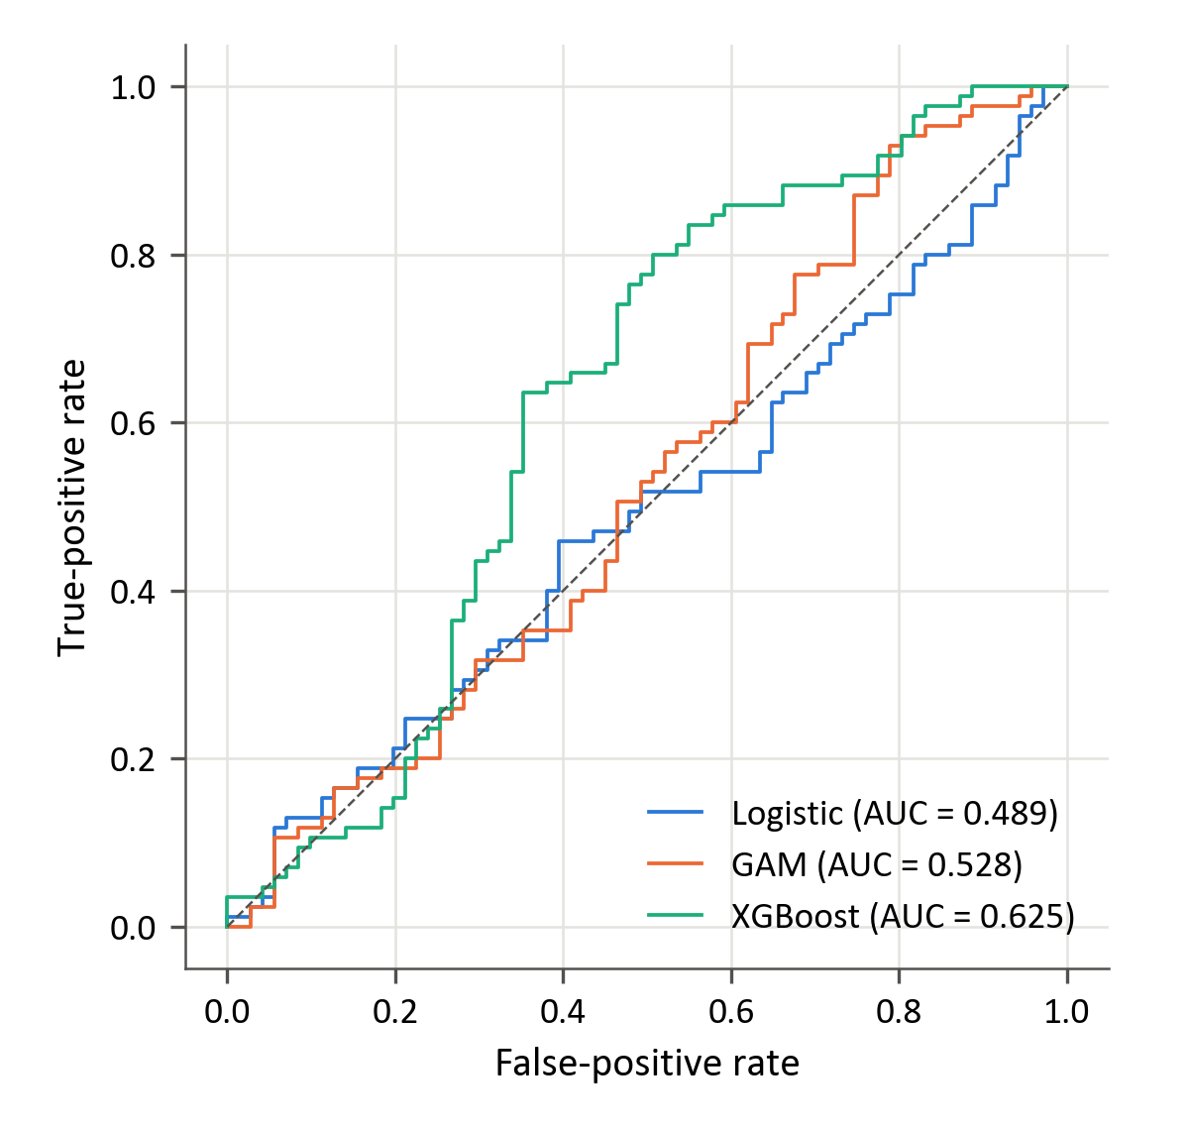
Figure 9: Out-of-sample ROC curves for momentum versus value
Figure 9 shows that XGBoost achieves the highest true-positive rate at most false-positive rates above approximately 0.25. Its ROC-AUCs within the three evaluation periods are 0.60, 0.57 and 0.55, all below the pooled estimate of 0.625. The pooled statistic includes comparisons between observations from different periods as well as comparisons within each period. The lower within-period estimates therefore suggest that differences between periods contribute to the aggregate discrimination. XGBoost retains modest within-period ranking ability, but the declining point estimates qualify its pooled advantage. Logistic regression's ROC-AUC remains below 0.5 in all three periods.
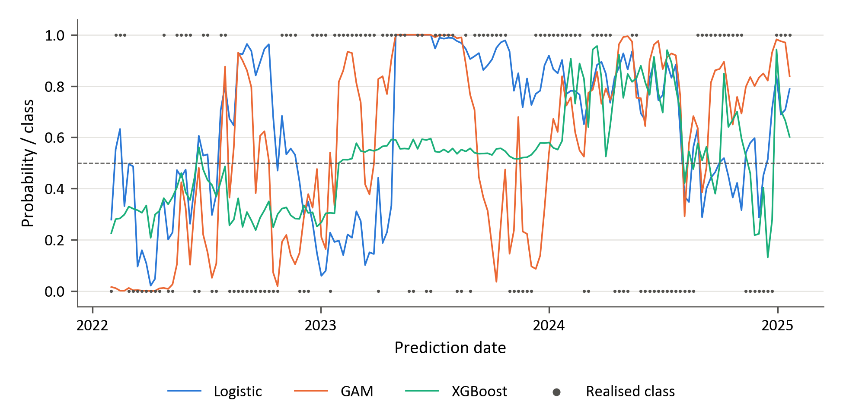
Figure 10: Walk-forward predicted probability that momentum leads value, with the realised class
Figure 10 shows that XGBoost's probabilities remain between 0.21 and 0.60 until January 2024, under the smallest learning rate in its grid and, from January 2023, the largest L2 penalty (Table C.6). During these first two periods, it predicts the prevailing leader in all but two weeks. Its overall accuracy of 62.8% is close to the 62.2% obtained by retrospectively selecting each calendar year's most frequent leader. This hindsight comparison is descriptive rather than an implementable forecasting benchmark; it suggests that much of the classification performance reflects persistent allocation to the prevailing factor. In the third period, probabilities range from 0.13 to 0.96 and log-loss deteriorates to 0.832, offsetting scores below 0.693 in the first two periods. Logistic regression and the GAM select their weakest available penalties at every tuning point and generate 17 and 22 confidently incorrect forecasts, which account for 41% and 62% of their total log-loss, respectively. Their poor probability scores are thus concentrated in a relatively small number of highly confident errors.

Momentum versus quality
For momentum versus quality, XGBoost's higher aggregate accuracy conceals strongly asymmetric recognition of the two leadership states. It leads the three measures in Table 4, but its ROC-AUC of 0.589 exceeds logistic regression's 0.570 by only 0.019. At the 0.5 threshold, XGBoost correctly identifies 82 of the 85 momentum-led weeks but only 14 of the 71 quality-led weeks. Its accuracy of 61.5% therefore reflects substantially greater sensitivity to momentum leadership than to quality leadership. The result offers limited evidence that the model can recognise both directions of a change in relative leadership.
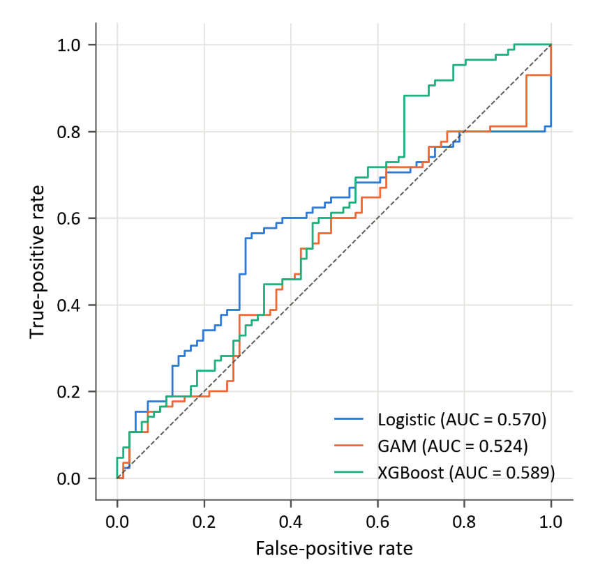
Figure 11: Out-of-sample ROC curves for momentum versus quality
In Figure 11, logistic regression generally achieves the highest true-positive rate at false-positive rates below approximately 0.55, whereas XGBoost leads at higher false-positive rates. Neither ROC curve therefore dominates across the full range of thresholds. Performance also varies markedly across periods: all three models have ROC-AUCs below 0.4 in the second period and between 0.70 and 0.81 in the third. XGBoost additionally achieves a first-period ROC-AUC of 0.75, compared with 0.35 for logistic regression and 0.40 for the GAM. The common second-period deterioration and subsequent recovery are consistent with changing predictive relationships, as discussed in the literature on financial regime variation (Ang & Timmermann, 2012). These subperiod comparisons do not, however, identify a particular regime or establish its economic cause.
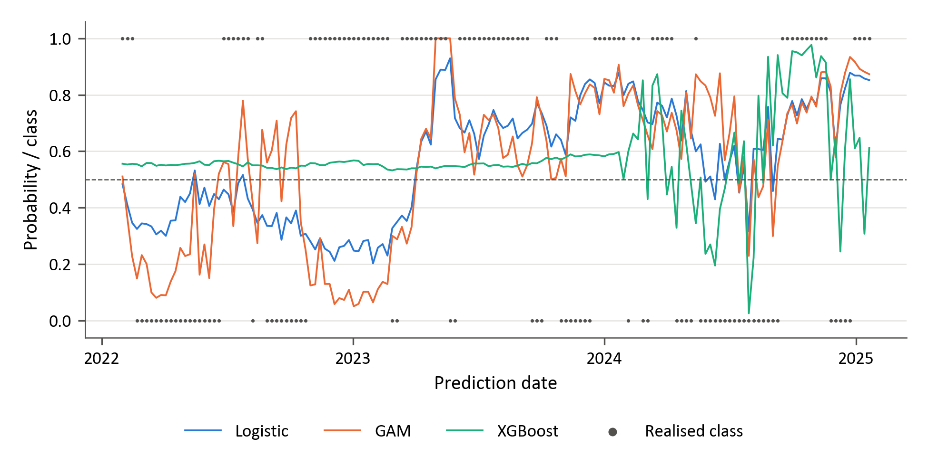
Figure 12: Walk-forward predicted probability that momentum leads quality, with the realised class
Figure 12 clarifies the distinction between probability ranking and threshold-based classification. Until January 2024, XGBoost's probabilities lie between 0.53 and 0.60 under the smallest learning rate and largest L2 penalty in its grid (Table C.6). It consequently predicts momentum leadership in every week of the first two periods. These uniform class decisions coexist with a first-period ROC-AUC of 0.75 because small differences between probabilities can still order outcomes even when every forecast exceeds 0.5. The first two periods therefore illustrate how the decision threshold can obscure differences in ranking performance. Logistic regression, with a penalty of λ = 10, produces one confidently incorrect forecast; the GAM produces eight. The more extreme errors of the latter indicate that its selected smoothing penalties do not ensure reliable probability estimates.

Value versus quality
Value versus quality provides the strongest evidence of discrimination in the study. XGBoost achieves an accuracy of 60.3%, a ROC-AUC of 0.664 and a log-loss of 0.670, while correctly identifying 45 of the 77 value-led weeks and 49 of the 79 quality-led weeks. Its 95% block-bootstrap ROC-AUC interval of 0.569 to 0.757 is the only one of the nine model–pair intervals to exclude 0.5. The interval also excludes 0.5 at the approximately 99.4% level used for the Bonferroni adjustment across the nine reported results, at 0.529 to 0.797. This adjustment addresses multiplicity within the reported comparison set, an important consideration in financial prediction research (Harvey, Liu, & Zhu, 2016), but does not account for any preceding model-development decisions informed by the evaluation sample. Evidence of superiority over logistic regression is weaker: the paired ROC-AUC difference of 0.066 has a 95% interval of −0.037 to 0.177. The GAM exhibits little discrimination, with a ROC-AUC of 0.495.
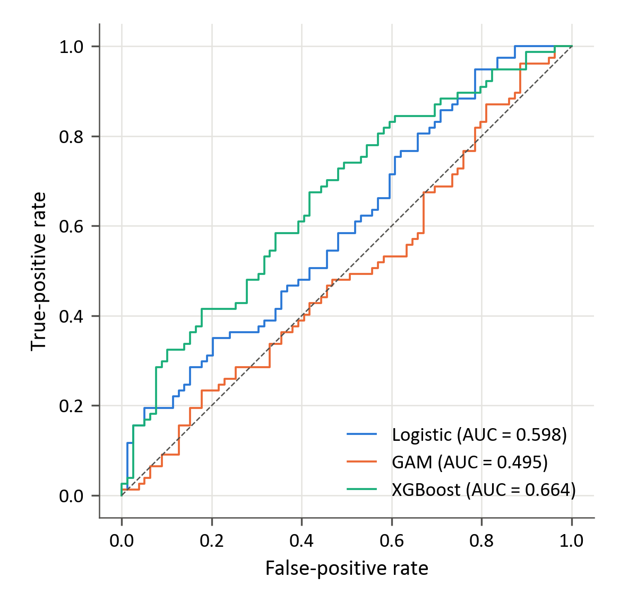
Figure 13: Out-of-sample ROC curves for value versus quality

Figure 13 shows that XGBoost achieves the highest true-positive rate over most false-positive rates between approximately 0.08 and 0.78. Its within-period ROC-AUCs of 0.78, 0.63 and 0.63 provide the most consistent above-chance point estimates across the three periods. Logistic regression performs comparably in the first period, with a ROC-AUC of 0.79, but falls below 0.5 in the subsequent periods, at 0.44 and 0.47. XGBoost's pooled advantage is therefore accompanied by more persistent within-period discrimination, although the small subperiod samples should not be treated as independent confirmations.
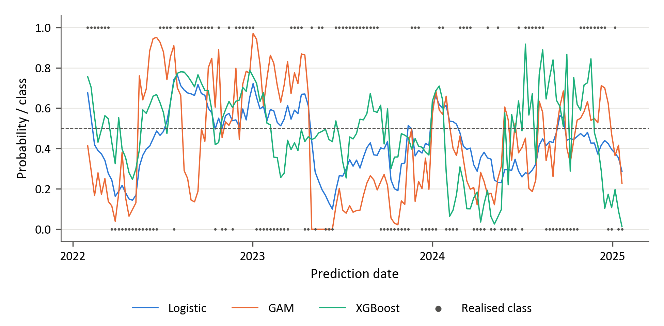
Figure 14: Walk-forward predicted probability that value leads quality, with the realised class
Figure 14 shows that XGBoost predicts each leadership state in at least one quarter of the weeks in every period and produces only one confidently incorrect forecast. Its accuracy exceeds the calendar-year hindsight rule by 3.2 percentage points, at 60.3% compared with 57.1%, whereas the corresponding difference is at most 1.3 points for the momentum pairs. This descriptive comparison is consistent with information beyond persistent classification of the prevailing annual leader. Nevertheless, accuracy declines from 67.3% to 57.7% and 55.8%, while log-loss increases from 0.579 to 0.671 and 0.759. Discrimination thus persists in point estimates as classification and probability quality weaken. The GAM produces 12 confidently incorrect forecasts, compared with none for logistic regression. Taken together, the results provide clearer evidence of above-chance ranking by XGBoost than of a statistically established advantage over the regularised linear model.

Classification errors and probability quality
Table 5 reports the realised class distributions in the common 156-week evaluation sample. The targets are comparatively balanced: momentum leads in 54.5% of observations in each momentum pair, while value leads quality in 49.4%. Consequently, the marked asymmetries in the model decisions cannot be attributed solely to severe imbalance in the observed targets.

Table 5: Realised class distribution in the 156-week evaluation block
Factor pair | Negative observations | Positive observations | Positive share
Momentum vs value | 71 | 85 | 54.5%
Momentum vs quality | 71 | 85 | 54.5%
Value vs quality | 79 | 77 | 49.4%

Table 6 reports the confusion matrices and predicted-positive shares at the 0.5 threshold. These diagnostics distinguish aggregate classification performance from the ability to recognise each leadership state and help explain differences between accuracy and ROC-AUC.
Table 6: Confusion-matrix diagnostics at the 0.5 threshold
Factor pair | Model | TN | FP | FN | TP | Predicted positive | Actual positive
Momentum vs value | Logistic | 24 | 47 | 31 | 54 | 64.7% | 54.5%
 | GAM | 28 | 43 | 34 | 51 | 60.3% | 54.5%
 | XGBoost | 38 | 33 | 25 | 60 | 59.6% | 54.5%
Momentum vs quality | Logistic | 35 | 36 | 30 | 55 | 58.3% | 54.5%
 | GAM | 27 | 44 | 24 | 61 | 67.3% | 54.5%
 | XGBoost | 14 | 57 | 3 | 82 | 89.1% | 54.5%
Value vs quality | Logistic | 55 | 24 | 48 | 29 | 34.0% | 49.4%
 | GAM | 46 | 33 | 46 | 31 | 41.0% | 49.4%
 | XGBoost | 49 | 30 | 32 | 45 | 48.1% | 49.4%

Similarity between the predicted-positive share and the realised positive share does not establish effective recognition of both classes. For momentum versus quality, logistic regression's predicted-positive share of 58.3% is closest to the observed 54.5%, yet it correctly identifies only 35 of the 71 quality-led weeks. Across the nine model–pair combinations, only XGBoost for momentum versus value and value versus quality correctly identifies more than half of the observations in each class. The distribution of errors therefore provides information that is not apparent from the class shares alone.
The threshold-based decisions can also understate a model's discrimination. For value versus quality, logistic regression predicts value leadership in 34.0% of weeks, compared with the realised 49.4%, and correctly identifies only 29 of the 77 value-led weeks. Its ROC-AUC of 0.598 therefore translates into an accuracy of 53.8% at the chosen threshold. Conversely, XGBoost's momentum–quality accuracy is supported by frequent positive decisions despite weak recognition of quality leadership. These cases show that ranking performance and the suitability of a particular classification threshold require separate assessment (Fawcett, 2006). They do not establish that a different threshold would improve performance on new observations.
Three model–pair combinations improve on the constant 0.5 forecast under log-loss: XGBoost for momentum versus quality and value versus quality, and logistic regression for value versus quality, whose score is 0.686. Logistic regression's log-loss rises to 1.140 for momentum versus value, where it selects its weakest penalty, while the GAM records the highest loss for every pair, ranging from 0.959 to 1.545. The concentration of loss in confidently incorrect forecasts is consistent with unstable probability estimation, although the comparison does not isolate regularisation as its cause. As a proper scoring rule, log-loss evaluates the assigned probabilities against the realised outcomes (Gneiting & Raftery, 2007). It should not be interpreted as a measure of calibration alone: strong discrimination does not necessarily produce well-calibrated probabilities (Niculescu-Mizil & Caruana, 2005).
The combined diagnostics indicate that discrimination, recognition of both classes and probability quality need not coincide. Value versus quality provides the most consistent combination of these properties for XGBoost over the full sample, although its final-period log-loss deteriorates. For momentum versus value, stronger classification coexists with a log-loss above the uninformative benchmark; for momentum versus quality, aggregate accuracy conceals limited recognition of quality leadership. These distinctions are relevant to whether forecasts are used to rank opportunities, trigger allocation changes or determine probability-weighted exposures. Their economic value remains outside the present evaluation, which does not estimate portfolio returns after transaction costs or market impact.

Feature importance
Figures 15–17 present the ten features with the largest global mean absolute SHAP values for each model. SHAP attributes model output to the input features (Lundberg & Lee, 2017). Here, the values are calculated for reference models refitted on the initial tuning sample, as described in Section 3.10; they do not aggregate the explanations of the successive walk-forward models. The rankings therefore describe the information used by these reference fits and cannot establish why predictive performance changes between evaluation periods. Mean absolute values also do not identify the direction of a feature's effect or establish an economic causal relationship.

Momentum versus value
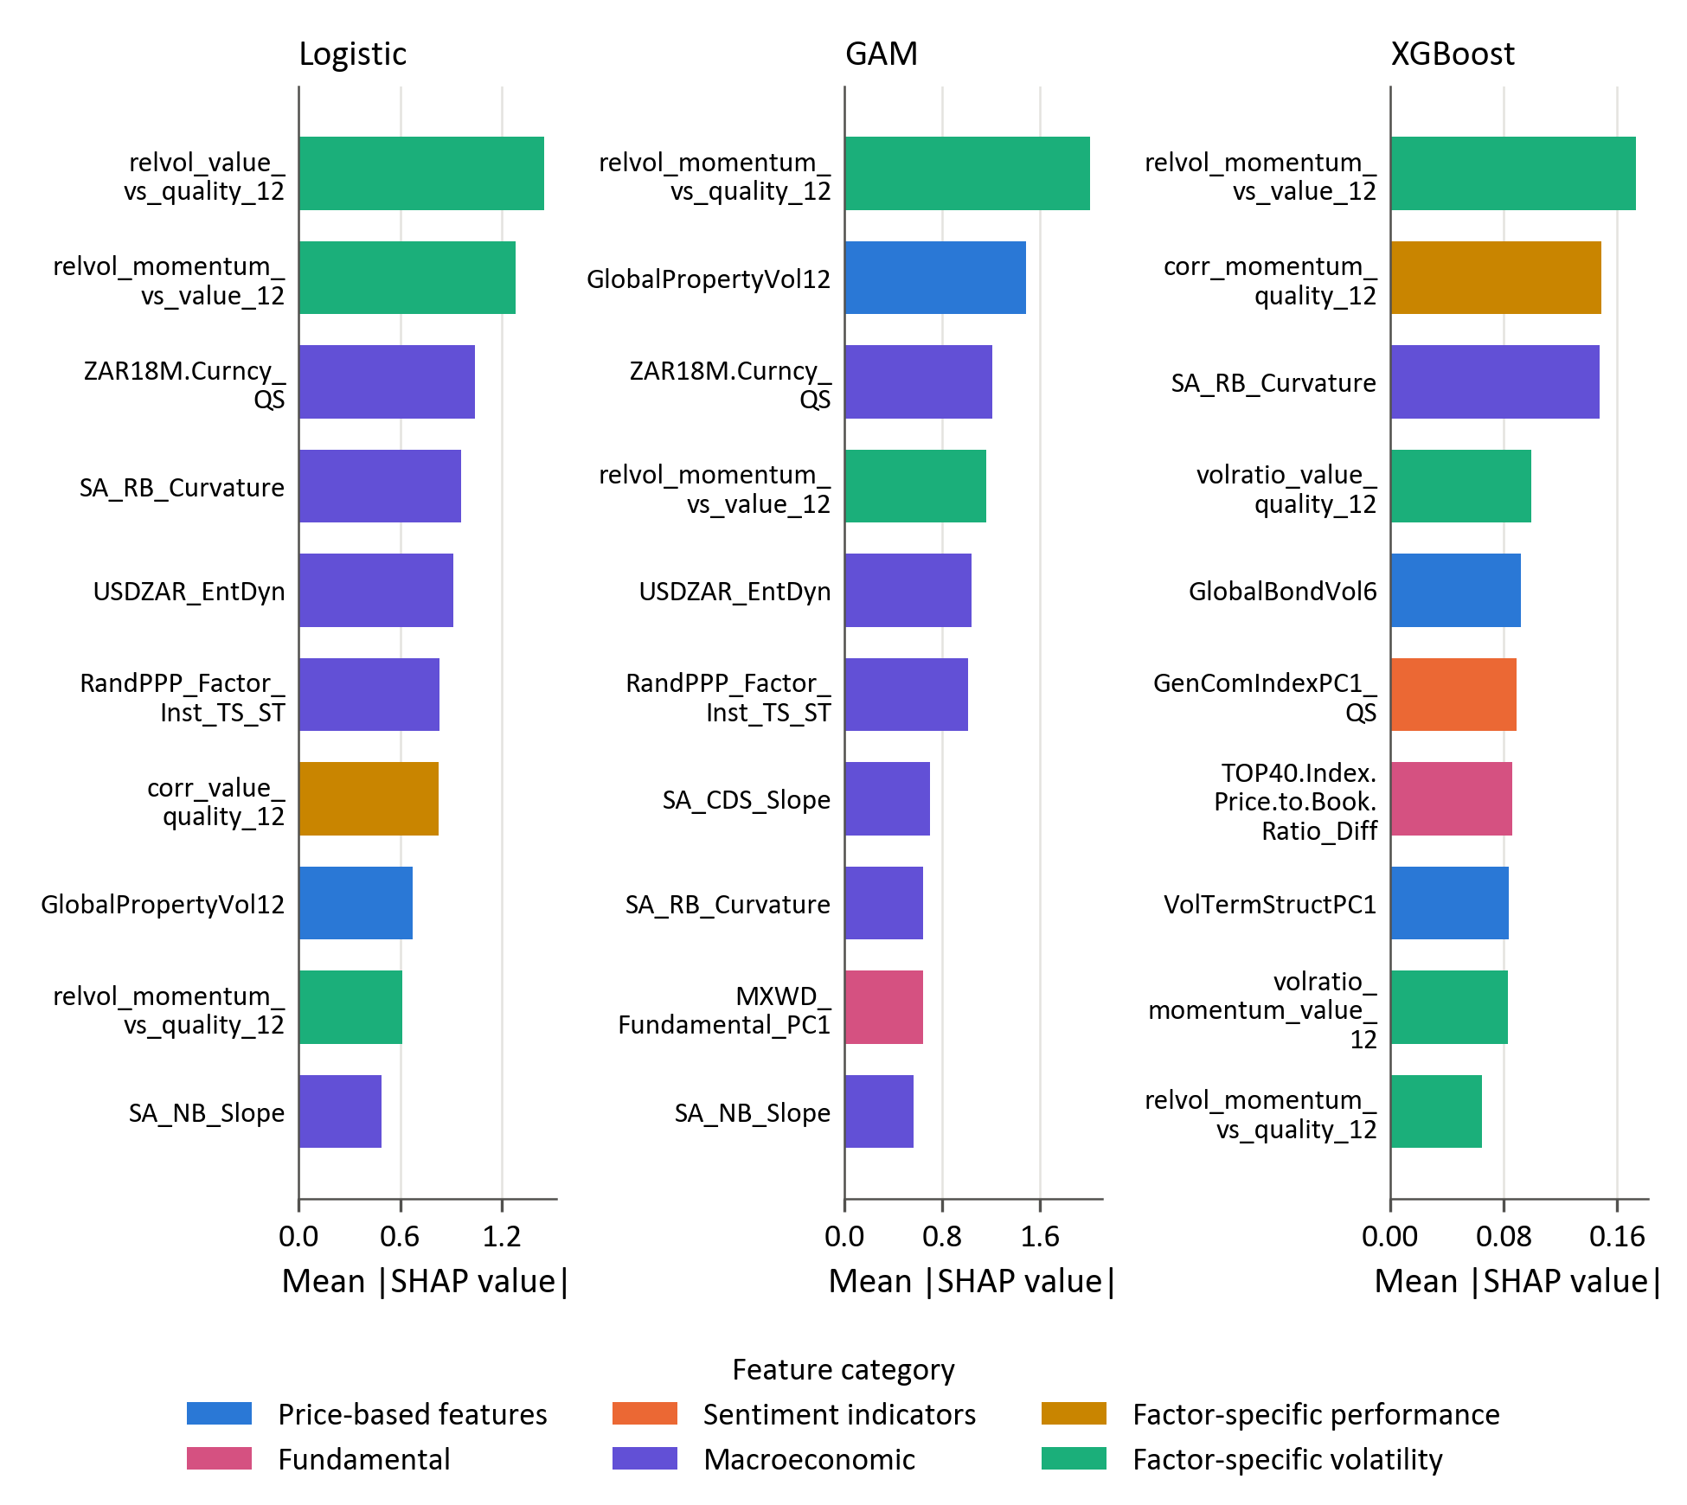
Figure 15: Global SHAP importance of the reference models for momentum versus value

Relative-volatility measures rank first in all three reference fits for momentum versus value, although the specific measure differs: momentum–value relative volatility for XGBoost, value–quality relative volatility for logistic regression and momentum–quality relative volatility for the GAM. This prominence is compatible with evidence that momentum risk varies over time and that momentum crashes are associated with adverse market conditions (Barroso & Santa-Clara, 2015; Daniel & Moskowitz, 2016). Beyond relative volatility, logistic regression and the GAM share medium-term USDZAR forward pricing, USDZAR entropy and rand PPP valuation among their six leading features. XGBoost instead assigns greater importance to momentum–quality correlation, South African real-yield-curve curvature, the value–quality volatility ratio, global bond volatility and the commodity index component. Since the models differ substantially in predictive performance, agreement on the leading feature category does not establish its sufficiency for timing. The results suggest differences in the representation and combination of information, rather than identifying the source of XGBoost's advantage.

Momentum versus quality

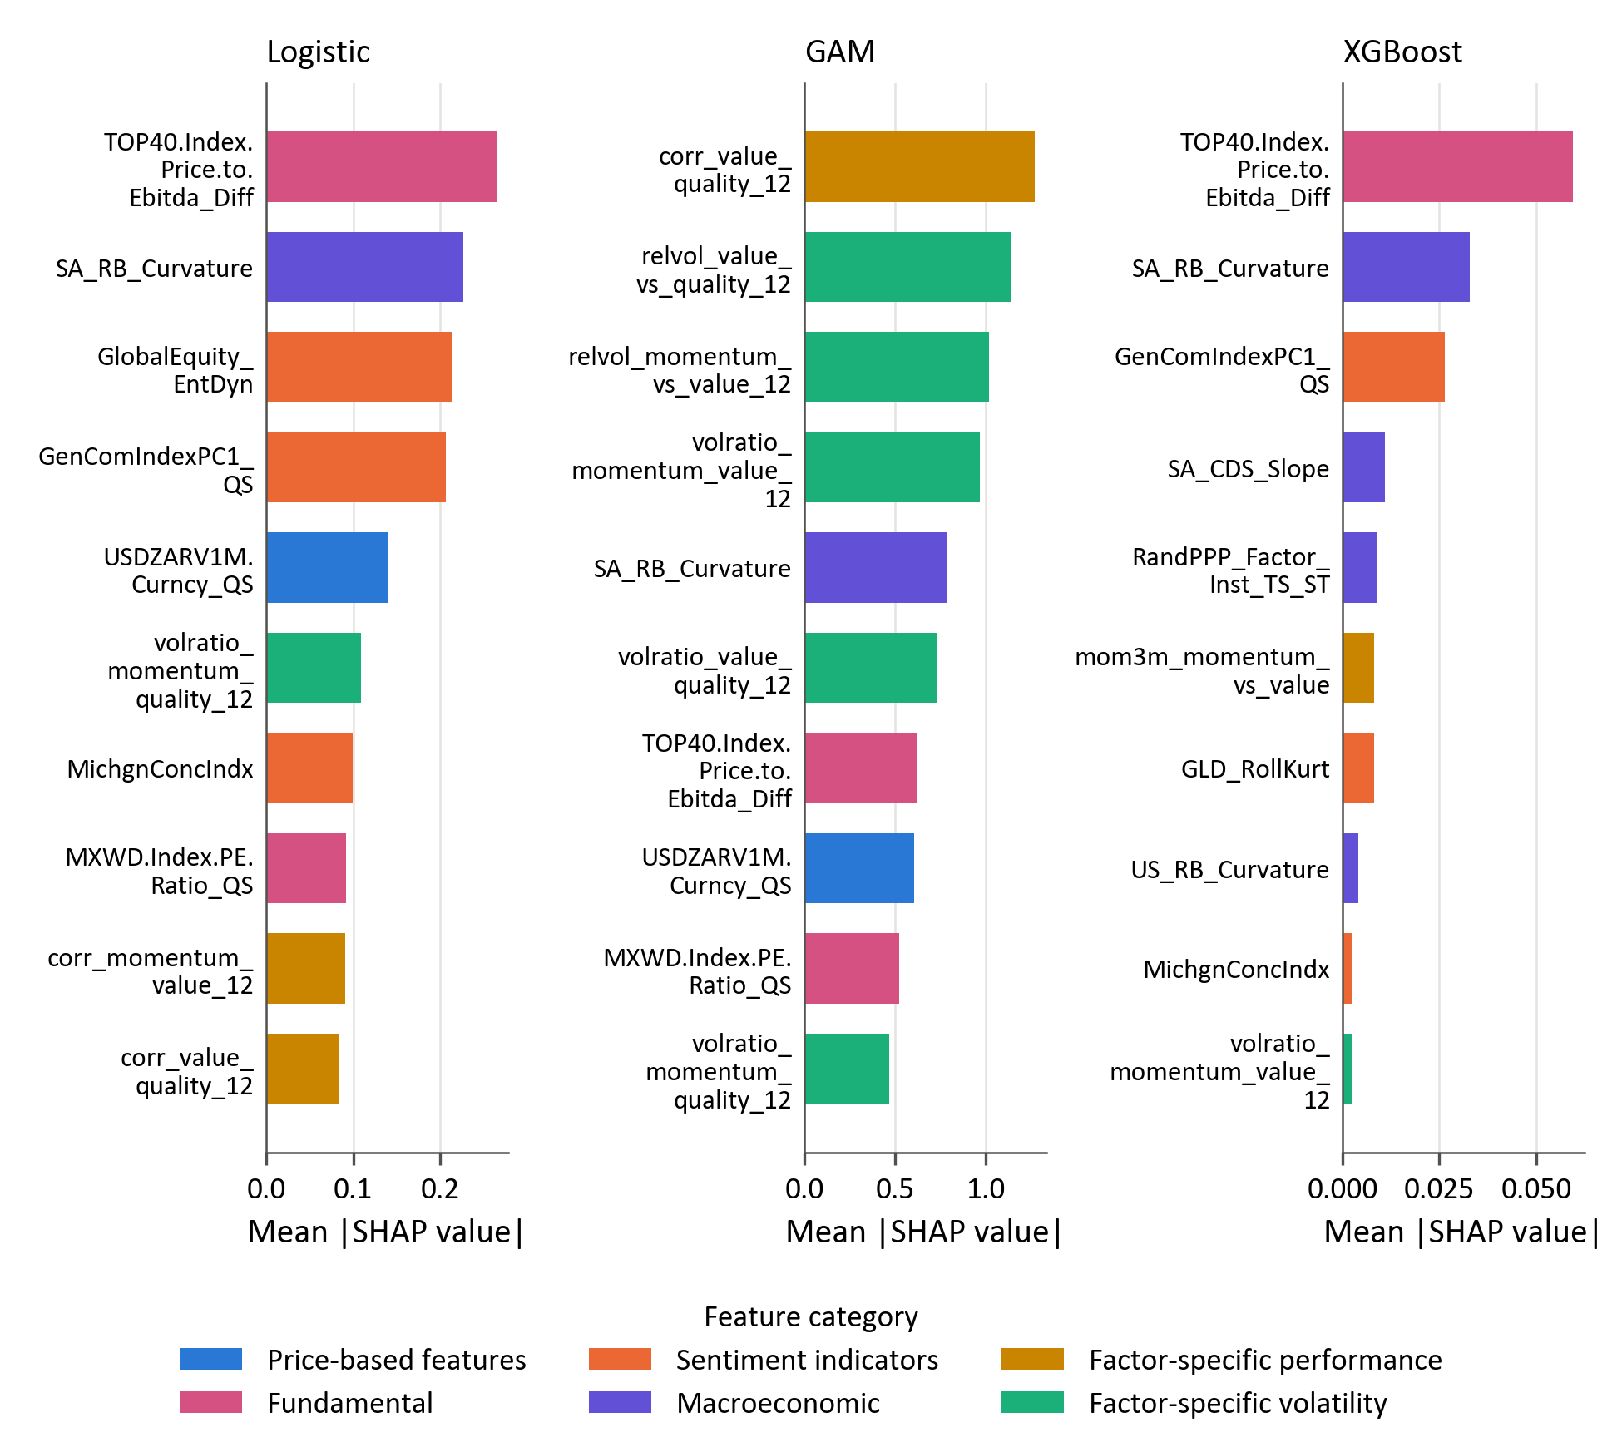
Figure 16: Global SHAP importance of the reference models for momentum versus quality

For momentum versus quality, logistic regression and XGBoost share the same two leading features: the change in the TOP40 price-to-EBITDA ratio and South African real-yield-curve curvature. The commodity index component also appears among the four leading features of both models. Their similar rankings accompany a difference in ROC-AUC of only 0.019, suggesting overlap in the information emphasised by the reference fits. The prominence of a valuation measure is relevant to the literature on valuation-based factor timing, which cautions that apparent valuation signals need not generate reliable timing gains (Asness, Chandra, Ilmanen, & Israel, 2017). The unstable subperiod results provide no evidence that this particular feature reliably times relative leadership. The GAM places greater emphasis on the value–quality correlation and relative-volatility measures, with the valuation variable ranked seventh. XGBoost's ten largest SHAP magnitudes sum to less than one sixth of the corresponding totals for the other pairs. This describes the limited variation attributed to features in its initial reference fit, rather than explaining subsequent changes in walk-forward performance.

Value versus quality

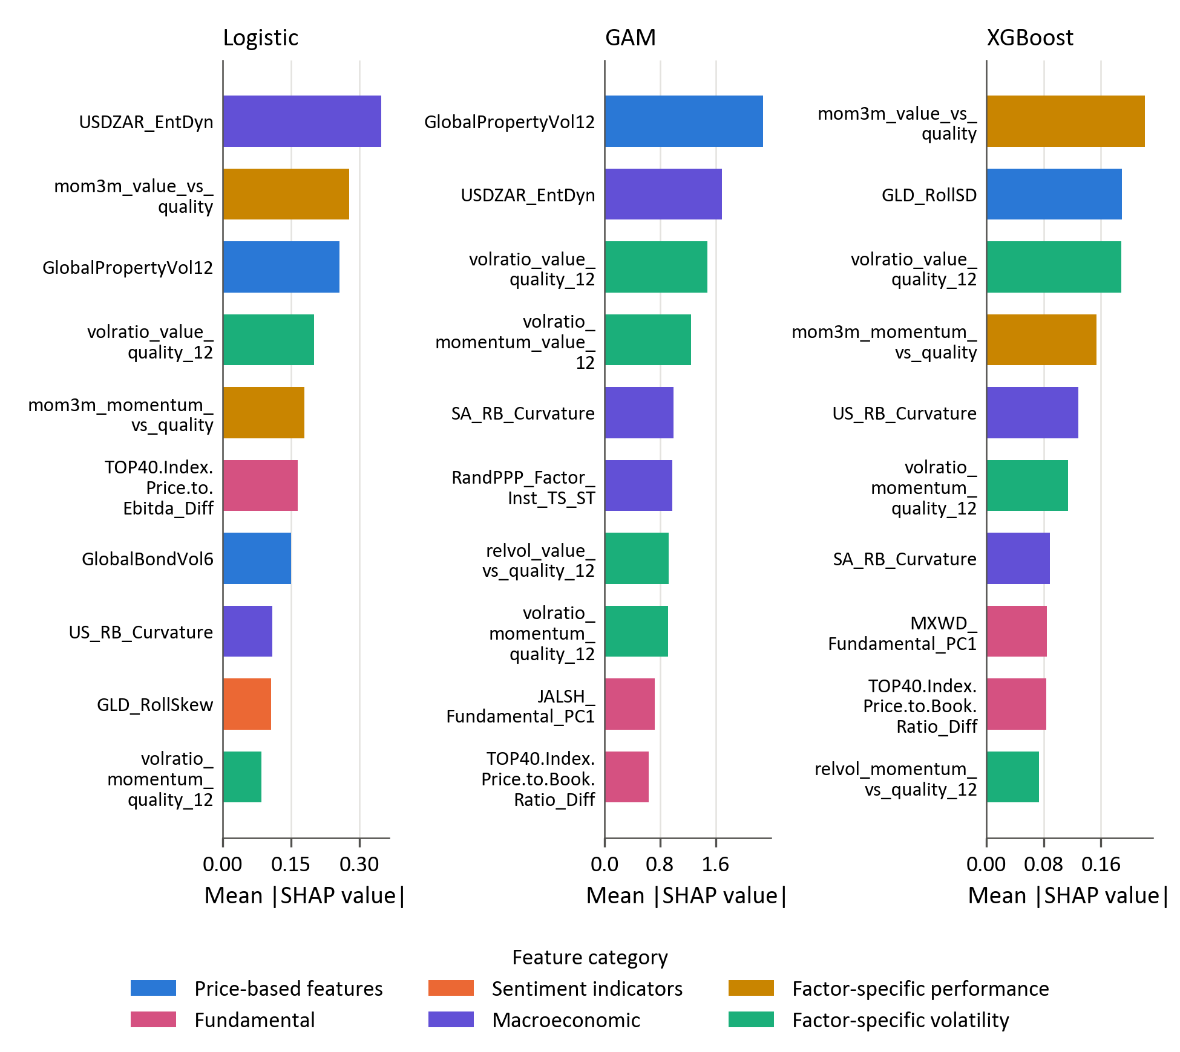
Figure 17: Global SHAP importance of the reference models for value versus quality

For value versus quality, recent relative performance is prominent in the models with the strongest pooled discrimination. The three-month relative return of value against quality ranks first for XGBoost and second for logistic regression, while the corresponding momentum–quality measure appears among the five leading features of both. These rankings are compatible with the broader relevance of recent factor performance documented in the factor-momentum literature (Gupta & Kelly, 2019), but the unsigned importance measures do not distinguish continuation from reversal. The value–quality volatility ratio ranks among the four leading features in all three models. Logistic regression and the GAM additionally emphasise USDZAR entropy and global property volatility, whereas XGBoost assigns importance to gold volatility and US and South African yield-curve curvature. The shared relative-performance features do not, by themselves, account for XGBoost's more persistent discrimination: establishing their incremental contribution would require a separate evaluation of the relevant features and functional relationships.

Chapter conclusion
The results provide limited and factor-pair-dependent evidence of predictability. XGBoost achieves the highest accuracy and ROC-AUC and the lowest log-loss for each pair, with a mean ROC-AUC of 0.626 compared with 0.552 for logistic regression and 0.516 for the GAM. It is the only model whose 95% block-bootstrap interval for mean ROC-AUC excludes 0.5, at 0.534 to 0.718. The evidence is strongest for value versus quality, whose individual AUC interval remains above chance after adjustment for the nine reported model–pair comparisons. For the momentum pairs, classification performance depends more heavily on persistent decisions favouring the prevailing leader, and momentum versus quality exhibits particularly asymmetric class recognition.
The findings do not support a monotonic relationship between model flexibility and out-of-sample performance. The fitted GAMs fail to improve consistently on logistic regression. XGBoost's mean-AUC advantage over the GAM is 0.110, with an unadjusted paired 95% interval of 0.006 to 0.221, whereas its advantage over logistic regression is 0.074, with an interval of −0.045 to 0.196. Thus, despite its leading point estimates, the evaluation does not statistically establish an improvement over the regularised linear benchmark. These intervals quantify uncertainty in the saved prediction–outcome sequences under the block-bootstrap design; they do not incorporate the uncertainty associated with repeating feature selection and model tuning.
Interactions and differences in regularisation provide possible interpretations of the tree ensemble's advantage. Gu, Kelly and Xiu (2020) attribute gains from trees and neural networks in US return prediction to nonlinear predictor interactions, offering a relevant comparison with the weaker additive specifications here. However, XGBoost and the GAM differ in their representation, penalties and estimation procedures, so the present design cannot isolate interactions as the source of the performance difference. Similarly, the association between weak penalties and confidently incorrect probabilities does not establish that stronger regularisation would improve forecasts on new data. The results support an advantage for particular fitted specifications, with substantial uncertainty about its mechanism and generality.
The SHAP analysis shows that the reference fits draw on relative-factor performance, volatility, currency conditions, valuation and yield-curve information, with South African real-yield-curve curvature appearing among the ten leading features in eight of the nine fits. The remaining rankings vary across models and factor pairs. These patterns offer hypotheses about the information associated with relative leadership, but they remain exploratory because the explanations concern training-sample reference fits and do not establish causal or temporally stable relationships. Overall, the chapter identifies selective predictive structure, most clearly for value versus quality, while leaving the general superiority of more flexible models and their economic value unresolved.

References
Ang, A., & Timmermann, A. (2012). Regime changes and financial markets. Annual Review of Financial Economics, 4, 313–337. https://doi.org/10.1146/annurev-financial-110311-101808
Asness, C. S., Chandra, S., Ilmanen, A., & Israel, R. (2017). Contrarian factor timing is deceptively difficult. The Journal of Portfolio Management, 43(5), 72–87. https://www.aqr.com/insights/research/journal-article/contrarian-factor-timing-is-deceptively-difficult
Barroso, P., & Santa-Clara, P. (2015). Momentum has its moments. Journal of Financial Economics, 116(1), 111–120. https://doi.org/10.1016/j.jfineco.2014.11.010
Daniel, K., & Moskowitz, T. J. (2016). Momentum crashes. Journal of Financial Economics, 122(2), 221–247. https://doi.org/10.1016/j.jfineco.2015.12.002
Fawcett, T. (2006). An introduction to ROC analysis. Pattern Recognition Letters, 27(8), 861–874. https://doi.org/10.1016/j.patrec.2005.10.010
Gneiting, T., & Raftery, A. E. (2007). Strictly proper scoring rules, prediction, and estimation. Journal of the American Statistical Association, 102(477), 359–378. https://doi.org/10.1198/016214506000001437
Gu, S., Kelly, B., & Xiu, D. (2020). Empirical asset pricing via machine learning. The Review of Financial Studies, 33(5), 2223–2273. https://doi.org/10.1093/rfs/hhaa009
Gupta, T., & Kelly, B. (2019). Factor momentum everywhere. The Journal of Portfolio Management, 45(3), 13–36. https://www.aqr.com/insights/research/working-paper/factor-momentum-everywhere
Harvey, C. R., Liu, Y., & Zhu, H. (2016). … and the cross-section of expected returns. The Review of Financial Studies, 29(1), 5–68. https://doi.org/10.1093/rfs/hhv059
Israel, R., Kelly, B., & Moskowitz, T. J. (2020). Can machines ‘learn’ finance? Journal of Investment Management, 18(2), 23–36. https://www.aqr.com/-/media/AQR/Documents/Alternative-Thinking/AQR-Alternative-Thinking-2Q19-Can-Machines-Learn-Finance.pdf
Lundberg, S. M., & Lee, S.-I. (2017). A unified approach to interpreting model predictions. Advances in Neural Information Processing Systems, 30. https://proceedings.neurips.cc/paper/2017/hash/8a20a8621978632d76c43dfd28b67767-Abstract.html
Niculescu-Mizil, A., & Caruana, R. (2005). Predicting good probabilities with supervised learning. In Proceedings of the 22nd International Conference on Machine Learning (pp. 625–632). Association for Computing Machinery. https://doi.org/10.1145/1102351.1102430
Page, D., McClelland, D., & Auret, C. (2024). Machine learning style rotation – evidence from the Johannesburg Stock Exchange. Cogent Economics & Finance, 12(1), Article 2402893. https://doi.org/10.1080/23322039.2024.2402893

Log-loss is the mean negative natural logarithm of the probability assigned to the realised outcome. A constant forecast of 0.5 therefore produces −ln(0.5) = ln(2) ≈ 0.693, irrespective of the realised class distribution. A higher loss indicates worse overall probability performance than this specific benchmark and can result from assigning very low probabilities to outcomes that occur.

