**Motor Design Assigment-1**

**-Basics of Magnetic Circuits-**

* **Air gap flux density calculation:**

For an infinitely permeable core, here is the formula for air gap flux density:

* **Inductance calculation:**

Here is the inductance formulation:

R is the reluctance and can be calculated using the formula below:

* **2D model of C-core**

C-core is modeled by using Maxwell 16.0. Core material is created as its relative permeability equals to 1000. Here is the flux density distribution over the c-core.

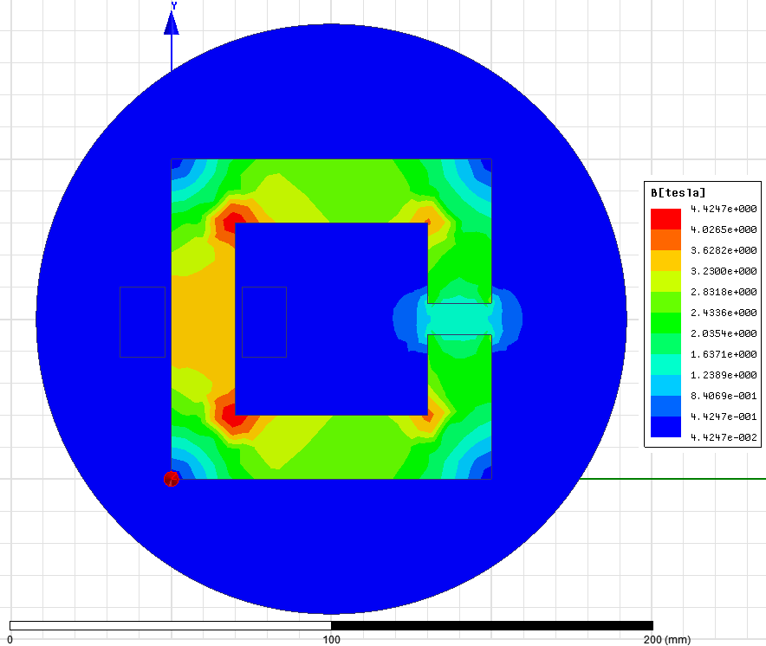

**Figure-1** Flux distribution of a material with

As it is seen from the figure, inner corners are the most intense areas. Their flux density values are over the saturation level that we face in real conditions. Outer corners' flux densities are lower than other areas as it is expected. Left bottom corner's circular mark is representing the z axis direction and it isn't related with flux density. Outer circular area is the selected boundary and its material is air.    
  
Air gap flux density is close to the calculated value and fringing effects are seen in the figure, too.  
  
Now core material is changed to **steel with BH curve** below:

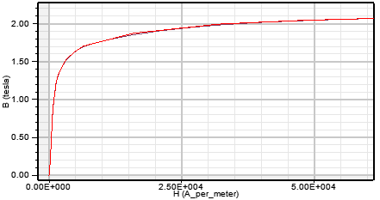

**Figure-2** BH curve of selected steel

After a certain point linear region finishes and BH curve starts saturation. 2.2 T is the maximum flux density value for this material. Now let's see the new flux density of c-core for this material.

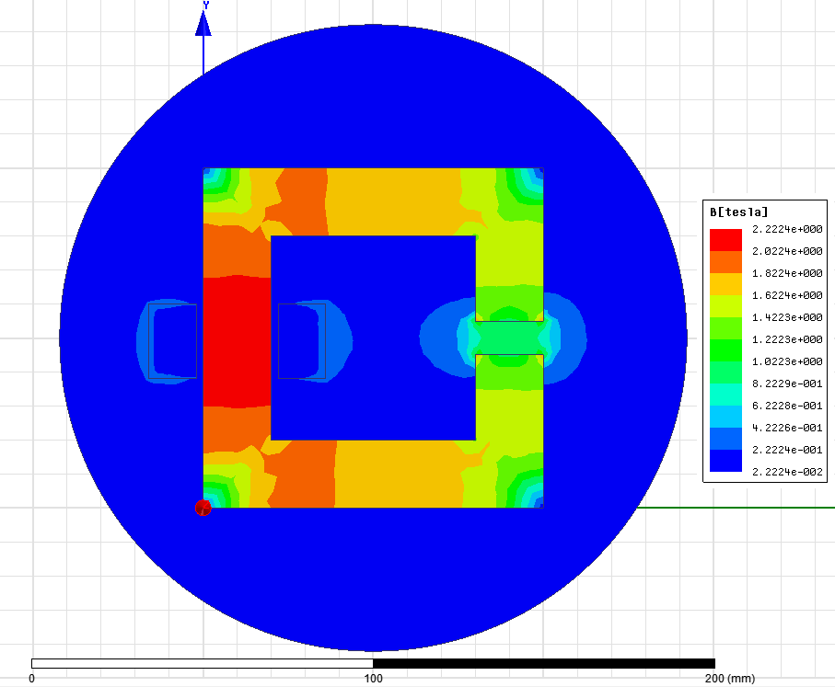

**Figure-3** Flux distribution of steel

As it is expected maximum flux density point in the core is reduced to the saturation level of BH curve. Outer corners are still rare by means of flux density. Air gap's flux density is also decreased comparing to the previous case. Due to the saturation around excitation, some of the fluxes couldn't find path to themselves and leakages occurred around the copper conductors.  
  
Now let’s see what happens if core material is switched to the **iron with the BH curve** below (normally Maxwell doesn't have a BH curve for iron, therefore it is inserted manually).

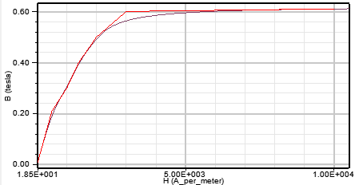

**Figure-4** BH curve of iron

Here is the flux density distribution of iron core:

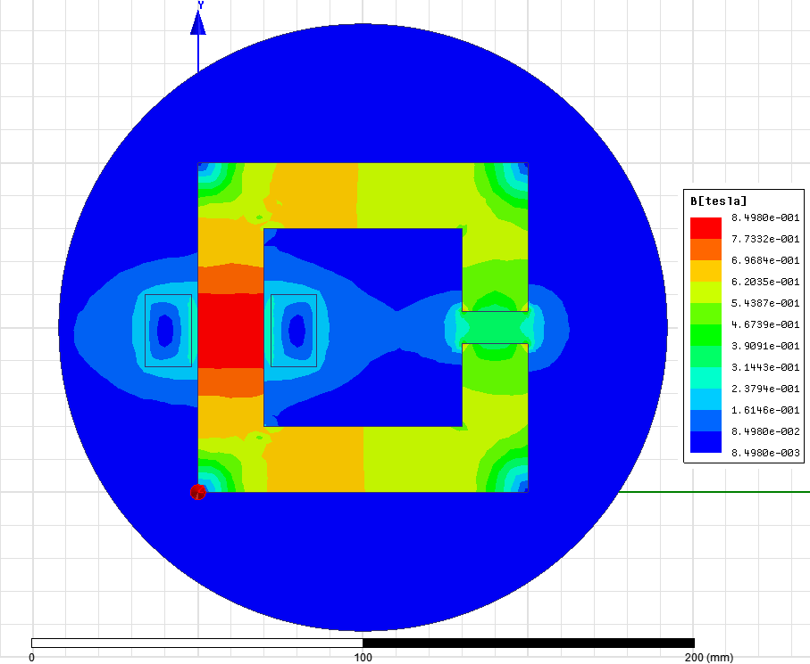  
**Figure-5** Flux distribution of iron

Comparing to the first analysis all of the flux densities are reduced dramatically. Leakages' effective region is also increased.

* **Flux density vectors**

Since the last analysis was for the iron material, its flux density is shown with vectors first.

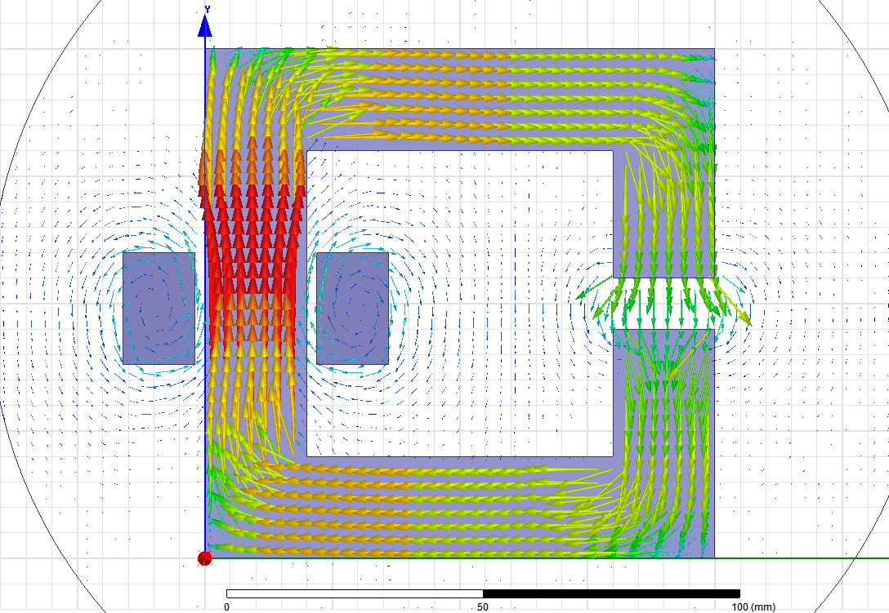

**Figure-6** Flux density vector of iron

In this figure, colors are still giving us idea about flux densities' magnitudes. All leakage and fringing fluxes are so visible.   
  
Now let’s see the vectors of steel with saturation:

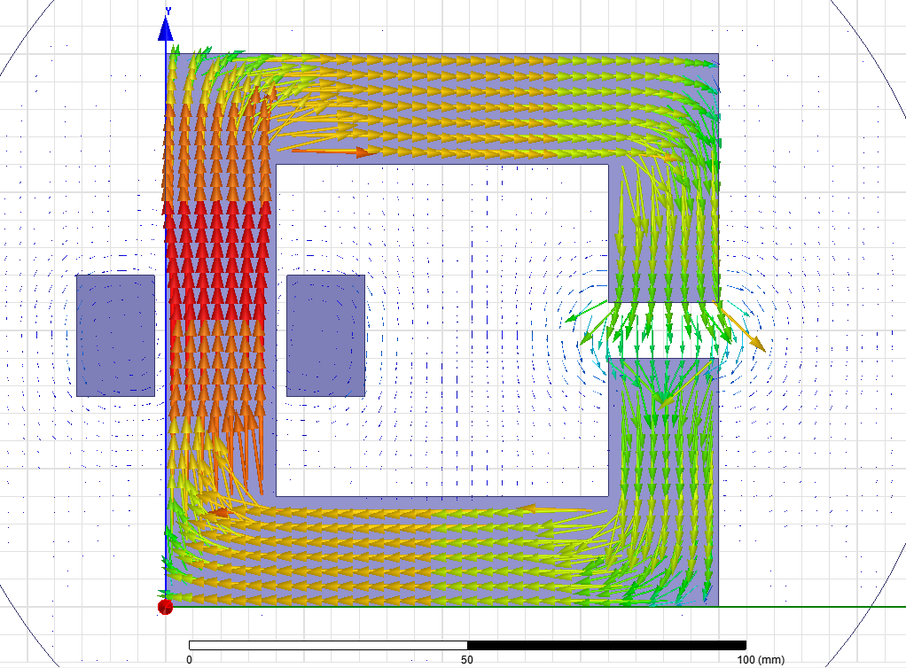  
**Figure-7** Flux density vector of steel

Leakage to core flux density ratio is reduced with steel material. Fringing fluxes are still active. Iron's and steel's colors aren't representing the same Tesla, therefore they shouldn't be compared directly with colors.  
Finally the material with relative permeability of 1000 is analyzed again to be able to see its flux density vectors:

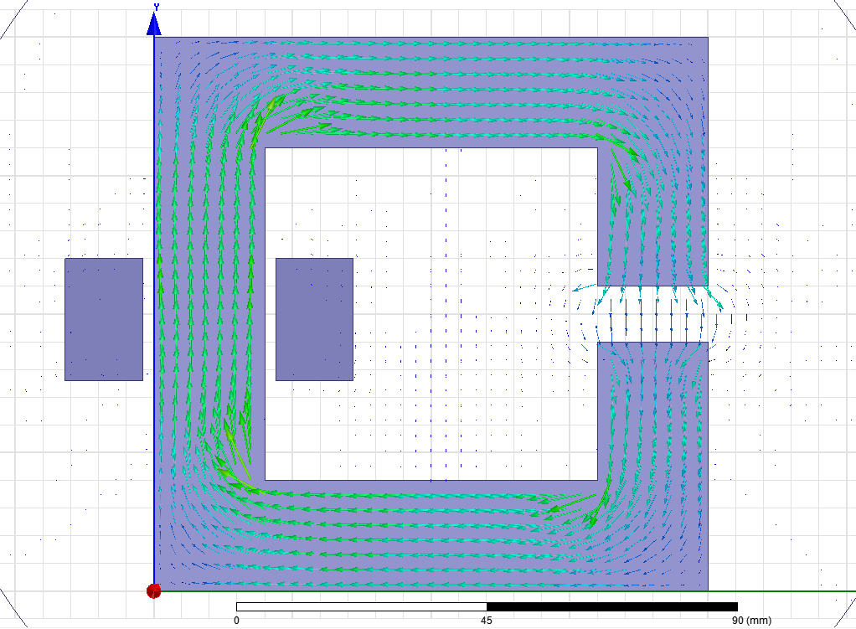

**Figure-8** Flux density vector of a material with

In this case, we see that leakages are in the minimum level. There is still fringing fluxes. There isn't any saturation in the core.

* **Air gap flux density distribution:**

In the middle of air gap, a line is drawn in the Maxwell. First and the last 10 mm lengths of this line are out of air gap. Middle 20 mm is the real length corresponds to the core. Once the peak flux density value is compared to the calculated value, it is seen that they are close to each other. Reason of this difference is saturation of the core, MMF drop in the core, fringing and leakage fluxes. Waveform is as it is expected.

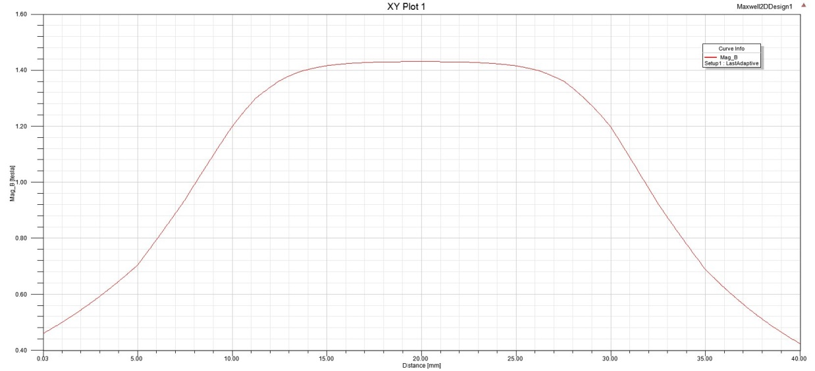

**Figure-9** Air gap flux density distribution of a material with

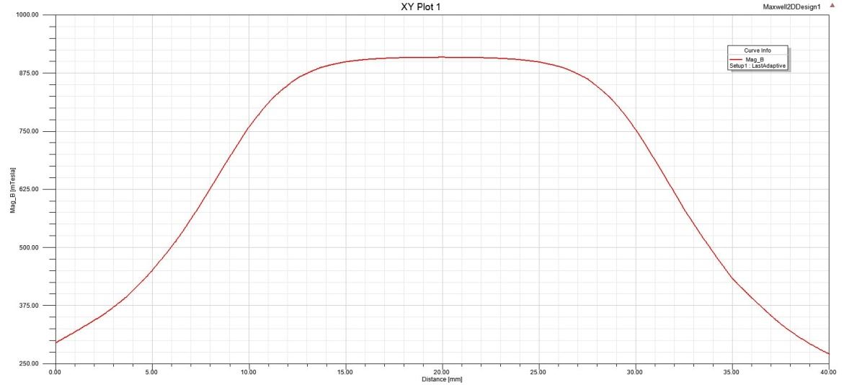

**Figure-10** Air gap flux density distribution of steel

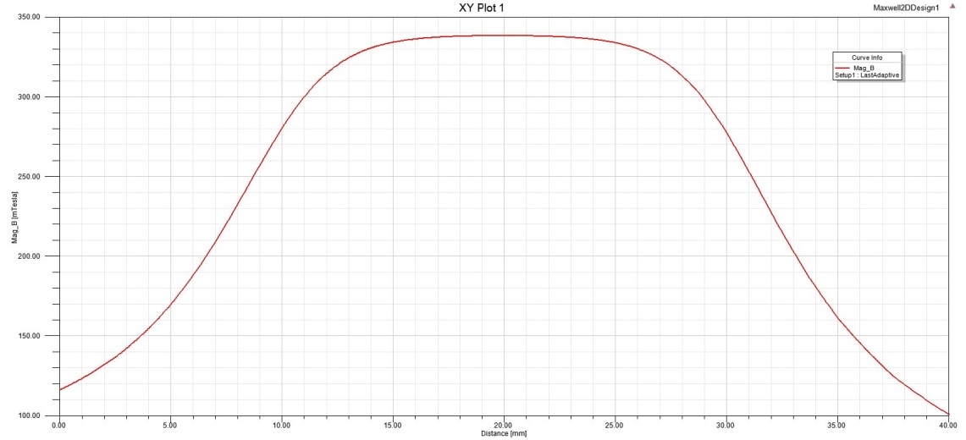

**Figure-11** Air gap flux density distribution of iron

* **Core and leakage flux calculations:**

To be able to calculate the total flux in the core, let us take a line in the core and integrate its flux density:

A vertical line is preferred in the core’s upper part. It is desired to minimize the fringing effects and be away from leakages. Here is the flux density graph for the material with :

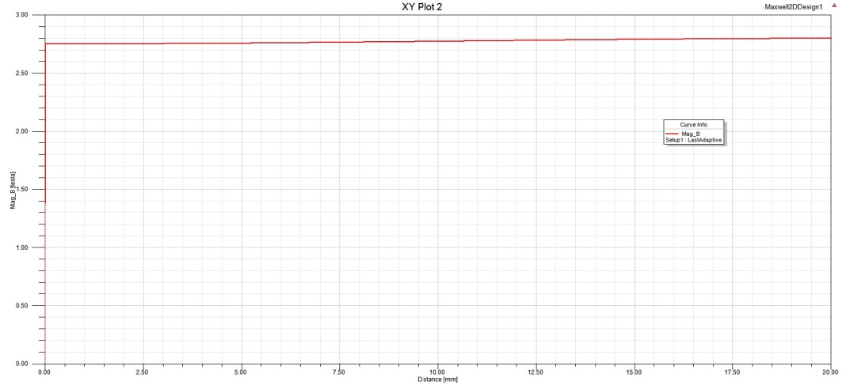

**Figure-12** Core’s flux density distribution

Using the formula below, it is possible to calculate the inductance value using flux value.

For calculating the leakage inductance, flux density of the outer area of the core is plotted.

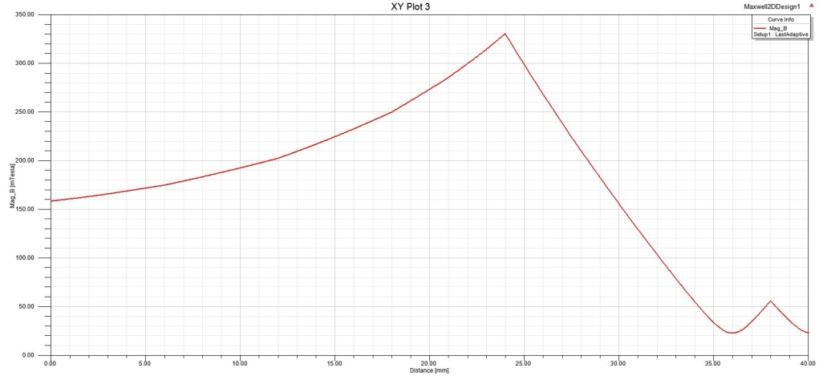

**Figure-13** Left-hand side of core’s flux density distribution