**Motor Design Assigment-3**

**-Electromechanical Energy Conversion-**

* **MMF Calculation:**

For an infinitely permeable core, here is the formula for MMF:

$$F=NI=Hl_{gap}$$

$$B= µ H$$

$$NI= \frac{B_{gap} l_{gap}}{µ}=\frac{0.5 x 2 x {10}^{-2}}{4π{10}^{-7}}= 7957.75 A$$

For a core material with permeability of 1000 there will be a MMF reduction on it.

$$∅=BA=0.5 x 2{ x 10}^{-2}= {10}^{-2} Wb$$

$$MMF_{core}= ∅xR_{core}$$

$$= {10}^{-2} \frac{30 x {10}^{-2}}{{10}^{3}x4π{10}^{-7} x 2 x {10}^{-2}}=119.36 A$$

So totally 8077 A would be enough for desired air gap flux density. But due to the fringing effects and leakages, this current wasn’t enough and 8500A is applied. (Let us consider as 85 A for 100 turns for future calculations).

Here is the result of the initial position:

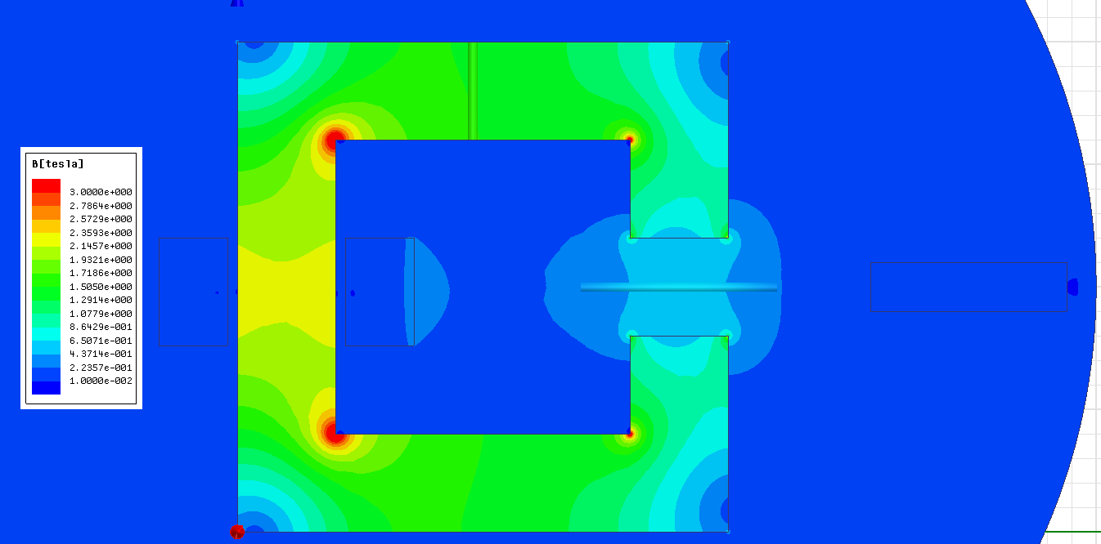

Position of the plunger is defined parametrically and analyses are done for 10 times automatically.

* **Magnetic Energy Calculation:**

Here is the magnetic stored energy of the core:



X axis of the graph is –x direction of Maxwell. So the first point is the initial point shown in the assignment picture.

As plunger moves to the core stored magnetic energy increases. First 30 mm’s increase is due to the fringing effects. After that point, change of the magnetic energy becomes faster. (This will correspond to the force). Once the entire plunger penetrates into the air gap, stored magnetic energy reaches its peak point (minimum reluctance, maximum inductance point). Then it starts to reduce as plunger lefts the air gap of the core.

* **Force Calculation:**

Calculation of the force couldn’t be completed in the Maxwell. Therefore analysis results are exported to Matlab and force is calculated there. Here is the force vs plunger’s position graph:



At its initial position plunger is away from even fringing effects and there isn’t any affective force on it. 3 cm later, to be able to minimize the reluctance core pulls the plunger stronger. Once plunger is in a symmetrical position on vertical axis there isn’t any force on it. As it moves forward, to be able to avoid reluctance increase, plunger is pulled in the opposite direction.

* **Inductance Calculation:**

I couldn’t achieve to calculate inductance in the Maxwell. Instead, calculated the flux densities of a line on the upper part of the core and multiplied those values with the core area to be able to have flux. After multiplying these values with number of turns and dividing them to the current values, here is the inductance vs position graph:



At the beginning, plunger isn’t in the scene and due to the large reluctance we’ve small inductance. As it gets closer and up to the minimum reluctance position, inductance of the core increases. Final reduction is again related with the plunger’s movement.