컴퓨터 네트워크

김황남 교수님

Project 2

2019171081

전기전자공학부

조민서

Setting by python code:

Host 1 is connected with switch 1, host 2 is connected with switch 4.

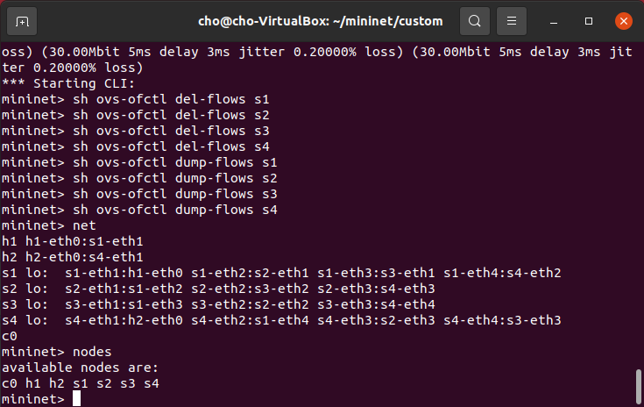

Applied flow rule:

Link between switch 2 and switch 3 has no specific rule, therefore ‘normal’ is applied, which transfer packet to ‘appropriate’ port. Other links has specific rule.

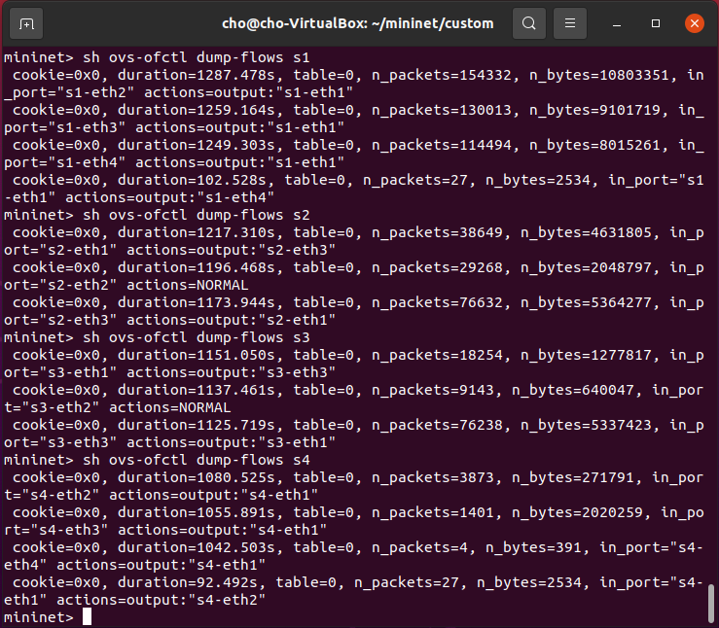

Measured Delay

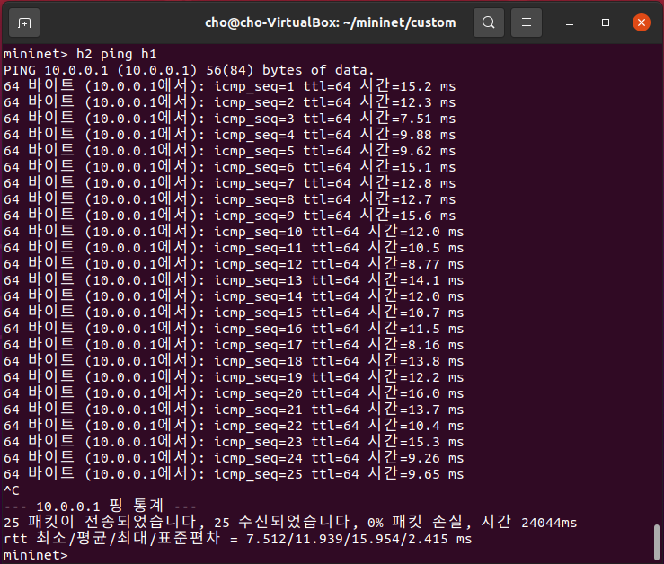

Measured jitter, packet loss rate between host 1 and host2 by iperf.

Host 1 as client, host 2 as server.

