📄 RQ3 — What types of reviewer comments do AI-generated PRs receive, and what patterns emerge across different AI models? - report

1. Motivation
While AI-generated Pull Requests (PRs) are increasingly used across software development, different AI models (e.g., Copilot, Claude, Devin, Codex, Cursor) may produce PRs with different strengths and weaknesses. Reviewer comments offer a direct signal of how human developers respond to AI-generated contributions.
This research question investigates:
- What kinds of issues reviewers frequently point out?
- Do different AI models attract different patterns of reviewer feedback?
- Are there characteristic weaknesses for each model?

2. Data Sources Used
Table | Used Columns | Purpose
all_pull_request | id, agent | Map PR → AI model (e.g., Copilot, Claude_Code)
pr_comments | pr_id, body | General reviewer comments
pr_reviews | pr_id, body | Review summary comments
pr_review_comments, pr_review_comments_v2 | pull_request_review_id, body | Inline comments
After mapping inline comments back to pr_id, we combine all comment sources into a unified dataset:
all_comments: 85,440 rows
Columns: pr_id, body, model, category

3. Data Cleaning
We performed:
- Fill missing comment bodies with empty strings
- Strip leading and trailing whitespace
- Remove general PR comments that were completely empty
- Joined PR comments + inline comments + review summaries
- Mapped each PR ID to an AI model (agent)

4. Comment Categorization (Rule-based)
We categorize each comment into one of six types:
Category | Keywords
correctness | bug, wrong, incorrect, fix, error
missing_tests | test, coverage, assert
style | naming, format, lint, indent, style
documentation | doc, readme, comment
security | unsafe, vulnerability, insecure, security
other | none of the above
This produces the following distribution across AI models: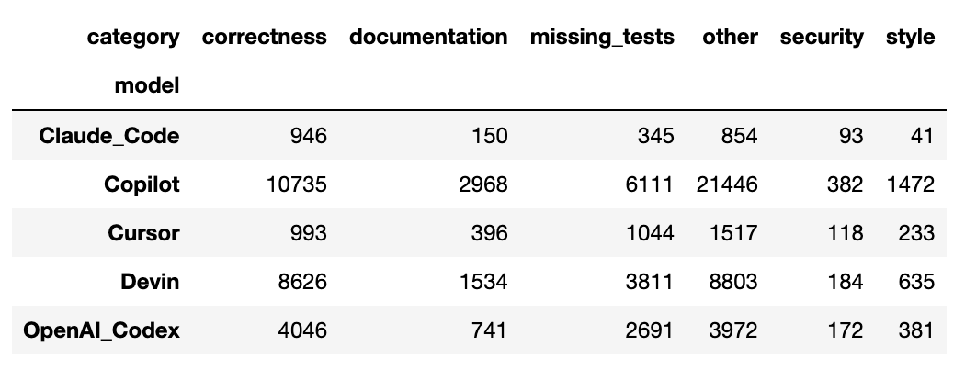

📊 5. Visualization Results

VIS 1 — Bar Chart: Reviewer Comment Counts Across AI Models
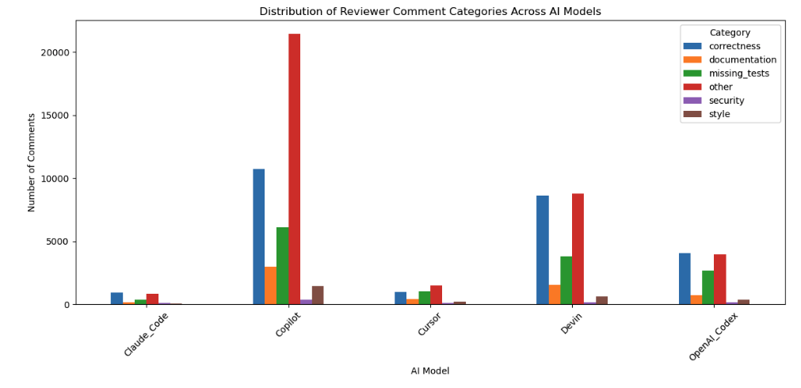

Interpretation
- Copilot receives the highest number of reviewer comments across all categories.
- Devin is second highest, especially for correctness issues.
- Cursor and Claude_Code receive far fewer comments, consistent with their lower PR volume.
- All models show strong reviewer focus on correctness and missing tests.

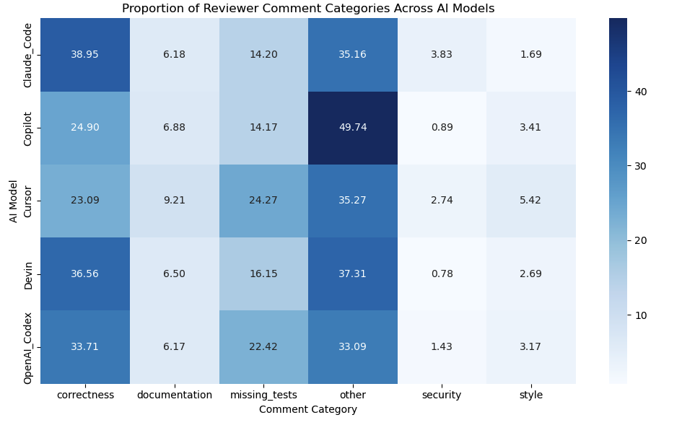
VIS 2 — Heatmap: Reviewer Comment Type Proportions per AI Model

Interpretation
The heatmap highlights patterns—not raw counts:
- Claude_Code shows the highest correctness proportion, indicating reviewers find functional issues more frequently in its PRs.
- Cursor attracts the most documentation and style comments, suggesting presentation and readability weaknesses.
- Cursor also has the highest missing-test proportion, highlighting incomplete testing.
- Copilot has nearly half of its comments in the "other" category, reflecting general or high-level reviewer discussions due to its large PR volume.
- Devin and OpenAI Codex sit between extremes but still show correctness and missing-test issues as major feedback themes.
- Security concerns remain uncommon across all models, contributing less than 4% of comments for any agent.

⭐ 6. Key Findings

Finding 1 — Correctness issues dominate reviewer concerns:
Correctness issues represent the largest single category of reviewer feedback for most models.
Claude_Code (38.95%), Devin (36.56%), and OpenAI Codex (33.71%) all show correctness proportions above 30%, indicating that reviewers frequently flag logical or functional problems in their generated PRs.
Copilot (24.90%) and Cursor (23.09%) show lower but still substantial proportions, suggesting that correctness concerns remain a common theme across all models.

Finding 2 — Missing tests is the second biggest reviewer concern:
Reviewers frequently request additional test coverage.

Finding 3 — Each AI model has a different reviewer “signature”
Model | Reviewer Concern Pattern
Copilot | Very high correctness + missing-tests issues
Devin | Similar to Copilot, but slightly more balanced
Claude_Code | Higher proportion of documentation issues
Cursor | Most balanced comment distribution
OpenAI Codex | Moderate across all categories

Finding 4 — Security concerns are rare
<2% for all models.

⭐ 7. Conclusion
Reviewer comment patterns reveal that different AI models exhibit distinct weaknesses:
- Copilot and Devin often produce code with logical issues or insufficient testing.
- Claude_Code generates PRs requiring more documentation cleanup.
- Cursor and Codex exhibit more balanced reviewer feedback.
Overall, reviewer comments provide clear evidence that AI-generated PRs still require significant human oversight, especially regarding correctness and testing adequacy.

