1718CSE 305 SOFTWARE ENGINEERING MIDTERM PROJECT

1-PROJECT TEAM INFO SHEET

DUE DATE (05/11/2020)

171805056 Ferhat Kamalı

Team Name : SoftTouch

Project Title : KaraokeNight (Website Project)

SoftTouch Members

Anıl Durmaz 181805080

Betül Başan 181805028

Betül Şahin 201805002

Ferhat Kamalı 171805056

SoftTouch Members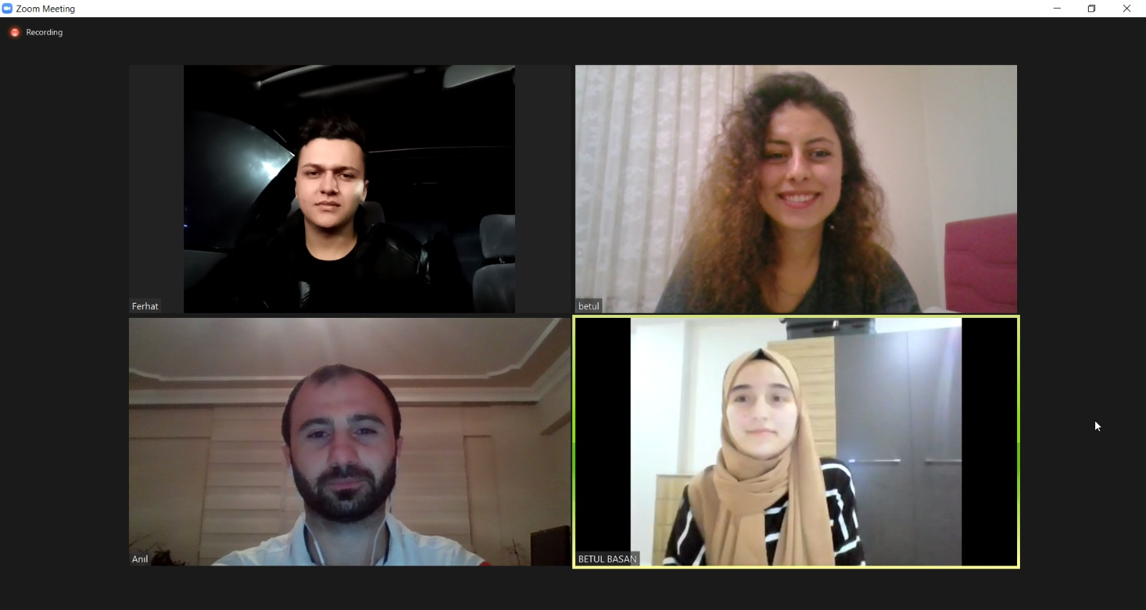

Ferhat KAMALI

Betül BAŞAN

Betül ŞAHİN 

Anıl DURMAZ

STRENGTHS OF OUR TEAM

* We are commnicate well with each other.
* We are focus on goals and results.
* We bring balance and equal out weaknesses. Cause we dont want to ignore weakness, we need to be aware of them. We offer each other support.

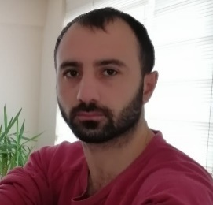ANIL DURMAZ

E-mail : [181805080@stu.adu.edu.tr](mailto:181805080@stu.adu.edu.tr)

Github : kizilelma23

Anıl Durmaz was born on May 3, 1991 in Bursa. He is originally from Erzurum. He graduated from Bursa Tophane Technical Vocational High School in 2010 and during this time he learned basic network knowledge, code and hardware knowledge. In 2012, he graduated from Uludağ University computer program department with a degree of 3.09 / 4. After my graduation, he worked as a worker in a factory until the summer of 2015. He did his military service between 2015-2016. When he came from the military, he started at another automotive company. In 2018, he took the Vertical Transfer Exam (DGS) and earned Adnan Menderes University computer engineering with 291,665 points and he is currently continuing to university as a 2nd grade student. At the same time, he work as a computer security technician in the days when he have no lessons.

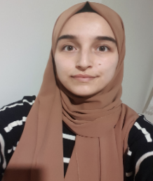BETÜL BAŞAN

E-mail : [181805028@stu.adu.edu.tr](mailto:181805028@stu.adu.edu.tr)

Github : BetulBasanADU

Betul Basan was born on October 8, 1999 in Kutahya. She graduated from Nafi Gural Science High School. She is now a 2nd grade student in Aydın Adnan Menderes University, Computer Engineering. In the first year of the university she had the opportunity to work with various programming languages and package programs. She is more interested in image processing. Most important to her is continue to improve continuously and she try to achive that the best she can. She still continue to improve herself with online courses and certificate programs.

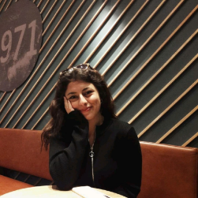BETÜL ŞAHİN

E-mail : [201805002@stu.adu.edu.tr](mailto:201805002@stu.adu.edu.tr)

Github : betulsahinn

Betul Sahin was born on August 9, 1999 in Antalya. She graduated from Gaziantep Central Anatolian High School in 2017. She know basic level network management and virtualization. She worked at Gaziantep University Information Technology Department for 2 years in the summer. She studied at Hasan Kalyoncu University between the academic years of 2017-2020, and now She is continuing her education life at Adnan Menderes University.



FERHAT KAMALI

E-mail : [171805056@stu.adu.edu.tr](mailto:171805056@stu.adu.edu.tr)

Github : Choacle

Ferhat Kamalı was born 1998 in Manisa. He finished primary school and highschool in Manisa to. After he gratuated from highschool he prepared one more year for univercity and he won computer science in Adnan Menderes Univercity. He has been interesting different programming languages, first year he started computer science. He is trying to be professional in java and c. In the last time He started to interested in different game engines like Unreal engine or Unity. Besides he has worked for 2 month in last year in a job that preparing advertisment in a market that call Hesmar.

Our First Virtual Meeting



SoftTouch Team Agreement

1- Methods of Communication : Group members communicate with each other by phone and mail.

2- Communication Response Time : Group members have to return to e-mails within 2 hours and phones within 1 hour.

3- Meeting Attendance : The meetings will be held every two days. Participation is mandatory. It starts at 12.15 and ends at 13.30.

4- Running Meetings : Meetings will be online and everyone should be prepared for their own topic.

5- Version Control : Fix bugs of the previous version.

6- Division of Work : The group coordinator divides the work to suit everyone.

7- Submitting Assigments : All members submit the assigments before deadline. The group coordinator review the submission.

8- Contingency Planning : If any group member leaves, the workload is distributed equally among the other members. If any group members consistently misses meetings or academically dishonest, alerted by the group coordinator. If this member continues her/his behavior, she/he must leave the team.

9- Roles and Responsibilities : Scrum Master is Betul Basan. Scrum Team is Anıl Durmaz(backend), Betul Basan(frontend), Betul Sahin(frontend, backend), Ferhat Kamalı(backend).

10- Main Contact for Instructor : Betul Basan