**Thesis Report**

**Team Members:**

**Ali Biçici**

**Ferhat Kamalı**

**Subject:**

**Twitter Sentiment Analysis**

Ingredients

1 Description of the Project 3

2 Plan of the Project 3

3 Steps of the Development Period 4

4 Member’s development parts 6

5 Referances 6

# 

# Description of the Project

Sentiment Analysis is a technique used in text mining. It may, therefore, be described as a text mining technique for analyzing the underlying sentiment of a text message, i.e., a tweet. Twitter sentiment or opinion expressed through it may be positive, negative or neutral. However, no algorithm can give you 100% accuracy or prediction on sentiment analysis.

As a part of Natural Language Processing, algorithms like SVM, Naive Bayes is used in predicting the polarity of the sentence. sentiment analysis of Twitter data may also depend upon sentence level and document level.

Methods like, positive and negative words to find on the sentence is however inappropriate, because the flavor of the text block depends a lot on the context. This may be done by looking at the POS (Part of Speech) Tagging.

**Why Twitter Sentiment Analysis?**

Sentiment Analysis Dataset Twitter has a number of applications:

**Business**: Companies use Twitter Sentiment Analysis to develop their business strategies, to assess customers’ feelings towards products or brand, how people respond to their campaigns or product launches and also why consumers are not buying certain products.

**Politics**: In politics Sentiment Analysis Dataset Twitter is used to keep track of political views, to detect consistency and inconsistency between statements and actions at the government level. Sentiment Analysis Dataset Twitter is also used for analyzing election results.

**Public Actions**: Twitter Sentiment Analysis also is used for monitoring and analyzing social phenomena, for predicting potentially dangerous situations and determining the general mood of the blogosphere.

# Plan of the Project

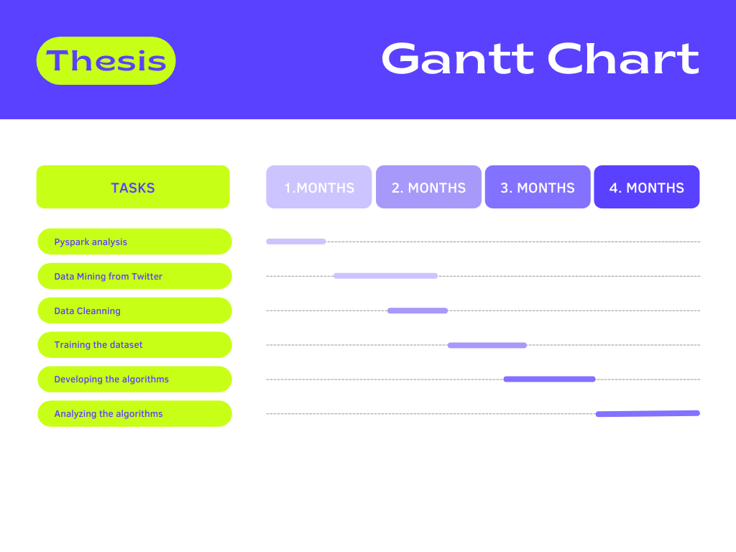

# Steps of the Development Period

Error 1 :

Exception: Java gateway process exited before sending the driver its port number

Error2 :

pyspark.sql.utils.IllegalArgumentException: u"Error while instantiating 'org.apache.spark.sql.hive.HiveSessionState':"

Error3 :

W:\Spark\spark-2.4.3-bin-hadoop2.7\python\pyspark\shell.py:45: UserWarning: Failed to initialize Spark session.

warnings.warn("Failed to initialize Spark session.")

Traceback (most recent call last):

File "W:\Spark\spark-2.4.3-bin-hadoop2.7\python\pyspark\shell.py", line 41, in <module>

spark = SparkSession._create_shell_session()

File "W:\Spark\spark-2.4.3-bin-hadoop2.7\python\pyspark\sql\session.py", line 583, in _create_shell_session

return SparkSession.builder.getOrCreate()

File "W:\Spark\spark-2.4.3-bin-hadoop2.7\python\pyspark\sql\session.py", line 173, in getOrCreate

sc = SparkContext.getOrCreate(sparkConf)

File "W:\Spark\spark-2.4.3-bin-hadoop2.7\python\pyspark\context.py", line 367, in getOrCreate

SparkContext(conf=conf or SparkConf())

File "W:\Spark\spark-2.4.3-bin-hadoop2.7\python\pyspark\context.py", line 136, in __init__

conf, jsc, profiler_cls)

File "W:\Spark\spark-2.4.3-bin-hadoop2.7\python\pyspark\context.py", line 198, in _do_init

self._jsc = jsc or self._initialize_context(self._conf._jconf)

File "W:\Spark\spark-2.4.3-bin-hadoop2.7\python\pyspark\context.py", line 306, in _initialize_context

return self._jvm.JavaSparkContext(jconf)

File "W:\Spark\spark-2.4.3-bin-hadoop2.7\python\lib\py4j-0.10.7-src.zip\py4j\java_gateway.py", line 1525, in __call__

answer, self._gateway_client, None, self._fqn)

File "W:\Spark\spark-2.4.3-bin-hadoop2.7\python\lib\py4j-0.10.7-src.zip\py4j\protocol.py", line 328, in get_return_value

format(target_id, ".", name), value)

py4j.protocol.Py4JJavaError: An error occurred while calling None.org.apache.spark.api.java.JavaSparkContext.

: java.net.BindException: Cannot assign requested address: bind: Service 'sparkDriver' failed after 16 retries (on a random free port)! Consider explicitly setting the appropriate binding address for the service 'sparkDriver' (for example spark.driver.bindAddress for SparkDriver) to the correct binding address.

at sun.nio.ch.Net.bind0(Native Method)

at sun.nio.ch.Net.bind(Unknown Source)

at sun.nio.ch.Net.bind(Unknown Source)

at sun.nio.ch.ServerSocketChannelImpl.bind(Unknown Source)

at io.netty.channel.socket.nio.NioServerSocketChannel.doBind(NioServerSocketChannel.java:128)

at io.netty.channel.AbstractChannel$AbstractUnsafe.bind(AbstractChannel.java:558)

at io.netty.channel.DefaultChannelPipeline$HeadContext.bind(DefaultChannelPipeline.java:1283)

at io.netty.channel.AbstractChannelHandlerContext.invokeBind(AbstractChannelHandlerContext.java:501)

at io.netty.channel.AbstractChannelHandlerContext.bind(AbstractChannelHandlerContext.java:486)

at io.netty.channel.DefaultChannelPipeline.bind(DefaultChannelPipeline.java:989)

at io.netty.channel.AbstractChannel.bind(AbstractChannel.java:254)

at io.netty.bootstrap.AbstractBootstrap$2.run(AbstractBootstrap.java:364)

at io.netty.util.concurrent.AbstractEventExecutor.safeExecute(AbstractEventExecutor.java:163)

at io.netty.util.concurrent.SingleThreadEventExecutor.runAllTasks(SingleThreadEventExecutor.java:403)

at io.netty.channel.nio.NioEventLoop.run(NioEventLoop.java:463)

at io.netty.util.concurrent.SingleThreadEventExecutor$5.run(SingleThreadEventExecutor.java:858)

at io.netty.util.concurrent.DefaultThreadFactory$DefaultRunnableDecorator.run(DefaultThreadFactory.java:138)

at java.lang.Thread.run(Unknown Source)

Solving the issues :

We just search them on Google and generally error’s source is basically happened from version of software. We just update software and and change the path.

# Member’s development parts

Ali Biçici :

* Data Mining
* Data cleaning
* Developing decision tree algorithm
* Reporting

Ferhat Kamalı:

* Train dataset
* Developing ECS algorithm
* Twitter streaming

# Referances

[1] <https://spark.apache.org/docs/latest/api/python/user_guide/index.html>

[2] <https://developer.twitter.com/en/docs/tutorials>

[3] <https://scikit-learn.org/stable/modules/generated/sklearn.svm.SVC.html>