A Spatial and Machine Learning Approach to Identifying High-Risk Functional Literacy Areas in the Philippines
STAT299 final paper, working draft, 29 October 2026
[AUTHOR NAME, ADVISER, AFFILIATION]
Note: Rough draft built from the run outputs (EDA_FINDINGS.md, ALE_LEAKAGE_FINDINGS.md, LISA_FINDINGS.md). Numbers are from the 2026-10-12 EDA and ALE runs and the 2026-10-28 spatial run. Bullets mark places still to be turned into prose. Highlighted brackets mark missing citations or data.

Abstract
Background. Nearly three in ten working-age Filipinos (29.2%, weighted) are not functionally literate in the 2024 FLEMMS, and the rate varies sharply by province.
Objective. We identify which individual and household characteristics predict functional illiteracy and which provinces form spatial clusters of high risk.
Method. We use 468,643 respondents aged 10 to 64 from the PSA FLEMMS 2024 public-use files. We select 45 features by supervised gain ranking on training households, keeping PCA as a diagnostic only. An XGBoost classifier with survey weights and class-imbalance correction is explained with accumulated local effects (ALE). Out-of-fold predictions are aggregated to 117 provinces and highly urbanised cities and tested with global Moran's I and LISA. A scenario simulation raises internet use and digital skills by 10 points in the high-risk cluster.
Results. The model reaches a weighted out-of-fold ROC-AUC of 0.701 and is well calibrated. Observed rates cluster in space (Moran's I = 0.34, p < 0.001), and predicted rates cluster more strongly (I = 0.65). High-High clusters appear in Eastern Visayas, the Zamboanga Peninsula and southern Davao, though none survives false-discovery correction. A 10-point rise in digital uptake lowers predicted illiteracy in these areas by about 1.1 points.
Conclusion. Population composition explains most of the provincial pattern. The Samar island group remains worse than predicted and warrants place-specific study.
Note: About 210 words. Recount after Results are final; limit is 250.

1. Introduction
The Philippines reports basic literacy of about 90% for persons aged five and above, yet only about 70.8% of persons aged 10 to 64 are functionally literate (Philippine Statistics Authority, 2024). The gap between reading and using what one reads is the problem this paper addresses.
National and regional aggregates hide where this gap is concentrated. The 2024 FLEMMS is the first round to release estimates at province and highly urbanised city (HUC) level, which makes a sub-national risk map possible for the first time [CITATION NEEDED].
- Point to keep from the proposal: interventions by DepEd and DOLE rely on lagging aggregate indicators [CITATION NEEDED].
- Point to keep: digital access as a prerequisite for functional literacy (Sabarwal & Noonan, 2025).
- Point to keep: intergenerational transmission (Biñas & Garvida, 2023).
- Drop or source: the "19 million Filipinos" figure [CITATION NEEDED] and San Juan City 94.5% [CITATION NEEDED].

1.1 Objectives
- Describe where functional illiteracy risk is geographically concentrated across provinces and HUCs, using LISA.
- Identify and quantify the individual and household factors associated with functional illiteracy.
- Build a predictive early warning model with gradient boosting and use it to simulate targeted digital interventions in high-risk areas.
Note: Objective 2 in the proposal mentions income and infrastructure. FLEMMS has no income variable, so the final model uses schooling, digital use and household proxies instead. Reword to match.

1.2 Scope
We study persons aged 10 to 64, the FLEMMS Form 2 and Form 3 universe. FLEMMS is a single cross-section, so the model predicts current status, not future change, and the simulations describe model associations, not causal effects.

2. Related Work
Note: Condense from reference/proposal-manuscript/02_lit_review.md. Keep it to about one page in the final paper.
- Functional literacy: definitions and measurement (UNESCO, 2020; World Bank, 2021).
- Spatial inequality in education and LISA as a tool to find clusters (Anselin, 1995; Xiang & Stillwell, 2023).
- Digital skills and resources (Sabarwal & Noonan, 2025).
- Machine learning as an early warning system in education (Chung & Lee, 2019).
- Interpretability: SHAP and ALE (Molnar, 2022). Add the original ALE paper [CITATION NEEDED] and the XGBoost paper [CITATION NEEDED].
- Wealth proxies from asset indicators (Filmer & Pritchett, 2001).

3. Data
We use the PSA FLEMMS 2024 public-use files: the member roster, household (RTF1), literacy (RTF2, Form 2) and ICT (RTF3, Form 3) records, merged on household and line number. The working-age universe has 496,770 persons aged 10 to 64. Of these, 468,643 (94.3%) have a valid Form 2 result and enter the analysis.
Item | Value
Persons aged 10 to 64 (merged) | 496,770
Analysis rows (valid FLITERATE and weight) | 468,643
Households in the analysis | 163,655
Weighted functional illiteracy rate | 29.2% (unweighted 30.6%)
Population represented | 85.0 million
Kish effective sample size | 242,573 (design effect about 1.93)
Spatial units (PRV codes) | 118 in the data, 117 mapped
Table 1. Analysis universe. Source: EDA_FINDINGS.md, LISA_FINDINGS.md.
- Target: FLITERATE, recoded 1 = functionally illiterate, 0 = literate.
- Weights: RESP_RFACT_F2 throughout, so all rates describe the national population.
- The 28,127 persons without a Form 2 record are older (mean age 36.3 vs 32.8) and slightly less often female. State this as a selection limit.
- Boundaries: OCHA COD-AB city and municipality polygons [CITATION NEEDED: dataset version and access date], dissolved to the FLEMMS province and HUC units. Each PRV code is matched by name to a boundary code using the PSA value set PRV_VS1. HUCs are carved out of the province that surrounds them.
- Code 999 ("BARMM63", the BARMM Special Geographic Area, n = 589) has no matching unit and is left out of the spatial weights.

4. Methods

4.1 Feature selection
PCA on the 750 encoded features needs 504 components to reach 95% of variance, so it reduces little. Because variance is not relevance, we keep PCA as a diagnostic and select features by XGBoost gain against the target instead.
- Split by household first (80/20, grouped on HHID), then select the top 44 features on training rows only.
- Exclude outcome proxies: READ_IND_F2 and READ_IND_F3 restate the literacy result (illiteracy rate near 100% at levels 2 and 3).
- Add AGE as a demographic control, for 45 features in total.

4.2 Predictive model
We fit an XGBoost classifier with 300 trees, depth 6 and learning rate 0.05. scale_pos_weight corrects class imbalance and the survey weight enters as a sample weight. For province aggregation we refit in 5 folds grouped by household, so every person is scored by a model that never saw their household.
- Prior correction: subtract log(scale_pos_weight) from the margin so predicted probabilities match observed rates.

4.3 Interpretation
We use accumulated local effects (ALE) because they stay within realistic data regions when features are correlated. Effects are reported on the log-odds scale and as odds ratios.
Note: SHAP results in 02_xgboost_xai/xgboost_shap_*.csv come from the older, unaudited pipeline. Either re-run SHAP on the audited model or drop SHAP from the paper. Friedman's H was promised in the proposal and is not done yet.

4.4 Spatial analysis
- Province and HUC rates: observed weighted rate, mean predicted rate, and their difference (residual).
- Weights: queen contiguity with 13 island units linked to their nearest neighbour; KNN with k = 6 as a check.
- Global Moran's I and LISA with 9,999 permutations. Clusters use p < 0.05; Benjamini-Hochberg FDR is reported as a sensitivity check.

4.5 Scenario simulation
In each High-High province, we switch randomly chosen eligible persons to internet use, digital skills, or both, until the weighted share rises by 10 percentage points. We re-score everyone with their out-of-fold model and report the change in the weighted mean predicted rate, with intervals from 50 Monte Carlo draws.

5. Results

5.1 Model performance
Metric | Grouped hold-out | Out of fold (5 folds)
ROC-AUC, weighted | 0.702 | 0.701
PR-AUC, weighted | 0.505 | 0.507
ROC-AUC, unweighted | 0.708 | 0.709
Recall, illiterate class (0.5 cutoff) | 0.59 | [DATA MISSING]
Precision, illiterate class (0.5 cutoff) | 0.44 | [DATA MISSING]
Table 2. Model performance. Source: ALE_LEAKAGE_FINDINGS.md, oof_model_metrics.csv.
Discrimination is moderate and stable across splits. Calibration is good after prior correction: in every risk decile the mean prediction is within 0.8 points of the observed rate.

5.2 Drivers of functional illiteracy
Feature | Meaning | Odds ratio
HGC_LEVEL_2 | Lower secondary completed | 0.50
HGC_LEVEL_1 | Elementary completed | 0.52
HGC_LEVEL_3 | Next level up [DATA MISSING: label] | 0.59
INTERNET_1 | Used internet, past 3 months | 0.90
DSKILL_INFO2_1 | Information and data literacy skill | 0.91
DSKILL_PROB6_1 | Problem-solving skill | 0.92
MM_WORK_1 | Never uses media for work or e-mail | 1.17
Table 3. Selected ALE effects, primary model. Odds ratios below 1 lower the risk. Source: ALE_LEAKAGE_FINDINGS.md.
- Schooling dominates: completing elementary or lower secondary roughly halves the odds.
- Each digital item lowers the odds by 8 to 10%. The items are correlated, so report them as a block.
- Age: low risk in the 20s and 30s, rising after 40 (about +0.22 log-odds at 60).
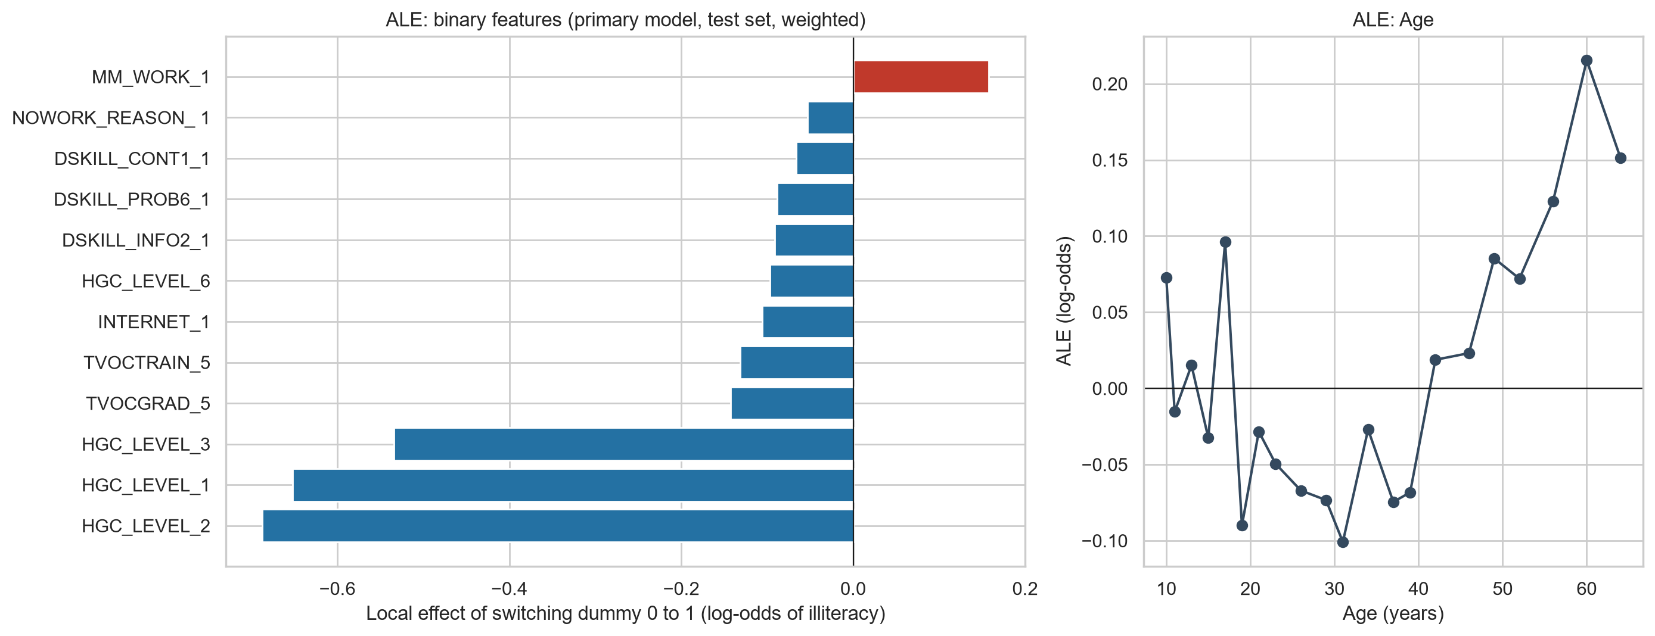
Figure 1. ALE curves for the primary model.

5.3 Province rates
Observed and predicted province rates correlate at 0.77, so the characteristics of residents explain most of the provincial pattern. Residuals range from -17.8 to +17.4 points.
Unit | Observed | Predicted | Residual (pp)
Tawi-Tawi | 66.4% | 49.0% | +17.4
Surigao del Norte | 42.9% | 30.4% | +12.5
Agusan del Norte | 44.3% | 32.2% | +12.0
Zamboanga del Sur | 48.9% | 37.0% | +12.0
Samar (Western) | 46.1% | 34.1% | +11.9
Apayao | 13.2% | 30.9% | -17.8
Benguet | 12.1% | 27.1% | -15.0
San Juan | 5.5% | 20.2% | -14.8
Sulu | 22.8% | 36.2% | -13.4
Isabela City | 21.9% | 35.1% | -13.2
Table 4. Largest residuals (observed minus predicted). Source: province_rates_observed_predicted.csv.
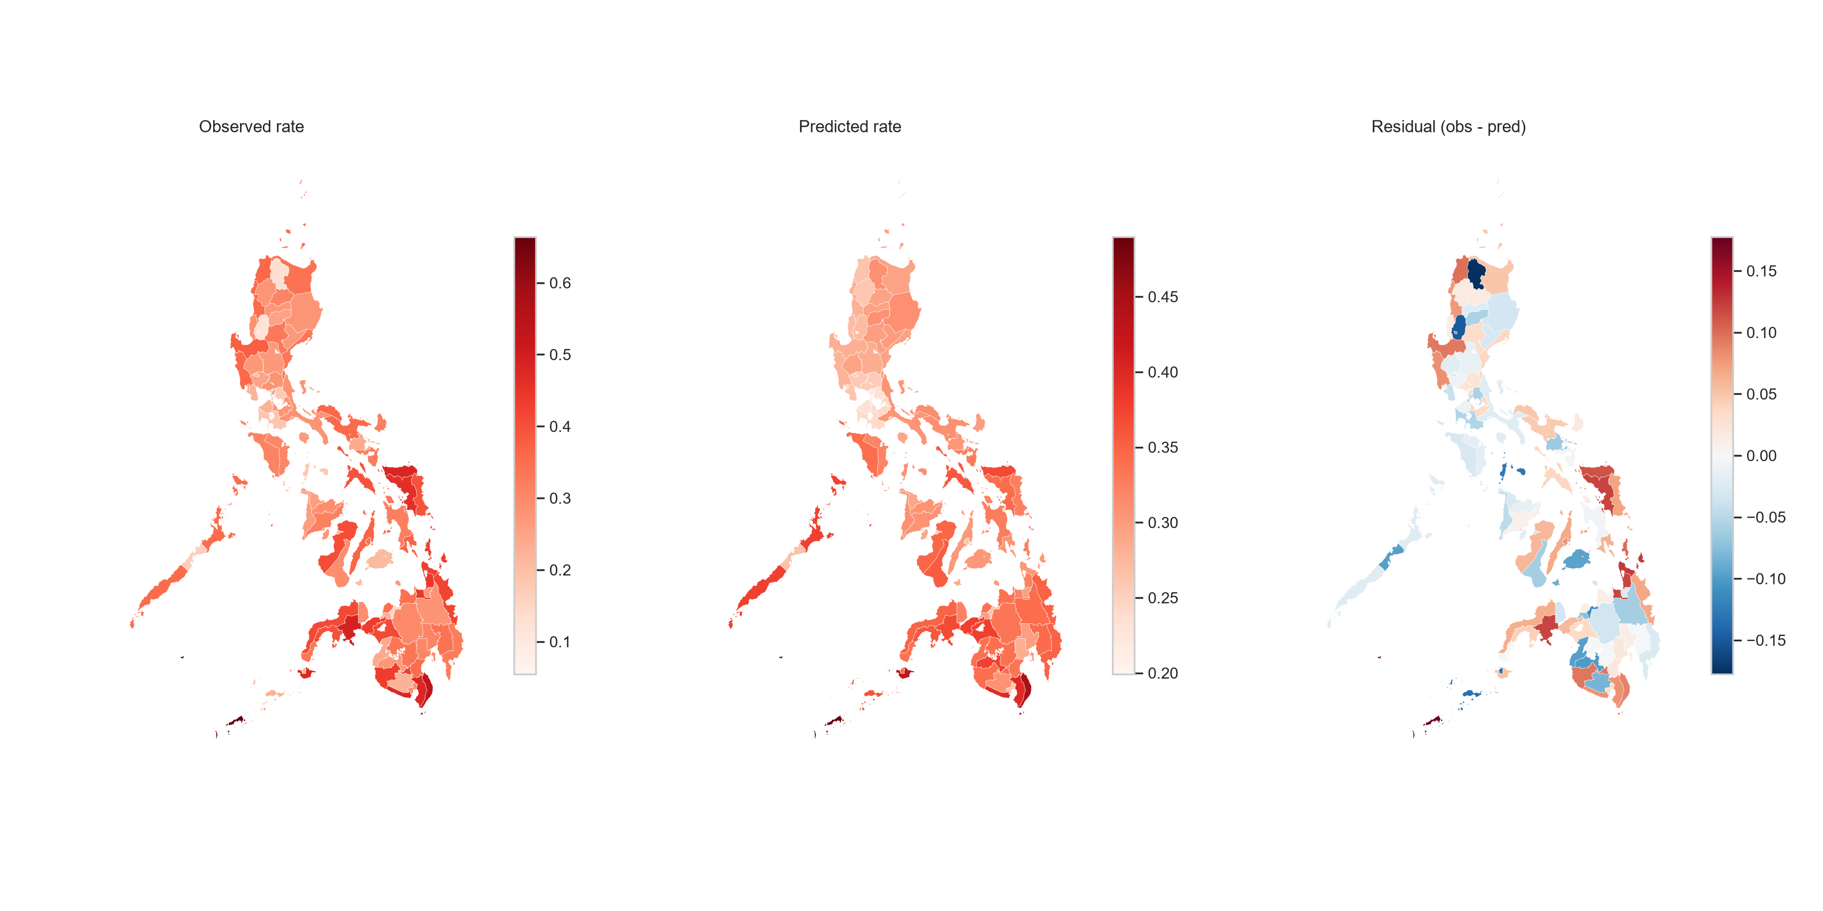
Figure 2. Observed and predicted functional illiteracy rates by province and HUC.

5.4 Spatial clustering
Variable | Queen I | p | KNN-6 I | p
Observed rate | 0.340 | 0.0001 | 0.375 | 0.0001
Predicted rate | 0.649 | 0.0001 | 0.608 | 0.0001
Residual | 0.114 | 0.063 | 0.125 | 0.006
Table 5. Global Moran's I, 9,999 permutations. Source: global_morans_i.csv.
Observed illiteracy clusters in space, and predicted rates cluster almost twice as strongly. Residual clustering is weak, so place-level factors outside the model add only a modest spatial signal.
Variable | High-High | Low-Low | Low-High | High-Low
Observed rate, p < 0.05 | 11 | 17 | 4 | 0
Observed rate, BH-FDR | 0 | 8 | 1 | 0
Predicted rate, p < 0.05 | 16 | 21 | 0 | 0
Residual, p < 0.05 | 7 | 6 | 5 | 3
Residual, BH-FDR | 0 | 0 | 0 | 0
Table 6. LISA cluster counts, queen weights, 117 units. Source: lisa_clusters.csv.
- High-High, observed (11): Eastern Samar, Northern Samar, Samar (Western), Leyte; Zamboanga del Norte, Zamboanga del Sur, Zamboanga Sibugay; Davao del Sur, Davao Occidental; Sarangani; Surigao del Norte.
- Low-Low, observed (17): 13 Metro Manila cities, plus Bulacan, Cavite, Rizal and Baguio City.
- High-High, predicted (16): shifts toward BARMM and central Mindanao (Lanao del Norte and del Sur, Maguindanao del Norte, Basilan, Sulu, North Cotabato, Sultan Kudarat), plus the Zamboanga and southern Davao units.
- Residual High-High (7): Eastern, Northern and Western Samar, Biliran, Surigao del Norte, Zamboanga Sibugay, Dinagat Islands.
None of the observed High-High clusters survives FDR correction, while most of the Metro Manila Low-Low cluster does. We therefore report the high-risk clusters as suggestive.
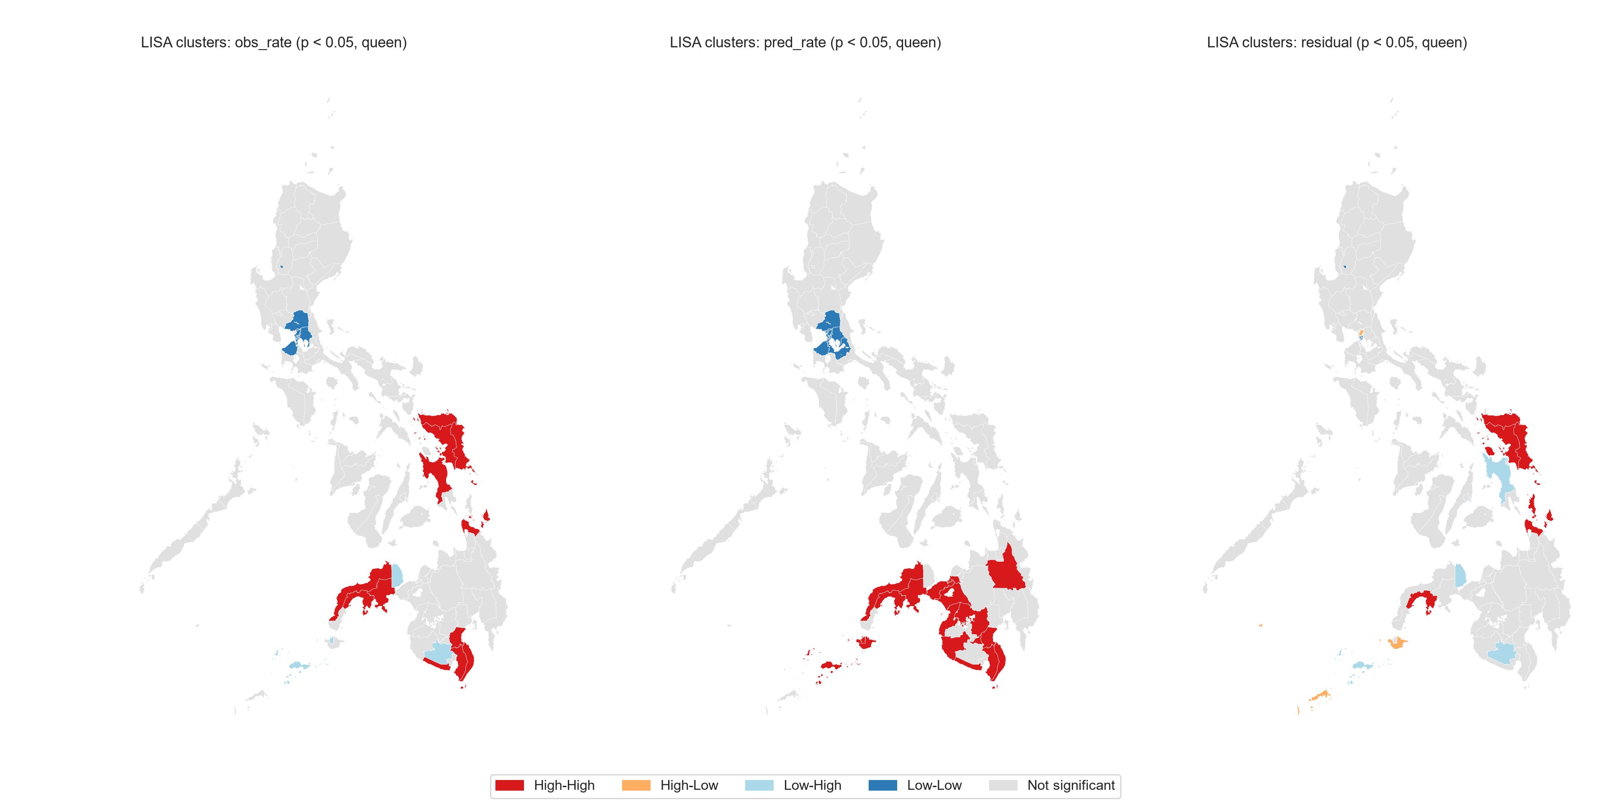
Figure 3. LISA cluster maps, p < 0.05.

5.5 Scenario simulation
Scenario | Effect in target units (pp) | MC interval (pp) | National effect (pp)
Internet use | -0.33 | -0.34 to -0.32 | -0.03
Digital skills (7 items) | -0.93 | -0.94 to -0.91 | -0.07
Internet plus skills | -1.11 | -1.14 to -1.09 | -0.09
Table 7. Effect of a 10-point rise in uptake in the 11 High-High units (7.8% of the weighted population). Source: simulation_summary.csv.
Effects are small. Digital skills move predictions about three times as much as internet use alone. The intervals cover only who takes up the change, not model refitting.
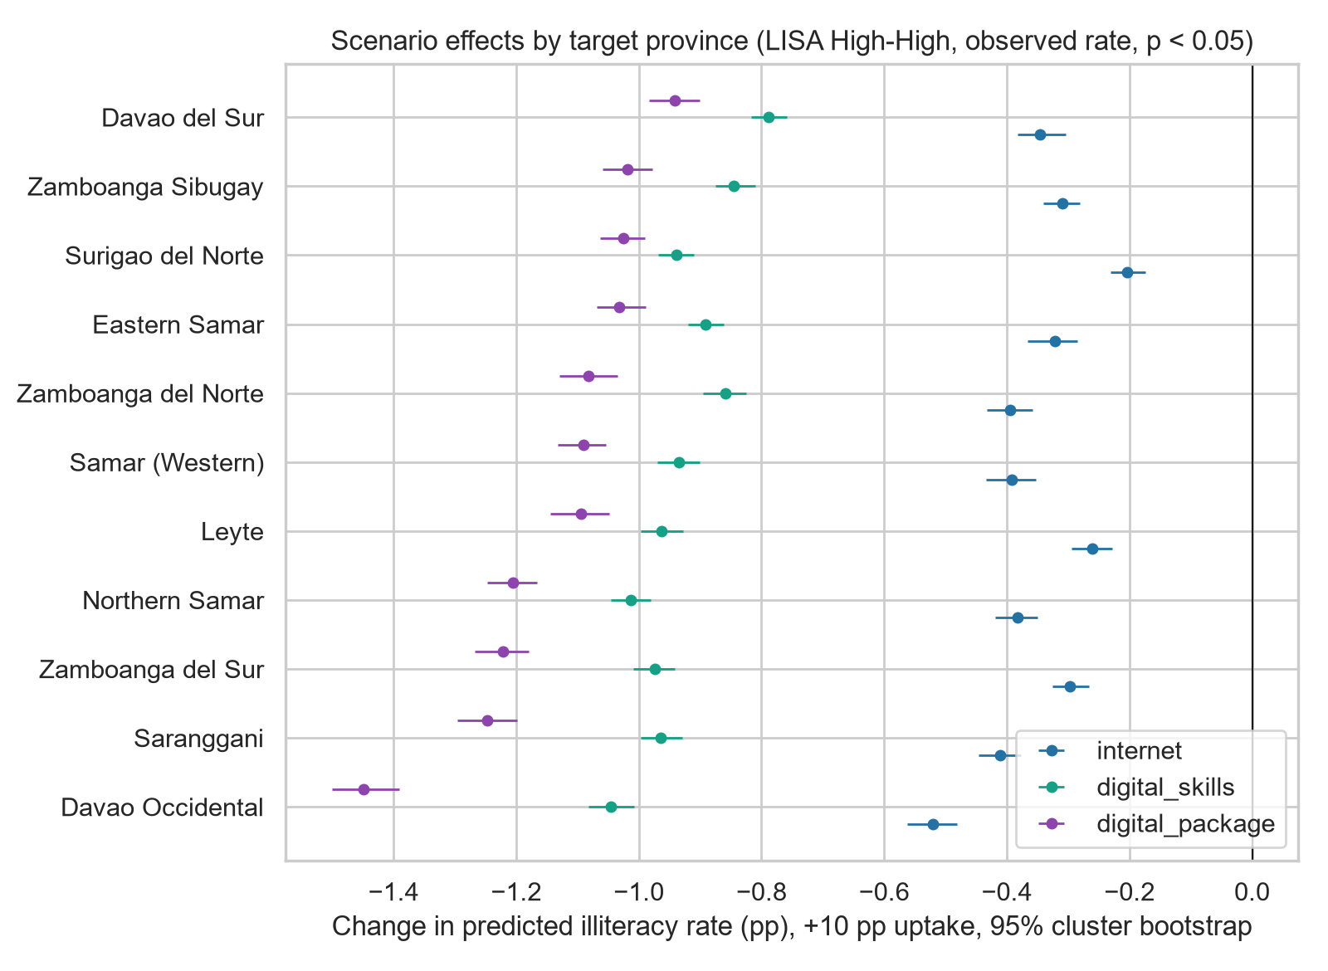
Figure 4. Scenario effects by target province.

6. Discussion
Most of the geography of functional illiteracy follows from who lives where. Predicted rates, which use only individual and household characteristics, cluster more strongly than observed rates, and the predicted high-risk zone covers the provinces with the lowest schooling.
- Composition versus place: residual clusters are weak overall, but the Samar island group is high on both observed rate and residual. This is the clearest case for a place-level factor [DATA MISSING: candidate explanations, e.g. school supply, typhoon exposure].
- BARMM: predicted risk is high, yet Sulu, Basilan and Isabela City do better than predicted. Check whether this reflects measurement, language of testing or real performance.
- Policy reading: digital interventions alone move risk by about 1 point. Schooling completion carries larger effects, so digital programmes should complement, not replace, schooling.
- Robustness: the high-risk clusters rest on unadjusted p-values. Use them to prioritise further study, not as final targets.

7. Limitations
- Cross-sectional data: associations, not causal effects.
- No income variable; household proxies only.
- Persons without a Form 2 record (5.7%) are excluded and differ slightly in age and sex.
- Multiple testing: High-High clusters do not survive FDR.
- Cotabato City has no PRV code in the data; its polygon is merged into Maguindanao del Norte.
- Form 3 questionnaire not in the repo, so the simulation universe is inferred from the data.
- Untuned hyperparameters; intervals exclude refitting uncertainty.

8. Conclusion
We combine a survey-weighted XGBoost model with spatial statistics to map functional illiteracy risk across 117 Philippine provinces and HUCs. Schooling is the dominant predictor, and composition explains most of the spatial pattern. Eastern Visayas, the Zamboanga Peninsula and southern Davao form the highest-risk area, and the Samar island group stands out as worse than its population profile predicts.

To-do before the final draft
- Re-run SHAP on the audited model, or remove SHAP from Methods and the abstract.
- Run Friedman's H and two-dimensional ALE for the top pairs, or drop them from the proposal promises.
- Fill the HGC_LEVEL_3 label from the PSA dictionary.
- Add out-of-fold recall and precision to Table 2.
- Confirm where Cotabato City respondents are coded.
- Check the Anselin (1995) reference: the proposal lists volume 7 and pages 97-115; verify against the journal.
- Add citations for ALE, XGBoost and the boundary dataset.
- Merge prose from 01_introduction_revised.md and 04_methodology_model_revised.md.

References
Note: Carried over from the proposal. Not yet checked for format or completeness.
Anselin, L. (1995). Local indicators of spatial association: LISA. Geographical Analysis, 7(2), 97-115. [VERIFY VOLUME AND PAGES]
Biñas, H. L., Jr., & Garvida, L. M. G. (2023). Through the kaleidoscopic features of lifelong learning: A multi-faceted exploration of functional illiterate parents' experiences in modular distance learning. European Journal of Education Studies, 10(6).
Chung, J. Y., & Lee, S. (2019). Dropout early warning systems for high school students using machine learning. Children and Youth Services Review, 99.
Filmer, D., & Pritchett, L. H. (2001). Estimating wealth effects without expenditure data or tears: An index using asset indicators.
Molnar, C. (2022). Interpretable machine learning: A guide for making black box models explainable.
Philippine Statistics Authority. (2024). Conduct of the 2024 Functional Literacy, Education and Mass Media Survey (FLEMMS).
Sabarwal, S., & Noonan, P. J. (2025). Digital skills development: Why, what, and how? World Bank Education Working Paper Series, No. 14.
UNESCO. (2020). Glossary. UNESCO Institute for Statistics.
World Bank. (2021). Learning poverty is a combined measure of schooling and learning.
Xiang, L., & Stillwell, J. (2023). Rural-urban educational inequalities and their spatial variations in China. Applied Spatial Analysis and Policy.

