**Instructions to install Environment for Python for CE3007**

Date: 2 Jan 2018

Author: Chng Eng Siong

1. We will be using Anaconda Environment for Python (Python 3.6)

<https://www.anaconda.com/download/>

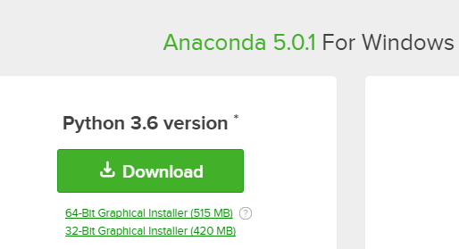

1. You need to install the following libraries using conda install
   1. <https://docs.anaconda.com/anaconda-cloud/user-guide/howto#use-packages>

Libraries you will need:

1. https://anaconda.org/anaconda/numpy
2. <https://anaconda.org/anaconda/scipy>
3. <https://anaconda.org/anaconda/matplotlib>

and you will use: https://docs.python.org/2/library/winsound.html

1. You can consider using PyCharm <https://www.jetbrains.com/pycharm/>

Some Help: Actually there are too many, I prefer using https://stackoverflow.com

1. You will need to learn how to organize python code into packages:
   1. <http://intermediate-and-advanced-software-carpentry.readthedocs.io/en/latest/structuring-python.html>

2) How to use numpy: <http://www.numpy.org/>

a. Examples in: <https://hackernoon.com/introduction-to-numpy-1-an-absolute-beginners-guide-to-machine-learning-and-data-science-5d87f13f0d51>

b. <http://cs231n.github.io/python-numpy-tutorial/>

3) Python for DSP: <https://www.pythonforengineers.com/audio-and-digital-signal-processingdsp-in-python/>

Date: 12 Feb 2019

**If your PyCharm does not work due to Path issue, try the following:**

1, After Installing Pycharm and Anaconda3

2, Run Anaconda Prompt

3, Type "python" to enter python console

4, Type "import os"

5, Type "print(os.environ['PATH'])"

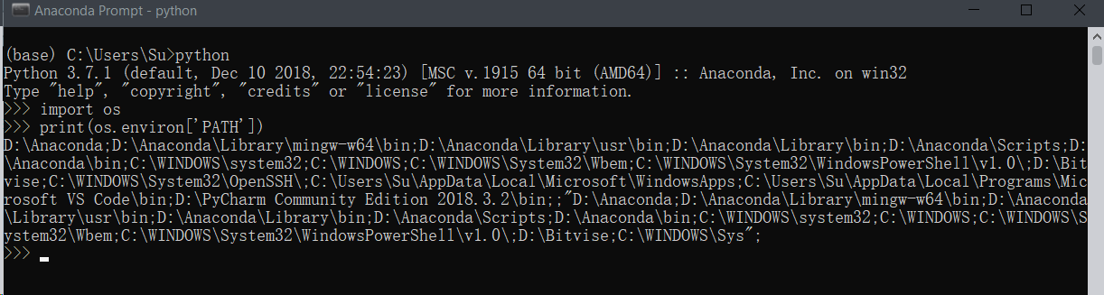

6, Copy all the necessary Anaconda and python related path, it starts as D:\Ana....

7, Open your Pycharm - Run - Edit Configurations - Environment Variables

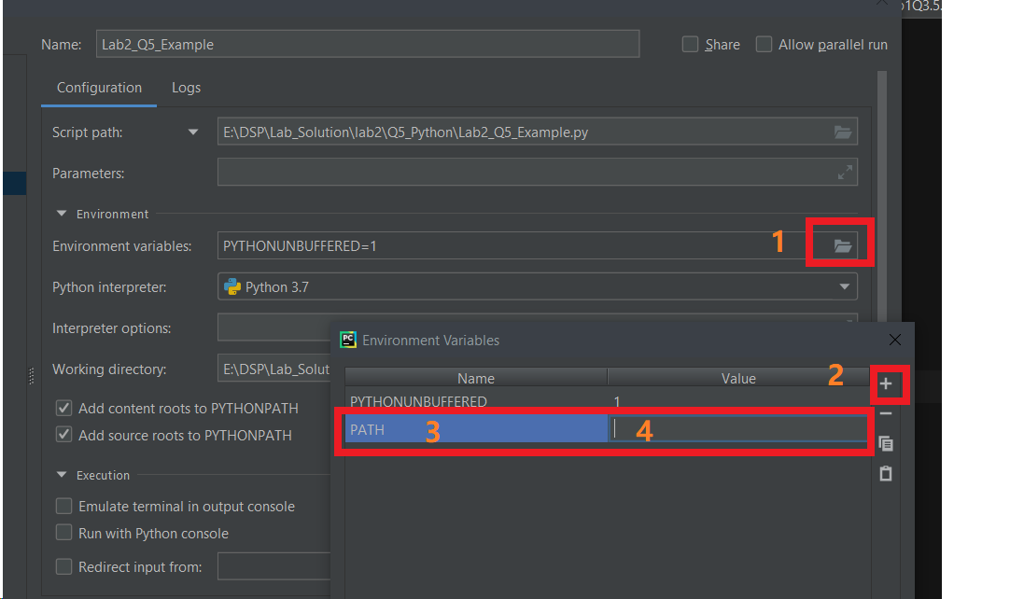

8. Paste what you copied into 4.

9. Click Apply -Ok

Done