

SAE - VIT AERODOMINATOR 7.0 

**TECHNICAL DESIGN REPORT**

TEAM NAME: THE THIRD DIMENSION 2

TEAM NUMBER: AD-002

COLLEGE NAME: NATIONAL INSTITUTE OF TECHNOLOGY, TIRUCHIRAPPALLI

**TEAM MEMBERS**

CHOCKALINGAM THENAPPAN

RITIK MALIK

SANKARSH PRASANNAA

SHANKAR R. JAVLE

GANESH ARAVIND. S. E.

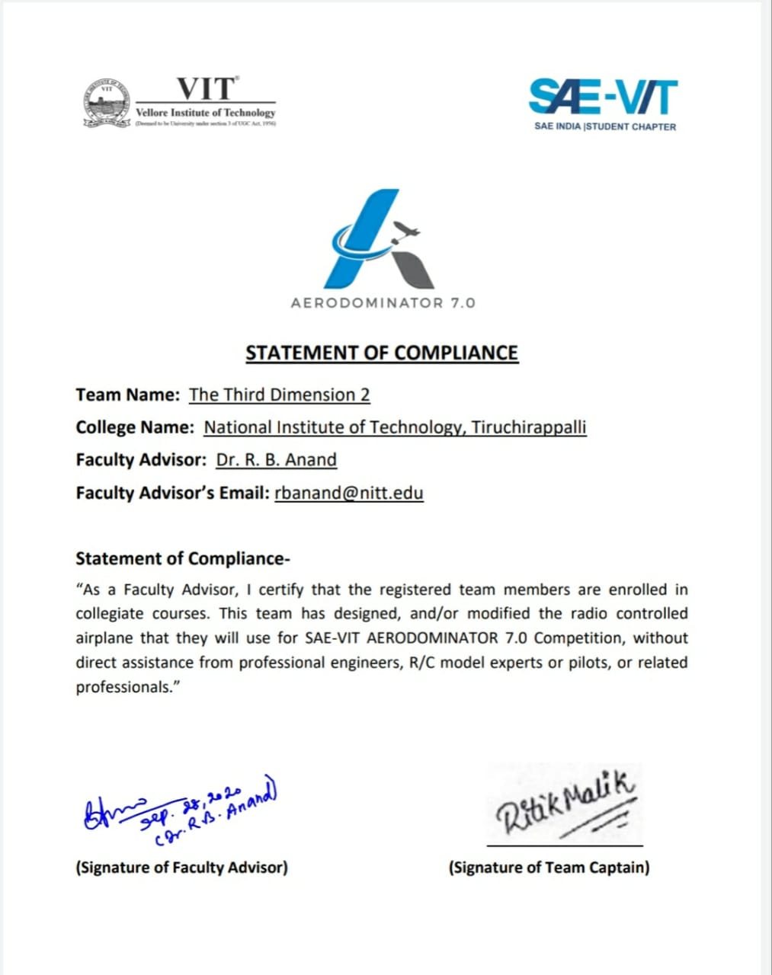

**TABLE OF CONTENT**

|  |  |  |
| --- | --- | --- |
| Sr. no | Name of the topic | Page no. |
| 1 | Abstract | 5 |
| 2 | Design Requirements | 5 |
| 3 | Wing design |  |
|  | 3.1 Airfoil selection | 5 |
|  | 3.2 Aspect Ratio | 6 |
|  | 3.3 Wing planform | 7 |
|  | 3.3 Wing configuration | 7 |
| 4 | Thrust-Drag analysis and Propulsion requirement |  |
|  | 4.1 Motor-propeller combination selection | 7 |
|  | 4.2 Velocity estimation | 8 |
|  | 4.3 Performance analysis | 9 |
| 5 | Fuselage and payload design |  |
|  | 5.1 Fuselage design | 9 |
|  | 5.2 Payload bay design and payload optimization | 9 |
| 6 | Tail design | 10 |
| 7 | Longitudinal static-stability analysis | 10 |
| 8 | Control surface sizing |  |
|  | 8.1 Aileron sizing | 12 |
|  | 8.2 Rudder-VS sizing | 13 |
| 9 | Servo sizing | 14 |

|  |  |  |
| --- | --- | --- |
|  | Title | Page no. |
| Table 1 | Drag estimation |  |
| Table 2 | Datasheet of motor |  |
| Table 3 | Payload optimization result | 10 |
| Table 4 | Servo sizing |  |

**Table of Tables**

**List of Figures**

|  |  |  |
| --- | --- | --- |
|  | Title | Page no. |
| Figure 1 | CL vs Alpha for different interpolation relations |  |
| Figure 2 | Thrust vs. V and Drag vs. V graphs |  |
| Figure 3 | Cm vs. Alpha graph |  |

**1.Abstract**

The following design report describes our team's design process philosophy and the reasoning behind the decisions taken w.r.t. design of a Micro Class RC aircraft under the organizers' constraints. The competition's main aim is to develop an airplane to carry and deliver **medical supplies** and **first aid**. So the design objective is to develop an airplane capable of producing **high lift** and carrying **as much payload as** possible and a stable flight.

**2.Design Requirements**

The main requirements for the design observed by our team are as follows :

* Restricted to **electric propulsion**
* The empty weight of aircraft is limited to **1.5 kg**
* The wingspan is limited to **85 cm**
* The plane should be able to be **hand-launched**
* Should be able to carry as much **payload** as possible (must carry at least one of both type of payload – cylindrical and circular)

**3.Wing design**

The wing is the most crucial part of the airplane as it is the significant lift-producing component and ensures our plane's capability to fly. The required design specifications for the wing were that it should produce enough lift for carrying a payload. The parameters we considered for wing design were airfoil selection, wing planform, and wing configuration.

**3.1 Airfoil selection**

Airfoil selection is a critical step for wing design since it determines lift and stall characteristics and pitching moment. Our selection criteria for airfoil was that it should provide high lift at low speed and low Reynold's number environmental conditions and also it should have a high stall angle (since aircraft should be able to hand launch, there is a high chance for aircraft to stall at launch). We approximated Reynold's number of 50,000 because we wanted to analyze the airfoils at low Reynolds number conditions during hand launch. We did literature surveys on the internet from experimental data and narrowed it down to three airfoils – s1223 RTL,e240, and FX74.**Here s1223 RTL is improved upon s1223 that we found in a research paper which is favorable for us at low Reynolds number conditions while hand launching**. Among these airfoils, s1223RTL has favorable lift characteristics, and e240 has a slightly higher stall angle. So we decided to go with the interpolation of these two airfoils. Cl vs. Alpha graph for different interpolation relations was plotted, and then the best combination was chosen.

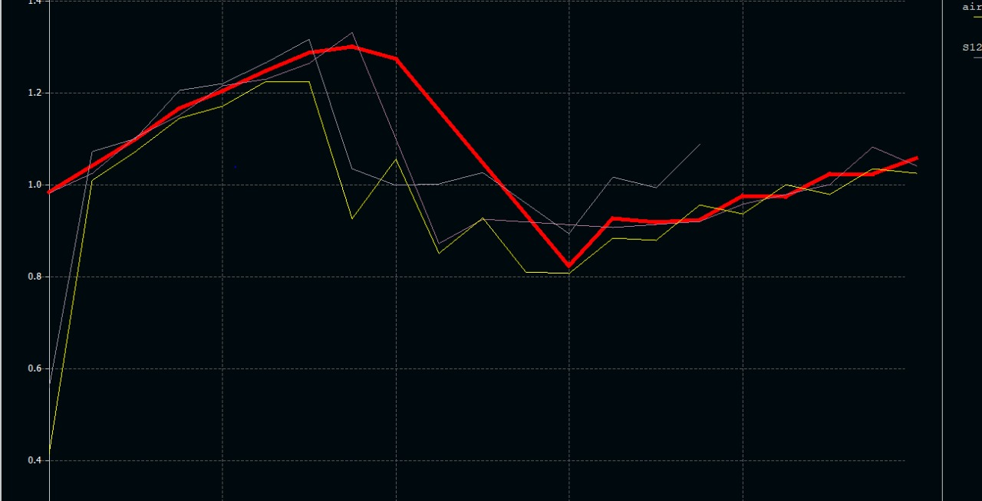

**Fig.1. CL vs Alpha for different interpolation relations**

From the graph, the Red thick line shows the best combination for good lit coefficient and stall angle which we got for interpolation relation of **74% s1223 RTL and 26% e240.**

**3.2 Aspect Ratio**

Aspect ratio is given by this formula

$$A.R. = \frac{s^{2}}{A}$$

It has a great effect on lift and drag coefficients. For constant span, lift increases with decreasing aspect ratio. Since our span limit is very low we had to increase the wing area by increasing the chord of the wing which leads to a decrease in aspect ratio. But since our main objective is to carry max. payload possible so aircraft doesn’t need to be much mobile so we can afford to with a low aspect ratio without compromising on functionality. So we have set our span as 84 cm and chord as 30 cm which gives us an aspect ratio of 2.8. We have taken a span very close to the limit so that we will be able to get a maximum lift and also able to carry more payload. It will also help our plane to fly at lower velocities and acts as a safety margin for unexpected environmental effects.

**3.3 Wing Planform**

The planform greatly affects the wing efficiency and induced drag produced by the wing. The factors we considered while selecting the planforms are good lift and manufacturability. We had to compromise drag because of span limit given by organizers is low so we had to go with a configuration that provides us good amount of lift.

$$C_{D-induced = \frac{C_{l}^{2}}{πeA.R.}}$$

e=efficiency factor. Elliptical wing have very good efficiency but it is very hard to manufacture it, While Rectangular wing is easy to manufacture as well as provide high lift. Tapered wing is a good combination of both elliptical and rectangular. **A tapered wing with same area will have a bigger root chord and it would increase the load on heavy central part of the fuselage which is used for supporting the wings**. So we compromised drag and decided to go with rectangular wing planform.

**3.4 Wing Configuration**

The wing configuration has influence over longitudinal and vertical static stability. Mainly three types of configurations are there : High ,middle and low. We neglected low config. because of danger of collisions with ground and also due to reduced head wind velocities. We have chosen high config. Because we wanted fuselage to be open for payload and components. And also we wanted the wings to be detachable so high config. allow the wing to be easily removable.

**4.Thrust-Drag Analysis and propulsion requirement**

**4.1Motor propeller combo selection**

Thrust is the pulling force that makes the plane travel through the air which can only be generated by electric propulsion as per the rules of competition. Drag is the resisting force produced by the motion of the body through the fluid; such as air, water. It acts opposite to the motion of the body so in our case drag opposes the thrust and slows down the plane. Drag force is given by $F_{d}=\frac{1}{2}C_{d}ρAv^{2}$.

Where Cd is called drag coefficient, A is an area of cross-section, v is the velocity of the plane. The Drag force changes with the AOA because, with pressure drag, the horizontal component of lift also contributes to creating drag.

Total drag force $F_{r}=F_{d}+Lsin∝$, L is the total lift produced.

The drag estimation is very important while choosing the proper motor because the thrust of the motor has to balance the drag force for a resultant velocity. It is also a very important factor for deciding the cruising velocity of a plane at which plane will cruise during flight.

|  |  |
| --- | --- |
| Velocity (m/s) | Drag force (Newton) |
| 12 | 2.687 |
| 13 | 3.199 |
| 14 | 3.681 |
| 15 | 4.219 |
| 16 | 4.972 |

**Table 1. Drag estimation**

We estimated drag force on our plane using the initial model and found out the estimated drag values. According to that, we have selected our motor-propeller combination that can produce enough thrust to counter the drag. We have selected AS 2814 1200 kV motor with propeller APC 10 in*5.5 in as was suggested by the motor manufacturer.

**4.2 Velocity estimation**

The cruising velocity depends on the different factors such as rpm of motor, pitch angle of the propeller, etc. We approached the problem mathematically by modeling the blade element at 70% of the radius of the propeller as done in most propeller blade element theories. We approached the problem mathematically by modeling a blade element of the propeller at 70 percent of the radius of each blade as done most often in propeller blade element theories. We used a constant pitch propeller that has the same AoA at all sections for a given velocity. The net aerodynamic force this section generates is resolved as the thrust force it provides and the force responsible for creating the counter-torque and deciding the RPM of the motor. The equation for the thrust, therefore, is calculated by applying the basic airfoil lift equation and resolving forces.

$$T\left(v,ω\right)=\frac{1}{2}ρA(0.7Rω)(\sqrt{{\left(0.7Rω\right)}^{2}+v^{2}})\left(C_{L_{o}}+ C_{L_{α}}\left(θ_{p}-\tan^{-1}\left(\frac{v}{0.7Rω}\right)\right)\right)$$

**Throttle Voltage Current RPM Torque(gm)**

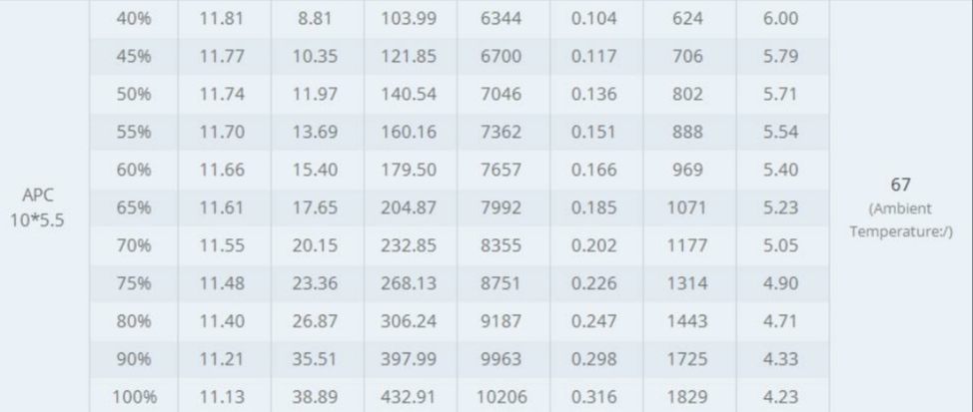

**Table 2. Datasheet of motor**

We found the rpm of the propeller at 75 % throttle from the datasheet of the manufacturer as 8751 rpm. Pitch angle for most of the commercial RC propellers is around 7 degrees. After fixing all these data, thrust as a function of velocity is plotted. A generalised drag function was also plotted versus velocity. **The intersection point of both curves gives us the cruising velocity of plane at which it will ideally cruise. It was obtained as 15 m/s.**

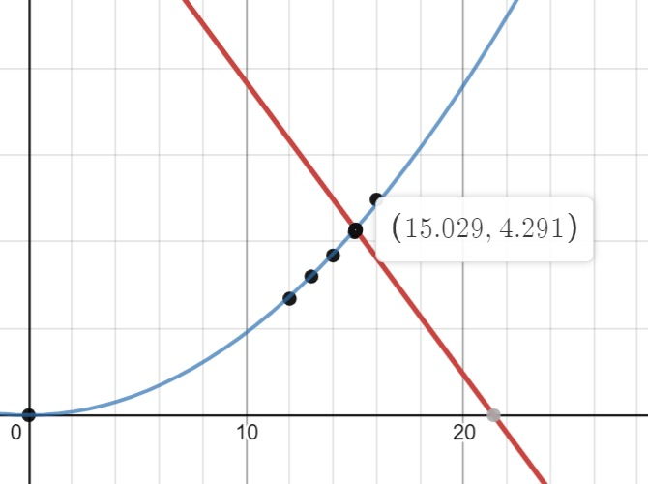

**Fig. 2. Thrust vs V and Drag vs. V graph**

**4.3 Performance analysis**

The battery that will be used to supply electric power is a 3S Li-Po battery of capacity 2200 mAh. From the datasheet of our chosen motor-propeller combination, at our cruising speed (15 m/s) and cruising throttle (75%), the current drawn is equal to 23.36 A. As battery capacity is 2200 mAh, this gives an estimated flight time of 5.6 minutes (approx. 335 seconds) and an estimated range of 5,034 meters (15m/s * 335.6 sec.) i.e., approximately 5 kilometres.

**5. Fuselage and payload design**

**5.1 Fuselage design**

The fuselage is the central and crucial part of fuselage as it houses all the electronic components and the payload. We wanted fuselage having good structural strength and also having enough volume to house the electronic components. Our fuselage is made up of balsa wood. We wanted to accommodate the electronics in the front so that CG of an empty plane and CG of payload can coincide so we decided the length of the fuselage accordingly and empennage to adjust the static margin as per requirements. **We have developed a truss structure at the backside which contributes to the structural strength of fuselage**. The cuts are made in order to minimize weight without compromising on structural integrity. The fuselage's width and height are set up to accommodate the payload box inside properly with minimum drag possible. The taper is provided to upper part of fuselage toward the tail so that drag can be minimized.

**5.2 Payload bay design and payload optimization**

We have placed the payload bay inside the fuselage and it is designed in such a way that t has sufficient volume for payload. **We wanted COG of empty plane and COG of the payload to coincide so that the plane could fly smoothly without the payload and with the payload without any extra pitching moment.**

We optimized our payload by iterating for various parameters like different length, width and height of the payload bay and the number of cylinders and spheres we can accommodate in that volume and followed by an optimization considering the weight of the payload. According to that an optimum amount of payload was decided which is given below.

|  |  |  |  |  |  |
| --- | --- | --- | --- | --- | --- |
| length | width | height | Number of cylinders | Number of spheres | Total weight (gm) |
| 13 | 8 | 8 | 2 | 6 | 480 |

**Table 3. Payload optimization result**

**6. Tail design**

The tail design is done by using tail volume coefficient method to estimate the required empennage dimensions. The tail volume coefficients for horizontal and vertical tail is given by ,

$$C_{Ht}=\frac{L_{Ht }× S_{Ht}}{C_{w}×S_{W}}$$

$$C_{Vt}=\frac{L_{Vt }× S_{Vt}}{C_{w}×S_{W}}$$

LHt and LVt  are called moment arms which are commonly approximated as distance between 25% of wing mean chord length to the tail quarter chord length of the vertical and horizontal stabilizer respectively .Cw is wingspan while S denotes the surface area.

Typical values for CHt are 0.2 to 0.7 and for CVt are 0.02 to 0.07. The higher the number ,more stability achieved. We chose to go with CHt as 0.53 and a CVt of 0.1. Our tail volume is higher than usual values because of long fuselage of the plane (long moment arm). **By rearranging the equation and selecting a suitable tail volume coefficient, required empennage length can be calculated**.

**7. Longitudinal static-stability analysis**

The stability of plane along the longitudinal axis according to the position of the centre of gravity and neutral point. Generally CG doesn’t coincide with point at resultant lift works so a pitching moment is produced which make moment unstable. The horizontal stabilizer produces counter torque to stabilize aircraft so designing of horizontal stabilizer is very crucial. To analyse stability of plane about longitudinal axis and parameters affecting it, a general moment equation was generated which is given below and all the data was analysed using xflr5.

$$C_{m}= C_{mac}+(C_{L})\frac{l_{cg}}{c}-V_{H}\left(C_{L_{E}}\right)$$

Cm is moment coefficient, Cmac is the moment of wing about the mean aerodynamic centre, CL is the lift coefficient of plane and CLE is the lift coefficient of horizontal stabilizer and VH is volume coefficient of horizontal stabilizer.

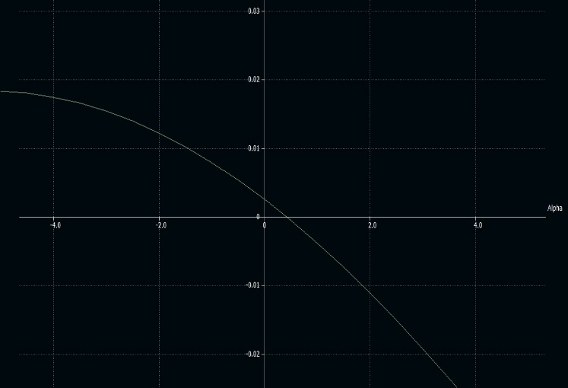This is the Cm versus alpha graph. **The position of neutral point is around 15.933 cm from leading edge of wing**. Now the degree of stability depends on one called static margin which is given as

$$S.M.=\frac{X_{np}-X_{cg}}{c}$$

**Fig.3. Cm vs. Alpha graph**

Knowing the position of position of CG which is 13.4 cm from leading edge of wing ,We can calculate the value of static margin which is coming around 0.08. Generally for most of the stable planes values of static margin is between 0.05 to 0.25,with stability getting smaller with lesser values of static margin. In our case value of static margin is 0.08 which is quite good because the value falls in mid range the plane is not too unstable or not too stable to resist the maneuvers.

**Control Surface sizing**

**Aileron sizing**

**Design outcome**: aileron activation must cause the plane to rotate 1 radian in 1 second

**Constraints/Assumptions**: Maximum angle of aileron deflection is 30 degrees, the ratio of aileron width to MAC of the plane is 0.25, the aileron will be located at the tip of the span to maximise moment.

**Procedure:** An Analytic equation was developed that described the angle rotated as a function of time and aileron deflection**. This equation is valid under the assumption that the roll resistance of the aircraft is directly proportional to the angular velocity which holds when velocity is much higher compared to product of angular velocity and half-span.**

$ϴ=\frac{K_{ail}}{K_{gli}}t-\frac{K_{ail}}{K_{gli}^{2}}\left(1-e^{-\frac{K_{pla}}{I}t}\right) (1)$

Kail – Aileron dependent constant, which is derived from the relation given below, from the paper Programmable Aileron Sizing Algorithm for use in preliminary aircraft design software, Published in the journal of engineering and applied sciences.

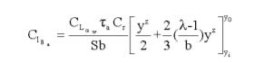 (2)

Kgli – Glider dependent constant, is the proportionality constant between the roll resistance of the glider and the angular velocity. Computed by hand assuming a radial variation of angle of attack across all surfaces and an extra component was added for the fuselage.

I – Moment of Inertia of the plane about the roll axis. Computed using Solidworks.

By substituting required values in (1) we can solve for required value of Kail and using (2) we can find the inboard location of the aileron assuming tip of span to be outboard position hence solving for aileron size.

All required constants were either present in the paper or were computed from Xflr5.

**Rudder sizing**

**Design outcome**: the plane must be able to withstand a crosswind of 4m/s

**Assumptions/Constraints**: Rudder chord is assumed to be around 0.6 of the VS to ensure enough extra length at the tip chord for structural soundness. Maximum deflection of Rudder was 30 deg

**Procedure**: Analytic relations describing Rudder behaviour was taken from the paper: An Educational Rudder Sizing Algorithm for Utilization in Aircraft Design Software published in the International Journal of Applied Engineering Research.

$C_{n_{δr}}=-C_{l_{α_{v}}}∀_{v}η_{v}τ_{r}\frac{b_{r}}{b_{v}}$ (1)

$N_{a}=qSbC_{n}$ (2)

Using the above equations, we can determine the rudder's functions as a function of the properties of the rudder and the vertical stabilizer. To compute the wind's effects, an ANSYS analysis is made where there is a crosswind of 4m/s when the glider is in steady flight condition on a model of the glider without the rudder. This gives the side drag of the glider. Using the side drag, we can calculate a VS-rudder combo that can keep the plane stable under such circumstances by analyzing both the effects of the rudder and the influence of crosswind on the VS, causing it to create a yawing moment.

**Servo sizing**

The proper servo must be selected to ensure all control surfaces' function in support of maneuverability of plane. Each control surface experience a different amount of force due to drag acting on it and its inertia. So servo need to be sized according to the torque needed for movement of control surfaces. Torque calculations are dependent on the control surface chord C, velocity V, control surface length L, Maximum control surface deflection S1 and maximum servo deflection S2. The given equation is taken from a research paper Northern Arizona University, which outlines the appropriate torque calculation for servo sizing.

$$T \left(oz-in\right)=8.56×{10}^{-6}\left(\frac{C^{2}V^{2}Lsin(S_{1})}{tan⁡(S_{2})}\right)$$

(All units in inches)

|  |  |  |  |  |  |
| --- | --- | --- | --- | --- | --- |
|  | Control surface max deflection from centre(degrees) | Servo max deflection from centre (degrees) | Max speed (inch/s) | Resulting servo torque (oz-in) | Torques plus 30 % (oz-in) |
| Aileron | 30 | 80 | 560 | 8.82744361 | 11.47567669 |
| Rudder | 30 | 80 | 560 | 16.04477952 | 20.85821338 |
| Elevator | 30 | 80 | 560 | 9.223777812 | 11.99091116 |

**Table 4. Servo sizing**

**The resulting torque requirement for each control surface was calculated and were increased by 30 %** for safety reasons and because sometimes servo do not work to their max. capacities. These final torque values were used to select appropriate servos.

**10. References :**

1. Aero design stuff, “ The wright stuff ”,Department of Mechanical engineering, Northern Arizona University
2. 2014Fall – BS-Thesis-T06-EML 4905 Senior design project, Florida International University
3. Programmable Aileron Sizing Algorithm for use in preliminary aircraft design software, The journal of engineering and applied sciences
4. An Educational Rudder Sizing Algorithm for Utilization in Aircraft Design Software, International Journal of Applied Engineering Research.
5. An Aerodynamic Comparative Analysis of Airfoils for Low-speed Aircrafts, Sumit Sharma, International Journal of Engineering and Technical research