Aphid Population Dynamics with Effects of Predators

Chuck Larrieu

9 July 2009

**Abstract:**

To gain an understanding of aphid population growth, as well as explore some aspects of predator-prey interaction, three separate experiments were conducted: The Clip Cage experiment, the Feeding experiment, and the Large Cage experiment. The Large Cage had two parts: the first measured population growth of aphid colonies with abundant resources by counting populations daily; and the second measured changes in population after predators were introduced. The Clip Cage Experiment consisted of isolating newborn aphid nymphs in clip cages and tracking development rates. This provided the parameters necessary to develop a model and run a simulation of the Large Cage experiment, which validated that model. In the Feeding experiment, maximum daily consumption rates of coccinellid larvae and adults were monitored. Key results include: a plot of aphid fecundity versus age; a stage based matrix model of aphid population growth, which could be used to compare experimental and calculated long-term population growth rates; a plot of maximum daily consumption rates versus age of coccinellid larvae, as well as the maximum daily consumption rates of adults; and a graph of aphid populations with predators present.

**Introduction:**

With modern pesticides failing to protect crops and the businesses which depend on them, as well as posing new and frightening health risks, responsible biological control has been proposed as an effective, safer means to pest control (Messing and Wright, 2006). As previous studies suggest, the augmentative release of predators can provide an effective means for biological control, and so the interaction of predator and prey is an essential area of study. The main goal of this study is to analyze the population dynamics of the pea aphid under ideal conditions, and to examine the effects of predator introduction with the use of ladybird beetles (hereby referred to as coccinellids). Previous studies have been done on aphid population growth, but in order to study predation dynamics, we must model and observe our own controlled populations due to the effect of temperature on development rates (Hutchison and Hogg, 1984). In order to analyze predator-prey population dynamics, we must first construct, parameterize, and test a model for aphid population growth, and then construct and test a model for the effect of predators.

**Materials and Methods:**

**Experiments:**

In our experiments, we are using the pink morph of the pea aphid, *Acyrthosiphon pisum*, convergent ladybird beetles, *Hippodamia convergens*, and faba bean plants, *Vicia faba*. We are interested in three aspects of biological control of aphid pests: predatory behavior of Ladybird Beetles, development of aphids, and aphid population growth. In order to observe these three aspects, we designed three separate experiments. All experiments were conducted at constant temperature, humidity, and light exposure.

Predatory Behavior (feeding experiment):

In order to measure predatory behavior of Ladybird Beetles, we began with first-instar Coccinellid larvae isolated in individual tubes. We fed each larva a set amount of medium sized aphids, ensuring both enough food and that the aphids would not reproduce in the tubes. The number of non-eaten aphids was recorded for each day, as this was much easier to record than the number of aphids consumed. The experiment was repeated for adult Coccinellidae. Because we didn’t have to keep track of larval development for adults as we did for the developing larvae, we used new batches of adults from day to day.

Aphid Development (clip-cage experiment):

We observed aphid development first by isolating adult aphids inside of clip-cages on broad bean plants. The next day, we took out all aphids except for one newborn nymph in each clip-cage. From there, we inspected each cage everyday for exuviae to tell whether or not an aphid promoted from one life stage to the next. All exuviae were removed upon recording as to not confuse the search for the next day. We recorded the instar level for each aphid until they became reproducing adults. After reaching the reproductive stage, we recorded how many offspring were produced each day, and removed said offspring.

Population growth (large cage experiment):

Our population experiment consisted of three large cages with generous plant supply. Each cage began with one adult aphid. Every day, the total population of aphids in each cage was recorded using counters. Plant supply was kept abundant throughout the experiment. After populations had grown significantly, we introduced predators into two of the large cages. We did not have time to finish the analysis of the effects of predators in our large cages.

**Aphid Population Dynamics:**

In analyzing the characteristics of aphid populations, we used the discrete, linear, stage-structured model

, Equation (1)



Where V is the vector of life stages of the pea aphid (first through fourth instars, new adults, and mature adults respectively from top to bottom), and M is the matrix of stage transition rates (Caswell, 2000). The matrix M is constructed as

, Equation (2)



with the *ij* entry representing the transition from stage *j* to stage *i.* The *s* values represent the probability of staying at the same stage from one time-step to the next, *p* values represent the probability of promoting to the next stage in one time-step, *f* -values represent the fecundity of each class of adult, and *c* represents the probability of jumping from fourth instar to mature adult in one time-step. The survival and development rates are obtained from the clip-cage experiment, and the fecundity rates are calculated from clip-cage data using a computing program (Caswell, 2000). This aphid life history is valid in the laboratory setting, where temperature, light exposure, and humidity are controlled.

Using this model, we find that the eigenvalue, , of M represents the long -term growth rate of an aphid population with no environmental constraints, and that the eigenvector, U, of M represents the stable stage distribution (Caswell, 2000). We found the growth rate and stage distribution using a numerical method with the R programming language (*The R Project*). After obtaining values for the parameters in M, we ran a simulation of the large cage experiment.



**Effect of Predators:**

Our continuous model of predation effects is based on our observation that, with abundant resources, the rate at which the aphid population grows is proportional to the population itself, and that with predation, the total rate of change of the population is equal to the rate of growth of aphids minus the rate of predation. This, of course, is an oversimplification, but the assumptions are reasonable in our laboratory setting. The model with predation included,

, Equation (3)



is based on the assumption that aphid population growth is not subject to environmental constraint, and predation rates follow the Holling Type 2 model (Brauer and Castillo-Chavez, 2001). We modified Holling Type 2 to be dependent upon total population and area of habitat rather than population density. With this form of the model, *N* represents total aphid population; *q* represents the saturation level of predation; *A* represents habitat area; *a* represents the semi-saturation level; and *r* represents the continuous growth rate. If compared to the discrete model earlier described, we also find that *r=*ln( ).



**Results and Discussion:**

**Clip Cage Results:**

In order to get fecundity values into the matrix model, we first had to collect fecundity data. Figure 1 shows daily fecundity versus age. It is important to realize that “temporal age” for aphids is not as significant as “developmental age,” which is why age is represented as “days as reproducing adult” rather than “days since birth.” For the matrix M, we need two fecundity values—one for first-day reproducing adults, and one for “mature” reproducing adults, or adults that have been reproducing for more than one day. The fecundity data gives average number of offspring for first-day adults, call it m1, and average number of offspring for mature adults, call it m, but in order to put *f*1 and *f*2 into the matrix, we needed to account for survivorship of the newborn aphids (Caswell, 2000).

It is interesting to note in Figure 1 that fecundity stays roughly constant for 6 or so days before decreasing linearly.

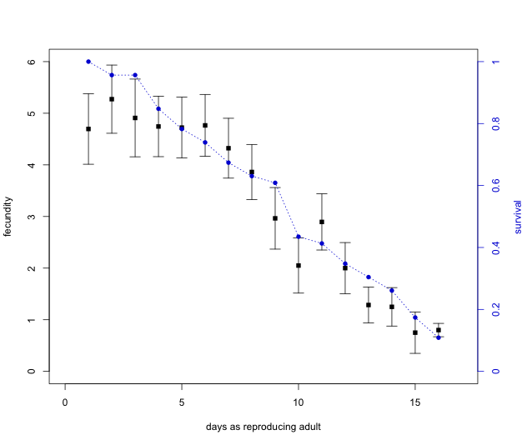

**Figure 1:** Aphid Fecundity. The blue, circular points represent the fraction of original adult aphids that are still alive on that day’s data collection. The black, square points represent the average number of offspring for different ages of adult aphids. Error bars indicate the 95% confidence interval.

Using the clip-cage data, we found

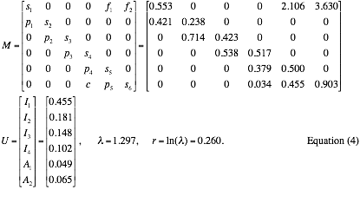

Equation 4 shows that over 45% of a stable aphid colony consists of first instar nymphs, 18% second instar, 15% third instar, 10% fourth instar, 5% first stage adults, and 7% second-stage adults. It is important to note that the sum of each column (fecundity excluded) is less than 1. The remainder would represent the mortality rate of each stage.

**Large Cage Results:**

From the stage transition information, we can model predicted daily growth rates. In Figure 2, we can compare the predicted daily growth rates and the actual data from the large cage experiment. The predicted model eventually settles on the long-term growth rate . Around days 9-13, we see a small anomaly in the data where error bars are slightly larger and growth rates are slightly higher than predicted by the model. Perhaps this indicates a slight insufficiency in the model. Also noteworthy is the long-term growth rate . With that kind of growth rate, an unchecked aphid colony will grow by almost than 220% in only three days. This is an astounding rate for non-bacterial creatures, making it clear as to why it is important to be able to control these populations. The general shape of the model can be explained by the fact that early on, the population is almost completely dependent on the fecundity of the initial adult aphid. This causes the first few days to give volatile results for the daily growth rates. Once the later generations of aphids begin to reproduce, the growth rate and stage distribution stabilize. Overall, the theory behind aphid stage transition and fecundity rates seems to have been validated by the data acquired from the Large Cage experiment.



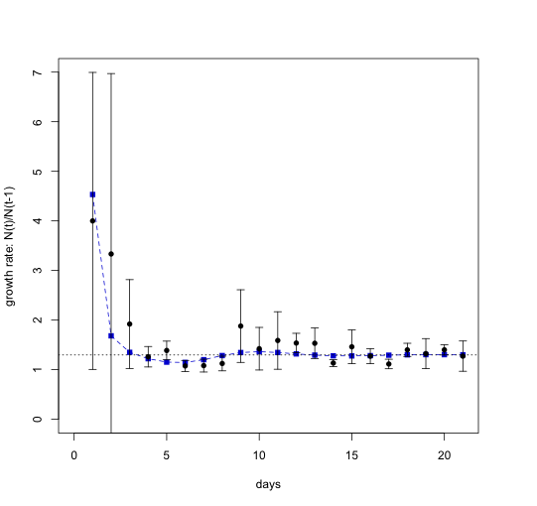 **Figure 2**: Predicted and Actual Daily Growth Rates. The predicted model of daily growth rates is in blue (squares). In black is the data from the large cage experiment (circles), with error bars indicating the 95% confidence interval.

**Predation Results:**

Although there was not enough time to fully analyze the data from the predation experiments, we did find some interesting results that could be subject to further study. Figure 3 depicts the consumption rates of coccinellids at different ages. Interesting features of the figure include a seemingly linear increase in consumption until day 10 or so, with a decline before the vertical black line, as well as relatively small error bars. The decline in consumption of larvae from days 10-15 is due to pupation of various individuals at various times. In preparation for pupation, the larvae must devote more time and energy to development rather than consumption. We also see that adult coccinellids do not consume as much as the later instar larvae. This is most likely due to reproductive investments, as we will see in the large cage predator data. In our experiment, we found *q*, the maximum daily consumption rate for adult coccinellids, to be 48.524.

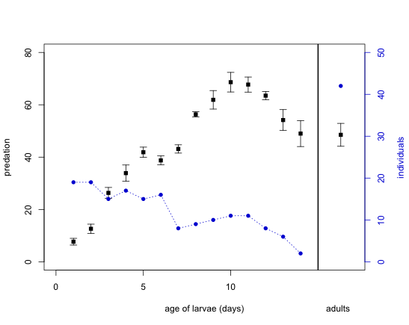

**Figure 3:** Predation Rates of Coccinellid Larvae and Adults. Blue, circular points represent the number of individuals used in the experiment for each day. Black, square points represent the average number of aphids consumed daily. The vertical black line separates larvae data from adult data. *q*=48.524 for adult coccinellids. Error bars indicate the 95% confidence interval.

The last experiment was to observe the change in aphid population when predators are introduced. We did not get a chance to comprehensively analyze our data or test the population-predation model presented in Equation 3. The initial population of Cage 2 was approximately 1361 and the initial population of Cage 3 was approximately 2317. We added adult coccinellids to each cage; 13 to Cage 2 and 23 to Cage 3. We decided not to replace dead coccinellids because in a real biological control situation, replacement would be impractical. Figure 4 presents conflicting results, which are indicative of the choice of predator. Using adults rather than larvae introduces high variability in effectiveness, as adult coccinellids must both feed and reproduce, whereas larvae are primarily concerned with feeding in order to grow. This variability turned out to have had a large effect in our experiment. In cage 2, we observed that most of the adults were mating instead of eating, and numerous clutches of coccinellid eggs were found. Coccinellid eggs were also present in Cage 3, but not nearly as many as in Cage 2. In Figure 4, we clearly see these complications in Cage 2, as there was a 49% increase in population from day 1 to day 2 and a 23% increase from day 2 to day 3. Cage 3, on the other hand, showed effective control from days 0-2. Day 3 showed a slight increase, but this was probably due to predator mortality.

**Figure 4:** Population Growth with Predators Present. The red line with square data points represents aphid population in Large Cage #3. The blue line with diamond data points represents aphid population in Large Cage #2.

**Conclusion and Recommendations:**

This study has succeeded in analyzing the pea aphid under ideal conditions, and this analysis can hopefully provide valuable information to the area of biological control. However, there are still many questions to be asked, and many experiments to be done. I recommend further inquiry into the effects of predation and the accuracy of the model in Equation 3. For example, a comparison of the effectiveness of third and fourth instar coccinellid larvae to that of adults in the large cage experiment would be useful in deciding which stage of coccinellid to use in biological control. The predation model could also be modified to include the effect of predator disturbance as found in a 2005 publication by the University of California at Davis (Nelson and Rosenheim, 2005). From the limited data of this study, I would suggest using late third instar or early fourth instar larvae, which is in accordance with the findings of a 1999 study by Wyss et al. (Wyss et al., 1999). Further experiments as to the timing of augmentative releases should also be conducted. The aforementioned Wyss et al study touched on this aspect, but a comprehensive experiment in which predators are released with a constant predator:prey ratio in different large cages at different population benchmarks—meaning that some cages would have predators released earlier than others. This experiment could be repeated for several predator:prey ratios for optimization. The purpose of this would be to decide at what stage in aphid population development is augmentative release most efficient, and at which predator prey ratios biological control should be executed.

**Acknowledgements:**

I would like to thank Glenn Ledder for his dedication to the students of the RUTE program, and all of the support he has given us in turning this research experience into one that we can all be proud of. I would also like to thank Swapna Purandare for her excellent maintenance of the laboratory environment, as well as her excellent guidance in the lab and discussions.

**References:**

Brauer, F. and Castillo-Chavez, C. (2001), *Mathematical Models in Population Biology and Epidemiology*, Springer.

Caswell, H. (2000), *Matrix Population Models: Construction, Analysis, and Interpretation*, 2nd ed., Sinauer.

Hutchison, William D and Hogg, David B. (1984) “Demographic statistics for the pea aphid (*Homoptera: Aphididae*) in Wisconsin and a comparison with other populations,” *Environmental Entomology.*Vol 13: 1173-1181.

Messing, Russell H. and Wright, Mark G. (2006). “Biological control of invasive species: solution or pollution?” *Frontier in Ecology and the Environment*. 4:132-140.

Nelson, Erik H. and Rosenheim, Jay A. (2005). “Encounters between aphids and their predators: the relative frequencies of disturbance and consumption,” *Center for Population Biology and Department of Entomology, One Shields Avenue, University of California, Davis, CA.*

*The R Project for Statistical Computing*, <http://www.r-project.org/>.

Wyss, Eric, Villiger, Mathias, Hemptinne, Jean-Louis, and Müller-Schärer, Heinz. (1999) “Effects of augmentative releases of eggs and larvae of the ladybird beetle, *Adaliabipunctata*, on the abundance of the rosy apple aphid, *Dysaphisplantaginea*, in organic apple orchards,” *EntomologiaExperimentalisetApplicata*, 90:167-173.