P.Steadius and P. Speedius Predation Modeling

Chuck Larrieu

29 June 2009

1. **Introduction:**

The goal of this study is to develop a model to accurately reflect the predatory behavior of two species of Ladybird Beetles in the presence of various population densities of prey. Understanding the consumption behavior of these predators could help in determining possible solutions to various pest control problems.

1. **Experimental Methods:**

**Procedure:** We have a box of fixed area, which contains a known number of prey, x, in a random distribution. We introduce the predator of interest and count the number of prey it consumes, R, in a fixed amount of time. We repeat this process for a variety of prey population densities.

**Species:** The predators that we are observing in this study are the P. Steadius and P. Speedius species of Ladybird Beetles.

1. **Experimental Results:**

**P. Steadius:** Figure 1 describes the data gathered for P. Steadius. It is important to note that the point (0,0) *must* be a point, because if there are no prey initially, then none can be consumed. For Steadius, R seems to be proportional to x throughout the data set, which suggests that a linear model be most appropriate.

Figure 1: P. Steadius Predation.

**P. Speedius:** In figure 2, we can see a noticeable difference in the data from Steadius. Notice that, once again, the point (0,0) must be included in the data. With smaller x-values, Speedius also seems to consume a number of prey proportional to the prey density. At higher x values, however, the R-values seem to start leveling off. It is also worthy to note that for small x-values, Speedius is more effective at consuming prey.

Figure 2: P. Speedius Predation.

**Parameters:** In our experiment, the predator seems to spend time either searching for prey, or “handling” prey. Handling time is the average amount of time the predator will spend on a given prey that takes time away from searching. The success of the predator at catching prey seems to depend on the searching speed, which we will call S, and the handling time, which we will call h.

**Observations:** Because handling time plays a more important role as the prey density increases (finding food is not as hard with a large prey density, and a predator can only consume so much in a given amount of time), and Steadius’s success seems to be proportional to the prey density, we can assume that its handling time isn’t large enough to play a significant role in its predatory behavior, at least in the domain of prey densities we used. We can see that this is not the case for Speedius. With respect to developing a model, it is appropriate to ignore h for Steadius, and to incorporate it for Speedius.

1. **Model Derivation**

**Biological Assumptions:** The models we are using are based on four biological assumptions. The first assumption is that the predator uses time either searching for or handling prey. Note that in the linear model, we assume that handling time isn’t significant. Our second and third assumptions are that search speed is constant, and handling time is constant. The last assumption is that the prey do not reproduce during the experiment.

**Steadius Model:** The data suggests a linear model of the form y=mx+b for Steadius, and it must contain (0,0) as a data point; so, more specifically, we want a linear model of the form y=mx. For Steadius, we know that the only parameter available for use is the searching speed, S, and we can confirm this with dimensional analysis.



In order for the units to make sense, a parameter with units of space per unit time must fit into the equation. This is consistent with our definition of S, as searching speed is the amount of space covered per unit time. The resulting model for Steadius is

. Equation (1)



**Speedius Model:** It is apparent from the data that a linear model for Speedius is insufficient. The reason that the model for Steadius doesn’t work for Speedius is that with Steadius, we assumed that time is only spent searching. Our observations of Speedius, however, show that the time to handle each prey plays a role in the data. Therefore, we must be more specific in denoting searching time, handling time, and total time. We then must define searching speed not as space covered per unit time, but rather space covered per unit searching time. This leaves us with a blank to fill in our dimensional analysis:



.



Now, in order for the units to work, we must introduce a new element into our equation. The amount of time spent searching divided by the total time is the fraction of time spent searching, which we will call f. This leaves us with the equation

. Equation (2)



Using our assumption that time is spent either handling or searching for prey, we must construct an equation relating f to h. We start by using dimensional analysis to find out which variables and parameters to use.



We know we need to include h in our model, because we previously designated it as a biological parameter. We also know that f has the units of search time divided by total time. Therefore, we must find an additional variable whose units multiply with the units of h to handling time divided by total time. In other words, we must fill in the following blank:



The parameter h has units of handling time per unit prey. In order to get units of handling time divided by total time, we need to multiply h by a variable that has units of prey divided by total time. The only variable that fits this criterion is R. This leads us to the equation

. Equation (3)



If we solve equation (3) for f, and plug the solution in for the f in equation (2), and then solve that equation for R, we arrive at our solution for the model of Speedius’s consumption behavior.

Equation (4)



It is convenient to rewrite this equation with parameters q=(1/h) and a=(1/hS). This gives us

. Equation (5)



**Finding the Best Linear Fit:** Now that we have our models, we need to calculate the values of our parameters that fit the data. Starting with the linear model, equation (1), we must define a function to measure fitting error. We can define the error of a particular point p as the square of the R-value given by the data minus the R-value the model would predict at that same x-value.

Equation (6)



Now we can define a fitting error function for data points 1 to N:

Equation (7)



If each term in F(S) is rewritten as a polynomial, all of the polynomials are added together, and S is factored out appropriately, we can rewrite F(S) as

. Equation (8)

Now, we want to find an S such that the fitting error function is minimized. To do this, we set the first derivative of F(S) with respect to S equal to zero, and solve for S. We can confirm that this is a minimum of F(S) by taking the second derivative and observing that it is always positive in the domain we’re interested in. If we do this, we find that

Equation (9)



gives us the optimal S to fit our data. As a reference for how good a fit our model gives us, it is useful to define F(S*) as the Residual Sum of Squares.

Equation (10)



Finding the Perfect Nonlinear Fit: In order to find the best parameter values for our nonlinear model, we first must define a new variable in terms of our old parameters.

Equation (11)



This allows us to write our nonlinear function R=qx/(a+x) as R=qZ. With our new form R=qZ, we can find the optimal q in the same exact method as we used to find the optimal S. In this case, Z is analogous to x, and q is analogous to S. Unsurprisingly, we find

 . Equation (12)

We must notice that this optimal q, as well as the RSS, is still dependent on “a.” We do not have a convenient mathematical method for finding the a-value that minimizes the RSS. However, if we have a suitable range of possible a-values, we can use a computer to find the value of “a” that we want. This is simple enough if we look at

. Equation (13)

From our data in Figure 2, we can see that the x-value that produces about half of a rough q value has to be somewhere between 0 and 300 at least. The computer can test thousands of values in this range and pick the one that minimizes the RSS. This allows us to compute a relatively accurate a-value.

1. **Results and Discussion**

**P. Steadius Results:** For the Steadius model, S=0.240, a=271.845, and q=92.614. The average RSS per point for the linear model is 6.862, and the average RSS for the nonlinear model is 6.537. The linear AIC is 1.995, and the nonlinear AIC is 1.982. In Figure 3, we can see the fitting of the two models.

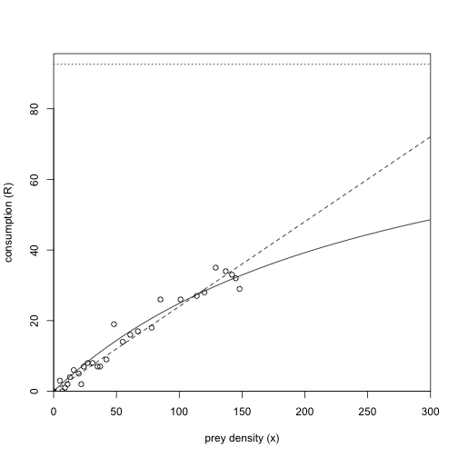

Figure 3: Steadius Model Fit.

**P. Speedius Results:** For Speedius, S=0.231, a=90.016, and q=46.675. The average RSS for the linear model is 17.564, and for the nonlinear it is 3.005. The linear AIC for Speedius is 2.933, and the nonlinear AIC is 1.232.

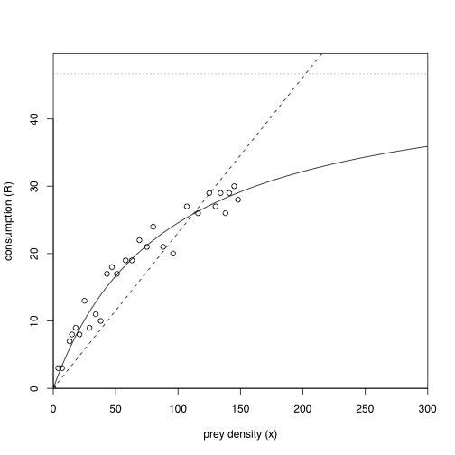

Figure 4: Speedius Model Fit.

**Discussion:** In deciding which model is best for each species, we must look at two aspects of the results. We must look at the average fitting error (average RSS), and the Akaike Information Criterion (AIC). The average RSS, as we saw before, tells us how much average error there is between the model and each data point. The AIC weighs the amount of error with the complexity of the model. An overly complex model, say, a fifth degree polynomial, may go through all points in a set of data, but it will also contain points that are biologically impossible. Complexity can provide for less error, but it also can make a model inflexible and impractical. The AIC takes this into account. In general, the lower the AIC value, the more reasonable the model is for the data.

For Steadius, the average RSS values for each model are comparable, with the nonlinear model edging out slightly. This is the same for the AIC values, although they are much closer. Because the average RSS and AIC values are so similar for Steadius, we could responsibly use either model to reflect the data, with an ever so slight preference for the nonlinear model. For all practical applications in this range of prey densities, it would probably be simpler to use the linear model.

In the case of Speedius, there is a clear favor for the nonlinear model. The average RSS is much lower for the nonlinear model. Similarly, the AIC value for the nonlinear model is significantly lower than that for the linear model.