CSCI690 Programming Assignment II

Di Sheng (1043932)

Q1. A TCP Connection Setup:

1. My local host (IP = 64.187.251.205) sent a TCP synchronize package to google (IP= 74.125.288.212), with sequence number = 0. The timestamp for this process was 15337625. (Refer toTsval in package No.402 in Figure 1)
2. The google server received my package and returned responding synchronize package with same sequence number (0) and Ack number = 1. The time-stamp for this package was 733177407 (Refer topackage No.403 in Figure1)
3. My local host received that responding package from google and then sent the other acknowledge package to google, with Seq=1 and Ack = 1. Time-stamp was 15337636 (Refer topackage No.404 in Figure1)

Q2

1. My local host (IP = 64.187.251.205) sent a TCP acknowledge package to google (IP= 74.125.288.212), with sequence number = 7 and Ack= 1564. The timestamp was 15345917. (Refer to in package No.556 in Figure 1)
2. The google server received my package and returned responding finish acknowledge package with sequence number = 1564 and Ack number = 7. The time-stamp for this package was 733185688 (Package No.557 in Figure1)
3. My local host received that responding package from google and then sent the other finish acknowledge package to google, with Seq=7 and Ack = 1565. Time-stamp was 15345917 (Package No.558 in Figure1)
4. Google received my FIN package, and sent back and ACK package with Seq=1565 and Ack = 8. Time-stamp was 733185700 (Package No.559 in Figure1)

Q3

The established state start at 16.777 second atfer capturing begin (See package No.402 in Figure 1) and the end time was 25.0833 second (Package No.559 in Figure1). Duration was 8.3063 second

Q4

After the three way handshake, my local host sent out a <PSH,ACK> package (Package No.553 in Figure1), which indicated that the host is acknowledging receipt of some previous data and also transmitting some more data. Then my local host received an <ACK> package (Package No. 554) from google which informed me that google has acknowledged my request. Since my request was invalid (not understood by the google sever), my local host then received an <ACK> package (Package No.555) from google to inform me what their response to my request.

In conclusion, totally three packages were transmitted in the established state, with minimum package size of 66 bytes (package No.554) and maximum package size of 1629 bytes (package No.555). The average package size was (66+72+1629)/3= 589 bytes.

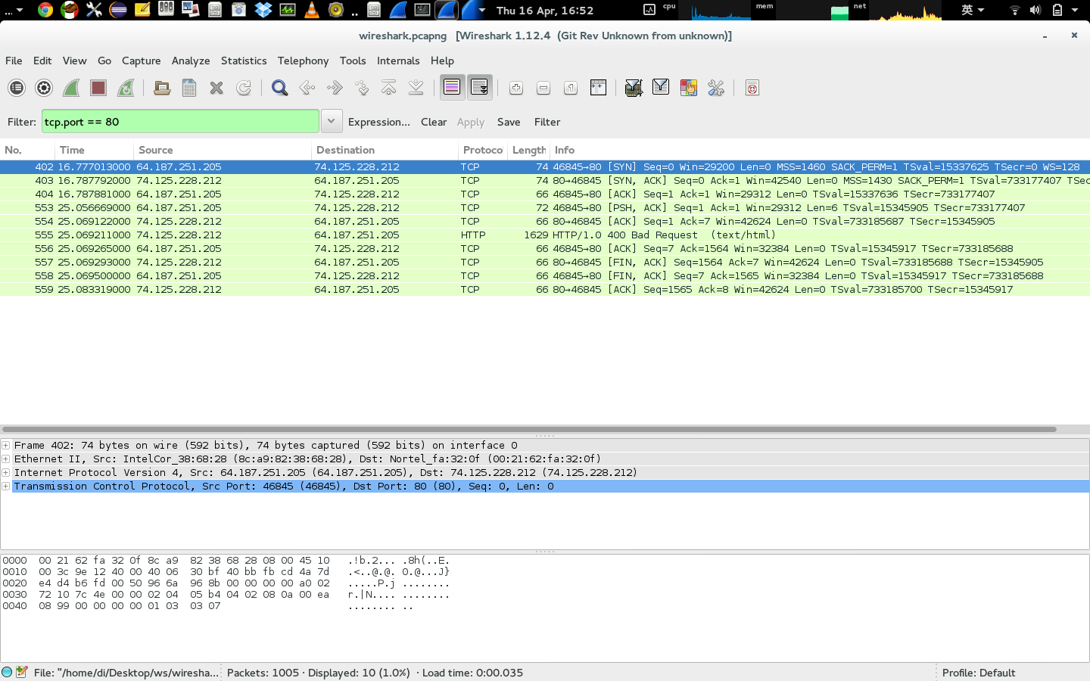

Figure1: Wireshark Screen Shot (if not clear, please refer to the attached .png file)