Chapter 1: Introduction to Database Systems

Overview
A database is a collection of interrelated data, and a Database Management System (DBMS) is software that manages and provides access to that data.

1. Database Applications Examples
Domain | Examples
Enterprise | Sales, Accounting, Human Resources
Manufacturing | Production, Inventory, Supply Chain
Banking & Finance | Accounts, Loans, Credit Cards, Stock Trading
Universities | Registration, Grades
Airlines | Reservations, Schedules
Telecommunication | Call Records, Billing
Web Services | E-commerce, Online Ads
Navigation | Maps, Routes

2. Purpose of Database Systems

Problems with File-System Approach
Problem | Description
Data Redundancy & Inconsistency | Duplication of data in multiple files
Difficulty in Accessing Data | Need new programs for each task
Data Isolation | Data scattered in multiple files/formats
Integrity Problems | Constraints buried in code
Atomicity Problems | Partial updates on failure
Concurrent Access Issues | Uncontrolled access leads to inconsistencies
Security Problems | Hard to restrict partial data access

3. Data Models
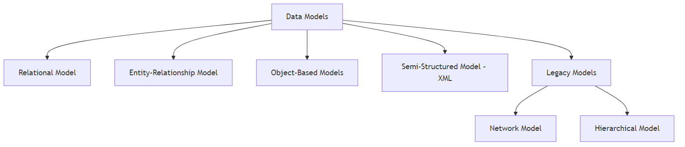
Diagram

Relational Model
- Data stored in tables (relations)
- Each table has rows (tuples) and columns (attributes)
- Invented by Ted Codd (Turing Award 1981)
Example: Instructor Table
ID | name | dept_name | salary
22222 | Einstein | Physics | 95000
12121 | Wu | Finance | 90000
45565 | Katz | Comp. Sci. | 75000

4. View of Data (Three-Level Architecture)
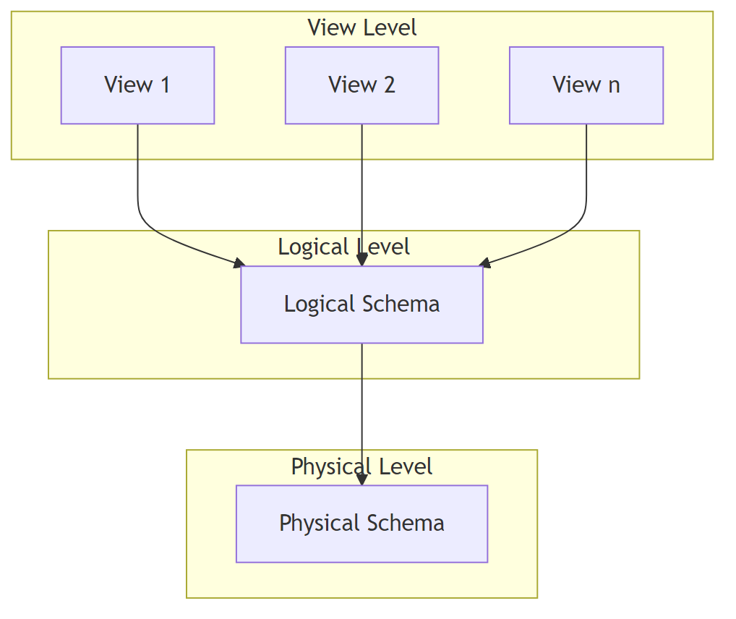
Diagram
Level | Description
View Level | What users see (customized views)
Logical Level | What data is stored and relationships
Physical Level | How data is physically stored

Key Concepts
- Schema: Overall structure of the database (like a type)
- Instance: Actual data at a point in time (like a value)
- Physical Data Independence: Ability to modify physical schema without changing logical schema

5. Database Languages

DDL (Data Definition Language)
- Defines database schema
- Creates data dictionary (metadata)
CREATE TABLE instructor (
ID CHAR(5),
name VARCHAR(20),
dept_name VARCHAR(20),
salary NUMERIC(8,2)
);

DML (Data Manipulation Language)
- Accesses and updates data
- Also called Query Language
Type | Description
Procedural DML | Specifies what data and how to get it
Declarative DML | Specifies only what data is needed (e.g., SQL)
SELECT name
FROM instructor
WHERE dept_name = 'Comp. Sci.';

6. Database Engine Components
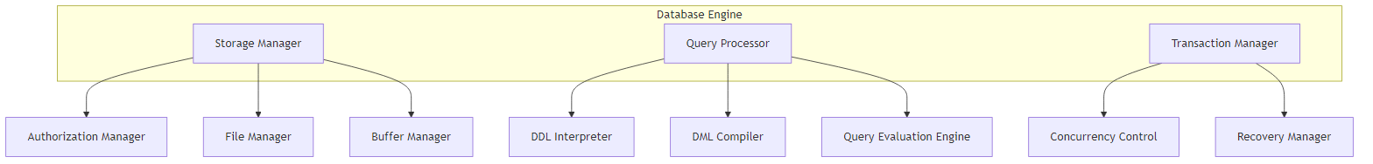
Diagram

Storage Manager
- Interface between low-level data and applications
- Manages: Data files, Data dictionary, Indices

Query Processor
- DDL Interpreter: Processes schema definitions
- DML Compiler: Translates queries + optimization
- Query Evaluation Engine: Executes queries

Query Processing Flow
Diagram

7. Transaction Management
A transaction is a collection of operations performing a single logical function.
Component | Purpose
Transaction Manager | Ensures database consistency despite failures
Concurrency Control Manager | Manages concurrent transaction interactions

8. Database Architecture
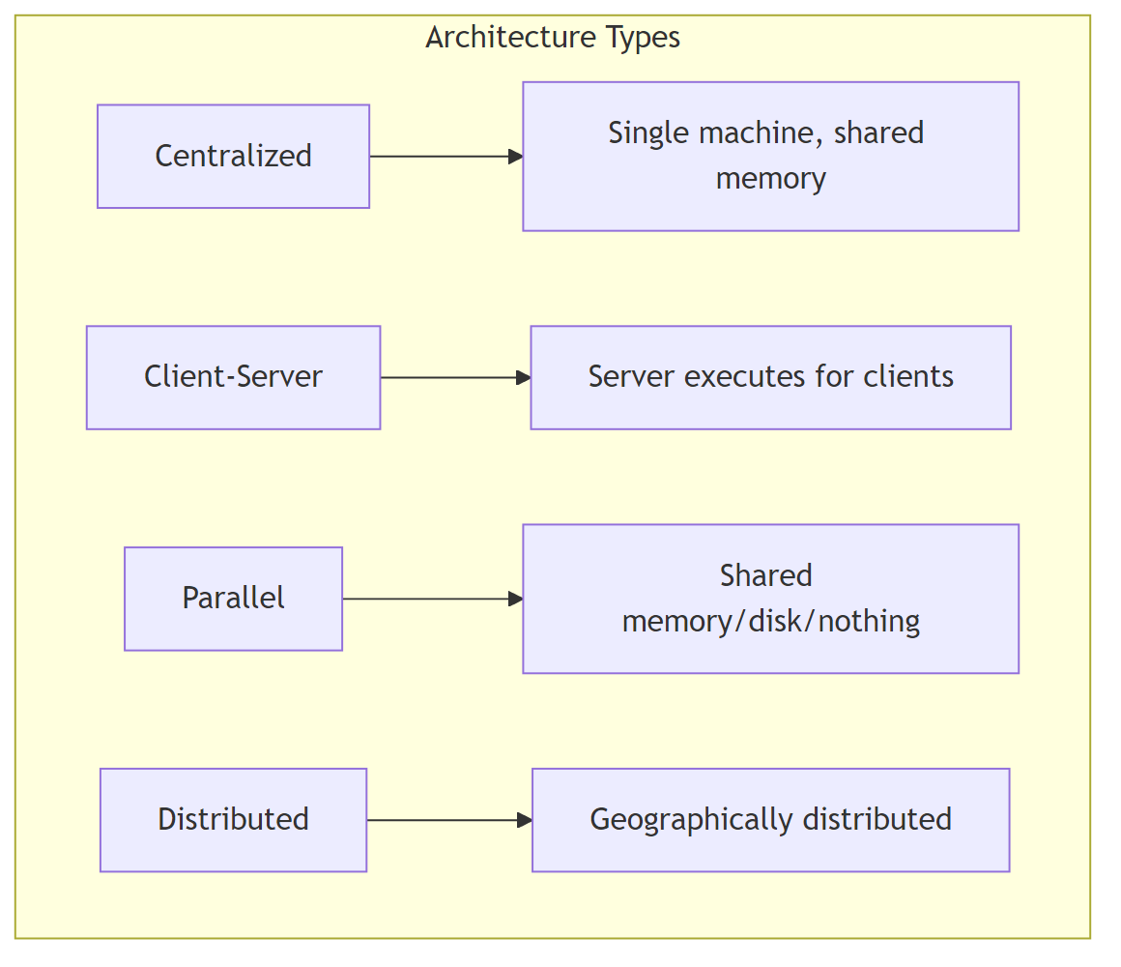
Diagram

Application Architectures
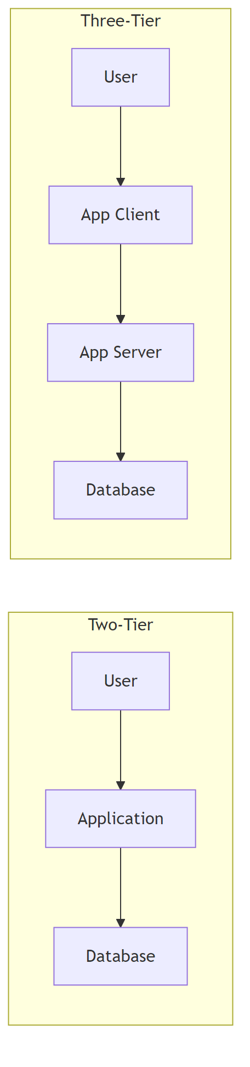
Diagram

9. Database Users
User Type | Description
Naive Users | Use pre-built applications
Application Programmers | Write application programs
Sophisticated Users | Use query languages directly
Specialized Users | Build specialized applications (CAD, multimedia)

10. Database Administrator (DBA)
Responsibilities: - Schema definition and modification - Storage structure and access method definition - Authorization management - Routine maintenance (backup, disk space, performance monitoring)

11. History of Database Systems
Era | Key Developments
1950s-60s | Magnetic tapes, punched cards, sequential access
Late 1960s-70s | Hard disks, Network/Hierarchical models, Relational model (Codd)
1980s | Commercial RDBMS, SQL standard, Parallel/Distributed DB
1990s | Data warehouses, Data mining, Web commerce
2000s | Big Data (NoSQL), MapReduce
2010s | SQL on MapReduce, In-memory databases

Key Takeaways
- DBMS solves file system problems (redundancy, inconsistency, security)
- Relational model organizes data in tables with rows and columns
- Three-level architecture provides data abstraction and independence
- SQL is the standard declarative query language
- Transaction management ensures data consistency and handles concurrency
- Database engine consists of storage manager, query processor, and transaction manager

