Chapter 3: Introduction to SQL

Overview
SQL (Structured Query Language) is the standard language for relational database management systems. Originally developed at IBM as SEQUEL, it has evolved through multiple ANSI/ISO standards.
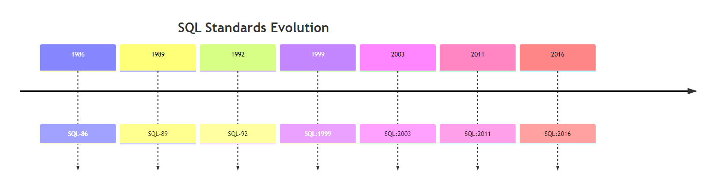
Diagram

SQL Components
Component | Description
DML | Data Manipulation Language - query, insert, update, delete
DDL | Data Definition Language - define schema, integrity constraints
View Definition | Commands for defining views
Transaction Control | Begin and end transactions
Embedded SQL | SQL embedded in programming languages
Authorization | Access rights to relations and views

Data Definition Language (DDL)

Domain Types in SQL
Type | Description | Example
char(n) | Fixed-length string | char(5) = ‘Hello’
varchar(n) | Variable-length string (max n) | varchar(20)
int | Integer | 42
smallint | Small integer | 100
numeric(p,d) | Fixed-point number (p digits, d decimal) | numeric(8,2) = 12345.67
real | Floating-point | 3.14159
double precision | Double-precision floating | 3.141592653589793
float(n) | Floating-point with n digits precision | float(10)

Create Table Syntax
CREATE TABLE table_name (
attribute1 datatype1,
attribute2 datatype2,
...,
integrity_constraint1,
integrity_constraint2
);
Example - University Database:
CREATE TABLE instructor (
ID char(5),
name varchar(20) NOT NULL,
dept_name varchar(20),
salary numeric(8,2),
PRIMARY KEY (ID),
FOREIGN KEY (dept_name) REFERENCES department
);
CREATE TABLE student (
ID varchar(5),
name varchar(20) NOT NULL,
dept_name varchar(20),
tot_cred numeric(3,0),
PRIMARY KEY (ID),
FOREIGN KEY (dept_name) REFERENCES department
);
CREATE TABLE course (
course_id varchar(8),
title varchar(50),
dept_name varchar(20),
credits numeric(2,0),
PRIMARY KEY (course_id),
FOREIGN KEY (dept_name) REFERENCES department
);

Integrity Constraints
Constraint | Description
PRIMARY KEY | Uniquely identifies each tuple
FOREIGN KEY ... REFERENCES | References primary key of another table
NOT NULL | Attribute cannot be null

Table Modifications
-- Insert a new tuple
INSERT INTO instructor VALUES ('10211', 'Smith', 'Biology', 66000);
-- Delete all tuples
DELETE FROM student;
-- Drop entire table
DROP TABLE r;
-- Add new attribute
ALTER TABLE r ADD A D;
-- Remove attribute
ALTER TABLE r DROP A;

Basic Query Structure
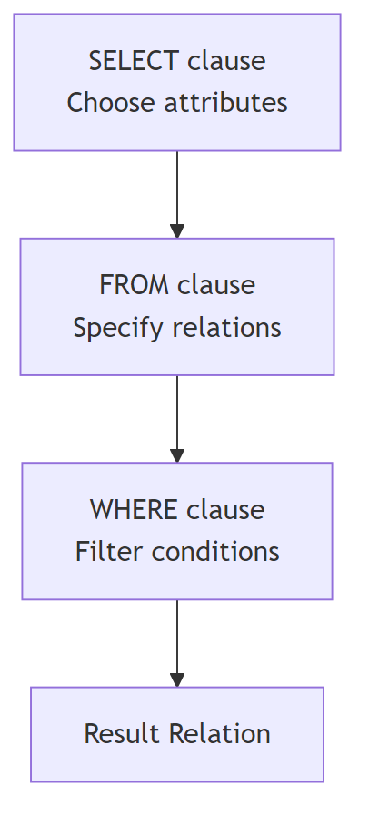
Diagram

General Form
SELECT A1, A2, ..., An
FROM r1, r2, ..., rm
WHERE P;
Clause | Purpose | Relational Algebra
SELECT | List attributes for result | Projection (π)
FROM | List relations involved | Cartesian Product (×)
WHERE | Specify selection conditions | Selection (σ)

SELECT Clause

Basic Selection
-- Select specific attributes
SELECT name FROM instructor;
-- Select all attributes
SELECT * FROM instructor;
-- Remove duplicates
SELECT DISTINCT dept_name FROM instructor;
-- Keep duplicates (default)
SELECT ALL dept_name FROM instructor;

Arithmetic Expressions
-- Arithmetic in SELECT
SELECT ID, name, salary/12 AS monthly_salary
FROM instructor;

Literals
-- Literal without FROM
SELECT '437' AS FOO;
-- Literal with FROM (repeats for each tuple)
SELECT 'A' FROM instructor;

WHERE Clause

Comparison Operators
Operator | Meaning
= | Equal
<> or != | Not equal
< | Less than
<= | Less than or equal
> | Greater than
>= | Greater than or equal

Logical Operators
-- Using AND, OR, NOT
SELECT name
FROM instructor
WHERE dept_name = 'Comp. Sci.' AND salary > 80000;

BETWEEN Operator
-- Salary between 90000 and 100000
SELECT name
FROM instructor
WHERE salary BETWEEN 90000 AND 100000;

FROM Clause and Joins

Cartesian Product
-- All combinations of instructor and teaches
SELECT *
FROM instructor, teaches;

Join with WHERE Condition
-- Natural join using WHERE
SELECT name, course_id
FROM instructor, teaches
WHERE instructor.ID = teaches.ID;
-- With additional conditions
SELECT name, course_id
FROM instructor, teaches
WHERE instructor.ID = teaches.ID
AND instructor.dept_name = 'Art';

Rename Operation (AS)
-- Rename relation
SELECT T.name
FROM instructor AS T, instructor AS S
WHERE T.salary > S.salary
AND S.dept_name = 'Comp. Sci.';

Self-Join Example
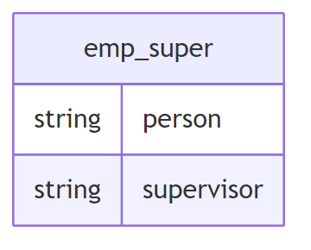
Diagram
-- Find supervisor of 'Bob'
SELECT supervisor
FROM emp_super
WHERE person = 'Bob';
-- Find supervisor's supervisor
SELECT S2.supervisor
FROM emp_super AS S1, emp_super AS S2
WHERE S1.person = 'Bob'
AND S1.supervisor = S2.person;

String Operations

LIKE Operator
Pattern | Matches
% | Any substring (including empty)
_ | Any single character
-- Name contains 'dar'
SELECT name
FROM instructor
WHERE name LIKE '%dar%';
-- Exactly 3 characters
WHERE name LIKE '___';
-- At least 3 characters
WHERE name LIKE '___%';
-- Escape special characters
WHERE title LIKE '100\%' ESCAPE '\';

String Functions
- Concatenation: ||
- Case conversion: UPPER(), LOWER()
- Length: LENGTH()
- Substring: SUBSTRING()

Ordering Results
-- Ascending order (default)
SELECT DISTINCT name
FROM instructor
ORDER BY name;
-- Descending order
ORDER BY name DESC;
-- Multiple columns
ORDER BY dept_name, name;

Set Operations
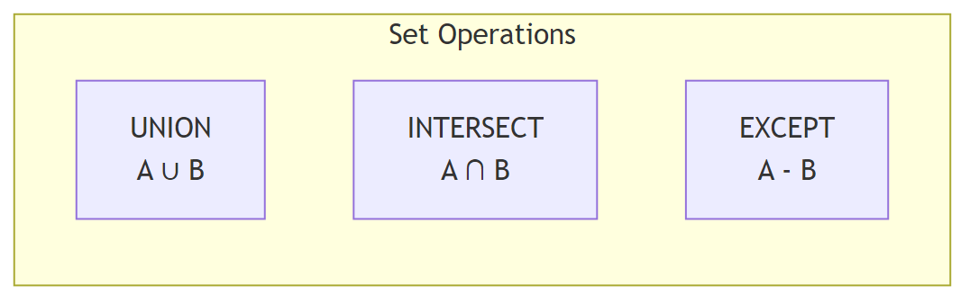
Diagram
Operation | Description | Keeps Duplicates
UNION | Combines results | No
UNION ALL | Combines results | Yes
INTERSECT | Common elements | No
INTERSECT ALL | Common elements | Yes
EXCEPT | Difference | No
EXCEPT ALL | Difference | Yes
-- Courses in Fall 2017 OR Spring 2018
(SELECT course_id FROM section WHERE semester = 'Fall' AND year = 2017)
UNION
(SELECT course_id FROM section WHERE semester = 'Spring' AND year = 2018);
-- Courses in Fall 2017 AND Spring 2018
(SELECT course_id FROM section WHERE semester = 'Fall' AND year = 2017)
INTERSECT
(SELECT course_id FROM section WHERE semester = 'Spring' AND year = 2018);
-- Courses in Fall 2017 but NOT in Spring 2018
(SELECT course_id FROM section WHERE semester = 'Fall' AND year = 2017)
EXCEPT
(SELECT course_id FROM section WHERE semester = 'Spring' AND year = 2018);

NULL Values

Three-Valued Logic
Operation | Result
5 + NULL | NULL
5 < NULL | UNKNOWN
NULL = NULL | UNKNOWN
NULL <> NULL | UNKNOWN

Boolean Operations with UNKNOWN
Expression | Result
TRUE AND UNKNOWN | UNKNOWN
FALSE AND UNKNOWN | FALSE
TRUE OR UNKNOWN | TRUE
FALSE OR UNKNOWN | UNKNOWN
-- Check for NULL
SELECT name
FROM instructor
WHERE salary IS NULL;
-- Check for NOT NULL
SELECT name
FROM instructor
WHERE salary IS NOT NULL;

Aggregate Functions
Function | Description
AVG(column) | Average value
MIN(column) | Minimum value
MAX(column) | Maximum value
SUM(column) | Sum of values
COUNT(column) | Number of values
COUNT(*) | Number of tuples
COUNT(DISTINCT col) | Number of distinct values
-- Average salary in Comp. Sci.
SELECT AVG(salary)
FROM instructor
WHERE dept_name = 'Comp. Sci.';
-- Count distinct instructors teaching in Spring 2018
SELECT COUNT(DISTINCT ID)
FROM teaches
WHERE semester = 'Spring' AND year = 2018;
-- Count all tuples in course
SELECT COUNT(*)
FROM course;

GROUP BY Clause
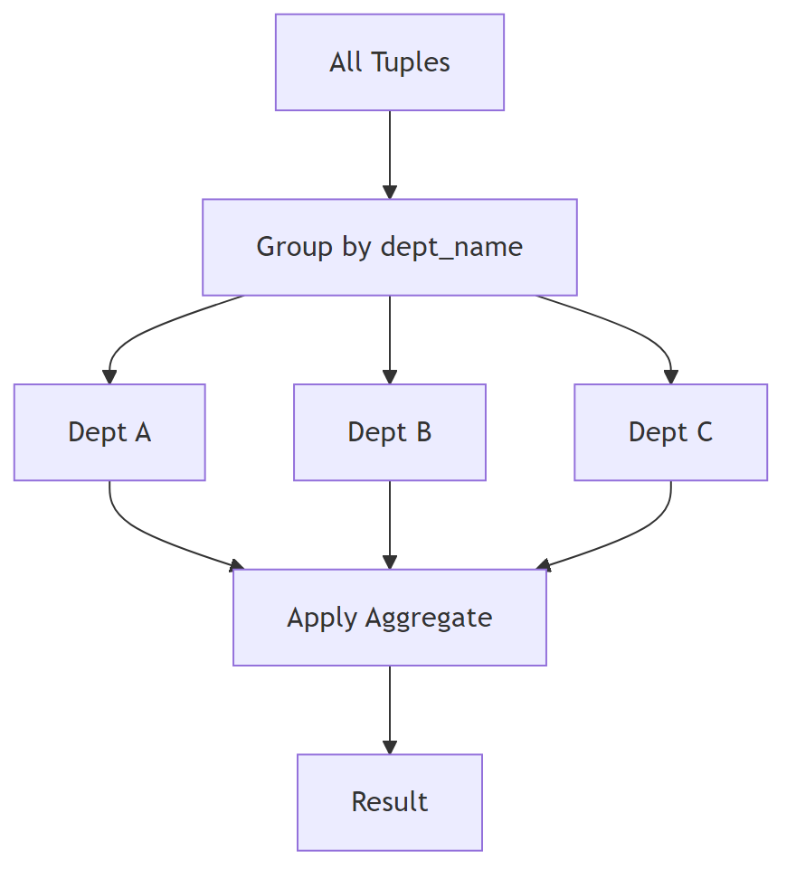
Diagram
-- Average salary by department
SELECT dept_name, AVG(salary) AS avg_salary
FROM instructor
GROUP BY dept_name;
Important Rule: Attributes in SELECT (outside aggregate functions) MUST appear in GROUP BY.
-- INCORRECT: ID not in GROUP BY
SELECT dept_name, ID, AVG(salary)
FROM instructor
GROUP BY dept_name; -- ERROR!

HAVING Clause
-- Departments with average salary > 42000
SELECT dept_name, AVG(salary) AS avg_salary
FROM instructor
GROUP BY dept_name
HAVING AVG(salary) > 42000;
Clause | Applies | When
WHERE | To individual tuples | Before grouping
HAVING | To groups | After grouping

Nested Subqueries
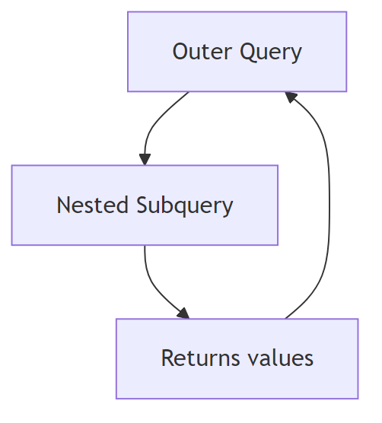
Diagram

Set Membership (IN / NOT IN)
-- Courses in both Fall 2017 and Spring 2018
SELECT DISTINCT course_id
FROM section
WHERE semester = 'Fall' AND year = 2017
AND course_id IN (SELECT course_id
FROM section
WHERE semester = 'Spring' AND year = 2018);
-- Names not in list
SELECT DISTINCT name
FROM instructor
WHERE name NOT IN ('Mozart', 'Einstein');

Set Comparison (SOME / ALL)
-- Salary greater than SOME instructor in Biology
SELECT name
FROM instructor
WHERE salary > SOME (SELECT salary
FROM instructor
WHERE dept_name = 'Biology');
-- Salary greater than ALL instructors in Biology
SELECT name
FROM instructor
WHERE salary > ALL (SELECT salary
FROM instructor
WHERE dept_name = 'Biology');
Expression | Equivalent
= SOME | IN
<> SOME | ≠ NOT IN
= ALL | ≠ IN
<> ALL | NOT IN

EXISTS / NOT EXISTS
-- Courses in both semesters using EXISTS
SELECT course_id
FROM section AS S
WHERE semester = 'Fall' AND year = 2017
AND EXISTS (SELECT *
FROM section AS T
WHERE semester = 'Spring' AND year = 2018
AND S.course_id = T.course_id);
-- Students who took ALL Biology courses
SELECT DISTINCT S.ID, S.name
FROM student AS S
WHERE NOT EXISTS (
(SELECT course_id FROM course WHERE dept_name = 'Biology')
EXCEPT
(SELECT T.course_id FROM takes AS T WHERE S.ID = T.ID)
);

UNIQUE (Test for Duplicates)
-- Courses offered at most once in 2017
SELECT T.course_id
FROM course AS T
WHERE UNIQUE (SELECT R.course_id
FROM section AS R
WHERE T.course_id = R.course_id
AND R.year = 2017);

Subqueries in FROM Clause
-- Departments with avg salary > 42000 (using subquery)
SELECT dept_name, avg_salary
FROM (SELECT dept_name, AVG(salary) AS avg_salary
FROM instructor
GROUP BY dept_name) AS dept_avg
WHERE avg_salary > 42000;

WITH Clause (Common Table Expression)
-- Find department(s) with maximum budget
WITH max_budget(value) AS (
SELECT MAX(budget)
FROM department
)
SELECT department.name
FROM department, max_budget
WHERE department.budget = max_budget.value;
-- Complex example: departments with total salary above average
WITH dept_total(dept_name, value) AS (
SELECT dept_name, SUM(salary)
FROM instructor
GROUP BY dept_name
),
dept_total_avg(value) AS (
SELECT AVG(value)
FROM dept_total
)
SELECT dept_name
FROM dept_total, dept_total_avg
WHERE dept_total.value > dept_total_avg.value;

Scalar Subquery
A subquery that returns a single value.
-- List departments with instructor count
SELECT dept_name,
(SELECT COUNT(*)
FROM instructor
WHERE department.dept_name = instructor.dept_name) AS num_instructors
FROM department;

Data Modification

DELETE
-- Delete all instructors
DELETE FROM instructor;
-- Delete with condition
DELETE FROM instructor
WHERE dept_name = 'Finance';
-- Delete with subquery
DELETE FROM instructor
WHERE dept_name IN (SELECT dept_name
FROM department
WHERE building = 'Watson');
-- Delete based on aggregate (evaluated first, then deleted)
DELETE FROM instructor
WHERE salary < (SELECT AVG(salary) FROM instructor);

INSERT
-- Insert with values
INSERT INTO course
VALUES ('CS-437', 'Database Systems', 'Comp. Sci.', 4);
-- Insert with column names
INSERT INTO course (course_id, title, dept_name, credits)
VALUES ('CS-437', 'Database Systems', 'Comp. Sci.', 4);
-- Insert with NULL
INSERT INTO student
VALUES ('3003', 'Green', 'Finance', NULL);
-- Insert from SELECT
INSERT INTO instructor
SELECT ID, name, dept_name, 18000
FROM student
WHERE dept_name = 'Music' AND total_cred > 144;

UPDATE
-- Update all tuples
UPDATE instructor
SET salary = salary * 1.05;
-- Update with condition
UPDATE instructor
SET salary = salary * 1.05
WHERE salary < 70000;
-- Update with subquery
UPDATE instructor
SET salary = salary * 1.05
WHERE salary < (SELECT AVG(salary) FROM instructor);

CASE Statement
-- Conditional update
UPDATE instructor
SET salary = CASE
WHEN salary <= 100000 THEN salary * 1.05
ELSE salary * 1.03
END;

Update with Scalar Subquery
-- Recompute total credits for all students
UPDATE student S
SET tot_cred = (
SELECT CASE
WHEN SUM(credits) IS NOT NULL THEN SUM(credits)
ELSE 0
END
FROM takes, course
WHERE takes.course_id = course.course_id
AND S.ID = takes.ID
AND takes.grade <> 'F'
AND takes.grade IS NOT NULL
);

SQL Query Processing Order
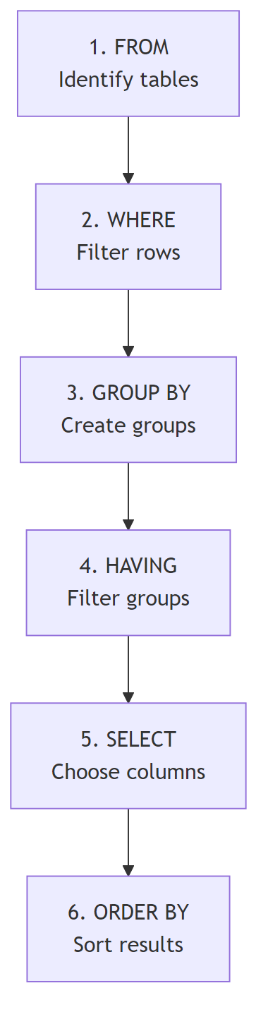
Diagram

Key Concepts Summary
Concept | SQL Keyword | Description
Selection | WHERE | Filter rows
Projection | SELECT | Choose columns
Join | FROM + WHERE | Combine tables
Aggregation | GROUP BY + Functions | Summarize data
Sorting | ORDER BY | Order results
Set Operations | UNION, INTERSECT, EXCEPT | Combine queries
Subqueries | IN, EXISTS, SOME, ALL | Nested queries
Modification | INSERT, UPDATE, DELETE | Change data

