Chapter 4: Intermediate SQL

Overview
This chapter covers advanced SQL features including join expressions, views, transactions, integrity constraints, data types, indexes, and authorization.

Join Expressions
Join operations combine two relations and return a result relation based on matching conditions.
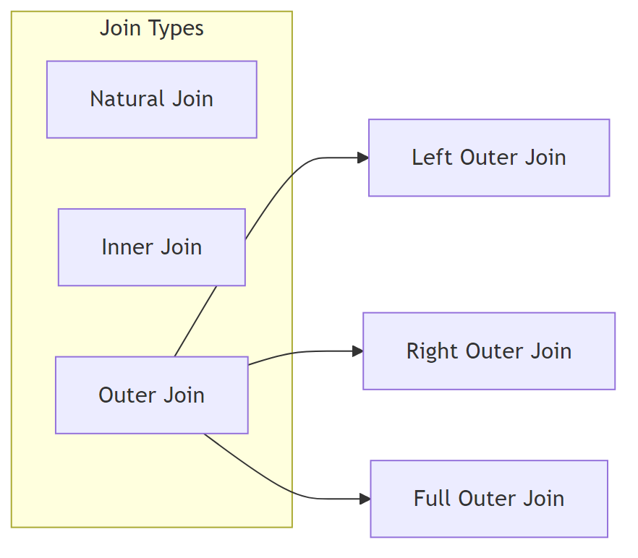
Diagram

Natural Join
Matches tuples with the same values for all common attributes and retains only one copy of each common column.
-- Without natural join
SELECT name, course_id
FROM student, takes
WHERE student.ID = takes.ID;
-- With natural join
SELECT name, course_id
FROM student NATURAL JOIN takes;
-- Multiple natural joins
SELECT A1, A2, ..., An
FROM r1 NATURAL JOIN r2 NATURAL JOIN ... NATURAL JOIN rn
WHERE P;
Warning: Be careful with unrelated attributes having the same name!
-- INCORRECT: May omit valid pairs due to dept_name match
SELECT name, title
FROM student NATURAL JOIN takes NATURAL JOIN course;
-- CORRECT: Explicitly specify join condition
SELECT name, title
FROM student NATURAL JOIN takes, course
WHERE takes.course_id = course.course_id;

Outer Joins
Outer joins preserve tuples that don’t have matches in the other relation by using NULL values.
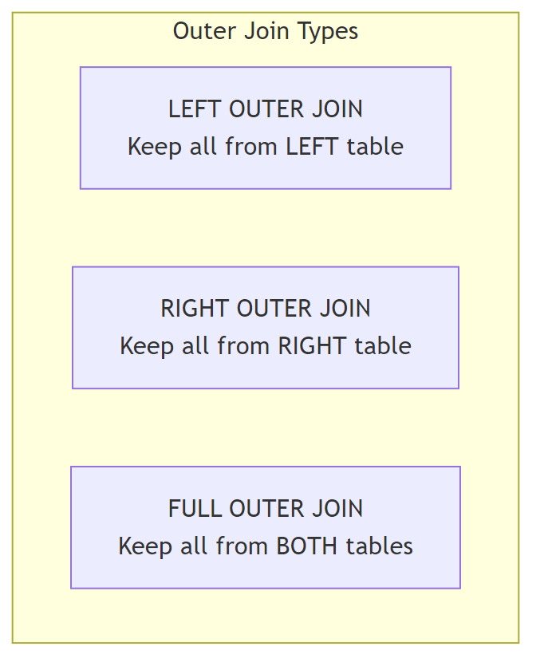
Diagram
Join Type | Symbol | Description
Left Outer Join | ⟕ | Keeps all tuples from left relation
Right Outer Join | ⟖ | Keeps all tuples from right relation
Full Outer Join | ⟗ | Keeps all tuples from both relations
Example Tables:
course_id | title | dept_name
CS-101 | Intro to CS | Comp. Sci.
CS-315 | Robotics | Comp. Sci.

course_id | prereq_id
CS-101 | CS-001
CS-437 | CS-315
-- Left outer join: keeps CS-315 (no prereq)
SELECT *
FROM course NATURAL LEFT OUTER JOIN prereq;
-- Right outer join: keeps CS-437 (no course info)
SELECT *
FROM course NATURAL RIGHT OUTER JOIN prereq;
-- Full outer join: keeps both unmatched tuples
SELECT *
FROM course NATURAL FULL OUTER JOIN prereq;

Join Conditions
Syntax | Description
NATURAL JOIN | Match on all common attributes
JOIN ... ON condition | Explicit join condition
JOIN ... USING (attr) | Match on specified attributes
-- Inner join with ON
SELECT *
FROM course INNER JOIN prereq
ON course.course_id = prereq.course_id;
-- Join with USING
SELECT *
FROM course FULL OUTER JOIN prereq
USING (course_id);
-- Left outer join with ON
SELECT *
FROM course LEFT OUTER JOIN prereq
ON course.course_id = prereq.course_id;

Views
A view is a virtual relation defined by a query. It provides a mechanism to hide certain data from users.
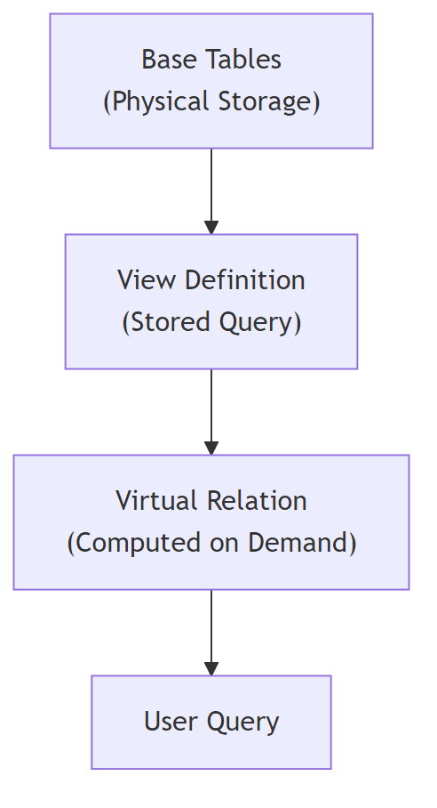
Diagram

View Definition
CREATE VIEW view_name AS
<query expression>;
-- View with renamed columns
CREATE VIEW view_name (col1, col2, ...) AS
<query expression>;
Examples:
-- View hiding salary information
CREATE VIEW faculty AS
SELECT ID, name, dept_name
FROM instructor;
-- Using the view
SELECT name
FROM faculty
WHERE dept_name = 'Biology';
-- View with aggregation
CREATE VIEW departments_total_salary(dept_name, total_salary) AS
SELECT dept_name, SUM(salary)
FROM instructor
GROUP BY dept_name;

Views Defined Using Other Views
-- First view
CREATE VIEW physics_fall_2017 AS
SELECT course.course_id, sec_id, building, room_number
FROM course, section
WHERE course.course_id = section.course_id
AND course.dept_name = 'Physics'
AND section.semester = 'Fall'
AND section.year = '2017';
-- Second view based on first
CREATE VIEW physics_fall_2017_watson AS
SELECT course_id, room_number
FROM physics_fall_2017
WHERE building = 'Watson';

View Expansion
When a view is queried, the system replaces the view with its definition:
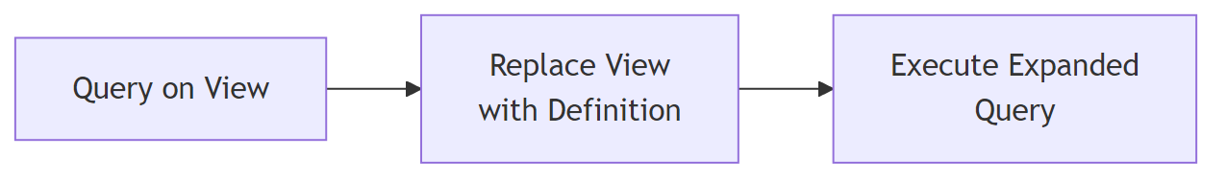
Diagram

Materialized Views
Type | Storage | Updates
Regular View | Not stored | Computed on each query
Materialized View | Physically stored | Must be maintained when base tables change

Updatable Views
Views are updatable only if they meet these conditions:
Requirement | Description
Single relation | FROM clause has only one table
Simple SELECT | No expressions, aggregates, or DISTINCT
NULL allowed | Unlisted attributes can be set to NULL
No grouping | No GROUP BY or HAVING clause
-- This insert on view...
INSERT INTO faculty VALUES ('30765', 'Green', 'Music');
-- ...translates to insert on base table with NULL salary
INSERT INTO instructor VALUES ('30765', 'Green', 'Music', NULL);

Transactions
A transaction is a unit of work consisting of a sequence of query and/or update statements.
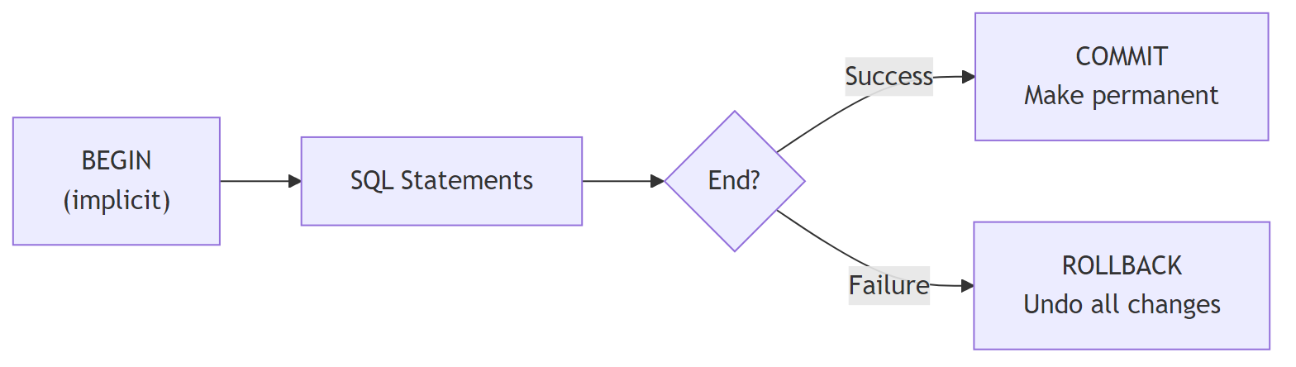
Diagram

Transaction Properties
Property | Description
Atomic | Either fully executed or completely rolled back
Isolated | Concurrent transactions don’t interfere
-- Commit changes
COMMIT WORK;
-- Rollback changes
ROLLBACK WORK;

Integrity Constraints
Integrity constraints ensure data consistency and guard against accidental damage.
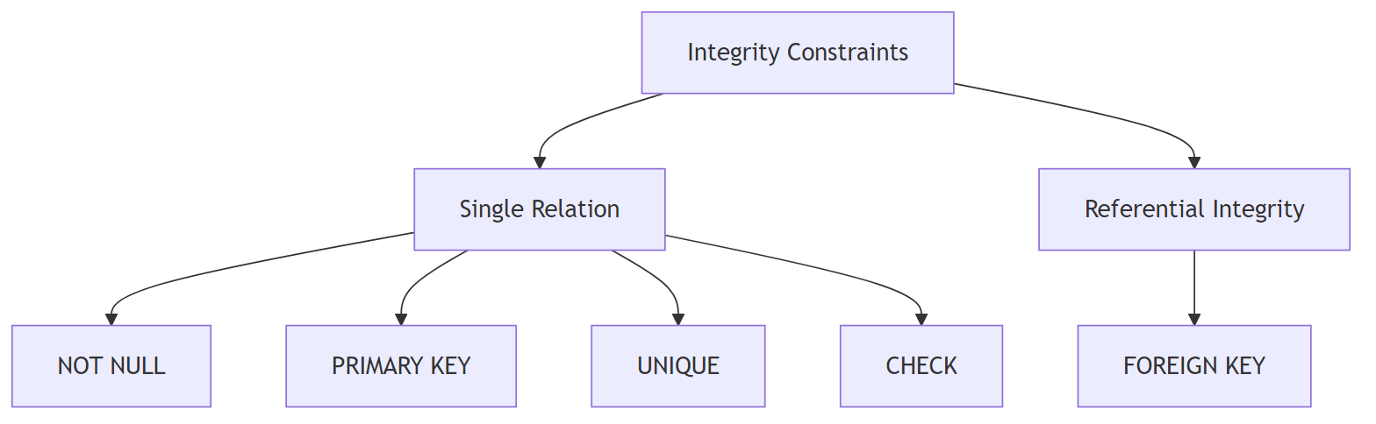
Diagram

Single Relation Constraints
Constraint | Description | Example
NOT NULL | Attribute cannot be null | name VARCHAR(20) NOT NULL
PRIMARY KEY | Unique identifier, not null | PRIMARY KEY (ID)
UNIQUE | Candidate key (can be null) | UNIQUE (email)
CHECK (P) | Predicate P must be satisfied | CHECK (salary > 0)
CREATE TABLE section (
course_id VARCHAR(8),
sec_id VARCHAR(8),
semester VARCHAR(6),
year NUMERIC(4,0),
building VARCHAR(15),
room_number VARCHAR(7),
time_slot_id VARCHAR(4),
PRIMARY KEY (course_id, sec_id, semester, year),
CHECK (semester IN ('Fall', 'Winter', 'Spring', 'Summer'))
);

Referential Integrity (Foreign Keys)
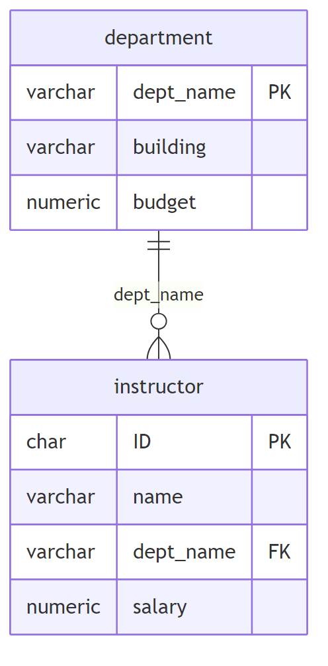
Diagram
-- Basic foreign key
FOREIGN KEY (dept_name) REFERENCES department
-- Explicit attribute reference
FOREIGN KEY (dept_name) REFERENCES department(dept_name)

Cascading Actions
Action | On DELETE | On UPDATE
CASCADE | Delete referencing tuples | Update referencing values
SET NULL | Set foreign key to NULL | Set foreign key to NULL
SET DEFAULT | Set to default value | Set to default value
NO ACTION | Reject if references exist | Reject if references exist
CREATE TABLE course (
course_id VARCHAR(8),
title VARCHAR(50),
dept_name VARCHAR(20),
credits NUMERIC(2,0),
FOREIGN KEY (dept_name) REFERENCES department
ON DELETE CASCADE
ON UPDATE CASCADE
);

Complex Check Conditions
-- Check with subquery
CHECK (time_slot_id IN (SELECT time_slot_id FROM time_slot))

Assertions
Database-wide constraints that must always be satisfied:
CREATE ASSERTION assertion_name CHECK (predicate);
-- Example: Ensure total credits equals sum of completed courses
CREATE ASSERTION credits_check CHECK (
NOT EXISTS (
SELECT * FROM student
WHERE tot_cred <> (
SELECT COALESCE(SUM(credits), 0)
FROM takes NATURAL JOIN course
WHERE takes.ID = student.ID
AND grade IS NOT NULL
AND grade <> 'F'
)
)
);

SQL Data Types and Schemas

Built-in Data Types
Type | Description | Example
DATE | Year, month, day | DATE '2005-07-27'
TIME | Hours, minutes, seconds | TIME '09:00:30.75'
TIMESTAMP | Date + time | TIMESTAMP '2005-07-27 09:00:30.75'
INTERVAL | Period of time | INTERVAL '1' DAY
-- Interval arithmetic
SELECT current_date + INTERVAL '1' MONTH;
-- Date subtraction gives interval
SELECT end_date - start_date FROM projects;

Large Object Types
Type | Description | Use Case
BLOB | Binary Large Object | Photos, videos, CAD files
CLOB | Character Large Object | Large text documents
Note: Queries return a pointer to large objects, not the objects themselves.

User-Defined Types
-- Create custom type
CREATE TYPE Dollars AS NUMERIC(12,2) FINAL;
-- Use in table definition
CREATE TABLE department (
dept_name VARCHAR(20),
building VARCHAR(15),
budget Dollars
);

Domains
-- Create domain with constraint
CREATE DOMAIN person_name CHAR(20) NOT NULL;
CREATE DOMAIN degree_level VARCHAR(10)
CONSTRAINT degree_level_test
CHECK (value IN ('Bachelors', 'Masters', 'Doctorate'));
Feature | Type | Domain
Constraints | No | Yes
NULL handling | N/A | Can specify NOT NULL
Check constraints | No | Yes

Index Definition
Indexes improve query performance by allowing efficient lookup without scanning all tuples.
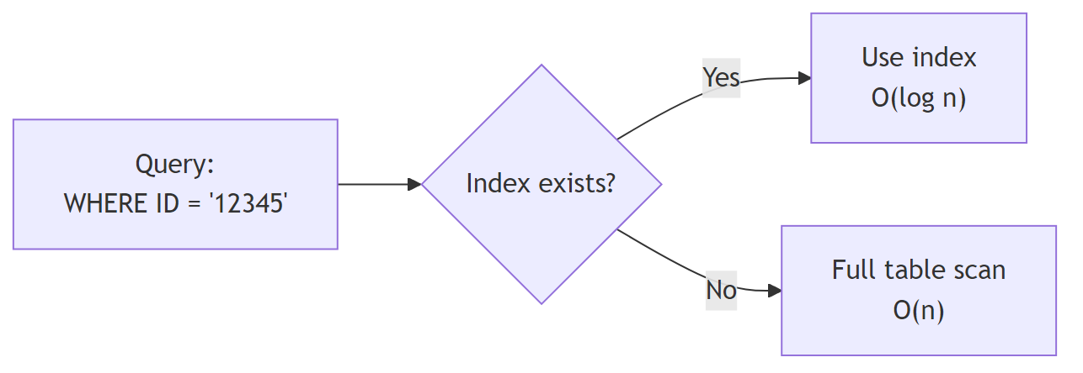
Diagram
-- Create index
CREATE INDEX index_name ON relation_name(attribute);
-- Example
CREATE INDEX studentID_index ON student(ID);
-- Query using index
SELECT *
FROM student
WHERE ID = '12345'; -- Uses studentID_index

Authorization
Authorization controls what users can access and modify in the database.

Privilege Types
Data Privileges | Description
SELECT | Read data
INSERT | Add new tuples
UPDATE | Modify existing tuples
DELETE | Remove tuples

Schema Privileges | Description
INDEX | Create/delete indexes
RESOURCES | Create new relations
ALTERATION | Add/delete attributes
DROP | Delete relations

GRANT Statement
GRANT <privilege list> ON <relation or view> TO <user list>;
-- Examples
GRANT SELECT ON department TO Amit, Satoshi;
GRANT SELECT, INSERT ON instructor TO U1, U2, U3;
GRANT ALL PRIVILEGES ON student TO admin;
-- Grant to all users
GRANT SELECT ON course TO PUBLIC;

REVOKE Statement
REVOKE <privilege list> ON <relation or view> FROM <user list>;
-- Examples
REVOKE SELECT ON student FROM U1, U2, U3;
REVOKE ALL ON instructor FROM Amit;

Roles
Roles group privileges for easier management:
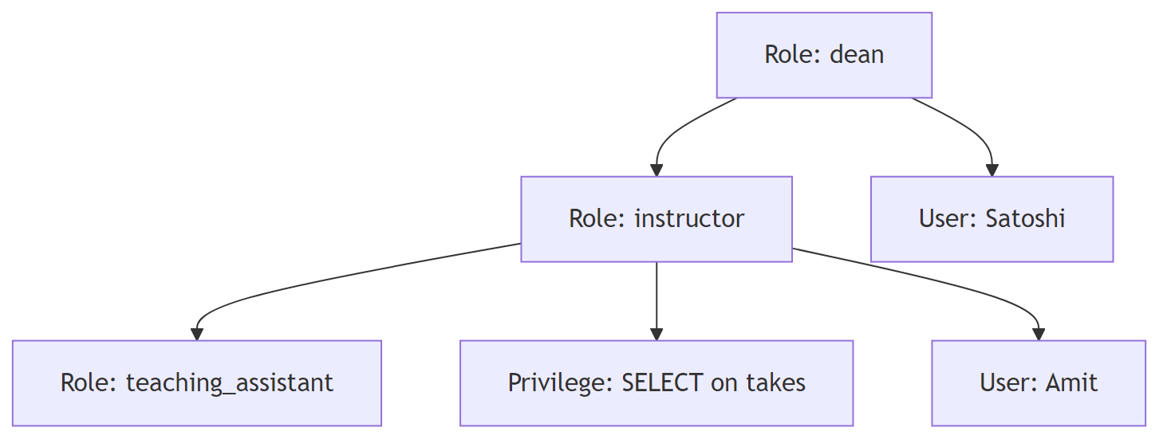
Diagram
-- Create role
CREATE ROLE instructor;
-- Assign user to role
GRANT instructor TO Amit;
-- Grant privileges to role
GRANT SELECT ON takes TO instructor;
-- Role hierarchy
CREATE ROLE teaching_assistant;
GRANT teaching_assistant TO instructor;
CREATE ROLE dean;
GRANT instructor TO dean;
GRANT dean TO Satoshi;

Authorization on Views
-- Create view
CREATE VIEW geo_instructor AS
SELECT * FROM instructor
WHERE dept_name = 'Geology';
-- Grant access to view
GRANT SELECT ON geo_instructor TO geo_staff;
Important: Granting privilege on a view does NOT grant privilege on underlying tables.

Additional Authorization Features
-- Grant REFERENCES privilege (for foreign keys)
GRANT REFERENCES (dept_name) ON department TO Mariano;
-- Grant with ability to pass on privilege
GRANT SELECT ON department TO Amit WITH GRANT OPTION;
-- Revoke with cascade (revokes dependent privileges)
REVOKE SELECT ON department FROM Amit, Satoshi CASCADE;
-- Revoke with restrict (fails if dependent privileges exist)
REVOKE SELECT ON department FROM Amit, Satoshi RESTRICT;

Summary Table
Topic | Key Concepts
Joins | Natural, Inner, Left/Right/Full Outer
Views | Virtual relations, updatable conditions, materialized
Transactions | COMMIT, ROLLBACK, atomicity, isolation
Constraints | NOT NULL, PRIMARY KEY, UNIQUE, CHECK, FOREIGN KEY
Cascading | CASCADE, SET NULL, SET DEFAULT
Data Types | DATE, TIME, TIMESTAMP, INTERVAL, BLOB, CLOB
User-Defined | CREATE TYPE, CREATE DOMAIN
Indexes | CREATE INDEX for efficient lookup
Authorization | GRANT, REVOKE, roles, privileges

