Chapter 5: Advanced SQL

Overview
This chapter covers advanced SQL features including accessing SQL from programming languages, functions and procedures, triggers, recursive queries, and advanced aggregation features for OLAP.

Accessing SQL from a Programming Language

Why Access SQL from Programming Languages?
Reason | Description
Expressiveness | SQL lacks full power of general-purpose languages
Non-declarative actions | Printing reports, GUI interaction, etc.

Two Approaches
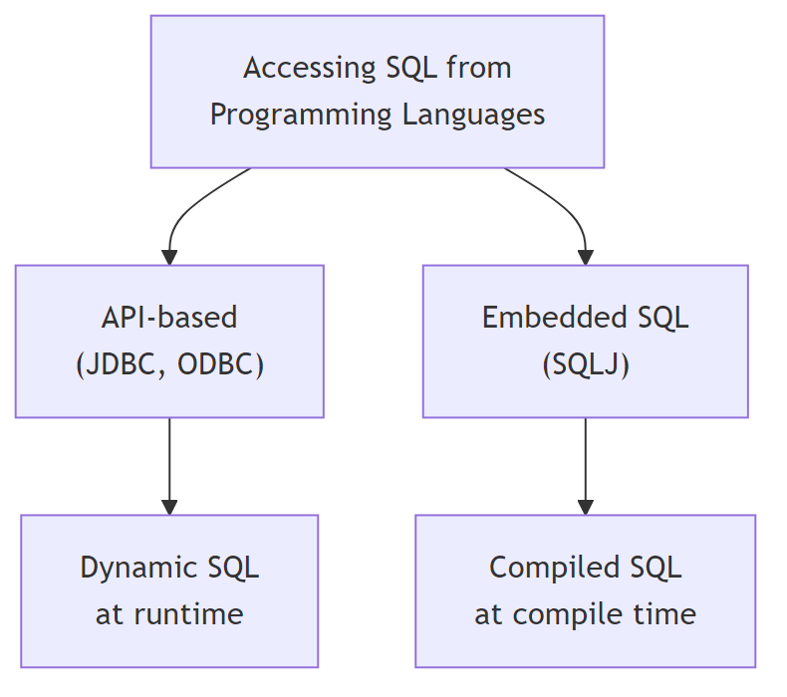
Diagram

JDBC (Java Database Connectivity)

JDBC Model
Diagram

Basic JDBC Steps
Step | Description
1. Open Connection | Connect to database server
2. Create Statement | Create statement object
3. Execute Query | Send SQL and fetch results
4. Handle Exceptions | Catch and process errors
5. Close Resources | Release connections

JDBC Code Example
public static void JDBCexample(String dbid, String userid, String passwd) {
try (Connection conn = DriverManager.getConnection(
"jdbc:oracle:thin:@db.yale.edu:2000:univdb", userid, passwd);
Statement stmt = conn.createStatement()) {
// Execute update
stmt.executeUpdate(
"INSERT INTO instructor VALUES('77987', 'Kim', 'Physics', 98000)");
// Execute query
ResultSet rset = stmt.executeQuery(
"SELECT dept_name, avg(salary) FROM instructor GROUP BY dept_name");
while (rset.next()) {
System.out.println(rset.getString("dept_name") + " " +
rset.getFloat(2));
}
} catch (SQLException sqle) {
System.out.println("SQLException: " + sqle);
}
}

ResultSet Methods
Method | Description
getString(col) | Get string value by column name or index
getInt(col) | Get integer value
getFloat(col) | Get float value
next() | Move to next row
wasNull() | Check if last read value was NULL

Prepared Statements (Preventing SQL Injection)
// SAFE: Using PreparedStatement
PreparedStatement pStmt = conn.prepareStatement(
"INSERT INTO instructor VALUES(?,?,?,?)");
pStmt.setString(1, "88877");
pStmt.setString(2, "Perry");
pStmt.setString(3, "Finance");
pStmt.setInt(4, 125000);
pStmt.executeUpdate();
// DANGEROUS: String concatenation - NEVER DO THIS!
// "INSERT INTO instructor VALUES('" + ID + "', '" + name + "', ...)"

SQL Injection Attack Example
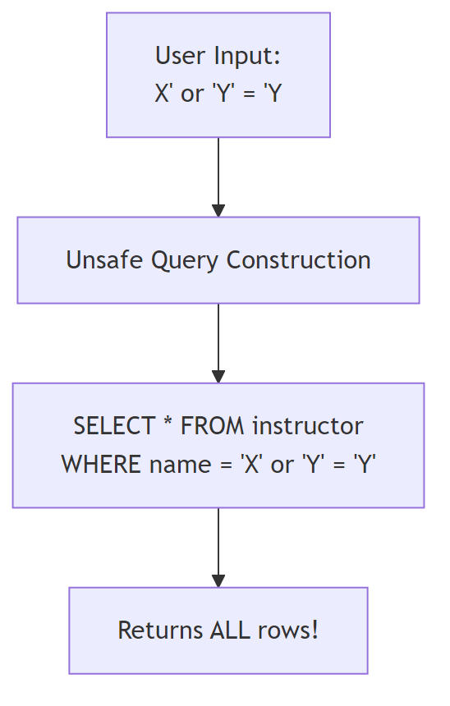
Diagram
Input: X'; UPDATE instructor SET salary = salary + 10000; --
Result: Executes unauthorized UPDATE!

Metadata Features
// ResultSet metadata
ResultSetMetaData rsmd = rs.getMetaData();
for (int i = 1; i <= rsmd.getColumnCount(); i++) {
System.out.println(rsmd.getColumnName(i));
System.out.println(rsmd.getColumnTypeName(i));
}
// Database metadata
DatabaseMetaData dbmd = conn.getMetaData();
ResultSet rs = dbmd.getColumns(null, "univdb", "department", "%");
ResultSet tables = dbmd.getTables("", "", "%", new String[]{"TABLES"});
ResultSet pks = dbmd.getPrimaryKeys("", "", tableName);

Transaction Control in JDBC
// Disable auto-commit
conn.setAutoCommit(false);
try {
// Multiple updates
stmt.executeUpdate("UPDATE account SET balance = balance - 100 WHERE id = 1");
stmt.executeUpdate("UPDATE account SET balance = balance + 100 WHERE id = 2");
conn.commit(); // Commit transaction
} catch (SQLException e) {
conn.rollback(); // Rollback on error
}

ODBC (Open Database Connectivity)
Feature | Description
Purpose | Standard API for database communication
Languages | C, C++, and other languages
Applications | GUI tools, spreadsheets, etc.

Embedded SQL
SQL statements embedded directly in host language code.

Syntax
EXEC SQL <embedded SQL statement>;
// Variable declaration
EXEC SQL BEGIN DECLARE SECTION;
int credit_amount;
EXEC SQL END DECLARE SECTION;
// Connect to database
EXEC SQL CONNECT TO server USER user_name USING password;

Cursor Operations
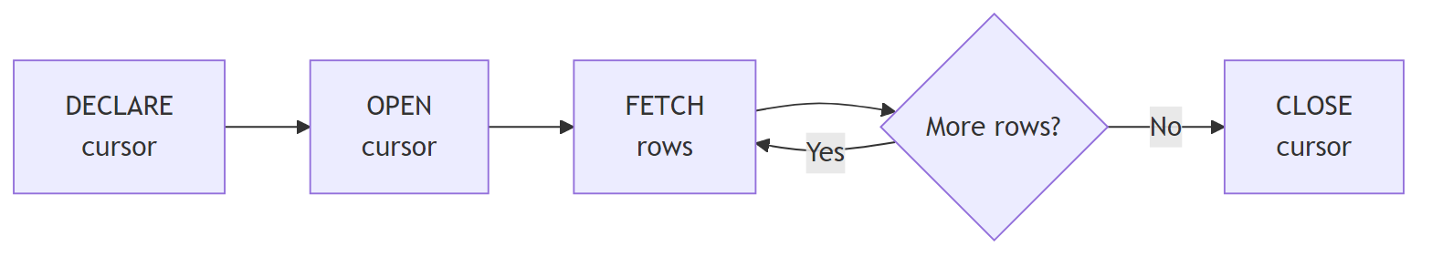
Diagram
// Declare cursor
EXEC SQL
DECLARE c CURSOR FOR
SELECT ID, name
FROM student
WHERE tot_cred > :credit_amount;
// Open cursor
EXEC SQL OPEN c;
// Fetch rows
EXEC SQL FETCH c INTO :si, :sn;
// Close cursor
EXEC SQL CLOSE c;

Updates Through Cursors
EXEC SQL
DECLARE c CURSOR FOR
SELECT *
FROM instructor
WHERE dept_name = 'Music'
FOR UPDATE;
// After fetching each tuple:
UPDATE instructor
SET salary = salary + 1000
WHERE CURRENT OF c;

Functions and Procedures
Functions and procedures store business logic in the database.

SQL Functions
-- Create function
CREATE FUNCTION dept_count(dept_name VARCHAR(20))
RETURNS INTEGER
BEGIN
DECLARE d_count INTEGER;
SELECT COUNT(*) INTO d_count
FROM instructor
WHERE instructor.dept_name = dept_name;
RETURN d_count;
END;
-- Use function
SELECT dept_name, budget
FROM department
WHERE dept_count(dept_name) > 12;

Table Functions
-- Function returning a table
CREATE FUNCTION instructor_of(dept_name CHAR(20))
RETURNS TABLE (
ID VARCHAR(5),
name VARCHAR(20),
dept_name VARCHAR(20),
salary NUMERIC(8,2)
)
RETURN TABLE (
SELECT ID, name, dept_name, salary
FROM instructor
WHERE instructor.dept_name = instructor_of.dept_name
);
-- Usage
SELECT * FROM TABLE(instructor_of('Music'));

Language Constructs
-- FOR loop
DECLARE n INTEGER DEFAULT 0;
FOR r AS
SELECT budget FROM department
WHERE dept_name = 'Music'
DO
SET n = n + r.budget;
END FOR;

External Language Routines
-- C procedure
CREATE PROCEDURE dept_count_proc(IN dept_name VARCHAR(20), OUT count INTEGER)
LANGUAGE C
EXTERNAL NAME '/usr/avi/bin/dept_count_proc';
-- C function
CREATE FUNCTION dept_count(dept_name VARCHAR(20))
RETURNS INTEGER
LANGUAGE C
EXTERNAL NAME '/usr/avi/bin/dept_count';

Security Considerations
Approach | Description
Sandbox | Use safe languages (Java)
Separate Process | Run in isolated process with IPC
Direct Execution | Run in database address space (risky)

Triggers
A trigger is a statement automatically executed as a side effect of database modification.
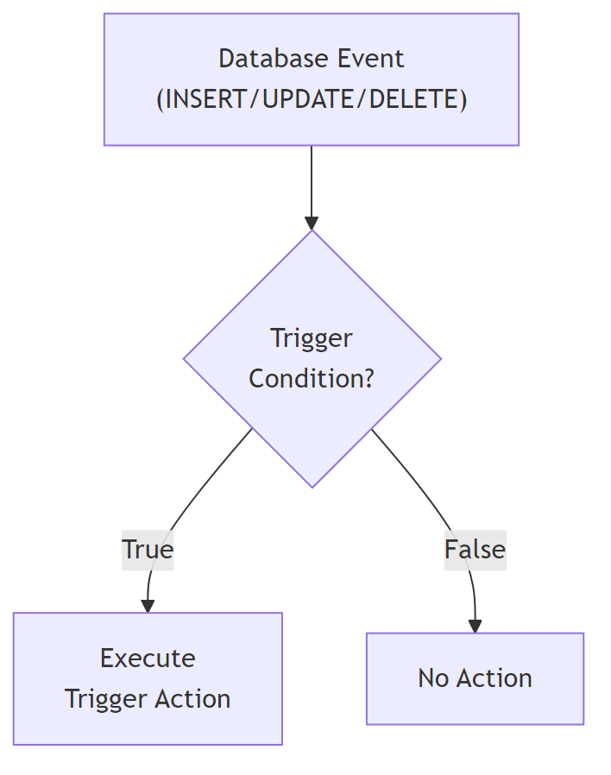
Diagram

Trigger Components
Component | Description
Event | INSERT, UPDATE, DELETE
Condition | WHEN clause (optional)
Action | SQL statements to execute
Timing | BEFORE or AFTER
Granularity | FOR EACH ROW or FOR EACH STATEMENT

Trigger Example
-- Trigger to maintain total credits
CREATE TRIGGER credits_earned
AFTER UPDATE OF takes ON (grade)
REFERENCING NEW ROW AS nrow
REFERENCING OLD ROW AS orow
FOR EACH ROW
WHEN nrow.grade <> 'F' AND nrow.grade IS NOT NULL
AND (orow.grade = 'F' OR orow.grade IS NULL)
BEGIN ATOMIC
UPDATE student
SET tot_cred = tot_cred + (
SELECT credits
FROM course
WHERE course.course_id = nrow.course_id
)
WHERE student.id = nrow.id;
END;

Statement-Level Triggers
-- Use transition tables instead of row references
CREATE TRIGGER summary_update
AFTER UPDATE ON sales
REFERENCING OLD TABLE AS old_sales
REFERENCING NEW TABLE AS new_sales
FOR EACH STATEMENT
BEGIN
-- Process all affected rows at once
END;

When NOT to Use Triggers
Situation | Better Alternative
Maintaining summary data | Materialized views
Database replication | Built-in replication
Field validation | Application methods/encapsulation
Risks: - Unintended execution during data load/backup - Cascading execution - Critical transaction failures

Recursive Queries
SQL:1999 permits recursive view definitions for queries like transitive closure.

Recursive CTE Syntax
WITH RECURSIVE rec_prereq(course_id, prereq_id) AS (
-- Base case
SELECT course_id, prereq_id
FROM prereq
UNION
-- Recursive case
SELECT rec_prereq.course_id, prereq.prereq_id
FROM rec_prereq, prereq
WHERE rec_prereq.prereq_id = prereq.course_id
)
SELECT * FROM rec_prereq;

Fixed-Point Computation
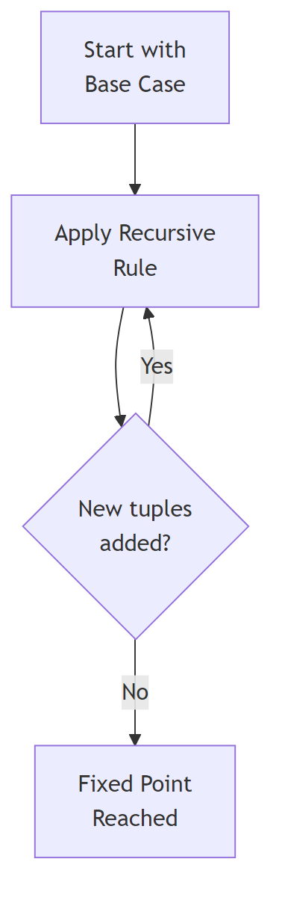
Diagram
Iteration | Description
Base | Direct prerequisites
1st recursion | Prerequisites of prerequisites
2nd recursion | 3 levels deep
… | Continue until no new tuples

Advanced Aggregation Features

Ranking Functions
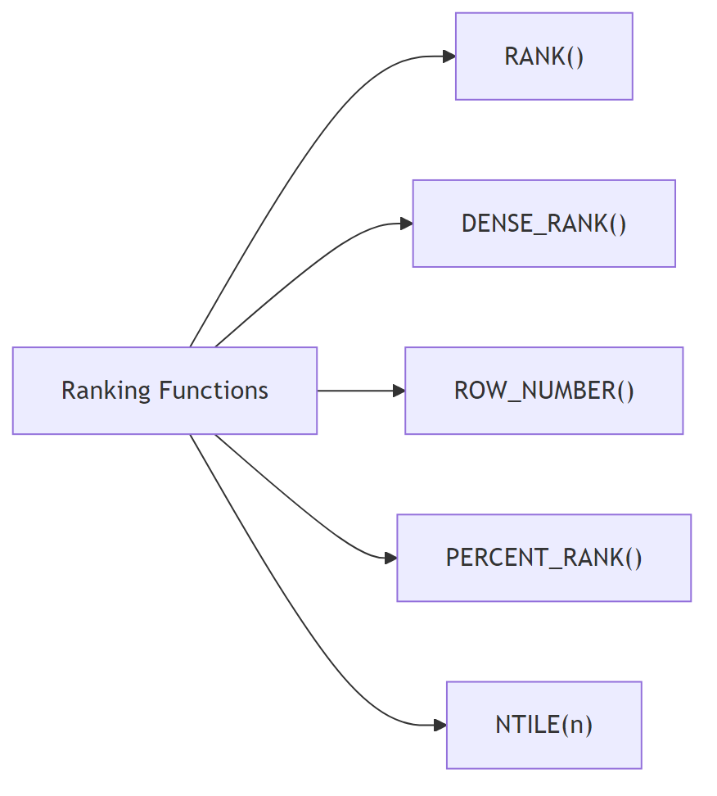
Diagram
Function | Description | Gaps
RANK() | Rank with gaps for ties | Yes
DENSE_RANK() | Rank without gaps | No
ROW_NUMBER() | Unique row number | N/A
PERCENT_RANK() | Percentile rank (0-1) | N/A
CUME_DIST() | Cumulative distribution | N/A
NTILE(n) | Divide into n buckets | N/A

Ranking Examples
-- Basic ranking
SELECT ID, RANK() OVER (ORDER BY GPA DESC) AS s_rank
FROM student_grades
ORDER BY s_rank;
-- Ranking with ties (RANK vs DENSE_RANK)
-- GPA: 4.0, 4.0, 3.8
-- RANK(): 1, 1, 3 (gap at 2)
-- DENSE_RANK(): 1, 1, 2 (no gap)
-- Ranking within partitions
SELECT ID, dept_name,
RANK() OVER (PARTITION BY dept_name ORDER BY GPA DESC) AS dept_rank
FROM dept_grades
ORDER BY dept_name, dept_rank;
-- NTILE: divide into quartiles
SELECT ID, NTILE(4) OVER (ORDER BY GPA DESC) AS quartile
FROM student_grades;

Windowing Functions
Window functions compute aggregates over a sliding window of rows.
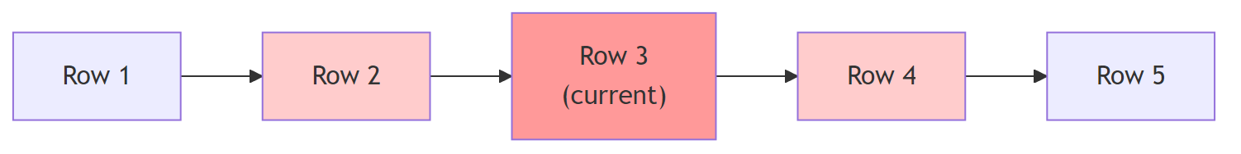
Diagram
-- Moving average (previous, current, next)
SELECT date, SUM(value) OVER (
ORDER BY date
ROWS BETWEEN 1 PRECEDING AND 1 FOLLOWING
) AS moving_avg
FROM sales;
-- Cumulative sum
SELECT date, SUM(value) OVER (
ORDER BY date
ROWS UNBOUNDED PRECEDING
) AS cumulative_total
FROM sales;

Window Specifications
Specification | Description
ROWS BETWEEN 1 PRECEDING AND 1 FOLLOWING | 3-row window
ROWS UNBOUNDED PRECEDING | All rows up to current
RANGE BETWEEN 10 PRECEDING AND CURRENT ROW | Value-based range
RANGE INTERVAL 10 DAY PRECEDING | Time-based range

Windowing with Partitions
-- Running balance per account
SELECT account_number, date_time,
SUM(value) OVER (
PARTITION BY account_number
ORDER BY date_time
ROWS UNBOUNDED PRECEDING
) AS balance
FROM transaction
ORDER BY account_number, date_time;

OLAP (Online Analytical Processing)

Multidimensional Data
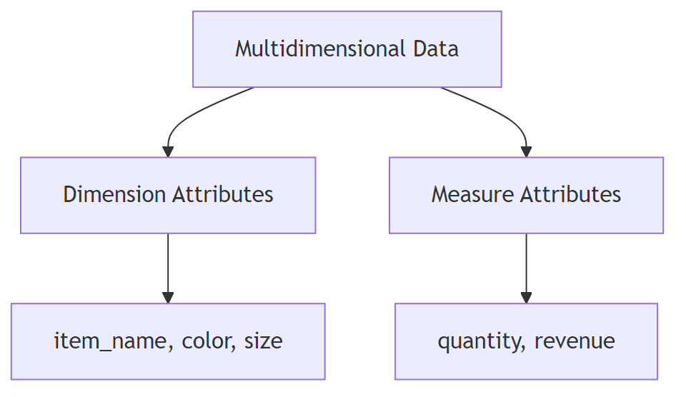
Diagram
Attribute Type | Purpose | Example
Dimension | Define viewing dimensions | item_name, color, size
Measure | Values to aggregate | quantity, revenue

Cross-Tabulation (Pivot Table)
| dark | pastel | white | Total
--------------+-------+--------+-------+-------
Skirt | 8 | 35 | 10 | 53
Dress | 20 | 10 | 5 | 35
Shirt | 14 | 7 | 28 | 49
Pants | 6 | 2 | 5 | 13
--------------+-------+--------+-------+-------
Total | 48 | 54 | 48 | 150

Data Cube
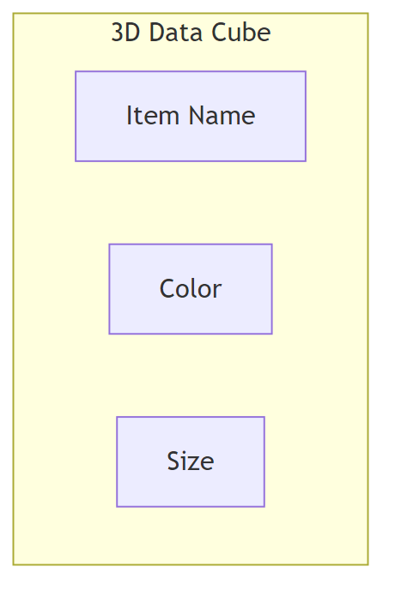
Diagram

OLAP Operations
Operation | Description
Pivoting | Change dimensions in cross-tab
Slicing | Fix value for one dimension
Dicing | Fix values for multiple dimensions
Roll-up | Move to coarser granularity
Drill-down | Move to finer granularity

CUBE and ROLLUP
-- CUBE: all possible groupings (2^n combinations)
SELECT item_name, color, size, SUM(quantity)
FROM sales
GROUP BY CUBE(item_name, color, size);
-- Generates groupings:
-- (item_name, color, size), (item_name, color), (item_name, size),
-- (color, size), (item_name), (color), (size), ()
-- ROLLUP: prefix groupings only
SELECT item_name, color, size, SUM(quantity)
FROM sales
GROUP BY ROLLUP(item_name, color, size);
-- Generates groupings:
-- (item_name, color, size), (item_name, color), (item_name), ()

GROUPING Function
-- Distinguish NULL from "all" aggregates
SELECT item_name, color, size, SUM(quantity),
GROUPING(item_name) AS item_flag,
GROUPING(color) AS color_flag,
GROUPING(size) AS size_flag
FROM sales
GROUP BY CUBE(item_name, color, size);
-- GROUPING returns 1 for aggregate rows, 0 otherwise

Combining CUBE and ROLLUP
-- Cross product of groupings
SELECT item_name, color, size, SUM(quantity)
FROM sales
GROUP BY ROLLUP(item_name), ROLLUP(color, size);
-- Generates: {item_name, ()} X {(color, size), (color), ()}

OLAP Implementation Types
Type | Description
MOLAP | Multidimensional arrays in memory
ROLAP | Relational database features only
HOLAP | Hybrid: summaries in memory, base data in RDBMS

Summary
Topic | Key Concepts
JDBC | Connection, Statement, ResultSet, PreparedStatement
SQL Injection | Always use PreparedStatement with parameters
Embedded SQL | EXEC SQL, cursors, host variables
Functions | Scalar functions, table functions
Procedures | IN/OUT parameters, external routines
Triggers | Event-condition-action, row/statement level
Recursion | WITH RECURSIVE, transitive closure
Ranking | RANK, DENSE_RANK, ROW_NUMBER, NTILE
Windowing | OVER, PARTITION BY, ROWS/RANGE
OLAP | CUBE, ROLLUP, GROUPING, data cubes

