Chapter 6: Database Design Using the E-R Model

Overview
The Entity-Relationship (E-R) model is a conceptual design approach that models an enterprise as a collection of entities and relationships. This chapter covers E-R concepts, diagrams, and conversion to relational schemas.

Database Design Phases
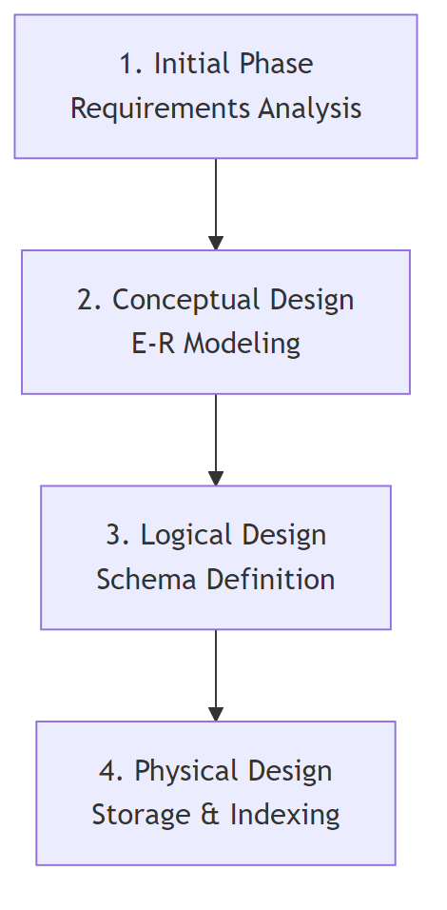
Diagram
Phase | Description | Decisions
Initial | Characterize data needs | What data to collect
Conceptual | Create E-R model | Entities, relationships, constraints
Logical | Convert to schema | Relation schemas, attribute distribution
Physical | Storage layout | Indexes, partitioning, file organization

Design Pitfalls to Avoid
Pitfall | Description
Redundancy | Repeated information leading to inconsistency
Incompleteness | Cannot model certain aspects of enterprise

Entity Sets
An entity is an object that exists and is distinguishable from other objects.
An entity set is a set of entities of the same type sharing the same properties.
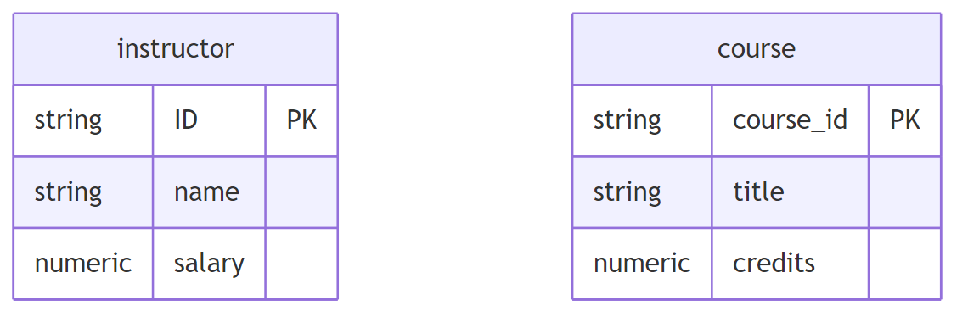
Diagram

E-R Diagram Notation for Entities
Symbol | Meaning
Rectangle | Entity set
Attributes inside | Properties of entity
Underlined attribute | Primary key

Relationship Sets
A relationship is an association among several entities.
A relationship set is a set of relationships of the same type.
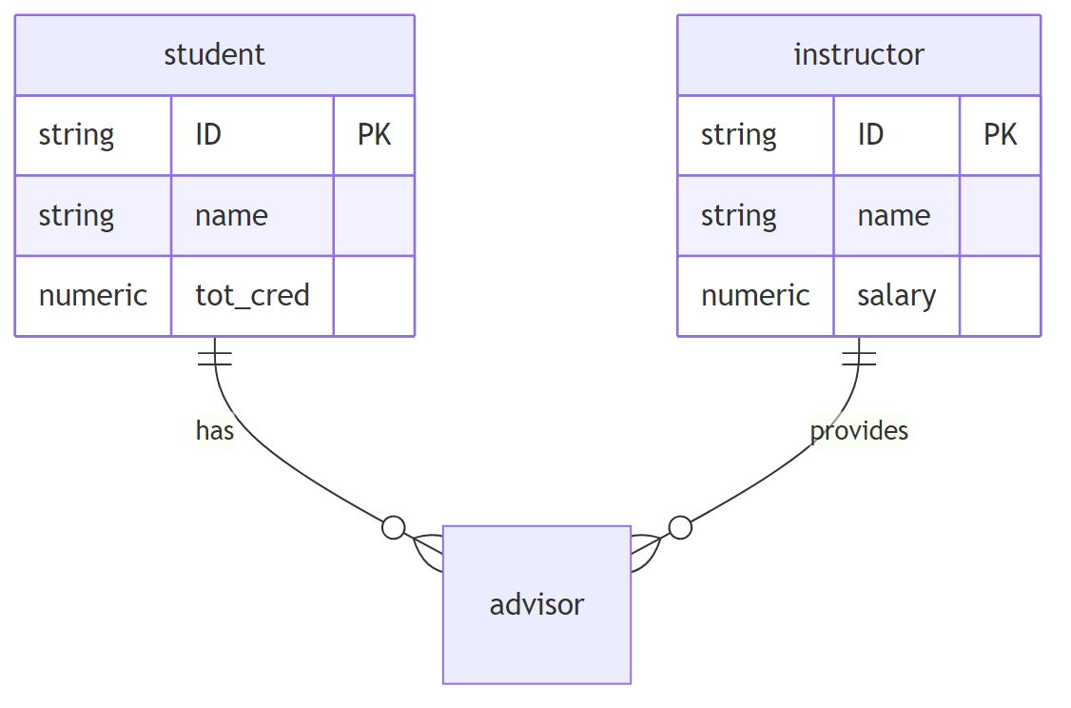
Diagram

Relationship Set Properties
Property | Description
Degree | Number of entity sets participating
Attributes | Descriptive properties of relationship
Roles | Labels when same entity set appears multiple times

Relationship with Attributes
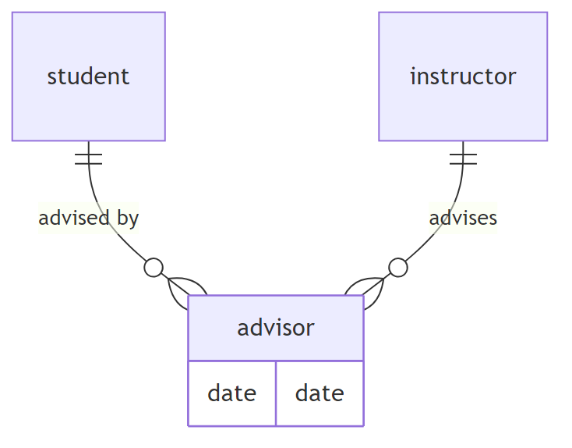
Diagram

Roles in Relationships
When the same entity set participates multiple times in a relationship:
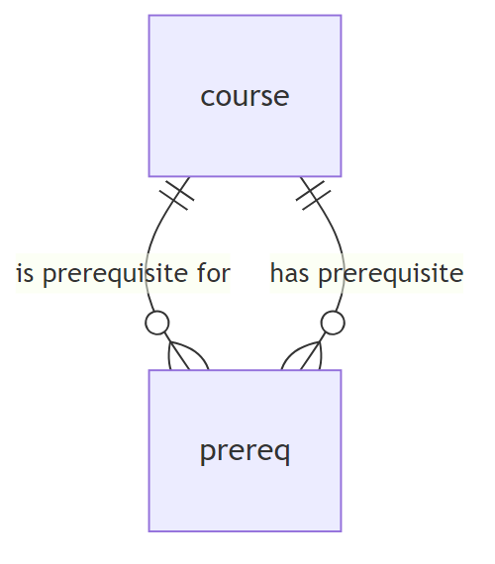
Diagram

Degree of Relationships
Degree | Name | Example
2 | Binary | student-advisor
3 | Ternary | student-instructor-project
n | N-ary | Multiple entity sets

Attributes

Attribute Types
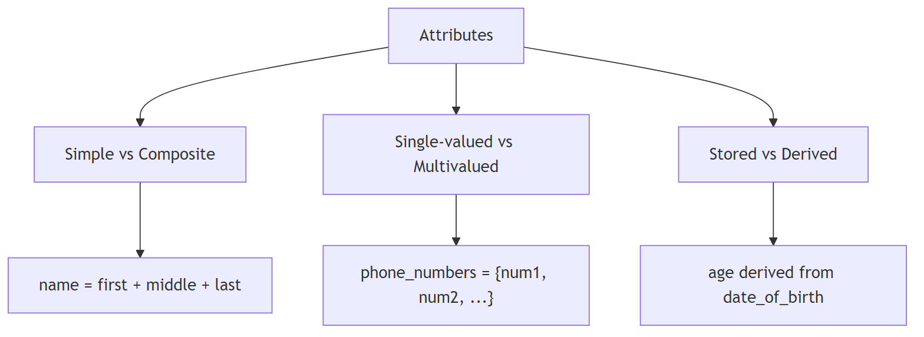
Diagram
Type | Description | Example
Simple | Cannot be divided | ID, salary
Composite | Can be divided into subparts | name (first, middle, last)
Single-valued | One value per entity | ID
Multivalued | Multiple values per entity | phone_numbers
Derived | Computed from other attributes | age (from date_of_birth)

Composite Attribute Structure
name
├── first_name
├── middle_initial
└── last_name
address
├── street
│ ├── street_number
│ ├── street_name
│ └── apartment_number
├── city
├── state
└── postal_code

Mapping Cardinality Constraints
Cardinality constraints express the number of entities that can be associated via a relationship.

Types of Cardinalities
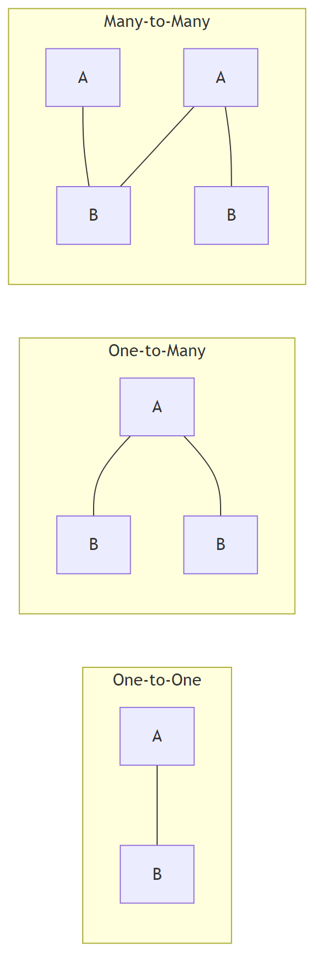
Diagram
Cardinality | Description | Example
One-to-One (1:1) | Each A associates with at most one B, and vice versa | Country-Capital
One-to-Many (1:N) | Each A can associate with many B’s, each B with one A | Department-Employees
Many-to-One (N:1) | Each A associates with one B, each B can have many A’s | Employees-Department
Many-to-Many (M:N) | Each A can associate with many B’s and vice versa | Students-Courses

E-R Diagram Notation for Cardinality
Symbol | Meaning
→ (arrow) | “One” side
— (line) | “Many” side
= (double line) | Total participation
l..h notation | Minimum l, maximum h

Participation Constraints
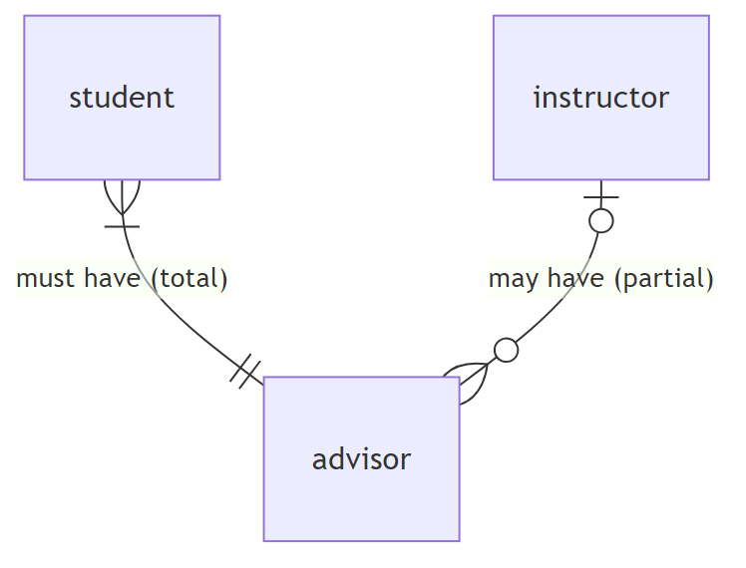
Diagram
Participation | Notation | Meaning
Total | Double line (=) | Every entity must participate
Partial | Single line (-) | Some entities may not participate

Min-Max Notation
Example: 0..* on instructor side, 1..1 on student side
- Instructor can advise 0 or more students
- Student must have exactly 1 advisor

Primary Keys

Primary Key for Entity Sets
- Attributes that uniquely identify each entity
- Underlined in E-R diagrams

Primary Key for Relationship Sets
Cardinality | Primary Key
Many-to-Many | Union of PKs of both entity sets
One-to-Many | PK of the “Many” side
Many-to-One | PK of the “Many” side
One-to-One | PK of either entity set

Weak Entity Sets
A weak entity set depends on another entity (identifying entity) for its existence.
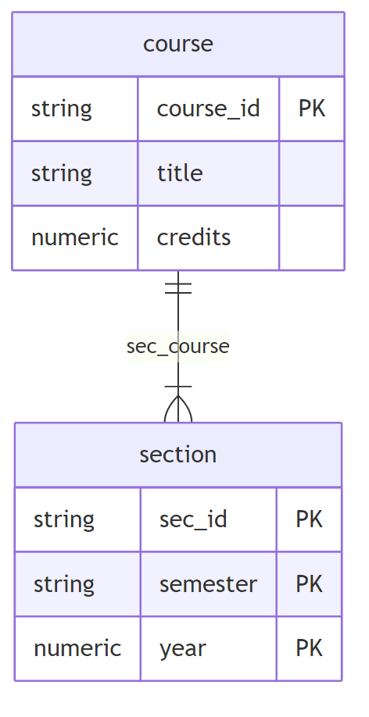
Diagram

Weak Entity Set Concepts
Term | Description
Weak Entity Set | Cannot be uniquely identified by its own attributes
Strong Entity Set | Has sufficient attributes for unique identification
Identifying Entity Set | Strong entity that “owns” the weak entity
Identifying Relationship | Links weak entity to identifying entity
Discriminator | Partial key that distinguishes weak entities

E-R Notation for Weak Entities
Symbol | Meaning
Double rectangle | Weak entity set
Dashed underline | Discriminator (partial key)
Double diamond | Identifying relationship
Primary Key of Weak Entity = PK of identifying entity + Discriminator
Example: section PK = (course_id, sec_id, semester, year)

Reduction to Relational Schemas

Converting Entity Sets
Entity Type | Conversion Rule
Strong Entity | Schema with same attributes
Weak Entity | Schema with own attributes + PK of identifying entity
-- Strong entity
student(ID, name, tot_cred)
-- Weak entity (section depends on course)
section(course_id, sec_id, semester, year)

Converting Composite Attributes
Flatten composite attributes into separate columns:
-- Composite name (first_name, middle_initial, last_name)
instructor(ID, first_name, middle_initial, last_name,
street_number, street_name, apt_number,
city, state, zip_code, date_of_birth)

Converting Multivalued Attributes
Create a separate schema:
-- Multivalued phone_number for instructor
inst_phone(ID, phone_number)
-- Each phone number becomes a separate tuple
-- (22222, '456-7890')
-- (22222, '123-4567')

Converting Relationship Sets
Cardinality | Conversion Rule
Many-to-Many | New schema with PKs of both entities + relationship attributes
One-to-Many (Total) | Add PK of “One” side as FK to “Many” side
Many-to-One (Total) | Add PK of “One” side as FK to “Many” side
One-to-One | Add FK to either side
-- Many-to-Many: separate table
advisor(student_id, instructor_id, date)
-- One-to-Many: add FK to "Many" side
-- Instead of separate inst_dept table:
instructor(ID, name, salary, dept_name) -- dept_name is FK

Schema Redundancy Rules
Situation | Rule
Weak entity’s identifying relationship | Redundant (already in weak entity schema)
One-to-Many with total participation | Can merge into “Many” side schema
Partial participation | May result in NULL values if merged

Extended E-R Features

Specialization (Top-Down)
Designate sub-groupings within an entity set with distinctive features.
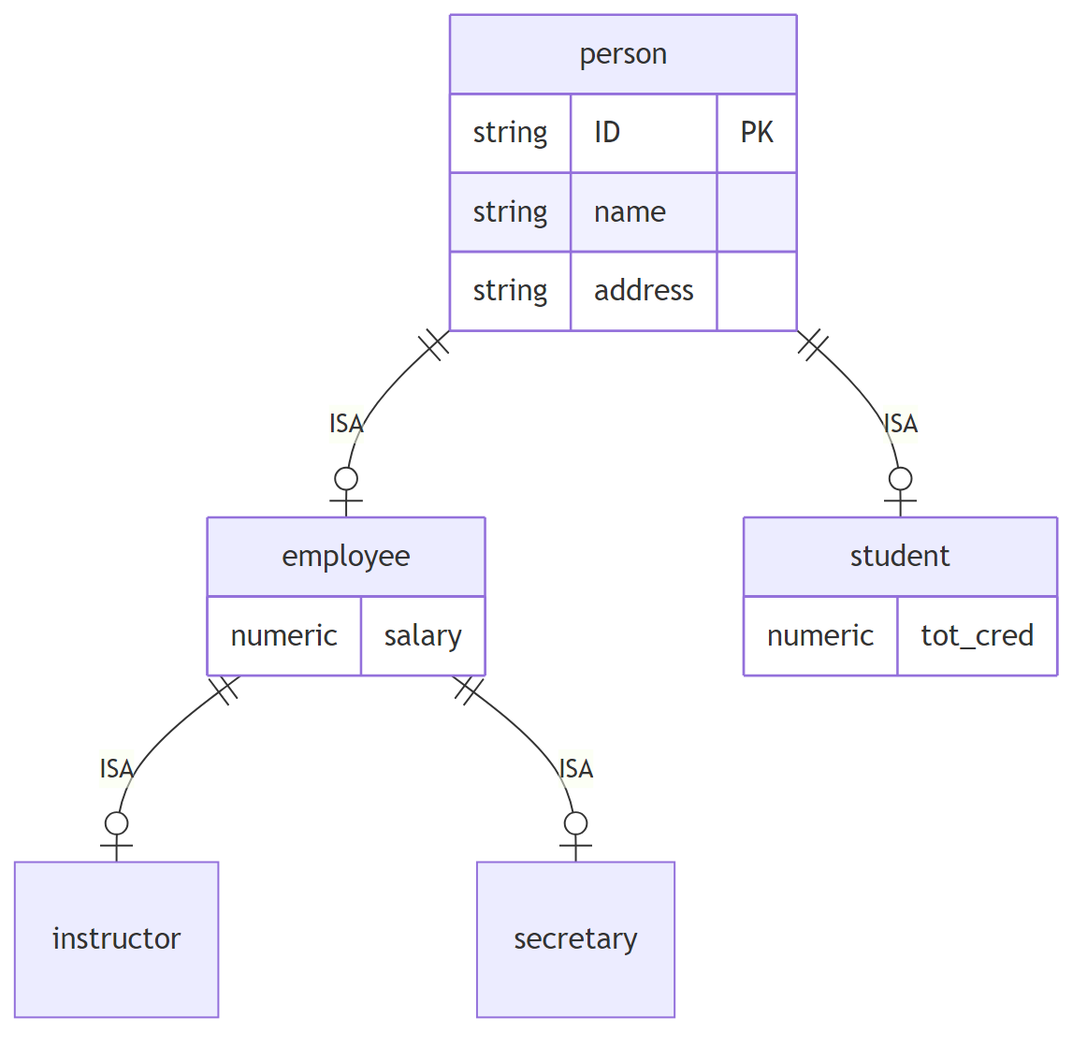
Diagram

Generalization (Bottom-Up)
Combine entity sets with common features into a higher-level entity set.

Specialization/Generalization Constraints
Constraint | Options | Description
Disjointness | Disjoint / Overlapping | Can entity belong to multiple lower-level sets?
Completeness | Total / Partial | Must entity belong to some lower-level set?

Converting Specialization to Schemas
Method 1: Separate Tables
person(ID, name, address)
employee(ID, salary) -- ID references person
student(ID, tot_cred) -- ID references person
Drawback: Need join to get complete information
Method 2: Combined Tables
employee(ID, name, address, salary)
student(ID, name, address, tot_cred)
Drawback: Redundancy for overlapping entities

Aggregation
Treat a relationship as an abstract entity to allow relationships between relationships.
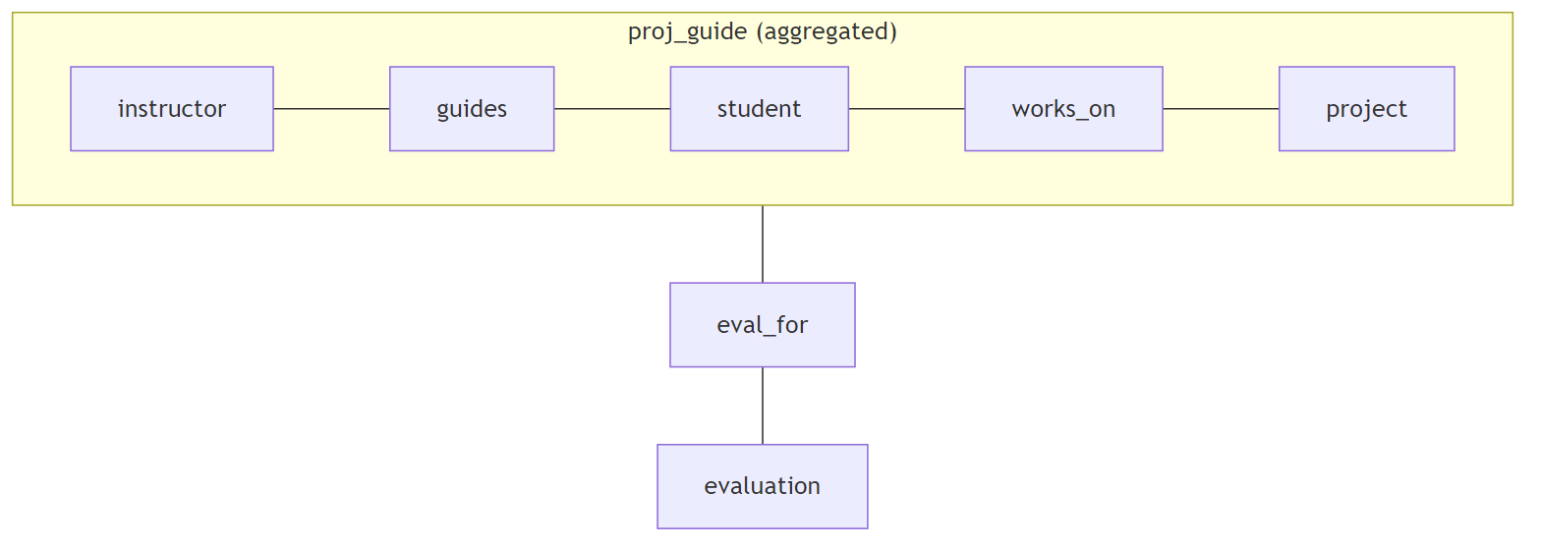
Diagram

Converting Aggregation to Schema
-- Aggregated relationship becomes entity
eval_for(student_id, project_id, instructor_id, evaluation_id)

Design Decisions

Entity vs. Attribute
Use Entity When | Use Attribute When
Need extra information about the item | Simple value
Item has multiple values | Single value
Item participates in relationships | No relationships needed
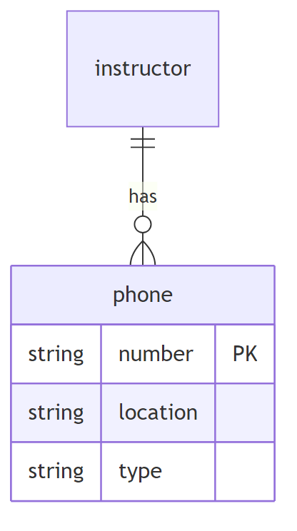 Use entity for phone if need location, type, etc.

Entity vs. Relationship
Guideline: Use relationship to describe an action between entities.

Binary vs. Non-Binary Relationships
Preference | Reason
Binary | Simpler, allows partial information
Non-binary | Shows multi-entity participation clearly

Converting N-ary to Binary
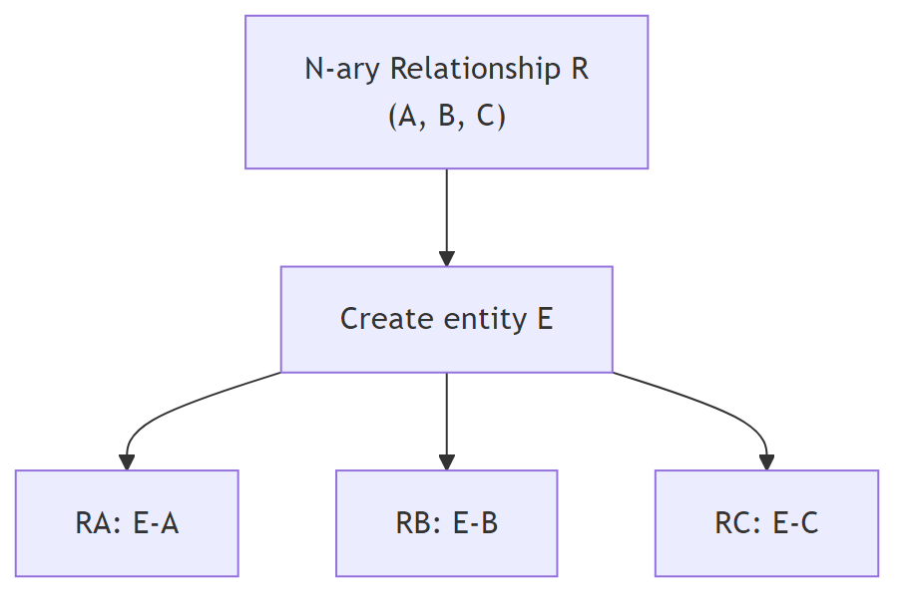
Diagram

E-R Diagram Symbols Summary

Entity Symbols
Symbol | Meaning
Rectangle | Strong entity set
Double rectangle | Weak entity set
Oval (attached) | Attribute
Double oval | Multivalued attribute
Dashed oval | Derived attribute
Underline | Primary key
Dashed underline | Discriminator

Relationship Symbols
Symbol | Meaning
Diamond | Relationship set
Double diamond | Identifying relationship
Line | Relationship link
Arrow (→) | “One” cardinality
Double line | Total participation

Specialization Symbols
Symbol | Meaning
Triangle with ISA | Specialization/Generalization
Disjoint | Subclasses are mutually exclusive
Overlapping | Entity can belong to multiple subclasses

Alternative Notations

Chen vs. Crow’s Foot (IE1FX)
Feature | Chen | Crow’s Foot
Entity | Rectangle | Rectangle
Relationship | Diamond | Line only
Cardinality | Arrow/Line | Crow’s foot symbols
Many | Line | Fork (crow’s foot)
One | Arrow | Single line

UML Class Diagrams
E-R Concept | UML Equivalent
Entity set | Class
Attributes | Class attributes
Relationship | Association line
Cardinality | Multiplicity notation
Specialization | Generalization arrow
Note: UML cardinality position is reversed compared to E-R notation.

University Database E-R Example
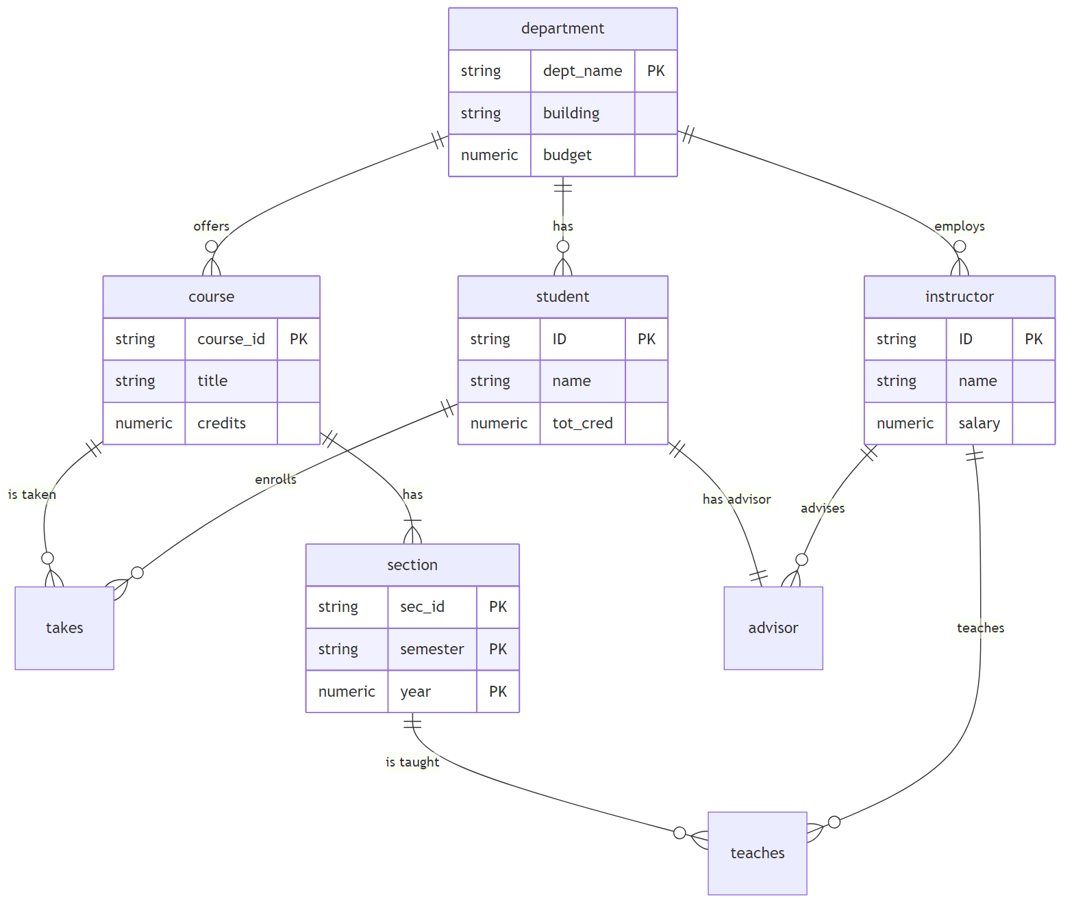
Diagram

Key Takeaways
Concept | Purpose
Entity Sets | Model real-world objects
Relationship Sets | Model associations between entities
Attributes | Describe properties
Cardinality | Constrain relationship participation
Weak Entities | Model dependent entities
Specialization | Model subtype hierarchies
Aggregation | Model relationships of relationships
Reduction to Schema | Convert E-R to relational tables

